**The Importance of Subantarctic Mode Water and**

**Antarctic Intermediate Water and Their Role in Global Climate**

|

STEPHANIE PENNINGTON

*Department of Atmospheric and Oceanic Science, University of Maryland, College Park*

July 5, 2016

**INTRODUCTION**

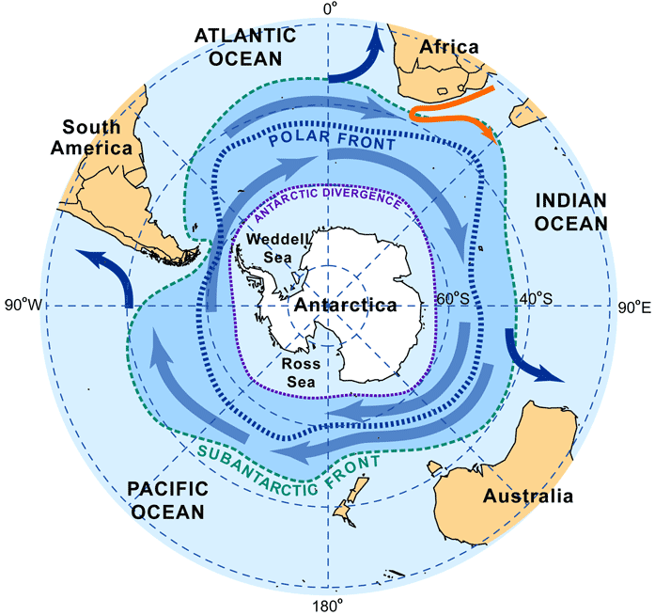 The Southern Ocean is home to two water masses that play a significant role in the global climate system. Subantarctic Mode Water (SAMW) and Antarctic Intermediate Water (AAIW) are particularly important for nutrient transport, heat storage, and ventilation throughout the global ocean circulation and uptake of anthropogenic CO2. These water masses are large in volume and are found in the upper branch of the thermohaline circulation. They begin in the Antarctic Circumpolar Current (ACC), a major current found in the Southern Ocean. Driven by westerly winds, the ACC is an eastward flowing current circling Antarctica and is unbounded by any landmass (see **Figure 1**), allowing for large volume transports. The Subantarctic Front (SAF) facilitates a portion of this transport - the north most bound of the ACC – and is composed of the SAMW and AAIW.

Photo courtesy of: <http://www.euroargoedu.org/floatdata.php?float=1901227>

Water masses are defined by numerous factors, including temperature, salinity, nutrient content, potential density, oxygen content, and potential vorticity. They can also be separated into three categories based on depth: upper ocean, intermediate, and deep waters. Water masses play an important role in the circulation of the World Ocean, in particular SAMW and AAIW, which will be further explored in this paper.

**SUBANTARCTIC MODE WATER**

Subantarctic Mode Water (SAMW) is considered an upper-ocean water mass with depths around 400-600m located in the Southern Ocean and ranges from the SAF to the equator (Talley 1999; Hartin 2012) (see **Figure 2**). SAMW has temperatures ranging from 15°C to 4°C (McCartney 1977) and an average salinity of 34.4 PSU (Baum 2004). SAMW is characterized by a potential vorticity minimum, oxygen maximum, and is pycnostad - which means that there is little density change in the vertical and is a local minimum (Baum 2004). SAMW is formed in the southeast Indian (80°-130° E) and southeast Pacific Oceans (120°-70° W) (Sloyan et al. 2010) at the northern SAF boundary by winter deepening of the upper-ocean mixed layer (Garabato et al. 2009). Nutrients such as nitrate, phosphate, and silicate are found in these waters and supply the global thermohaline with nutrients as well as play a part in primary production (Ayers and Strutton 2013).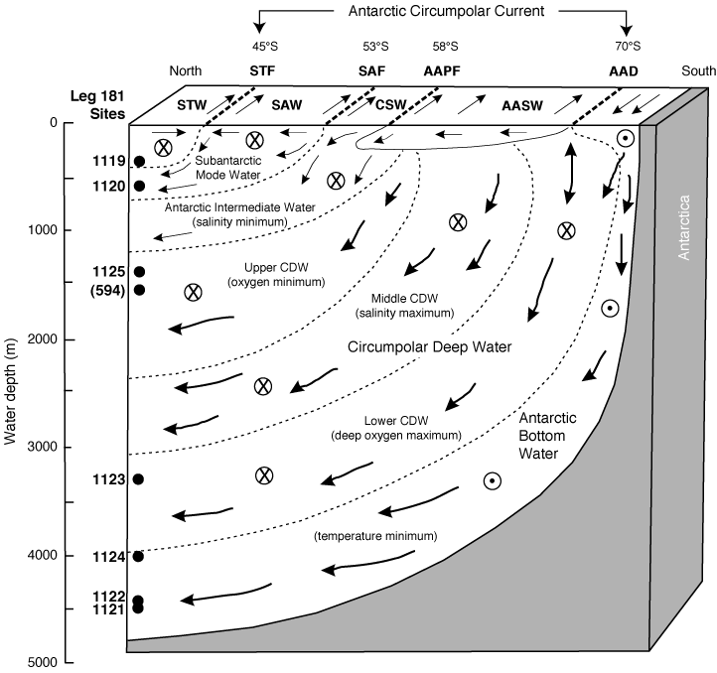

Photo courtesy of: http://www-odp.tamu.edu/publications/181_SR/synth/s_f5.htm

**ANTARCTIC INTERMEDIATE WATERS**

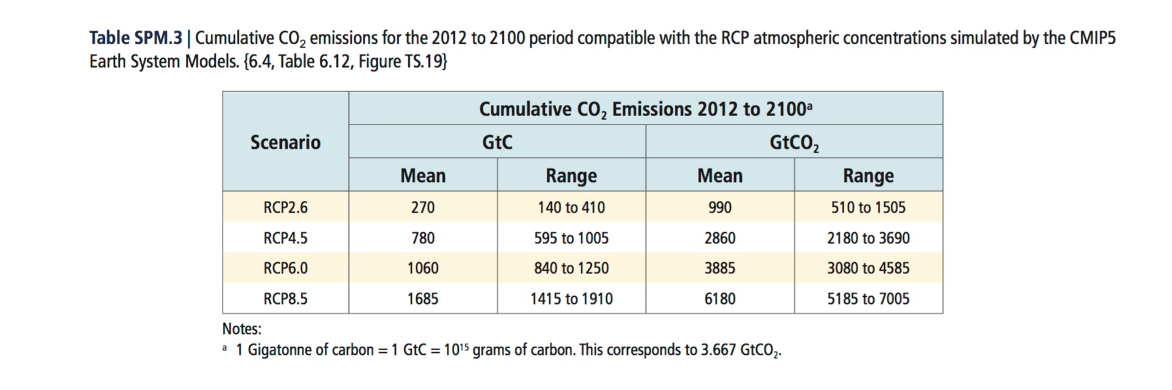 Antarctic Intermediate Water (AAIW) is a cold, low-salinity intermediate water mass with depths around 600-1125m located in the Southern Ocean near the SAF that ranges from the Polar Front to around 20°N (Talley 1999; Hartin 2012) (see **Figure 2**). AAIW is characterized by a salinity minimum and high oxygen content. The formation of AAIW is highly contested amongst researchers. A hypothesis accepted by some is that AAIW is formed in the southeast Pacific near the Drake Passage, which is a narrow passageway between South America and Antarctic where the ACC flows (Piola and Gordon 1989). AAIW and SAMW have shown to be connected with formation near the Drake Passage and deep convection during winter north of the ACC (Weijer et al. 2012).

**FUTURE PREDICTIONS IN A CHANGING CLIMATE**

Photo Courtesy of: https://www.ipcc.ch/pdf/assessment-report/ar5/wg3/ipcc_wg3_ar5_summary-for-policymakers.pdf

In the IPCC’s Fifth Assessment Report (AR5), four scenarios of ranging radiative forcing (in Wm-2) were input into the CMIP5 Earth System Models to predict changes in CO2 emissions (in GtCO2). Shown in **Figure 3** (Table SPM.3), which was taken from the IPCC AR5 Summary for Policymakers, CO2 emissions can range from 990-6180 with changes in radiative forcing ranging from 2.6-8.5 respectively (IPCC 2013).

SAMW and AAIW act as a carbon sink, absorbing anthropogenic CO2 and carrying it throughout the world’s oceans. This mechanism is important to the global climate system and makes SAMW and AAIW sensitive to climate forcing, making these water masses vital to researchers who use them as a predictability mechanism. Some researchers used past Assessment Report values (AR4) with various climate models to predict changes in global climate.

Various findings included a decrease in the subduction in the Southern Ocean overturning circulation of SAMW and AAIW would result in a decrease of CO2 intake in the future (Downes et al. 2009). In the same study, it was concluded that changes in the properties of these water masses could also influence the rate of uptake and storage (Downes et al. 2009).

**DISCUSSION AND CONCLUSION**

Climate models used to predict changes in the ocean and atmosphere are not without errors, however. Many variables used in a climate model can be over or underestimated and it is important to look at the results skeptically and thoroughly to gain an understanding of the general climate progressions.

Subantarctic Mode Water and Antarctic Intermediate Water are pivotal water masses responsible for uptake of anthropogenic CO2, transport of heat and nutrients, and ventilation through subduction. Due to these factors, these water masses provide researchers valuable indicators of climate change for years to come.

**REFERENCES**

--Ayers, Jennifer M., and Peter G. Stratton. "Nutrient Variability in Subantarctic Mode Waters Forced by the Southern Annular Mode and ENSO." *Geophysical Research Letters* 40, no. 13, 3419-423.

--Baum, Steven K. "Glossary of Physical Oceanography and Related Disciplines." May 26, 2004. http://www.mcirano.ufba.br/ftp/books/baum_04.pdf.

--Cerovecki, Ivana, Lynne D. Talley, Matthew R. Maloff, and Guillaume Maze. "Subantarctic Mode Water Formation, Destruction, and Export in the Eddy-Permitting Southern Ocean State Estimate." *Journal of Physical Oceanography* 43 (July 2013): 1485-509.

--Downes, Stephanie M., Nathaniel L. Bindoff, and Stephen R. Rintoul. "Impacts of Climate Change on the Subduction of Mode and Intermediate Water Masses in the Southern Ocean." *Journal Of Climate* 22, no. 12 (June 15, 2009): 3289-3302. *Academic Search Complete*, EBSCO*host*

--Garabato, Alberto C. N., Loïc Jullion, David P. Stevens, Karen J. Heywood, and Brian A. King. “Variability of Subantarctic Mode Water and Antarctic Intermediate Water in the Drake Passage during the Late-Twentieth and Early-Twenty-First Centuries.” *Journal of Climate* 22, no. 13 (July 1, 2009): 3661-3688

--Herraiz-Borreguero, Laura, and Stephen Rintoul. "Subantarctic mode water: distribution and circulation." *Ocean Dynamics* 61, no. 1 (January 2011): 103-126. *Academic Search Complete*, EBSCO*host*

--Hartin, Corinne, "Subantarctic Mode and Antarctic Intermediate Water during the Present and Last Glacial Maximum" (2012). Open Access Dissertations. Paper 866.

--IPCC, 2013: Summary for Policymakers. In: *Climate Change 2013: The Physical Science Basis. Contribution of Working Group I to the Fifth Assessment Report of the Intergovernmental Panel on Climate Change* [Stocker, T.F., D. Qin, G.-K. Plattner, M. Tignor, S.K. Allen, J. Boschung, A. Nauels, Y. Xia, V. Bex and P.M. Midgley (eds.)]. Cambridge University Press, Cambridge, United Kingdom and New York, NY, USA, pp. 1–30, doi:10.1017/CBO9781107415324.004.

--McCartney, M. S., Subantarctic mode water. (1977) A Voyage of Discovery: George Deacon 70th Anniversary Volume, M. Angel, Ed., Pergamon, 103–119.

--Piola, A. R., and A. L. Gordon (1989), Intermediate water in the southwestern South Atlantic, *Deep-Sea Research I*, *36*, 1-16.

--Shao, Andrew E., Sarah T. Gille, Sabine Mecking, and LuAnne Thompson. "Properties of the Subantarctic Front and Polar Front from the Skewness of Sea Level Anomaly." *Journal of Geophysical Research*, July 26, 2015. doi:10.1002/2015JC010723.

--Sloyan, Bernadette M., and Igor V. Kamenkovich. "Simulation of Subantarctic Mode and Antarctic Intermediate Waters in Climate Models.” Journal of Climate: Vol 20, No 20. October 15, 2007.

--Sloyan, Bernadette M., Lynne D. Talley, Teresa K. Chereskin, Rana Fine, and James Holte. "Antarctic Intermediate Water and Subantarctic Mode Water Formation in the Southeast Pacific: The Role of Turbulent Mixing: Journal of Physical Oceanography: Vol 40, No 7." July 1, 2010.

--Smith, Ryan, Melicie Desflots, Sean White, Arthur J. Mariano, and Edward H. Ryan. "The Antarctic Circumpolar Current." The Antarctic Circumpolar Current. http://oceancurrents.rsmas.miami.edu/southern/antarctic-cp.html.

--Talley, Lynne. "SIO 210: Introduction to Physical Oceanography." SIO 210: Introduction to Physical Oceanography. 2015. http://www-pord.ucsd.edu/~ltalley/sio210/Southern/.

--Weijer, Wilbert, Bernadette M. Sloyan, Mathew E. Maltrud, Nicole Jeffery, Matthew W. Hecht, Corinne A. Hartin, Erik van Sebille, Ilana Wainer, and Laura Landrum. 2012. "The Southern Ocean and Its Climate in CCSM4." *Journal Of Climate* 25, no. 8: 2652-2675. *Academic Search Complete*, EBSCO*host*