CIS150AB – Lesson 14 At-Home Final Project

Name: Stephanie

MEID: Roussy

Programming Assignment

Playing cards are used in many computer games, including versions of such classics as Solitaire, Hearts, and Poker. Design a Card class that contains a string data field to hold a suit (spades, hearts, diamonds, or clubs) and an integer data field for a value from 1 to 13. Include get and set methods for each field.

Using two Card objects, design an application that plays a simple version of the card game War. Deal two Cards, one for the computer and one for the player. Determine the higher card, then display a message indicating whether the cards are equal, the computer won, or the player won.

Playing cards are considered equal when they have the same value, no matter what their suit is. For this game, assume that the Ace has a value of 1, and is the lowest value compared to the other cards. Jacks have a value of 11, Queens have value of 12, and the King has value of 13.

When playing, be sure that the two Cards dealt are not the same Card. For example, a deck cannot contain more than one Queen of Spades.

Your goal is to create a UML Diagram, flowchart and pseudocode for the above application. Review the Grading Rubric to review how your project will be graded.

Please make sure to use the following instructions:
- The application should have a minimum of a Card class and a class that contains the main method for the application.
- The Card object should have get/set methods, constructor method and any work methods that are necessary.
- Appropriate output and input statements should exist in your logic to provide a pause for user input after each round of play. A simple “Press 1 to continue playing or 0 to quit” prompt with corresponding input would be acceptable.
- The card rank should be printed to the screen, and not the value (e.g. “Jack of Spades” should be printed as the card, and not “11 of Spades”)
- Two of the same cards should never appear on the screen during a single round of play. Logic should exist in your application to handle this. Do not attempt to set up an array to keep track of the deck and prior cards played. Just be sure that the computer and player do not play the exact same card.

Submission Instructions
- If you would like, you can submit a working C# code in addition to your required UML diagram, pseudocode and flowchart. This is optional, but if you decide to do so and expand your learning, your score on the assignment will consist of your work on the flowchart plus the best score on either the pseudocode or the C# code.
- C# is the only programming language that will be used throughout the course. Submission of code in any other language (Java, Python, C++, etc.) will be marked as zero, and you will be asked to resubmit, even if the code is correct.
- The code should be able to run when copied and pasted into an online compiler such as OnlineGDB.
- Although not required, feel free to include a screenshot of your executed code in the OnlineGDB.

_______________________________________________________
UML Diagrams (required, insert below)

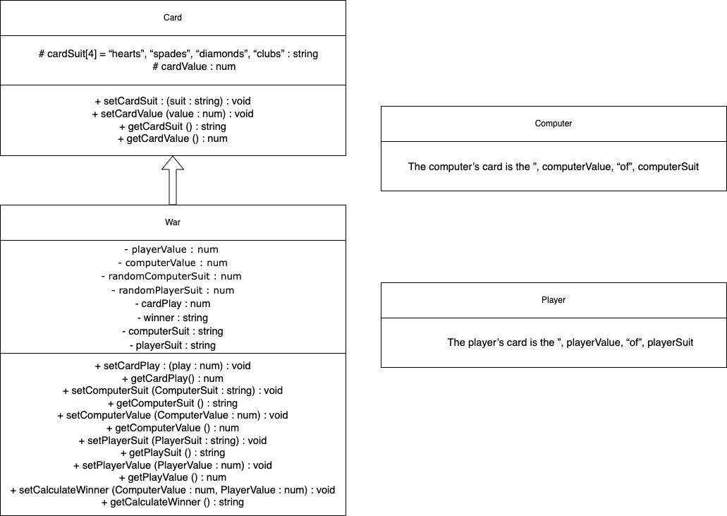

_______________________________________________________
Flowchart (required, insert below)

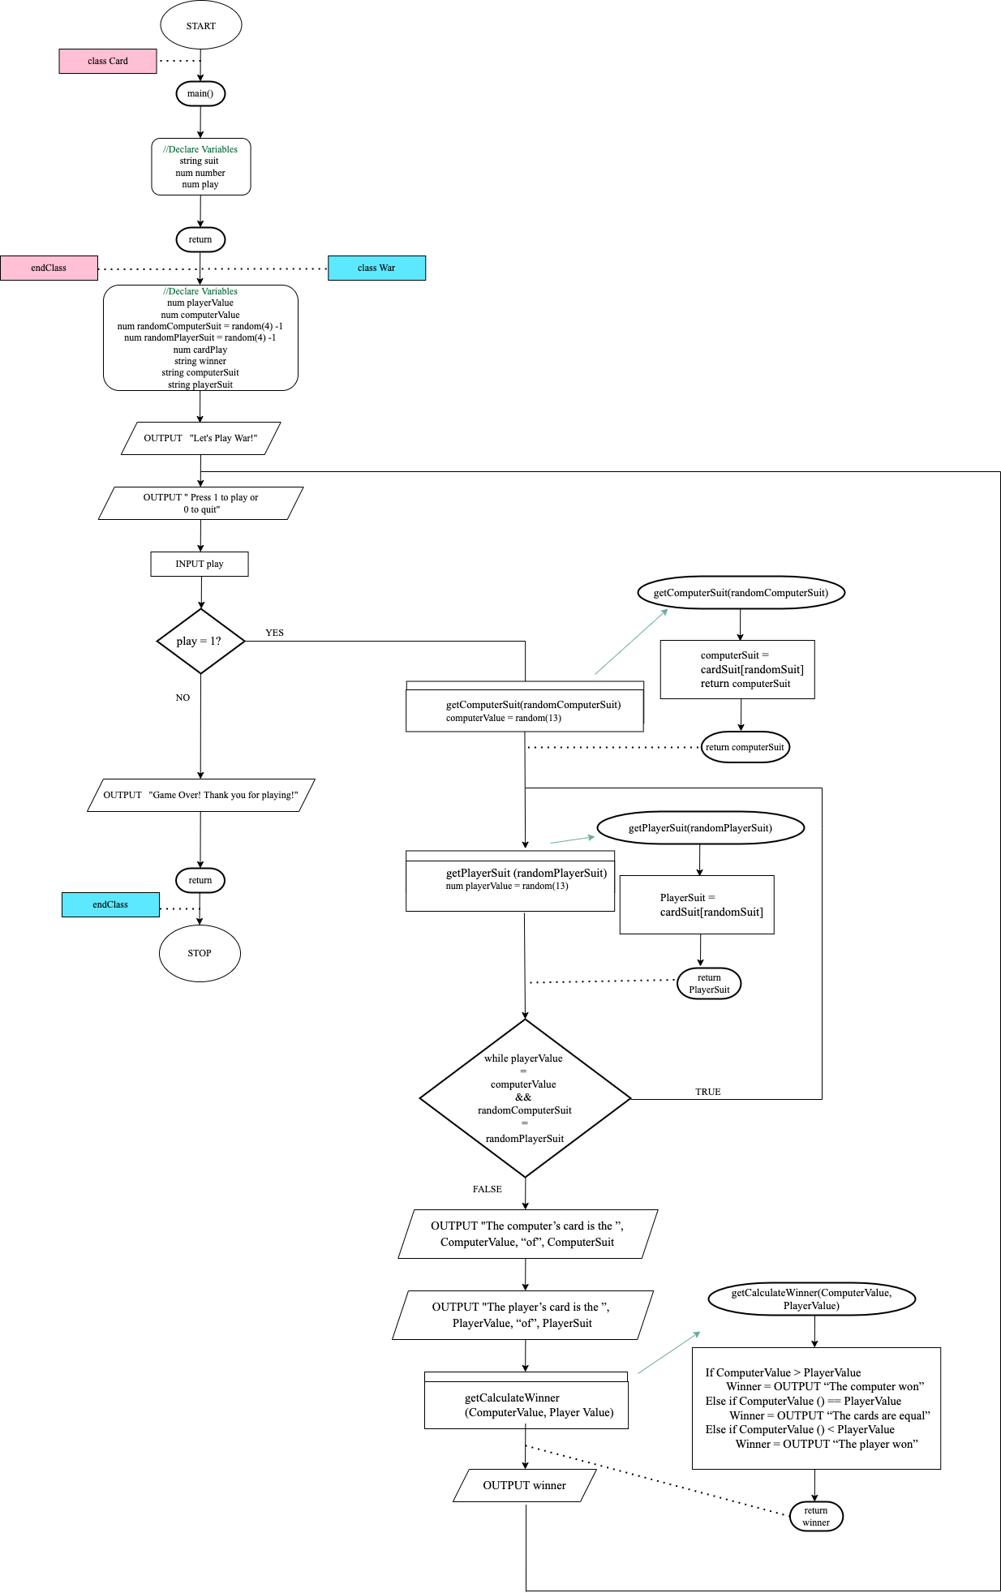
_______________________________________________________
Pseudocode (required, insert below)

Class Card
// Declarations
protected string cardSuit[4] = “hearts”, “spades”, “diamonds”, “clubs”
protected num cardValue

public void setCardSuit (string suit)
CardSuit = suit
return

public void setCardValue (num value)
CardValue = value
Return

public string getCardSuit ()
return suit

public num getCardValue ()
return value

endClass

Class War inheritsFrom Card
// Declarations
private num playerValue
private num computerValue
private num randomComputerSuit = random(4)-1 // setting a random number from 0-3 to get a position of the suit array string. Must minus 1 to start at 0 for the first position in array
private num randomPlayerSuit = random(4)-1
private num cardPlay
private string winner
private string computerSuit

// loop created for playing war

OUTPUT “Let’s Play War!”
OUTPUT “Press 1 to play or 0 to quit”
INPUT cardPlay
public void setCardPlay (num play)
CardPlay = play
Return

public string getCardplay ()
return play

while play = 1
//Setting and Getting the Computer’s card value and suit

public void setComputerSuit (cardSuit[randomComputerSuit])
computerSuit = cardSuit[randomSuit]
return computerSuit

public void setComputerValue (num Value)
ComputerValue = Value
Value = random(13) // setting value with a random number between 1 and 13
return Value

public string getComputerSuit ()
return computerSuit

public string getComputerValue ()
return computerValue

//Setting and Getting the Player’s card value and suit

public void setPlayerSuit (cardSuit[randomPlayerSuit])
playerSuit = cardSuit[randomSuit]
return playerSuit

public void setPlayerValue (num Value)
playerValue = Value
Value = random(13) // setting value with a random number between 1 and 13
return Value

//while the card value and suit of player is the same as the computer’s:

While playerValue = computerValue && randomComputerSuit = randomPlayerSuit

// get a new suit and value for player until it no longer matches computer
public void setPlayerSuit (cardSuit[randomPlayerSuit])
playerSuit = cardSuit[randomSuit]
return playerSuit

public void setPlayerValue (num Value)
playerValue = Value
endWhile

public string getPlayerSuit ()
return playerSuit

public string getPlayerValue ()
return playerValue

War Computer

OUTPUT “The computer’s card is the ”, Computer.getComputerValue (), “of”, Computer.getComputerSuit ()

return

War Player

OUTPUT “The player’s card is the ”, Player.getPlayerValue (), “of”, Player.getPlayerSuit ()

public void setCalculateWinner(num ComputerValue, num PlayerValue)
If ComputerValue > PlayerValue
Winner = OUTPUT “The computer won”
Else if ComputerValue () == PlayerValue
Winner = OUTPUT “The cards are equal”
Else if ComputerValue () < PlayerValue
Winner = OUTPUT “The player won”
return winner

public num getCalculateWinner ()
return CalculateWinner

endWhile
OUTPUT "Game Over! Thank you for playing!"

return

endClass

_______________________________________________________
C# code (optional, insert below)

