***MATLAB QUESTION 1***

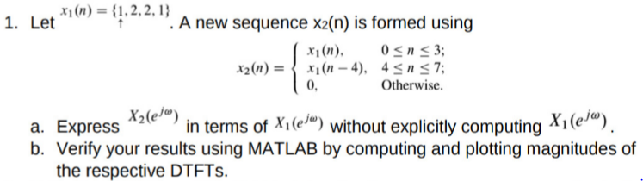

**SOLUTION**

1. x2=x1(n)+x1(n-4). So

X2(e^jw)= X1(e^jw)+X1((e^jw)(e^-4jw)= 2(e^-j2w)cos (2w)X1(e^jw)

The magnitude |X1(e^jw)| is scaled by 2 and changed by |cos 2w| while the phase |X1(e^jw)| is changed by 2w.

1. OPERATION ON THE SEQUENCE

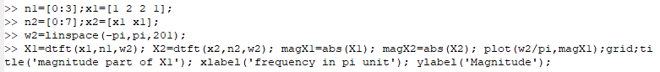



**PLOT:**

