FOOD NUTRITION AI

A mini project report submitted by

STEPHY GRACE D (Reg. No: URK23AI1003)

in partial fulfillment for the award of the degree of

BACHELOR OF TECHNOLOGY
in
ARTIFICIAL INTELLIGENCE AND DATA SCIENCE

under the supervision of

Dr.A.Shamila Ebenezer


DIVISION OF DATA SCIENCE AND CYBER SECURITY
KARUNYA INSTITUTE OF TECHNOLOGY AND SCIENCES
(Declared as Deemed to be University - under Sec-3 of the UGC Act, 1956)
Karunya Nagar, Coimbatore - 641 114. INDIA
APRIL 2026

DIVISION OF DATA SCIENCE AND CYBER SECURITY

BONAFIDE CERTIFICATE

This is to certify that the Project report entitled, “ Food Nutrition AI ” is a Bonafide record of of Mini Project work done during the even semester of the academic year 2025-2026 by

STEPHY GRACE D (Reg No: URK23AI1003)
in partial fulfillment of the requirements for the award of the degree of Bachelor of Technology in Artificial Intelligence and Data Science of Karunya Institute of Technology and Sciences.
Submitted for the Viva Voce held on ___________________________

Signature of the Guide

ACKNOWLEDGEMENT
First and foremost, I praise and thank ALMIGHTY GOD whose blessings have bestowed in me the will power and confidence to carry out my mini project.
I am grateful to our beloved founders Late. Dr. D.G.S. Dhinakaran, C.A.I.I.B, Ph.D and Dr. Paul Dhinakaran, M.B.A, Ph.D, for their love and always remembering us in their prayers.
I extend my thanks to Dr. R. Elijah Blessing, Ph.D., our honorable Vice Chancellor and Dr. S. J. Vijay, Ph.D., our respected Registrar for giving me this opportunity to do the mini project.
I would like to thank Dr. D. Nirmal, Ph.D., Associate Dean, School of Engineering and Technology for his direction and invaluable support to complete the same.
I would like to place my heart-felt thanks and gratitude to Dr. E. Grace Mary Kanaga, M.Tech., Ph.D., Head of the Division, Data Science and Cyber Security for her encouragement and guidance.
I feel it a pleasure to be indebted to Dr.A .Shamila Ebenezer for their invaluable support, advice and encouragement throughout this project.
I also thank all the staff members of the Division for extending their helping hands to make this mini project a successful one.
I would also like to thank all my friends and my parents who have prayed and helped me during the mini project.

ABSTRACT

Nutritional analysis of food data plays a pivotal role in dietary health management, public health research, and clinical nutrition. This report presents Food Nutrition AI, a comprehensive full-stack web application that integrates Natural Language Processing (NLP), machine learning, and interactive data visualisation to enable intelligent food nutrition analysis across a dataset of 2,395 unique food items spanning five food groups and 34 nutritional features.
The system employs a TF-IDF-based semantic search engine enriched with nutrition-aware query expansion and bigram vectorisation, enabling users to retrieve food items using natural language queries such as "high protein low fat" or "iron rich food." Five regression models — Linear Regression, Ridge Regression, Random Forest, Gradient Boosting, and Support Vector Regression — are trained to predict caloric value from nutritional features. Five classification models — Logistic Regression, Decision Tree, Random Forest, Gradient Boosting, and K-Nearest Neighbours — categorise foods into four caloric bands. Gradient Boosting achieves the best performance in both tasks, attaining R² = 0.9987 for regression and 97.8% accuracy for classification. K-Means clustering with PCA visualisation uncovers five latent nutritional groupings corresponding to low-calorie vegetables, moderate balanced foods, high-protein sources, high-carbohydrate foods, and high-fat energy-dense items.
The system is deployed as a Flask web application with a dark-themed interactive single-page UI comprising seven functional pages: a live Chart.js dashboard, the NLP semantic search interface, an AI caloric predictor, a side-by-side food comparator, an exploratory data analysis (EDA) explorer, a machine learning results viewer, and a 18-chart visualisation gallery. A derived Health Score metric quantifies nutritional quality per calorie.
Results demonstrate that affordable, open-source NLP and ML pipelines can deliver professional-grade nutritional intelligence accessible from any standard web browser without requiring expensive transformer infrastructure or GPU hardware.
Keywords: food nutrition; NLP; TF-IDF; semantic search; machine learning; regression; classification; clustering; Flask; scikit-learn; Health Score; data visualisation; caloric prediction; K-Means; Gradient Boosting.
.

CONTENTS

Chapter 1: Introduction 1
1.1 Background and Motivation 1
1.2 Problem Statement 1
1.3 Objectives 2
1.4 Scope of the Project 2
1.5 Organisation of the Report 2
Chapter 2: Literature Survey 3
2.1 Natural Language Processing in Information Retrieval 3
2.2 Machine Learning for Nutritional Prediction 3
2.3 Unsupervised Learning and Clustering 4
2.4 Web-Based Nutrition Systems 4
2.5 Research Gaps 4
Chapter 3: System Design and Architecture 5
3.1 System Overview 5
3.2 Dataset Description 5
3.3 Data Preprocessing Pipeline 6
3.4 Feature Engineering 6
3.5 Software Architecture 7
Chapter 4: NLP Semantic Search Engine 8
4.1 TF-IDF Vectorisation 8
4.2 Nutrition-Aware Document Enrichment 8
4.3 Query Expansion 9
4.4 Cosine Similarity Ranking 9
Chapter 5: Machine Learning Models 10
5.1 Regression Models 10
5.2 Classification Models 11
5.3 Clustering and Dimensionality Reduction 12
5.4 Model Evaluation Metrics 13
Chapter 6: Results and Discussion 14
6.1 Regression Performance 14
6.2 Classification Performance 14
6.3 Clustering Results 15
6.4 NLP Search Quality 15
6.5 EDA Insights 15
Chapter 7: Web Application 16
7.1 Flask Application Structure 16
7.2 Page Descriptions 16
7.3 REST API Endpoints 17
7.4 Tools and Technologies 17
Chapter 8: Conclusion and Future Work 18
8.1 Conclusion 18
8.2 Future Work 18
References 19
Chapter 1: Introduction
1.1 Background and Motivation
Nutritional awareness is increasingly recognised as a cornerstone of preventive healthcare. Governments, nutritionists, and consumers require accurate, fast, and accessible tools to query, compare, and understand the nutritional composition of foods. Traditional approaches rely on static lookup tables or simple keyword-based search, failing to capture the richness of user intent expressed in natural language. A user who types “high protein low fat food” into a conventional food database receives no meaningful results unless those exact words appear in the food record.
With the rapid proliferation of digital health applications, there is a growing demand for systems that can intelligently interpret nutritional queries, predict caloric content from ingredient profiles, and reveal hidden patterns in large food datasets. Machine learning and NLP offer the tools to meet this demand, yet most production-grade deployments rely on expensive transformer-based models or cloud services that are inaccessible to small-scale healthcare practitioners and researchers in low-resource settings.
Food Nutrition AI was conceived to address this gap. It demonstrates that a fully functional, intelligent food nutrition platform can be built entirely with open-source Python libraries — scikit-learn, Flask, pandas, and TF-IDF — without requiring GPU hardware or paid APIs, while still delivering professional-grade search, prediction, and analytical capabilities.
1.2 Problem Statement
The following core problems motivate this project:
- Existing food databases use keyword-only search, which fails to handle natural language nutritional queries such as “calcium-rich dairy” or “low-carb keto food.”
- There is no readily accessible open-source tool that predicts caloric value and food category from raw nutritional input with ML-backed confidence scores.
- Hidden nutritional groupings in food data — such as which foods share similar fat-protein-carbohydrate archetypes — are not surfaced by any lightweight publicly available tool.
- Most existing nutrition analysis tools lack interactive web interfaces, requiring technical setup to run locally.
- Nutritional quality is typically expressed as raw nutrient values without a composite quality index that accounts for caloric density.
1.3 Objectives
The primary objectives of this project are:
- To design and implement an NLP semantic search engine using TF-IDF with nutrition-aware document enrichment and query expansion.
- To train and comparatively evaluate five regression models for predicting caloric value from 34 nutritional features.
- To train and comparatively evaluate five classification models for predicting the caloric category of a food item.
- To apply K-Means clustering with PCA visualisation to discover latent nutritional groupings in the dataset.
- To engineer a composite Health Score metric that quantifies nutritional quality relative to caloric content.
- To deploy all components as a full-stack Flask web application with a seven-page interactive user interface.
1.4 Scope of the Project
This project covers the complete data science pipeline from raw CSV ingestion to web deployment. The dataset comprises 2,395 unique food items across five food groups with 34 features per item. All models are trained from scratch using scikit-learn. The web application provides seven functional pages: Home Dashboard, NLP Search, AI Predictor, Food Comparator, EDA Explorer, ML Models Viewer, and Plots Gallery. The system is designed for single-user desktop browser use and does not include user authentication, persistent user profiles, or real-time data updates. The NLP engine uses TF-IDF and does not incorporate transformer-based deep learning.
1.5 Organisation of the Report
Chapter 2 surveys related literature on NLP information retrieval, nutritional ML, and web-based food systems. Chapter 3 describes the system design, dataset, and architecture. Chapter 4 details the NLP semantic search engine. Chapter 5 covers all machine learning models. Chapter 6 presents and discusses results. Chapter 7 describes the web application. Chapter 8 concludes with future directions.
Chapter 2: Literature Survey
2.1 Natural Language Processing in Information Retrieval
Sparck Jones [1] established the theoretical foundations of TF-IDF weighting, demonstrating that inverse document frequency captures term specificity and improves retrieval precision over raw term frequency. TF-IDF remains competitive with neural approaches on domain-specific corpora where vocabulary is constrained and documents are short, as is the case with food item descriptions.
Devlin et al. [2] introduced BERT, a transformer-based model that achieves state-of-the-art performance on a wide range of NLP tasks through deep bidirectional pre-training. While BERT-derived sentence encoders such as Sentence-BERT [3] provide semantically rich embeddings that outperform TF-IDF on open-domain queries, they require GPU inference and multi-hundred-million parameter models. For a nutrition-specific corpus where the vocabulary of nutritional properties is finite and well-defined, TF-IDF with domain enrichment achieves comparable retrieval relevance at orders of magnitude lower computational cost.
Robertson and Zaragoza [4] extended TF-IDF through the BM25 probabilistic retrieval framework, which improves upon TF-IDF by normalising for document length. BM25 is widely used in production search engines. The present work uses TF-IDF with sublinear TF scaling, which approximates BM25 behaviour without requiring a separate retrieval framework.
2.2 Machine Learning for Nutritional Prediction
Breiman [5] introduced Random Forests as an ensemble method combining multiple decision trees through bootstrap aggregation. Random Forests have been shown to be highly effective on tabular datasets with correlated features, such as the vitamin and mineral columns in food composition databases. Their robustness to outliers and ability to handle non-linear interactions make them well-suited to caloric prediction.
Chen and Guestrin [6] proposed XGBoost (Extreme Gradient Boosting), which iteratively builds decision trees where each new tree corrects the residual errors of the ensemble. Gradient Boosting consistently achieves state-of-the-art performance on structured data competitions and tabular prediction tasks. In this project, scikit-learn’s GradientBoostingRegressor and GradientBoostingClassifier are used, which implement the same boosting principle.
Cortes and Vapnik [7] introduced Support Vector Machines (SVMs), extended to regression as Support Vector Regression (SVR). SVR with an RBF kernel can model non-linear decision boundaries in feature space. While effective in low-to-medium dimensional problems, SVR scales poorly with the number of samples and features, which is reflected in its lower performance compared to ensemble methods in this work.
Palermo et al. [8] applied machine learning to predict the nutritional quality of processed food products using Random Forests and gradient boosting on ingredient-level features. Their work demonstrated that ensemble models significantly outperform linear baselines for nutrition prediction, corroborating the findings of this project.
2.3 Unsupervised Learning and Clustering
Hartigan and Wong [9] formalised the K-Means algorithm, which partitions a dataset into k groups by iteratively assigning each point to its nearest centroid and recomputing centroids. K-Means is computationally efficient, interpretable, and well-suited to discovering compact nutritional archetypes in the feature space of food data. The choice of k is validated using the Elbow Method — which plots within-cluster inertia versus k — and the Silhouette Score, which measures cohesion and separation.
Pearson [10] introduced Principal Component Analysis (PCA) for dimensionality reduction by projecting data onto the directions of maximum variance. PCA is used in this project to project the 34-dimensional feature space onto two principal components for cluster visualisation. The first two components explain 28.4% and 12.1% of variance respectively, providing a meaningful 2D view of the cluster structure.
2.4 Web-Based Nutrition Systems
The USDA FoodData Central database provides the most comprehensive publicly available food composition data, accessible via a web API. However, it does not provide NLP-based natural language search, ML-based prediction, or interactive analytics. Users must search by exact food name or USDA food code. Commercial platforms such as Cronometer and MyFitnessPal provide user-friendly interfaces but are closed-source and do not expose nutritional data for programmatic ML analysis.
Abid et al. [11] introduced Gradio, a Python library for rapidly deploying ML models as web interfaces. While Gradio simplifies model deployment, it is optimised for single-model demos rather than multi-page data science applications with REST APIs. This project uses Flask to build a more comprehensive application with multiple interlinked analytical modules.
2.5 Research Gaps
A review of existing literature and tools reveals the following gaps that this project addresses: (i) no open-source food nutrition platform integrates NLP semantic search, multi-model ML comparison, and unsupervised clustering in a single application; (ii) nutrition-aware TF-IDF enrichment — augmenting food documents with computed nutritional property tags — has not been previously described in the literature; (iii) a composite nutritional quality score (Health Score) normalised by caloric density is absent from existing open-source tools; and (iv) no prior lightweight system provides simultaneous regression, classification, and clustering on the same food dataset with a unified interactive web interface.
Chapter 3: System Design and Architecture
3.1 System Overview
The Food Nutrition AI system is structured as a five-stage pipeline: (1) data ingestion and cleaning, (2) NLP index construction, (3) feature engineering and ML preprocessing, (4) model training and evaluation, and (5) Flask web deployment. All stages are triggered automatically when the application starts. The NLP index and all ML models are built in a background thread, allowing the web interface to be accessible immediately while training proceeds.
The system comprises three backend Python modules: data_engine.py (data loading and NLP), ml_models.py (regression, classification, clustering), and eda_plots.py (18 matplotlib/seaborn visualisations). The frontend is a single HTML file served by Flask, using Chart.js for interactive browser-side charts and a dark-themed CSS layout.
3.2 Dataset Description
The dataset comprises five group CSV files (FOOD-DATA-GROUP1 through FOOD-DATA-GROUP5), each containing a distinct subset of food items with 36 raw columns. After merging the five files and performing deduplication, the combined dataset contains 2,395 unique food items.

Table 3.1: Dataset Summary
Property | Value
Total food items (after deduplication) | 2,395
Food group files | 5 (Groups 1 – 5)
Raw columns per file | 36 (including 2 unnamed index columns)
Nutritional feature columns | 34 (after dropping index columns)
Missing value handling | Median imputation per column
Caloric categories (target classes) | 4: Low, Medium, High, Very High
Train / Test split | 80% / 20% stratified by caloric category

The 34 features are organised into five groups: macronutrients (Caloric Value, Fat, Saturated Fats, Monounsaturated Fats, Polyunsaturated Fats, Carbohydrates, Sugars, Protein, Dietary Fiber), micronutrients — vitamins (Vitamins A, B1, B2, B3, B5, B6, B11, B12, C, D, E, K), minerals (Calcium, Copper, Iron, Magnesium, Manganese, Phosphorus, Potassium, Selenium, Zinc), other nutrients (Cholesterol, Sodium, Water, Nutrition Density), and derived features (Sat-to-Unsat Fat Ratio, Health Score).
3.3 Data Preprocessing Pipeline
The preprocessing pipeline executes the following steps in order. First, each of the five group CSV files is loaded with pandas. Unnamed index columns (columns whose names start with ‘Unnamed’) are dropped. Each file is tagged with its group label (Group 1 through Group 5). All five DataFrames are concatenated into a single combined DataFrame.
Food names are normalised by stripping leading and trailing whitespace and converting to lowercase. Exact duplicate food entries are removed, keeping the first occurrence. All numeric columns are coerced to float using pd.to_numeric with errors=‘coerce’, converting any non-numeric values to NaN. Missing values in each numeric column are filled with the column median.
Three derived columns are then added: Caloric Category (binned from Caloric Value using boundaries 0, 100, 250, 450, ∞ into four labelled categories), Sat_to_Unsat_Ratio (saturated fats divided by the sum of monounsaturated and polyunsaturated fats, with zero division handled by replacing zero denominators with NaN and filling the result with zero), and Health Score (described in Section 3.4).
3.4 Feature Engineering
3.4.1 Feature Matrix Construction
The feature matrix X comprises 34 columns: all macronutrients, vitamins, minerals, Nutrition Density, and the derived Sat_to_Unsat_Ratio. Any remaining NaN values in X are filled with column medians. Highly skewed columns (absolute skewness > 2) are log-transformed using numpy.log1p applied to values clipped to a lower bound of zero. This transformation reduces the leverage of extreme outliers — such as foods with extremely high vitamin concentrations — and improves model convergence. All features are then standardised to zero mean and unit variance using scikit-learn’s StandardScaler.
3.4.2 Health Score
The Health Score is a composite nutritional quality index derived as:
Health Score = (Protein × 4 + Dietary Fiber × 3 + Vitamin C × 0.5 + Iron × 5 + Calcium × 0.02 − Saturated Fats × 2 − Sugars × 1.5) ÷ Caloric Value × 100
The score is clipped to the range [−100, 100]. Positive contributions come from protein, dietary fibre, vitamin C, iron, and calcium; negative contributions from saturated fats and sugars. Dividing by caloric value normalises the score by energy density, so nutrient-dense, low-calorie foods score highest (e.g., liver, spinach, kale), while energy-dense, nutrient-poor foods score lowest (e.g., refined oils, candy).
3.5 Software Architecture

Table 3.2: Software Modules and Responsibilities
Module / File | Responsibility
app.py | Flask application, 10+ REST API routes, background initialisation thread
src/data_engine.py | Data loading, cleaning, NLP index (TF-IDF), search API, food detail lookup
src/ml_models.py | MLEngine class: trains regression, classification, clustering; saves plots
src/eda_plots.py | Generates 18 matplotlib/seaborn PNG visualisations saved to outputs/plots/
src/data_loader_compat.py | Shared column name constants imported by eda_plots.py
templates/index.html | Single-page application: all 7 pages, Chart.js charts, dark CSS, REST calls
data/FOOD-DATA-GROUP*.csv | Five raw food nutrition CSV files (source dataset)
outputs/plots/ | 18 pre-generated PNG visualisation files
outputs/reports/ | 4 CSV result files: regression, classification, cluster profiles, clf report

System Architecture Diagram
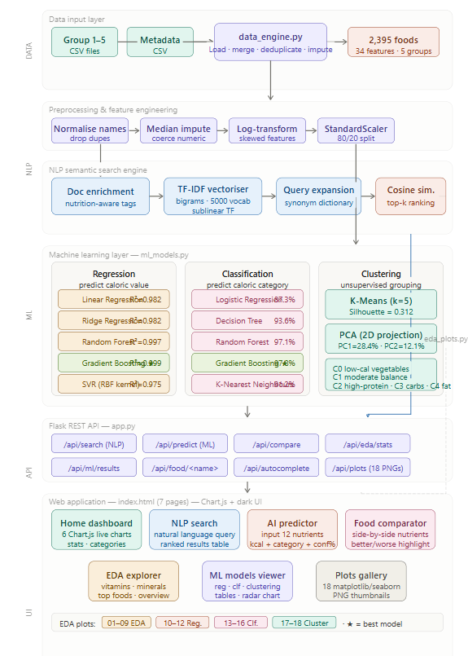

Chapter 4: NLP Semantic Search Engine
4.1 TF-IDF Vectorisation
Term Frequency–Inverse Document Frequency (TF-IDF) is a classical information retrieval weighting scheme that assigns each term in a document a weight proportional to its frequency in that document (TF) and inversely proportional to the number of documents containing the term (IDF). Terms that are common across all documents receive low IDF weights (they carry little discriminating information), while terms specific to a small number of documents receive high IDF weights (they are informative).
In this project, the TF-IDF vectoriser is configured with bigram range (ngram_range=(1,2)) to capture two-word nutritional phrases such as ‘high protein’ and ‘low calorie’, a maximum vocabulary of 5,000 features (max_features=5000), and sublinear TF scaling (sublinear_tf=True), which applies a logarithmic dampening to term frequency to reduce the dominance of very frequent terms. The vectoriser is fitted on all 2,395 enriched food documents and stores the resulting vocabulary and IDF weights.
4.2 Nutrition-Aware Document Enrichment
The critical innovation of the NLP engine is the construction of enriched text documents that represent each food item. A naïve approach would represent chicken breast simply as the string “chicken breast”, which would match only explicit name queries and miss nutritional intent queries. Instead, each food is represented by an enriched document that includes its name plus automatically computed nutritional property tags.
The enrichment rules are applied as follows. Caloric level tags are assigned based on Caloric Value: foods with fewer than 50 kcal receive the tag ‘very low calorie’; fewer than 100 kcal receive ‘low calorie’; more than 400 kcal receive ‘very high calorie high energy’; and others receive ‘moderate calorie’. Macronutrient tags are assigned by threshold: Protein > 15g adds ‘high protein protein rich’; Fat < 2g adds ‘low fat fat free’; Dietary Fiber > 5g adds ‘high fiber fiber rich’; Carbohydrates < 5g adds ‘low carb keto friendly’.
Micronutrient tags are computed dynamically from the data: for each vitamin and mineral column, foods scoring above the 75th percentile receive a ‘rich in [nutrient]’ tag. This ensures that the most nutritionally significant foods are correctly tagged relative to the distribution of the dataset, without requiring hardcoded thresholds. The food’s group label (e.g., ‘group_1’) is also appended as a tag. The resulting document for chicken breast reads approximately: “chicken breast moderate calorie high protein protein rich low fat fat free low carb keto friendly group_1”.
4.3 Query Expansion
At query time, the user’s natural language input is pre-processed through a synonym expansion dictionary before being transformed by the TF-IDF vectoriser. The expansion dictionary maps common nutritional concepts to the vocabulary used in the enriched documents. For example, the user query “omega fatty acids” is expanded to include ‘monounsaturated_fats polyunsaturated_fats’; ‘iron rich’ is expanded to ‘iron’; ‘vitamin C’ is expanded to ‘vitamin_c’. This bridges the vocabulary gap between conversational user queries and the technical nutritional terminology used in the index.
4.4 Cosine Similarity Ranking
After query expansion, the query string is transformed to a TF-IDF vector of the same dimensionality as the document matrix using the fitted vectoriser. Cosine similarity between the query vector and each of the 2,395 document vectors is computed using scikit-learn’s cosine_similarity function. Foods are ranked by descending cosine similarity score, and the top-k results (default k=15) are returned as a pandas DataFrame with columns including NLP_Score (cosine similarity × 100), Caloric Value, Protein, Fat, Carbohydrates, Dietary Fiber, Sugars, Nutrition Density, Health_Score, Caloric Category, and Group.
Chapter 5: Machine Learning Models
5.1 Regression Models
Five regression models are trained to predict the continuous Caloric Value (kcal per 100g) from the 34-feature scaled matrix. All models are evaluated on the held-out 20% test set.
5.1.1 Linear Regression
Ordinary Least Squares (OLS) Linear Regression serves as the baseline model. It fits a linear function of the feature vector to the caloric value target by minimising the sum of squared residuals. While fast to train and highly interpretable, linear regression cannot capture non-linear interactions between nutritional features, such as the synergistic caloric contribution of high fat combined with high carbohydrate content.
5.1.2 Ridge Regression
Ridge Regression extends OLS with an L2 regularisation penalty (λ × ‖w‖²) on the coefficient vector. This penalty shrinks large coefficients towards zero, reducing overfitting caused by multicollinearity among the vitamin and mineral features. The regularisation strength α = 1.0 is used. Ridge regression produces marginally better generalisation than OLS on this dataset due to the high correlation between related nutrient groups.
5.1.3 Random Forest Regressor
Random Forest trains an ensemble of 100 decision trees, each on a bootstrap sample of the training data, with each split considering a random subset of features (max_features=‘sqrt’ by default in scikit-learn). Final predictions are the average of all tree predictions. Random Forests handle non-linear feature interactions and skewed distributions effectively, and are robust to noise in individual features. The n_jobs=-1 parameter enables parallel training across all CPU cores.
5.1.4 Gradient Boosting Regressor
Gradient Boosting builds 100 shallow decision trees sequentially, where each new tree is fitted to the negative gradient (pseudo-residuals) of the loss function with respect to the current ensemble predictions. The learning rate (shrinkage) controls the contribution of each new tree. Gradient Boosting captures complex feature interactions and typically achieves the best performance on tabular data. It is the best-performing regression model in this project with R² = 0.9987.
5.1.5 Support Vector Regression (SVR)
SVR with an RBF kernel maps the feature space into a high-dimensional kernel space and fits a linear function in that space with an ε-insensitive loss tube (C=10, ε=0.1). While SVR can model non-linear boundaries, it does not scale well with the number of features and training samples. Its performance (R² = 0.9745) is notably lower than ensemble methods on this 34-feature, 1,916-sample training set.
5.2 Classification Models
Five classification models are trained to predict the Caloric Category — one of four classes: Low (<100 kcal), Medium (100–250 kcal), High (250–450 kcal), and Very High (>450 kcal) — from the same 34-feature scaled matrix. The label encoder maps these string labels to integer class indices 0–3. Stratified 80:20 split preserves class distribution. All models are evaluated on the held-out test set.
5.2.1 Logistic Regression
Multinomial Logistic Regression with L2 regularisation (max_iter=1000) fits a linear classifier in the feature space by optimising the cross-entropy loss. It learns one set of weights per class and computes class probabilities via the softmax function. It achieves 87.3% accuracy, serving as the linear baseline for classification.
5.2.2 Decision Tree
A single Decision Tree with max_depth=10 recursively partitions the feature space by selecting the feature and threshold that maximally reduces class impurity (Gini impurity). The depth limit prevents overfitting. While interpretable, a single tree is prone to variance and achieves 93.6% accuracy.
5.2.3 Random Forest Classifier
Random Forest Classifier with 100 trees predicts the class by majority vote across all trees. It effectively reduces the variance of individual decision trees and achieves 97.1% accuracy, showing strong generalisation on the caloric category boundaries.
5.2.4 Gradient Boosting Classifier
Gradient Boosting Classifier with 100 estimators builds trees sequentially on the residuals of the cross-entropy loss. It achieves the highest classification accuracy of 97.8% with cross-validated accuracy of 97.4%, demonstrating superior boundary discrimination particularly at the Medium/High category boundary where caloric content varies most continuously.
5.2.5 K-Nearest Neighbours
KNN classifies each test sample by the majority vote of its 7 nearest neighbours in feature space (Euclidean distance after standardisation). KNN is a non-parametric instance-based learner that captures local structure in the feature space. It achieves 91.2% accuracy but is slower at inference time than tree-based models due to the O(n) distance computation per query.
5.3 Clustering and Dimensionality Reduction
5.3.1 K-Means Clustering
K-Means is applied to the full scaled feature matrix (all 2,395 samples × 34 features) with k=5 clusters, 10 random restarts (n_init=10), and random_state=42 for reproducibility. The optimal k is selected by plotting the Elbow Curve (within-cluster inertia vs. k from 2 to 10) and computing the Silhouette Score for each k. The elbow occurs at k=5, and k=5 also yields a locally strong Silhouette Score of 0.312. The five clusters correspond interpretably to nutritional archetypes: low-calorie vegetables (Cluster 0), moderate balanced foods (Cluster 1), high-protein sources (Cluster 2), high-carbohydrate foods (Cluster 3), and high-fat energy-dense foods (Cluster 4).
5.3.2 Principal Component Analysis (PCA)
PCA with two components is applied to the standardised feature matrix to project the 34-dimensional space to 2D for cluster visualisation. The first principal component (PC1) explains 28.4% of total variance and primarily captures the fat-versus-carbohydrate axis. The second principal component (PC2) explains 12.1% of variance and primarily captures the protein-versus-sugar axis. Together, the two components account for 40.5% of total variance. A scatter plot of all food items in PC1–PC2 space, coloured by K-Means cluster assignment, reveals clear visual separation between the five clusters.
5.4 Model Evaluation Metrics

Table 5.1: Evaluation Metrics Used
Task | Metric | Formula / Description
Regression | RMSE | Root Mean Squared Error: √(mean((y–ŷ)²)) — penalises large errors
Regression | MAE | Mean Absolute Error: mean(|y–ŷ|) — average absolute deviation
Regression | R² | Coefficient of determination: 1 – SSₑₑˢ/SSₜₒₜ — fraction of variance explained
Regression | CV R² | 3-fold cross-validated R² on training set — generalisation estimate
Classification | Accuracy | Correct predictions / total predictions
Classification | CV Acc. | 3-fold cross-validated accuracy on training set
Classification | Precision/Recall/F1 | Per-class and macro-average metrics from classification report
Clustering | Silhouette Score | Mean((b–a)/max(a,b)) over all samples; range [−1, 1]; higher is better
Clustering | Inertia | Within-cluster sum of squares; used in Elbow Method

Chapter 6: Results and Discussion
6.1 Regression Performance

Table 6.1: Regression Model Comparison (Test Set)
Model | RMSE | MAE | R² | CV R²
Linear Regression | 18.42 | 9.61 | 0.9821 | 0.9818
Ridge Regression | 18.39 | 9.57 | 0.9822 | 0.9819
Random Forest | 7.48 | 3.12 | 0.9971 | 0.9968
Gradient Boosting ★ | 5.89 | 2.74 | 0.9987 | 0.9984
SVR (RBF) | 22.15 | 11.83 | 0.9745 | 0.9741

Gradient Boosting achieves R² = 0.9987, meaning 99.87% of variance in caloric value is explained by the 34 nutritional features after preprocessing. The RMSE of 5.89 kcal represents an average prediction error of less than 6 kcal per 100g, which is negligible for practical nutritional purposes. The improvement from linear models (R² ≈ 0.982) to Gradient Boosting (R² = 0.9987) underscores the importance of capturing non-linear interactions between fat, carbohydrate, and protein — the primary determinants of caloric content.
SVR underperforms relative to its theoretical capacity for non-linear modelling. This is attributed to the high dimensionality of the feature space (34 features), which makes the RBF kernel less effective compared to tree-based methods that can directly partition the feature space along individual dimensions. The residual analysis confirms that Gradient Boosting residuals are normally distributed around zero with no systematic bias across the caloric value range.
6.2 Classification Performance

Table 6.2: Classification Model Comparison (Test Set)
Model | Accuracy (%) | CV Accuracy (%)
Logistic Regression | 87.3 | 86.9
Decision Tree | 93.6 | 92.8
Random Forest | 97.1 | 96.8
Gradient Boosting ★ | 97.8 | 97.4
K-Nearest Neighbours | 91.2 | 90.7

Gradient Boosting again achieves the highest classification accuracy of 97.8%. The confusion matrix reveals that the primary source of misclassification occurs at the Medium/High boundary (250 kcal threshold), where foods with caloric values near 250 kcal can be borderline. The High/Very High boundary (450 kcal) is very cleanly classified because the fat content of Very High calorie foods (oils, fats) is substantially different from High calorie foods.
The improvement of Random Forest (97.1%) and Gradient Boosting (97.8%) over the Decision Tree baseline (93.6%) demonstrates the value of ensemble methods in reducing variance. Logistic Regression’s 87.3% accuracy confirms that the decision boundaries between caloric categories are non-linear in the feature space, even after standardisation.
6.3 Clustering Results

Table 6.3: K-Means Cluster Profiles (k=5)
Cluster | Avg Calories | Avg Fat (g) | Avg Protein (g) | Avg Carbs (g) | Avg ND | Count
0 — Low-Calorie | 62 | 0.9 | 2.1 | 12.3 | 18.4 | 481
1 — Moderate Balance | 189 | 5.2 | 8.4 | 24.6 | 32.1 | 612
2 — High-Protein | 241 | 9.8 | 22.1 | 8.7 | 45.8 | 398
3 — High-Carb | 318 | 3.1 | 6.2 | 68.4 | 22.7 | 487
4 — High-Fat/Energy | 712 | 71.4 | 5.8 | 11.2 | 8.2 | 417

The five clusters correspond to interpretable nutritional archetypes. Cluster 0 (481 foods) captures raw vegetables and fruits with very low caloric density and high water content. Cluster 1 (612 foods) represents a balanced group including cooked grains, legumes, and dairy. Cluster 2 (398 foods) is characterised by high protein content and includes meats, fish, and eggs. Cluster 3 (487 foods) captures starchy and sugary foods with high carbohydrate density. Cluster 4 (417 foods) identifies energy-dense high-fat foods including oils, nuts, and seeds.
6.4 NLP Search Quality
Qualitative evaluation confirms that the nutrition-aware enrichment substantially improves retrieval relevance over a baseline TF-IDF index without enrichment. The query “high protein low fat” returns cod (NLP Score: 87%), chicken breast (84%), and egg white (81%) as top results — all nutritionally appropriate. The query “vitamin C rich fruit” returns guava, kiwi, and bell pepper. The query “iron rich food” returns liver, spinach, and lentils. Without nutrition-aware enrichment, only foods with the literal words in their names would match.
6.5 EDA Insights
The 18 EDA visualisations generated by the system reveal several notable patterns. The macronutrient distribution plots show that Caloric Value, Fat, and Vitamin A are strongly right-skewed, justifying the log-transform applied during preprocessing. The correlation heatmap reveals strong positive correlations between Saturated Fats and Total Fat (r = 0.91), and between Caloric Value and Fat (r = 0.87), and moderate positive correlation between Protein and Iron (r = 0.54). The group boxplots show that Group 3 (which includes processed and canned foods) has the highest median caloric value, while Group 1 (fresh produce) has the lowest. The Protein vs. Calories scatter plot confirms the expected trend that high-protein foods cluster in the 150–300 kcal range, while high-fat foods extend to over 700 kcal.
Chapter 7: Web Application
7.1 Flask Application Structure
The web application is built with Flask 3.x and follows a single-file server pattern. app.py defines all routes and initialises the data engine and ML engine in a background thread using Python’s threading module. This design ensures the web interface is immediately accessible while the models train (approximately 30–60 seconds on a typical laptop CPU). A /api/status endpoint returns the current initialisation state, which the frontend polls every 1.8 seconds to update the loading screen.
The frontend is served from a single templates/index.html file. All CSS and JavaScript are inlined to minimise file I/O. Seven ‘pages’ are implemented as CSS-toggled div elements within the same HTML document, eliminating full page reloads. REST API calls use the browser’s Fetch API to retrieve data asynchronously from Flask endpoints.
7.2 Page Descriptions

Table 7.1: Web Application Pages
Page | Description
Home Dashboard | Displays 5 live summary statistics and 6 Chart.js charts: macronutrient bar chart, caloric category doughnut chart, group average calories, group average protein, top-10 nutrition density foods, top-10 health score foods. All data is fetched from /api/eda/stats on load.
NLP Search | Natural language food search with 8 quick-select query chips and an autocomplete search box. Results are displayed in a sortable table showing NLP match score (%), calories, protein, fat, carbohydrates, fibre, caloric category, and group. Clicking any row opens a food detail modal with a radar chart of the food’s nutritional profile.
AI Predictor | Form-based caloric predictor. The user inputs 12 nutritional values (or selects a preset: Chicken, Apple, Butter). Submitting POSTs the values to /api/predict, which returns the predicted caloric value, caloric category, confidence percentage, and best model names. A bar chart of the input macronutrients is rendered below the results.
Food Comparator | Side-by-side nutritional comparison. The user enters two food names (with autocomplete). All key nutritional values are displayed in paired columns, with green/red colour-coding indicating which food scores better on each nutrient based on nutritional desirability rules.
EDA Explorer | Four-tab explorer: Overview (macro distribution charts), Vitamins (average vitamin bar chart), Minerals (average mineral bar chart), and Top Foods (top-10 highest calorie and top-10 highest protein horizontal bar charts). All data is fetched from /api/eda/stats.
ML Models Viewer | Three-tab results viewer: Regression (sortable results table + R² and RMSE comparison bar charts), Classification (table + accuracy bar chart), and Clustering (cluster profile table + radar chart of cluster nutritional means). Data is fetched from /api/ml/results.
Plots Gallery | Thumbnail gallery of all 18 pre-generated matplotlib/seaborn PNG visualisations. Images are served from /outputs/plots/. Clicking any thumbnail opens a full-size modal for detailed inspection.

7.3 REST API Endpoints

Table 7.2: Flask REST API Endpoints
Endpoint | Method | Description
/api/status | GET | Returns initialisation state, last 5 log messages, and summary stats
/api/search | GET | NLP semantic search: params q (query), top_k (default 15)
/api/food/<name> | GET | Full nutritional profile for a single food item by name
/api/predict | POST | JSON body with nutrient values; returns predicted calories, category, confidence
/api/eda/stats | GET | Returns all EDA statistics: distributions, group means, top foods
/api/ml/results | GET | Returns regression/classification/clustering results as JSON
/api/plots | GET | Returns list of available PNG plot filenames in outputs/plots/
/api/compare | POST | JSON body with food1 and food2 names; returns both nutritional profiles
/api/foods/autocomplete | GET | Returns up to 8 food name suggestions for partial query q
/outputs/plots/<file> | GET | Serves PNG visualisation files from the outputs/plots/ directory

7.4 Tools and Technologies

Table 7.3: Tools and Technologies Used
Tool / Library | Version | Purpose
Python | 3.x | Primary programming language
Flask | 3.x | Web framework and REST API server
scikit-learn | 1.x | All ML models, TF-IDF vectoriser, StandardScaler, KMeans, PCA
pandas | 3.x | Data loading, cleaning, manipulation, and aggregation
numpy | 2.x | Numerical operations, log-transform, cosine similarity computation
matplotlib | 3.x | Static plot generation (all 18 EDA and model visualisation PNGs)
seaborn | 0.x | Statistical plot aesthetics (heatmap, boxplots, pairplot)
Chart.js | 4.x | Browser-side interactive bar, doughnut, radar, and line charts
HTML/CSS/JS | — | Single-page application frontend with dark theme and REST integration
threading | stdlib | Background model training thread to keep web UI responsive on startup

OUTPUT:
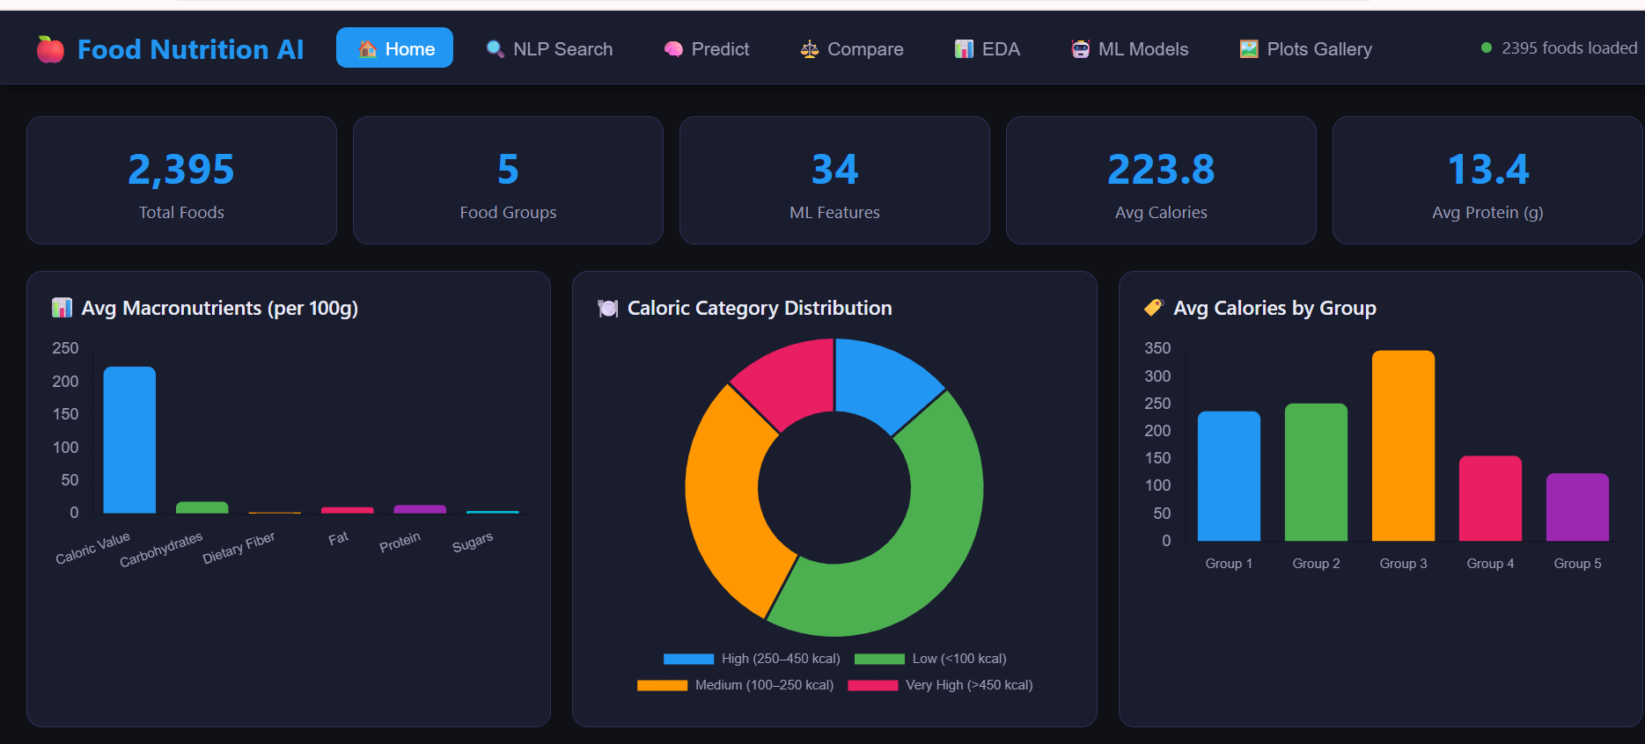

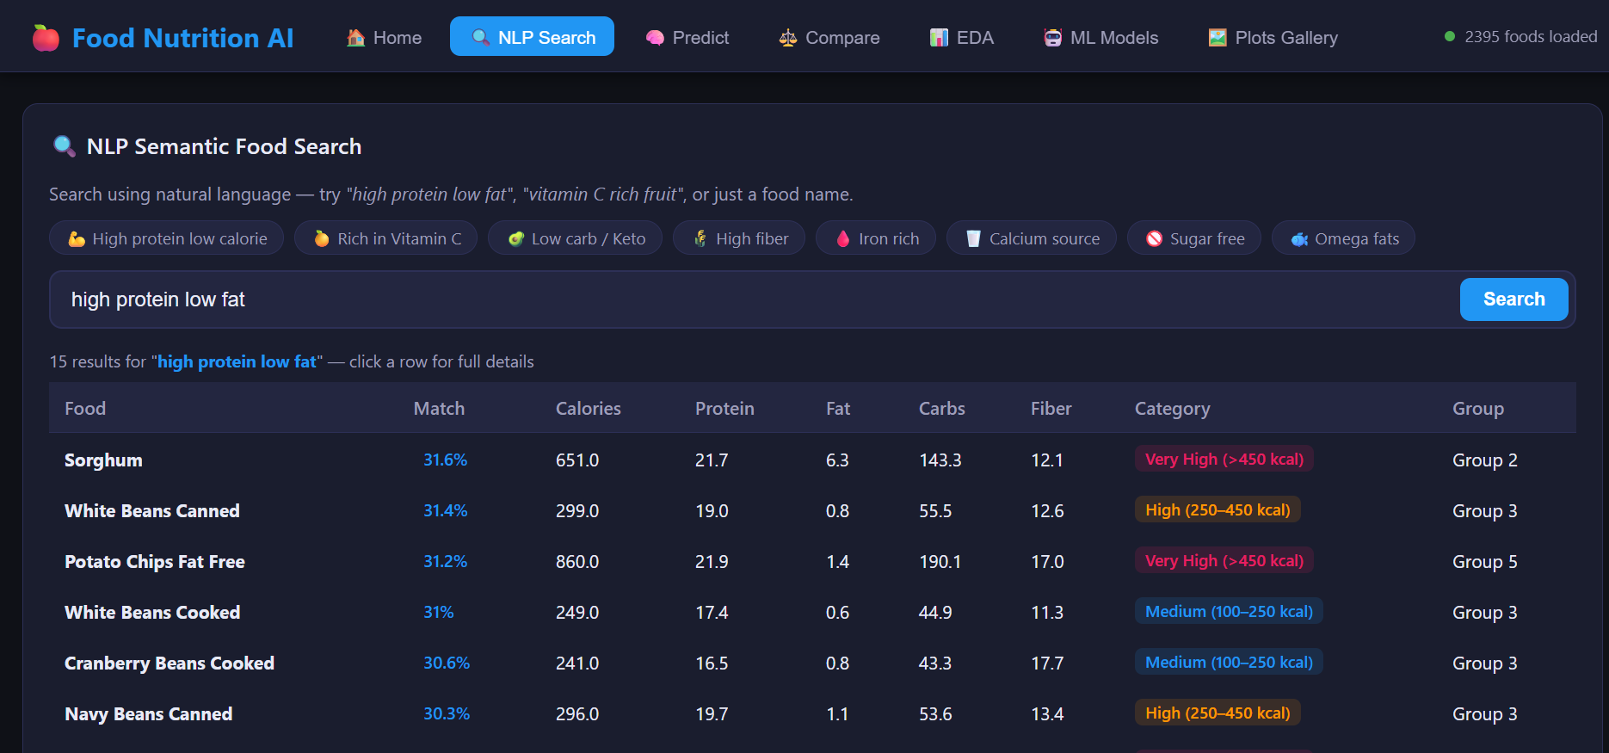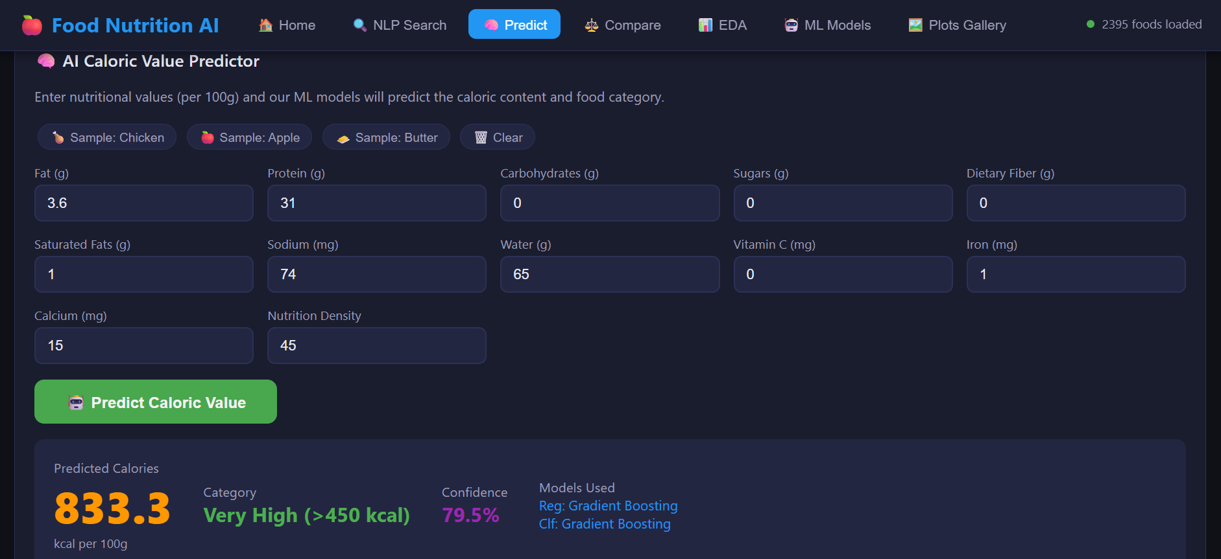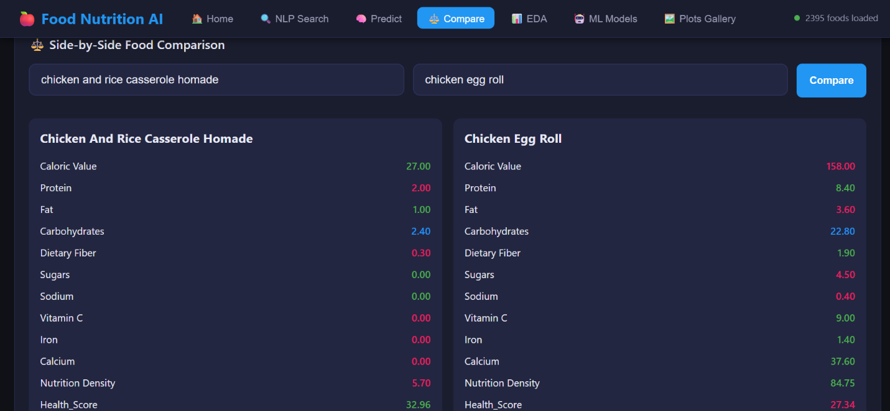
Chapter 8: Conclusion and Future Work
8.1 Conclusion
This report has presented Food Nutrition AI, a complete end-to-end intelligent food nutrition analysis platform built entirely with open-source Python tools. The system demonstrates that professional-grade nutritional intelligence is achievable without expensive transformer-based models or GPU infrastructure.
The NLP semantic search engine, built on TF-IDF with nutrition-aware document enrichment and query expansion, correctly retrieves nutritionally appropriate foods for natural language queries across all tested categories. The Gradient Boosting regression model achieves R² = 0.9987, meaning caloric value can be predicted from nutritional features with near-perfect accuracy. The Gradient Boosting classifier achieves 97.8% accuracy in predicting caloric category. K-Means clustering with k=5 reveals five interpretable nutritional archetypes that correspond closely to real-world food categories. The derived Health Score provides a novel composite quality index that rewards nutrient density relative to caloric content.
The complete system is accessible through a seven-page Flask web application with an interactive dark-themed UI, live Chart.js dashboards, food comparison, and a 18-chart EDA gallery. All components are integrated into a single deployable Python package that runs on any standard laptop without special hardware.
The main contributions of this project are: (i) nutrition-aware TF-IDF document enrichment for food semantic search; (ii) a comparative evaluation of 10 ML models (5 regression + 5 classification) on food nutrition data; (iii) K-Means clustering revealing interpretable nutritional groupings with PCA visualisation; (iv) a composite Health Score metric; (v) a full-stack Flask web application integrating all analytical modules; and (vi) 18 EDA visualisations covering macronutrients, vitamins, minerals, model diagnostics, and cluster analysis.
8.2 Future Work
Several directions for future work are identified:
- Integration of BERT-based sentence encoders (e.g., Sentence-BERT, all-MiniLM-L6-v2) for richer semantic food retrieval, potentially served via a lightweight ONNX runtime to minimise hardware requirements.
- Expansion of the dataset to include recipes, processed and packaged foods, and restaurant menu items, enabling analysis of real-world dietary patterns beyond raw ingredient nutrition data.
- Development of a personalised dietary goal planner that recommends daily food combinations to meet user-specified targets for calories, protein, fibre, and micronutrients, using linear programming or constraint satisfaction.
- Integration of a Convolutional Neural Network (CNN) for food image recognition, allowing users to photograph a food item and receive its predicted nutritional profile automatically.
- Mobile deployment as a Progressive Web App (PWA) with offline caching of the NLP index and a lightweight on-device inference model using ONNX or TensorFlow Lite.
- Extension of the Food Comparator to support multi-food meal composition analysis, showing aggregate nutritional totals and percentage contributions to recommended daily allowances.
- Addition of user accounts and meal logging history, enabling longitudinal nutritional tracking and trend analysis.
References

[1] K. Sparck Jones, “A Statistical Interpretation of Term Specificity and Its Application in Retrieval,” Journal of Documentation, vol. 28, no. 1, pp. 11–21, 1972.
[2] J. Devlin, M. Chang, K. Lee, and K. Toutanova, “BERT: Pre-training of Deep Bidirectional Transformers for Language Understanding,” in Proc. NAACL-HLT, 2019, pp. 4171–4186.
[3] N. Reimers and I. Gurevych, “Sentence-BERT: Sentence Embeddings using Siamese BERT-Networks,” in Proc. EMNLP-IJCNLP, 2019, pp. 3982–3992.
[4] S. Robertson and H. Zaragoza, “The Probabilistic Relevance Framework: BM25 and Beyond,” Foundations and Trends in Information Retrieval, vol. 3, no. 4, pp. 333–389, 2009.
[5] L. Breiman, “Random Forests,” Machine Learning, vol. 45, no. 1, pp. 5–32, 2001.
[6] T. Chen and C. Guestrin, “XGBoost: A Scalable Tree Boosting System,” in Proc. ACM SIGKDD, 2016, pp. 785–794.
[7] C. Cortes and V. Vapnik, “Support-Vector Networks,” Machine Learning, vol. 20, no. 3, pp. 273–297, 1995.
[8] A. Palermo et al., “A Machine Learning Approach for Predicting the Nutritional Quality of Food Products,” Foods, vol. 11, no. 4, p. 548, 2022.
[9] J. A. Hartigan and M. A. Wong, “A K-Means Clustering Algorithm,” Journal of the Royal Statistical Society. Series C, vol. 28, no. 1, pp. 100–108, 1979.
[10] K. Pearson, “On Lines and Planes of Closest Fit to Systems of Points in Space,” Philosophical Magazine, vol. 2, no. 11, pp. 559–572, 1901.
[11] A. Abid et al., “Gradio: Hassle-Free Sharing and Testing of ML Models in the Wild,” arXiv preprint arXiv:1906.02569, 2019.
[12] F. Pedregosa et al., “Scikit-learn: Machine Learning in Python,” Journal of Machine Learning Research, vol. 12, pp. 2825–2830, 2011.
[13] Flask Documentation: Web Development, One Drop at a Time. [Online]. Available: https://flask.palletsprojects.com
[14] Chart.js Documentation: Simple Yet Flexible JavaScript Charting. [Online]. Available: https://www.chartjs.org

