**Lourdes Matha College of Science and Technology**

**(Managed By Archdiocese Of Changanacherry)**

**(Affiliated To APJ Abdul Kalam Technological University, Kerala)**

**Kuttichal, Thiruvananthapuram-695574**

**Department of Computer Applications**

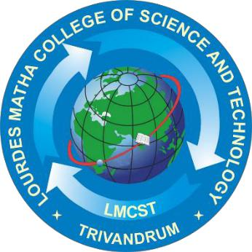

**Certificate**

**This is to certify that the project work entitled “BE SAFE BREATH ANALYSER” is a bonafide record of the work done by Mr JAYAKRISHNAN J U, Reg No LMC17MCA003, student of Department Computer of Applications, Lourdes Matha College of Science & Technology, Kuttichal, Thiruvananthapuram, affiliated to APJ Abdul Kalam Technological University, Kerala during the academic year 2019-2020 from January 2019 to July 2020 in partial fulfilment of the requirements for the award of the degree of Master of Computer Applications from APJ Abdul Kalam Technological University, Kerala.**

**Prof. Sherin Joseph**

**(Internal Supervisor)**

**Prof. Justin G Russel**

**(Project Co-Ordinator) Prof. Selma Joseph**

(**Head of the Dept.)**