**BE SAFE**

**BREATH ANALYSER**

**A Project Report**

***Submitted by:***

**JAYAKRISHNAN J U**

**LMC17MCA003**

*in partial fulfilment of the requirements for the award of the degree in*

**MASTER OF COMPUTER APPLICATIONS**

*at*

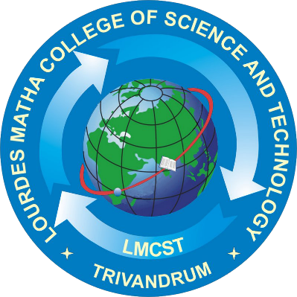

**Department of Computer Applications**

**(Affiliated To APJ Abdul Kalam Technological University, Kerala)**

**Lourdes Matha College of Science and Technology**

**(Managed By Archdiocese Of Changanacherry)**

**Kuttichal, Thiruvananthapuram-695574**

**MAY 2020**