**Mini Project on**

**Chat server using C**

Submitted By:

PUNYASHREE R

STEPin ID:

104274

**TABLE OF CONTENTS**

TITLE 1

TABLE OF CONTENTS 2

LIST OF FIGURES 3

1. Intoduction

1.1 Definition 4

1.2 Problem Statement 4

1. Description 4

2.1 Server 5

2.2 Client 6

2.3 Client - Sever Architecture 6

1. Test Plan

3.1 Software Requirements 7

3.2 Server side chat application algorithm 8

3.3 Client side chat application algorithm 8

1. Output

4.1 Client side 9

4.2 Server side 9

**LIST OF FIGURES**

Fig 1. Server Architecture 5

Fig 2. Client Architecture 6

Fig 3. Client-Server Architecture 7

1. **Introduction**

**1.1 Definition**

The client server model is still used today on the internet where a user computing may connect to a service operating on a remote system through the internet protocol suite web browser are clients that connect to web server and retrieve web page for display. Most people use Email client to retrieve their Email from their Internet service provider's mail storage servers. Online Chat uses a variety of clients, which vary depending on the chat protocol being used. Game Clients usually refer to the software that is the game in only multiplayer online games for the computer.

Increasingly, existing large client applications are being switched to websites, making the browser a sort of universal client. This avoids the hassle of downloading a large piece of software onto any computer you want to use the application on. An example of this is the rise of Webmail.

**1.2 Problem statement:**

To design a chat server over the internet that offers a real-time transmission of text messages from sender and receiver.

1. **Description:**

In this Mini-Project the chatroom for 50 users is created with few commands and authorization system.It also additional features such as sending private messages, signing up and signing in,Changing nickname and password.

The concept of sending letters and telegraphs has been reduced due to the new era of internet Mailing.One such facility is being provided by the Chat server.A message or information can be sent via many medias,such as it can be telephonic,telegrams,fax etc to the recepient.Each such information requires a high level of security.To maintain such security and smooth completion of any communication it requires more time and human efforts in manual systems.

Chat server automates all the aspects stated above related to a communication in a highly secure environment.This project has been developed to receive instant and urgent messages and to provide total user satisfaction.

**2.1 SERVER**

A server computer is a computer dedicated to running a server application. A server application is a Computer program that accepts Computer network connections in order to service requests by sending back responses. Examples of server applications include Mail transfer agent, File server, and Proxy server. Server is also a designation for computer models intended for use in running server applications, often under heavy workloads, unattended, for an extended period of time. While any workstation computer can run server operating systems and server applications, a server computer usually has special features intended to make it more suitable. These features can include a faster Central processing unit, faster and more plentiful RAM, and larger Hard disk drive, but these traits are shared with high-end Desktop computer. More obvious distinctions include redundancy in power supplies, network connections, and RAID as well as Modular design.

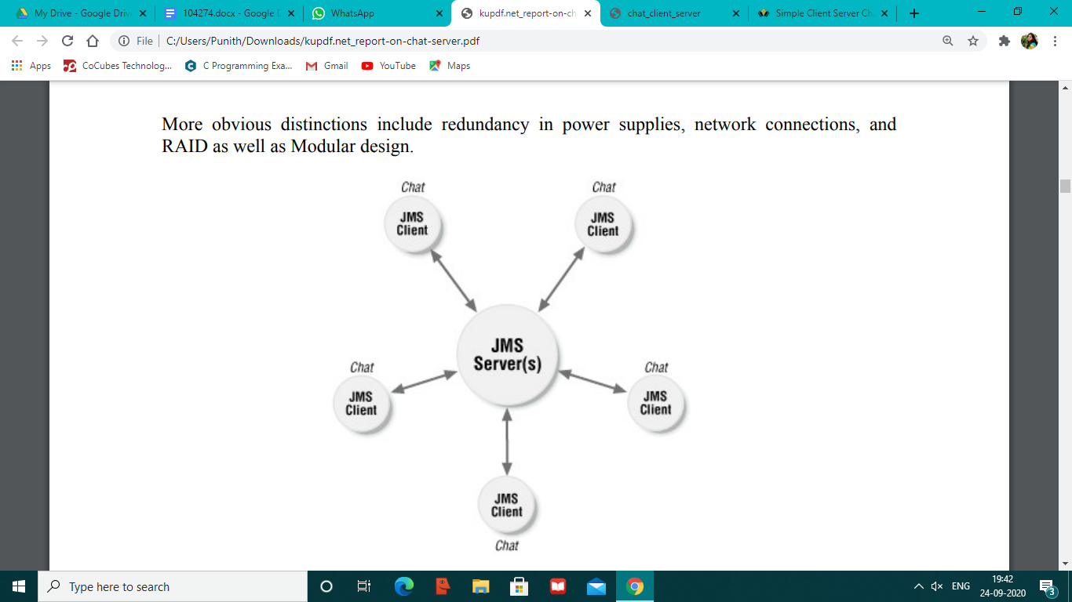

Fig 1. Server Architecture

**Chat Server**

Chat server is an application, which does the following things.

• Listens for incoming calls from clients. Client running in any pc can connect to the server if IP address of the pc where server is running is known.

• Listens for messages from all the connected clients.

• Broadcast the message from clients to all the clients connected to the server.

• You can also type-in messages in the server, which will be broadcasted to all the clients.

**2.2 CLIENT**

A client is an Application software or system that accesses a remote service on another Computer system, known as a Server computing, by way of a Network. The term was first applied to Peripheral device that were not capable of running their own stand-alone Computer program, but could interact with remote computers via a network. These Dumb terminals were clients of the Time sharing Mainframe computer.

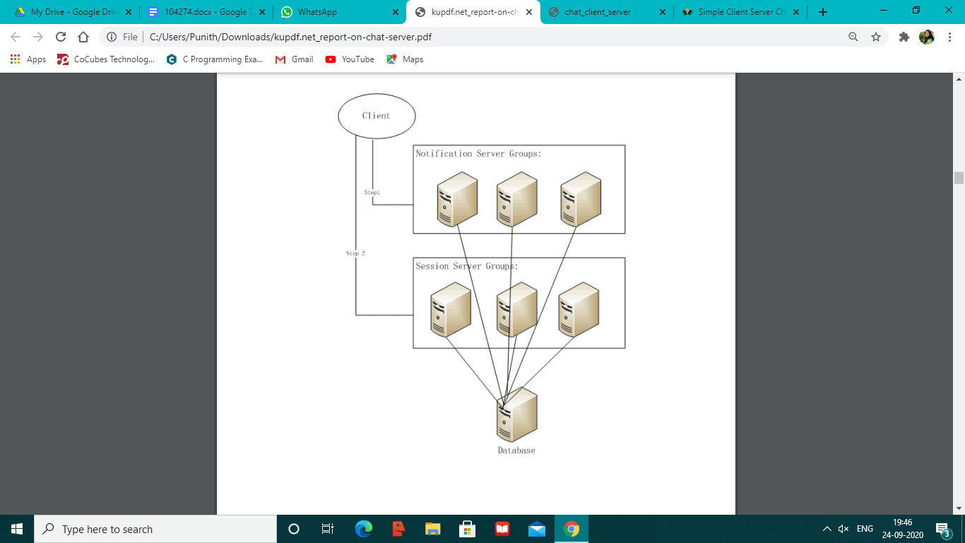

Fig 2. Client Architecture

**Chat Client**

Chat client does the following things.

• Send messages to server as well as all the connected the clients.

• View the messages from all the clients and server.

**2.3 THE CLIENT - SERVER ARCHITECTURE**

The client-server architecture model distinguishes Client (computing) systems from Server (computing) systems, which communicate over a Computer network. A client-server application is a Distributed system comprised of both client and server software. A client software process may initiate a communication session, while the server waits for requests from any client.

Client/server describes the relationship between two computer programs in which one program, the client, makes a service request from another program, the server, which fulfills the request. Although programs within a single computer can use the client/server idea, it is a more important idea in a network. In a network, the client/server model provides a convenient way to efficiently interconnect programs that are distributed across different locations. Computer transactions using the client/server model are very common. Most Internet applications, such as email, web access and database access, are based on the client/server model. For example, a Web browser is a client program at the user computer that may access information at any web server in the world. To check your bank account from your computer, a web browser client program in your computer forwards your request to a web server program at the bank. That program may in turn forward the request to its own database client program that sends a request to a database server at another bank computer to retrieve your account balance. The balance is returned back to the bank database client, which in turn serves it back to the web browser client in your personal computer, which displays the information.

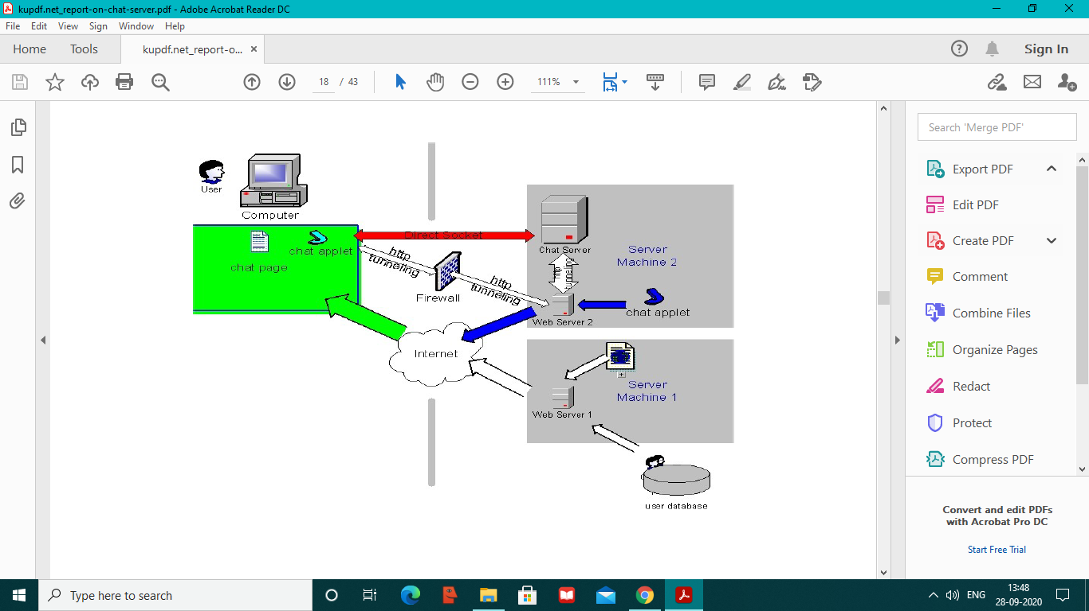

Fig 3 Client-Server Architecture

1. **TEST PLAN**

**3.1 Software Requirements**

Software’s can be defined as the programs which run on computer. It provides the relationship between the human and computer.Various software’s are neded in this project for its development which are as follows:

* Operating system - Windows 7 and above
* Others - Visual Studio

We will be using visual basic as our front hand because it is easier to use and it provides features for the user for the development of this project.

**Algorithm for chat application client and server:**

**3.2 Server Side Chat application algorithm**

STEP 1: Start the program.

STEP 2: Declare the variables and structure for the socket.

STEP 3: Create a socket using socket functions

STEP 4: The socket is binded at the specified port.

STEP 5: Using the object the port and address are declared.

STEP 6: If the binding is successful write the message to the client.

STEP 7: Close the socket if the client sends a goodbye message.

STEP 8: Execute the client program.

**3.3 Client Side Chat application Algorithm**

STEP 1: Start the program.

STEP 2: Declare the variables and structure.

STEP 3: Socket is created and connects function is executed.

STEP 4: If the connection is successful then server sends the message.

STEP 5: The message from the server is responded by the client.

STEP 6: Stop the program

1. **OUTPUT**

**4.1 Client side**

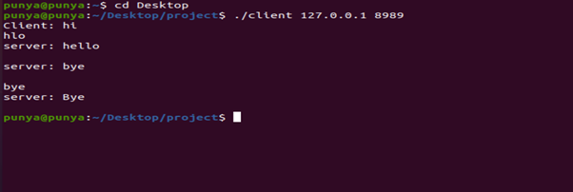

**4.2 Server side**

