./

Learning Report – MULTIPURPOSE SMART BAND

Course Code: <CODE>



|  |  |  |  |  |  |
| --- | --- | --- | --- | --- | --- |
| **Ver. Rel. No.** | **Release Date** | **Prepared. By** | **Reviewed By** | **Approved By** | **Remarks/Revision Details** |
| 1. | 19/09/2020 | Deeksha P |  |  |  |
|  |  |  |  |  |  |
|  |  |  |  |  |  |
|  |  |  |  |  |  |
|  |  |  |  |  |  |

**Document History**

# 

Table of Contents

1.2 Design 3

High Level Design 3

Low Level Design 4

# 

# 1.2 Design

## High Level Design

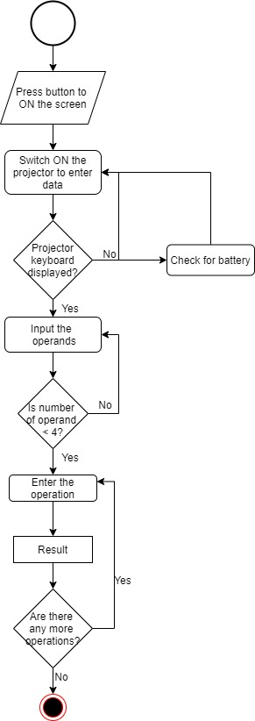

Figure 1: Activity Diagram

## Low Level Design

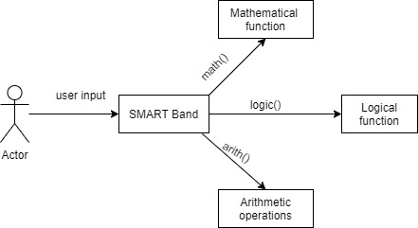

Figure 2: Communication Diagram

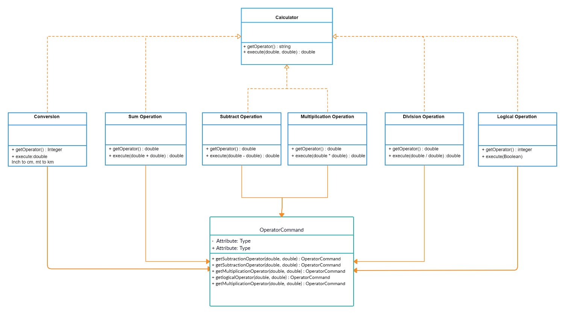

Figure 3:Class Diagram