DIVISION

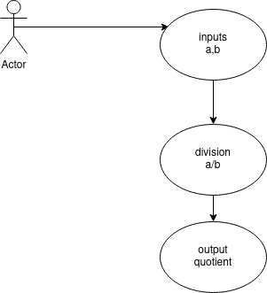
BEHAVIOURAL DIAGRAM

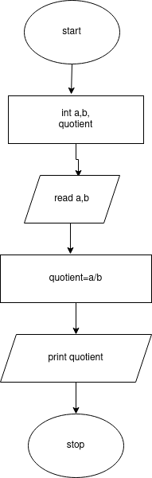
STRUCTURAL DIAGRAM

