Contents

Chapter 1 – Topic 1

Chapter 2 – Requirement Analysis 1

A) High-level requirements 1

B) Low-level requirements 1

Chapter 3 – Design 2

A) Use-case Diagram: 2

B)Sequence Diagram 2

Chapter 4 – Test plan 4

Chapter 5 – Implementation 5

# 

# Chapter 1 – Topic

This project consists of two modules namely arithmetic progression and geometric progression. The user can select the progression which he wants to print.

Arithmetic progression- A sequence of numbers in order that the common difference of any two successive numbers is a constant value.

Example:- 1 2 3 4 5 is an arithmetic progression because there is a common difference of 1 between them.

Geometric progression- A sequence of numbers where each term after the first is found by multiplying the previous one by a fixed non-zero number called the common ratio.

Example:- 1 2 4 8 is a geometric progression with a common ration of 2.

The given program prints the sequence of ‘n’ terms which is given as input by the user.

# Chapter 2 – Requirement Analysis

## A) High-level requirements

Print the correct sequence of numbers according to the choice given by the user.

## B) Low-level requirements

# Chapter 3 – Design

## A) Use-case Diagram:

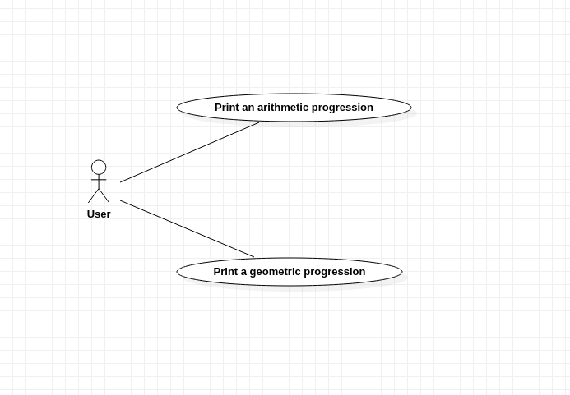

## B)Sequence Diagram

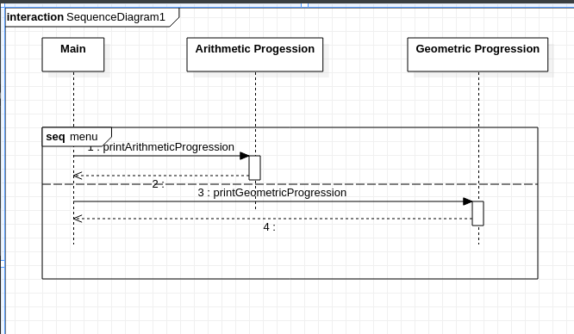

Sequence Diagram

# Chapter 4 – Test plan

|  |  |  |  |  |
| --- | --- | --- | --- | --- |
| TestID | Description | Input | Expected Output | Actual Output |
| Testcase_1 | Arithmetic Progression Testcase 1 | 1,2,10 | 1 3 5 7 9 11 13 15 17 19 | 1 3 5 7 9 11 13 15 17 19 |
| Testcase_2 | Arithmetic Progression Testcase 2 | 2,9,5 | 2 11 20 29 38 | 2 11 20 29 38 |
| Testcase_3 | Arithmetic Progression Testcase 3 | 2,-5,4 | 2 -3 -8 -13 -18 | 2 -3 -8 -13 -18 |
| Testcase_4 | Geometric Progression Testcase 1 | 1,2,10 | 1 2 4 8 16 32 64 128 256 512 | 1 2 4 8 16 32 64 128 256 512 |
| Testcase_5 | Geometric Progression Testcase 2 | 3,4,6 | 3 12 48 192 768 3072 | 3 12 48 192 768 3072 |
| Testcase_6 | Geometric Progression Testcase 3 | 10,-2,8 | 10 -20 40 -80 160 -320 640 -1280 | 10 -20 40 -80 160 -320 640 -1280 |

# Chapter 5 – Implementation

This section consists of screenshots of output as well as the GitHub repository link.

[GitHub link](https://github.com/stepin85209/Mini.git)

