MINI-PROJECT TITLE:

*Student Details Management System*

SF Id: 104321

E-mail Id: [priyapydee@gmail.com](mailto:priyapydee@gmail.com)

TABLE OF CONTENTS

|  |  |
| --- | --- |
| TITLE | PAGE NUMBER |
| Abstract | 04 |
| Introduction | 05 |
| Objectives | 06 |
| Modules | 07 |
| Tools Used | 09 |
| Flow Chart | 10 |
| Conclusion | 11 |
| References | 12 |

TABLE OF FIGURES

|  |  |  |
| --- | --- | --- |
| Figure Number | Page Number | Description |
| 1 | 07 | Modules used |
| 2 | 10 | Flow Chart |

1. **ABSTRACT**

Every school, college and educational institute maintains a database of student data as they will be requiring it frequently for various purposes.

Earlier this was done manually by maintaining handwritten registers, which is not a very good technique as it may incur many errors and lead to time wastage.

Nowadays, every application is being digitized in order to make things easy for us. So, this mini-project aims at digitizing the traditional students register and successfully provide an efficient performance.

1. **INTRODUCTION**

The idea of this project originated from an experience a lot of people have had throughout my academic years. In the beginning of a new academic year, both in school and college, the management would collect basic information such as the names of our parents, contact numbers, e-mail details and aadhaar numbers. As they maintained a manually handwritten register, errors were bound to happen and they would always come back to us mid-year asking for details once again. This was a tedious process as educational institutions already have a hectic schedule packed with activities. Digitizing this system and establishing one easily usable database centrally will minimize a lot of time wastage.

1. **OBJECTIVES**

* To design a C-Project for the concept of a Student Data Register.
* Provide features that enable us to add new student data, delete existing data, modify data, view the data as a list and search through the system for a particular entry based on some criteria.
* Write efficient C code for the above features.
* Test the system by giving various inputs and ensure they meet the desired standards.

1. **MODULES**

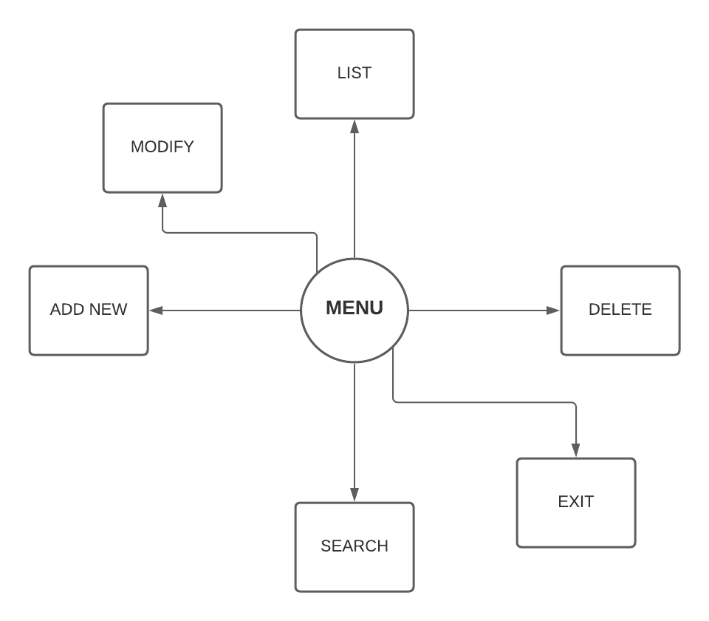(Fig 1: Modules used in the Mini-Project)

*Descriptions of each module*:

* *Menu*: Every time the program is run, a Menu page will be the first one to be displayed. It will contain a list of activities that can be done on the system numbered 1-6, for a particular key pressed; the user will be taken to the corresponding module.
* *Add new*: This module is used to enter new student data, the different details are as follows:
* Name of the student
* Address
* Father’s Name
* Mother’s Name
* Phone Number
* Gender
* E-mail Id
* Aadhaar Number
* *List*: This module is used to view the data of all the students present on the system.
* *Exit*: This module is used to quit and exit the system.
* *Modify*: This module is used to make changes to the existing student data on the system. In order to modify the details, we have to enter the name of the student. We will then be allowed to re-enter the details of the student as per the changes.
* *Search*: This module is used to search through the system for the details of a particular student. This is the most important and useful feature on this system, because in manual systems it’s extremely difficult to find the data through register books. We can enter the name of the student and the corresponding data available on the system will be displayed on screen.
* *Delete*: This module is used to erase a particular student’s data present on the system. Typing in the student’s name and pressing enter key will delete the data.

1. **TOOLS USED**:

* CodeBlocks v20.3
* LucidChart

1. **FLOWCHART**

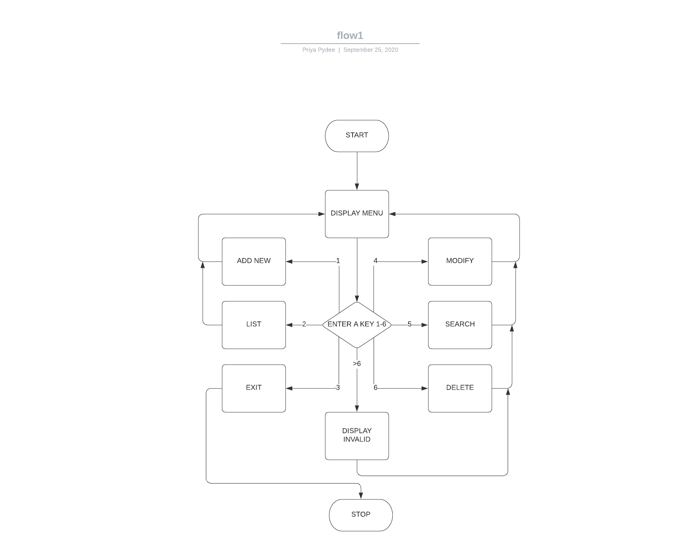

(Fig 2: Flow of the system)

1. **CONCLUSION**

With the help of this mini-project we will be able to easily create, maintain and access student details and hence save the precious time of educational institutes.

1. **REFERENCES**

[1] LucidChart.com

[2] Wikipedia