**ARCHITECTURE:**

## ER Diagram of Banking System

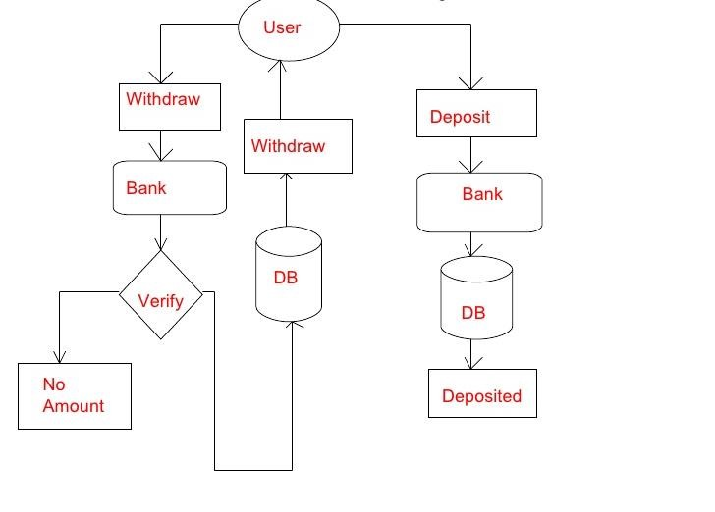

**USE CASE**

