`12FR./

**DESIGN AND IMPLEMENTATION OF COVID MANAGEMENT SYSTEM IN COVID CARE CENTRES**

Course Code: <CODE>

|  |  |  |  |  |  |
| --- | --- | --- | --- | --- | --- |
| **Ver. Rel. No.** | **Release Date** | **Prepared. By** | **Reviewed By** | **Approved By** | **Remarks/Revision Details** |
| 1.0 | 22-09-2020 | Koushani D |  |  |  |
| 1.1 | 23-09-2020 | Koushani D |  |  |  |
|  |  |  |  |  |  |
|  |  |  |  |  |  |
|  |  |  |  |  |  |

**Document History**

# 

# Contents

|  |  |  |
| --- | --- | --- |
| Sl. No. | Topic | Page number |
| 1. | Problem statement | 4 |
| 2. | Research | 5 |
| 3. | Requirements | 6 |
| 4. | Design | 8 |
| 5. | Testing | 10 |

**Design and implementation of COVID management system in COVID care centres**

1. **System or software development**
   1. **Problem Statement**

* One of the major problems faced by a covid care centre is manually managing the patients’ information and records, and also keeping information such as bed availability, test reports, etc.
* The existing management task on keeping patients records and information still has to be done manually by hand written and recorded in paper document. Records is not always reliable because it is hand written and might cause human error. Data duplication problem might also happen when handling such long data. There is a possibility that data might get misplaced when doing manual filling.
* The amount of data and paperwork that needs to be recorded could consume a lot of space and the retrieval of data can be time consuming because it has to be searched from the filling cabinet. This will cause waste of resource in term of time and money. In addition, it would also cause inconvenience and ineffectiveness in daily work.
* Hence, the project is to build a database system which is used to count the Corona virus disease (COVID) availability of supplies on daily basis in local Covid-19 hospitals.
* To count various attributes related to Covid-19 as follows: Number of beds available, number of beds occupied, number of tests conducted, number of test results positive, number of test results negative, record of each patient, number of patients admitted, number of patients discharged, number of patients deceased.

**1.2. Research on the project**

Coronavirus disease (COVID-19) is an infectious disease caused by a newly discovered coronavirus.

Most people infected with the COVID-19 virus will experience mild to moderate respiratory illness and recover without requiring special treatment.  Older people, and those with underlying medical problems like cardiovascular disease, diabetes, chronic respiratory disease, and cancer are more likely to develop serious illness.

The best way to prevent and slow down transmission is be well informed about the COVID-19 virus, the disease it causes and how it spreads. This caused the immediate need of a database system which can efficiently handle the large amount of information that requires to be updated on a daily basis.

According to the reports by WHO this virus spread is being rapidly growing. So, the old style of recording through pen and paper may lead to missing of some important data due to human intervention. Hence there arose a demand for the system which manages the data and keeps the count of data on daily basis.

Hence proposed system can be implemented to satisfy all the demands and needs.

The main objective of this project is to develop a web-based database management system. The objectives of this project are as shown below:

1. To understand and define the requirement for a database management system.
2. To analyze and design a database specific to a particular centre.
3. To build up a database that will store information such as patients’ details, number of beds available, number of tests conducted, etc.
4. Select a suitable programming language to implement the system.
5. To design a user interface for the centre’s database management system
6. This objective is to design a user web interface that is user-friendly
7. To improve the employee management of the centre, analyze a better way to review data and ensure the system can adapt the specification needs.
8. To improve efficiency of information management and improve data integrity.
   1. **REQUIREMENTS**

The main module is patient information. Patient information management module will keep track of patients’ report- patients admitted, discharged and deceased. Another module is bed availability, with this module in the system employee bed count can be managed more effectively about number of beds available. The last module keeps track of the number of tests conducted in a covid care centre daily.

In this project, the web-based database management system has several modules and features, as listed below:

* Input information of new patient
* Search record for existing patient
* Status of patient
* Viewing entire database
* Edit information of existing record
* Delete patient records
* Total number of beds
* Number of beds available
* Serial number of available beds
* Number of tests conducted
* Number of test results positive
* Number of test results negative
* Update information
* High level requirements:

|  |  |
| --- | --- |
| **ID** | **Description** |
| HL_01 | Must add the record of a new patient correctly |
| HL_02 | Must view the record of the patient requested |
| HL_03 | Must search the record of the patient requested |
| HL_04 | Must edit the record details of a patient |
| HL_05 | Must delete the specific details of a patient correctly |
| HL_06 | Must print the number of beds available |
| HL_07 | Must print the test records on a daily basis |

* Low level requirements:

|  |  |
| --- | --- |
| **ID** | **Description** |
| LL_01 | Must store the record in the database |
| LL_02 | Must view the entire database |
| LL_03 | Must find the correct record from the database |
| LL_04 | Must store the edited record in the database |
| LL_05 | Must delete the correct record from the database |
| LL_06 | Must update when beds become available/occupied |
| LL_07 | Must update regularly |

**2. Design**

**2.1 Structural design**

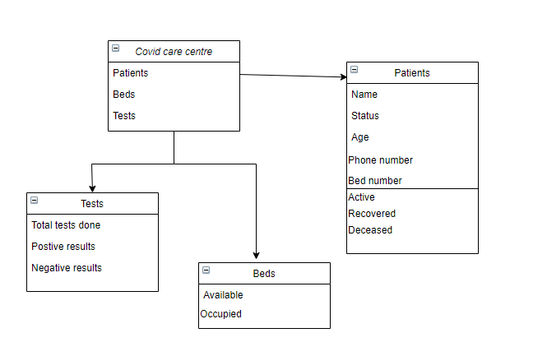

**Fig 2.1: Structural class diagram for COVID management system**

**2.2 Behavioral design**

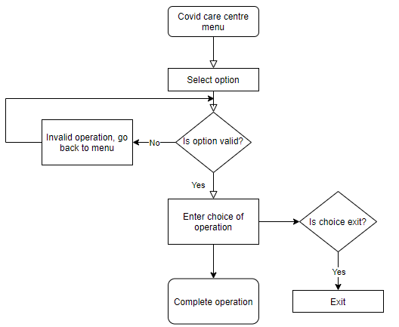

**Fig 2.2: Behavioral class diagram for COVID management system**

**3. Test plan**

**3.1. Evaluation on Performance Testing**:

Module: Update patient information

Objective: This will allow user to update information of a new patient.

Success Criteria: Users able to view the record of new patient in the patients list

Expected results: Patient information updated

**3.2. Evaluation of User Acceptance Testing:**

Objective: The testing will involve the web-based system. This will test how well the users understand the use the features/module offered.

Test Steps: The users will have a firsthand on using the web-based system.

Users will be given the freedom to do whatever they want to the web-based system.

Users will be observed to check if they are uncomfortable or irritated when using this web-based system.

Users will be requested to grade this web-based system.

Expected results: Users should be able to understand the functionality of the web-based system and know how to use the buttons and navigation buttons provided.

Users should not feel irritated or uncomfortable when using the web-based system.

Users should not feel lost or unsure of what to do with the web-based system.