./

Learning Report – Applied SDLC AND Software Testing



|  |  |  |  |  |  |
| --- | --- | --- | --- | --- | --- |
| **Ver. Rel. No.** | **Release Date** | **Prepared. By** | **Reviewed By** | **Approved By** | **Remarks/Revision Details** |
| 1 | 17/09/2020 | 99002528 |  |  |  |
| 2 | 18/09/2020 | 99002528 |  |  |  |
| 3 |  |  |  |  |  |
|  |  |  |  |  |  |
|  |  |  |  |  |  |

**Document History**

# 

Contents

Checklist 3

Activity and Tasks 4

**Activity 1**– System/Software Development 4

**Activity 2** –CI Workflow for C Programming 4

**Activity 3** – Agile Aspects 4

# 

# Checklist

* Installation of SW on Phone and Desktop
* Additional Aspects …

# Activity and Tasks

## **Activity 1**– System/Software Development

* Sub Tasks
* Complete and Evolve

## **Activity 2** –CI Workflow for C Programming

* Sub Tasks
* Complete and Evolve

## **Activity 3** – Agile Aspects

* …..

**Consumer product – Digital Hearing Aid**

**How my system look like:**

* Battery up to 6000Mah.
* Containing all the Security features like FaceId, finger print scanner, pin, etc.
* Giving more advanced features at some low cost (Rs.30,000).
* Decrease the weight of the mobile.
* Good Camera by giving the better camera quality.
* Charge the phone with lesser amount of time.
* Compatible with other O.S
* User friendly interface.
* Advanced chip and processor to increase the performance.
* Increase in RAM size (upto 16GB)

**Costing and Ageing Graph :**

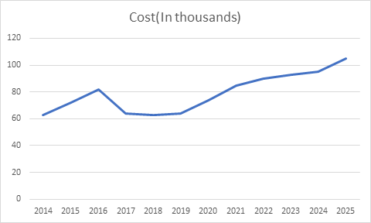

**SWOT Analysis:**

**Strengths:**

* Amazing software and O.S
* Tag of Innovation
* Consumer Loyalty
* Wide developer control in hands of user
* Design Consistency
* Globally Iconic
* Proficient Research

**Weakness:**

* High Price
* Restriction on the phone
* No Variety
* Incompatibility with other software

**Opportunities:**

* Continued Technology Advancement
* Market Potential of Smart Phones
* Geographic Expansion
* Accessories
* Utilize Artificial Intelligence
* Consistent Customer Growth

**Threats:**

* Competition from other cheaper priced smart-phones
* Aggressive Competition

**High Level Requirement:**

* Battery Management
* Processor
* Performance
* Microphone
* Amplifier
* Receiver
* Size

|  |  |
| --- | --- |
| **ID** | **DESCRIPTION** |
| 001 | Battery Management |
| 002 | Processor |
| 003 | Performance |
| 004 | Microphone |
| 005 | Amplifier |
| 006 | Receiver |
| 007 | Size |

**Low Level Requirement:**

* **Battery Performance**: Should have a higher battery life.
* **Microphone:** Should have at least two Microphone for better audibility or a single omnidirectional microphone for catching signals from different directions.
* **Amplifier:** Should amplify the input signal for better processing of signal.
* **Analog to Digital convertor**
* **Digital Signal Processor:** Should cancel the disturbances such as echo or noise present in input signal using adaptive filter and give a noiseless signal.
* **Adaptive filter with LMS algorithm**
* **Digital to Analog convertor**
* **Receiver:** Give output signal in such a way that it doesn’t cause discomfort to users.

|  |  |
| --- | --- |
| **ID** | **DESCRIPTION** |
| 001 | Battery Performance |
| 002 | Microphone |
| 003 | Amplifier |
| 004 | Analog to Digital Convertor |
| 005 | Digital Signal Processor |
| 006 | Adaptive filter with LMS algorithm |
| 007 | Digital to Analog Signal |
| 008 | Receiver |

**Design:**

**High level Design (Structure Diagram):**

**Class Diagram:**

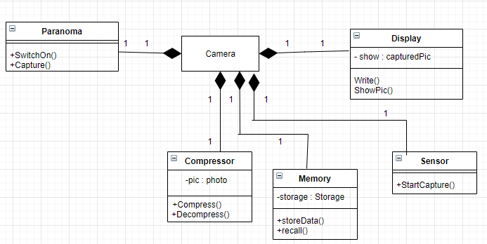

**High level Design (Behavioural Diagram):**

**Use Case Diagram:**

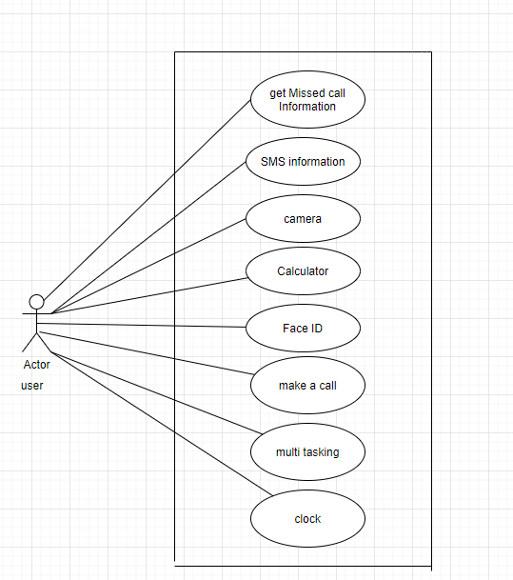

**State Diagram:**

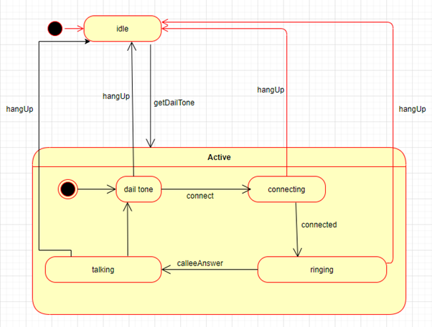

**Low Level Design(Structure Diagram):**

**Class Diagram:**

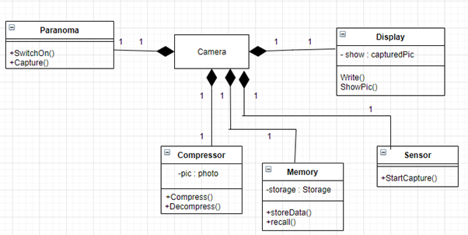

**Low level Design (Behavioural Diagram):**

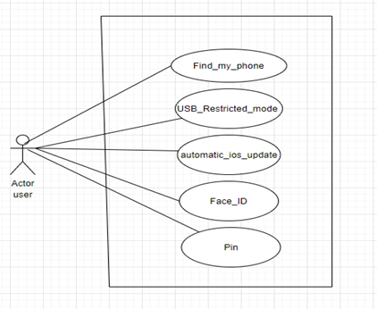

**GIT:**

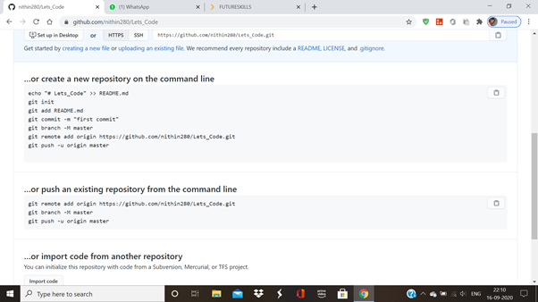

**Make:**

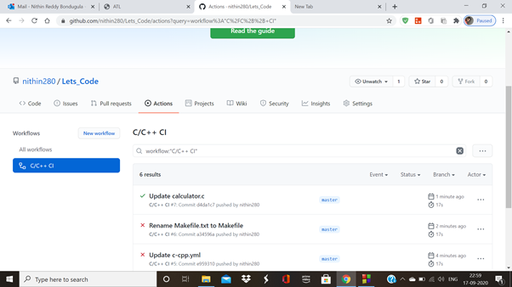

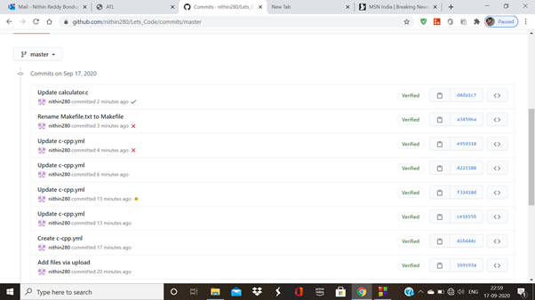

**Build:**

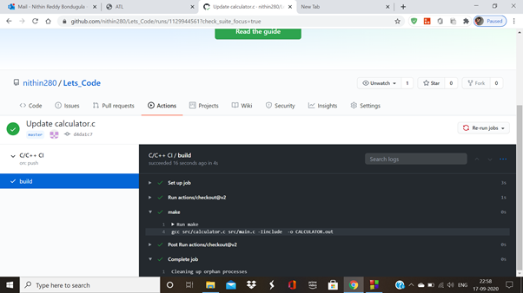

**Code Quality:**

