./

Learning Report – Applied SDLC AND Software Testing



|  |  |  |  |  |  |
| --- | --- | --- | --- | --- | --- |
| **Ver. Rel. No.** | **Release Date** | **Prepared. By** | **Reviewed By** | **Approved By** | **Remarks/Revision Details** |
| 1 | 17/09/2020 | 99002528 |  |  |  |
| 2 | 18/09/2020 | 99002528 |  |  |  |
| 3 |  |  |  |  |  |
|  |  |  |  |  |  |
|  |  |  |  |  |  |

**Document History**

# 

Contents

Checklist 3

Activity and Tasks 4

**Activity 1**– System/Software Development 4

**Activity 2** –CI Workflow for C Programming 4

**Activity 3** – Agile Aspects 4

# 

# Checklist

* Installation of SW on Phone and Desktop
* Additional Aspects …

# Activity and Tasks

## **Activity 1**– System/Software Development

* Sub Tasks
* Complete and Evolve

## **Activity 2** –CI Workflow for C Programming

* Sub Tasks
* Complete and Evolve

## **Activity 3** – Agile Aspects

* …..

**Consumer product - Apple iphone**

**Release date -** 15th sep,2014

**Finish**

* Silver
* Gold
* Space Grey

**Capacity**

* 16GB
* 32GB
* 64GB
* 128GB

### Weight and Dimensions

* Width: 2.64 inches (67.0 mm)
* Height: 5.44 inches (138.1 mm)
* Depth:0.27 inch (6.9 mm)
* Weight: 4.55 ounces (129 grams)

**Chips**

* A8 chip with 64-bit architecture
* M8 motion coprocessor

**Touch ID**

* Fingerprint identity sensor built into the Home button

**Display**

* Retina HD display
* 4.7-inch (diagonal) LED-backlit widescreen Multi‑Touch display with IPS technology
* 1334-by-750-pixel resolution at 326 ppi
* 1400:1 contrast ratio (typical)
* 500 cd/m2 max brightness (typical)
* Full sRGB standard
* Dual-domain pixels for wide viewing angles
* Fingerprint-resistant oleophobic coating on front
* Support for display of multiple languages and characters simultaneously
* Display Zoom
* Reachability

**iSight Camera**

* 8-megapixel iSight camera with 1.5µ pixels
* Autofocus with Focus Pixels
* ƒ/2.2 aperture
* Optical image stabilization (iPhone 6 Plus only)
* True Tone flash
* Five-element lens
* Hybrid IR filter
* Backside illumination sensor
* Sapphire crystal lens cover
* Auto image stabilization
* Auto HDR for photos
* Face detection
* Exposure control
* Panorama (up to 43 megapixels)
* Burst mode
* Tap to focus
* Photo geotagging
* Timer mode

**RAM**

* 1gb

**External Buttons and Connectors**

* Home/Touch ID sensor
* Volume up/down
* Ring/silent
* On/off-Sleep/wake
* Microphone
* Lightning connector
* 3.5mm headphone jack
* Built-in speaker

**Video Recording**

* 1080p HD video recording (30 fps or 60 fps)
* True Tone flash
* Slo-mo video (120 fps or 240 fps)
* Time-lapse video with stabilization
* Cinematic video stabilization
* Continuous autofocus video
* Take still photos while recording video
* Improved face detection
* 3x zoom
* Video geotagging

**FaceTime HD Camera**

* 1.2-megapixel photos
* ƒ/2.2 aperture
* 720p HD video recording
* Backside illumination sensor
* Auto HDR for photos and videos
* Face detection
* Burst mode
* Exposure control
* Timer mode

**Video Calling**

* FaceTime video
* Initiate video calls over Wi‑Fi or cellular to any FaceTime-enabled device

**Cellular and Wireless**

* **Model A1549 (GSM)*/ Model A1522 (GSM)\***
  + UMTS/HSPA+/DC-HSDPA (850, 900, 1700/2100, 1900, 2100 MHz)
  + GSM/EDGE (850, 900, 1800, 1900 MHz)
  + LTE (Bands 1, 2, 3, 4, 5, 7, 8, 13, 17, 18, 19, 20, 25, 26, 28, 29)
* **Model A1549 (CDMA)*/ Model A1522 (CDMA)\***
  + CDMA EV-DO Rev. A and Rev. B (800, 1700/2100, 1900, 2100 MHz)
  + UMTS/HSPA+/DC-HSDPA (850, 900, 1700/2100, 1900, 2100 MHz)
  + GSM/EDGE (850, 900, 1800, 1900 MHz)
  + LTE (Bands 1, 2, 3, 4, 5, 7, 8, 13, 17, 18, 19, 20, 25, 26, 28, 29)

**Model A1586*/ Model A1524\***

* + CDMA EV-DO Rev. A and Rev. B (800, 1700/2100, 1900, 2100 MHz)
  + UMTS/HSPA+/DC-HSDPA (850, 900, 1700/2100, 1900, 2100 MHz)
  + TD-SCDMA 1900 (F), 2000 (A)
  + GSM/EDGE (850, 900, 1800, 1900 MHz)
  + FDD-LTE (Bands 1, 2, 3, 4, 5, 7, 8, 13, 17, 18, 19, 20, 25, 26, 28, 29)
  + TD-LTE (Bands 38, 39, 40, 41

**Audio Calling**

* FaceTime audio
* iPhone 6 to any FaceTime audio-enabled device over Wi‑Fi or cellular
* Voice over LTE (VoLTE)
* Wi‑Fi calling

**Audio Playback**

* Audio formats supported: AAC (8 to 320 Kbps), Protected AAC (from iTunes Store), HE-AAC, MP3 (8 to 320 Kbps), MP3 VBR, Audible (formats 2, 3, 4, Audible Enhanced Audio, AAX, and AAX+), Apple Lossless, AIFF, and WAV
* User-configurable maximum volume limit

**TV and Video**

* AirPlay Mirroring, photos, audio, and video out to Apple TV (2nd generation or later)
* Video mirroring and video out support: Up to 1080p through Lightning Digital AV Adapter and Lightning to VGA Adapter (adapters sold separately)
* Video formats supported: H.264 video up to 1080p, 60 frames per second, High Profile level 4.2 with AAC-LC audio up to 160 Kbps, 48kHz, stereo audio in .m4v, .mp4, and .mov file formats; MPEG-4 video up to 2.5 Mbps, 640 by 480 pixels, 30 frames per second, Simple Profile with AAC-LC audio up to 160 Kbps per channel, 48kHz, stereo audio in .m4v, .mp4, and .mov file formats; Motion JPEG (M-JPEG) up to 35 Mbps, 1280 by 720 pixels, 30 frames per second, audio in ulaw, PCM stereo audio in .avi file format

**Siri**

* Use your voice to send messages, set reminders, and more
* Get proactive suggestions
* Use hands-free
* Listen and identify songs

**Power and Battery**

* Built-in rechargeable lithium-ion battery
* Charging via USB to computer system or power adapter
* Talk time: Up to 14 hours on 3G
* Internet use: Up to 10 hours on 3G, up to 10 hours on LTE, up to 11 hours on Wi‑Fi
* HD video playback: Up to 11 hours
* Audio playback: Up to 50 hours
* Standby time: Up to 10 days

**External Buttons and Connectors**

* Home/Touch ID sensor
* Volume up/down
* Ring/silent
* On/off-Sleep/wake
* Microphone
* Lightning connector
* 3.5mm headphone jack
* Built-in speaker

### Operating System

**iOS 9**  
 **The world’s most advanced mobile operating system gets major enhancements to built-in apps, a smarter Siri and search, and much more.**

**Pros**

* High Quality cameras
* Easy to use in one hand
* No heating issues

**Cons**

* Shorter Battery
* Not Water proof

**Price during release time**

* Rs.53,500 for 16gb
* Rs.62,500 for 64gb
* Rs.71,500 for 32gb

**Consumer product - Apple iphone 11**

**Release date -** 10th sep,2019

**Finish**

* green
* yellow
* black
* purple
* white

**Capacity**

* 64GB
* 128GB
* 256GB

### Weight and Dimensions

* Width: 2.98 inches (75.7 mm)
* Height: 5.94 inches (150.9 mm)
* Depth:0.33 inch (8.3 mm)
* Weight: 194 grams

**Chip**

* A13 Bionic chip
* Third‑generation Neural Engine

**Face ID**

* Enabled by TrueDepth camera for facial recognition

**Display**

* Liquid Retina HD display
* 6.1‑inch (diagonal) all-screen LCD  
   Multi-Touch display with IPS technology
* 1792x828‑pixel resolution at 326 ppi
* 1400:1 contrast ratio (typical)
* True Tone display
* Wide colour display (P3)
* Haptic Touch
* 625 nits max brightness (typical)
* Fingerprint‑resistant oleophobic coating
* Support for display of multiple languages and characters simultaneously

**TrueDepth Camera**

* 12MP camera
* ƒ/2.2 aperture
* Portrait mode with advanced bokeh and Depth Control
* Portrait Lighting with six effects (Natural, Studio, Contour, Stage, Stage Mono, High‑Key Mono)
* Animoji and Memoji
* 4K video recording at 24 fps, 30 fps or 60 fps
* 1080p HD video recording at 30 fps or 60 fps
* Slow-motion video support for 1080p at 120 fps
* Next‑generation Smart HDR for photos
* Extended dynamic range for video at 30 fps
* Cinematic video stabilisation (4K, 1080p and 720p)
* Wide colour capture for photos and Live Photos
* Retina Flash
* Auto image stabilisation
* Burst mode

**External Buttons and Connectors**

* Ring/Silent
* Volume Up/Down
* Lightning connector
* Built-in Stereo Speakers
* Built-in Microphones
* Side Button

**Video Recording**

* 4K video recording at 24 fps, 30 fps or 60 fps
* 1080p HD video recording at 30 fps or 60 fps
* 720p HD video recording at 30 fps
* Extended dynamic range for video up to 60 fps
* Optical image stabilisation for video (Wide)
* 2x optical zoom out; digital zoom up to 3x
* Audio zoom
* Brighter True Tone flash
* QuickTake video with subject tracking
* Slow-motion video support for 1080p at 120 fps or 240 fps
* Time-lapse video with stabilisation
* Cinematic video stabilisation (4K, 1080p and 720p)
* Continuous autofocus video
* Take 8MP still photos while recording 4K video
* Playback zoom
* Video formats recorded: HEVC and H.264
* Stereo recording

**RAM**

* 4gb

**Camera**

* Dual 12MP Ultra Wide and Wide cameras
* Ultra Wide: ƒ/2.4 aperture and 120° field of view
* Wide: ƒ/1.8 aperture
* 2x optical zoom out; digital zoom up to 5x
* Portrait mode with advanced bokeh and Depth Control
* Portrait Lighting with six effects (Natural, Studio, Contour, Stage, Stage Mono, High-Key Mono)
* Optical image stabilisation (Wide)
* Five‑element lens (Ultra Wide); six‑element lens (Wide)
* Brighter True Tone flash with Slow Sync
* Panorama (up to 63MP)
* Sapphire crystal lens cover
* 100% Focus Pixels (Wide)
* Night mode
* Auto Adjustments
* Next-generation Smart HDR for photos
* Wide colour capture for photos and Live Photos
* Advanced red‑eye correction
* Auto image stabilisation
* Burst mode
* Photo geotagging
* Image formats captured: HEIF and JPEG

**Video Recording**

* 4K video recording at 24 fps, 30 fps or 60 fps
* 1080p HD video recording at 30 fps or 60 fps
* 720p HD video recording at 30 fps
* Extended dynamic range for video up to 60 fps
* Optical image stabilisation for video (Wide)
* 2x optical zoom out; digital zoom up to 3x
* Audio zoom
* Brighter True Tone flash
* QuickTake video with subject tracking
* Slow-motion video support for 1080p at 120 fps or 240 fps
* Time-lapse video with stabilisation
* Cinematic video stabilisation (4K, 1080p and 720p)
* Continuous autofocus video
* Take 8MP still photos while recording 4K video
* Playback zoom
* Video formats recorded: HEVC and H.264
* Stereo recording

**Cellular and Wireless**

**Model A2221**[**\***](https://www.apple.com/in/iphone-11/specs/#footnote-0)

* FDD‑LTE (Bands 1, 2, 3, 4, 5, 7, 8, 11, 12, 13, 17, 18, 19, 20, 21, 25, 26, 28, 29, 30, 32, 66)
* TD‑LTE (Bands 34, 38, 39, 40, 41, 42, 46, 48)
* UMTS/HSPA+/DC‑HSDPA (850, 900, 1700/2100, 1900, 2100 MHz)
* GSM/EDGE (850, 900, 1800, 1900 MHz)

**All models**

* Gigabit-class LTE with 2x2 MIMO and LAA[4](https://www.apple.com/in/iphone-11/specs/#footnote-4)
* 802.11ax Wi‑Fi 6 with 2x2 MIMO
* Bluetooth 5.0 wireless technology
* Ultra Wideband chip for spatial awareness[5](https://www.apple.com/in/iphone-11/specs/#footnote-5)
* NFC with reader mode
* Express Cards with power reserve

**Video Calling**

* FaceTime video calling over Wi‑Fi or cellular

**Audio Calling**

* FaceTime audio
* Voice over LTE (VoLTE)
* Wi‑Fi calling

**Siri**

* Use your voice to send messages, set reminders and more
* Get intelligent suggestions on your Lock screen and in Messages, Mail, QuickType and more
* Activate hands‑free with only your voice using “Hey Siri”
* Use your voice to run shortcuts from your favourite apps

**Power and Battery**

Lasts up to 1 hour longer than iPhone XR

**Video playback:**

* Up to 17 hours

**Video playback (streamed):**

Up to 10 hours

**Audio playback:**

* Up to 65 hours

**Fast‑charge capable:**

* Up to 50% charge in 30 minutes with 18W adapter or higher (sold separately)
* Built-in rechargeable lithium‑ion battery
* Wireless charging (works with Qi charger)
* Charging via USB to computer system or power adapter

**Operating System**

* **iOS 13**  
   **iOS is the world’s most personal and secure mobile operating system, packed with powerful features and designed to protect your privacy.**

**Sensors**

* Face ID
* Barometer
* Three‑axis gyro
* Accelerometer
* Proximity sensor
* Ambient light sensor

**SIM Card**

* Dual SIM (nano-SIM and eSIM)
* iPhone 11 is not compatible with existing micro-SIM cards.

**Pros**

* Improvements to the camera like new ultra-wide angle lens
* Ability to take clearer photos in the dark
* Improvement in battery life
* Waterproof

**Cons**

* It lacks fingerprint scanner
* Heavier

**Price**

* Rs.63,999 for 64gb
* Rs.70,599 for 128gb
* Rs.75,900 for 256gb

**Future iPhone may have additional features like**

* There may be more cameras with higher pixels
* Very fast and updated i.o.s
* Larger screen
* There may be a notch which may be used for face recognition
* It may be available in various colous
* Upgrade in the chip or the chip of better version is used
* It will support 5g network
* There may be a 3d camera
* Touch id
* Advanced Processor
* Increase in RAM size
* Increase in Storage
* Increase in battery capacity
* Increase in cost

**Price of an iPhone in future**

It may start at Rs.1,00,000

**How my system look like:**

* Battery up to 6000Mah.
* Containing all the Security features like FaceId, finger print scanner, pin, etc.
* Giving more advanced features at some low cost (Rs.30,000).
* Decrease the weight of the mobile.
* Good Camera by giving the better camera quality.
* Charge the phone with lesser amount of time.
* Compatible with other O.S
* User friendly interface.
* Advanced chip and processor to increase the performance.
* Increase in RAM size (upto 16GB)

**Costing and Ageing Graph :**

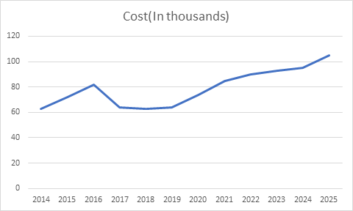

**SWOT Analysis:**

**Strengths:**

* Amazing software and O.S
* Tag of Innovation
* Consumer Loyalty
* Wide developer control in hands of user
* Design Consistency
* Globally Iconic
* Proficient Research

**Weakness:**

* High Price
* Restriction on the phone
* No Variety
* Incompatibility with other software

**Opportunities:**

* Continued Technology Advancement
* Market Potential of Smart Phones
* Geographic Expansion
* Accessories
* Utilize Artificial Intelligence
* Consistent Customer Growth

**Threats:**

* Competition from other cheaper priced smart-phones
* Aggressive Competition

**High Level Requirement:**

* Mobile O.S
* Connectivity
* Power Management
* Memory Subsystem
* Multimedia Accelerator
* Performance
* User Interface

**Low Level Requirement:**

* **Battery Performance**: Compared with older generations of battery technology, lithium-ion batteries charge faster, last longer, and have a higher power density for more battery life in a lighter package.

* **RAM:** Size of the RAM plays a key role in performance.

* **Security:** Use Security framework to protect information, establish trust, and control access to software.

* **Data Manipulation:** The Data value type allows simple byte buffers to take on the behaviour of Foundation objects. You can create empty or pre-populated buffers from a variety of sources and later add or remove bytes. You can filter and sort the content, or compare against other buffers. You can manipulate subranges of bytes and iterate over some or all of them.

**Design:**

**High level Design (Structure Diagram):**

**Class Diagram:**

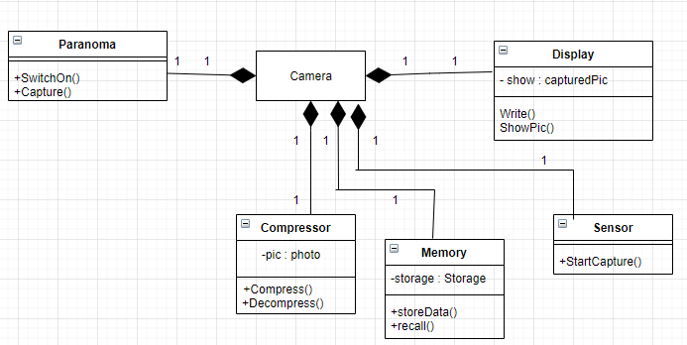

**High level Design (Behavioural Diagram):**

**Use Case Diagram:**

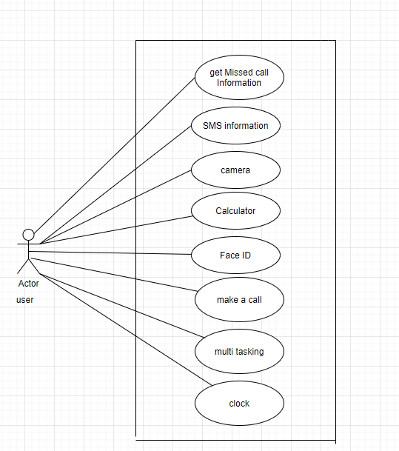

**State Diagram:**

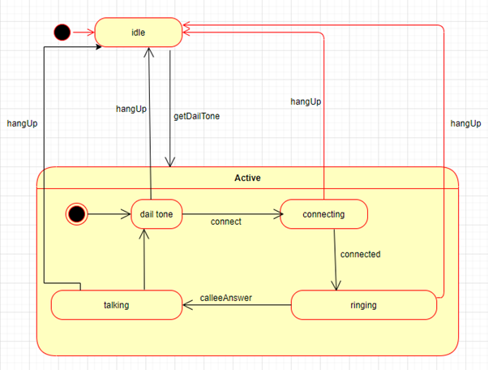

**Low Level Design(Structure Diagram):**

**Class Diagram:**

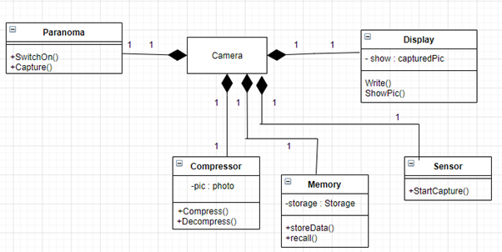

**Low level Design (Behavioural Diagram):**

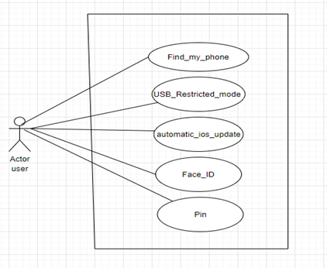

**GIT:**

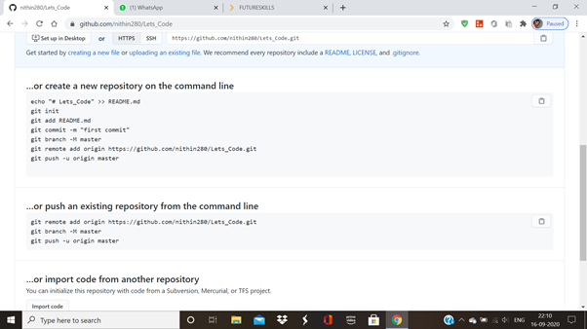

**Make:**

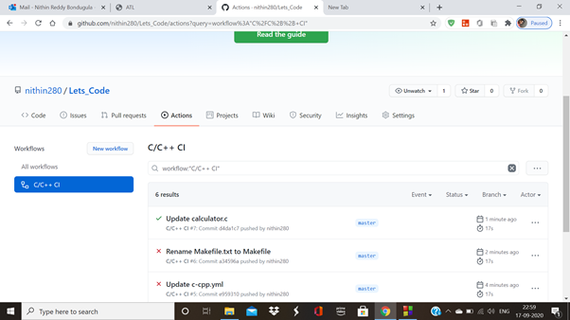

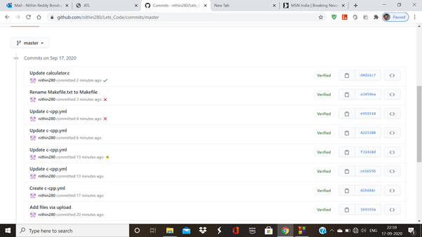

**Build:**

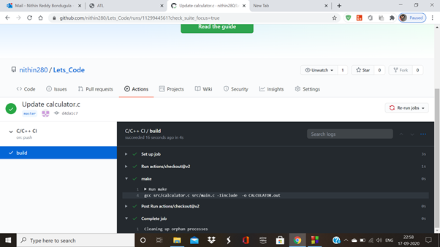

**Code Quality:**

