**Requirements**

After analyzing the existing Movie Ticket Booking system to see which of their features to be included and how to implement them. The hardware and software requirements which are sufficient for installing and running application for best results to get optimum performance are given below:

* **Hardware requirements:**
  + - Intel core i7 processor or higher
    - RAM 256MB
  + **Software Requirements:**
    - Front-end tool : Code blocks 20.3
    - Web Browser : Google Chrome
    - Documentation : MS Word
  + **Platform:**
    - Windows 7 or later

**Methodology**

The methodology that will be used throughout the development process will be variation on the Iterative waterfall life cycle. The basic idea behind this method is to develop a system through repetitive cycles by taking inputs from customers and giving them to the administrators and in smaller portions at a time like incremental format. At each iteration, design modifications are made and new functional capabilities are added. The goal for this implementation is to create a product to which the user can react. The analysis of iteration is based upon user feedback, and the program analysis facilities available.

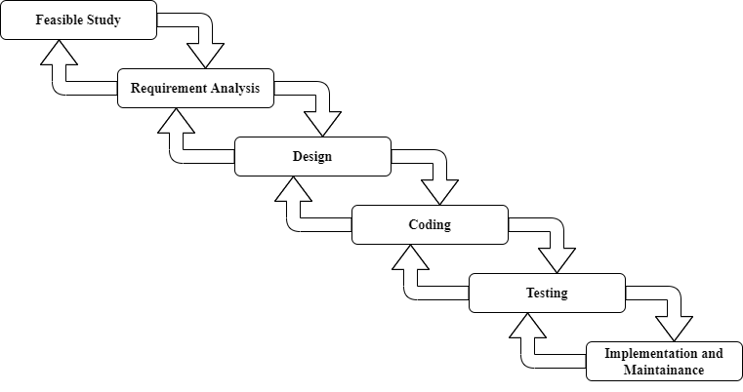

The Iterative waterfall life cycle

**Testing**

1. **Unit testing:**

It focuses on smallest unit of software design. In this we test an individual unit or

a group of inter related units. It is often done by programmer by using sample inputs and observing the outputs.

1. **Integration Testing:**

Testing is a very important process which is done before implementation of any to make an accurate user friendly, client requirement satisfying software. Integration testing works to expose defects in the interfaces and interaction between integrated components.

1. **System testing:**

System testing of software or hardware is testing conducted on a complete, integrated system to evaluate the system’s compliance with its specified requirements.