Q. What is Appium? Why do we need Appium?
- Appium is a test automation tool that is used for testing native and hybrid mobile applications.
- It was created by Sauce Labs and supported by multiple mobile OS platforms including both Android and iOS.
- We can perform multiple tests parallelly on multiple platforms at the same time.
- Appium is an important test automation tool because almost every web application has a mobile application version of it, and we don’t have to mention the demand for mobile applications separately in today’s world.
- Appium supports various languages, which have Selenium client libraries, such as Java, PHP, Objective C, C#, Python, JavaScript with node.js, Ruby, and many others
- Appium runs on top of Selenium framework that allows us to use the functionalities Selenium WebDriver as well.

Q. Explain the components and the architecture of Appium?
A. There are 4 components involved in working flow right from the client command to the automation on the device or emulator or simulator:
1. Client
2. Appium Server
3. Automation Framework- XCUITest Driver(for iOS)/ UIAutomator2 Driver(for Android)
4. Device/Simulator.

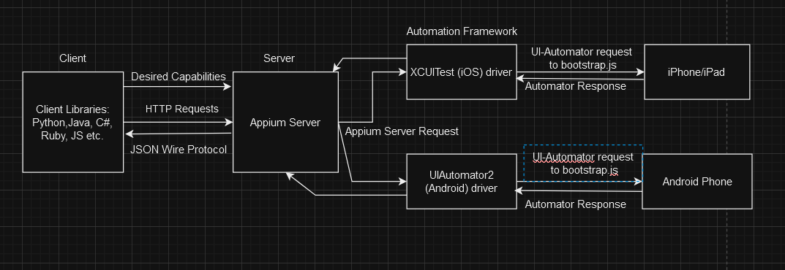

Working:
- The client sends the commands written in a particular language using client libraries of that language along with a JSON key-value object that contains information about the automator name, device name, platform name, platform version, app package, app activity etc.
- These commands are converted into JSON objects and sent to the Appium server as HTTP requests via JSON Wire Protocol.
- The server sends the requests to the Automation Framework which is XCUI Test driver for iOS platform devices and UIAutomator2 for Android based devices over the WebDriver protocol.
- The Automators then communicate with the bootstrap.jar running in the device/emulator to perform the actions.
- The actions results are sent back to the server and converted back to JSON and the client receives it.

Q. What are the advantages and disadvantages of Appium?
A. Advantages:
i. Cross-platform testing is supported.
ii. Free
iii. Supports multiple languages like Python, Java, C#, JS, Ruby etc.
iv. Can automate both native and hybrid mobile apps.
v. Integrates well with Selenium.
vi. Good community and support.

Disadvantages:
i. Relies on 3rd party automation frameworks like XCUITest, UIAutomator2.
ii. Setting up of Appium is a bit complex.
iii. Very limited support for web-based applications.
iv. Slow execution speed and test scripts may become unstable and brittle on poor maintenance.

