**Project Title**: Career Track Analysis

**Description**: Analyzed the career track enrollments and completions of students in an online learning platform (365) by retrieving data from an SQL database and visualizing the results in Tableau.

**Background**: 365, an online learning platform, wanted to understand student engagement with their career tracks, focusing on enrollments and completions to improve course offerings and student support.

**Objective**: To analyze, and visualize data on career track enrollments and completions to provide insights that can help enhance their educational services.

**Role**: Data Analyst

**Responsibilities**:

* Cleaned and prepared the data for analysis using MySQL
* Retrieved data from the SQL database.
* Import the extracted data into Tableau
* Developed visualizations in Tableau to present key insights.
* Conducted data analysis to identify trends and patterns.

**Tools**: MySQL, Tableau

**Technologies**: Data extraction and manipulation, data visualization

**Approach and Methodology**

Defined key metrics and KPIs to analyze, such as the number of enrollments, duration of completion and number of completions.

* **Data Preparation**: Cleaned and transformed the data to ensure accuracy and relevance.

select a.*,

case

when days_for_completion = 0 then 'Same day'

when days_for_completion between 1 and 7 then '1 to 7 days'

when days_for_completion between 8 and 30 then '8 to 30 days'

when days_for_completion between 31 and 60 then '31 to 60 days'

when days_for_completion between 61 and 90 then '61 to 90 days'

when days_for_completion between 91 and 365 then '91 to 365 days'

when days_for_completion > 365 then '366+ days'

end as completion_bucket

from

(select cs.date_enrolled, cs.date_completed, c.track_name, cs.student_id,

row_number() over(order by cs.student_id desc, c.track_name desc) as student_track_id,

case when cs.date_completed is not null then 1

else 0 end as track_completed,

datediff(cs.date_completed, cs.date_enrolled) as days_for_completion

from career_track_info c

join career_track_student_enrollments cs on c.track_id=cs.track_id) as a;

* **Data Retrieval**: Retrieved the transformed data from the SQL database.
* **Visualization**: Imported the data into Tableau and created dashboards to visualize the insights.

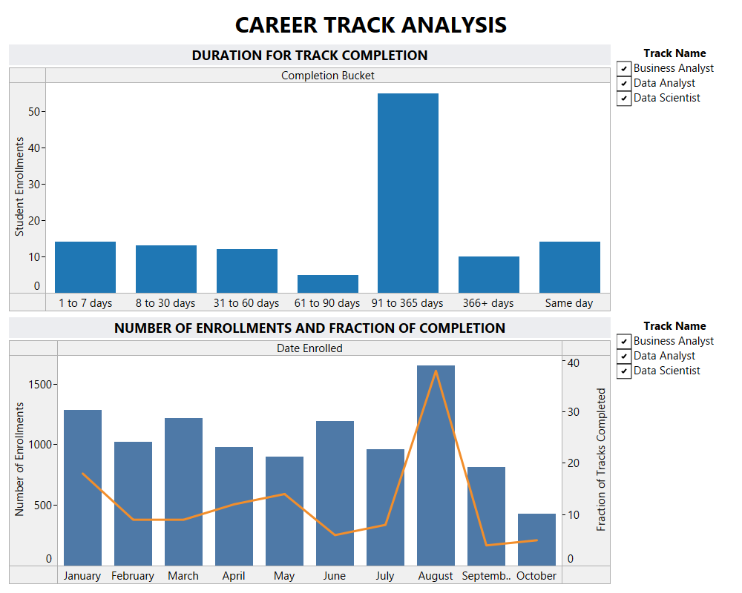

* **Analysis**: Analyzed the data to identify trends, such as the most popular career tracks and completion rates across different student demographics.

**Results of Analysis**:

1. Which is the month with the most enrollments?

Month with most Enrollments: August (1653)

1. Which career track do students enroll most in?

Data Analyst (5130)

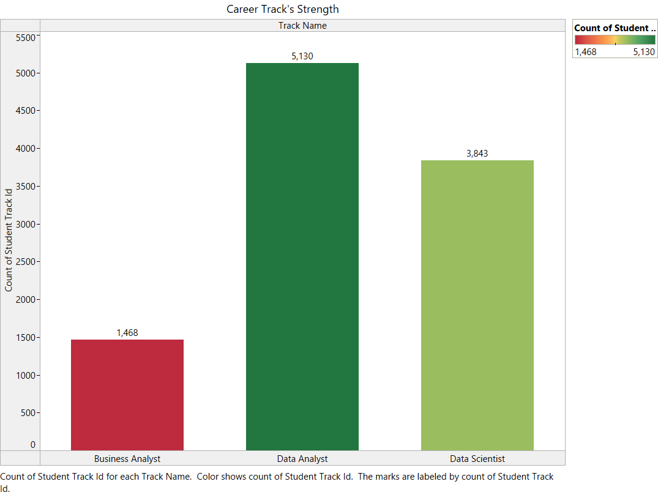

1. What is the career track completion rate? Can you say if it’s increasing, decreasing, or staying constant with time?

The enrollment is high during the months January, April, May and August.

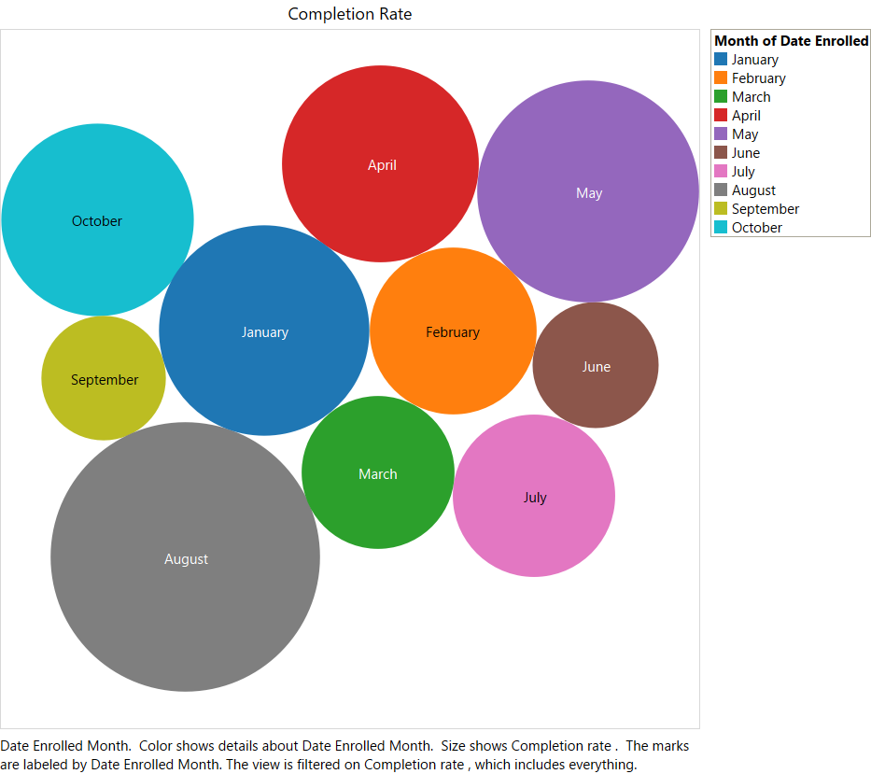

1. How long does it typically take students to complete a career track? 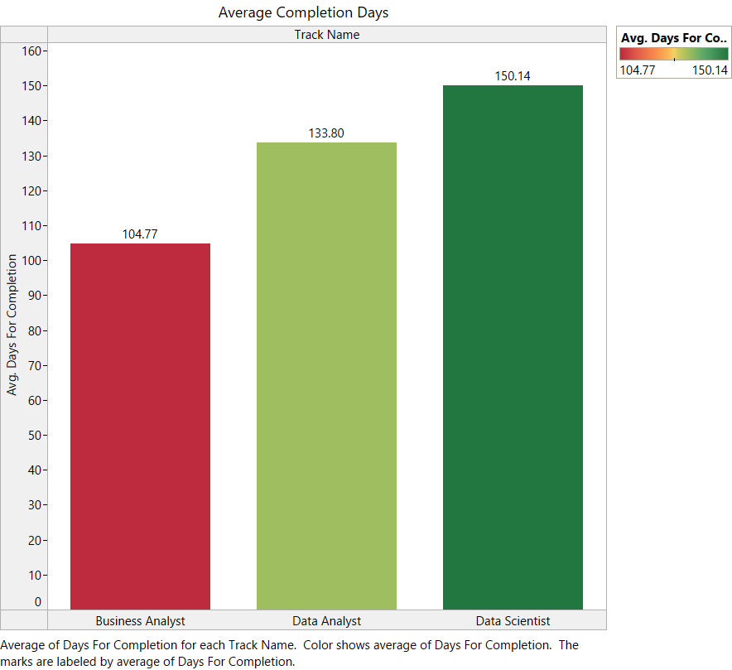
2. What advice and suggestions for improvement would you give the 365 team to boost engagement, increase the track completion rate, and motivate students to learn more consistently?

From the Analysis, it is observed that the learning platform should increase the student engagement to increase the track completion and maintain the consistency in enrollment through high quality learning experience