./



**A MINI PROJECT DOCUMENT**

**ON**

“LIBRARY MANAGEMENT SYSTEM”

SUBMITTED BY :- VINAY H P

CANDIDATE ID :-  104955

Version Number:

Team Members :

Team No:

Module: Model Based System Engineering

|  |  |  |  |  |  |
| --- | --- | --- | --- | --- | --- |
| **Ver. Rel. No.** | **Release Date** | **Prepared. By** | **Reviewed By** | **Approved By** | **Remarks/Revision Details** |
| 1 | 22-09-2020 | Vinay H P |  |  |  |
| 2 | 23-09-2020 | Vinay H P |  |  |  |
|  |  |  |  |  |  |
|  |  |  |  |  |  |
|  |  |  |  |  |  |

**Document History**

# 

**Table of contents**

|  |  |
| --- | --- |
| 1 | Introduction |
| 2 | Problem statement |
| 3 | Description |
| 4 | Design |
| 5 | Requirements |
| 6 | Test plan |
| 7 | Test case |
| 8 | Outputs |
| 9 | Conclusion |

**Introduction:**

The project titled Library Management System is Library Management software for monitoring and controlling the transactions in a library .The project “Library Management System” is developed in php, which mainly focuses on basic operations in a library like adding new books, and updating new information, searching books and members and return books.

This project of “LIBRARY MANAGEMENT” of gives us the complete information about the library. We can enter the record of new books and retrieve the details of books available in the library. We can issue the books to the students and maintain their records and can also check how many books are issued and stock available in the library. In this project we can maintain the late fine of students who returns the issued books after the due date.

Throughout the project the focus has been on presenting information and comments in an easy and intelligible manner. The project is very useful for those who want to know about Library Management System.

**Problem statement:**

This study will support and manage library transactions and services in SDSSU-Cagwait Campus. Also, the computer technology students will be able to develop a system program using visual basic 6.0 software for s design of library monitoring system in response to the problems in the current manual library operations, services and transactions are enumerated below.

* Lack of security : The data of the manual library were not secured with respect to the confidentiality of reports and documents of library transactions.
* Lack of Data Storage : There were a lot of library files, reports and documents which are not well-accomodated/saved.
* Poor Data Storage : TRhe data storage of the manual library management was not enough to accept a number of files and reports.
* Lack of information : Reports and updates with respect to library transactions and services are not well disseminated.
* Slow retrieval of Data : The viewing of library reports and files in terms of issuing and returning of books were not well-established/implemented.
* Misplaced Library Cards : The library cards with respect to issuing and returning of books were lost and rejected.
* Issuing of Books is Show : The issuing of books slow where borrowers (faculty, students , staff and clients) will have to wait for further library transactions.
* Time Consuming : The library services in terms of issuing of books through library cards consumed a lot of time.
* Lost books : There were books in the library which were not included in inventory of books per semester.

**Description :**

Library management system is a project which AIMS in developing a computerized system to maintain all the daily work of library. This Project has many features which are generally not available in normal library management systems like facility of user login it also has a facility of admin login through which the admin can monitor the whole system. it has also facility where student after logging in their account can see list of books issued and its issue date and return date and also students can request the librarian to add new books by filling the book request form . The librarian after logging into his account ie admin account can generate various reports ych as student report, issue report, teacher report and book report.

**Design :**

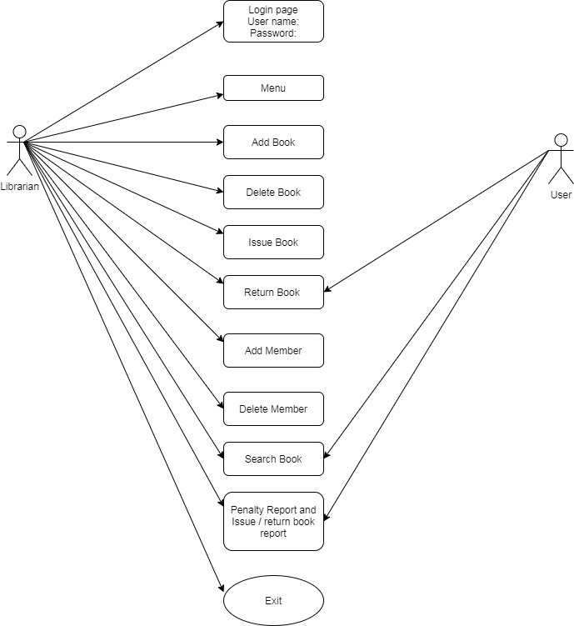

**Requirements :**

**Software Requirements:**

* MinGW Compiler
* Code::Blocks IDE v20.03

**Operating System:**

* Windows OS
* Ubuntu

**Test Plan :**

The resources here required are gcc compiler or any ide of C to develop and build the code.

1. To check if the program menu displays all options correctly
2. To check if the admin login authenticates the user to  enter valid name and password  and program menu displays all the options
3. To check if the user  enter invalid information
4. To check if the user can add data
5. To check if the user can delete a book from the list
6. To check if the user can edit the book details
7. To check if the user can search a particular book in the system
8. To check if the user can issue a book
9. To check if the user can view the list of books
10. To check if the user can close the application.

**Test Cases :**

Testing involves the design of test cases that validate that the internal program logic is functioning properly.

1. Test case 1 : To check if the admin login authenticates the user to  enter valid name and password  and program menu displays all the options

Expected output : if the user entered correct username and password it will display login successfully else it displays invalid credentials.

1. Test case 2 : Enter valid username and password then it will go to the Main Menu Bar displaying.

1.Add Book, 2. Delete Book, 3. Issue Book, 4. Retrurn Book, 5. Add Member, 6. Delete Member,

Expected output : Enter Particular number for which menu to go for example for add book press number 1 and then press enter key.

1. Test case 3 : For add book it displays the 1. Book no, 2. Book Name, 3. Author Name, enter the valid number , name , and author.

Expected outpt : It will displays the book added successfully.

1. Test case 4 : If the user wants to delete the book press number 2 in the main menu and press enter key it shows the enter book number.

Expected output : if user enters the valid book number the output displays the book is deleted successfully else no such book exits

1. Test case 5 : If the admin wants to add member press number 5 and enter it displays the enter member no , member name, member address, member mobile no.

Expected output : The outout displays the member added successfully.

1. Test case 6 : If the user wants to return the book enter number 4 and press enter key out displays the enter the book no user has to enter valid book no.

Expected output: output displays the book returned successfully.

**Expected outputs :**

The expected outcomes of development and connect multiple databases is that it provides the online Library Management System in which user can get registration and search the different kind of books on base of different parameter such as Book ID, Author Name etc as long as confirm the booking of book in advance. By connecting the more than two databases with each other, system will execute the efficient, reliable and reduce the database terrific as well as database performance will be increased.

**Conclusion :**

* The library management system allows the user to store the book detatils and the person’s details.
* This software allows storing the details of all the data related to library.
* The implementation of the system will reduce data entry time and provide readily calculated reports.
* User friendly and efficient management of records