./

Report – Candidates Election System

Course Code: <CODE>



Version Number:

Team Members :

Team No:

Module: Model Based System Engineering

|  |  |  |  |  |  |
| --- | --- | --- | --- | --- | --- |
| **Ver. Rel. No.** | **Release Date** | **Prepared. By** | **Reviewed By** | **Approved By** | **Remarks/Revision Details** |
|  | 14/11/2020 | Srushti Rangari |  |  |  |
|  |  |  |  |  |  |
|  |  |  |  |  |  |
|  |  |  |  |  |  |
|  |  |  |  |  |  |

**Document History**

# 

**Table of contents**

|  |  |  |
| --- | --- | --- |
| **Sr. No.** | **Contents** | **Page no.** |
| 1. | Problem statement | 4 |
| 2. | Description | 4 |
| 3. | Requirements | 4 |
| 4. | Research | 5 |
| 4.1 | Existing system | 5 |
| 4.2 | Proposed system | 5 |
| 4.3 | Use case diagram | 6 |
| 5. | Test Plan | 7 |
| 6. | Test Cases and Expected outcomes | 8 |
|  |  |  |

**1. Problem Statement:**

To elect the candidates from the given list and display the result of a winning candidate

**2. Description**

This Election System aims to increase the voting percentages across the country; with the proposed system, people outside their hometown can also cast their vote. Overall, project is very economical and flexible; new features and sub-modules can be added as per user requirements. This proposed system is a generalized system which can find applications for elections held at college, institutions and also elections conducted for government.

**3. Requirements**

Software Requirements (OperatingSystem Database):

Win-98, Win-XP, Win-7, Win-8, Win-10, Linux

IDE used: Code::blocks 20.03

Coding Language: C

**User Characteristics**

Every user should be:

* Comfortable with Internet Browser.
* He must have brief knowledge of voting system.
* He must also have basic knowledge of English too.

**4. Research**

**4.1 Existing System:**

In the current context, voting is done using ballot paper and counting is done manually. This manual system is very uneconomical, requiring large manpower and it takes a lot of time. Possibility of invalid or fraud votes cannot be ruled out in the current voting system.

**4.2 Proposed System:**

The proposed digital voting system makes use of computer and internet which makes the overall voting procedure easy. It saves time and avoids errors such as invalid votes and miscalculation of votes. Voting and counting both are done with the help of a computer, the election process is easy, and this system proves to be much economical, compared to the manual system.

**4.3 Use case diagram:**

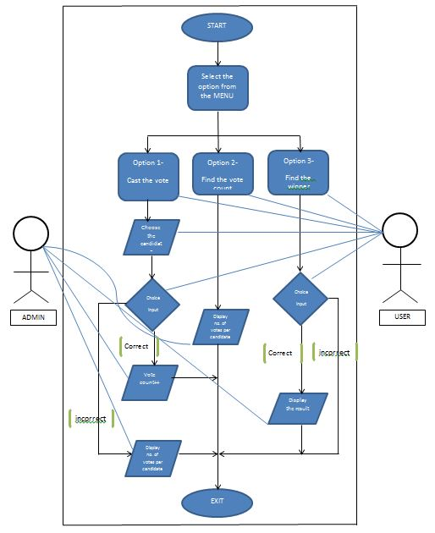

**5. Test plan**

A test plan is a document which describes the scope, approach and strategies of intended test activities.

The proposed Election is developed with the following **test cases**:

1. Select the option from menu button
2. Choose Positions for Voting
3. Find the Vote count
4. Find the winner based on the total votes the candidate received.

**6. Test Cases and Expected outcomes**

The proposed digital Voting System in C is developed with the following test plans:

**Test case 1**

Select the option from menu button. The menu consists of following set of options:

* + 1. Cast the vote
    2. Find the vote count
    3. Find the leading candidate
    4. Exit

Expected Outcome:

Given from the set of options in the menu, user can select what function he/she wants to perform.

**Test case 2**: Choose Positions for Voting

Display the list of candidates/nominees standing in the election process.

Expected Outcome:

User can choose any one candidate from the list of candidates displayed on the screen and gives the corresponding input.

There is a provision if user doesn’t find any candidate eligible to be voted for.

**Test case 3**: Find the Vote count

Count the total number of votes received by each candidate.

Expected Outcome:

The user should be able to see how many votes are received by each candidate and thus the transparency is maintained

**Test case 4**: Find the leading candidate

Based on the total votes count for each candidate, the candidate getting maximum number of votes is displayed on the screen.

Expected outcome:

At the end of election process the user should be able to see the name of winner of the election process.

If there is any tie then there is no winning situation and the default statement is displayed on the screen.