**Mini Project**

**on**

**Vending Machine**

**Submitted By**

Name : Shubham S N

Candidate ID : 104991

**Table of Contents:**

|  |  |  |
| --- | --- | --- |
| **Sl.No** | **Contents** | **Page No.** |
| 1 | Problem Statement | 3 |
| 2 | Description | 3 |
| 3 | Requirements | 4 |
| 4 | Design | 5-6 |
| 5 | Test Plan | 7 |
| 6 | Test Case | 8 |
| 7 | Conclusion | 9 |

**1.Problem Statement**

A Chocolate vending machine is to be designed to dispense chocolate chosen by the user using C programming language.This vending machine displays the list of different chocolates available in the machine and accepts the payment by cash or debit/credit card as per the choice of the user before dispensing the chocolate.

**2.Description**

Vending Machines are the automated machines which will dispense a variety of objects or items without any supervision of the operator. In the vending machine the controls will be easy and simple, users can select the required item by selecting from the list of the items available. The users can pay by inserting money directly or by paying using the credit/debit card in the method they prefer.

In this project, the Vending machine is designed for dispensing Chocolates of different varieties. At first users are provided with the options of available Chocolates along with prices of each chocolates. From the list displayed users can select the Chocolate of his/her choice. Then he can make payment for the selected Chocolate either by cash payment or by credit/debit card. If the user selects to pay by cash machine prompts the user to insert money inside the machine and if the money inserted is greater than the price of chocolate, the remaining money change is dispensed back to the user. If the user chooses to pay by credit/debit card, the user is asked to insert the card into the slot provided and is asked to insert the pin for the card inserted. If the user enters a 4 digit pin the amount will be deducted and the card is ejected back. On the successful payment, the machine dispenses the Chocolate that the user selected and the process is completed.

**3.Requirements**

**Software Requirements:**

* **IDE** : Code::Blocks IDE v20.03
* **Compiler** : MinGW Compiler
* **Operating System** : Windows, Linux
* **Programming Language** : C Language

**Functional Requirements:**

* The system shall provide a Multimedia screen display and

buttons.

* The system shall be provided with multiple payment methods.
* The system should display the available chocolates.
* The system should display the price of chocolates.
* The system must display multiple options for payment, once

the customer selects the product.

* The system shall check for properly inserted cash or

credit/debit card payment.

* The system shall dispense the selected chocolate by the user

correctly.

* The system shall be able to detect the low amount of stock and

report immediately.

* The system should have high Processing speed, less power

Consumption, high level security and Remote management.

**4.Design**

The design of the system mainly deals with providing an easy way for dispensing chocolates for the user. The Basic functions of C language like functions, file operations and other simple mathematics functions are used to design this vending machine. The list of available chocolates is displayed along with the price of each one. The user selected chocolate is stored and the price for the selected one is noted. The user is provided with the option of choosing two modes of payments namely by Cash or Credit/Debit card as per the choice of the user.

For different options selected different functions are written. The Functions are used to check various choices made by the user. For cash or credit/debit card payments the correctness of the selected payment mode is evaluated. In Cash payment, remaining cash if any is dispensed accordingly and for the card payment the pin is authenticated. The system is designed in such a way that the price of chocolate is compared with payment made by the user and if it does not match then the user is asked to try again. If the user wishes to see the bill, there is an option to display the bill. The system is designed for the correct dispense of the chocolate selected by the user.

**Flowchart**

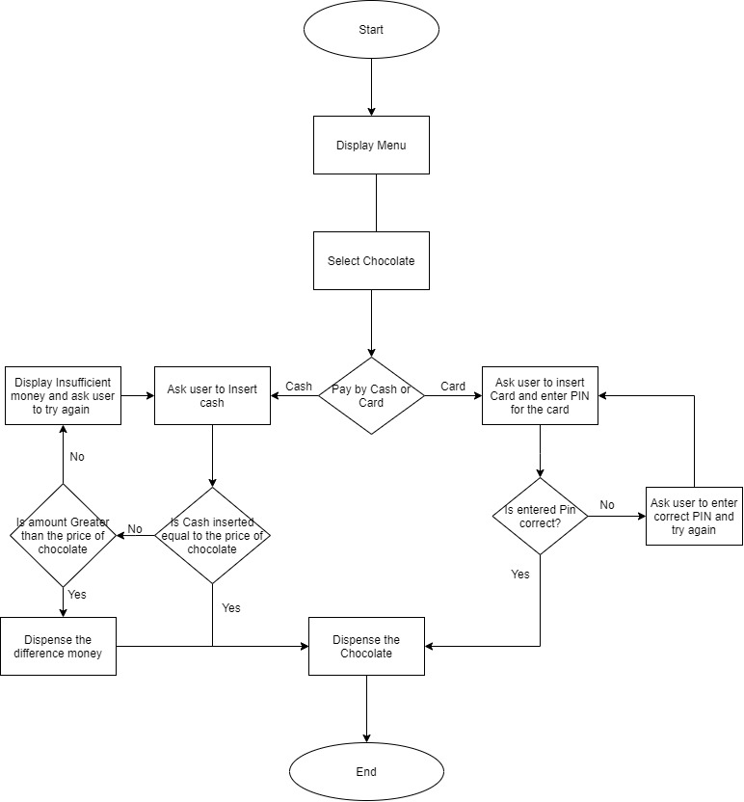

Fig 1 : Flowchart diagram of Vending Machine

**4. Test Plan**

|  |  |
| --- | --- |
| **S.No** | **Test Objective** |
| 1. | To check if the program displays a list of all the available chocolates correctly. |
| 2. | To check if the user has selected a chocolate from the list displayed. |
| 3. | To check if the program displays the price of the selected chocolate. |
| 4. | To check if the program displays the available options for payment. |
| 5. | To check if the user is selected type of payment and display instructions for selected mode of payment |
| 6. | To compare the cash paid and return the balance money if paid more |
| 7. | To check if the pin entered is correct for credit/debit card payment |
| 8. | To check if the payment is successfully completed.. |
| 9. | To display bill if user select to view bill |
| 10. | To dispense the chocolate after successful completion of payment |

**5. Test Cases**

|  |  |  |  |
| --- | --- | --- | --- |
| **S.No** | **Objective** | **Expected Result** | **Actual Result** |
| 1. | When the customer didn’t press any button from the keypad, a message “Choose a chocolate” should appear on the display. | Message Should be displayed that  “Choose a chocolate” | A message is displayed  “Choose a chocolate” |
| 2. | When a customer selects a chocolate, its price detail must be displayed for the Selected product | Price of the chocolate must be displayed | According to list user selected chocolate’s price is displayed |
| 3. | When customer confirms chocolate selection, multiple payment options must be displayed | Payment options such as cash or credit/debit card payment has to displayed | Choice of payment is displayed and the user input is stored |
| 4. | When customer hits “1” from keypad, a message should appear on the display “Please insert your money” | If “1” is pressed, message “Please insert your money” is displayed | Message “Please insert your money” is displayed and cash inserted is processed |
| 5. | When customer hits “2” from keypad, a message should appear on the display “Insert your card” | If “2” is pressed, message “Insert your card”is displayed | Message “Insert your card” is displayed and card inserted is checked |
| 6. | If customer slides a credit/debit card, a message should appear on the keypad LCD “Please insert a 4-digit PIN” | If the card is inserted,  A message “Please insert a 4-digit PIN”  is displayed | Message “Please insert a 4-digit PIN”  is displayed”  PIN entered is stored |
| 7. | When a customer inserts a 4-digit code for the credit/debit card, the system should send the product to the customer. | If the PIN entered is correct, system should dispense the chocolate selected | If the 4 digit PIN is entered then the chocolate is dispensed |

**6.Conclusion**

Vending machines are very useful machines which can be used to dispense various items without any operator required. Here vending machine is used to dispense chocolates of around 10 varieties. The system displays the list of chocolates along with prices. The vending machine is designed and tested which dispenses the chocolates for the user selected choice. This machine is helpful as the human operator is not required and the user by his/her own can use this machine according to his/her need. This machine offers flexibility of payment as users can choose to pay by cash or by credit/debit card.