./

Learning Report –

BAG UMBRELLA

Course Code: <CODE>



|  |  |  |  |  |  |
| --- | --- | --- | --- | --- | --- |
| **Ver. Rel. No.** | **Release Date** | **Prepared. By** | **Reviewed By** | **Approved By** | **Remarks/Revision Details** |
| 01 | 17/09/2020 | Ajmire Nikhitha | 99002665  99002678 |  | Made changes to the requirements table |
| 02 | 18/09/2020 | Ajmire Nikhitha | 99002665  99002678 |  | Added mapping to requirements table |
| 03 | 19/09/2020 | Ajmire Nikhitha | 99002665  99002678 |  | Added Learning report for new application. |
|  |  |  |  |  |  |
|  |  |  |  |  |  |

**Document History**

# 

**REQUIREMENT SHEET**

**BAG UMBRELLA**

**TABLE OF CONTENTS**

Activity-1

Ageing and Cost Gradation…………………………………………………………................................ 6

SWOT Analysis of the Project…………………………………………………………………………………….. 8

Requirements Mapping……………………………………………………………………………………………… 9

Design…………………………………………………………………………………………………………………………10-11

Test Plans……………………………………………………………………………………………………………………12

Activity-2

V Methodology…………………………………………………………………………………………………………….13

Agile Methodology……………………………………………………………………………………………………….14-15

References……………………………………………………………………………………………………………………16

Activity 3

Multipurpose Calculator…………………………………………………………………………………………………17-20

**LIST OF FIGURES**

Fig 1 : Use case Diagram ……………………………………………………………………………………………………………………10

Fig 2: Component Diagram…………………………………………………………………………………………………………………11

**BAG UMBRELLA**

**Activity 1**

1. **System/Software Development**
   1. **Costing**
   2. **Ageing**

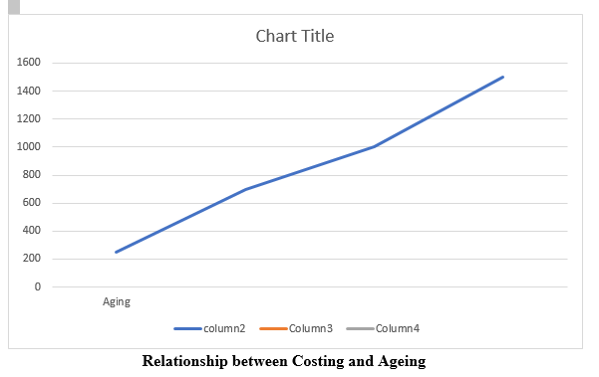

**Fig 1 Relationship between Costing and Ageing**

**1.3 Identify the product**

The product is Bag Umbrella. It is just like a good friend. It is right there when you need, and waiting in the wings when you do not. It sticks with you both rain and shine.

**Features**

* 1. Light weight.
  2. Easy to carry.
  3. Occupies less space.
  4. Bag is going to have separate pouch which is going to be extendable.
  5. Made up of soft material.
  6. Provided in customized manner.
  7. Protects against UV Rays and Heat.
  8. Eco-Friendly.
  9. Easy movement.
  10. Automatically adjustable.

**How my product going to look like:**

When rainy days you can press the button, then the umbrella will open. When you want to hide the umbrella you can press the top of umbrella, then the umbrella can hide inside the backpack. A part from this additional features are added so that the quality and usability of product is enhanced.

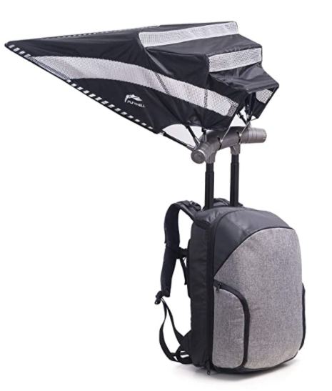 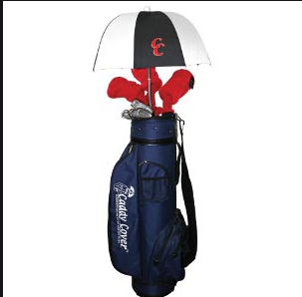

**1.4**  **SWOT Analysis**

|  |  |
| --- | --- |
| S  1. Bag Umbrellas are portable, easily transportable and are pretty affordable. Prices can vary depending on quality and additional features.  2. Local based products  3. High manufacturing quality  4. Unique product concept  5. Large and relative easy market for profit | W  1.Expensive cost per unit  2.Limited scale channels |
| O  1.Our product becomes a necessity (must have)  2.Expand our commercial market with other retail stores  3.More promotion of brand in different channels | T  In current situation competitors are increasing enormously. We are providing you the product with all features at low cost with perfect quality. |

Table 1 SWOT Analysis for BAG UMBRELLA

**1.5 Detailed Requirements**

**Requirements for Umbrella**

Perimeter tape, outer canopy, stretches, runner, Inner canopy, shaft, open/close button, Handle ring, end top, rib tape, umbrella panel, wrap popper, special material to fight against UV-rays and heat .

**Requirements for Bag**

Padded adjustable straps, front pockets, side water bottle pocket, main internal compartment, main compartment zipper, top grab/carry handle ventilating mesh or groomets, pocket for umbrella.

1. **Design**

**Use case diagram**

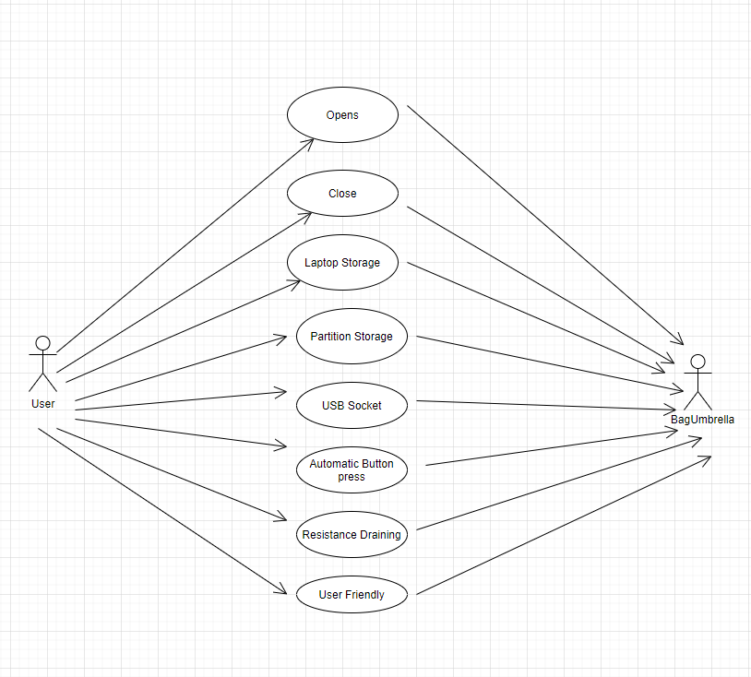

Fig 3.1 Use case diagram

**Component Diagram**

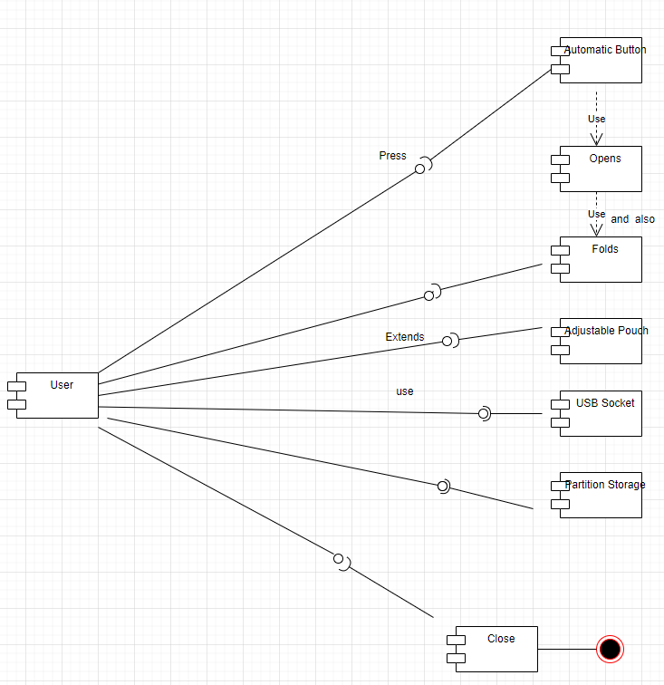

Fig 3.2 Component diagram

1. **Test Plans**

**UV rays and heat:**

Outside part of umbrella is a combination of light colours as light colours acts as a reflector.

**Windproof:** If you reside in an area that faces typhoons or daily drizzles, it is best to consider getting a windproof umbrella. These models are specifically designed to withstand severe weather to keep you warm and safe.

**Summer and Winter:** If it is then there will be an automatic button on shoulder of bag. You can press on that button respectively according to the weather you are exposing.

**Activity 2**

**V Model**

**Requirement analysis:**

The high-level requirements are bag and umbrella where the umbrella is built in bag with well-defined features where acceptance test design which discovers the performance defects in the user environment which goes parallely with the requirement analysis.

**System design:**

With the input of requirements documents feasibility study is conducted on bag and umbrella like how feasible bag and umbrella works and what are all the

specialities. System design is parallely done where the whole system functionality is tested.

**Architecture Design:**

At this stage analysis of system design document is done and generate high level design as different components are ready to build the product. And in Integration testing the internal modules like all the parts of bag and umbrella.

**Module Design:**

As above 3 steps acts as input for this stage, an individual module that is bag and umbrella is designed and generates low-level design. In Unit testing each individual module functions are tested.

**Coding:**

As it is not the software product, it doesn’t have software construction rather whole product is designed at this stage that is Bag Umbrella is designed as a whole.

**Agile Methodology:**

**Theme**

Bag Umbrella

**Epic**

**High-level requirements**: Bag and Umbrella

**Low-level requirements**:

**For Umbrella**

Perimeter tape, outer canopy, stretches, runner, Inner canopy, shaft, open/close button, Handle ring, end top, rib tape, umbrella panel, wrap popper.

**For Bag**

Padded adjustable straps, front pockets, side water bottle pocket, main internal compartment, main compartment zipper, top grab/carry handle ventilating mesh or groomets, pocket for umbrella.

**User Stories**

**User story 1**:

As a regular customer

I want a bag umbrella with low cost provided with all features

So that it is going to be affordable for everyone

**User story 2:**

As a student

I want multiple features like USB socket, user friendly, extendable pouch, automatic folder and adjustable etc., in bag umbrella and should be light-weight

So that not only students but also other employees get beneficial when the weather conditions change

**User story 3:**

As a traveller

I want all features that should be included in one piece rather than going for different types of umbrellas seperately.

So that it will be very useful for travellers and also for others as well.

**References**

<https://en.wikipedia.org/wiki/Umbrella>

<https://www.trendhunter.com/trends/vinyl-bag>

**MULTIPURPOSE CALCULATOR**

**Requirements Mapping:**

|  |  |
| --- | --- |
| **Name** | **Description** |
| H_01 | Operand1 |
| H_02 | Operand 2 |
| H_03 | Basic Arithmetic Ops (add, sub, mul, div) |
| H_01_L_01 | Find out if number is Prime |
| H_01_L_02 | Find out if number is positive |
| H_01_L_03 | Find out if number is negative |
| H_01_L_04 | Find out if number is equal to zero |
| H_01_L_05 | Find out if the Modulo of two numbers |
| H_01_L_06 | Find out if a number is even |
| H_01_L_07 | Find out if a number is odd |
| H_01_L_08 | Find out the percentage of the number |
| H_01_L_09 | Find out the factorial of given number |
| H_01_L_09 | Find out area of a parallelogram |

Table 2: Requirements Mapping

**UML DIAGRAM**

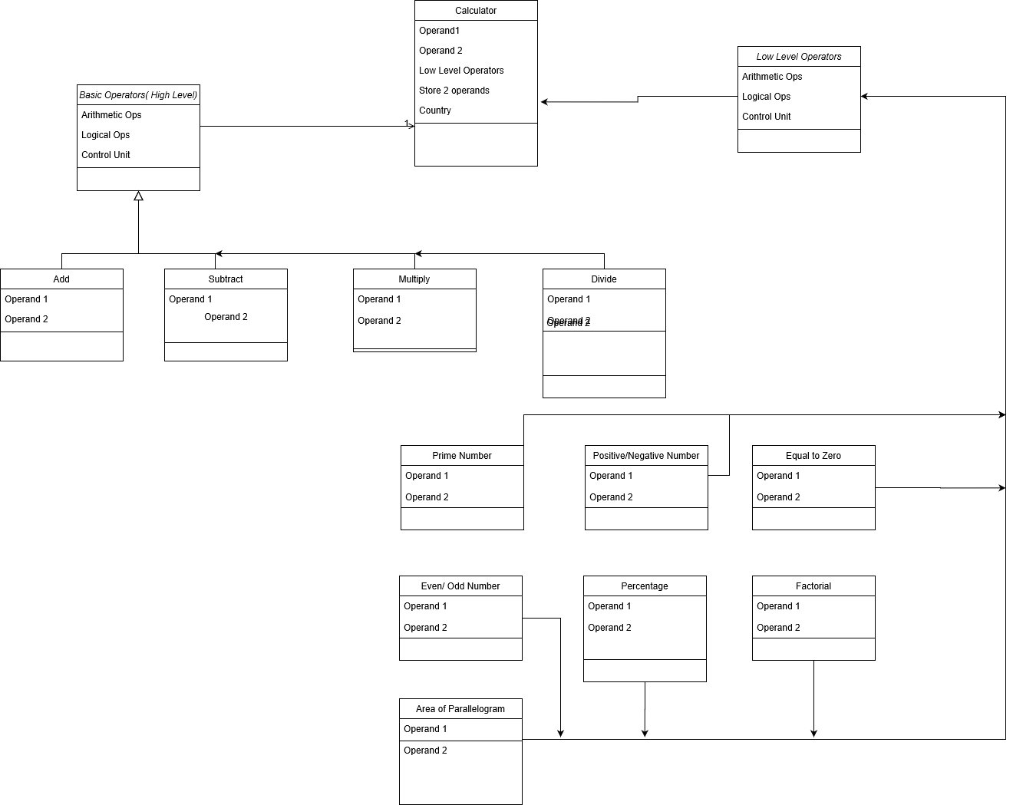

**TEST PLANS**

|  |  |  |  |  |  |
| --- | --- | --- | --- | --- | --- |
| **Product ID** | **Description** | **Precondition** | **Expected Input** | **Expected Output** | **Actual Output** |
| H_01 | Operand 1 | Uninitiated | Initiate | Initiated | Initiated |
| H_02 | Operand 2 | Uninitiated | Initiate | Initiated | Initiated |
| H_03 | Arithmetic Operators | Undefined | Define basic operators | Defined basic operators | Defined Basic Operators |
| H_01_L_01 | Prime number | Not verified | Any integer number | Verify if prime number or not | Verify if prime number or not |
| H_01_L_02 | Positive Number | Not verified | Any integer number | Verify if positive number or not | Verify if positive number or not |
| H_01_L_03 | Negative Number | Not verified | Any integer number | Verify if negative number or not | Verify if negative number or not |
| H_01_L_04 | Zero | Not verified | Any integer number | Verify if number is 0 or not | Verify if number is 0 or not |
| H_01_L_05 | Even number | Not verified | Any integer number | Verify if even number or not | Verify if even number or not |
| H_01_L_06 | Odd number | Not verified | Any integer number | Verify if odd number or not | Verify if odd number or not |
| H_01_L_07 | Percentage | Not calculated | 2 integer numbers | Calculate percentage of a number | Calculate percentage of a number |
| H_01_L_08 | Factorial | Not calculated | Any integer number | Calculate the factorial of a number | Calculate the factorial of a number |
| H_01_L_08 | Area | Not calculated | Two float nums | Calculate the area of a parallelogram | Calculate the area of a parallelogram |

**Test Plans**

**GITHUB REPOSITORY**

The link to the GitHub repository: <https://github.com/99002645>

**SCREENSHOTS**

