MiniProject
On

Determining the zone of coronavirus

By:
Srikarani Vanaparty
Candidate ID:105090
Table of Contents
S.No | Content
1 | Problem Statement
2 | Problem Description
3 | Requirements
4 | Design
5 | Test Plan
6 | Test Cases
7 | Expected Results

1.Problem Statement:
To determine the zone of coronavirus based on the given input. Whenever the user enters name of a particular region, then it identifies in which zone (Red or Green or Orange) the entered region based on details entered in the file and gives the output according to the index value.
2. Problem Description:
A novel type of coronavirus (2019-nCoV) infecting humans appeared in Wuhan, China, at the end of December 2019. Since the identification of the outbreak the infection quickly spread involving in one month more than 31,000 confirmed cases with 638 death. The Union Health Ministry on May 1 reclassified districts as coming under red, orange and green zones with specific guidelines for each heading into the lockdown extension announced by the Ministry of Home Affairs.
This classification is based on infection rates besides other factors. 319 districts with either zero confirmed cases or no confirmed cases in the last 21 days were classified as coming under the “green zone”. 130 districts were classified under falling under the” red zone” based on the relatively higher number of total number of active cases, the doubling rate of confirmed cases and the extent of testing and surveillance feedback from the districts. 284 districts were identified as under the "orange zone" - that were neither in the red or green zones. In this pandemic situation, it is important to know the zone of a particular area so that more precautions are to be taken to move forward. This Project determines the zone of a particular region based on the given input. Whenever the user enters name of a particular region, then it identifies in which zone (Red or Green or Orange) the entered region is and gives the output according to the index value (for district value=1, state value=2). For example, the entered region is Telangana then the output is based on number of times the existence of region in the file i.e, if infected cases are 15 in file, it gives output as "Telangana is in ORANGE ZONE !!!". It also has the capability of taking user details (Name, District, State) into the file.
3. Requirements:
- Initial dataset of patients with covid-19 positive in order to display the zone based on the infected cases in that particular region.
3.1. Software Requirements:
1.Operating System: Windows, Linux or any other system
2. Front end tool: CodeBlocks IDE
3. Programming language used: C

3.2. Functional Requirements:
Find zone: To find the zone by the name of region. For example, if you enter name of the region: Nizamabad, then it displays “ Nizamabad comes under orange zone”.
4. Design:
Basic design flow:

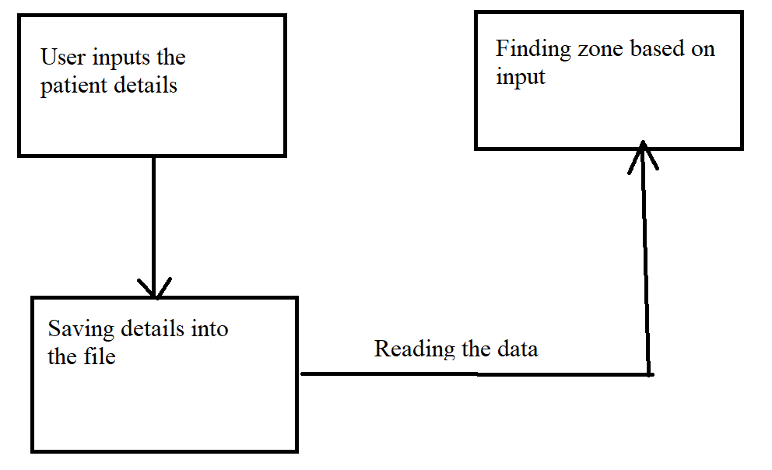

5. Test Plan:
A Test Plan is a detailed document which describes scope, strategies, approach of intended test activities that helps us determine the effort needed to validate the quality of the application under test. The test plan serves as a blueprint to conduct software testing activities as a defined process.
The proposed project is developed with the following test cases:
- Enter the name of region to be known in which zone it is.
- Details entered by the user are written into the file.
- Displays the zone of the region.
6. Test Cases:
S.No | Objective | Expected Result
1 | To Enter the name of a region | The zone of a particular area is printed correctly.
2 | To check if the zone is printed for a particular region is correct or not. | Specific zone of a particular is printed correctly based on the infected cases.
3 | To check the details entered by user are written into a file | Displays the details are entered successfully.
4 | If the region is not included in the details entered by user | Displays the details are not entered properly.

7. Expected Results:
Write operation: Successful insertion of given inputs into the file which are provided by the user.
Read operation: Returns the zone of the given region based on the incidence of cases existed in file.

