./

**ONLINE SELECTION OF MUSICAL INSTRUMENT COURSES**

**ONLINE SELECTION OF MUSICAL INSTRUMENT COURSES**

Course Code: <CODE>



Version Number:

Team Members :

Team No:

Module: Model Based System Engineering

|  |  |  |  |  |  |
| --- | --- | --- | --- | --- | --- |
| **Ver.Rel. No.** | **Release Date** | **Prepared. By** | **Reviewed By** | **Approved By** | **Remarks/Revision Details** |
|  |  |  |  |  |  |
|  |  |  |  |  |  |
|  |  |  |  |  |  |
|  |  |  |  |  |  |
|  |  |  |  |  |  |

**Document History**

# 

**TABLE OF CONTENTS**

|  |  |  |
| --- | --- | --- |
| **Chapter No.** | **Contents** | **Page No.** |
| 1 | Problem Statement | 2 |
| 2 | Description | 2 |
| 3 | Requirements | 3 |
| 4 | Test Plan | 4 |
| 5 | Test Cases | 5 |
| 6 | Conclusion | 6 |
| 7 | References | 7 |

**CHAPTER 1**

**PROBLEM STATEMENT:**

The online selection of musical instrument courses by a student from a music school.

Students often find it difficult to maintain the courses to learn and the total amount to be paid. Thus this project helps the students to know which instrument course they have selected to learn.

**CHAPTER 2**

**DESCRIPTION:**

* The project is focused to help the students to select the offered instrument courses they wish to learn from a music school.
* This is used to keep note of the instrument courses selected online along with the total registration fees.
* The name of the student is asked as an input in the welcome screen.
* The courses can be selected by giving corresponding numbers.
* By choosing from the list they can know the instruments they wish to learn (like veena, flute, mridangam etc).
* After selecting the courses, the courses selected along with their respective registration fees are displayed.

**CARNATIC MUSIC DESCRIPTION:**

The origins of South Indian music are traced to prehistoric times. Musical instruments form a favorite subject for sculptors, painters and the authors of ancient Tamil and Sanskrit texts. Vocal and instrumental genres have since coalesced into a single body of compositions and themes. These form the basis for creative elaboration and self-expression.Several strands have been intertwining throughout Indian music history. According to celebrated Kannada writer, Kota Shivarama Karanth, Indian culture today is so varied as to be called ‘cultures’.*

Music was cultivated by nobility and common people alike. A mere glance at India’s literary heritage, including poetry, drama, mythology and scholarly texts, reveals an ongoing quest for new ideas. The same can be said of performers, instrument makers and skilled amateurs. The resulting “art music” is in fact an amalgam of different *“*regional” or *“*indigenous”styles (dēsi). Today it is being studied all over the world on account of its continuity, infinite variety and a rare capacity for self-rejuvenation.

Carnatic music owes its name to the Sanskrit term Karnātaka Sangītam which denotes “traditional” or “codified” music. The corresponding Tamil concept is known as Tamil Isai.These terms are used by scholars upholding the “classical” credentials and establishing the “scientific” moorings of traditional music. Besides Sanskrit and Tamil, Telugu, Kannada and Malayalam have long been used for song lyrics.

**CHAPTER 3**

**REQUIREMENTS:**

Software Requirements:

* Code::Blocks version 20.03
* C programming language
* Windows 10 Operating System

Data Requirements:

* Name of the student.
* Instrument courses selected from the instrument courses list.

**CHAPTER 4**

**TEST PLAN:**

FLOW CHART:

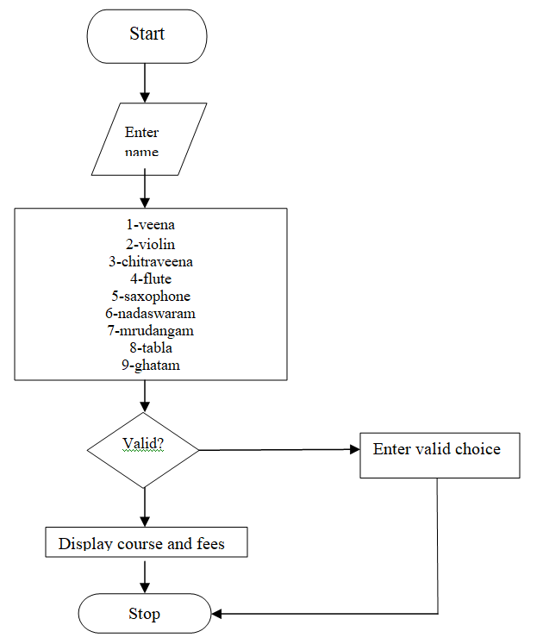

**CHAPTER 5**

**TEST CASES:**

The below mentioned test cases can be executed.

|  |  |  |  |
| --- | --- | --- | --- |
| **TEST CASE** | **TEST SCENARIO** | **TEST DATA** | **RESULT** |
| 1 | * Enter Name | (Enter student name)  Eg: Anagha | Hello Anagha, Welcome to our music school. Enter  1-VEENA  2-VIOLIN  3-CHITRAVEENA  4-FLUTE  5-SAXOPHONE  6-NADASWARAM  7-MRUDANGAM  8-TABLA  9-GHATAM |
| 2 | * Invalid choice | (Enter other than 1,2,3,4,5,6,7,8,9) | Enter valid choice. |
| 3 | * To select VEENA | (Enter number 1)  1 | VEENA-Rs.600 |
| 4 | * To select VIOLIN | (Enter number 2)  2 | VIOLIN-Rs.500 |
| 5 | * To select CHITRAVEENA | (Enter number 3)  3 | CHITRAVEENA-Rs.550 |
| 6 | * To select FLUTE | (Enter number 4)  4 | FLUTE-Rs.550 |
| 7 | * To select SAXOPHONE | (Enter number 5 )  5 | SAXOPHONE-Rs.500. |
| 8 | * To select NADASWARAM | (Enter number 6)  6 | NADASWARAM-Rs.300 |
| 9 | * To Select MRUDANGAM | (Enter number 7)  7 | MRUDANGAM-Rs.500 |
| 10 | * To Select TABLA | (Enter number 8)  8 | TABLA-Rs.500 |
| 11 | * To Select GHATAM | (Enter number 9)  9 | GHATAM-Rs.500 |

**CHAPTER 6**

**CONCLUSION:**

The project is useful for students to select the instrument courses they want. The project is expected to give the course and the registration fees accurately. Thus by displaying the course and registration fee the students can be clear about the instrument course chosen and the fees to be paid.

**CHAPTER 7**

**REFERENCES:**

* Code::Blocks- <http://www.codeblocks.org/downloads/binaries#windows>
* Indian Instruments- <https://en.wikipedia.org/wiki/List_of_Indian_musical_instruments>
* Switch Statement in C-<https://www.geeksforgeeks.org/switch-statement-cc/>
* <https://www.tutorialspoint.com/cprogramming/switch_statement_in_c.htm>