**Contents**

1. Introduction………………………………………………………......1
2. Problem Statement……………………………………………………1
3. Description…………………………………………………………...1
4. Objectives…………………………………………………………….2
5. Requirements…………………………………………………………2

5.1 Data requirements…………………………………………………………...2

5.2 Software requirements………………………………………………………2

5.3 Functional requirements…………………………………………………….3

1. Design………………………………………………………………...4

Conclusion………………………………………………………………5

References………………………………………………………………6

**List of figures**

1. Design…………………………………………………………….4
2. **Introduction**

Departmental store is a large retail trade organization. It consists of several departments which are organized and classified accordingly runs under the same ownership and management. Departments are classified based on the type of goods sold which fulfills the customer requirements at one place. It provides maximum shopping convenience so it is called Universal providers. In this type of stores, it is necessary to automate the billing process in order to avoid errors caused by human beings and also make their work easy.

1. **Problem Statement**

Design and develop an efficient departmental store billing system using C programming which add the new products, edit the existing products search items based on product code and calculates the total bill.

1. **Description**

The project aims to manage the billing process smoothly in large organizations without making any errors. The main feature of this system is, the staff of the organization can easily calculate the total bill for the products purchased by the customers and also it gives some additional features like add the new items by giving a unique code, name and price of the product and search the items based on code, name and price which gives the list of products based on the search. The products can be easily deleted if it is not available in the store and also modifies the product price easily by edit product option.

1. **Objectives**

* **Accuracy:** To develop a system provides an accurate result in calculating the bills and it avoids the error.
* **Maintain cost:** To develop a standalone system and no need to spend the cost on maintenance.
* **Fast Billing:** To develop an efficient system to limit the delay while delivering the bill to the customers.

1. **Requirements**
   1. **Data requirements**

The data collected for each of the product is as follows

* Unique code for each product (Barcode)
* Name of the product
* Price of the product
* Total no of pieces available (Quantity)
  1. **Software Requirements**

It deals with the Operating system, IDE, Programming language and Compiler that are used in this system and are mentioned as follows.

* Operating System: Windows or Ubuntu
* IDE: Code Blocks
* Programming Language: C
* Compiler: MinGW
  1. **Functional requirements**

The functions that are required for efficient billing system is as follows:

* Calculate bill: It calculates the total price of the purchased products and displays the total amount to pay by the customer.
* Add product: It adds the new product by taking a unique code, name, price and quantity.
* Edit Product: It is helpful in modifying the attributes of the product.
* Display: It displays all the products available in the store.
* Search: It is used to search the product whether it is available in the store or not.

1. **Design**

The flow of the proposed system is as shown in figure 1.

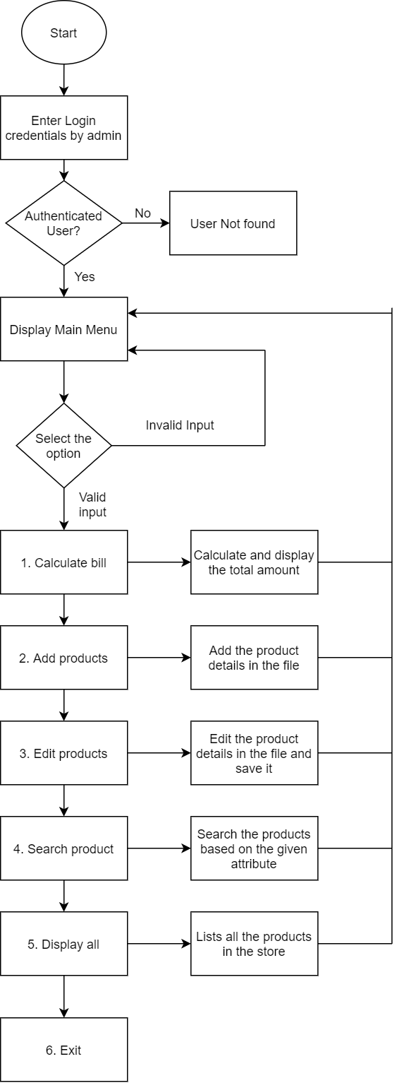

Figure 1 Design

**Conclusion**

In conclusion, the billing system in departmental store project was proposed in an efficient way to minimize the errors caused by the manual operations and also it automates the process of billing and stock maintenance which is helpful for the customers and also for the staff in the stores by using this system. It enhance the operation of the store in an accurate and effective way.

**References**

[1]. <http://www.codeblocks.org/>

[2]. <https://www.draw.io/>

[3.] <https://www.tutorialspoint.com/software_testing_dictionary/test_plan.htm>