

**MINI PROJECT**

**ON**

**NUMBER SYSTEM CONVERSION**

**BY**

**GAGANA A**

**(SF ID:105440)**

**TABLE OF CONTENTS**

|  |  |  |
| --- | --- | --- |
| SERIAL NO | CONTENTS | PAGE NO |
| 1. | PROBLEM STATEMENT | 4 |
| 2. | REQUIREMENTS | 4 |
| 3. | DESCRIPTION | 4 |
| 4. | TEST PLAN | 6 |
| 5. | TEST CASES AND EXPECTED RESULT | 8 |
| 6. | CONCLUSION | 12 |
| 7. | REFERENCES | 12 |

**LIST OF FIGURES**

|  |  |  |
| --- | --- | --- |
| SERIAL NO | CONTENTS | PAGE NO |
| 1. | NUMBER BASE CONVERSION | 4 |

**LIST OF TABLES**

|  |  |  |
| --- | --- | --- |
| SERIAL NO | CONTENTS | PAGE NO |
| 1. | TEST CASES AND EXPECTED RESULT | 8 |

**1.PROBLEM STATEMENT**

This project aims to convert a given number from one number system to another number system and to provide faster and easier number system conversion to the user.

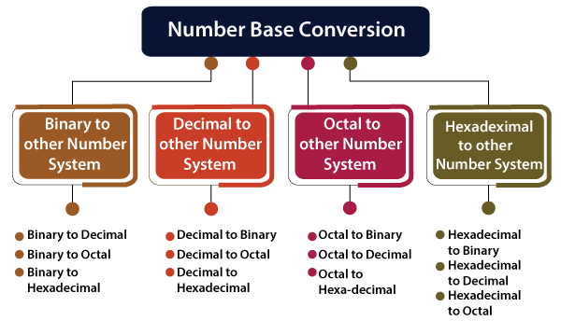

Figure 1: Number base conversion

**2.REQUIREMENTS**

Software Requirements:

* Code::Blocks version 20.03
* C programming language
* Windows Operating System

**3.DESCRIPTION**

One of the most important applications of the number system is in computer technology. Generally, a computer uses the binary number system, but humans will use the hexadecimal or decimal number system, as it is easier to understand. For this reason, the number system conversion is required.

Number System Conversion is a converter which allows you to convert between different numeral systems like the binary system, hexadecimal system, octal number system and decimal system.

From this project, the user can easily convert any number system such as: Binary to decimal, octal, hexadecimal. Decimal to binary, octal, hexadecimal. Octal to binary, decimal, hexadecimal. Hexadecimal to binary, decimal, octal. The user has to choose numbers and then enter the number according to their conversion. The whole project is designed in ‘C’ Programming language .This project would be easy to operate and to understand by the users.

The general representation of number systems are:

Decimal Number – Base 10 – N10

Binary Number – Base 2 – N2

Octal Number – Base 8 – N8

Hexadecimal Number – Base 16 – N16

The functions to be performed in this project for conversion of a number from one number system to another number system are listed below:

1:BINARY TO DECIMAL

2:BINARY TO OCTAL

3:BINARY TO HEXA-DECIMAL

4:DECIMAL TO BINARY

5:DECIMAL TO OCTAL

6:DECIMAL TO HEXA-DECIMAL

7:OCTAL TO BINARY

8:OCTAL TO DECIMAL

9:OCTAL TO HEXA-DECIMAL

10:HEXA-DECIMAL TO BINARY

11:HEXA-DECIMAL TO DECIMAL

12:HEXA-DECIMAL TO OCTAL

1. **TEST PLAN**

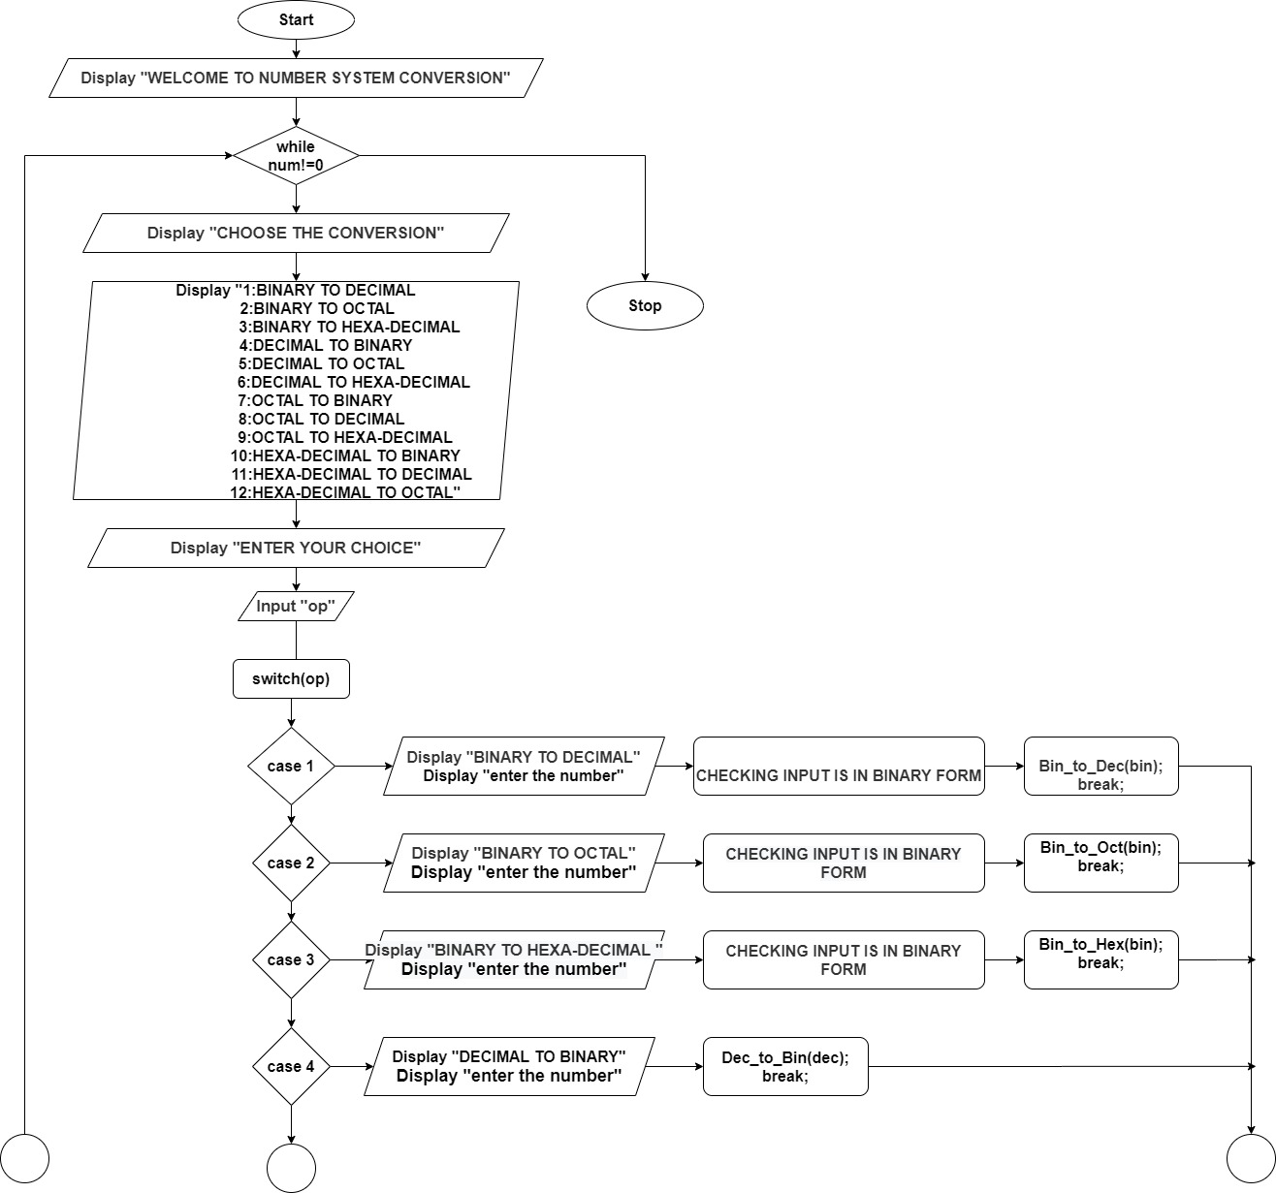

**yes**

**no**

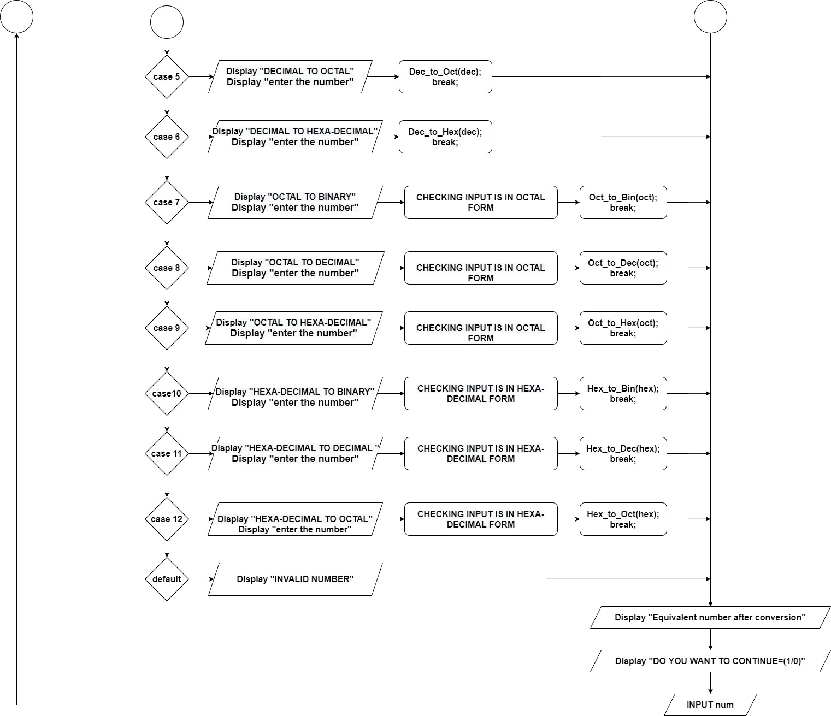

**5.TEST CASES AND EXPECTED RESULTS**

Table 1: Test cases and Expected results

|  |  |  |  |
| --- | --- | --- | --- |
| **TEST CASES** | **TEST SCENARIO** | **TEST DATA** | **EXPECTED RESULT** |
| 1 | Binary to Decimal | a)  Enter your choice : 1  Enter the number in Binary form : 1010  b)  Enter your choice : 1  Enter the number in Binary form : 5 | Equivalent Decimal number : 10  5 is not a Binary number |
| 2 | Binary to Octal | a)  Enter your choice : 2  Enter the number in Binary form : 1010  b)  Enter your choice : 2  Enter the number in Binary form : 8 | Equivalent Octal number : 12  8 is not a Binary number |
| 3 | Binary to Hexadecimal | a)  Enter your choice : 3  Enter the number in Binary form :1010  b)  Enter your choice : 3  Enter the number in Binary form :22 | Equivalent Hexadecimal number: A  22 is not a Binary number |
| 4 | Decimal to Binary | Enter your choice : 4  Enter the number in Decimal form : 8 | Equivalent Binary number : 1000 |
| 5 | Decimal to Octal | Enter your choice : 5  Enter the number in Decimal form : 8 | Equivalent Octal number : 10 |
| 6 | Decimal to Hexadecimal | Enter your choice : 6  Enter the number in Decimal form : 8 | Equivalent Hexadecimal number: 8 |
| 7 | Octal to Binary | a)  Enter your choice : 7  Enter the number in Octal form : 6  b)  Enter your choice : 7  Enter the number in Octal form : 8 | Equivalent Binary number : 110  8 is not a Octal number |
| 8 | Octal to Decimal | a)  Enter your choice : 8  Enter the number in Octal form : 6  b)  Enter your choice : 7  Enter the number in Octal form : 9 | Equivalent Decimal number : 6  9 is not a Octal number |
| 9 | Octal to Hexadecimal | a)  Enter your choice : 9  Enter the number in Octal form : 6  b)  Enter your choice : 7  Enter the number in Octal form : 8 | Equivalent Hexadecimal number : 6  8 is not a Octal number |
| 10 | Hexadecimal to Binary | a)  Enter your choice : 10  Enter the number in Hexadecimal form : B  b)  Enter your choice : 10  Enter the number in Hexadecimal form : K | Equivalent Binary number : 1011  K is not a Hexadecimal number |
| 11 | Hexadecimal to Decimal | a)  Enter your choice : 11  Enter the number in Hexadecimal form : B  b)  Enter your choice : 10  Enter the number in Hexadecimal form : Y | Equivalent Decimal number : 11  Y is not a Hexadecimal number |
| 12 | Hexadecimal to Octal | a)  Enter your choice : 11  Enter the number in Hexadecimal form : B  b)  Enter your choice : 10  Enter the number in Hexadecimal form : Q | Equivalent Decimal number : 13  Q is not a Hexadecimal number |

**6.CONCLUSION**

From this project, the user can easily convert any number system such as: Binary to Decimal, Octal, Hexadecimal. Decimal to Binary, Octal, Hexadecimal. Hexadecimal to Binary, Octal, Decimal. The user has to choose numbers and then enter the number according to their conversion. This project has made the number system conversion fast and easy for the users. This project is easy to understand and operate for the users.

**7.REFERENCES**

[1]<https://www.javatpoint.com/conversion-of-number-system-in-digital-electronics>

[2]<https://www.geeksforgeeks.org/number-system-and-base-conversions/>

[3]<https://www.rapidtables.com/math/number/Numeral_system.html>

[4]<https://www.tutorialspoint.com/basics_of_computers/basics_of_computers_number_system_conversion.htm>