Git instalacja

dla ubuntu

sudo apt-get install git

utworzenie klucza ssl

cd ~/.ssh

ssh-keygen -t -C „stepu@tlen.pl”

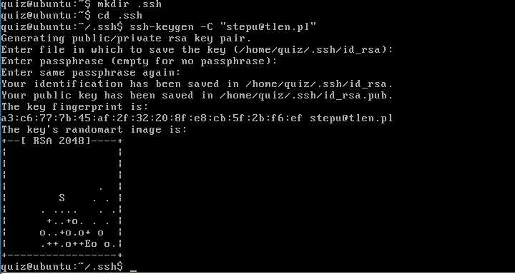

w pliku id_rsa.pub znajduje się klucz publiczny. Otwieramy plik edytorem tekstowym o kopiujemy zawartość w pole KeY na GitHub'ie.

On the GitHub site Click “Account Settings” > Click “SSH Public Keys” > Click “Add another public key

Test everything out.
To make sure everything is working you’ll now SSH to GitHub. Don’t change the “git@github.com” part.That’s supposed to be there.
$ ssh git@github.comAttempts to ssh to github
Which should give you this:
The authenticity of host 'github.com (207.97.227.239)' can't be established.RSA key fingerprint is 16:27:ac:a5:76:28:2d:36:63:1b:56:4d:eb:df:a6:48.Are you sure you want to continue connecting (yes/no)?
Don’t worry, this is supposed to happen. Type “yes”.
PTY allocation request failed on channel 0Hi username! You've successfully authenticated, but GitHub does not provide shell access.Connection to github.com closed.

Having problems?

Then: Set Up Your Info
Now that you have Git set up and your SSH keys entered into GitHub, it’s time to configure your personal info.
- Set your username and email.
Git tracks who makes each commit by checking the user’s name and email. In addition, we use this info to associate your commits with your GitHub account. To set these, enter the code below, replacing the name and email with your own. The name should be your actual name, not your GitHub username.
$ git config --global user.name "Firstname Lastname"Sets the name of the user for all git instances on the system$ git config --global user.email "your_email@youremail.com"Sets the email of the user for all git instances on the system

More about user info
- Set your GitHub token.
Some tools connect to GitHub without SSH. To use these tools properly you need to find and configure your API Token.
On the GitHub site Click “Account Settings” > Click “Account Admin.”

At the command line run the following code, using your GitHub username and token in place of the ones shown.
$ git config --global github.user usernameSets the GitHub username for all git instances on the system$ git config --global github.token 0123456789yourf0123456789tokenSets the GitHub token for all git instances on the system
*Note* If you ever change your GitHub password, a new token will be created and will need to be updated.

Git clone git@github.com:stepu/sfQuiz.git

