EEG Field Kit — Design and Assembly Document
Monocoque helmet with permanently mounted electrodes, integrated electronics, internal wiring and per-site contact lights; electronics schematics; travel case; fitting instructions; adversarial design review
Document: DSN-EEG-002 Revision: E Date: 1 September 2026
Issued by: TI One Voice research programme (one.witysk.org), Brussels, Belgium
Governing documents: DSN-EEG-003 Rev B (manufacturing design package), then RFQ-EEG-001 Rev D (requirements and acceptance), then ICD-EEG-006 Rev A (module interfaces). Part identifiers are governed by PARTS-EEG-019 Rev A. Where this document and tools/design.py disagree, design.py governs.
Revision E — what changed and why
Rev E changes no illustration. It corrects the text where package v2 found it to be wrong, and it renames the figures. Rev D used the HM-xx prefix for both figure labels and part numbers, and the two namespaces collided: HM-07 was the boom microphone arm in section 10 and the battery hatch in DSN-EEG-003 section 4, in the STL set, in the kit BOM and in the RFQ scope line. A manufacturer printing “HM-07” produced a different part depending on which document was open, and section 10 requires the part identifier to be engraved in the model, so the wrong identifier would have been moulded into the part. From Rev E, figures are FIG-nn and HM-xx means a part and nothing else. The battery hatch is HM-08. PARTS-EEG-019 is the single register and carries the full migration table.
The other corrections in Rev E, each of them an ECO in ECO-EEG-016:
• Section 6, wiring. The harness is now TWO cables, not one twenty-way. A 12-way screened electrode bundle carries the eight scalp sites, the two ear references, the bias lead and the screen; a separate 10-way ribbon carries the eight contact-light lines, the light common and its return. Rev D ran all of it through one connector at the far edge of the analogue zone, which forced eight digital conductors across the whole front end and put them in the same cable as eight high-impedance electrode leads. DSN-EEG-003 Rev A.2 recorded that and accepted it; that was the wrong call (ECO-EEG-014). WH-EEG-008 is the wire list.
• Section 5, contact lights. Each site carries a two-lead bicolour LED between its own line and a common phase line. Rev A of the carrier had no driver for them at all: the shift-register module's outputs were never brought to the board (ECO-EEG-001). They are dark at power-on because the phase line is an input at reset, so no current can flow whatever the register contains.
• Section 7, the pod. POD-P1 is now a released parametric model with the panel openings of RFQ M-02 cut in it: three touch-proof DIN 42802 sockets, the headphone jack, the boom connector, the room-microphone port, a data USB-C on the isolator module and a SEPARATE charge-only USB-C. Rev D implied one connector for both, which cannot be reconciled with the isolation requirement (ECO-EEG-003).
• Section 10, parts. The table is corrected and extended: the battery hatch is HM-08, the module plate MP-01 is new, and every part now names the file that defines it. Parts that had no file in Rev D — the TPU pads, the yoke, the chin strap, the service key, the fit-test coupon, the bottom foam layer — are listed with their status.
• Section 11, the travel case. The internal size is about 340 × 250 × 210 mm, which is what an assembled helmet standing upright needs. RFQ Rev C gave 300 × 220 × 110 mm in one place and the larger figure in the kit BOM; the larger one is correct and RFQ Rev D says so.
• Section 13, schematics. The figures here are the design intent. The released schematic is SCH-EEG-005 Rev B, eight sheets, generated from the same source as the board. Two circuits changed: the envelope detector is a full-wave rectifier into a 48.8 Hz Butterworth filter on a quad op-amp, because the Rev A dual left the filter out of circuit entirely (ECO-EEG-004 and 006), and the input protection is on the carrier EEG-CAR-01, not on a separate panel board.
• Section 12, the adversarial review. Every objection now carries its status in package v2. Three of them are answered; the rest still are not, and say so.
What changed in Revision C
Revision B still asked the participant to snap eight electrode carriers onto rails. They are now permanently mounted: the participant never handles an electrode, and set-up drops from eight placements to none. Section 4 argues that change and answers the obvious objection, which is cleaning. The frame geometry has also been corrected — in Revision B the arches were drawn terminating short of the halo, which was a drafting error rather than a design intent; every junction is now a filleted node and no section ends in free air. The figures have been redrawn on a human figure with a face and hair so that front, rear and three-quarter views are unambiguous, and two new scenes show the helmet in use: at a mirror and at the session runner. Section 12 is a new adversarial review of this design by its own author.

Contents

1. The instrument
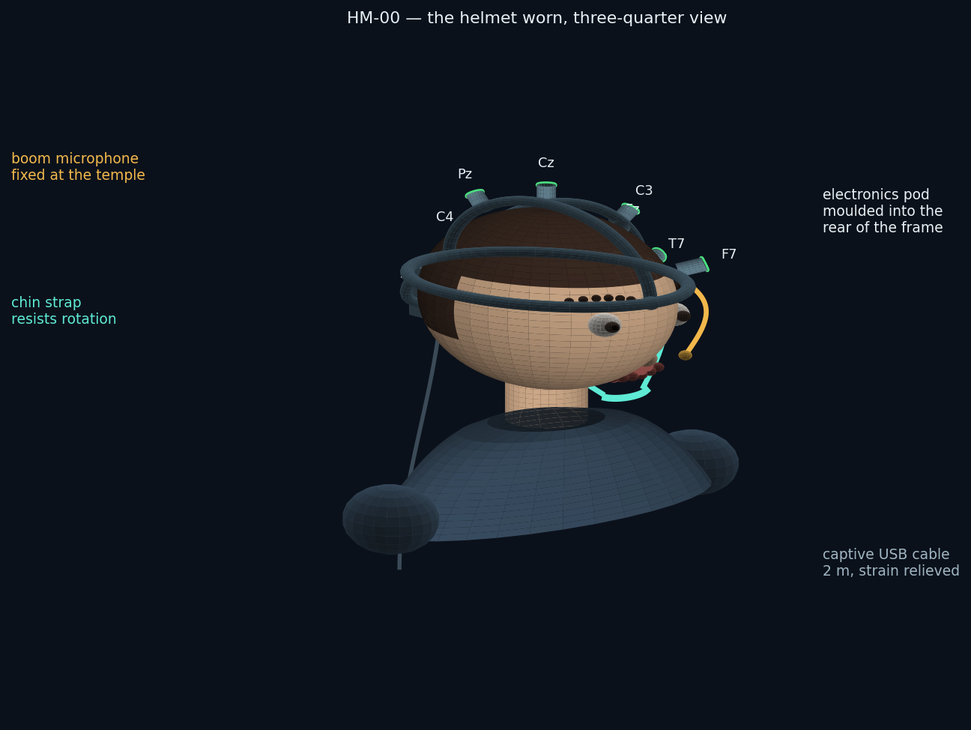
FIG-01 — the helmet worn. A single printed frame carries eight permanently mounted electrode assemblies, the electronics pod at the occiput, the boom microphone at the left temple and the chin strap. One captive cable leaves the helmet.
The design target is not a laboratory headset. It is an instrument that will be posted to twenty or more strangers in turn, fitted by each of them without help, worn for two hours in their own home, posted back, cleaned, and posted out again. Almost every decision below follows from that sentence rather than from anything about EEG.
Property | How it is achieved | What it prevents
Nothing to assemble | Frame, arches, rail stubs and pod shell print as one body; electrodes are permanently mounted | A participant assembling the instrument wrongly and nobody finding out until analysis
Nothing to place | Electrode positions are fixed by the frame geometry, with ±7 mm of built-in travel for head shape | Sites drifting by centimetres between participants, which would put the group difference inside the placement error
Nothing exposed | All conductors run inside the hollow sections | Snagged, pulled and broken leads in transit and in use
Nothing to interpret | Each site shows red, amber or green; the runner holds the session until all are green | A participant deciding for themselves whether a contact is good enough
Nothing to remove for gel | A port through the top of each assembly takes a blunt syringe | The remove-regel-replace cycle that makes self-fitted wet electrodes fail
Nothing to open | Battery behind a tool-free hatch; everything else sealed | Field disassembly, and the failures that follow it

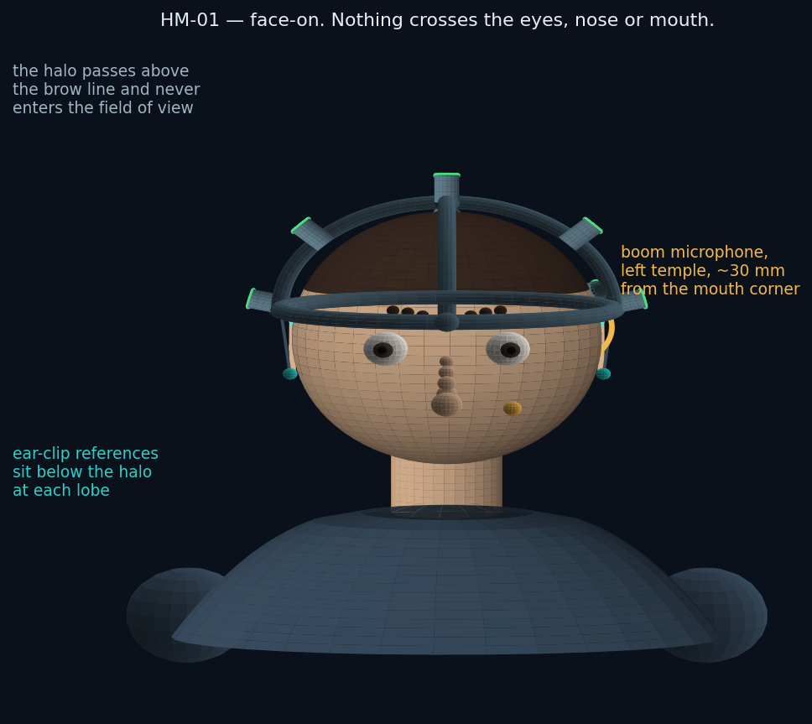
FIG-02 — face-on. The halo passes above the brow line; nothing crosses the eyes, the nose or the mouth, and the boom sits clear of the line of sight. A participant can read, watch the screen and speak normally.

2. Views
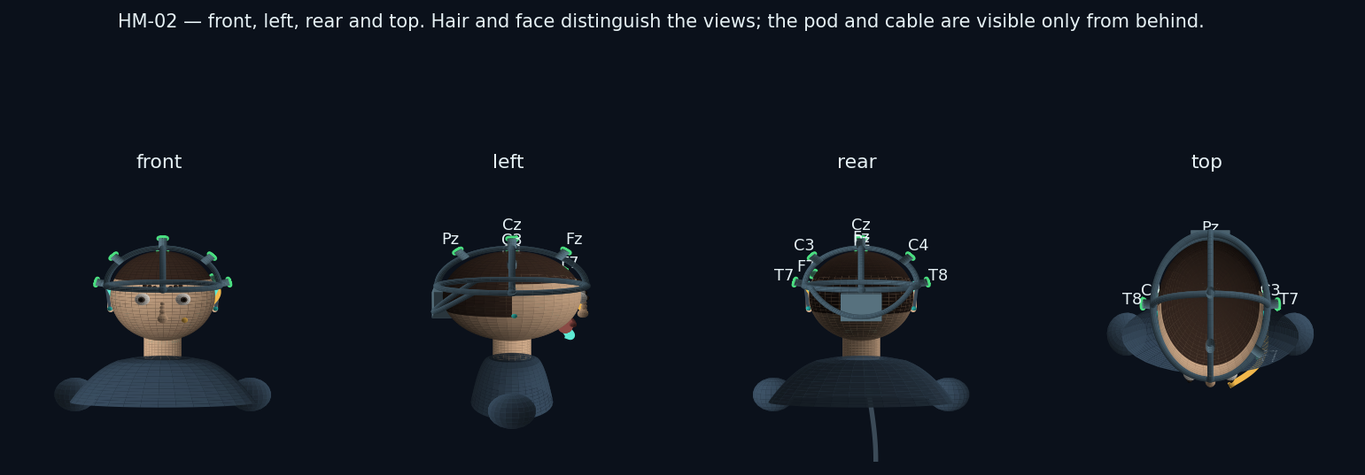
FIG-03 — front, left, rear and top. The pod and the cable are visible only from behind, which is deliberate: from the front the instrument reads as a headband rather than as medical equipment.
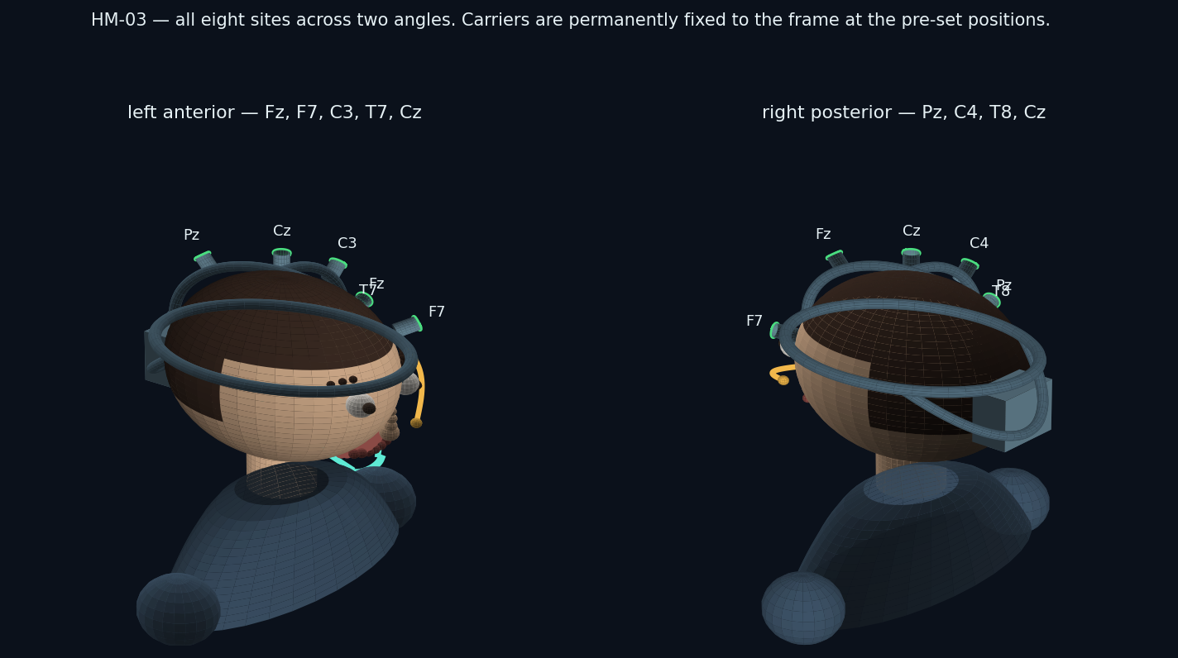
FIG-04 — all eight sites across two three-quarter views. Fz, Cz and Pz on the sagittal arch; C3 and C4 on the coronal arch; T7, T8 and F7 on stubs rising from the halo.
Site | Carried on | Why it is there
Cz | Crown junction of both arches | The primary electrode. The N100 that the whole study rests on is largest here, so it sits at the most mechanically stable point on the frame.
Fz, Pz | Sagittal arch, fore and aft of Cz | Front-to-back gradient of the auditory response; Fz also carries the frontal activity that separates the two outcome branches.
C3, C4 | Coronal arch | Left-right symmetry check, and the motor activity that appears before a willed silent reply.
T7, T8 | Halo stubs, above each ear | Closest scalp sites to the auditory cortex; the temporal-versus-frontal order of arrival is measured here.
F7 | Halo stub, left front | Speech-related frontal site. Expected to be contaminated during speaking blocks and treated as an artifact monitor rather than a signal channel.

3. Fixation: how the helmet is held on
Three mechanisms hold the instrument, and keeping them separate is what makes it work unsupervised.
- Weight is carried by the halo, on TPU pads at the brow and at the occiput. The pads are the only parts that touch the forehead, and they are consumable.
- Position is held by the occipital yoke, which closes onto the back of the skull under a ratchet dial. The skull is wider behind the ears than at the brow, so a yoke pulling down and forward cannot ride up. This is the same principle as a climbing helmet's cradle, and it is what takes up the 52–62 cm range on one frame.
- Rotation is resisted by the chin strap, which does nothing when the participant is still and everything when they look down, speak for twenty minutes, or press a button. Without it the whole electrode geometry migrates over a two-hour session and the reliability repeat at the end of the session disagrees with the start.
- Contact force is set by the spring in each assembly, and is deliberately independent of all three. Tightening the dial or the strap does not press the electrodes harder.
The instruction this makes possible
Every self-applied EEG system fails the same way: the wearer tightens whatever tightens until it hurts, which bows the frame and lifts the electrodes on the opposite side. Because contact force here comes from a spring rather than from tension, the runner can say the one thing that is both true and counter-intuitive: “If a light is red, adjust that site — do not tighten anything.”
The chin strap is removable, and the runner says so. For a population whose central complaint is being controlled by others, a strap under the chin is not a neutral object, and a participant who finds it distressing can run the session without it at the cost of a stability warning in the session report. That is a real trade — the report records whether the strap was fitted, and the analysis can test whether it mattered.

4. Why the electrodes are permanently mounted
Revision B had the participant snap eight carriers onto rails. Revision C fixes them to the frame at manufacture. The reasoning is that every placement a participant performs is a placement that can go wrong invisibly, and unlike a bad contact, a mis-placed electrode does not announce itself — impedance can be perfect two centimetres from where the protocol says the electrode is. Removing the step removes the failure.
 | Removable carriers (Rev B) | Fixed assemblies (Rev C)
Set-up actions by the participant | 8 placements, each with a position to find and a collar to lock | None. Gel, put it on, adjust only if a light is red
Placement error | Depends on the participant reading a rail engraving correctly, eight times | Bounded by the frame geometry and ±7 mm of travel
Parts that can be lost in the post | 10 (8 plus 2 spares) | 0
Cleaning | Carriers come off and can be immersed | Cups come off at refurbishment with a service tool; the frame is wiped, never immersed
Failure of one lead | Replace that carrier | Frame returns for service, or the conductor is replaced through the channel cover
Time to fit | Eight to twelve minutes for a first-timer | Two to three minutes

4.1 The assembly, and how it is cleaned
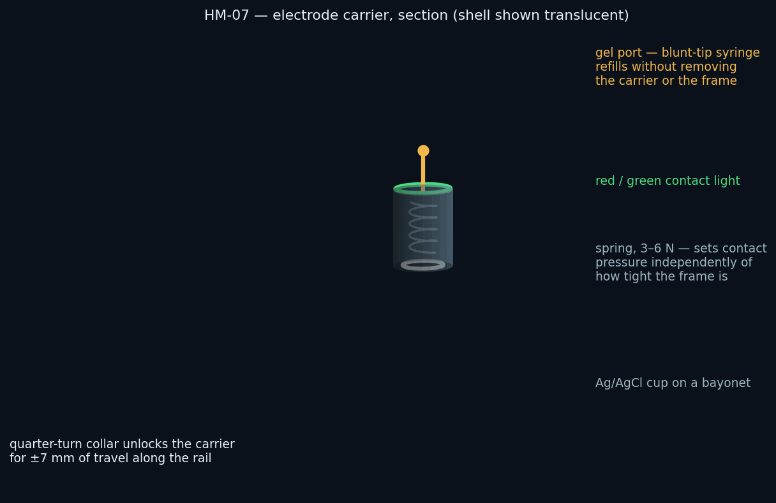
FIG-05 — section through one electrode assembly. The body is bonded into the frame; the cup, the spring and the light are inside it. The gel port runs through the top, coaxial with the cup.
Cleaning was the objection to fixing the electrodes, and it is answered by separating what a participant touches from what a technician touches. The participant touches nothing: gel goes in through the port, and the outside of the frame is wiped. At refurbishment the technician releases each cup with a service tool — a quarter-turn key that engages a slot no finger can reach — and the eight cups, the two ear clips and the boom go into an ultrasonic bath together, exactly as loose electrodes would. The frame, which contains the electronics, is never immersed; its outer surfaces are convex and closed, and its gel ports are flushed with warm water through the same syringe used to fill them.
Step | Who | How
Between sites, during a session | Participant | Add gel through the port. Nothing is removed.
End of session | Participant | Wipe the outside of the frame with the supplied wipe. Nothing is dismantled.
Refurbishment, per participant | Operator | Release the eight cups, two ear clips and boom with the service key; ultrasonic clean and disinfect per the electrode supplier's protocol; flush the gel ports; wipe the frame with 70 % IPA; replace the TPU pads and the chin liner; refit cups.
Every ~25 sessions | Operator | Replace the cups outright — sintered Ag/AgCl electrodes wear, and the RFQ costs them as a consumable rather than a permanent part.
On failure | Service | Open the channel cover strip on the skull-facing side and replace the conductor, or return the frame. Two spare frames per twenty-five kits are held for this.

The honest cost of this decision
Fixing the electrodes moves a failure from something a participant can fix in the field to something only the operator can fix. A single broken conductor takes a whole helmet out of circulation rather than a two-euro carrier. The fleet arithmetic absorbs that by holding two spare frames per twenty-five kits and by making the conductor replaceable through the channel cover, but it is a genuine transfer of risk from the participant to the operator — accepted because the participant is the one who cannot recover from their own mistakes, and the operator can.

5. Contact lights, and how a participant uses them
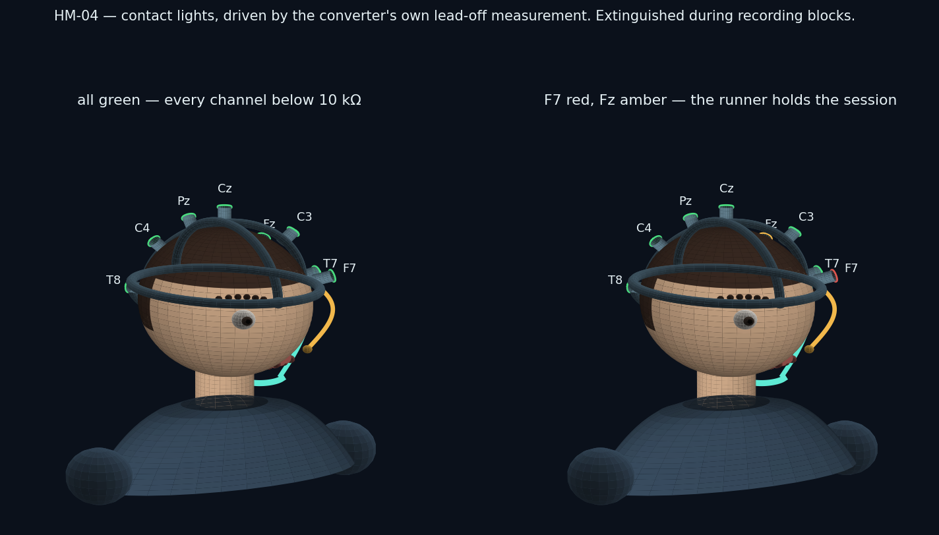
FIG-06 — the same helmet in two states. Left: all eight below 10 kΩ. Right: F7 above 20 kΩ and Fz marginal.
Light | Impedance | What it means | What the participant does
Green | below 10 kΩ | Ready | Nothing
Amber | 10–20 kΩ | Usable but marginal | Add gel through that site's port and wait a few seconds
Red | above 20 kΩ, or lead off | Not usable | Slide that assembly a few millimetres to part the hair, then add gel
Slow pulse | measurement running | The check is in progress | Wait, keep still
Off | during recording | Deliberately dark | Nothing — the lights are extinguished so nothing on the head can be watched or reacted to while data is being taken

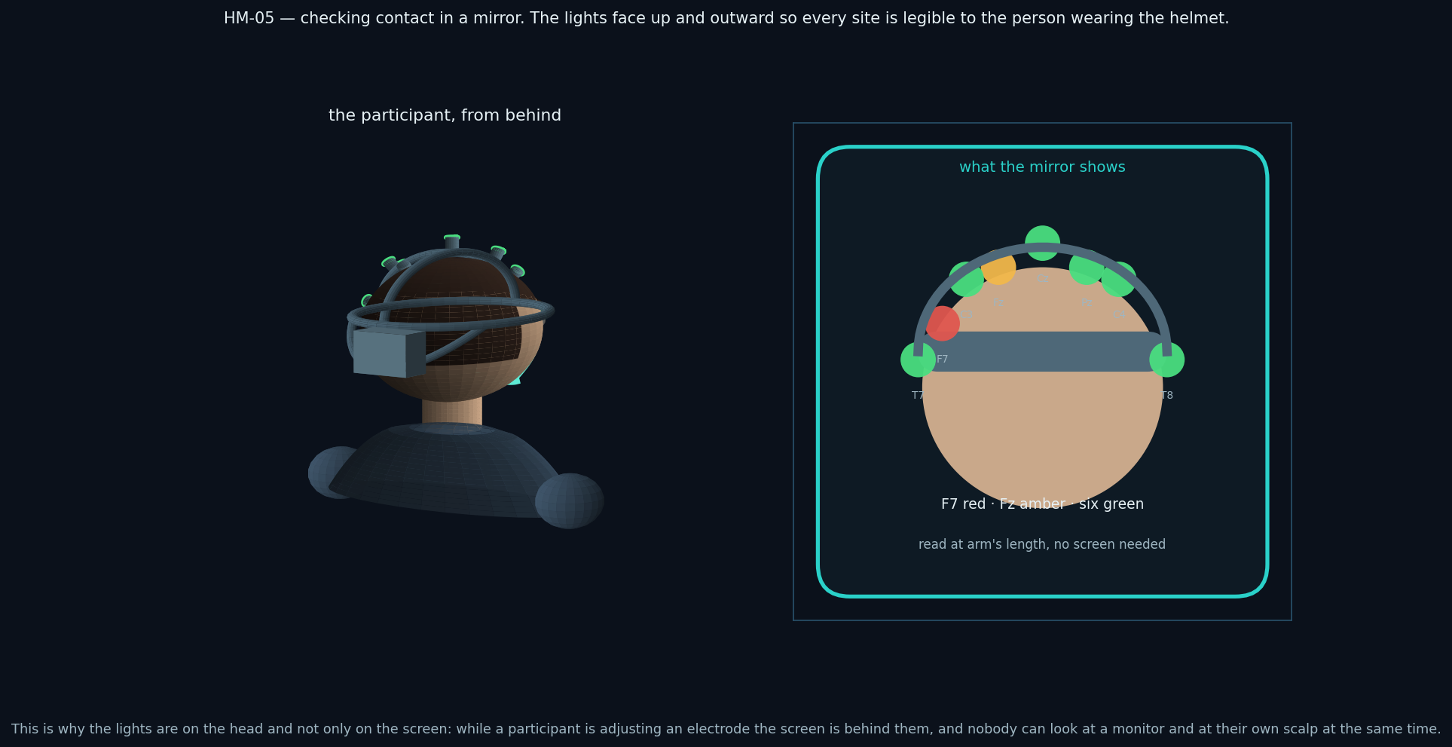
FIG-07 — the same information read in a mirror. The lights sit on top of each assembly and face up and outward for exactly this reason.
The lights exist because of a geometry problem rather than a preference. While a participant is adjusting an electrode their hands are on their head and the screen is behind them; nobody can look at a monitor and at their own scalp at once. A mirror plus lights closes that loop without a second person in the room. The lights are driven from the converter's own lead-off measurement — the same numbers the screen shows — so the head and the screen cannot disagree.
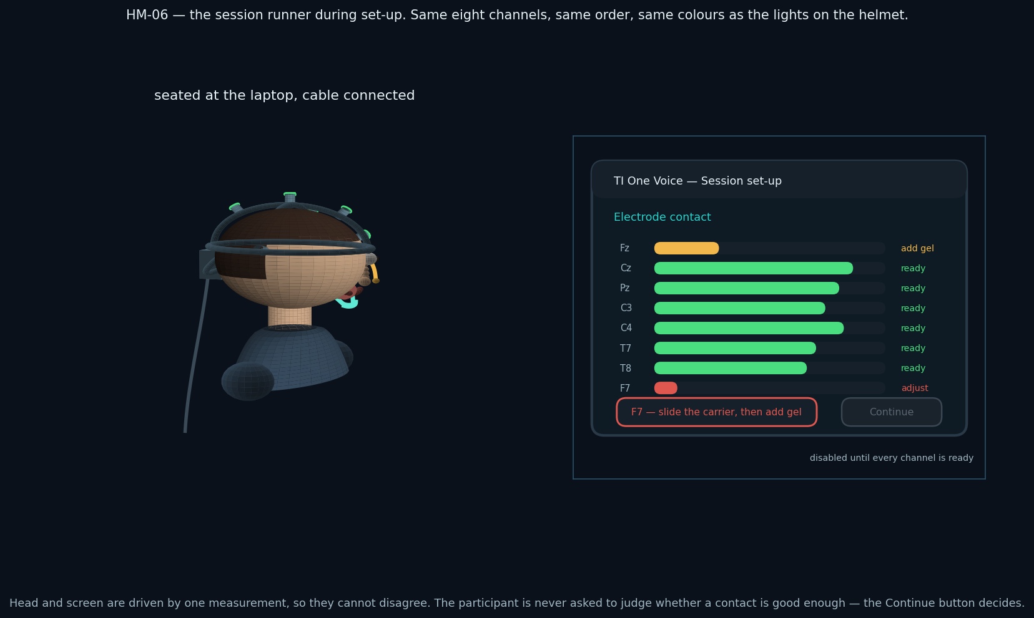
FIG-08 — the session runner during set-up, and the participant at the laptop. The Continue control stays disabled until every channel is ready; the participant is not asked to judge sufficiency.
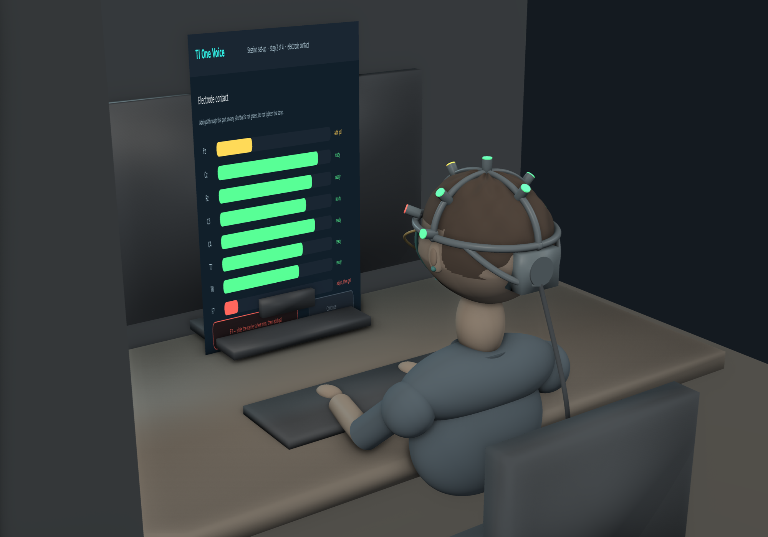
FIG-09 — the same moment rendered in three dimensions, viewed from behind and to the left: a participant seated at their own desk, mid-set-up, reading the contact screen. Fz is amber and F7 is red on the screen, and the same two sites are amber and red on the helmet — one measurement, two displays. Note what is visible from behind and what is not: the pod, the cable and the yoke are all rear-facing, so from the front the instrument reads as a headband. The figure is a modelled human form rather than a photograph, and the render shows design geometry: nothing in this document has been manufactured.

6. Wiring
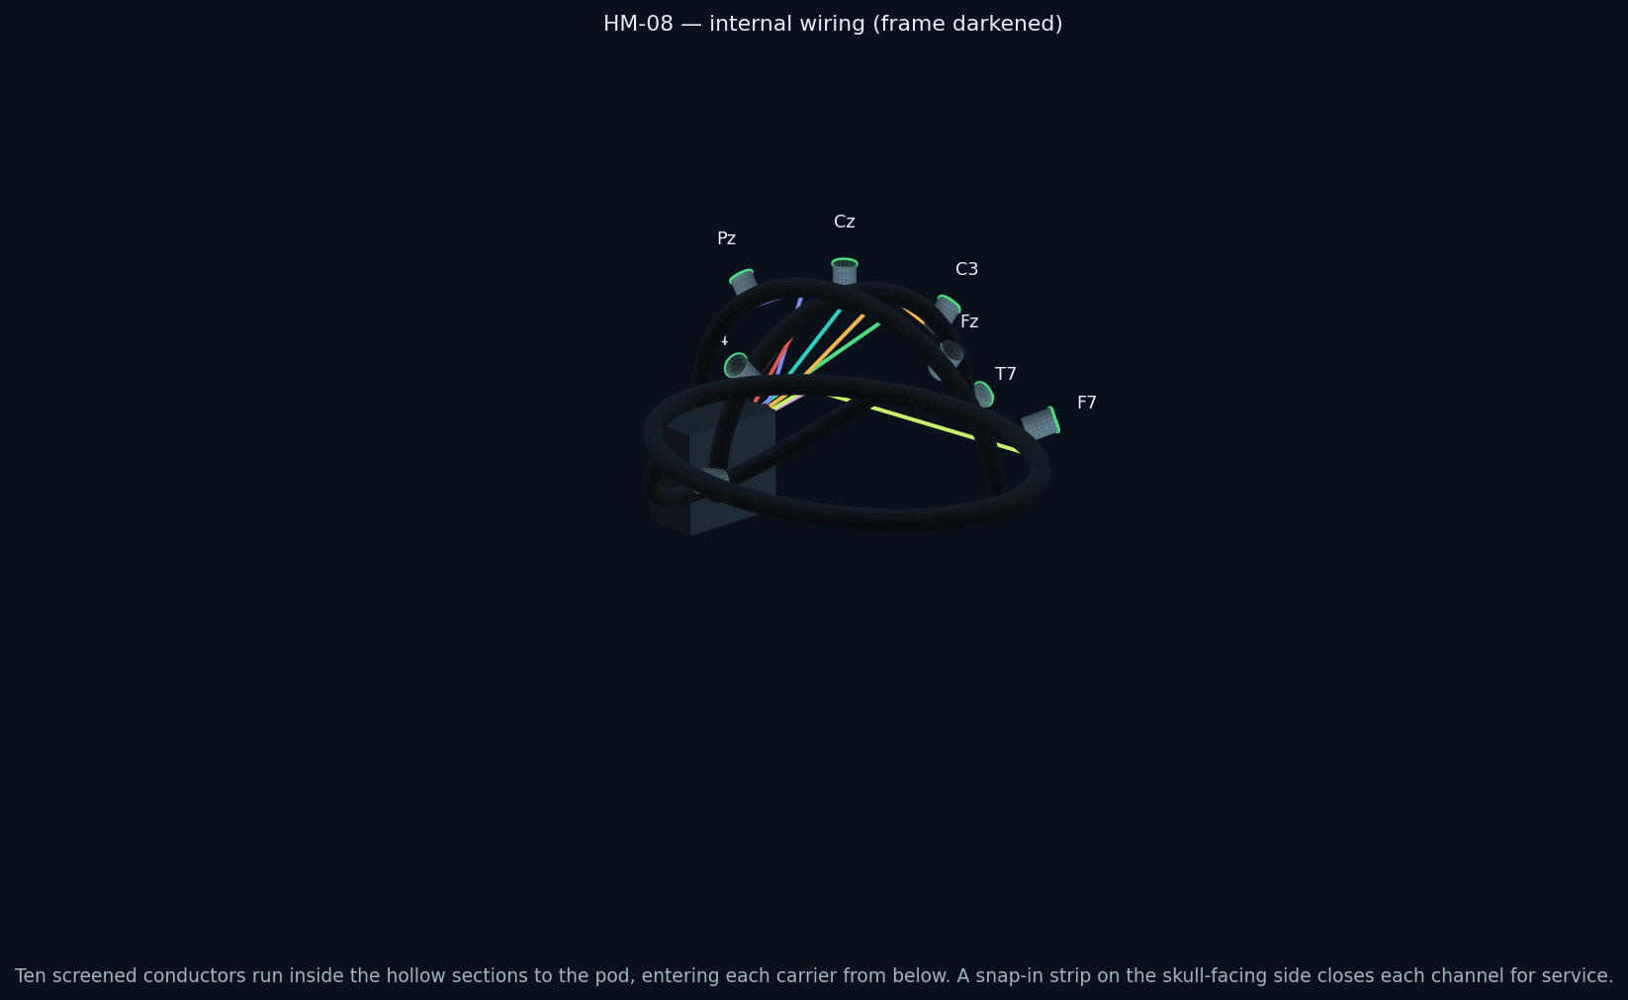
FIG-10 — routing inside the frame, drawn with the structure darkened. Each conductor enters its assembly from below, runs along its arch to the crown, then rearward to the pod.
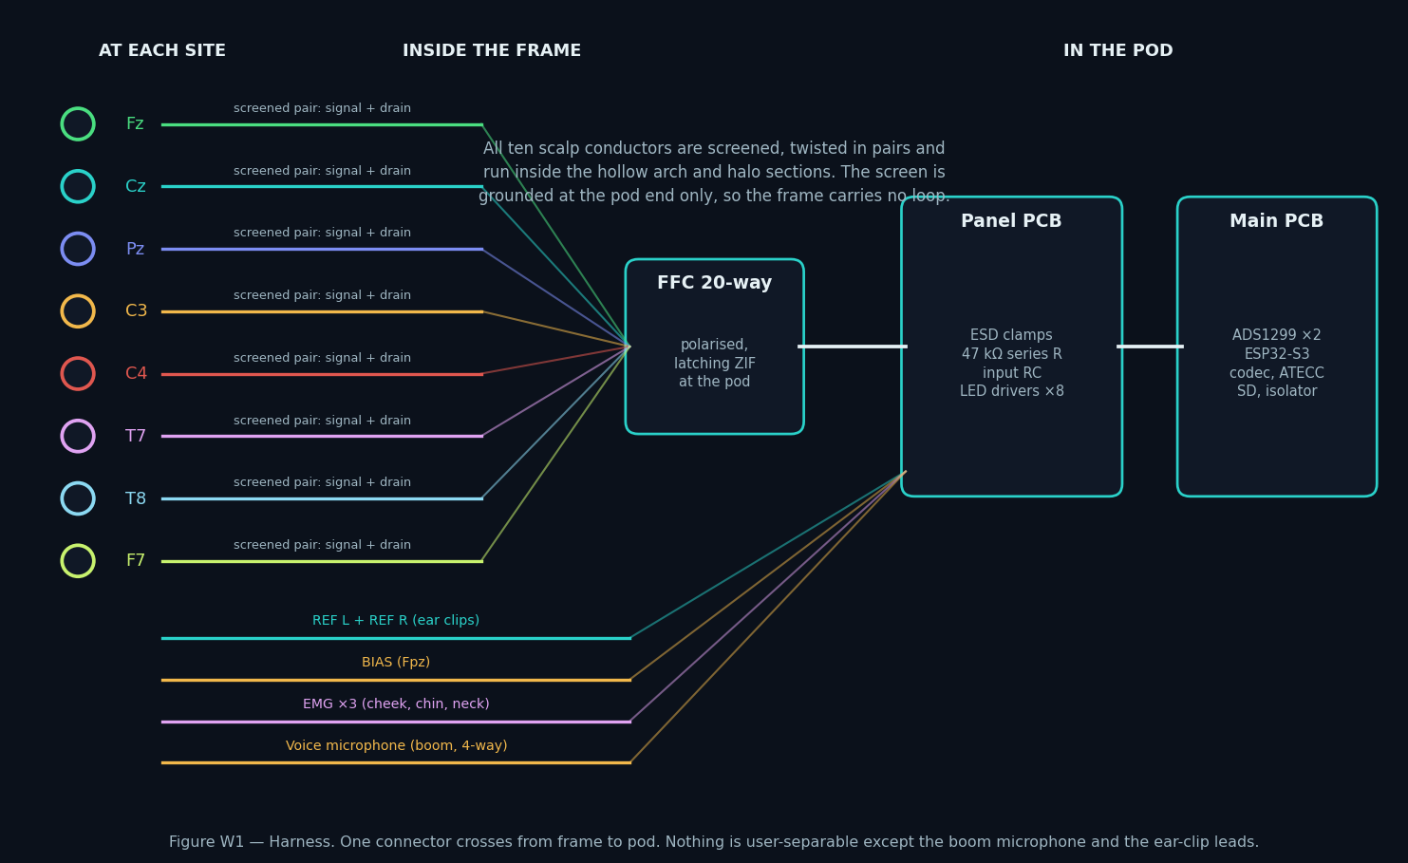
FIG-11 — the harness as a schedule. Superseded in Rev E: the harness is two cables. Eight scalp sites, two references and the bias lead converge on a 12-way screened bundle; the eight contact lights leave on a separate 10-way ribbon. WH-EEG-008 is the controlled wire list.
Run | Conductors | Route | Notes
Eight scalp sites | 8 × screened | Assembly base → channel in the arch or halo → crown → rearward → pod, on the 12-way screened bundle to J14 | One conductor per site plus one overall screen. The screen is grounded at the pod end only, at R91, so the frame carries no loop.
Reference | 2 × screened | Ear clip → temple → halo channel → pod, on the same 12-way bundle | Linked earlobes into SRB1, shared by all sixteen channels
Bias | 1 × screened | Fpz pad → halo front channel → pod, on the same 12-way bundle | Driven common-mode return, not an earth. Leaves the carrier through R11.
EMG | 3 × screened | External: face pads plug into a three-way socket under the pod | Kept external because the pads go on the face, which no frame geometry can fix
Voice microphone | 4-way | Boom → left temple channel → pod | Boom detaches at the temple for cleaning and replacement
Room microphone | internal | On the pod PCB | Hardware-muted outside scripted windows
Host link | captive USB-C, 2 m | Gland under the pod | The only cable leaving the helmet
Contact lights | 10-way ribbon | Eight assemblies → crown → rearward → pod, on a separate 10-way ribbon to J30 | NEW IN REV E (ECO-EEG-014). Eight drive lines, the LED_V phase common and its return. Kept out of the electrode bundle so no digital conductor shares a cable with an electrode lead.

The channels are closed by snap-in cover strips on the skull-facing side of every section. That location is chosen so the strips are invisible in use, cannot be picked at absent-mindedly, and are reachable with a plastic pick on the bench. Conductors are routed with a service loop at the pod end, so a replacement can be drawn through without dismantling the assembly at the far end.

7. The electronics pod
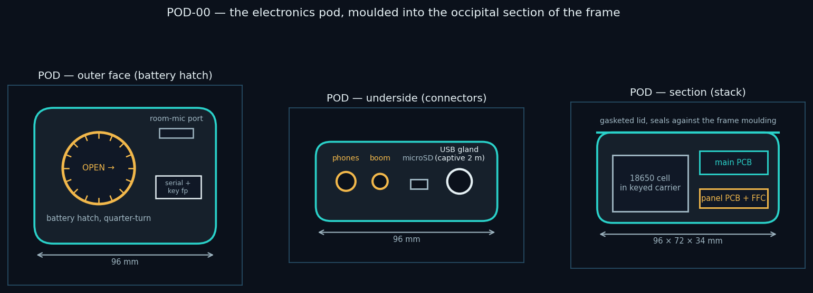
FIG-12 — the pod as drawn for a consolidated board (96 × 72 × 34 mm). SUPERSEDED: Phase 1 uses POD-P1, now a released parametric model with the panel openings of RFQ M-02, and Phases 2–3 use the 116 × 46 × 88 mm occipital shell on HM-01. Note that the data and charge USB-C connectors are separate (ECO-EEG-003).
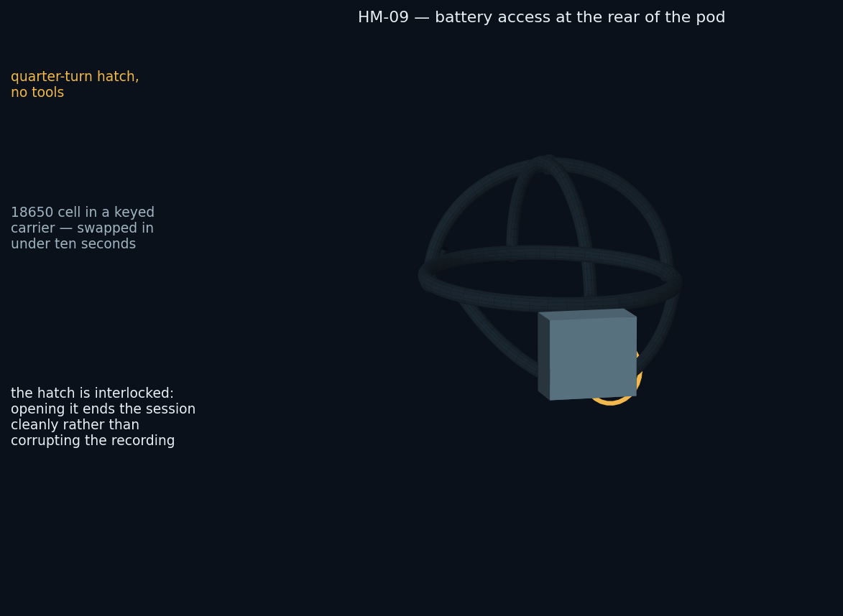
FIG-13 — battery access. A quarter-turn hatch, no fasteners, and a keyed cell carrier that cannot be inserted the wrong way round.
Siting the electronics at the occiput does three things simultaneously: it counterbalances the arches so the helmet does not want to tip forward over two hours; it puts every connector behind the head where no lead crosses the field of view; and it is the shortest route for conductors that are already travelling rearward. The hatch is interlocked — opening it ends the session cleanly and writes a marker rather than truncating the recording mid-block.
Item | Specification
Battery | Protected 18650, ≥ 3000 mAh, ≥ 4 h at 1000 Hz. A charged spare travels in the case, so a flat cell never ends a session.
Access | Quarter-turn hatch, tool-free, keyed carrier, swap under ten seconds, interlocked to the session state
Charging | Inhibited in hardware while a session is active (S-01); charge overnight with the helmet in its case
Connectors (underside) | 3.5 mm headphones · boom microphone · EMG three-way · microSD · captive USB-C gland
Sealing | Gasketed lid against the frame moulding; every opening on the underside, shielded from gel and from knocks
Marking | Serial, hardware revision, device key fingerprint, and “research instrument — not a medical device”

8. Microphones, reference path and cable
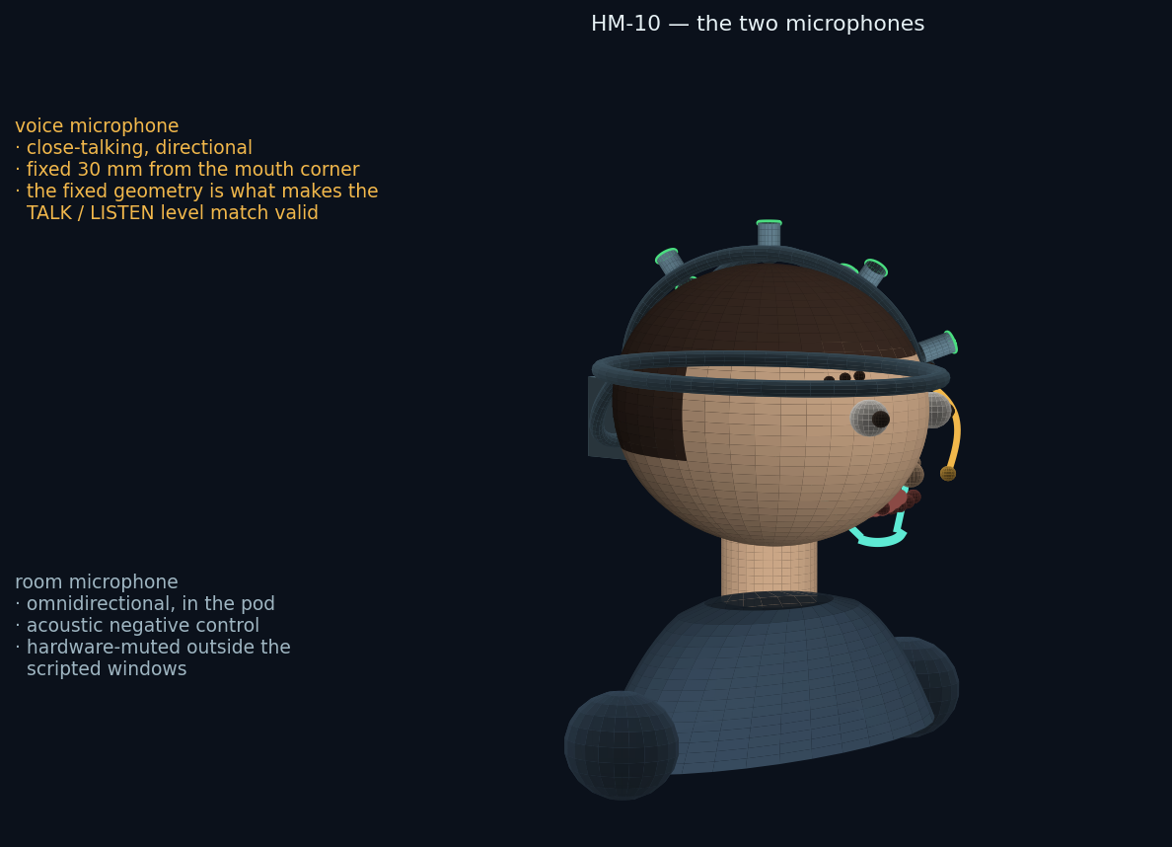
FIG-14 — the two microphones. They cannot be the same capsule: one must hear only the wearer at a fixed distance, the other only the room.
The boom's fixed geometry is a measurement requirement. Test One compares the brain's response to the participant's live voice against a played-back recording of that same voice; if the mouth-to-microphone distance differs between the two, the levels differ and what is measured is loudness rather than authorship. Fixing the boom to the frame holds that geometry across sessions and across people, which a clip-on or a phone microphone cannot.
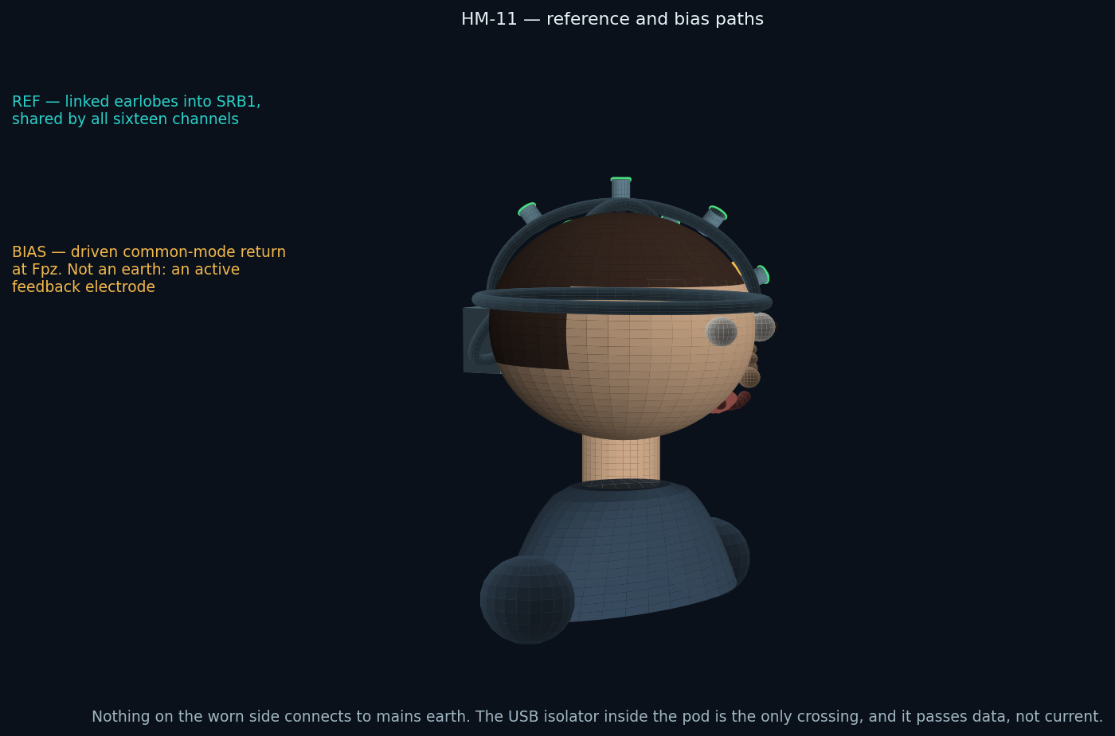
FIG-15 — reference and bias. Neither is an earth connection.
This figure exists because “where is the ground?” is the first question anyone asks about an amplifier strapped to a head, and the answer is that there is not one in the mains sense. The worn side is a floating, battery-powered island. The reference is the linked earlobes; the bias electrode at Fpz is an actively driven common-mode return, not a safety earth. The only crossing to mains-referenced equipment is the USB isolator inside the pod, and it passes data rather than current.
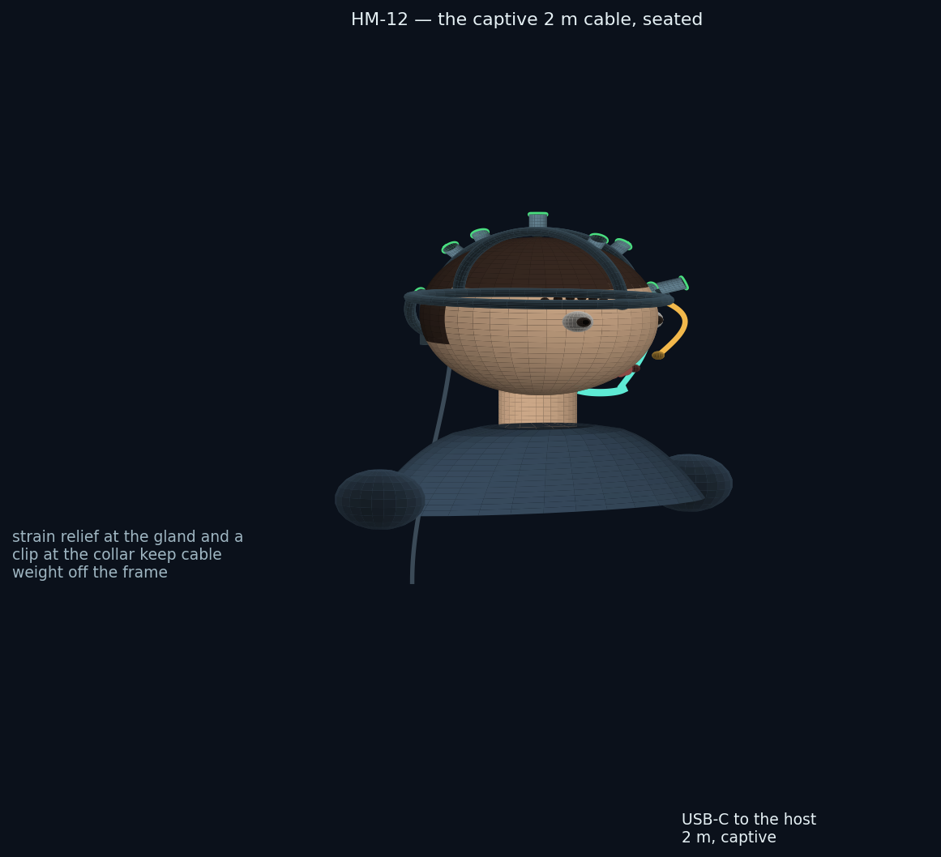
FIG-16 — the captive two-metre cable. Long enough to reach a laptop on a desk from a chair, short enough not to trail across the floor.

9. Fitting the helmet
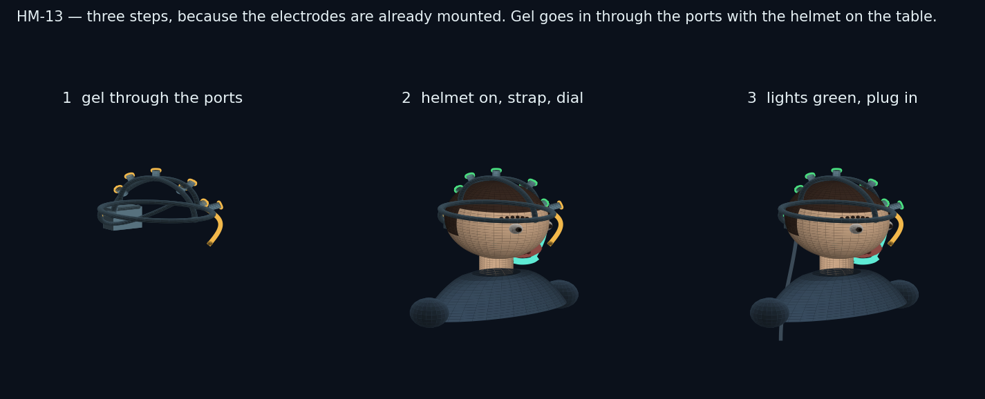
FIG-17 — three steps, down from eight in Revision B, because the electrodes are already mounted.
- With the helmet on the table, put gel into each of the eight ports and onto the two ear clips. The lights show amber while the cups are dry.
- Put the helmet on front-to-back, brow pad first, let the rear yoke settle, fasten the chin strap if you are using it, then turn the dial two clicks past first resistance.
- Clip the ear references on, swing the boom to about three centimetres from the corner of your mouth, and plug in the cable. Watch the lights: amber means add gel through that port, red means slide that site a few millimetres first. Do not tighten anything.
Total time for a first-time participant is expected to be two to three minutes, against eight to twelve in the previous arrangement, and the number of ways to get it wrong is now small enough to enumerate on a card in the lid of the case.

10. Frame, parts and printing
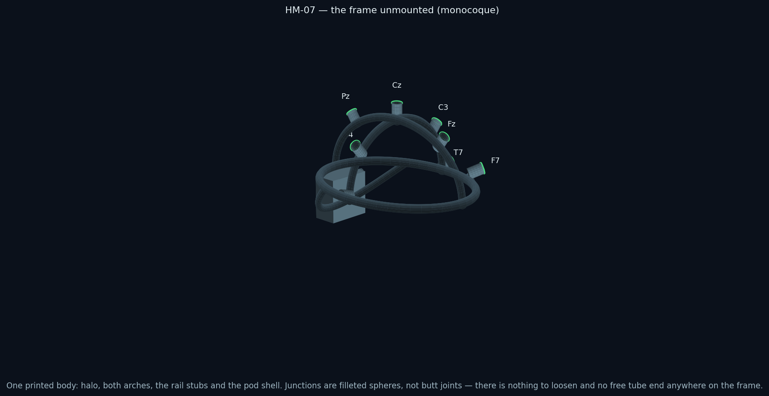
FIG-18 — the frame unmounted. Halo, both arches, the three rail stubs and the pod shell are one body; every junction is a filleted node and no section terminates in free air.
ID | Part | Qty/kit | Material | Notes
HM-01 | Frame monocoque: halo, sagittal arch, coronal arch, rail stubs, pod shell, internal channels | 1 | PA12, MJF | One print, about 240 g. mech/stl/HM-01_frame_monocoque.stl. A STEP model follows the Stage 0 fit measurement (section 12 objection 3).
HM-02 | TPU pads: brow, occiput ×2, crown | 4 + 4 spare | TPU 85A | Consumable, replaced each turnaround. mech/step/HM-02_brow_pad.step — the other three follow the same form.
HM-03 | Occipital yoke and ratchet dial | 1 | PA12 + POM pawl | 2 mm per click, 52–62 cm. Bought-in ratchet; the yoke model is a Phase 1 deliverable (PARTS-EEG-019).
HM-04 | Electrode assembly: body, spring, cup seat, bicolour light, gel port | 8 + 2 spare | PA12 + steel spring + bicolour LED | Bonded into the frame at manufacture. mech/step/HM-04_electrode_assembly_body.step, drawing MECH-EEG-020.
HM-05 | Ag/AgCl cups on service bayonet | 8 + 2 spare | Sintered Ag/AgCl | Bought in. Released only with the HM-09 service key. Replaced outright every ~25 sessions (SVC-EEG-013).
HM-06 | Chin strap and chin cup with liner | 1 | PA12 + webbing | Removable, and the runner says so before it is first mentioned. Liner consumable.
HM-07 | Boom microphone arm | 1 | PA12 + gooseneck | Detaches at the temple. THIS IS HM-07 — the battery hatch is HM-08. See PARTS-EEG-019 and ECO-EEG-015.
HM-08 | Battery hatch, quarter-turn, and keyed cell carrier | 1 each | PA12 | RENAMED IN REV E from HM-07. Tool-free, interlocked. mech/step/HM-08_battery_hatch.step.
HM-09 | Service key for cup release | 1 per operator, not in the kit | PA12 | Deliberately absent from the participant's kit. Controlled item: SVC-EEG-013 section 3. mech/step/HM-09_service_key.step.
CASE-00 | Foam insert, two layers | 1 | Closed-cell PE, 25 mm | BOTH layers now supplied as DXF at 1:1. Cut-outs labelled per RFQ M-06.
MP-01 | Module mounting plate — NEW IN PACKAGE v2 | 1 | PA12, MJF | Carries every purchased module above the carrier; the modules connect by keyed 2.54 mm ribbon jumpers. ICD-EEG-006.
FIT-01 | Fit-test coupon — NEW IN PACKAGE v2 | 1 per batch | PA12, same build as the batch | Three bores at 9.20, 9.35 and 9.15 mm. Checked before the batch is accepted (QP-EEG-010).

Property | Specification
Process | MJF or SLS in PA12. MJF preferred: it clears powder from the internal wiring channels reliably and needs no support structures inside them. FDM cannot produce the enclosed channels and is acceptable only for Phase 1 form studies.
Sections | Halo 12 × 6 mm hollow with a 4 × 3 mm channel; arches 9 × 5 mm hollow with a 3 × 2.5 mm channel; junction nodes filleted at R4; pod walls 2.4 mm
Tolerances | Bayonet, collar and hatch fits at +0.15/−0.05 mm; fit-test coupons ship with the print file set
Finish | Bead-blasted, dyed graphite, teal accents; no paint on skin-contact surfaces
Skin contact | PA12 and TPU grades with ISO 10993-5/-10 declarations (S-05)
Marking | Site names and part IDs engraved in the model, not labelled, so they survive repeated disinfection

11. Travel case
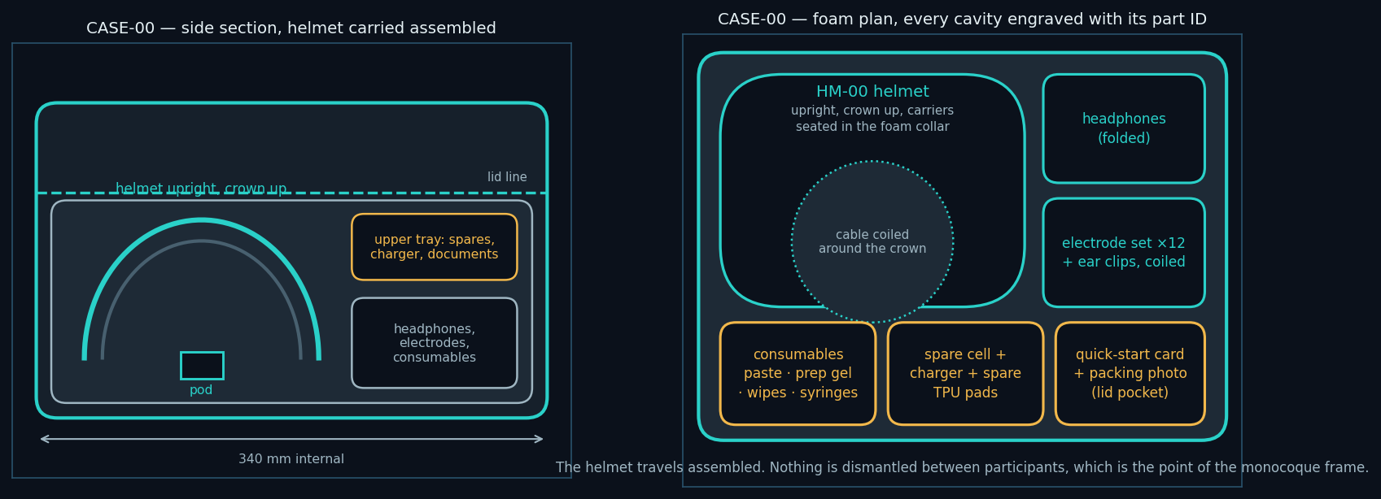
FIG-19 — side section and foam plan. The helmet travels assembled and upright, supported at the halo so nothing bears on the electrode cups.
Sizing the case around an assembled helmet costs money — a bigger case, and postage is already the largest line in the fleet budget. It is the right cost, because the alternative is a participant assembling an instrument at home, which is the failure this whole revision is designed to remove. The foam supports the frame at the halo only; the cups, the boom and the pod sit in clearance pockets and touch nothing.

12. Adversarial review of this design
What follows is an attempt to attack the design in this document as a hostile reviewer would. Each item is a real weakness; where there is a mitigation it is stated, and where there is not, that is stated too. Nothing here has been tested, because nothing has been built.
# | Objection | Response
1 | A single broken conductor takes a whole helmet out of the fleet, where a removable carrier could have been swapped in the field. | Accepted. Mitigated by service loops, channel covers that allow a conductor to be drawn through on the bench, and two spare frames per twenty-five kits. It remains a transfer of risk from participant to operator, made deliberately. STATUS IN PACKAGE v2: unchanged and accepted.
2 | A monocoque frame cannot be resized. The 52–62 cm claim rests entirely on the yoke, and heads outside it are excluded. | Partly accepted. Exclusion by head circumference is an eligibility criterion that biases the cohort, and it must be declared in the pre-registration and reported. If Stage 0 finds the range too narrow, a second shell size is the fix, at the cost of a second print and a second stock line. STATUS IN PACKAGE v2: unchanged. Stage 0 must measure it.
3 | Fixed electrode positions assume that scalp geometry scales proportionally across head shapes. It does not, exactly. ±7 mm may be insufficient at T7/T8 for a long, narrow skull. | Not resolved. This is the single most important thing Stage 0 must measure: fit the frame on eight heads spanning the range, mark the actual electrode positions against measured 10–20 sites, and report the error. If it exceeds about 10 mm at any site, the carrier travel or the frame geometry has to change before any fleet is built. STATUS IN PACKAGE v2: unchanged and still the most important open question. RFQ Rev D section 9.2 now names the measurement.
4 | Coarse, thick or braided hair defeats a spring-loaded cup that the wearer cannot see. The gel port helps but does not part hair. | Accepted, and it is a fairness problem rather than only a technical one: if the instrument works less well on some hair types, the cohort skews. Stage 0 must recruit across hair types explicitly, and the result must be reported by hair type rather than pooled. STATUS IN PACKAGE v2: unchanged. RFQ Rev D section 9.2 now requires recruitment across hair types and reporting by hair type rather than pooled.
5 | Lights on the head will be photographed. A red light on someone's scalp will circulate as evidence that “the device detected something”. | Real and largely unavoidable. Mitigations: the lights extinguish during recording, so no photograph taken during a session shows a lit device; the quick-start card and the runner both name them “contact lights”; and every light state means impedance and nothing else. The interface rule against showing findings on the head is otherwise unchanged. STATUS IN PACKAGE v2: unchanged. The lights are dark at power-on as well as during recording, which is one more circumstance in which no photograph can show a lit device.
6 | The counterweight claim is asserted, not measured. Mass at the occiput sits at the point of greatest moment about the neck. | Not resolved. Total worn mass and the position of the centre of gravity must be measured on the first prototype and reported. If the helmet is front-heavy or rear-heavy the fix is pad geometry, not more mass. STATUS IN PACKAGE v2: unchanged. RFQ Rev D section 9.2 now requires the mass and centre-of-gravity measurement on the first prototype.
7 | A strap under the chin, on this population, is not a neutral object. | Accepted, and addressed in section 3: the strap is removable, the runner says so before it is first mentioned, and the session report records whether it was fitted so that the analysis can test whether it mattered. STATUS IN PACKAGE v2: unchanged and addressed in section 3.
8 | If a cup bayonet seizes after twenty disinfection cycles, refurbishment breaks and the fleet stops. | Not resolved. Twenty-five release-and-refit cycles with disinfectant exposure belong in the Phase 1 test plan, and the RFQ's acceptance section should be amended to include them. STATUS IN PACKAGE v2: RFQ Rev D section 9.2 now requires twenty-five release-and-refit cycles with disinfectant exposure, and the FIT-01 coupon checks the fit on every batch.
9 | A damaged captive cable disables the whole helmet. | Partly mitigated: the gland is specified as a replaceable module rather than a moulded-in cable, so a service centre can fit a new cable. A participant still cannot. STATUS IN PACKAGE v2: unchanged. The gland is a replaceable module.
10 | These are rendered illustrations, not CAD. Dimensions are indicative and no clearance has been checked. | Accepted without qualification. This document specifies intent and interfaces; the STEP files that follow are what a manufacturer can quote against, and any dimension here is provisional until then. STATUS IN PACKAGE v2: partly answered. The carrier, POD-P1, MP-01, HM-04, HM-08, HM-09, the pads and the coupon are now released as parametric STEP models with dimensioned drawings. HM-01 is still a rendered form study.
11 | Permanently mounted electrodes make the instrument harder to repurpose — a different montage needs a different frame. | Accepted, and it is a cost worth naming: this design trades flexibility for reliability. It is the right trade for a fixed pre-registered protocol and the wrong one for a general-purpose research amplifier. Anyone wanting the latter should buy a commercial cap. STATUS IN PACKAGE v2: unchanged and accepted.
12 | Nothing in this document has been reviewed by a qualified electrical safety engineer. | True. RFQ section 8 makes that review a gate on Phase 2, and no unit goes on a head before it. The schematics in section 13 are the input to that review, not evidence of having passed it. STATUS IN PACKAGE v2: UNCHANGED AND STILL BLOCKING. RISK-EEG-011 is the pack the reviewer receives. No unit goes on a head before written sign-off.

The three things Stage 0 must answer before any fleet is ordered
Does the fixed geometry put the electrodes where the protocol says they are, across a real range of head shapes? (Objection 3.)
Does it work on the range of hair types the cohort will actually contain? (Objection 4.)
Does the timing chain hold — the measurement the whole study rests on — on a hand-built unit in a domestic room? (RFQ F-21.)
The first two are new to this revision and neither is expensive to answer. Both are cheaper to answer now than to discover in the fleet.

13. Electronics — schematics

13.1 System interconnect
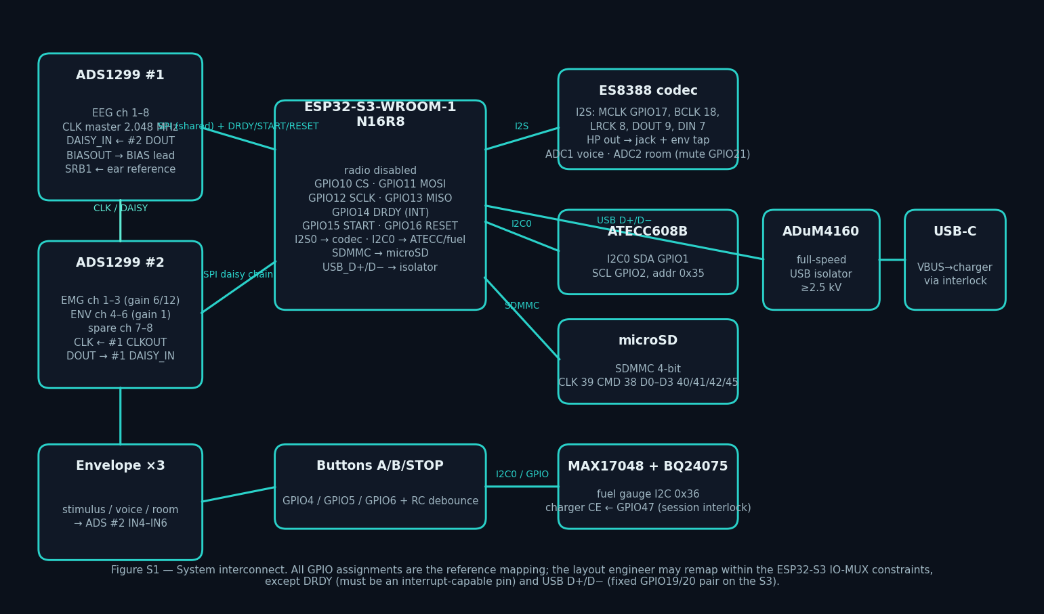
FIG-20 — devices, buses and reference pin assignments. Two ADS1299s share one SPI bus and one sample clock in daisy-chain mode, so all sixteen channels arrive as one frame per data-ready interrupt.

13.2 Power tree
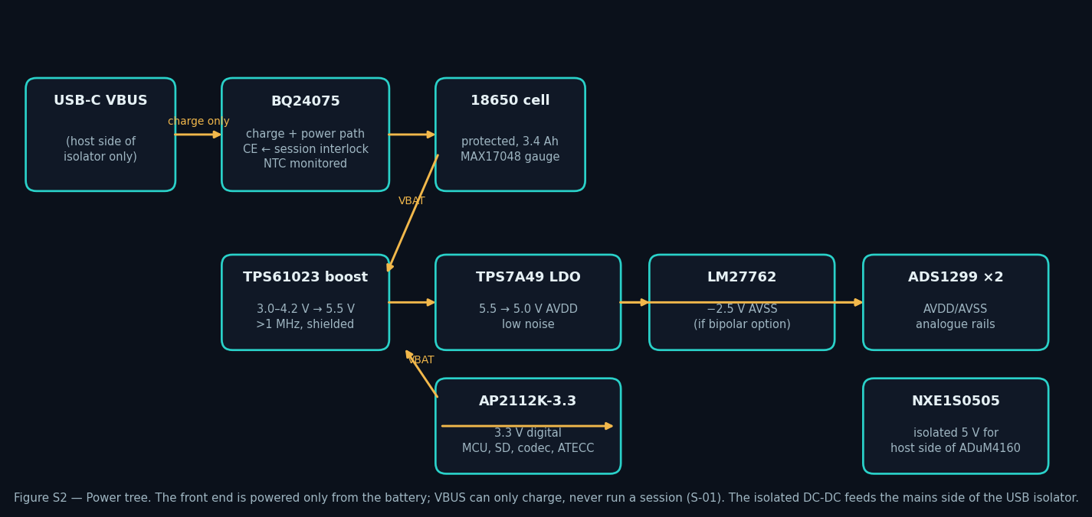
FIG-21 — the battery is the only source during recording; the charger's enable pin is held off by the session interlock; the isolated converter feeds only the mains side of the USB isolator.

13.3 Envelope detector (×3)
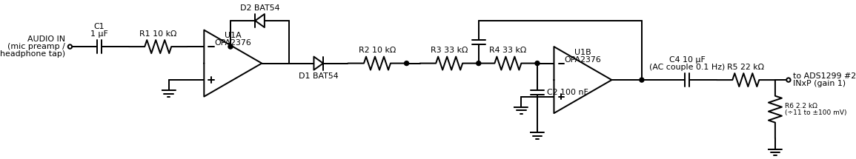
FIG-22 — envelope detector. Superseded in Rev E by SCH-EEG-005 sheet 3: a precision full-wave rectifier, a second-order Butterworth low-pass at f0 = 48.8 Hz with Q = 0.74, and a buffered ×0.0909 output, on one OPA4376 quad per channel. The Rev A dual op-amp left the filter out of circuit (ECO-EEG-004) and its equal-R equal-C network would have put the corner at 31 Hz (ECO-EEG-006).

13.4 Electrode input protection (×16)
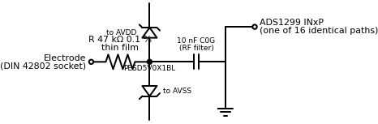
FIG-23 — one of sixteen identical input protection paths. In package v2 these are on the carrier EEG-CAR-01 itself as R1–R16, D1–D16 and C1–C16, not on a separate panel board. Clamp leakage must stay below 1 nA or the lead-off reading — and therefore the contact light on the head — is wrong. The current budget is in RISK-EEG-011 section 4.

13.5 Converter cascade
Signal | ADS1299 #1 (EEG) | ADS1299 #2 (EMG / envelopes) | Note
CLK | internal oscillator, CLKOUT enabled | CLK in ← #1 CLKOUT | One 2.048 MHz clock; simultaneous sampling on all sixteen channels
SPI | CS, SCLK, MOSI shared | shared | Daisy-chain mode, one chip-select
Data | DOUT → MCU MISO | DOUT → #1 DAISY_IN | #2 shifts through #1: one frame per DRDY
DRDY | → MCU interrupt | not connected | The sample counter increments only here
SRB1 | ← linked ear clips | ← same net | One reference for all channels
BIAS | BIASOUT → Fpz via 47 kΩ | BIASINV in #1's loop | Closed-loop drive from the channel average
Gain | ×24 | ×6 or ×12 EMG; ×1 envelopes | Set at session start, logged in metadata

Layout rules that are requirements, not preferences
Analogue and digital grounds partitioned, joined at one point under the converters; guard ring around all input nets; no digital trace beneath the front end.
8 mm creepage across the isolation barrier; the only copper crossing it is the USB isolator.
Boost converter and inductor on the digital side, at least 15 mm from any input net.
Every input RC identical in value and in layout, or the eight contact lights disagree with each other for reasons that have nothing to do with anyone's scalp.
The 3D-print file set that follows this document will contain one file per part ID in section 10 — STEP for manufacturing, STL or 3MF for printing — with the fit-test coupons and the case foam DXF. Three parts are bought in rather than printed: the assembly springs, the microphone gooseneck and the ratchet pawl.

