
Functional Design
Dream Job · AI-assisted job discovery and application platform
VERSION | 1.0
DATE | 8 September 2026
AUTHOR | Stephane van der Aa
STATUS | Describes the implemented system

Document control
Document | Functional Design (FDD)
Version | 1.0
Date | 8 September 2026
Author | Stephane van der Aa
Status | Describes the implemented system
Specifies | Dream Job SRS v0.3 (Dream_Job_Requirements.docx)
Companion | Technical Architecture · DPIA
Generated from | docs/Functional_Design.md by docs/build_fdd.py

Contents
Table of contents — not yet built.
Click in the line above and press F9, or right-click and choose “Update field” → “Update entire table”, to populate it.

1. Purpose and reading guide
The SRS says what Dream Job must do. This document says how the product behaves — the screens, the states, the decisions the system makes on its own, and the decisions it deliberately leaves to the job seeker. It is the reference for acceptance testing and for anyone who has to explain the product to a user.
Requirement identifiers from the SRS are cited inline (FR-xxx, NFR-xxx, CR-xxx). Section 12 maps every requirement to the module that implements it.
Where the implementation makes a judgement the SRS left open, it is called out in a box like this:

Decision. What was chosen, and why.

2. The product in one page
Most job search tools react to what has been published. Dream Job starts from who the job seeker is and what they actually want, maps the relevant slice of the market — including companies that have not advertised — judges each company's capacity and likelihood to hire, and then removes the friction of applying.
The system is opinionated about scope: it collects what the directives justify rather than downloading the world.
Three properties shape every screen:
1. Nothing is invented. Every statement in a generated CV or email traces to a fact in the profile. A factual-consistency check runs before anything can be approved (FR-322, CR-405).
2. Nothing is sent automatically. Scoring is advisory; the job seeker takes every decision to apply (NFR-305). There is no path through the product in which a message reaches a stranger without a human approving it.
3. Nothing is hidden. Sub-scores, provenance, sample sizes, the AI call log, the cost so far — all of it is on screen. A user who disagrees with the ranking can see exactly what produced it.

3. Actors
Actor | Description
Job seeker | Primary user. Supplies profile and directives, reviews rankings, approves and triggers applications.
Administrator | Maintains adapters, monitors campaigns, manages model selection and budgets. In a single-tenant deployment this is the same person.
LLM service | DeepSeek by default; any OpenAI-compatible endpoint, including a local one for privacy-sensitive steps (CR-409, NFR-306).
External sources | Job boards, ATS portals, company directories, financial registries, company websites, compensation sites, news and event feeds.
Hiring contact | Recipient of an introduction email. Not a user, but a data subject whose rights the product must honour (NFR-302).

Decision (OQ-04). Built as a single-node, multi-job-seeker installation. Private data is isolated per job seeker at the query level; the knowledge base is shared. This supports a household or a small coaching practice without the operational weight of a hosted service. See §11.

4. The journey
The SRS describes a ten-stage pipeline (§2.3). The interface groups it into the five phases users actually think in, and gives each a colour that stays fixed throughout the product:
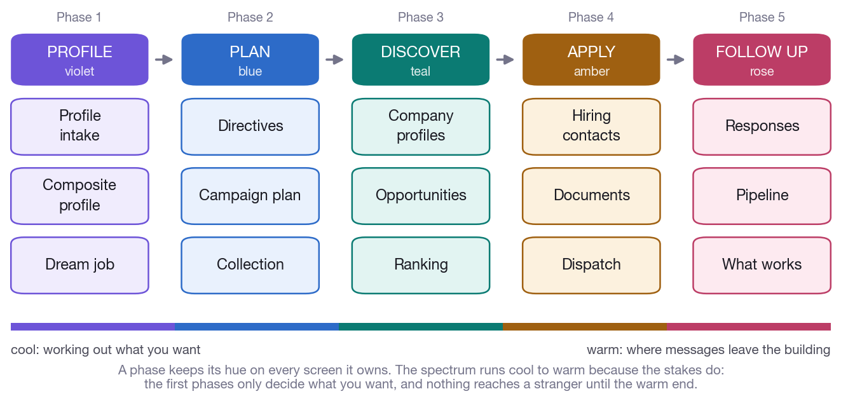
Figure 1. The five phases and the fifteen stages inside them. A phase keeps its colour on every screen it owns, so a user always knows where in the pipeline they are standing.
Cool at the start (working out what you want), warm at the end (where messages actually leave the building).
The "Where I am" screen renders this as a live map. Each of the fifteen stages reports one of five states — done, running, ready, blocked and why, or not started — with real counts, and links to the screen that advances it. A blocked stage never just says "not done"; it says what would unblock it, because the commonest way to get lost in a fifteen-stage pipeline is not knowing the next move. A one-line version of the same map sits at the top of every working screen.

5. Phase 1 — Profile

5.1 Intake (FR-102, FR-103)
Two documents go in.
The LinkedIn export. The section structure of LinkedIn's "Save to PDF" is the base schema of the profile (FR-102): Contact, Summary, Top Skills, Languages, Experience, Education, Certifications, Publications, Projects, Honors, Volunteering, Recommendations. The parser is deterministic first — the export places contact details in a narrow left column that interleaves with the body text, so extraction works from word x-positions rather than reading order — with LLM extraction as the fallback for passages the splitter cannot segment.
The CV, as PDF or DOCX. Sections, dates, employers and titles are extracted, and so is the photo, which the tailored CV needs later.
Verified against the real documents: the product owner's LinkedIn export and CV produce 8 experience entries, 27 top skills, 4 languages, 3 publications, a 1,163-character summary, and an extracted 300×300 photo.
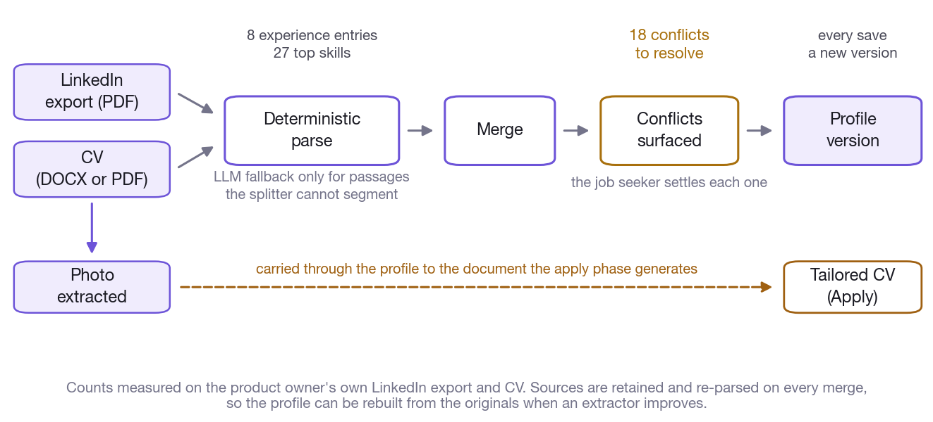
Figure 2. What the two source documents become, measured on the product owner's own export and CV — and where the extracted photo travels to.

5.2 Conflict resolution (FR-103)
The two documents disagree, and the system says so rather than silently picking one. Every disagreement over a date, title or employer becomes a conflict the job seeker resolves — LinkedIn value, CV value, or a manual override.
Verified: the real pair produces 18 conflicts, including the employer naming (NGA Human Resources vs Alight Solutions (formerly NGA Human Resources)) and the strategy role's dates (LinkedIn 2014-11 → 2023-10 vs CV 2016 → 2020). Both are genuine ambiguities that would otherwise reach a CV.
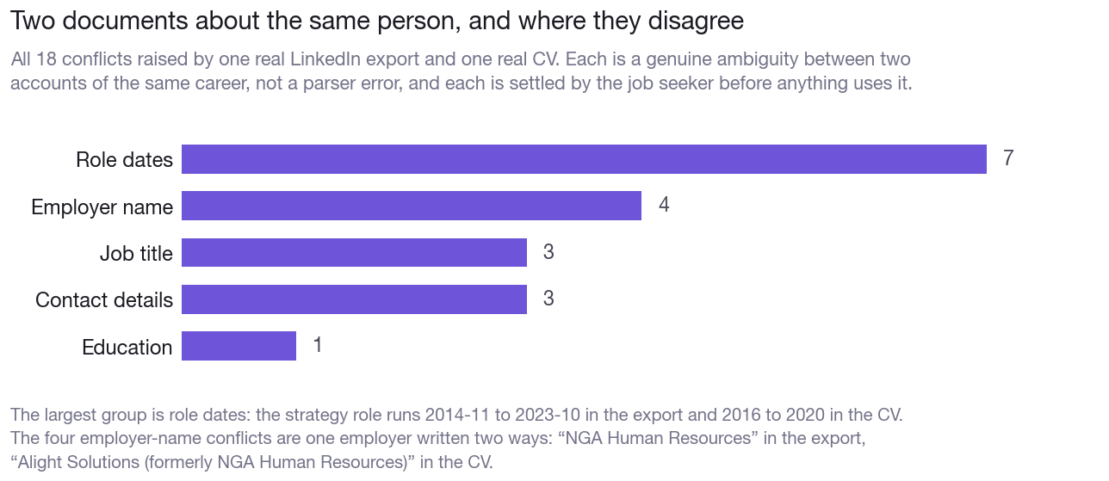
Figure 3. How the eighteen conflicts break down. Role dates dominate, and the four employer-name conflicts are one employer written two ways.
Unresolved conflicts are shown as urgent, because everything downstream inherits them.

5.3 Versions, skills, evidence, personas
• Versions (FR-105). Every save creates a new version. Campaigns record the version they used, so an old ranking stays explainable.
• Skills (FR-107). A bundled ESCO-style taxonomy of several hundred software, data and HR skills with synonyms, LLM normalisation for the rest. Proficiency, years of experience and last-used year are derived from the experience timeline. Verified: 52 normalised skills from the real profile.
• Evidence (FR-441). Repositories, publications, talks, certificates, attached to skills and achievements, cited with verifiable links in tailored CVs.
• Personas (FR-442). One job seeker can search as an architect and as a product leader, each with its own emphasis, dream-job statement and directive defaults. The knowledge base stays common.

5.4 Do not disclose (FR-106)
Flagged fields are excluded from every generated document and stripped before any prompt leaves the machine (CR-410). The screen states both plainly. This is the mechanism for a date of birth, a photo, or a current salary.

5.5 Composite profile (FR-121–FR-127)
An LLM synthesises the user-supplied data and verified online findings into the canonical representation used for matching and generation: narrative summary, career trajectory, core and adjacent competencies, seniority, domains, achievements, public footprint, inferred preferences, constraints.
Every statement carries its source — user input, LinkedIn export, CV, or a specific URL — and the screen makes each one traceable and editable (FR-125).
Online enrichment (FR-122) searches for the job seeker using name, employers, locations and declared handles as anchors: personal site, repositories, newsletters, publications, talks, press.
Identity matching is the risk that matters here (FR-123, RK-02). A namesake's career must never reach a CV. Every finding is scored on multiple independent signals, each recorded separately:
Signal | What it compares
Name variants | Spelling, ordering, diacritics, initials
Employer overlap | Organisations named on the page against the profile
Location | Cities and regions
Timeline consistency | Dates on the page against the career span
Cross-links | Whether the page links to a profile already confirmed
Photo similarity | Perceptual hash against the profile photo

Findings are classified confirmed / probable / doubtful. Only confirmed merges automatically (FR-124). Probable and doubtful are presented with their evidence for the job seeker to confirm or reject, and a rejection is permanent — the finding is never proposed again.
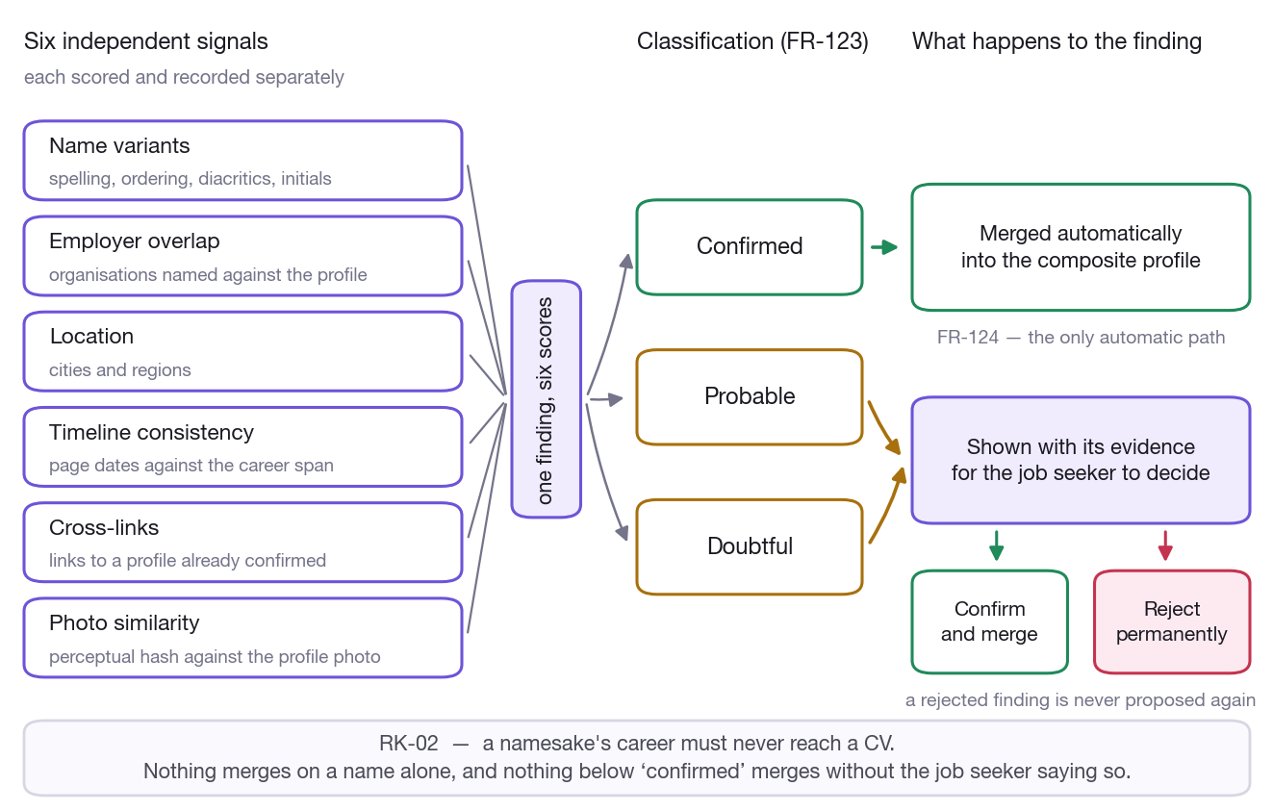
Figure 4. Six independent signals decide a finding's class. Only confirmed merges on its own; everything else waits for the job seeker.
Enrichment can be switched off entirely (FR-126), in which case no request leaves the machine and the composite profile is built from the documents alone.
Special-category data (FR-127) is never stored — health, political opinions, religion, sexual orientation, trade-union membership.

Decision. The filter distinguishes the person from the vocabulary. An earlier keyword sweep deleted "healthcare data company", "medical devices", "Political Science" and "human rights platform" from ordinary professional histories — protecting nobody while destroying exactly the careers that need representing. Detection now runs three tiers: an occupational sense wins outright; an assertion about a person ("diagnosed with", "member of the X party") is removed; a bare category noun is removed unless the sentence is plainly technical.

5.6 Dream job (FR-109, FR-128)
A free-text field, in the job seeker's own words and language, with no length limit: the work itself, the organisation, the people, the impact, the conditions, and what to avoid.
An LLM turns it into a dream job model: target roles, role families, responsibilities, company characteristics, culture and values cues, deal-breakers, and implicit preferences the job seeker did not state. It is shown for confirmation, versioned, and used as a first-class input to planning, discovery, speculative openings and scoring.
Verified against a real statement: deal-breakers come back structured with a hard flag and a detectable_from list naming which opportunity fields can evidence them — which is what makes them usable in scoring rather than decorative.

6. Phase 2 — Plan

6.1 Directives (FR-141–FR-149)
Directives bound the campaign. They are structured controls, not free text (FR-141), because they have to translate reliably into each source's own query language. The single free-text field is "notes to the AI".
Group | Covers
Job content (FR-142) | Titles with synonyms, function family, seniority range, must-have and nice-to-have skills, industries of interest and exclusion, management scope, keywords to avoid
Company type (FR-143) | Size bands, stage, trajectory, ownership, explicit include/exclude lists
Location (FR-144) | Geocoded areas with radius, countries, relocation willingness, maximum commute by mode
Work arrangement (FR-145) | On-site / hybrid with minimum remote days / remote, FTE percentage, contract type, travel tolerance
Compensation (FR-146) | Minimum package, currency, equity treatment

Compensation is used for filtering and scoring only. An explicit disclose_in_content flag, default off, is what any generating code must check before a figure can appear in a document.
Discretion mode (FR-385) is for job seekers who are currently employed. It excludes the current employer, its group entities (matched on name prefix and shared domain, not just exact name) and any flagged company; excludes contacts likely to expose the search; and suppresses LinkedIn actions that signal job hunting. It is indicated in a bar across the whole interface, not buried in settings.

6.2 Campaign planning (FR-161–FR-166)
The planner reads the source catalogue, selects sources the directives and coverage metadata justify (FR-164 — no Asian boards for a Benelux search), and has an LLM generate each source's native query form grounded in the composite profile, the directives and the dream job model.
Before anything runs, the job seeker sees the whole plan: sources, queries, expected volume, estimated duration, estimated cost — and can edit or exclude any source (FR-163).
Knowledge-base reuse (FR-342) is reported concretely before launch: per entity type, how many records are reused versus scheduled, and the time and cost avoided. Staleness defaults follow FR-343 — vacancies 7 days, company websites 90 days, filings 1 year.
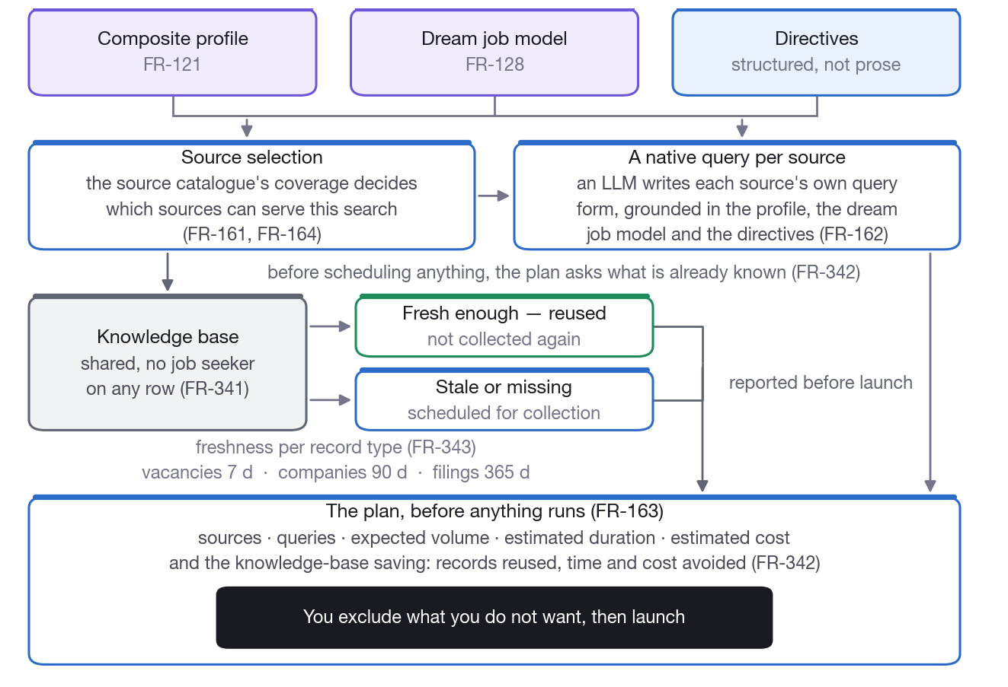
Figure 5. Everything the planner settles before a single request is made, including which records the knowledge base can already answer for.

6.3 Collection (FR-181–FR-186)
Twenty-four adapters over a common four-step contract:
Type | Count | Sources
ATS | 7 | Greenhouse, Lever, SmartRecruiters, Ashby, Recruitee, Personio, Workday
Job boards | 7 | EURES, VDAB, Jobat, StepStone, Indeed, Welcome to the Jungle, generic
Registries | 5 | NBB, KBO/BCE, Companies House, KvK, SEC EDGAR
Directories | 1 | OpenCorporates
Website | 1 | Bounded company-site crawler
News / events | 3 | RSS, event radar, social

Decision. ATS endpoints are the highest-value sources and are implemented first. They are public, keyless, structured JSON, and they are the freshest statement of what a company is actually hiring for. A board aggregates yesterday's postings; boards-api.greenhouse.io is the company's own list.

Collection runs as resumable background jobs with per-adapter progress, error counts, pause, resume and cancel. A crash loses at most the page in flight. Explicit caps bound every job — pages, companies, people, wall-clock duration — and an administrator's per-source cap is a ceiling a campaign cannot raise.
Sources whose terms prohibit automated access are disabled by default and require an explicit administrator acknowledgement (IR-101). Indeed and StepStone ship in that state.

6.4 Browser automation (FR-201–FR-208)
LinkedIn and Glassdoor defend against automation. Rather than circumventing that, the system attaches to a browser the user launched and logged into themselves, over the Chrome DevTools Protocol.
It never requests, captures, stores or replays credentials, cookies or session tokens (FR-202, NFR-203). A dedicated profile directory keeps the user's normal browser untouched.
• Scope is the plan's target list only (FR-205). An explicit allowlist of URLs is enforced; open-ended crawling is refused.
• Duration is announced before starting (FR-204) and refined during execution, computed from the same pacing distribution the executor uses.
• It stops immediately on a captcha, challenge or rate-limit page (FR-203).
• The user can watch, pause, and skip individual targets (FR-206).

CR-401 is unavoidable and is presented as such.
LinkedIn's user agreement prohibits automated access including through a session the user logged into themselves. The design reduces technical friction; it does not remove the contractual restriction, and the account may be restricted. The warning is shown before the first run and the acknowledgement recorded. The system refuses to run without it. This is the job seeker's decision to make, and the product's job is to make sure they make it knowingly.

7. Phase 3 — Discover

7.1 Company profiling (FR-221–FR-226)
A bounded crawl of the company's own site, prioritised by a URL scorer so a 30-page budget is spent on the pages that matter: about, products, customers and references, team and leadership, careers, news, locations, values.
The result is a standardised profile with a fixed schema (FR-222), displayed in a consistent layout: identity and legal identifiers, business summary, sector codes, size, locations, structure and departments, key people, references, financial summary, hiring signals, competitors, sources. Every field carries confidence and provenance (NFR-402); low-confidence fields are visibly flagged.
For larger companies a departmental map (FR-223) shows business units, functions, locations and, where known, the head of each — which is what turns "apply to this company" into "apply to this department".
Company pages are the exact injection vector NFR-205 is about, so crawled text reaches the model as fenced, explicitly-labelled untrusted data.
Profiles are shared across job seekers and refreshed incrementally (FR-226).

7.2 Competitors and signals (FR-224, FR-225, FR-402)
Competitors are found by combining signals — shared sector codes, shared customers, press co-mentions, similar product descriptions, directory classifications — because no single one is reliable enough to reach the three suggestions per company the acceptance criteria ask for.
Hiring signals are recorded with dates and sources: headcount growth, new offices, funding rounds, product launches, recent postings. Timing intelligence (FR-402) detects events that typically precede hiring and recommends an application window; opportunities where the moment is favourable are flagged in the ranked list.

7.3 Financial analysis (FR-241–FR-246)
Five years of filings per company, from the registry for its jurisdiction.
Extracted per year: revenue, gross margin, EBIT, EBITDA where derivable, net result, equity, cash, total debt, headcount, personnel costs, capex. XBRL and CSV are handled structurally; PDF filings through table extraction with LLM assistance for the awkward ones.
Computed: revenue and headcount CAGR, margin trends, personnel cost per FTE (the pay-level proxy), liquidity and solvency ratios, and a trajectory classification with confidence.
Then two 0–100 scores — ability to pay and investment capacity — each with a rationale that cites the figures used. A rationale that names no numbers is treated as a defect.
Belgian abbreviated accounts frequently omit turnover. Where filings are unavailable or incomplete the profile falls back to secondary signals and is clearly marked estimated (FR-245) rather than presenting a guess as a figure. Balance-sheet totals and sign conventions are reconciled and inconsistencies flagged rather than silently accepted (NFR-404).
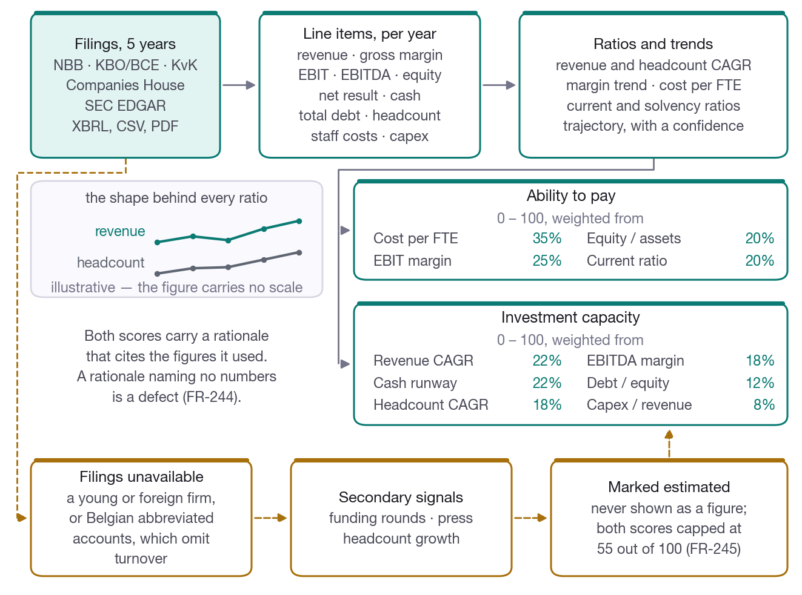
Figure 6. Five years of filings become two 0–100 scores, with the weights that produce them and the marked-estimated path taken when filings are missing.

Decision (OQ-01). Belgium is first-class (NBB + KBO), with the UK (Companies House), the Netherlands (KvK), the US (SEC EDGAR) and OpenCorporates implemented to the same contract. France (Infogreffe) and Germany (Bundesanzeiger) are not implemented; companies in those jurisdictions fall through to the FR-245 estimated path. Adding them is a new adapter and no pipeline change.

7.4 Opportunities (FR-261–FR-265)
Every collected vacancy is normalised into an opportunity. For every interesting company without a matching vacancy, an LLM generates speculative openings (FR-262): roles the company is likely to need or able to create in the next 6–12 months, from its profile, hiring signals, financial capacity, department map, competitors' hiring, and the job seeker's own profile. Each carries a plausibility score and a rationale.

FR-263 is a hard rule that reaches into the email text.
A speculative opening is visibly distinct in every view — its own colour, outside the five phase hues, plus an explicit badge — and the introduction email is written as a spontaneous application that never asserts a vacancy exists.

Compensation estimates (FR-264) come with a confidence and a source list, drawn first from posted ranges on similar vacancies in the collected corpus, which is the most defensible source available.

7.5 Scoring and ranking (FR-281–FR-285, FR-383)
Seven weighted sub-scores: profile fit, dream-job fit, directive fit, company attractiveness, compensation fit, plausibility (speculative only), and reachability.

Decision. Sub-scores are computed deterministically wherever the question is factual — skill overlap, distance, band membership, financial scores. The LLM is used for the semantic dream-job component and for the written rationale. This makes the ranking reproducible, cheap, and explainable in terms a user can argue with.

Every score is explainable: the sub-scores and a one-paragraph rationale are on screen (FR-282).
The dream-job fit meter (FR-383) is deliberately separate from the overall score, listing criteria met, partially met and violated — because a role can suit a CV perfectly and still not be what the person wants.
User control (FR-284). Check, pin, drag to re-order, mark not interested with a reason. Manual order overrides the computed ranking and survives recalculation, implemented as a stable rank that recomputation never touches. Feedback re-tunes that job seeker's weights and suggests directive refinements (FR-285).
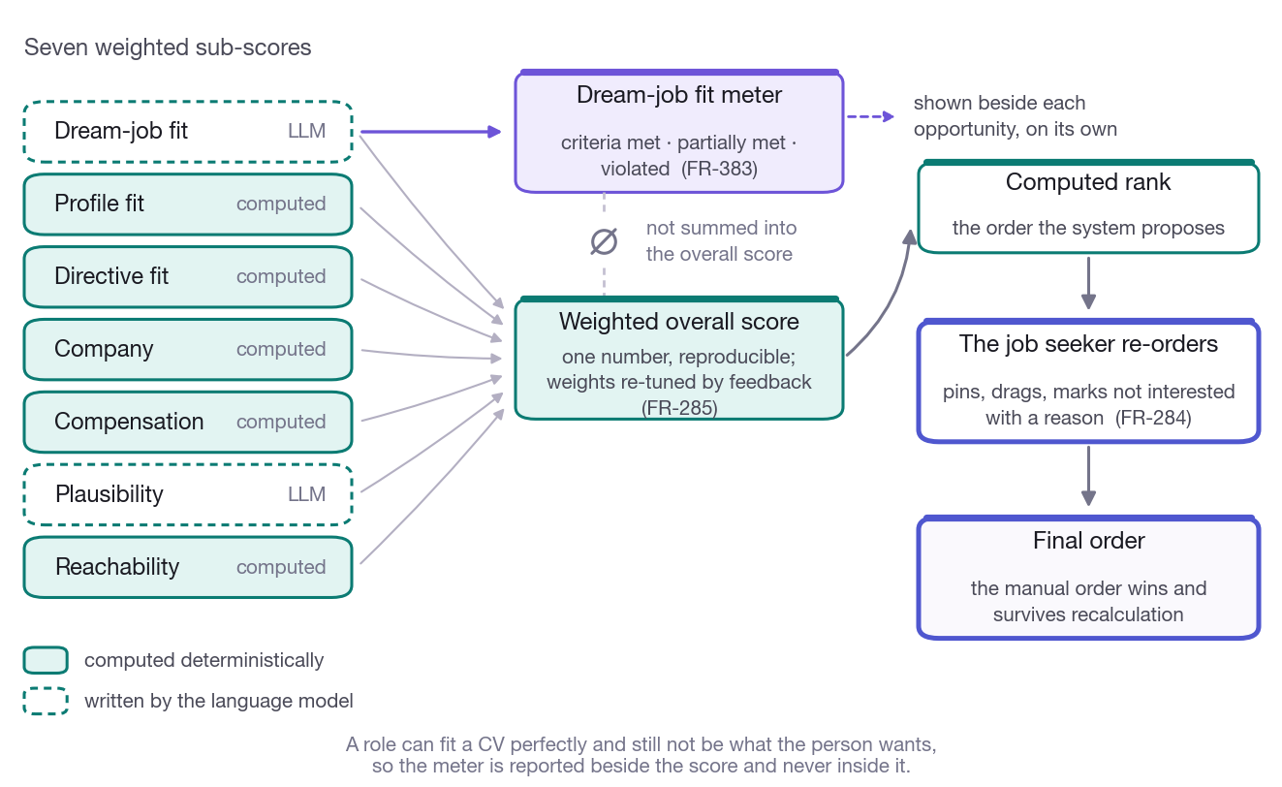
Figure 7. Which sub-scores are computed and which are written by the model, why the dream-job meter stays outside the total, and where the manual order wins.

8. Phase 4 — Apply

8.1 Hiring contacts (FR-301–FR-306)
Priority: the hiring manager of the relevant department where identifiable, then talent acquisition, then a generic careers mailbox. Candidates are ranked and presented with role, source and confidence.
Addresses are found or inferred (FR-303) from the company website, press pages, or pattern inference from other addresses on the same domain — and the method is recorded, because an inferred address deserves less confidence than a published one.
Every address is validated before use (FR-304): syntax, MX lookup, disposable and role-address detection, SMTP verification where the receiving server permits, and catch-all detection. Results are valid / risky / invalid / unknown; invalid is never used. Many providers blackhole verification, so an inconclusive probe is recorded as unknown, never as valid. Probes are rate-limited and cached per address (FR-305).
Introduction routes (FR-302, FR-461) are ranked by strength: first-degree contacts, alumni, former colleagues now at the company, shared communities. The message to the intermediary is a different artefact from the application itself, and the product keeps them distinct.
Data protection is on the screen, not in the settings. Only professional contact details are stored (FR-306). An objection blocks an address permanently and for everyone on the installation (NFR-302), enforced in the query the generator uses rather than only in the interface. Contacts collected through browser automation carry a retention deadline and are never shared between job seekers (NFR-303).

Decision (OQ-03). Browser-collected contacts are not shared, matching the SRS's proposed default. (OQ-05) Third-party lookup services are behind a config flag, off by default; the built-in DNS and SMTP validation needs no third party and no data-processing agreement.

8.2 Generated material (FR-321–FR-331)
Four artefacts per selected opportunity:
Artefact | Purpose | Sent?
Tailored CV | Emphasises relevant experience, using only true profile facts | Attached
Company & job briefing (FR-329) | Interview preparation: full company profile, five-year financials with charts, signals, competitors, the opening in full, the contact, likely interview topics, questions to ask | Never sent
Motivation & fit (FR-330) | Why this job, why you fit it, why you fit the company, anticipated objections with answers, rehearsable talking points | Never sent
Introduction email | Addressed to the hiring contact | Sent

CVs are produced in DOCX and PDF from configurable templates, in the language of the opportunity (nl / fr / en / de), including the photo where the job seeker has one and has not marked it do-not-disclose.
The factual-consistency check (FR-322, RK-03) gates approval. Claims are extracted and matched against profile facts. The date, employer and title checks are deterministic, because that is what actually catches a hallucinated employer; an LLM judge contributes as one signal, not as the arbiter. A failed check visibly blocks approval. A leak scan (NFR-206) flags content attributable to no source in this job seeker's own provenance set.
Review and approval (FR-324). Preview, edit, regenerate with an instruction, approve or discard. Bulk approval opens a mandatory summary of exactly what goes to whom — recipient, company, role, and whether the opening is real or speculative.
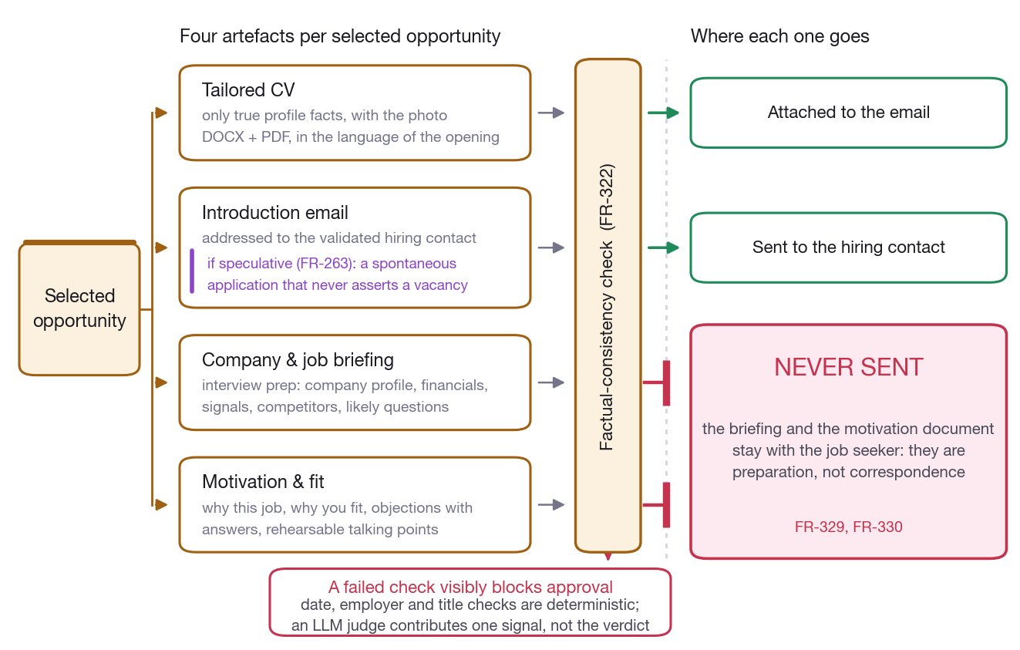
Figure 8. The four artefacts per opportunity, the check that gates approval, and the two documents that are never sent to anyone.

8.3 Dispatch (FR-325–FR-327)
Two backends behind one interface:
 | Gmail OAuth | Resend
Sends as | The job seeker's own mailbox | stephane@stepvda.com
Replies | Land in the inbox; detected by IMAP | No inbox; webhook events
Credentials | Refresh token, encrypted per job seeker, revocable | API key
Scopes | gmail.send + gmail.readonly for bounce reading | —

Note. The Resend backend is complete but the API key has not yet been supplied. It fails with an actionable message and the status screen reports "not configured" rather than showing a broken state.

Guard rails are enforced server-side (FR-325, RK-05): a configurable rate, a daily cap, and send windows expressed in the recipient's time zone, derived from the company's country. Only validated addresses are used; objected contacts are refused.
Every send is logged with recipient, timestamp, attachments, message-id and delivery status, and recorded in an immutable audit trail with who approved it (NFR-702). Bounces are detected by parsing DSN structure rather than string-matching subjects. Follow-up reminders fire after a configurable silence (FR-327).

9. Phase 5 — Follow up

9.1 Recording responses

Extension beyond the SRS, at the product owner's request. Automatic detection only covers replies arriving in a pollable mailbox. In practice many do not: a recruiter phones, answers on LinkedIn, or replies through an ATS portal — and Resend has no inbox at all.

Any response can be entered by hand and is then treated exactly like a detected one: classified, moving the pipeline card, feeding the learning.
The person entering it also states what they think happened. That stated outcome overrides the model's classification — they were there. Corrections after the fact are one click, because a misread rejection quietly distorts every rate it is counted in.
Recording a rejection is given exactly the same visual weight as recording good news. It is data, and the analysis needs it.
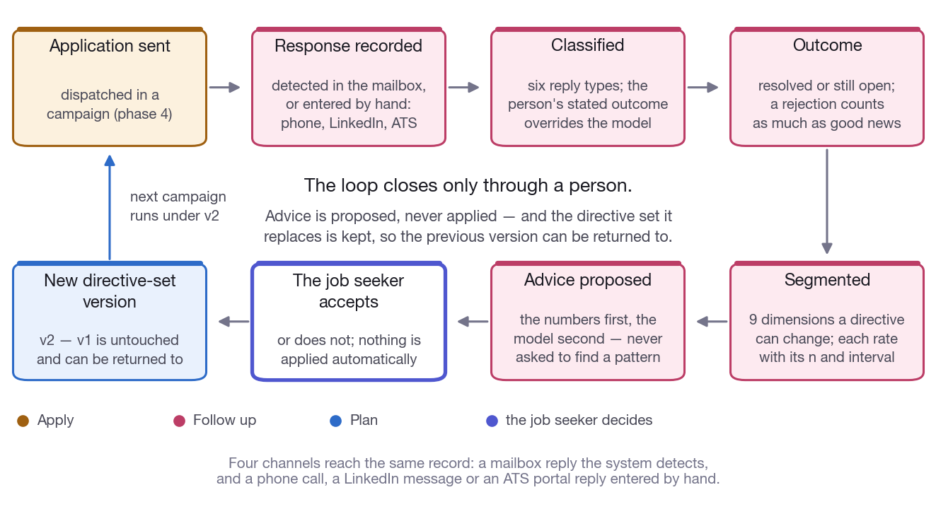
Figure 9. The follow-up loop. Every path from a response back to a changed directive passes through the job seeker, and the previous directive version is kept.

9.2 The pipeline board (FR-421–FR-424)
Five stages — sent, replied, interview, offer, closed — moved automatically by reply detection where possible and by hand otherwise.
Replies are classified (FR-422) as interest, information request, interview invitation, rejection, referral or auto-reply, and the appropriate response is drafted in the same thread using the briefing and motivation documents as context. Drafts wait for the job seeker; nothing sends itself.
Where a reply proposes interview times (FR-423), the slots are extracted — including relative dates in four languages — checked against the connected calendar, and the confirmation drafted, with the briefing attached to the calendar entry on approval.
Mock interviews (FR-424) run turn by turn: the LLM interviews using the briefing, gives feedback on each answer against the motivation document, and ends with a list of weak spots. Sessions are stored and repeatable.

9.3 What works, and where to redirect

Extension beyond the SRS, at the product owner's request: if a lot of rejections are received for a certain type of job, the AI should advise on how to redirect the type of job or company to get higher acceptance rates.

FR-425 analyses the variables of how an application was written. This adds the question a job seeker actually asks after a month: which kinds of job and company answer me, and which ignore me.
Outcomes are segmented across nine dimensions a directive can change: function family, seniority, company size band, company stage, sector, work arrangement, country, advertised-versus-speculative, and language.
Every rate is reported with its sample size and a Wilson confidence interval. Sample size is given the same visual weight as the percentage, because a 50% reply rate from 2 applications and one from 40 are the same number and entirely different evidence.
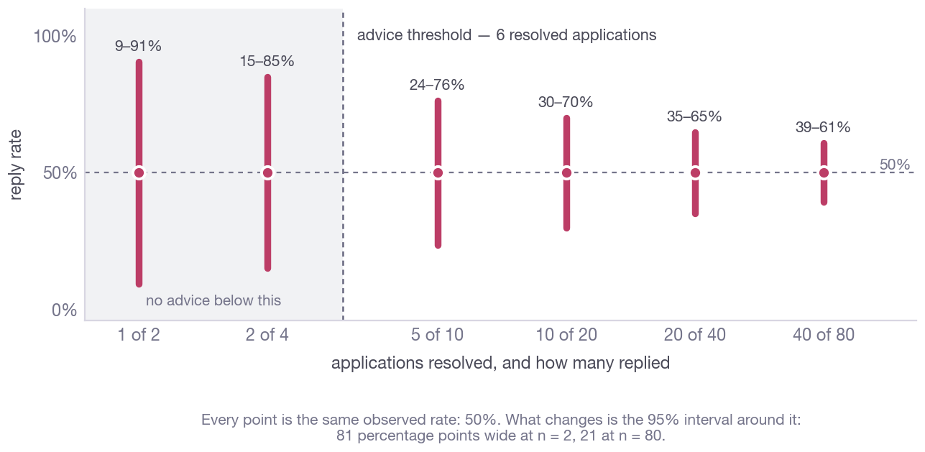
Figure 10. The same observed reply rate — 50% — at six sample sizes. The percentage never moves; only the interval around it does. This is why the advice refuses to speak below six resolved applications.
Three rules govern the advice:
1. The numbers come first, the model second. Segment rates are computed deterministically. The model is handed that table and asked to turn it into advice — it is never asked to find the pattern, because a language model asked to spot trends in a table will find one whether or not it is there.
2. Proposals are validated against the data. A proposal naming a segment the job seeker never applied to is dropped, and the figures are re-attached from the real analysis rather than trusted from the model.
3. Nothing is applied automatically. Accepting a proposal writes a new directive-set version; the previous one is untouched and can be returned to.
Advice refuses to speak below roughly six resolved applications, and says so. A proposal that conflicts with the dream-job statement is flagged, not hidden — the data does not overrule what the person said they want; it only reports what wanting it is costing.
Verified: 8 data-engineering applications with 5 replies against 9 data-science applications with 1 reply and 8 rejections — the weak segment is identified, the stronger one proposed, and an invented segment is rejected.
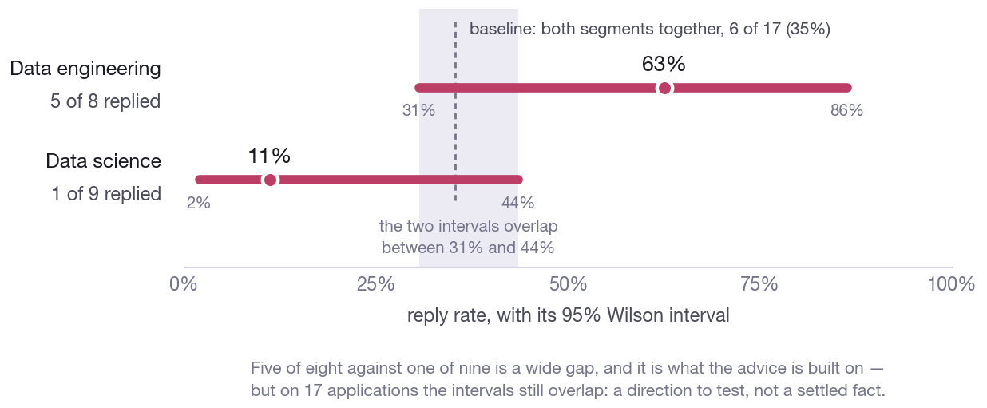
Figure 11. The verified example. Five of eight against one of nine is a wide gap and drives the advice, but at seventeen applications the intervals still overlap.

9.4 Monitoring (FR-401–FR-403)
Watched companies are rechecked on a configurable interval for new vacancies, signals, news and filings; matching vacancies are added to the ranked list automatically. A weekly digest carries new opportunities, replies, follow-ups due, watchlist changes and one recommended next action.

10. Dream-job intelligence (FR-381–FR-384, FR-443, FR-444)
• Gap analysis (FR-381). What separates the composite profile from the dream job model — skills, experience, certifications, languages, leadership scope, visibility. Each gap names a concrete closing action, an estimated effort, and the opportunities where that gap was decisive, computed from which opportunities lost points on that dimension rather than asserted.
• Stepping stones (FR-382). When nothing clears the dream-job threshold, two or three sequences of intermediate roles reachable now that plausibly lead there. Opportunities are taggable destination or stepping stone.
• Values match (FR-384). The company's derived values against those in the dream-job statement, with mismatches surfaced as explicit warnings on the company profile and in the motivation document.
• LinkedIn suggestions (FR-443). Headline, About, skills, keywords — with the keyword advice grounded in term frequency across the actual collected vacancies, not generic advice. Presented as editable text; the system never modifies LinkedIn.
• Negotiation brief (FR-444). Ability-to-pay, personnel cost per FTE, market data and the job seeker's own directives, into a suggested ask with arguments and fallbacks.

11. Isolation, administration and export
Isolation (FR-101, FR-344). Private tables carry a job-seeker id and every query filters on it. Shared knowledge-base rows carry no link back to the job seeker whose campaign produced them.

Open item. An administrator is itself a job seeker row and can read any campaign dashboard and the AI call log, including other job seekers' prompt text. Correct when the operator is the sole data controller; it needs a policy decision before a shared installation. Recorded in the DPIA.

Administration (FR-361–FR-364). Campaign dashboard with per-source records, errors, token consumption and cost; model selection, budgets and prompt templates; adapter enable/disable with the IR-101 acknowledgement flow; the AI call log with a scheduled redaction sweep.
Erasure and export (FR-108, NFR-301). Deleting a job seeker removes every private row and every file on disk while leaving shared market data intact. The table list is derived from the live schema, so a table added by a later migration cannot be silently missed. Full data export is one call.
Campaign export (FR-463). A PDF bundle and a machine-readable JSON package — ranked list, company profiles, briefings, motivation documents, application history — respecting do-not-disclose flags and containing no other job seeker's data.

12. Requirement traceability
154 of 157 requirements (98%) are cited in the implementation: 103 of 104 Must, 43 of 44 Should, 8 of 9 Could. The full matrix — requirement to file — is generated from the source and reproduced in the Technical Architecture, §11.
Not cited in code, by nature:
Id | Requirement | Why
NFR-103 | Campaign completes non-browser stages within 4 hours | A performance target, measurable only against a real campaign
NFR-304 | A DPIA shall be produced before production use | A document, delivered as DPIA.md
NFR-503 | Usable on a laptop; tablet-acceptable | Implemented in CSS media queries, which the matrix does not scan

Known limitations
Carried forward honestly rather than closed:
• Passkeys (NFR-202) are not implemented; the requirement's "strong passwords with MFA" branch is. MFA is opt-in per account.
• Database-level encryption (NFR-201) is partial. Credentials and secrets are encrypted with per-job-seeker keys; the SQLite file itself relies on disk-level encryption. SQLCipher would add a dependency.
• France and Germany have no financial-registry adapter (§7.3).
• Employer-review collection for FR-384 has no adapter; the consuming path exists and is unfed.
• Actiris (Brussels) is not implemented among the Belgian public employment services; VDAB is.
• Microsoft 365 mail and calendar are not implemented; Gmail and Google Calendar are. FR-325 is an either/or.
• DuckDuckGo search returns a bot-check page from datacentre ranges, so FR-122 degrades to declared and handle-derived URLs in such an environment.

13. Acceptance criteria status
SRS §8 scenario | Status
Import LinkedIn PDF and CV, resolve conflicts, obtain composite profile and dream job model | Verified on the real documents — 18 conflicts surfaced, photo extracted, model confirmed
Planted homonym presented for confirmation, never merged once rejected | Implemented; permanent rejection enforced
Directives through structured controls, plan reviewed, source excluded, launch | Implemented
Scope-capped LinkedIn run, duration within ±25%, stops on challenge | Implemented; not exercised against live LinkedIn
20 companies with profiles, five-year financials, 3 competitors, 2 speculative openings each | Implemented; keyed registries degrade without credentials
Ranked list with explainable scores; manual order survives recalculation | Implemented and tested
Five opportunities: contact, tailored CV, briefing, motivation, email, bulk approve, dispatch, bounce | Implemented; dispatch needs the Resend key or Gmail OAuth
Second job seeker reuses profiles, sees no private data of the first | Implemented and tested
Gap analysis with 3 gaps, 2 stepping-stone paths, fit meter | Implemented
Discretion mode excludes employer, group entities and contacts everywhere | Implemented
Watchlist, injected vacancy, notification, digest | Implemented
Interview-invitation reply, calendar check, drafted confirmation, mock interview | Implemented; calendar needs OAuth credentials
Export bundle respects flags, contains no other job seeker's data | Implemented and tested

Companion documents: Technical Architecture · DPIA · README

