

Technical Architecture
Describes the implemented system

DOCUMENT | Technical Architecture (TA)
VERSION | 1.0
DATE | 8 September 2026
AUTHOR | Stephane van der Aa
STATUS | Describes the implemented system

Specifies Dream Job SRS v0.3, technology constraints CR-407–CR-410
Companion documents: Functional Design · DPIA

Document control
Document | Technical Architecture (TA)
Version | 1.0
Author | Stephane van der Aa
Date | 8 September 2026
Status | Describes the implemented system
Specifies | Dream Job SRS v0.3, technology constraints CR-407–CR-410
Companion | Functional Design · DPIA

Contents
The table of contents is empty until the field is updated.
This table of contents is a live field. If it shows the line above rather than a list of sections, click in it and press F9 (or right-click and choose Update field) to populate it.

1. Constraints and what follows from them
The SRS fixes the stack (§2.5, CR-407–CR-410). Everything below is a consequence of taking those constraints seriously rather than working around them.
Layer | Fixed choice | What it forces
Frontend | React SPA | Route-level code splitting; the API is the only contract
Backend | Python | FastAPI, asyncio, in-process job runner
Database | SQLite | WAL mode, one writer, SQL confined to a repository layer
LLM | DeepSeek | OpenAI-compatible transport, so a local model substitutes without code change
Browser | CDP via Playwright | Attach-only; no credential handling anywhere in the codebase

The most consequential constraint is SQLite. One writer means the job runner is in-process and cooperative rather than a worker pool, and it means writes are serialised deliberately instead of contended for. That is a reasonable trade for a single-node product and it is the assumption to revisit first if multi-user concurrency ever becomes real (CR-408 anticipates exactly this).

2. System shape
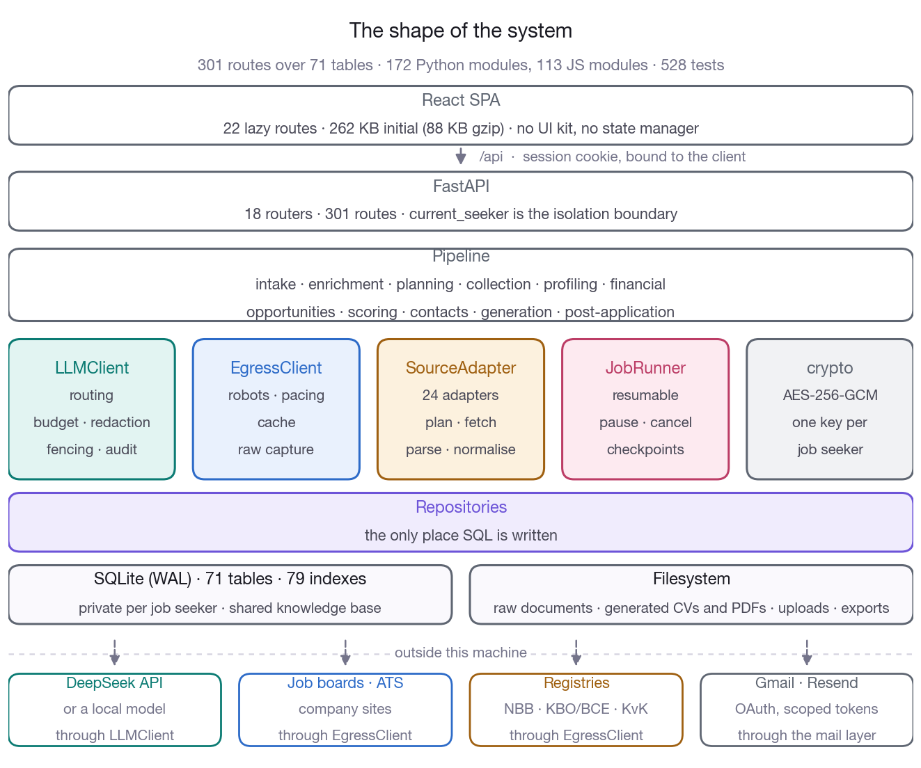
Figure 1. The system in one picture: the SPA talks only to the API, the pipeline reaches the outside world only through the five modules below it, and SQL is written in exactly one layer.
Scale. 172 Python modules / 72,820 lines · 113 JS modules / 34,082 lines · 17 test files / 13,406 lines · 507 tests · 10 migrations · 21 versioned prompt templates.
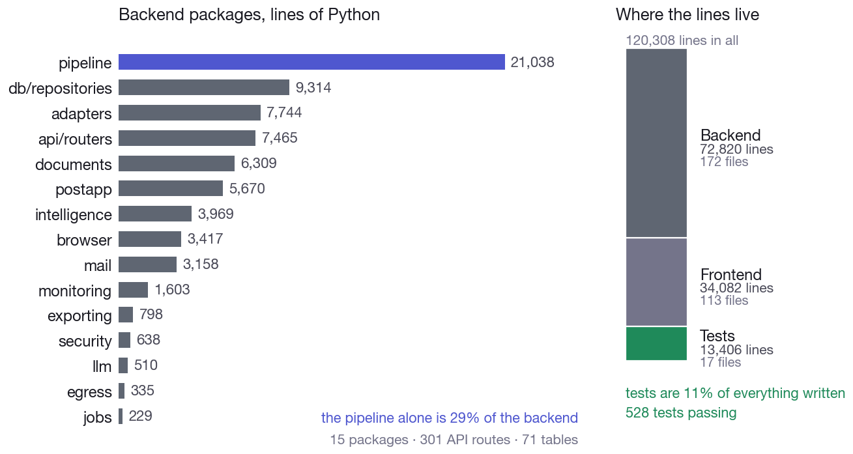
Figure 2. Where the 120,308 lines sit. The pipeline package is 29% of the backend on its own; tests are 11% of everything written.

3. The five chokepoints
The architecture rests on funnelling five concerns through exactly one place each. That is what makes the corresponding requirements enforceable rather than aspirational — each is a property of one module, not a convention 172 modules have to remember.
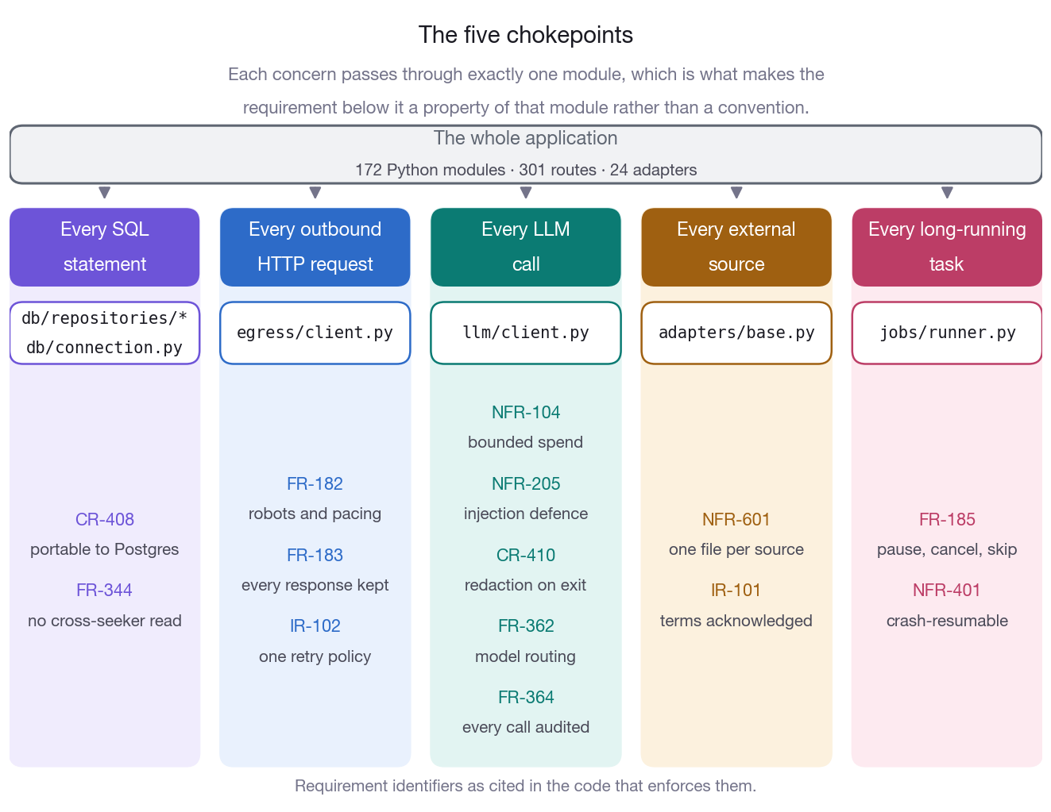
Figure 3. The whole application narrows to five modules. Under each is the requirement that module makes true for every caller, which is why these are properties rather than conventions.
Chokepoint | Module | Enforces
Every SQL statement | db/repositories/*, db/connection.py | CR-408 portability, FR-344 isolation
Every outbound HTTP request | egress/client.py | FR-182 robots + rate limits, FR-183 raw capture, IR-102
Every LLM call | llm/client.py | NFR-104 budget, NFR-205 injection defence, CR-410 redaction, FR-362 routing, FR-364 audit
Every external source | adapters/base.py | NFR-601 extensibility, IR-101 terms status
Every long-running task | jobs/runner.py | FR-185 control, NFR-401 resumability

3.1 Persistence — db/
read_tx() # concurrent readers under WAL
write_tx() # one global lock; SQLite serialises anyway, so queueing
# in-process turns "database is locked" into an orderly wait
Repositories return plain dicts, never cursors. JSON columns encode and decode at the boundary. Migrations are forward-only NNN_name.sql files with a recorded checksum; editing an applied migration is a warning, not a silent divergence.
Schema shape. 71 tables split by scope:
- Private — carry job_seeker_id: profile and versions, conflicts, skills, evidence, personas, enrichment findings, composite profile, dream job model, directives, campaigns, plan items, opportunities, application packages, dispatches, replies, pipeline cards, mock interviews, gap analyses, exports.
- Shared — the knowledge base, carrying no link back to a job seeker: companies, financial years and analyses, competitor links, hiring signals, vacancies, raw documents, events, source catalogue.
- Restricted — contact, which is shared except when collected through browser automation, where shareable = 0, owning_campaign_id is set and retention_until applies (NFR-303).
Full-text search over companies and vacancies uses FTS5, kept in sync by the knowledge-base writer.
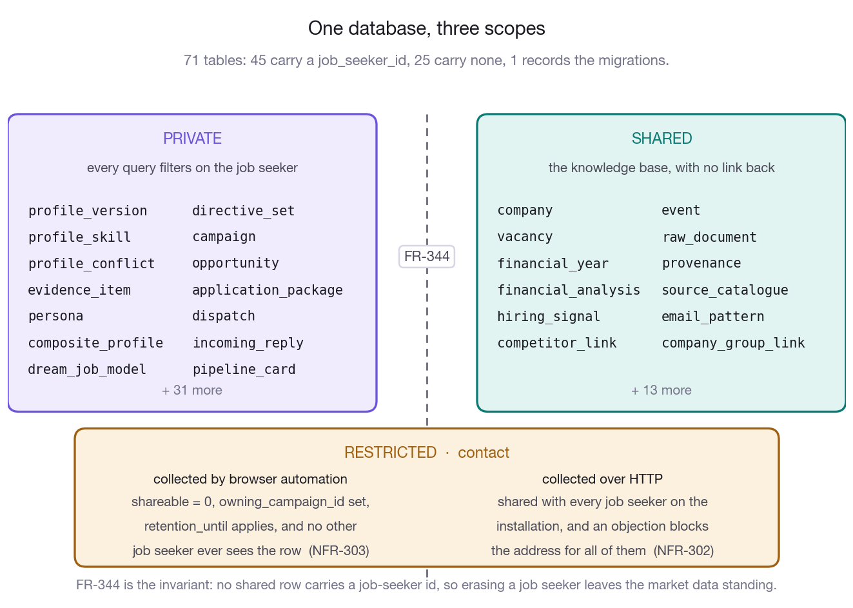
Figure 4. How the 71 tables divide. Private tables carry a job_seeker_id and shared ones carry none, so erasing a job seeker leaves the market data standing; contact is the one table that sits across the line.

3.2 Egress — egress/client.py
One async client for all outbound HTTP.
- robots.txt parsed and cached per domain; a disallowed fetch raises rather than proceeding.
- Per-domain pacing with exponential back-off on 429/503 and relief on success. Concurrency capped by semaphore (NFR-102 asks for at least 20).
- Response cache with a configurable TTL, so a repeat campaign does not re-fetch unchanged pages.
- Raw capture (FR-183, DR-102): every response is written to disk under a content-hash path and registered in raw_document, so extractors can be re-run when they improve.
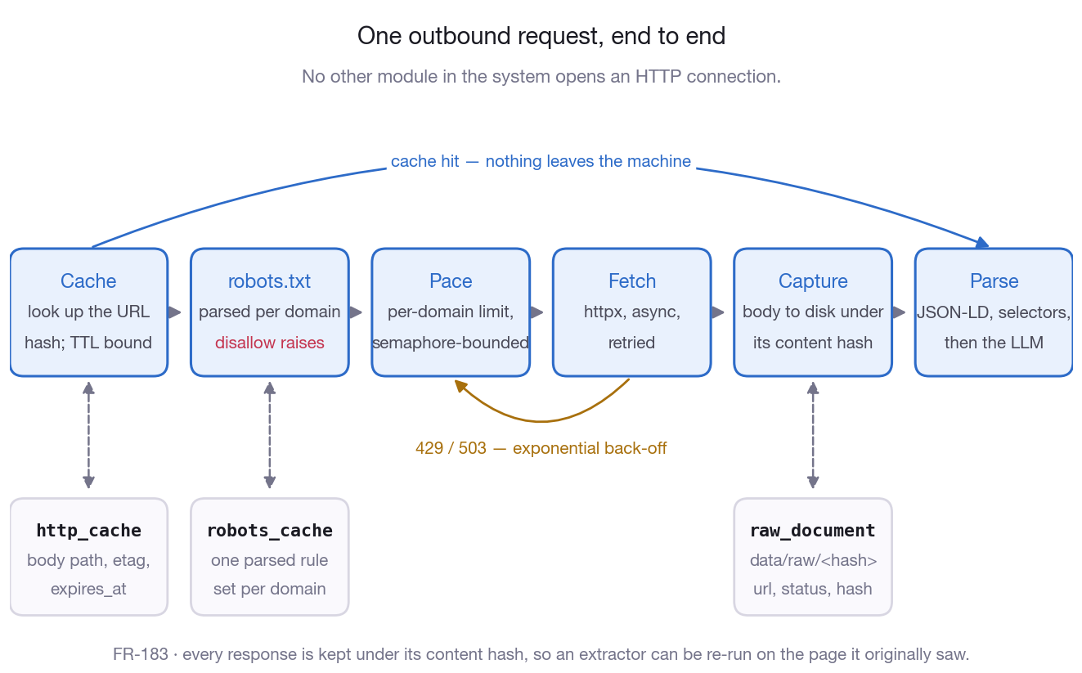
Figure 5. The path every outbound request takes through egress/client.py, including the two places it stops early: a cache hit that never leaves the machine, and a robots.txt disallow that raises.

3.3 LLM — llm/client.py
llm.complete_json(
"extract.vacancy", # task id → routing, budget, audit
system=..., user=...,
untrusted={"page": html}, # fenced, never concatenated into instructions
entity_type="vacancy", entity_id=vid,
)
- Routing (FR-362, NFR-306). Administrator settings beat .env; a per-task model override beats the cheap/strong split; privacy-sensitive tasks — composite profile, tailored CV, motivation document — route to a local OpenAI-compatible endpoint when one is configured. Settings are cached 30 seconds and invalidated on save, so a change on the admin screen takes effect on the next call rather than the next restart.
- Budget (NFR-104). Checked before each call, debited after. should_degrade() lets the pipeline shed optional work — speculative openings for low-ranked companies first — instead of stopping mid-campaign.
- Injection defence (NFR-205). Scraped text is fenced in labelled untrusted blocks, fence delimiters neutralised, known injection phrasings annotated rather than removed (the model still sees the page, visibly marked). A system preamble states the rule. Output is validated before use.
- Redaction (CR-410, FR-106, FR-127). Do-not-disclose fields and special-category data are stripped before anything leaves the machine.
- Audit (FR-364). Task, template, version, model, provider, tokens, cost, latency and the related record are written to llm_call, with a scheduled redaction sweep.
Prompts are versioned .md templates with a metadata header (NFR-602); the version travels into llm_call.prompt_version, so a regression in generated output can be tied to the prompt revision that caused it.
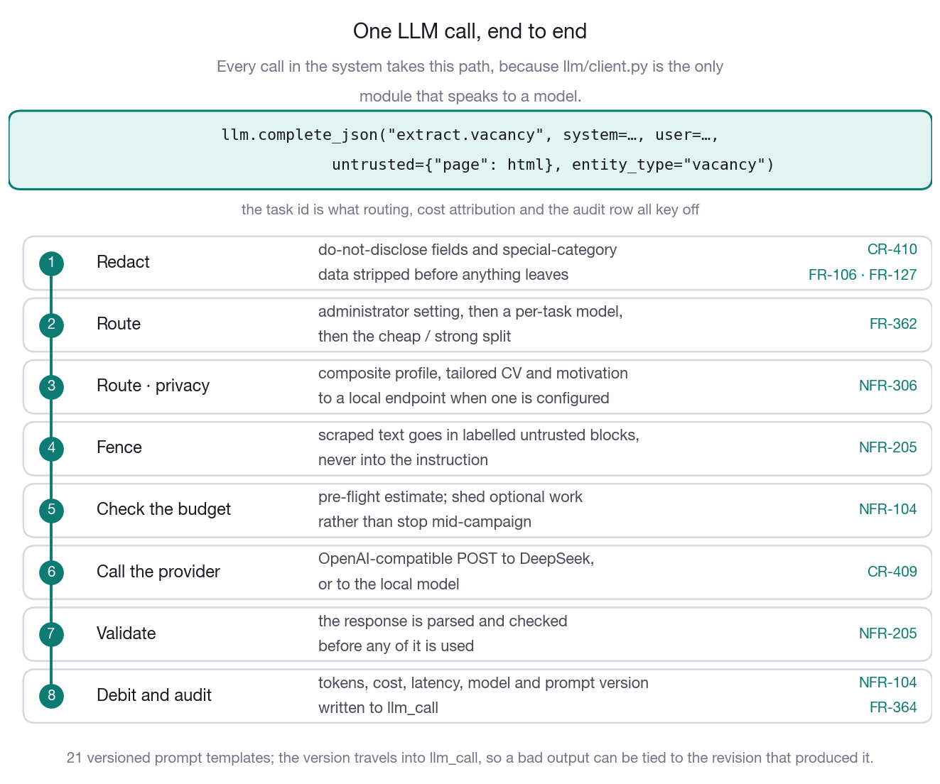
Figure 6. The eight steps between a call site and a model reply. Redaction comes first and the audit row last, so no call can skip either.

3.4 Adapters — adapters/base.py
Four methods, and the pipeline calls nothing else:
plan(directives, composite, caps) → [PlanItem] native query form
fetch(item) → [RawRecord] through EgressClient
parse(raw) → [dict] deterministic, LLM fallback
normalise(parsed, raw) → NormalisedRecord knowledge-base columns
Each adapter declares coverage, capabilities, rate limit, cost and terms-of-service status; sync_catalogue() writes that into source_catalogue at boot, where the planner reads it (FR-161, FR-164) and the administrator can override it (FR-363).
24 adapters: 7 ATS · 7 job boards · 5 registries · 1 directory · 1 website crawler · 3 news/events.
Extraction prefers JSON-LD JobPosting where present, then deterministic selectors, then LLM extraction. Success rate is tracked per adapter so layout breakage surfaces within one campaign (NFR-403).
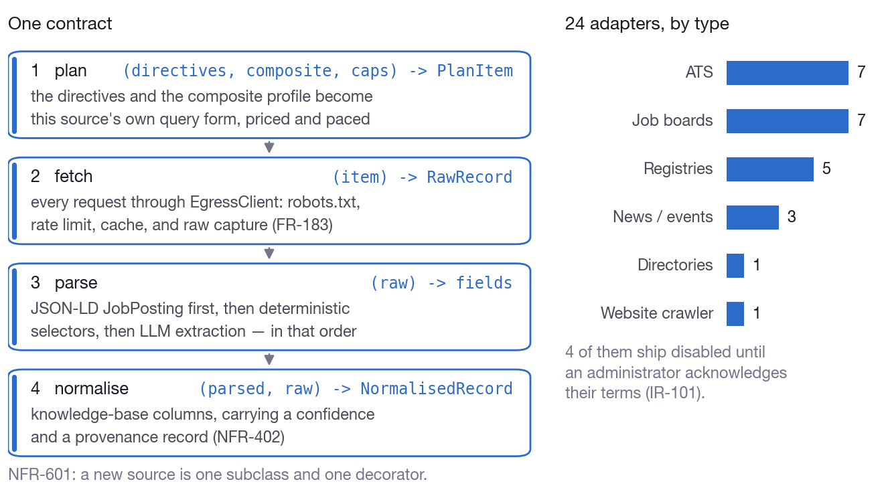
Figure 7. The four-method contract every source implements, and how the 24 adapters divide by type.

3.5 Jobs — jobs/runner.py
In-process asyncio. Each job checkpoints after every unit of work, so a crash loses at most the page in flight (NFR-401). checkpoint_barrier() is where a worker yields and honours pause, cancel and per-target skip. On boot, jobs left running by a restart are marked resumable.
Deliberately not a broker: a broker buys nothing on a single node and breaks the one-writer invariant.
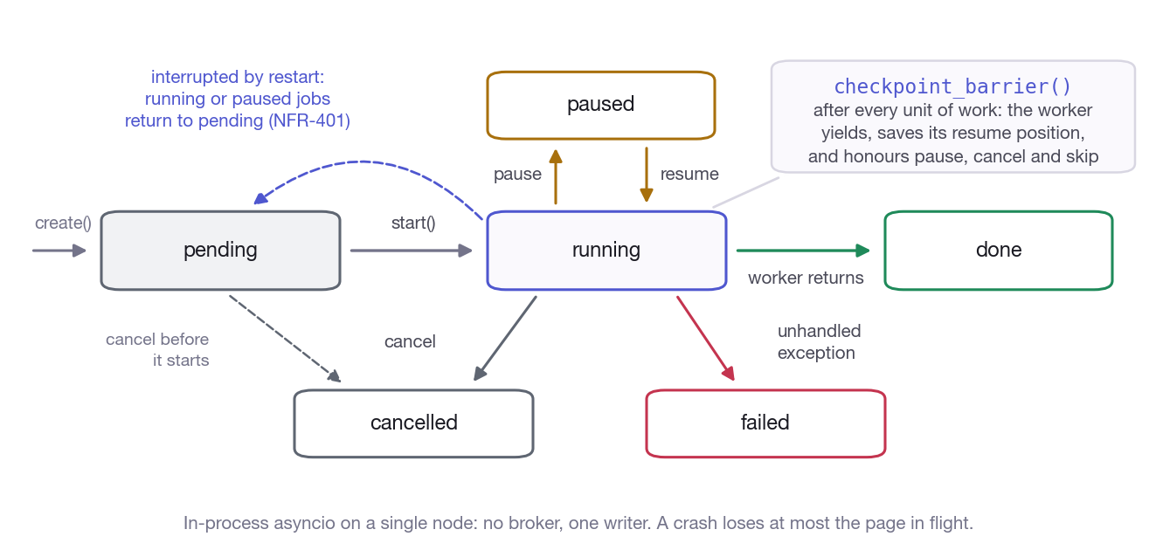
Figure 8. Job states and the transitions between them. A restart returns running and paused jobs to pending rather than losing them.

4. Security
Concern | Mechanism
Data at rest (NFR-201) | AES-256-GCM, keys derived per job seeker by HKDF from one master key. Deleting a job seeker makes their ciphertext unreadable even if a copy survives.
Passwords (NFR-202) | Argon2id, with a policy requiring three of four character classes
MFA (NFR-202) | TOTP, secret stored encrypted
Sessions (NFR-202) | Random token; only the HMAC is stored; bound to a UA+IP fingerprint
Third-party credentials (NFR-203) | Never stored. Browser automation attaches to a session the user owns
Mail tokens (NFR-204) | Encrypted, scoped to send + bounce-read, revocable from the UI
Prompt injection (NFR-205) | Content isolation, instruction/data separation, output validation
Leakage (NFR-206) | Generated documents scanned against the job seeker's own provenance set
Audit (NFR-702) | Append-only trail of who approved and sent what, with the versions used

Known gaps, stated rather than glossed: passkeys are not implemented (the password+MFA branch is); the SQLite file itself is not encrypted, so whole-database confidentiality rests on disk encryption — SQLCipher would add a dependency.

5. Frontend
React 18 + Vite + react-router. Five dependencies in total: react, react-dom, react-router-dom, vite, @vitejs/plugin-react. No UI kit, no chart library, no date library, no state manager — charts are inline SVG, icons are inline SVG, state is hooks plus one session context.
Route-level code splitting. 22 lazy chunks behind a shared shell:
Chunk | Raw | Over the wire | What it contains
initial | 262 KB | 88 KB | shell + design system + router
per page | 9–50 KB | 3–14 KB | loaded on navigation

Down from 858 KB unsplit — the administration area and the PDF previews no longer load before the profile page can paint (NFR-101).
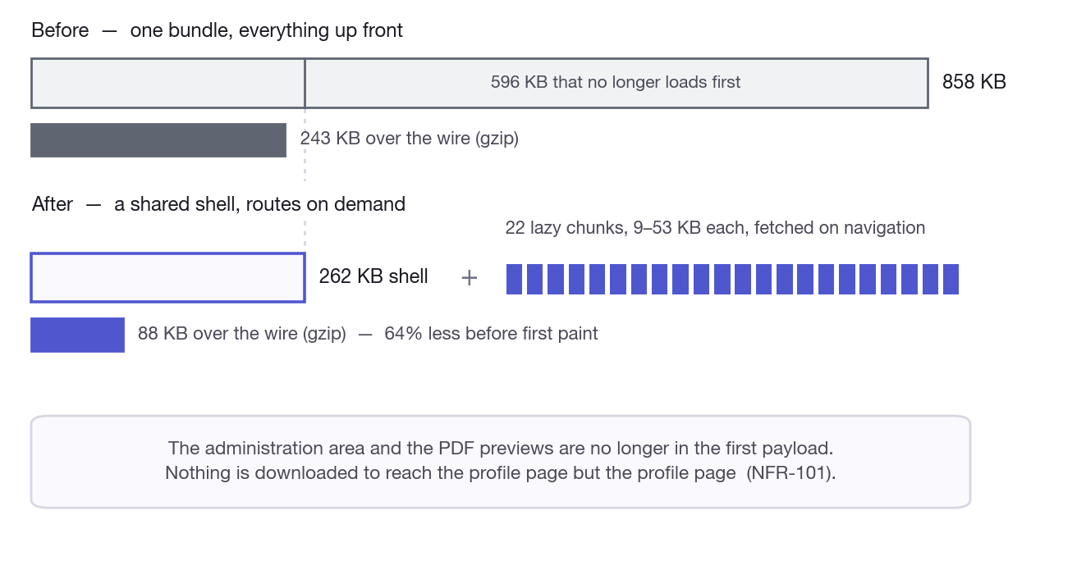
Figure 9. The same numbers as a picture: what used to arrive in one payload against the shell plus 22 chunks fetched on navigation.
Design system. One app.css of tokens and layout, one theme.css that re-points the tokens to the spectrum palette. Colour is structural: each of the five journey phases owns a hue, so a violet screen is always about the profile and an amber one is always about applying.
All six hues verified at WCAG AA (≥4.5:1) for small text against both the surface and their own tint, in light and dark:
Phase | Light · on white | Light · on tint | Dark · on surface | Dark · on tint
Profile | 5.37 | 4.63 | 6.39 | 5.92
Plan | 5.19 | 4.56 | 7.10 | 6.25
Discover | 5.13 | 4.51 | 8.40 | 6.99
Apply | 5.05 | 4.52 | 8.51 | 7.49
Follow up | 5.25 | 4.55 | 7.19 | 6.63

Body text stays near-neutral; colour carries identity and state and never has to be read. Speculative openings hold a hue outside all five phases, so FR-263 survives on colour alone. prefers-reduced-motion disables animation.
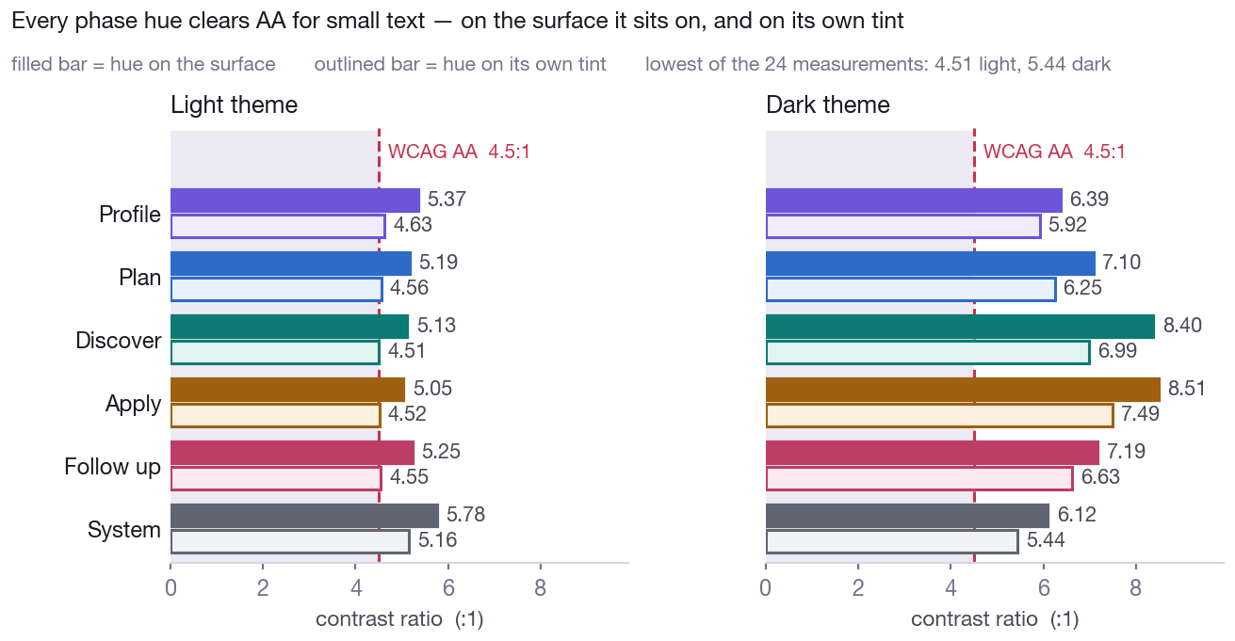
Figure 10. Every measurement against the 4.5:1 line, in both themes. Filled bars are the hue on the surface, outlined bars the hue on its own tint; the system hue is the sixth not listed in the table.
Help is structural, not optional. All copy lives in help/content.js — 18 screen entries and 22 glossary terms — so it is reviewable as a whole and translatable as a unit (NFR-501). A screen cannot ship without help because the drawer resolves its content from the route. 386 inline concept tips across the screens; ? opens the panel anywhere.

6. Deployment
cp .env.example .env
python3 -m dreamjob.security.crypto --generate-key # master key + session secret
pip install -r requirements.txt
cd frontend && npm install && cd ..
./scripts/dev.sh # API :8000, SPA :5173 with /api proxied
Production is the same process serving the built SPA from frontend/dist. Migrations run at startup. The periodic scheduler (watchlist, digest, follow-ups, contact retention, log redaction) starts from the API or runs under launchd/cron.
scripts/browser.sh launches a Chromium-based browser with a remote debugging port and a dedicated profile, for the collection steps that need a logged-in session.

7. Data flow: one campaign
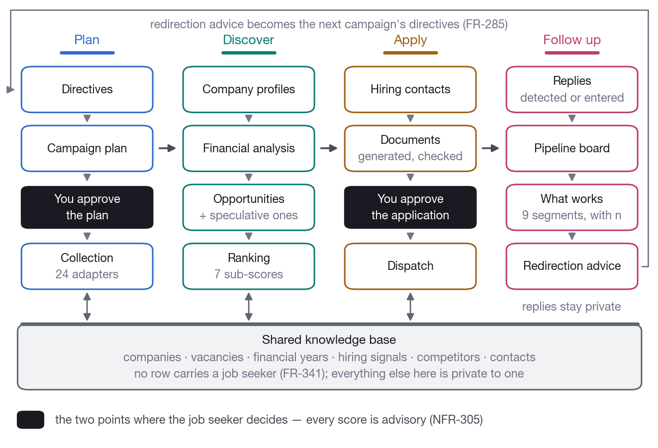
Figure 11. One campaign end to end. The job seeker decides at two points, marked dark; the shared knowledge base is written and read at every collection stage, and the follow-up phase feeds the next campaign's directives.
Every stage persists its artefacts and can be re-run independently (NFR-603).

8. Performance
Requirement | Approach
NFR-101 interactive views < 2s at p95 | 79 indexes; FTS5 for search; deterministic sub-scores avoid an LLM call per row; lazy routes keep first paint small
NFR-102 ≥20 concurrent HTTP workers, serialised writes | Semaphore-bounded async egress; one global write lock under WAL
NFR-103 typical campaign < 4 hours | Caps bound the work; ATS JSON is cheap; not yet measured against a real campaign
NFR-104 bounded LLM spend | Pre-flight check, post-call debit, graceful degradation
CR-406 browser automation is slow | Accepted by design: tens to low hundreds of targets, announced up front

9. Testing
507 tests, 13,406 lines. Each runs against a migrated temporary database and without network access; LLM and HTTP paths are stubbed or skipped.
The tests worth naming are the ones that encode a requirement rather than a function:
- A private table added by a later migration is still exported and erased (FR-108) — coverage is derived from the live schema, so a new table cannot be silently missed.
- Manual ranking survives recalculation (FR-284).
- A second job seeker's data appears nowhere in an export (FR-463).
- A redirection proposal naming an unseen segment is dropped, and effects are recomputed from the stored figures (§9.3 of the FDD).
- A professional history in a regulated domain is not stripped as special-category data, and a personal assertion is (FR-127).
- Administrator model settings actually change the routing decision (FR-362).
- Browser automation persists no cookie or token (NFR-203).
Verified end-to-end against the real source documents: LinkedIn export and CV parsed and merged, 18 conflicts surfaced, photo extracted, 52 skills normalised, and the dream-job model generated through the live DeepSeek API.

10. Extension points
To add | Do this | Touching
A job board or registry | Subclass SourceAdapter, @register_adapter | One file
A jurisdiction's filings | A registry adapter + extractor mapping | Two files
A CV template | A module under documents/templates/ | One file
A mail backend | Implement MailBackend | One file
A language | Add to the prompt templates and help/content.js | Content only
A local model | Set DREAMJOB_LOCAL_LLM_* and list the task groups | Configuration
PostgreSQL | Replace db/connection.py and the repository bodies | The layer built for it

11. Requirement traceability
154 of 157 requirements (98%) are cited in the implementation — 103/104 Must, 43/44 Should, 8/9 Could. Regenerate the matrix with:
python3 scripts/traceability.py
The three uncited requirements and the known limitations are listed in the Functional Design, §12.
Companion documents: Functional Design · DPIA · README

