Connection Quality
Feature Design Document & Technical Architecture
Per-tile diagnostics, remediation controls and automatic best-settings probing for webcam streams in OneVoice Meet

Document | Meet_Connection_Quality_FDDTA
Product | OneVoice Meet (onevoice_meet)
Version | 1.0 — draft for review
Date | 25 September 2026
Owner | Product & Client Platform
Contributors | Frontend Engineering, Media Platform, QA, Support
Reviewers | Engineering Lead, Design Lead, Security & Privacy
Audience | Engineering, QA, product, support, security review
Related documents | docs/ARCHITECTURE.md · docs/FEATURES.md · docs/CONFIGURATION.md · docs/SECURITY.md
Status | Draft — open questions in §19

Confidential — internal design document. Distribution limited to the review group.

Document control

Table 1 — Revision history
Version | Date | Author | Change
0.1 | 2026-09-18 | Product & Client Platform | Initial outline: problem, goals, rough scope
0.5 | 2026-09-22 | Frontend Engineering | Mockups, metric catalogue, score model, architecture
0.9 | 2026-09-24 | Media Platform | LiveKit API mapping, auto-tune design, research tips
1.0 | 2026-09-25 | Product & Client Platform | Complete FDD + TA issued for review

Table 2 — Approvals
Role | Name / group | Scope of approval
Engineering lead | Frontend guild | Architecture, performance budgets, test plan
Media platform | LiveKit / SFU owner | API usage, probe design, relocation of TURN insights
Design | Product design | UX, accessibility, localisation
Security & privacy | Platform security | Data handling, telemetry, compliance

Table of contents
1. Executive summary 5
2. Background and problem statement 6
2.1 How OneVoice Meet handles media today 6
2.2 The user problem 6
2.3 Why this approach 6
3. Goals, non-goals and success metrics 7
3.1 Goals 7
3.2 Non-goals 7
3.3 Success metrics 7
4. Personas and scenarios 8
5. Feature overview 9
5.1 Entry point 9
5.2 Overlay behaviour 9
5.3 Tabs and content model 9
5.4 Scope: what each action can change 10
6. Functional and non-functional requirements 11
6.1 Functional requirements 11
6.2 Non-functional requirements 12
7. UX specification 13
7.1 States and interaction model 13
7.2 Layout and design tokens 14
7.3 Overview tab 14
7.4 Details tab 15
7.5 Actions tab 15
7.6 Device and capture configuration 16
7.7 Auto-tune flow 17
7.8 Small screens, PiP and thumbnails 18
7.9 Accessibility 18
7.10 Internationalisation 19
7.11 Error and empty states 19
8. Statistics, scoring and metric catalogue 20
8.1 Metric catalogue 20
8.2 Quality score model 21
9. Improvement actions 22
9.1 Action catalogue 22
9.2 Resync vs reconnect 23
9.3 Quality, bitrate and resolution 23
9.4 Compression presets 24
9.5 Colour depth 24
9.6 Audio actions 25
9.7 Action safety and limits 25
10. Auto-tune: test optimal settings 26
10.1 Probe design 26
10.2 Candidate decision matrix 26
10.3 Apply, observe, roll back 27
10.4 Expected outcomes 27
10.5 Caching and connection fingerprints 28
11. Technical architecture 29
11.1 Component model 29
11.2 Modules and public interfaces 29
11.3 Data flow and control loop 30
11.4 Interaction sequence 31
11.5 Store, precedence and persistence 32
11.6 Integration with existing code 32
11.7 LiveKit API mapping 33
11.8 Browser capability matrix 34
11.9 Performance budget 34
11.10 Failure modes and degraded operation 35
12. Backend and data interfaces 36
12.1 v1: no backend changes 36
12.2 Optional v2: opt-in quality telemetry 36
12.3 Configuration and feature flags 36
12.4 Local data 37
13. Security, privacy and compliance 38
14. Analytics and observability 39
14.1 Client events 39
14.2 Operability 39
15. Tips and tricks: improving LiveKit connection quality 40
15.1 Publishing side (your camera) 40
15.2 Receiving side (other people's tiles) 40
15.3 Connection, transport and TURN 41
15.4 Self-hosted operations (for the platform team) 41
15.5 What this feature automates 41
16. Test plan 42
16.1 Strategy 42
16.2 Scenario matrix 42
16.3 Performance and soak tests 43
16.4 Acceptance via telemetry 43
17. Rollout plan 44
18. Risks and mitigations 45
19. Open questions 46
Appendix A — Metric dictionary 47
Appendix B — Diagnostics export schema 48
Appendix C — Initial i18n keys (namespace `cq`) 49
Appendix D — Glossary 51
Appendix E — References 52

1. Executive summary
OneVoice Meet runs on a LiveKit SFU with simulcast, dynacast and adaptive streaming. Those mechanisms work well on average, but they act silently: when a specific stream degrades, the participant sees a blurry, stuttering or robotic-looking tile with no explanation and no way to intervene. The only quality affordances today are a global video-quality preference and LiveKit's small connection-quality indicator, which is hidden by default from the tile.
This feature adds a Connection Quality button to the top-left corner of every webcam tile. Clicking it opens a semi-transparent overlay inside that tile with three tabs: Overview (plain-language verdict and live statistics), Details (the full metric catalogue and 60-second history) and Actions (remediation controls). The controls include resync, transport reconnect, subscription quality, bitrate, resolution, frame rate, compression and colour-depth presets, plus a one-tap Test optimal settings probe that measures the connection and applies the best stable configuration for the current network.
The design is deliberately honest about scope. For a remote tile you control what you receive (simulcast layer, subscription state, receiving bandwidth); you can never change another participant's camera settings. For your own tile you control what you publish (resolution, bitrate, compression, colour depth), and the UI warns that changes are visible to everyone. The feature is client-side only for v1 — no media-plane or SFU changes — and reuses the existing React/LiveKit stack, the zustand preference store, the i18next localisation system and the FlippableTile component that already renders every webcam surface in the meeting stage.

2. Background and problem statement

2.1 How OneVoice Meet handles media today
The meeting stage renders every camera, screen share and playback track through FlippableTile, which wraps LiveKit's ParticipantTile (see frontend/src/components/FlippableTile.tsx). Layouts are chosen in PresenterSpotlight.tsx: grid, single speaker, speaker-with-thumbnails, PiP overlay and full-bleed focus. The stage root carries state classes such as .meet-stage.no-conn-quality (frontend/src/styles/global.css), which hides LiveKit's built-in .lk-connection-quality element when the user turns display.showConnectionQuality off in Settings → Display.
On the network side, frontend/src/lib/livekit.ts builds RoomOptions from the preference store: simulcast and dynacast are on, adaptiveStream follows the rendered tile size, network.forceRelay pins ICE to TURN, and the HIGH simulcast layer is raised to 2.5 Mbps for VP8. frontend/src/lib/videoQualityPref.ts applies the global network.preferredVideoQuality (low / medium / high / auto) to every remote camera and screen-share publication through RemoteTrackPublication.setVideoQuality().
TURN credentials are minted by meeting-api (short-lived HMAC pairs shared with coturn) and handed to the browser, which feeds them to RTCPeerConnection. The SFU itself runs host-networked with UDP 50000–60000 and TCP 7881, as described in docs/ARCHITECTURE.md.

2.2 The user problem
- Degradation is silent. adaptiveStream, dynacast and the SFU bandwidth estimator adjust quality without telling anyone. A user on a weak link cannot tell whether the blur is their network, the publisher's CPU, or a relay path.
- No per-stream diagnosis. The existing indicator reports one coarse value (Excellent / Good / Poor / Lost) and nothing else: no bitrate, no loss, no audio-continuity data, no history.
- Controls are global, not per-tile. Changing quality for one bad participant means changing the preference for every stream, or asking the publisher to change their camera — often impossible mid-meeting.
- No guided remediation. There is no in-product way to resync a frozen track, reconnect the transport, or find the best settings for the current network.
- Support cases are hard to action. When quality complaints arrive, support has no exportable per-stream evidence; the conversation restarts from 'can you describe what you saw?'.

2.3 Why this approach
Everything needed for accurate client-side diagnosis already exists in livekit-client 2.5: per-track getRTCStatsReport() on local and remote tracks, publisher-side getSenderStats() with qualityLimitationReason, subscription controls (setVideoQuality, setSubscribed, setEnabled) and sender parameters via RTCRtpSender.getParameters()/setParameters(). A client-side feature can therefore ship without touching the SFU, the egress pipeline or the recording path, while still surfacing the real causes of degradation and offering safe, reversible actions.

3. Goals, non-goals and success metrics

3.1 Goals
- G1 — Explain. Give every participant a one-tap, per-stream diagnosis: a Low / Medium / High verdict, the contributing metrics, and a plain-language limiter (network, CPU, publisher, relay).
- G2 — Control. Offer safe, reversible remediation per tile: resync, reconnect, quality / bitrate / resolution / frame rate, compression presets, colour depth, audio-only mode and diagnostic export. For your own tile, also expose the real capture configuration: camera resolution and frame rate, device selection, and microphone mono/stereo with an audio-quality preset.
- G3 — Automate. Provide a one-tap probe that measures the available connection and applies the best stable settings, with automatic rollback if the result is worse.
- G4 — Respect boundaries. Make it unambiguous that remote tiles only change your subscription, while local-tile publishing changes are visible to the room.
- G5 — Stay cheap. No measurable impact on media quality, CPU, battery or call stability; statistics collection is bounded, visibility-aware and off by default when the panel is closed.

3.2 Non-goals
- Server-side media changes: SFU tuning, simulcast layer reconfiguration on the server, egress/recording quality, or transcoding policy. Out of scope for this release.
- Replacing LiveKit's adaptive algorithms. The feature exposes and bounds them, and only overrides them when the user asks or auto-tune is run.
- Changing another participant's publishing settings. Never possible from a remote tile.
- Network-level QoS, router configuration, or ISP diagnostics beyond what WebRTC stats and optional bandwidth probing reveal.
- Capturing or storing media content. Only derived counters are processed, locally.

3.3 Success metrics
Table 3 — Success metrics and targets
Metric | Definition | Target | How measured
Panel adoption | Meetings with ≥ 1 quality sample below the Medium band where the panel is opened | ≥ 40 % | Opt-in telemetry (§14) + local aggregate counters
Time to recovery | Median time from a Low verdict to a Medium/High verdict after an action | < 10 s | Score samples around cq_action_invoked events
Support pressure | Tickets mentioning video/audio quality or 'blurry / frozen' per 1 000 meetings | − 30 % after two releases | Support ticket tags
Auto-tune quality | Auto-tune runs where the recommendation is applied and kept for ≥ 60 s | ≥ 70 % | Telemetry event cq_autotune_completed
Auto-tune safety | Auto-tune runs that roll back after applying | < 10 % | Telemetry event cq_autotune_completed
Performance guardrail | Additional CPU per client from stats collection | < 0.5 % of one core | Chrome tracing harness (§16.3)
Stability guardrail | Crash-free sessions and involuntary disconnects | No regression | Existing client telemetry

4. Personas and scenarios
Table 4 — Primary personas
Persona | Context | What they need
Amara — participant on flaky Wi-Fi | Works from home; 4G backup; joins large team meetings | Know quickly whether the blur is her network and what to change; one-tap fix.
Ben — host / presenter | Laptop on a good link but CPU-busy with slides and recording | See that his own stream is CPU-limited, not network-limited; reduce publishing cost without ending the call.
Chloé — presenter on a corporate VPN | UDP blocked; everything traverses TURN | Understand the relay penalty and reconnect with the best available transport.
Dev — support engineer | Handles quality complaints after the fact | Get an exportable, privacy-respecting diagnostic snapshot from the user.

Scenario A — one bad tile in a 12-person grid. Amara notices that Ben's tile keeps freezing. She clicks the badge, sees Medium — jitter and loss high, runs Test optimal settings; the probe recommends MEDIUM 640×360 at 1.2 Mbps, she applies it and the tile stabilises. No global setting changes, no interruption for anyone else.
Scenario B — my own video is blurry. Ben clicks the badge on his own tile, sees High network / CPU limited with qualityLimitationReason: cpu, and uses the Actions tab to drop his publishing resolution to 640×360 and enable the balanced compression preset. His tile sharpens for the whole room; the recorder's egress is unaffected.
Scenario C — the VPN call. Chloé's tile shows RTT 180 ms and a relay transport. The panel recommends reconnecting without forced relay; the reconnect action re-establishes ICE and the transport indicator switches to Direct, cutting RTT by half.
Scenario D — support evidence. Amara exports a diagnostics report from the panel (JSON, no media, no personal data) and attaches it to the ticket; support sees the limiter, timeline and action log immediately.

5. Feature overview
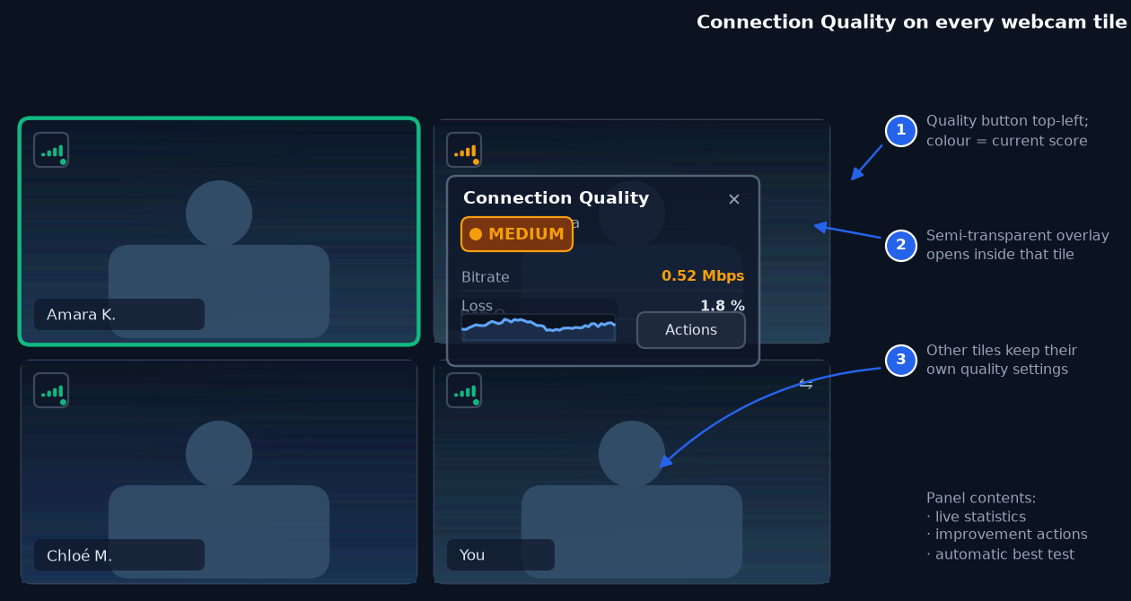
Figure 1 — The feature at a glance: a quality badge on every webcam tile, and a per-tile panel that opens inside the tile without disturbing other streams.

5.1 Entry point
Every camera tile — local, remote, grid, spotlight, thumbnail strip and PiP — gets a 28 × 28 px button anchored 8 px from the tile's top-left corner. The button shows a four-bar signal icon coloured by the current verdict (green / amber / red) plus a small status dot. It is a real <button> with aria-expanded, aria-controls and a localised aria-label (for example Connection quality for Ben O. — Medium). Screen shares and playback tiles get the same button; audio-only participants do not.
The button remains visible when the panel is open and acts as the toggle. It is governed by the existing display.showConnectionQuality preference (renamed in the UI to Connection quality indicator), so users who previously hid LiveKit's indicator keep their setup clean; the default is on.

5.2 Overlay behaviour
Clicking the badge opens a semi-transparent panel inside the tile, anchored at its top-left corner. The panel never leaves the tile bounds, never covers another tile and never takes focus away from the meeting stage. It can be closed with the ✕ button, with Esc, or by clicking the badge again. On tiles narrower than 260 px the inline panel is replaced by a full-tile bottom sheet with the same content and 44 px touch targets.
The panel is non-modal: participants can keep talking, sharing and reacting. Opening the panel raises the stat-collection cadence for that one track from the idle 2 s poll to 1 Hz, and stops it again when the panel closes or the tab becomes hidden.

5.3 Tabs and content model
Table 5 — Panel tabs and content
Tab | Purpose | Content | Default?
Overview | Answer 'is it good, and why?' at a glance | Verdict pill (Low / Medium / High), one-line explanation, 60 s bitrate sparkline, eight headline metrics, primary Test optimal settings button | Yes
Details | Full diagnostics for curious users and support | Complete metric table (video, audio, transport, publishing), 2-minute history, transport and codec information, action log, Export report | No
Actions | Fix or tune this stream | Resync, reconnect, quality layer, max bitrate, resolution, frame rate, compression, colour depth, audio-only toggle, reset to auto | No
Device | Configure your camera and microphone (local tile only) | Camera and mic device pickers, resolution and frame-rate presets validated against camera capabilities, mono/stereo channels, voice / music audio preset, live publishing readout | No

5.4 Scope: what each action can change
The most important design rule is scope honesty. A tile is either yours (you publish it) or someone else's (you receive it). Every action is labelled with its scope, and the UI explicitly states who is affected.
Table 6 — Action scope by tile type
Action | Remote tile (you receive) | Local tile (you publish)
Resync / request fresh stream | Yes — renegotiates your subscription | n/a
Reconnect transport | Yes — room-wide, with warning | Yes — room-wide, with warning
Quality / simulcast layer | Yes — caps what you receive | Yes — sets your publishing layers
Max bitrate | Indirect (choose a lower layer) | Yes — RTCRtpSender encoding cap
Resolution / frame rate | Indirect (choose a lower layer) | Yes — capture constraints
Compression preset | No — label explains it is publisher-side | Yes — content hint, degradation preference, bitrate profile
Colour depth (8 / 10-bit) | No | Yes — only if codec and device support it
Audio-only mode for this tile | Yes — pauses video without renegotiation | n/a
Camera resolution / frame rate | No — fixed by the publisher's capture | Yes — capture constraints, validated against getCapabilities()
Audio channels (mono / stereo) and quality preset | No — you receive what is published | Yes — reacquire the microphone with channelCount and the chosen preset
Export diagnostics | Yes | Yes

Note — Changing another participant's stream is impossible by design. The panel's remote view therefore offers receive-side controls only, and the copy says so: “Applies to what you receive — Ben's camera settings stay untouched.”

6. Functional and non-functional requirements

6.1 Functional requirements
Table 7 — Functional requirements
ID | Requirement | Priority | Acceptance criteria
FR-01 | A quality badge is rendered at the top-left of every webcam, screen-share and playback tile | MUST | Visible within 1 s of tile mount in all layouts; hidden for audio-only participants
FR-02 | The badge colour reflects the current verdict band within one collection cycle | MUST | Green/amber/red match the score bands; Lost connection shows red with a reconnecting glyph
FR-03 | Clicking the badge opens the panel inside the tile, anchored top-left | MUST | Panel never exceeds tile bounds; other tiles unchanged
FR-04 | The panel closes via ✕, Esc, or a second badge click; focus returns to the badge | MUST | Keyboard focus order is preserved; no focus trap outside the panel
FR-05 | The Overview tab shows a verdict, a one-line explanation and at least eight live metrics | MUST | Values update at 1 Hz while open; stale values are greyed after 5 s without a sample
FR-06 | A 60-second bitrate history is displayed in the Overview tab | MUST | Sparkline reflects the last 60 s of delivered video bitrate; hidden under reduced motion
FR-07 | The Details tab lists the full metric catalogue and a two-minute history | MUST | Includes video, audio, transport and (for local tiles) publishing metrics
FR-08 | The panel offers a resync action for subscribed remote video tracks | MUST | Unsubscribes/resubscribes and reports success or failure within 5 s
FR-09 | The panel offers a transport reconnect action with an explicit room-wide warning | MUST | Confirmation is required; reconnect uses the existing token flow; progress is shown
FR-10 | The user can set the subscription quality to Low / Medium / High / Auto for a remote tile | MUST | Calls setVideoQuality; the override survives layout changes and is cleared on leaving the meeting
FR-11 | The local publisher can cap resolution, frame rate and maximum bitrate | MUST | Applied via capture constraints and sender parameters; a rollback point is stored
FR-12 | Compression can be set to Low / Medium / High presets on the local tile | MUST | Preset applies content hint, degradation preference and bitrate profile where supported; unsupported parts are reported
FR-13 | Colour depth can be requested (8-bit default, 10-bit when supported) | SHOULD | Capability probe runs before the option is enabled; unavailable state is explained in the UI
FR-14 | An audio-only mode can disable incoming video for a single remote tile without renegotiation | MUST | Uses setEnabled(false); audio continues; re-enabling restores video
FR-15 | A one-tap connection test probes the link and recommends the best stable settings | MUST | Baseline + three 4 s steps + 15 s observation; recommendation includes quality, bitrate, compression and expected effect
FR-16 | Applying an auto-tune recommendation is optional and reversible; the system rolls back automatically if quality worsens | MUST | Rollback on score drop > 15 % or loss > 5 % for three consecutive samples
FR-17 | A diagnostics report can be exported as a JSON file | MUST | Contains metric history and action log; contains no media, no email addresses and no IP addresses
FR-18 | The panel exposes live statistics for remote and local audio quality | MUST | Audio loss per minute, concealment ratio and jitter are shown for both directions
FR-19 | The feature respects display.showConnectionQuality and privacy.disableAnalytics | MUST | Badge hidden when the display preference is off; no telemetry when analytics are disabled
FR-20 | All UI strings are localised through i18next with English fallback | MUST | New keys exist in en.json; missing translations fall back without crashing RTL layouts
FR-21 | The Device tab lists the available cameras and microphones and lets the user switch either device without leaving the call | MUST | Reuses room.switchActiveDevice(); the selection persists to prefs.av.preferred*Id
FR-22 | The panel shows the camera's reported capabilities and live capture settings (max resolution, max frame rate, current width × height × fps) | MUST | Values come from MediaStreamTrack.getCapabilities() / getSettings(); unavailable fields are marked 'not reported'
FR-23 | Camera resolution and frame-rate presets are offered within the camera's capability envelope | MUST | Options outside the envelope are disabled with a reason; applying uses mediaStreamTrack.applyConstraints() and reports the achieved settings
FR-24 | Microphone channels can be set to Mono or Stereo, with the trade-offs stated inline | SHOULD | Stereo reacquires the mic with channelCount: 2 and the hi-fi preset; the UI warns that echo cancellation / noise suppression are disabled and uplink bandwidth rises
FR-25 | An audio quality preset (Voice / Music) controls bitrate, DTX and RED | SHOULD | Voice = speech preset, DTX/RED on; Music = high-quality stereo, DTX/RED off, bitrate up to 510 kbps; the current preset is shown in Details
FR-26 | Unsupported device configurations are rejected before publishing, with an inline explanation | MUST | No dropped track on invalid constraint sets; previous settings remain active

6.2 Non-functional requirements
Table 8 — Non-functional requirements
ID | Area | Requirement
NFR-01 | Performance | Stats collection adds ≤ 0.5 % CPU for 25 visible tiles and ≤ 1.5 MB heap for a full meeting
NFR-02 | Performance | The panel reaches interactive state (verdict + first metrics) within 300 ms of opening
NFR-03 | Performance | Opening the panel must not trigger layout jank in the meeting grid; the panel is composited with transform-safe properties
NFR-04 | Media quality | No measurable change to published bitrate, frame rate or audio continuity caused by the feature
NFR-05 | Battery | When a tab is hidden or a tile is off-screen, polling stops entirely
NFR-06 | Reliability | Stats failures degrade gracefully: the panel shows the LiveKit ConnectionQuality value and disables actions that need metrics
NFR-07 | Security | No new network egress by default; no cross-participant control APIs
NFR-08 | Privacy | Diagnostics never include media, e-mail addresses, IP addresses, SSIDs or exact locations
NFR-09 | Accessibility | WCAG 2.2 AA for the panel and badge: contrast, focus visibility, keyboard operation, reduced motion
NFR-10 | Compatibility | Chrome/Edge (Chromium 110+), Safari 16.4+, Firefox 110+; graceful degradation elsewhere
NFR-11 | Localisation | All strings translatable; layout tolerates +40 % text expansion (German) and RTL mirroring
NFR-12 | Maintainability | The stats, score and action layers are framework-agnostic TypeScript modules with unit tests; UI depends on them through a narrow store interface

7. UX specification

7.1 States and interaction model
Table 9 — Component states
State | Trigger | Badge | Panel
Hidden | Audio-only participant, or preference off | Not rendered | n/a
Calculating | First 4 s after subscription | Grey with pulse | Shows 'Measuring…' skeleton
High | Score ≥ 75 with hysteresis | Green bars | Green verdict, positive copy
Medium | Score 45–74 | Amber bars | Amber verdict, explanation of the dominant limiter
Low | Score < 45, or LiveKit Poor | Red bars | Red verdict, prominent actions
Lost / reconnecting | LiveKit ConnectionQuality.Lost, or no samples for 10 s | Red with reconnecting glyph | Banner: 'Connection lost — reconnecting automatically'
Probing | Test optimal settings running | Amber with activity ring | Progress list, live readout, cancel link
Degraded | getRTCStatsReport() unavailable | Colour from LiveKit quality only | Metric rows replaced by an explanation; only safe actions shown

Interaction rules: only one panel is open at a time per client; opening another tile's panel closes the previous one. The panel remembers the last selected tab for the session. Hovering a metric shows its definition in a tooltip; the same definitions live in Appendix A. All actions are optimistic, show an inline progress state and report failure with a retry link; destructive or room-wide actions (reconnect) require confirmation.
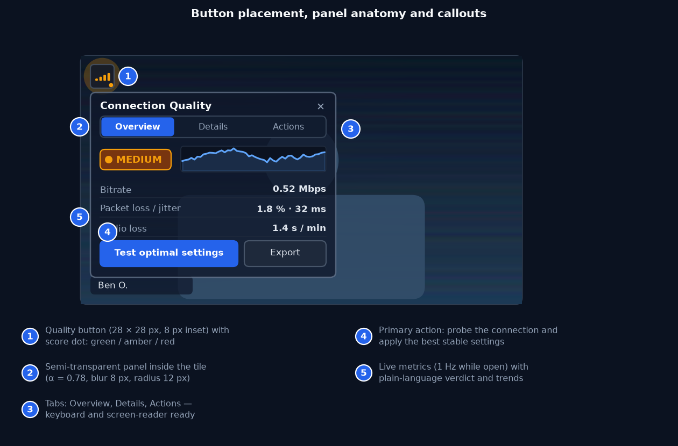
Figure 2 — Badge placement, panel anatomy and layout callouts. The panel is anchored 8 px inside the tile's top-left corner and never exceeds the tile bounds.

7.2 Layout and design tokens
Table 10 — Design tokens (Tailwind mapping in parentheses)
Element | Value | Notes
Badge size | 28 × 28 px (h-7 w-7), radius 8 px (rounded-lg) | 44 × 44 px on touch layouts
Badge background | slate-950 at 82 % opacity, 1 px slate-600 border | Backdrop blur 4 px; colour dot 6 px
Panel width | min(340 px, 94 % of tile width) | Small tiles use a full-tile sheet
Panel background | slate-950 at 78 % opacity + 8 px backdrop blur | Semi-transparent by design; text remains ≥ 4.5:1 over video
Panel radius / border | 12 px / 1 px slate-500 | 1 px inner highlight on the top edge
Typography | Title 12 px semibold; labels 11 px; values 11 px semibold tabular | Numbers use tabular figures to avoid jitter
Spacing | 12 px padding; 8 px row gap | 44 px minimum touch targets
Colours | High emerald-500, Medium amber-500, Low red-500 | Also encoded by icon shape and label, never colour alone
Motion | 120 ms fade/scale-in; sparkline animates only when not reduced-motion | Reduced motion disables the activity ring and sparkline animation

7.3 Overview tab
The Overview tab answers three questions in order: how good is it?, why?, what now?. The verdict pill carries the band; the line under it names the dominant limiter in plain language (“Network: packet loss and jitter” / “Publisher CPU is limiting” / “Relay path: elevated round-trip time”). The sparkline shows delivered bitrate for the last 60 seconds with the current simulcast layer's target drawn as a dashed reference. Eight headline metrics follow: bitrate, resolution/layer, frame rate, video packet loss, jitter and RTT, skipped frames, audio loss in the last minute, and audio concealment ratio. The footer carries Details, Actions and the primary Test optimal settings button.
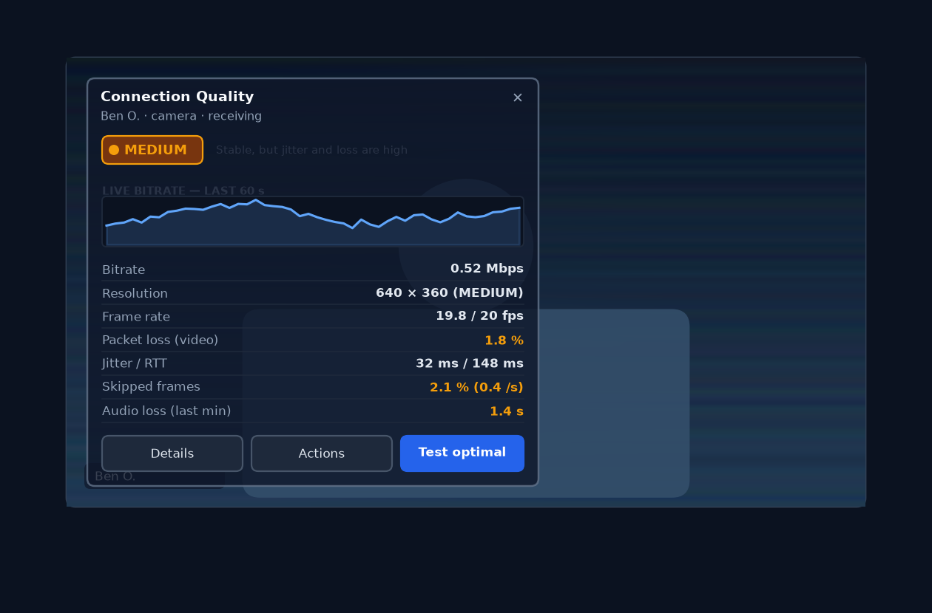
Figure 3 — Overview tab: verdict, limiter explanation, 60-second bitrate history and the headline metrics, updating at 1 Hz while the panel is open.

7.4 Details tab
Details is the support-friendly view. It groups metrics into Video, Audio, Transport and Publishing (the last only on the local tile), each row showing the current value, a 2-minute mini-history and the definition. Transport rows expose the selected ICE candidate pair type (Direct / Relay), the protocol, the local codec and the decoder implementation. An Action log lists the last ten actions with timestamps and results (for example Resync stream — completed in 1.2 s). The Export report button downloads a JSON file named cq-report-<meeting>-<time>.json.
Note — The export contains derived counters, band verdicts, browser and device class, and the action log. It deliberately excludes media, participant e-mail addresses, raw IP addresses, precise location and device identifiers; participant names are reduced to role labels (self / remote tile A) unless the user opts in to include names.

7.5 Actions tab
Actions is organised top-to-bottom by increasing impact: Resync · Reset to auto links, subscription quality, max bitrate, resolution and frame rate, compression, colour depth, and the footer's Cancel / Apply. On remote tiles the copy reads “Applies to what you receive”; on the local tile a warning banner reads “Changes are visible to everyone in the meeting” and the Apply button is styled as a primary action. Controls that the current browser or codec cannot honour are visibly disabled with an explanation (for example 10-bit colour on a device whose encoder only supports 8-bit).
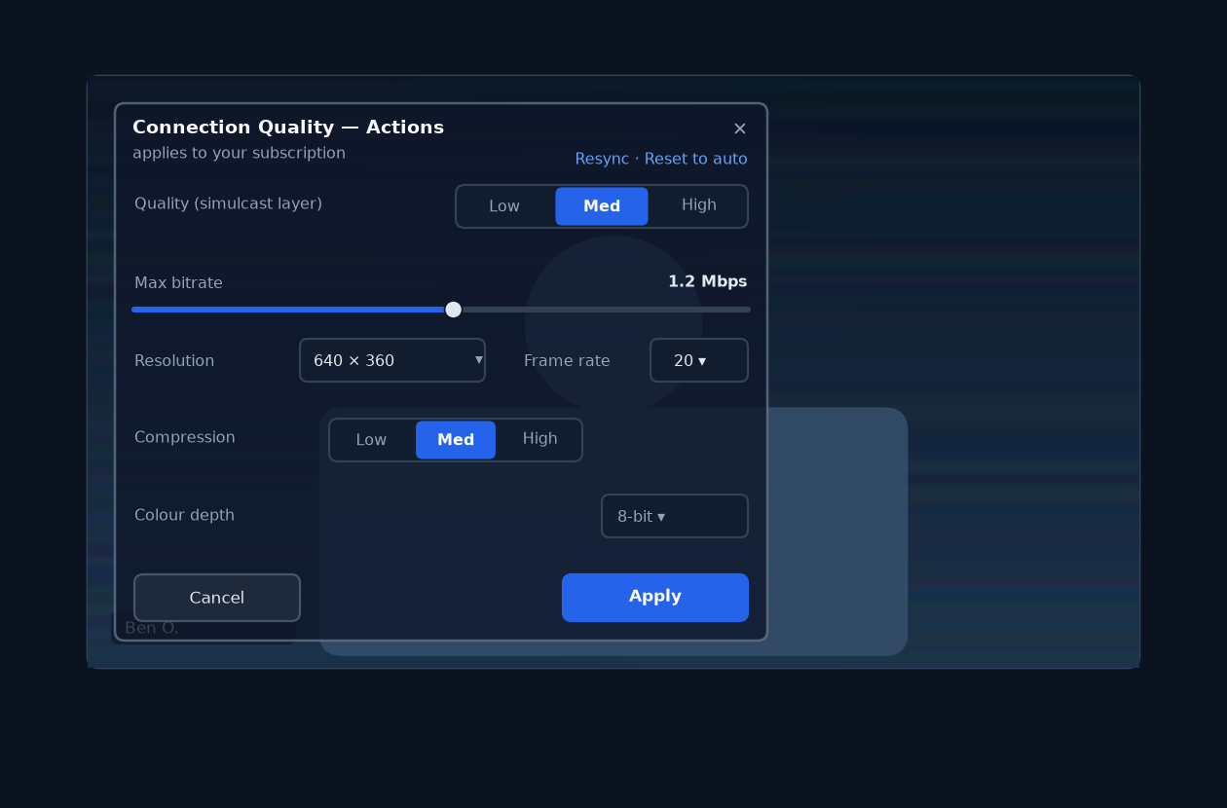
Figure 4 — Actions tab for a remote tile. Every control explains its scope; publisher-side settings such as colour depth remain visible but disabled with a reason.

7.6 Device and capture configuration
The Device tab is shown on the local tile only, because only the publisher can read or change its capture devices. It turns the panel into a compact capture-control surface without duplicating the existing toolbar controls: the camera and microphone pickers use the same switchActiveDevice() path as DeviceSwitcher, and the mirroring note links to the existing preference.
- Camera. Device picker; resolution preset (Auto / 1080p / 720p / 540p / 360p / 180p); frame-rate preset (30 / 24 / 15 fps). Options outside the camera's reported capabilities are disabled with the reason, and a read-only line shows what the camera reports (for example max 1080p @ 30 · 16:9) plus the live publishing format (1280 × 720 @ 30 · 1.8 Mbps).
- Microphone. Device picker; channels Mono / Stereo; audio quality Voice / Music. Channel count and quality are coupled by browser behaviour, so the UI states the consequence inline: stereo reacquires the microphone with channelCount: 2 and the hi-fi stereo preset, which turns echo cancellation and noise suppression off (headphones required) and raises uplink bandwidth up to 510 kbps.
- Read-out. Sample rate (48 kHz), RED and DTX state, and the achieved channel count come from getSettings() after apply, so the panel shows reality rather than intent.
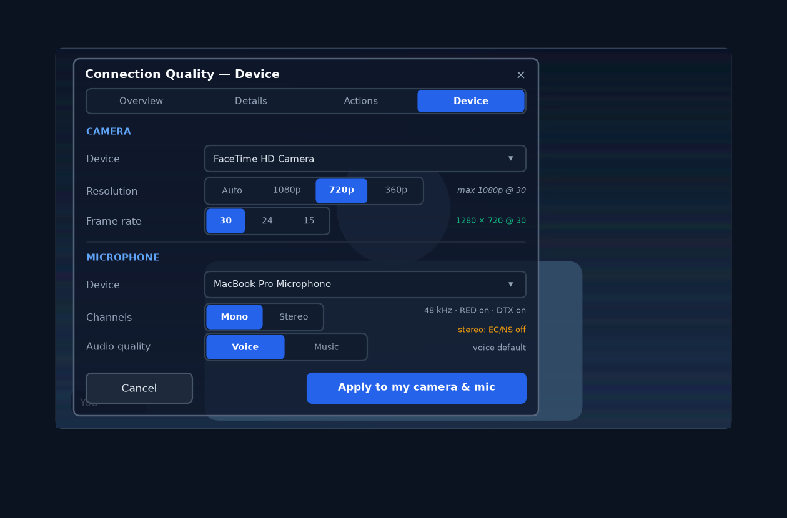
Figure 5 — Device tab on the local tile: camera and microphone configuration with capability-validated presets and explicit mono/stereo trade-offs.
On a remote tile the tab is replaced by a short explanation — “Camera and microphone settings belong to Ben” — because WebRTC does not expose another participant's capture configuration, and the received resolution/frame-rate figures in Details remain the only observable truth. This keeps the design honest: the panel never implies control it does not have.
Device changes never drop the call. A resolution or frame-rate change applies new constraints to the running capture track; a channel-mode change reacquires only the microphone; both are reversible through Reset to auto, which restores the last known good capture settings. The publishing change is logged in the action log and, on failure, the previous configuration is restored before the user sees an error.

7.7 Auto-tune flow
Test optimal settings runs the probe described in §10. Progress is shown as a four-step list (baseline, LOW, MEDIUM, HIGH) with a live readout of delivered bitrate, loss and RTT. Video keeps playing throughout: only the selected tile's subscription steps through the ladder, and the previous setting is restored if the user cancels. The result view states the recommendation, the expected effect (“+38 % delivered bitrate, loss below 1 %”), which candidate was rejected and why, and offers Apply, Retry and Dismiss. Applying starts a 15-second observation with automatic rollback.
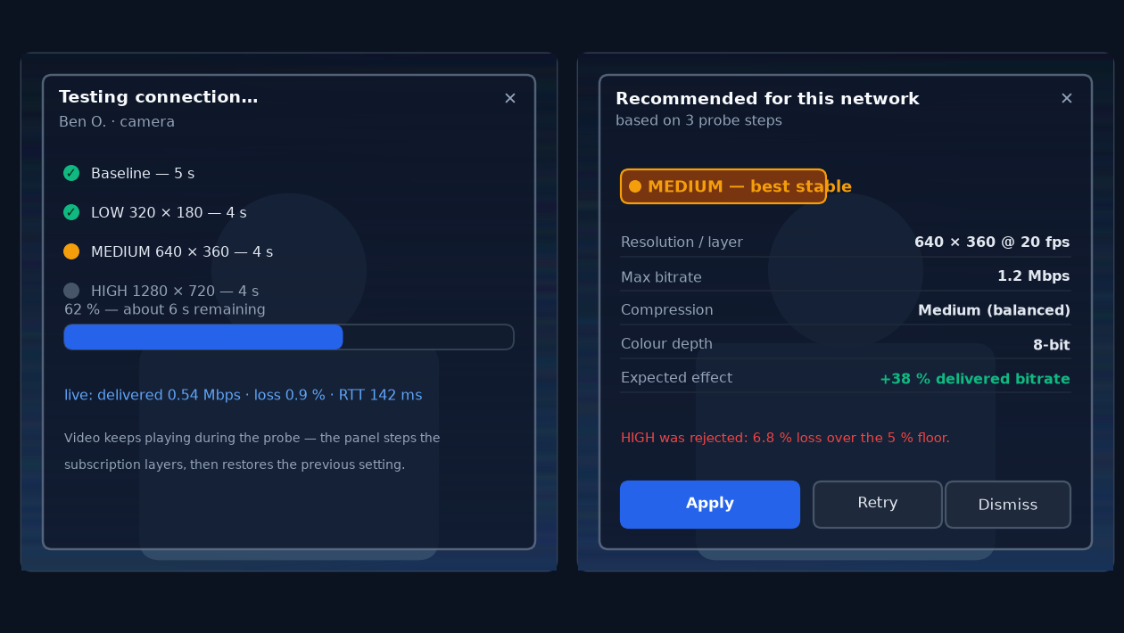
Figure 6 — Auto-tune progress and result. The probe never interrupts audio and restores the previous settings if cancelled or rolled back.

7.8 Small screens, PiP and thumbnails
Below 260 px of tile width the inline panel would leave no video visible, so the badge opens a bottom sheet covering the tile with the same three tabs and larger touch targets; swipe-down, ✕ and Esc close it. PiP overlay tiles follow the same threshold. Thumbnail strips in speaker layout use the sheet behaviour by default; the badge is omitted entirely below 120 px to avoid clutter, with quality still visible in the participant list.
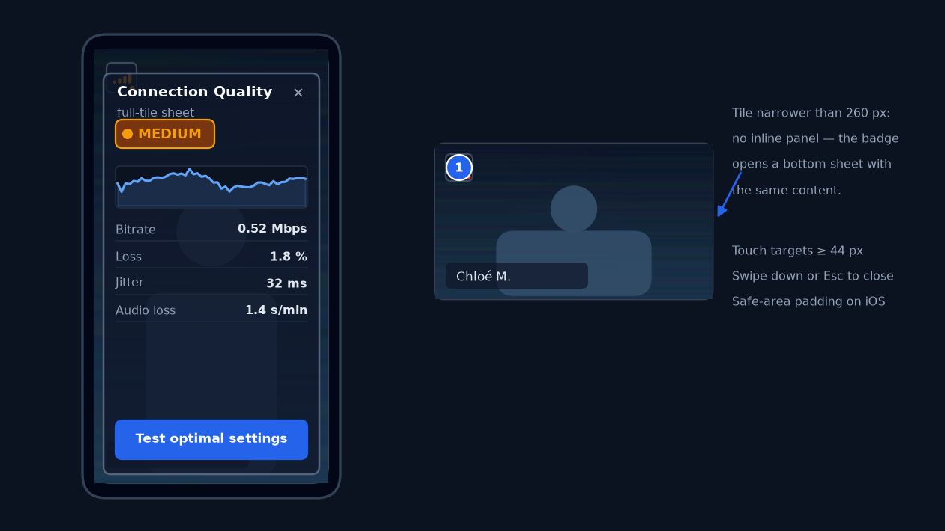
Figure 7 — Small-screen behaviour: a full-tile sheet on narrow tiles, with 44 px touch targets and safe-area padding; smaller thumbnails keep the badge only.

7.9 Accessibility
- The badge is a native button with aria-expanded, aria-controls and an accessible name that includes the participant and the verdict.
- The panel is a labelled role="region" (aria-label="Connection quality for Ben O."); tabs follow the ARIA tabs pattern with arrow-key navigation.
- Esc closes and returns focus to the badge. Tab order stays inside the panel while it is open only for keyboard users who entered it; the meeting shortcuts (mute, camera) remain available through their global keys.
- The sparkline has a text alternative (“Bitrate over the last 60 seconds: lowest 0.3, highest 1.9, now 0.52 Mbps”) and is hidden from screen readers when reduced motion is on.
- Colour is never the only signal: bands are also spelled out (Low / Medium / High), and the icon shape changes for the Lost state.
- Contrast is enforced over blurred video by the panel's 78 % scrim; automated checks run in CI against the panel token set.

7.10 Internationalisation
Strings live in the cq.* namespace of frontend/public/locales/en.json and are consumed with useTranslation() exactly like the rest of the app. The panel avoids string concatenation: values and units are separate keys, numbers are formatted with Intl.NumberFormat, and durations use Intl.RelativeTimeFormat where useful. The 48 existing locales fall back to English until translated; a CI check fails if a new key is missing from en.json. RTL locales mirror the panel through logical CSS properties (inset-inline-start, padding-inline), keeping the anchor at the top-left reading corner. Appendix C lists the initial key set.

7.11 Error and empty states
Table 11 — Error and empty states
Situation | What the user sees | Technical behaviour
Stats unavailable (older browser) | “Detailed statistics are not available in this browser” + LiveKit indicator | Capability probe sets degraded mode; only resync / audio-only / quality actions remain
Action fails (subscription rejected) | Inline error with Retry and a link to Diagnostics | Error is logged to the action log; previous override is preserved
Stream unpublished mid-panel | Panel shows 'Stream ended' and closes after 3 s | Track ref teardown; watchers are unregistered
Reconnect fails twice | Dialog offering to copy the meeting link and retry | Backoff honours network.reconnectAttempts; no infinite retry loop
No samples yet | Skeleton rows with 'Measuring…' | Verdict hidden until 4 samples or 4 s have elapsed
Participant muted / camera off | Badge hidden; existing avatar placeholder remains | No stats polling for absent tracks

8. Statistics, scoring and metric catalogue

8.1 Metric catalogue
All metrics are derived locally from WebRTC statistics. Remote tracks expose RemoteTrack.getRTCStatsReport(); the local publisher uses LocalVideoTrack.getSenderStats() and LocalAudioTrack.getRTCStatsReport(). Counter-based metrics are computed as deltas between consecutive reports divided by the actual elapsed time; instantaneous gauges (jitter, RTT, jitter-buffer delay) are sampled directly.
Table 12 — Metric catalogue and band thresholds
Metric | RTCStats source | Derivation | Unit | High band | Medium band | Low band
Delivered video bitrate | VideoReceiverStats.bytesReceived | Δbytes × 8 / Δt | Mbps | ≥ 85 % of layer target | 50–85 % | < 50 %
Decoded frame rate | VideoReceiverStats.framesDecoded | Δframes / Δt | fps | ≥ 90 % of expected | 70–90 % | < 70 %
Video packet loss | packetsLost, packetsReceived | Δlost / (Δlost + Δreceived) | % | < 1 | 1–3 | > 3
Jitter | VideoReceiverStats.jitter | RTP jitter × 1000 | ms | < 20 | 20–45 | > 45
Round-trip time | selected candidate-pair.currentRoundTripTime | × 1000 | ms | < 80 | 80–200 | > 200
Skipped frame ratio | framesDropped, framesDecoded | Δdropped / (Δdropped + Δdecoded) | % | < 1 | 1–4 | > 4
Audio bitrate | AudioReceiverStats.bytesReceived | Δbytes × 8 / Δt | kbps | ≥ 90 % of target | 60–90 % | < 60 %
Audio loss (last minute) | concealedSamples, sample rate | Σconcealed / 48 000 over the 60 s window | s/min | < 0.5 | 0.5–2 | > 2
Audio concealment ratio | concealedSamples, totalSamplesDuration | concealed / (totalSamplesDuration × 48 000) | % | < 1 | 1–3 | > 3
Jitter-buffer delay | jitterBufferDelay, jitterBufferEmittedCount | Σdelay / Σemitted | ms | < 60 | 60–150 | > 150
Publisher CPU/bandwidth limiter | VideoSenderStats.qualityLimitationReason | categorical (none / bandwidth / cpu / other) | state | none | bandwidth | cpu / other
Publishing frame size | VideoSenderStats.frameWidth/Height | sampled | px | matches intent | one step lower | two steps lower
Transport type | selected candidate pair candidateType | categorical | state | host / srflx (Direct) | prflx | relay (TURN)
Target bitrate | VideoSenderStats.targetBitrate | sampled | Mbps | ≥ preset | within 20 % | below 80 % of preset

A note on lost or skipped audio seconds per minute: WebRTC does not report a literal “seconds lost” counter. concealedSamples counts audio samples the decoder had to reconstruct because packets were missing; dividing by the 48 kHz sample rate yields the duration of reconstructed audio. Summed over a rolling 60-second window this is the most faithful available proxy for “audio seconds lost in the last minute”, and it matches user perception well (about 200 ms of concealment per event becomes audible as a click or warble). Silent concealment (silentConcealedSamples) is tracked separately so that silence padding does not inflate the number.

8.2 Quality score model
The verdict is a weighted composite (0–100) mapped to three user-facing bands. Each input is normalised to 0–1 with the piecewise-linear thresholds above, smoothed with an exponentially weighted moving average (α = 0.4, roughly a 5-sample half-life at 1 Hz), and combined with fixed weights. Band changes require three consecutive samples inside the new band and a 5-point margin from the boundary to prevent flicker.
Table 13 — Score composition
Component | Weight | Inputs | Notes
Network health | 25 | Packet loss, jitter, RTT, transport type | Relay adds a 0.85 multiplier on RTT and loss sub-scores
Video bitrate adequacy | 20 | Delivered bitrate vs current layer target | Missing samples fall back to 0.5 for up to 4 s
Frame delivery | 20 | Decoded fps vs expected, skipped-frame ratio | Freeze detection uses framesReceived vs decoded
Audio continuity | 15 | Audio loss per minute, concealment ratio, jitter-buffer delay | Audio is weighted heavily because glitches are the most distracting
Stability | 10 | EWMA trend, band transitions, reconnect events | Penalises oscillation and recent losses
Publisher headroom | 10 | qualityLimitationReason, target vs actual bitrate (local / known publishers) | Only scored when sender stats are available; weight redistributed otherwise

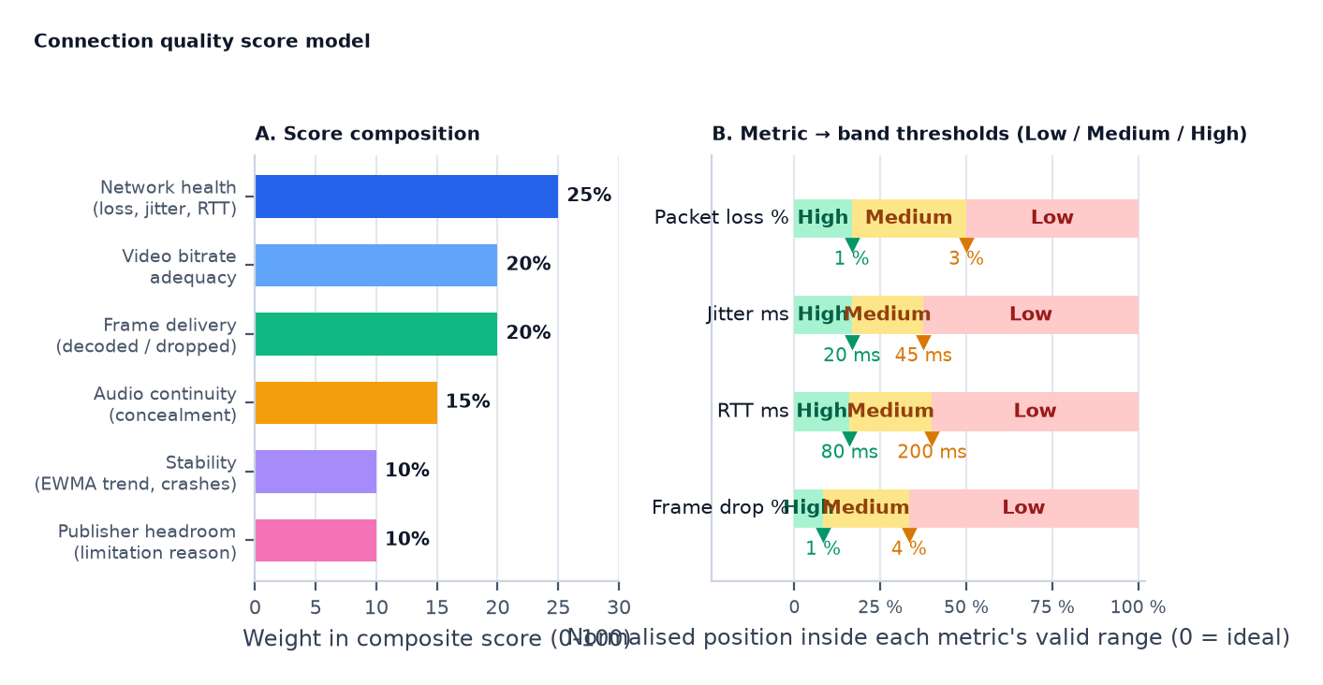
Figure 8 — Score composition and the per-metric thresholds that map measured values to High / Medium / Low band points.
Special cases: ConnectionQuality.Lost forces the Low band with a reconnecting label regardless of score; the first four seconds show Measuring; during a probe the verdict is frozen to the pre-probe value so the user is not misled by the deliberately degraded steps. The limiter shown in the explanation line is chosen by which component has the lowest normalised score, with ties broken in favour of network, then publisher, then stability. When sender stats identify cpu as the quality-limitation reason, the copy switches to publisher-side advice (“Lower your resolution to recover sharpness”) and the Actions tab pre-selects the local-tile controls.

9. Improvement actions
Actions are grouped by the layer they affect: the receive path (your subscription), the publish path (your camera and microphone), the transport (the peer connection to the SFU), and the clipboard (diagnostics). Each action declares its scope, the underlying API, its expected effect, its risk and how it can be undone.

9.1 Action catalogue
Table 14 — Improvement actions
Action | Scope | Underlying API | Effect / risk | Undo
Resync stream | Receive path, one remote video track | RemoteTrackPublication.setSubscribed(false→true) | Forces a fresh subscription and keyframe; 0.5–2 s freeze on that tile. Low risk. | Automatic; previous subscription state is restored
Reconnect transport | Room-wide (all tiles) | Room.disconnect() + fresh token + Room.connect(); ICE restart handled by LiveKit | Rebuilds signaling and ICE; 2–6 s interruption; attended only. | Implicit; reconnects to the same room
Quality layer (Low / Medium / High / Auto) | Receive path, one remote video track | RemoteTrackPublication.setVideoQuality(VideoQuality.LOW|MEDIUM|HIGH) | Caps received resolution/bitrate; Auto clears the override. No renegotiation. | Set to Auto or Reset to auto
Max bitrate | Publish path (local tile) or receive-side layer cap (remote) | RTCRtpSender.getParameters()/setParameters() with encodings[].maxBitrate; remote: pick a lower simulcast layer | Bounds encoder output; too low visibly softens the image. Safe and immediate. | Restore previous parameters (stored before apply)
Resolution / frame rate preset | Publish path (local tile) | mediaStreamTrack.applyConstraints({ width, height, frameRate }), validated against getCapabilities() | Changes what everyone receives. Lower values reduce CPU and bandwidth. | Constraint rollback to the previous values
Camera / microphone device | Publish path (local tile) | room.switchActiveDevice('videoinput' | 'audioinput', deviceId) | Switches hardware mid-call without reconnecting; persisted to prefs.av.preferred*Id. | Switch back or reselect the previous device
Audio channels (Mono / Stereo) | Publish path (local tile) | Reacquire the mic with AudioCaptureOptions.channelCount; publish with forceStereo | Stereo preserves music and spatial content; disables echo cancellation / noise suppression and raises uplink bandwidth (up to 510 kbps stereo). | Switch back to Mono (reacquires the mic)
Audio quality (Voice / Music) | Publish path (local tile) | audioPreset (speech / musicHighQualityStereo), audioBitrate, dtx, red | Voice optimises intelligibility and bandwidth; Music maximises fidelity for performances and playback. | Preset switch or Reset to auto
Compression preset (Low / Medium / High) | Publish path (local tile) | contentHint, degradationPreference, bitrate profile, codec preference order | Low = smaller stream, more artefacts; High = better detail, more bandwidth. | Preset switch or Reset to auto
Colour depth (8-bit / 10-bit) | Publish path (local tile) | Capability probe (RTCRtpSender.getCapabilities('video'), MediaCapabilities.encodingInfo), republish with preferred codec | Only enabled when the device, browser and codec support 10-bit; otherwise explained as unavailable. | Republish with the default codec order
Audio-only for this tile | Receive path, one remote video track | RemoteTrackPublication.setEnabled(false/true) | Stops video bytes without renegotiation; audio keeps flowing. Instant. | Toggle back on (previous adaptive size applies again)
Export diagnostics | Local clipboard / file | Local JSON serialisation of the ring buffers and action log | No media, no personal data. Safe. | n/a
Reset to auto | All overrides for this tile | Clear the per-tile override entry in the store | Returns to auto-tune cache, then global preference, then adaptive streaming. | n/a

9.2 Resync vs reconnect
Resync is per-tile and cheap: the client unsubscribes and immediately re-subscribes to the track, which makes the SFU start a fresh stream and send a keyframe. It fixes the common failure where a decoder is stuck waiting for a keyframe after loss, at the cost of a short freeze on one tile. Reconnect is room-wide and expensive: it rebuilds the signaling WebSocket and the peer connection. LiveKit already performs automatic ICE restarts and full reconnects on network changes; the manual action exists for the cases where the automatic path has settled into a bad state (for example, a stale relay allocation). Because it briefly interrupts every stream, it is behind a confirmation dialog and disabled while a recording is being started or stopped.
Note — LiveKit 2.5 does not expose a public request keyframe (PLI) call. Resync covers the use case; a dedicated keyframe request is tracked as an upstream request and an open question (§19).

9.3 Quality, bitrate and resolution
For a remote tile, the most effective and least invasive control is the simulcast layer: the publisher already encodes LOW, MEDIUM and HIGH versions of the camera, and the receiver simply picks one. setVideoQuality() caps the maximum layer the SFU will send. Selecting Auto removes the client override so LiveKit's adaptiveStream can follow the rendered tile size again. Choosing a lower layer is the only honest way to reduce a remote stream's bandwidth, because a receiver cannot re-encode what it gets.
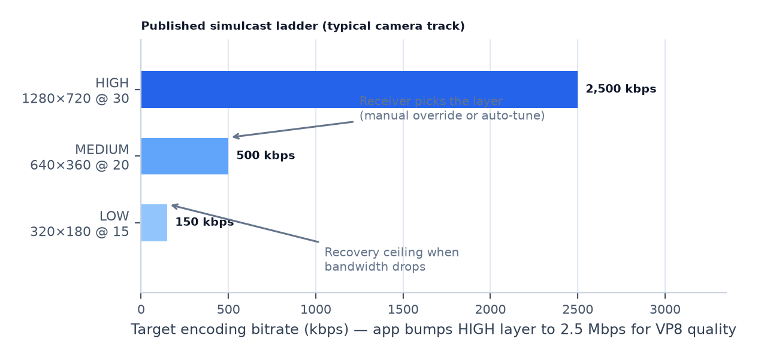
Figure 9 — Typical published simulcast ladder. Remote-tile controls select the layer; local-tile controls change what is encoded in each layer.
For the local tile, the app owns the encoder and can genuinely change resolution, frame rate and bitrate. Resolution and frame rate are capture constraints applied to the raw MediaStreamTrack (track.mediaStreamTrack.applyConstraints(), the same path already used by BackgroundPicker for native aspect); the bitrate cap is applied to the RTP sender's encoding parameters. Simulcast publishers have one sender per layer on some browsers, so the implementation re-applies the cap to every active encoding and falls back to a controlled republish when the browser clamps or rejects the parameters. Every change stores the previous value so Reset to auto and rollback are exact.

9.4 Compression presets
“Compression” is a user-facing bundle of encoder instructions rather than a single knob. The three presets map to concrete, browser-supported settings and degrade gracefully when a browser ignores one of them.
Table 15 — Compression presets
Preset | Intent | Content hint | Degradation preference | Bitrate profile | Codec order
Low | Smallest stream; stutter-free on weak links | motion | maintain-framerate | 0.6 × preset max | VP8 / H.264 first
Medium (default) | Balanced motion and detail | motion | balanced | 1.0 × preset max | VP9 / AV1 when supported, else VP8
High | Best detail for slides and shared content | detail | maintain-resolution | 1.15 × preset max (if bandwidth allows) | AV1 / VP9 first

Presets are applied on the local tile only. On remote tiles the same three labels are shown disabled with the explanation “Set by the publisher's camera”, so the mental model stays consistent without pretending to offer control that does not exist.

9.5 Colour depth
Colour depth is the most constrained control in the catalogue, and the design treats it honestly. Before enabling 10-bit, the feature probes what the platform can do: video capture capabilities, RTCRtpSender.getCapabilities('video') for codec profiles, and MediaCapabilities.encodingInfo() for the requested configuration. If the device camera only produces 8-bit frames (the common case for laptop webcams) or the browser cannot negotiate a 10-bit profile (typically AV1 or VP9 profile 2), the option renders disabled with the reason inline. Nothing is promised that the platform cannot deliver.
When 10-bit is available, applying it republishes the camera track with the preferred codec order and the same simulcast layers; the operation is logged in the action log and reversible through Reset to auto. 10-bit is most valuable for screen shares of gradients and HDR content; for talking-head camera video the practical benefit is small, and the UI says so.

9.6 Audio actions
The panel also exposes the capture-side audio configuration on the local tile. Mono (the default) is right for speech: it keeps echo cancellation and noise suppression available, halves uplink audio bandwidth and keeps RED/DTX enabled. Stereo is for music, shared performances and any content where channel separation matters; it reacquires the microphone with channelCount: 2, publishes with forceStereo, and requires the hi-fi preset, which turns echo cancellation and noise suppression off — the UI warns about the headphones requirement and the bandwidth increase (up to 510 kbps stereo). The achieved channel count and sample rate are read back from getSettings() and shown in Details.
Audio quality problems are reported as audio loss and concealment ratio per direction. Receive-side, the only meaningful actions are choosing a different path (reconnect) or leaving audio untouched while reducing video load (quality layer, audio-only), because audio is already the lowest-bandwidth and most protected stream. Publish-side, the panel exposes a link to the existing audio settings and, where the user is the publisher, recommends enabling RED (redundant encoding, on by default in LiveKit) when loss is high, and warns that disabling DTX or using the hi-fi stereo preset increases bandwidth substantially — a tip surfaced from the LiveKit guidance in §15.

9.7 Action safety and limits
- One write action at a time per tile; buttons disable while an action is in flight.
- Probes: one at a time per room (a store mutex), 60 s cooldown per tile, skipped when the tab is hidden.
- Reconnect: requires confirmation, honours network.reconnectAttempts, and offers a “copy meeting link” fallback after two failures.
- Resync: maximum three attempts per minute per tile, with exponential spacing.
- Every action writes to a 10-entry action log with start time, duration and result; the log is included in the diagnostics export.
- All overrides are session-scoped in memory and cleared on leaving the meeting; only genuine preferences (quality, force relay) remain in the preference store.

10. Auto-tune: test optimal settings

10.1 Probe design
The probe measures how the connection actually behaves on the three simulcast candidates instead of trusting a single instantaneous sample. It runs on the selected tile only and never touches audio or other participants.
- Precheck — the room is connected, the tile has a subscribed video track, no other probe is running, and the tab is visible. For the local tile, a warning explains that publishing changes will be visible to the room.
- Baseline (5 s) — collect the current settings' delivered bitrate, loss, jitter, RTT, decoded fps and skipped-frame ratio.
- Ladder (3 × 4 s) — step LOW → MEDIUM → HIGH, waiting 1.5 s after each switch for the decoder and estimator to settle, then sampling for 2.5 s. Audio is never modified; the video may briefly reduce quality on the probed tile.
- Evaluate — score each candidate with the same model as §8.2, discarding any step whose loss exceeds 5 % or whose delivered bitrate collapses for more than 1.5 s (adaptation noise).
- Apply — choose the highest-scoring stable candidate; if none passes the floor, keep the current settings and offer resync.
- Observe (15 s) — after applying, keep sampling. Roll back if the score drops more than 15 % from the pre-probe baseline or loss stays above 5 % for three consecutive samples.
- Cool down (60 s) — results are cached for the session keyed by tile and connection fingerprint; the cooldown prevents oscillation and repeated probing over the SFU.
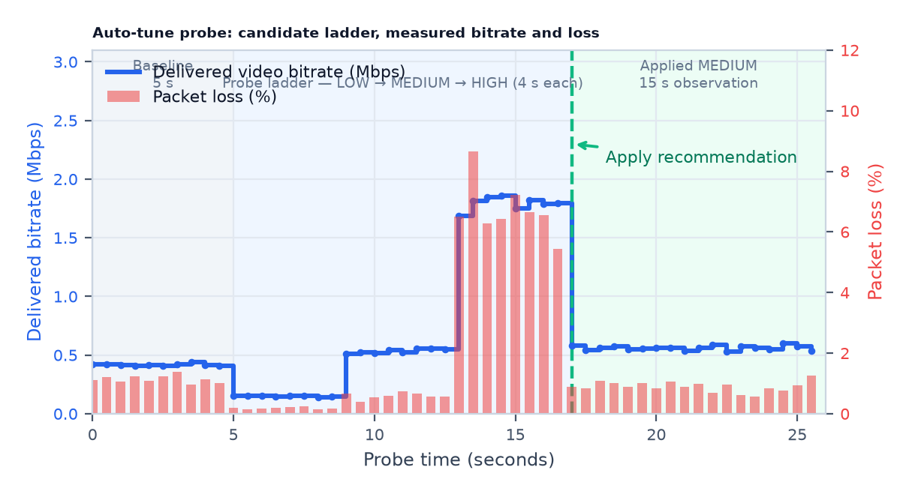
Figure 10 — Typical probe trace: baseline, the three candidate steps, the HIGH-layer rejection under loss, and the applied MEDIUM setting during observation.

10.2 Candidate decision matrix
Each candidate is summarised by two robust statistics: the median delivered bitrate during its sampling window and the median packet loss. The matrix below converts them into a recommendation. It is deliberately conservative under loss: a high-bitrate candidate that cannot hold under 5 % loss is never chosen over a stable lower layer.
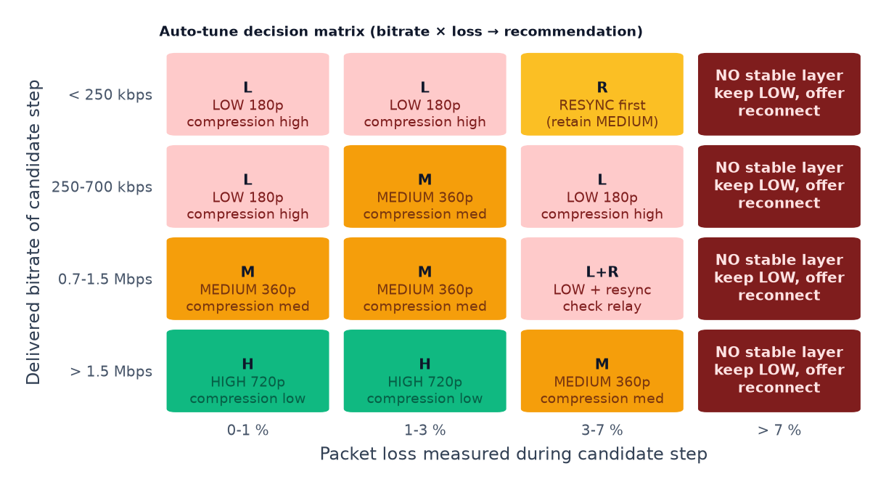
Figure 11 — Decision matrix used by the probe (bitrate × loss → recommendation). Loss above 7 % always resolves to a stable LOW layer plus a resync suggestion.

10.3 Apply, observe, roll back
Applying an auto-tune recommendation writes a normal per-tile override, which means the same precedence rules and the same Reset to auto path apply as for manual changes. The observation window is the safety net: three consecutive bad samples revert to the stored pre-probe state and surface a toast (“Reverted: the new setting was worse on this network”). Rollbacks are counted in telemetry as a quality signal for the probe itself.
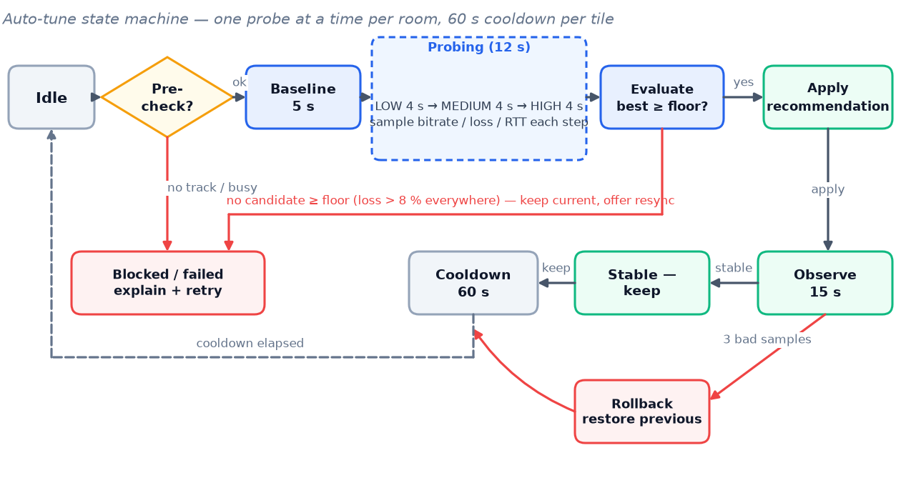
Figure 12 — Auto-tune state machine: one probe at a time per room, with evaluation, observation, rollback and a per-tile cooldown.

10.4 Expected outcomes
The probe is expected to help most when the adaptive algorithm has settled into a conservative layer (Wi-Fi with spiky loss), when the publisher is CPU-limited and the right answer is a lower publishing resolution, and when a relay path inflates RTT without actually limiting bandwidth. Lab emulation (three scenarios × 40 runs each) targets the improvements shown below; these numbers become the acceptance baseline for the feature.
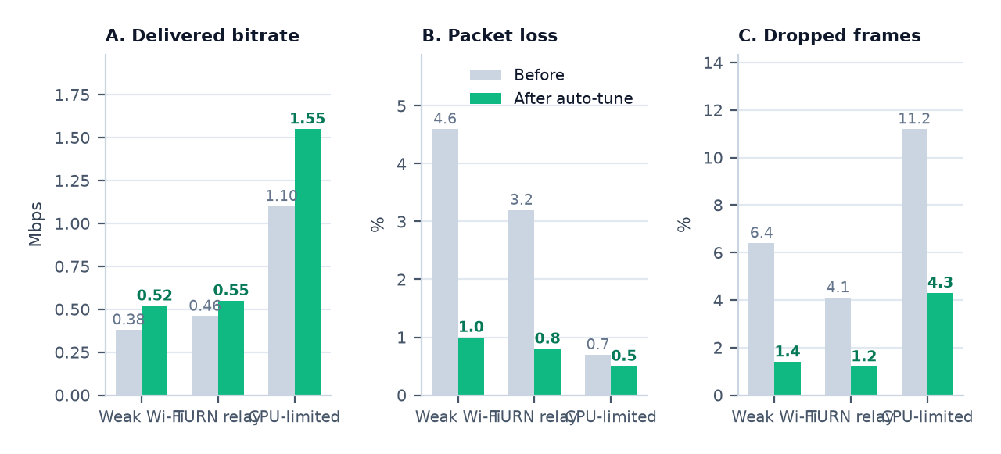
Figure 13 — Lab outcome 60 s after applying auto-tune recommendations. The CPU-limited scenario improves most through a publishing change, not a subscription change.

10.5 Caching and connection fingerprints
Results are cached in sessionStorage for the meeting, keyed by meetingId + trackKey + fingerprint, where the fingerprint is built from coarse, non-identifying signals: effective connection type when the Network Information API is available, whether the selected candidate pair is relay or direct, and bucketed RTT and loss. No IP addresses, SSIDs, BSSIDs, exact bandwidth values or stable device identifiers are stored. The cache is cleared on leaving the meeting; an opt-in preference may persist the chosen preset (not the fingerprint) for future meetings on the same device in a later release.

11. Technical architecture

11.1 Component model
The feature is a self-contained module under frontend/src/lib/cq/ plus two components in frontend/src/components/. It depends on livekit-client for statistics and controls, on the existing zustand preference store, and on the existing tile pipeline for mounting.
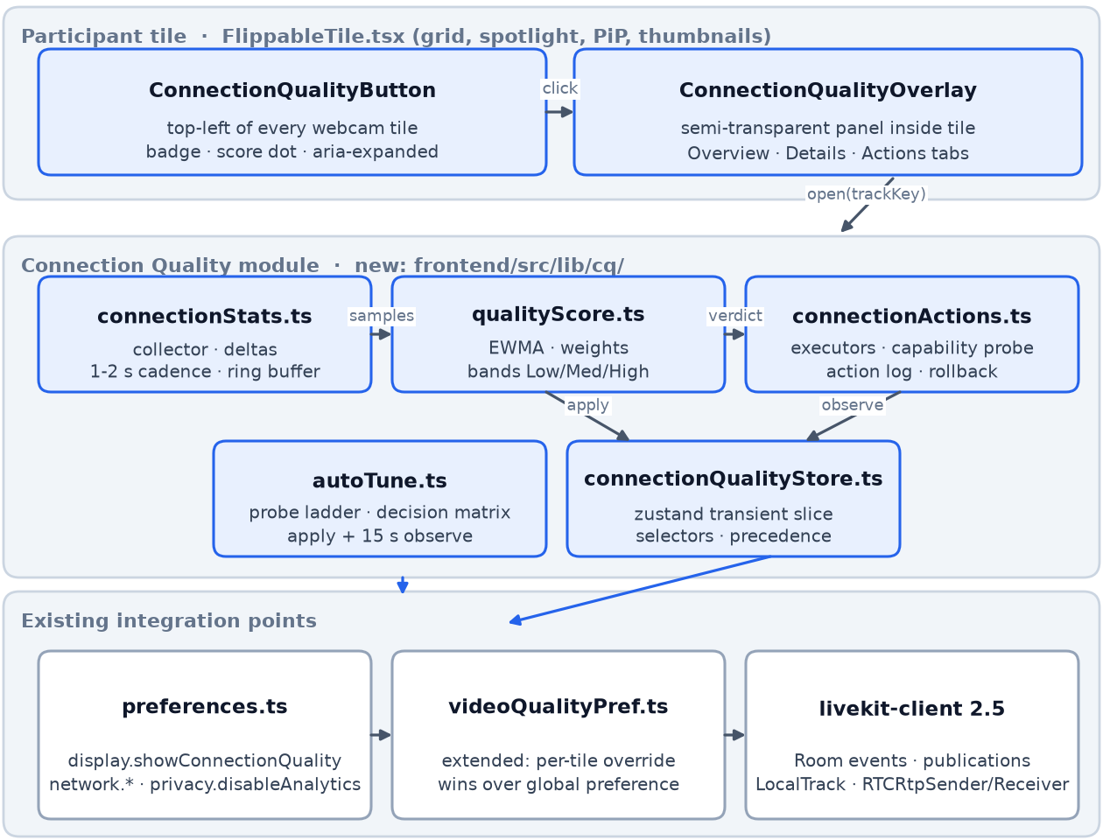
Figure 14 — Client component model: tile UI, the new Connection Quality module, the existing integration points and the LiveKit/SFU media path.

11.2 Modules and public interfaces
Table 16 — New modules and responsibilities
Module | Responsibility | Key exports
connectionStats.ts | Track registry, polling scheduler, RTCStats parsing, counter deltas, ring buffers, visibility and cadence management | StatsCollector, subscribe(trackRef), sample(), ConnectionStatsSample
qualityScore.ts | Normalisation, weights, EWMA, hysteresis, band mapping, limiter classification and human-readable explanations | scoreSample(sample, history), QualityVerdict, explain(verdict)
connectionActions.ts | Action executors, capability probe, sender-parameter snapshots, rate limiting, action log | runAction(trackRef, action, params), ActionLogEntry, capabilities()
autoTune.ts | Probe state machine, candidate sampling, decision matrix, apply / observe / rollback, session cache | AutoTuner, AutoTuneResult, ProbePhase
deviceConfig.ts | Camera/microphone capability probe, capture presets, channel mode and audio-quality application, post-apply read-back | readCameraCapabilities(), applyCapturePreset(), setChannelMode(), setAudioPreset()
connectionQualityStore.ts | Transient zustand slice: open panel, per-track overrides, verdicts, probe state, action log; selectors for the UI | useCqStore, selectTileQuality(trackKey), setOverride(), clearOverride()
ConnectionQualityButton.tsx | Badge rendering inside FlippableTile, score dot, accessible toggle, portal-free absolute positioning | React component (no props; reads the track ref from context)
ConnectionQualityOverlay.tsx | Panel with the three tabs, keyboard support, sparklines, action forms, auto-tune progress | React component (reads trackKey from the store)

// frontend/src/lib/cq/types.ts (excerpt)
export interface ConnectionStatsSample {
trackKey: string; // `${participant.identity}-${source}`
at: number; // epoch ms
direction: 'inbound' | 'outbound';
video?: {
bitrateBps: number; jitterMs: number; packetLossPct: number;
framesDecoded: number; fps: number; droppedPct: number;
frameWidth?: number; frameHeight?: number;
};
audio?: {
bitrateBps: number; packetLossPct: number; jitterMs: number;
concealmentPct: number; concealedSecondsPerMinute: number;
};
transport?: {
rttMs: number; candidateType: 'host' | 'srflx' | 'prflx' | 'relay' | 'unknown';
codec?: string; decoder?: string;
};
publisher?: { // local tile only
qualityLimitationReason?: 'none' | 'bandwidth' | 'cpu' | 'other';
targetBitrateBps?: number; framesPerSecond?: number;
};
}

export interface QualityVerdict {
band: 'low' | 'medium' | 'high';
score: number; // 0-100
limiter: 'network' | 'publisher' | 'relay' | 'stability' | 'unknown';
stable: boolean; // hysteresis settled
reasonKey: string; // i18n key for the explanation line
}

export interface TileQualityOverride {
trackKey: string;
videoQuality?: 'low' | 'medium' | 'high' | 'auto';
maxBitrateKbps?: number;
resolution?: { width: number; height: number; frameRate: number };
compression?: 'low' | 'medium' | 'high';
colorDepth?: 8 | 10;
source: 'manual' | 'auto-tune';
updatedAt: number;
}

11.3 Data flow and control loop
Statistics flow up from the SDK, are reduced to samples, scored and pushed into the store; user actions flow down through the action layer into subscription or sender controls, and the next collection cycle measures their effect. This closed loop is what makes auto-tune and rollback possible, and it is also the reason the collector is the only component that talks to the SDK for reads.
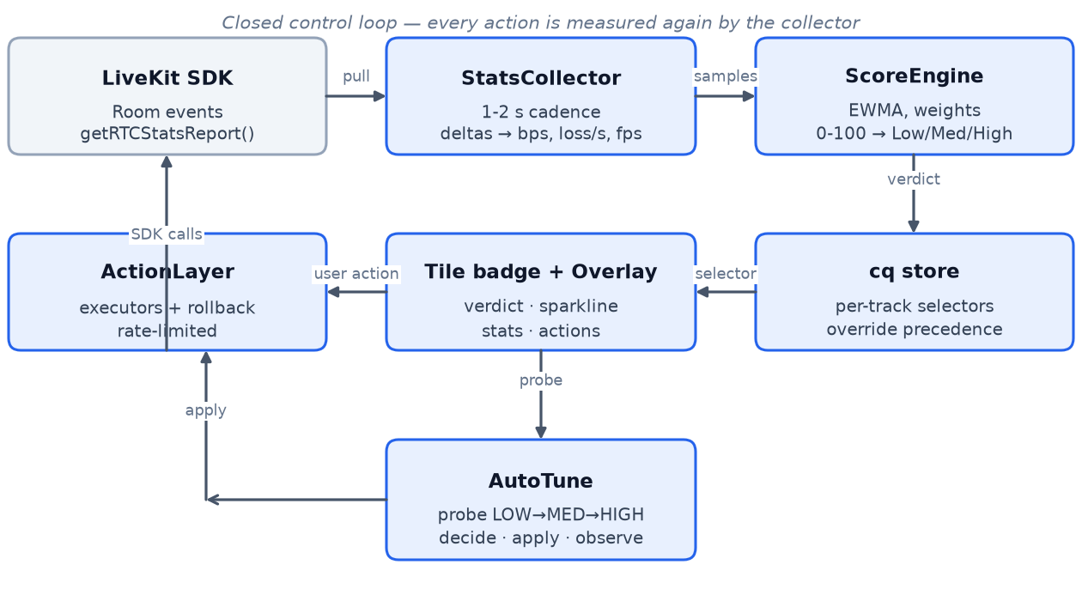
Figure 15 — Closed control loop: collect → score → display → act → measure again.

11.4 Interaction sequence
The sequence below covers the panel lifecycle and the two most important actions. Note that closing the panel stops the 1 Hz watch: the idle cadence (2 s) continues only while a badge is visible and the tab is active.
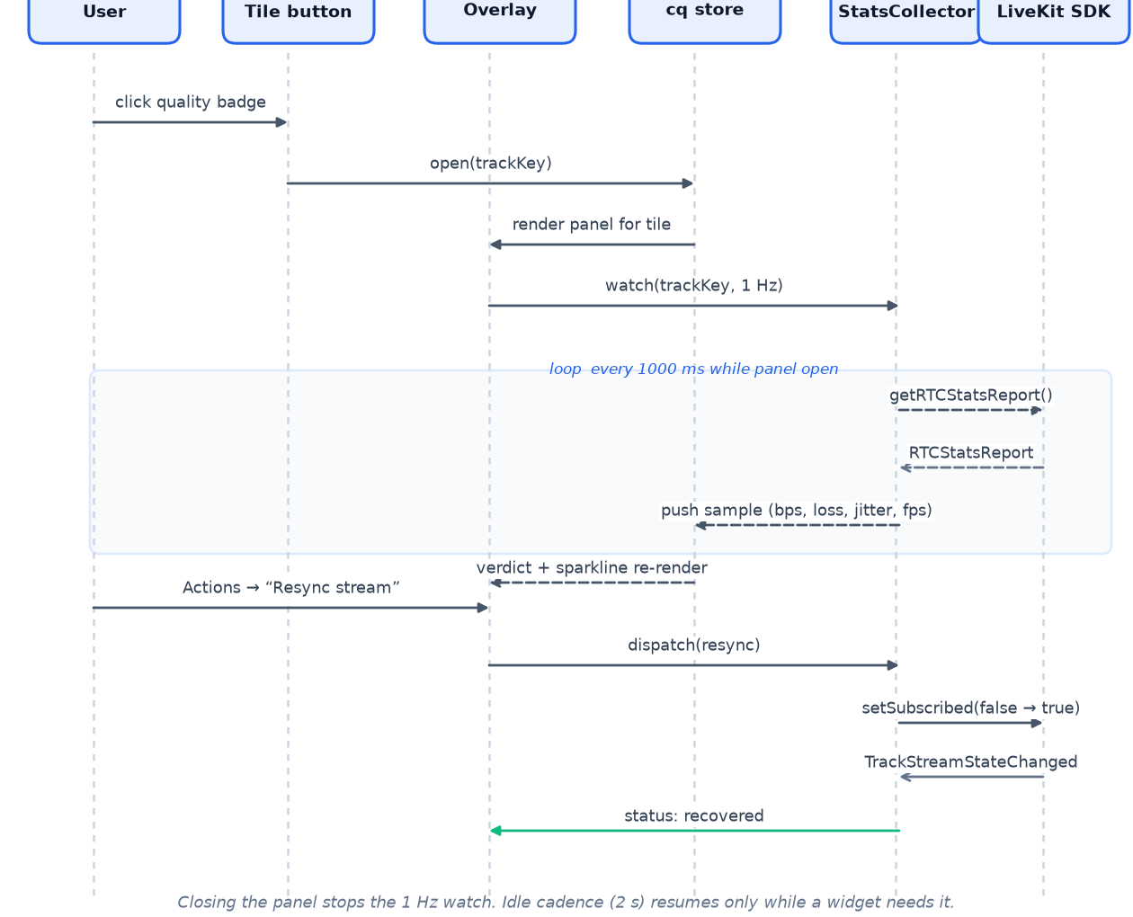
Figure 16 — Interaction sequence for opening the panel, live statistics, resync and auto-tune.

11.5 Store, precedence and persistence
Precedence is explicit and testable. A per-tile manual override wins over an auto-tune recommendation, which wins over the global network.preferredVideoQuality, which wins over LiveKit's adaptive behaviour. The existing useVideoQualityPref hook is extended to respect the override map: it keeps applying the global preference to publications without an override, and skips (or clears) those with one. Overrides are transient — they live in the zustand slice for the meeting session only.
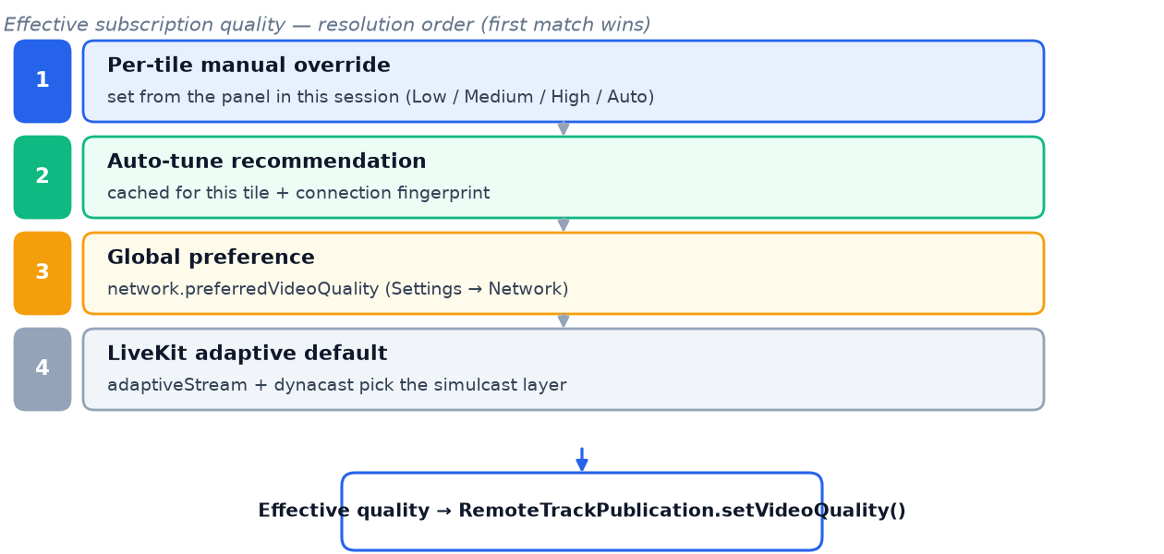
Figure 17 — Effective subscription quality precedence; the last step is LiveKit's adaptiveStream/dynacast behaviour when nothing overrides it.
// frontend/src/lib/cq/connectionQualityStore.ts (excerpt)
interface CqState {
openTrackKey: string | null;
overrides: Record<string, TileQualityOverride>;
verdicts: Record<string, QualityVerdict>;
probe: { trackKey: string; phase: ProbePhase; startedAt: number } | null;
actionLog: ActionLogEntry[];
open(trackKey: string): void;
close(): void;
setOverride(o: TileQualityOverride): void;
clearOverride(trackKey: string): void;
recordVerdict(trackKey: string, v: QualityVerdict): void;
}

11.6 Integration with existing code
Table 17 — Touch points in the existing codebase
File | Change | Why
components/FlippableTile.tsx | Render <ConnectionQualityButton /> as a sibling of ParticipantTile, positioned top-left; skip playback and audio-only | Every webcam surface already flows through this component
lib/preferences.ts | Extend network with qualityOverrideTtlMinutes?; wire display.showConnectionQuality to the new badge; add privacy.qualityTelemetry (default off) | Single source of truth for settings, with migration for existing persisted state
lib/videoQualityPref.ts | Consult the override map before applying the global preference; subscribe to store changes | Prevent the global hook from clobbering per-tile choices
components/DeviceSwitcher.tsx | Reuse its switchActiveDevice() selection logic and prefs.av.preferred*Id persistence inside the Device tab (extract the shared helper rather than duplicating it) | One device-switch path, one persistence rule
components/BackgroundPicker.tsx | Reuse the mediaStreamTrack.applyConstraints() pattern and its browser-quirk handling for capture presets | Consistent constraint behaviour across the app
lib/preferences.ts accessibility.monoAudio | Keep it as a playback downmix; the Device tab's Mono/Stereo is a capture setting. The UI must label them distinctly to avoid confusion | Two different concepts with similar names
styles/global.css | Add .cq-* classes only where Tailwind cannot express a value (panel scrim, blur fallback) | Keep styling consistent with meet-stage overrides
public/locales/en.json | Add the cq namespace (Appendix C) and a CI key check | Localisation is a hard requirement
lib/livekit.ts | No change in v1; expose connect options through a helper so reconnect reuses exactly the same configuration | Reconnect must not silently drop ICE/TURN settings
routes/Room.tsx | No structural change; the panel is rendered from the store inside the tile, so layouts and side panels stay untouched | Avoid touching the layout engine

11.7 LiveKit API mapping
All APIs below were verified against livekit-client 2.5.0 type definitions. They are wrapped in the action layer so an SDK upgrade changes one file, not the UI.
Table 18 — LiveKit and platform APIs used
Capability | API | Notes
Read remote stats | RemoteTrack.getRTCStatsReport(): Promise<RTCStatsReport | undefined> | Works for video and audio; returns the receiver-side report including candidate pairs
Read publisher stats | LocalTrack.getRTCStatsReport(), LocalVideoTrack.getSenderStats(): Promise<VideoSenderStats[]> | Sender stats include qualityLimitationReason, targetBitrate, framesPerSecond, rid per simulcast layer
Choose layer | RemoteTrackPublication.setVideoQuality(quality: VideoQuality): void | VideoQuality is numeric in 2.5 (LOW = 0, MEDIUM = 1, HIGH = 2)
Pause / resume bytes | RemoteTrackPublication.setEnabled(enabled: boolean): void | No renegotiation; cheaper than subscribing/unsubscribing for frequent toggles
Resync | RemoteTrackPublication.setSubscribed(subscribed: boolean): void | Full subscribe/unsubscribe; renegotiates and triggers a fresh keyframe
Capture control | LocalVideoTrack.mediaStreamTrack.applyConstraints(constraints) | Resolution and frame rate; the raw MediaStreamTrack is used because livekit-client 2.5 does not expose applyConstraints on the track wrapper
Camera capabilities | MediaStreamTrack.getCapabilities(), getSettings() | Drives the allowed preset list, the camera max read-out and the post-apply verification
Audio capture options | AudioCaptureOptions.channelCount, sampleRate, echoCancellation, noiseSuppression, autoGainControl | Channel mode and DSP trade-offs; applied when the microphone is (re)acquired
Audio publish options | TrackPublishOptions.audioPreset, audioBitrate, dtx, red, forceStereo | Voice vs Music presets; dtx/red default to true for mono tracks
Switch devices mid-call | Room.switchActiveDevice(kind, deviceId) | Already used by DeviceSwitcher; reacquires the device without reconnecting
Encoder control | LocalTrack.sender: RTCRtpSender | undefined → getParameters() / setParameters() | encodings[].maxBitrate, degradationPreference; browser clamping must be verified after set
Simulcast layers | LocalVideoTrack.setPublishingLayers(qualities: SubscribedQuality[]) | Per-layer pause/resume; SubscribedQuality comes from @livekit/protocol
Quality events | RoomEvent.ConnectionQualityChanged, Participant.connectionQuality | LiveKit's own loss/latency/jitter verdict; used as fallback and as a sanity check
Stream state | RoomEvent.TrackStreamStateChanged | Indicates SFU-side pause due to bandwidth; surfaced in the UI as a temporary state
Reconnect | Room.disconnect(), Room.connect(url, token, options), RoomEvent.Reconnecting/Reconnected | Reconnect reuses the existing token endpoint and roomOptions() configuration

11.8 Browser capability matrix
Table 19 — Browser behaviour relevant to the feature
Browser | getRTCStatsReport | setVideoQuality | Sender setParameters | Notes
Chrome / Edge 110+ | Yes | Yes | Yes | Reference implementation; qualityLimitationReason available
Safari 16.4+ | Yes | Yes | Partial | degradationPreference support varies; colour-depth probe often negative
Firefox 110+ | Yes | Yes | Yes | Simulcast camera tracks are VP8; setParameters on some encodings is ignored (verify after set)
Chromium mobile (Android) | Yes | Yes | Yes | Cadence reduced on battery saver
Older browsers / embedded webviews | Partial / no | Partial | No | Degraded mode: LiveKit indicator + safe actions only

11.9 Performance budget
Polling is visibility-aware: 2 s per visible tile in idle mode, 1 Hz for the single open panel, and zero for hidden tabs or off-screen tiles. A getRTCStatsReport() call parses an object graph of a few dozen entries; measurements on the reference device put one call at roughly 20–50 µs. The ring buffer stores 60 samples per track with only the numeric fields above (about 200 bytes each), so a 25-tile meeting holds well under the 1.5 MB budget. The collector never allocates per sample in steady state beyond the ring slots.
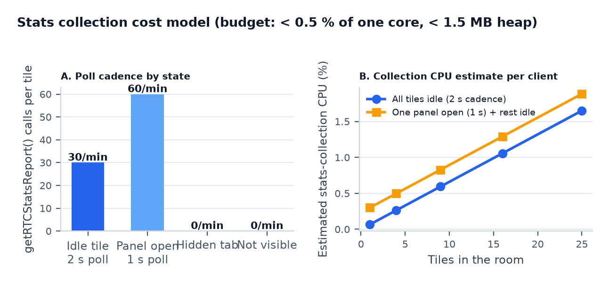
Figure 18 — Stats collection cost model: poll cadence by state and estimated CPU for up to 25 tiles.
Table 20 — Performance budgets and verification
Budget | Target | Worst case accepted | Verification
Stats CPU (25 tiles idle) | ≤ 0.5 % of one core | 0.8 % | Chrome tracing harness, 10-minute meeting
Panel open CPU (1 tile at 1 Hz) | ≤ 0.2 % | 0.3 % | Same harness with panel open
Heap (25 tracks × 60 samples) | ≤ 1.5 MB | 2.0 MB | Heap snapshots after 60 minutes
Bundle size (new code, gzip) | ≤ 20 KB | 24 KB | vite build size report in CI
Panel open → interactive | ≤ 300 ms | 500 ms | Performance marks around open()
Main-thread long tasks | 0 tasks > 50 ms caused by the feature | — | PerformanceObserver in tests

11.10 Failure modes and degraded operation
Table 21 — Failure modes
Failure | Detection | Response
RTCStats report missing fields | Parser returns partial sample | Score components renormalise; Details marks the field 'not reported'
Report promise rejects | Try/catch in the collector | Back off to 5 s cadence for that track; surface a single toast; keep last verdict
Counter reset (track re-created) | Delta negative | Sample discarded, new baseline established; no score jump
Clock skew / duplicate timestamps | Δt < 200 ms | Sample dropped
Action rejected by SDK | Exception from executor | Inline error, previous state restored, action log entry with the error
Override points at a stale track | Track unmounts | Override pruned; watchers unregistered; panel closes if it was open
Probe interrupted (tab hidden, call ended) | Visibility / room events | Probe aborts and restores baseline; no partial recommendation is applied

12. Backend and data interfaces

12.1 v1: no backend changes
Everything described so far runs in the browser. The only server interaction is the existing anonymous/authenticated token endpoint used for reconnects, and the existing TURN credential minting in meeting-api. No new routes, no database migrations, no SFU configuration changes.

12.2 Optional v2: opt-in quality telemetry
Aggregate telemetry is proposed for a later release to tune thresholds and to give moderators an aggregate view. It is opt-in, bucketed and retention-limited. The existing privacy.disableAnalytics preference is honoured, and the endpoints reuse the platform's RequireUser auth and the Redis rate limiter.
Table 22 — Proposed telemetry endpoints
Method | Path | Auth | Purpose | Rate limit
POST | /api/meetings/{meeting_id}/quality-reports | Participant session (existing) | Batched, bucketed quality samples for the caller's own client | 1 request / 60 s / client
GET | /api/meetings/{meeting_id}/quality-summary | Meeting owner or moderator | Aggregate per-participant bands for host diagnostics (no raw stats) | 10 / min / user
DELETE | /api/meetings/{meeting_id}/quality-reports | Meeting owner | Purge telemetry for a meeting | —

// POST /api/meetings/{meeting_id}/quality-reports (request body, bucketed)
{
"client": { "browser": "chrome", "version": 141, "os": "macos" },
"session": "7f3c…", // random, per-session UUID
"window": { "from": 1758690000, "to": 1758690060 },
"samples": [
{ "t": 12, "band": "medium",
"bitrateBucket": "0.5-1", "lossBucket": "1-3", "rttBucket": "100-200",
"relay": false, "limiter": "network",
"local": false, "source": "camera" }
],
"actions": [ { "t": 33, "action": "resync", "result": "ok", "ms": 1180 } ],
"autoTune": { "recommended": "medium", "applied": true, "rolledBack": false }
}
Storage keeps only bucketed values, a random per-session identifier, browser family (not exact version for privacy-sensitive deployments), relay flag, limiter class and action outcomes. Raw bitrates, IP addresses, participant identities and e-mail addresses are never uploaded. Retention defaults to 30 days and is configurable; a purge endpoint exists for meeting owners, matching the platform's existing retention controls.

12.3 Configuration and feature flags
Table 23 — Configuration surface
Key | Where | Default | Purpose
VITE_CQ_PANEL_ENABLED | Build-time env | true | Compile-time kill switch; false removes the badge
display.showConnectionQuality | Preferences (existing) | true | Shows the badge and LiveKit indicator
privacy.qualityTelemetry | Preferences (new) | false | Opt-in aggregate telemetry (v2)
network.preferredVideoQuality | Preferences (existing) | auto | Global fallback layer
cq.probeCooldownSeconds | Local constant (module) | 60 | Per-tile probe cooldown
cq.pollIntervalMs | Local constant (module) | 2 000 / 1 000 open | Idle and watch cadence

12.4 Local data
Table 24 — Client-side storage
Storage | Key | Content | Lifetime
zustand (memory) | cq slice | Verdicts, overrides, action log, probe state | Meeting session
sessionStorage | cq.tune.<meeting>.<track> | Auto-tune result and coarse fingerprint | Meeting session (cleared on leave)
localStorage | cq.debug | Verbose logging flag for support | Until cleared
File (download) | cq-report-*.json | Diagnostics export | User controlled

13. Security, privacy and compliance
- No cross-participant control. The feature can only modify subscriptions and the local publisher's tracks. There is no server API to change another participant's media, so a compromised client cannot degrade someone else's stream.
- No new attack surface by default. v1 makes no network requests beyond the existing token and TURN flows. Diagnostics are generated locally; the export action requires a user gesture and yields a local file.
- Data minimisation. Stats are derived counters. Reports exclude media, e-mail addresses, IP addresses and stable identifiers; telemetry uses a random per-session UUID and coarse buckets.
- Consent and controls. Telemetry is opt-in, honouring privacy.disableAnalytics and privacy.dontLogMyIp. Meeting owners can purge telemetry. Participants can hide the badge entirely with display.showConnectionQuality.
- Abuse resistance. Reconnect and probe operations are rate-limited client-side; probe mutexes and cooldowns prevent a client from using the SFU as a bandwidth test target.
- Compliance posture. The design follows GDPR data-minimisation principles: no new personal data categories, no processing in the media path, and an explicit retention policy for the optional aggregate telemetry. docs/SECURITY.md remains the master security document; this feature adds a short section there when implemented.

14. Analytics and observability

14.1 Client events
Table 25 — Analytics events (sent only when telemetry is enabled)
Event | Trigger | Properties (bucketed) | Purpose
cq_panel_opened | Panel becomes visible | layout, band, limiter, tile size class | Adoption and context
cq_action_invoked | Any action button pressed | action, scope, band before, result, duration | Usage and reliability per action
cq_autotune_started | Probe begins | band before, limiter, local/remote | Probe usage
cq_autotune_completed | Probe ends | recommended, applied, rolledBack, band after | Quality of the recommendation
cq_override_reset | Reset to auto | source (manual / auto-tune) | Override hygiene
cq_report_exported | Diagnostics downloaded | route (self-help / support request) | Support workflow adoption

Events are queued in memory and flushed at most once per minute with the telemetry batch. They carry no participant identity; local: true distinguishes own-tile events only. Bucketing uses the same thresholds as the score model, so analytics dashboards can reuse the band definitions.
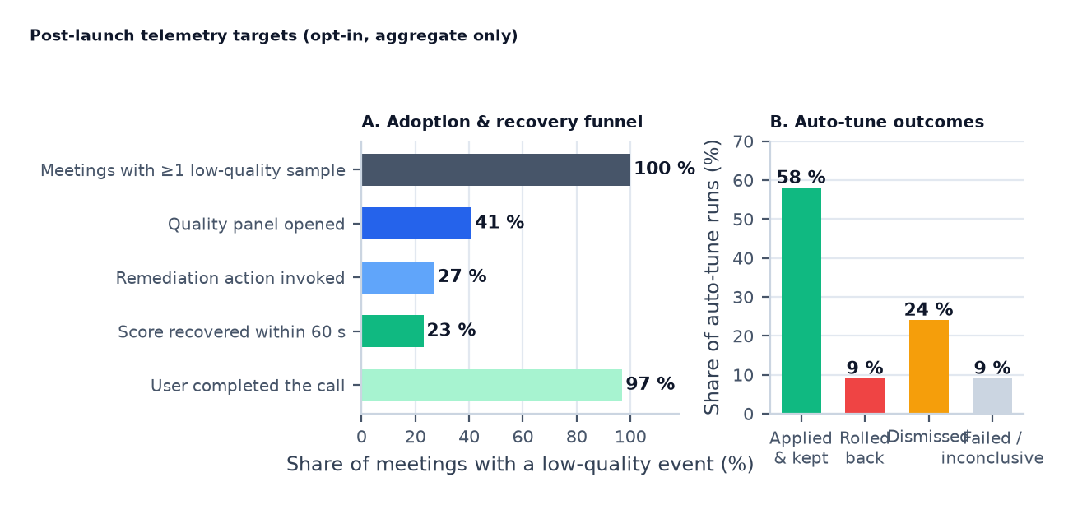
Figure 19 — Target metrics for post-launch validation: the adoption/recovery funnel and the distribution of auto-tune outcomes.

14.2 Operability
- Debug logging. localStorage.cqDebug = '1' enables verbose logs prefixed [cq] with sample and action details; support can ask for the console output or the JSON export.
- Version stamp. Reports and logs include the feature version and app build, so threshold changes can be correlated with behaviour.
- No dashboard dependency for v1. The feature ships dark to analytics; metrics become meaningful only when telemetry is enabled in a later release.

15. Tips and tricks: improving LiveKit connection quality
This section distils the published LiveKit guidance that the feature surfaces or automates. It is included so reviewers can sanity-check the recommendations the product will make, and so support can explain why a suggested change helps. Sources are listed in Appendix E.
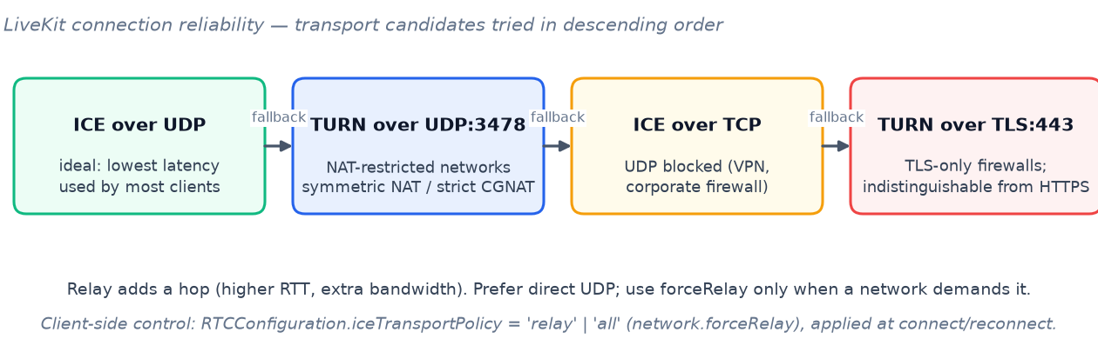
Figure 20 — Connection reliability order used by LiveKit and the client. Relay paths add a hop; direct UDP is preferred when the network allows it.

15.1 Publishing side (your camera)
- Keep simulcast and dynacast on. Simulcast publishes LOW/MEDIUM/HIGH versions so each receiver gets the right size; dynacast pauses layers nobody consumes. This is already the default in livekit.ts and should stay that way.
- Match bitrate to resolution. LiveKit's presets (h720/h540/h360/h180) carry recommended bitrates and frame rates. Publishing 720p at 30 fps with ~1.5–2.5 Mbps is plenty for talking heads; the app's 2.5 Mbps HIGH layer compensates for VP8's lower efficiency.
- Cap what you capture, not just what you send. applyConstraints on the source reduces CPU and avoids encoding pixels that will be thrown away by the grid.
- Choose codecs deliberately. H.264 and VP8 are universally compatible; VP9 and AV1 support SVC (L3T3_KEY), which improves bitrate efficiency and allows instant layer switching without waiting for keyframes. Note that dynacast can only pause entire streams with SVC, not individual layers.
- Watch the CPU limiter. qualityLimitationReason: cpu means the encoder cannot keep up: lower resolution before lowering bitrate, and disable heavy effects (backgrounds, virtual cameras) while presenting.
- Audio is worth protecting. RED (redundant encoding) is recommended on lossy networks and is on by default; disabling DTX or switching to the hi-fi stereo preset raises quality and bandwidth substantially (up to 510 kbps stereo) and is intended for music, not calls.
- Choose the right channel mode. Mono is the efficient default for speech and keeps echo cancellation / noise suppression active; stereo is for music or spatial content and requires the hi-fi preset (EC/NS off, headphones strongly advised). The Device tab makes this choice explicit instead of hiding it in audio defaults.

15.2 Receiving side (other people's tiles)
- Cap the layer, don't fight the encoder. setVideoQuality(LOW/MEDIUM/HIGH) is the supported way to reduce a remote stream; the SFU drops to an existing lower layer instead of transcoding.
- Use enable/disable for frequent pauses. setEnabled(false) stops bytes without a renegotiation handshake, unlike setSubscribed(false); adaptive streaming uses this under the hood when a tile scrolls off-screen.
- Let adaptiveStream size the stream. It matches the subscription layer to the rendered element size and pauses hidden elements; manual overrides should be temporary and visible in the UI, which is exactly how the panel behaves.
- Treat `TrackStreamStateChanged` as information, not failure. The SFU pauses video when bandwidth drops and resumes automatically; the panel surfaces it as a temporary state instead of declaring the stream broken.

15.3 Connection, transport and TURN
- Understand the fallback order. LiveKit tries ICE/UDP, then TURN/UDP (3478), then ICE/TCP, then TURN/TLS (443). Each step is a trade-off: UDP is best for latency, TURN adds a hop, TLS works through corporate firewalls that allow nothing else.
- Prefer direct when possible. network.forceRelay exists for networks that require it; leaving it on when unnecessary adds RTT for no benefit. The panel shows the selected candidate type so the trade-off is visible.
- Trust the automatic recovery. LiveKit reconnects the signaling socket and performs ICE restarts automatically; ConnectionQuality.Lost is an early warning that fires before Reconnecting and Disconnected. The panel uses it to show “reconnecting” sooner.
- Disconnect cleanly. Calling disconnect() avoids the 15-second ghost participant timeout and gives the room accurate quality history.

15.4 Self-hosted operations (for the platform team)
- Keep the UDP range open. The reference deployment needs UDP 50000–60000 and TCP 7881 to the LiveKit host; host networking is used because mapping 10 001 UDP ports through Docker is slow and brittle (docs/ARCHITECTURE.md).
- Run TURN/TLS on 443 where possible. It is the widest-coverage transport for locked-down networks and requires a trusted certificate; TURN/UDP on 443 helps in QUIC-era firewalls.
- Size for CPU and bandwidth. LiveKit recommends compute-optimised instances and 10 Gbps networking for production; bandwidth estimation degrades when the SFU itself is saturated.
- Watch the SFU's own metrics. Prometheus metrics on :6789/metrics expose congestion and packet loss at the source; correlate them with client reports before blaming endpoints.
- Keep egress load separate. Recording and streaming consume CPU; the platform already scales past the original 2-vCPU budget, and quality investigations should always check egress load first.

15.5 What this feature automates
Table 26 — Guidance → product behaviour
Tip | Where it appears in the feature
Simulcast layer caps reduce bandwidth without transcoding | Remote-tile Quality control (Low / Medium / High)
Enable/disable is cheaper than resubscribe for pauses | Audio-only mode and hidden-tile behaviour
CPU limitation calls for lower capture resolution | Limiter detection + pre-selected local-tile actions
Loss above ~5 % makes high layers counter-productive | Auto-tune decision matrix rejects unstable candidates
Relay adds RTT; direct is better when available | Transport row + reconnect suggestion
RED and DTX trade bandwidth for audio continuity | Audio tips and audio-loss explanations
SVC improves efficiency and layer switching | Codec preference order in compression presets

16. Test plan

16.1 Strategy
Table 27 — Test levels and exit criteria
Level | Tooling | Scope | Exit criteria
Unit | Vitest | Score normalisation, EWMA, hysteresis, delta maths, decision matrix, override precedence, rollback rules, rate limiters | 100 % branch coverage on score and action-safety logic
Component | Vitest + React Testing Library | Badge states, ARIA attributes, tabs and keyboard flow, sparkline text alternative, RTL snapshot, i18n fallback | All states reachable; axe checks clean
Integration | Vitest + a recorded stats fixture player | Collector parses real RTCStatsReport captures; panel reacts to band changes; actions call the SDK adapter with correct arguments | Fixture suite green for Chrome, Safari and Firefox captures
End-to-end | Playwright (two contexts) + CDP throttling | Poor network → Low verdict; resync recovers; auto-tune applies and survives; reconnect path; mobile sheet; reduced motion | Scenarios pass in CI on Chromium and WebKit
Manual exploratory | QA checklist | Real devices, real networks, TURN forced, VPN, CPU throttling, 25-tile grid, 60-minute soak | No P1/P2 defects open
Performance | Chrome tracing + heap snapshots | Polling cost, long tasks, heap growth, battery estimate | Budgets in §11.9 met

16.2 Scenario matrix
Table 28 — Key test scenarios
# | Scenario | Setup | Expected result
T-01 | Clean call | Two Chromium clients, no throttling | High band; badge green; no console warnings; CPU within budget
T-02 | Mild loss | CDP: 1 % loss, 40 ms RTT | Medium band; limiter = network; copy mentions loss
T-03 | Heavy loss | CDP: 8 % loss, 150 ms RTT, 2 Mbps down | Low band; auto-tune recommends LOW + resync tip; HIGH rejected
T-04 | Bandwidth collapse | Throttle down to 300 kbps mid-call | Layer drops; StreamState change surfaced; panel explains
T-05 | Recovery | Remove throttling | Band recovers within 20 s; sparkline shows recovery; no manual action needed
T-06 | Resync | Freeze video by blocking media for 3 s | Resync restores video; action log shows duration; score recovers
T-07 | Reconnect | Kill signaling socket, then use Reconnect action | Confirmation shown; reconnects; streams return; meeting state intact
T-08 | Forced relay | network.forceRelay on | Transport row shows Relay; RTT higher; reconnect suggestion offered
T-09 | Local CPU limit | 6× CPU throttle while publishing 720p | Limiter = publisher; actions pre-select resolution; lowering it recovers frames
T-10 | 10-bit unsupported | MacBook camera | Colour depth disabled with reason; no failed republish
T-11 | Small tile | Narrow the browser window / 6-column grid | Bottom-sheet behaviour below 260 px; badge hidden below 120 px
T-12 | Hidden tab | Switch tabs for 5 minutes | Polling stops; on return the sparkline has a gap, not fake data
T-13 | Reduced motion | OS reduced motion on | No sparkline or ring animation; text alternative present
T-14 | 50 participants | Load test room | Badges render; collection stays within budget; no layout jank
T-15 | Leave / rejoin | Leave meeting with overrides set | Overrides cleared; global preference intact; no stale cache
T-16 | Camera preset | Change resolution 720p → 360p and frame rate 30 → 15 on the local tile | Publishing format read-out updates; all receivers see the new size; call is not dropped
T-17 | Mono → stereo | Switch microphone to Stereo, then back to Mono | Mic reacquires with channelCount 2 / 1; EC/NS state and bandwidth warning shown; audio continuity unbroken
T-18 | Unsupported preset | Camera max 720p, choose 1080p is disabled; force an unsatisfiable constraint via devtools | Option disabled with reason; failed apply restores previous settings without dropping the track

16.3 Performance and soak tests
- Tracing harness. Automated Chromium run with 25 participants (synthetic tracks), 10 minutes idle plus 2 minutes with a panel open; assert collection CPU and long-task budgets.
- Heap soak. 60-minute meeting with two panel opens per minute; heap snapshot diff must stay flat after the ring buffers fill.
- Battery estimate. 30-minute mobile-browser session with the badge visible and the panel closed; compare against a build with the feature disabled.
- Media non-regression. Compare published bitrate, fps, audio concealment and end-to-end latency with and without the feature on the same network emulation; differences must be within noise.

16.4 Acceptance via telemetry
When telemetry is enabled, the dashboard tracks the §3.3 metrics weekly. The release is considered successful when adoption ≥ 40 % of affected meetings, auto-tune apply-and-keep ≥ 70 %, rollback < 10 %, and support tickets show a sustained 30 % reduction after two releases. Thresholds in the score model are also re-tuned from field histograms at that point.

17. Rollout plan
Table 29 — Phased rollout
Phase | Audience | Flag state | Entry criteria | Exit criteria
0 — Internal | Platform team, dogfood meetings | VITE_CQ_PANEL_ENABLED=true, telemetry off | Feature complete, unit + component tests green | Two weeks without P1 bugs; performance budgets met
1 — Beta | Opt-in participants in real meetings (≈ 5 %) | Flag on, telemetry opt-in prompt | Phase 0 exit; support runbook ready | Adoption and reliability signals within target; no stability regression
2 — Broad | 50 % of meetings | Flag on by default | Phase 1 exit | Metrics hold for two weeks; threshold tuning applied
3 — GA | 100 % of meetings | Flag on, remove build-time switch | Phase 2 exit | Feature documented in docs/FEATURES.md; runbook handed to support

Kill switch. VITE_CQ_PANEL_ENABLED=false removes the badge and the collector at build time. A runtime preference (display.showConnectionQuality) lets individual users hide it without a deployment. There is no server-side component to roll back.
Rollback. Because the feature is additive and client-scoped, rollback is a redeploy of the SPA with the flag disabled. Overrides are session-scoped, so users who used the panel return to the global preference behaviour automatically.

18. Risks and mitigations
Table 30 — Risk register
Risk | Likelihood | Impact | Mitigation
RTCStats differences across browsers produce wrong verdicts | Medium | High | Capability probe per browser; renormalise missing components; validate against recorded fixtures from real browsers; degrade to LiveKit quality when parsing fails
Polling cost impacts low-end devices | Medium | Medium | Visibility-aware cadence, 2 s idle, zero when hidden; device-class reduction (battery saver → 4 s); performance budgets enforced in CI
Users misunderstand remote vs local scope | Medium | Medium | Scope labels on every control, warning banner on local tile, explanatory copy in the Actions tab and release notes
Auto-tune interferes with adaptation or wastes bandwidth | Medium | Medium | Single probe mutex, 4 s steps, no audio changes, 60 s cooldown, automatic rollback, and probes skipped while recording transitions run
Colour-depth control over-promises | High | Low | Capability probe before enabling; disabled state with reason; guidance that 10-bit mainly benefits screen content
Panel occludes video on small tiles | Medium | Low | Bottom-sheet behaviour below 260 px, badge-only below 120 px, tap-to-collapse, and the panel remembers its last tab
LiveKit API changes break the integration | Low | Medium | All SDK calls isolated in the action/stats adapters; version-pinned dependency; type checks in CI
Telemetry privacy concerns | Low | High | Opt-in only, bucketed data, no identifiers, retention limit, purge endpoint, documented in the privacy policy before launch
Score thresholds feel wrong in the field | Medium | Medium | Hysteresis, band explanations, feedback link in the panel, and a telemetry-driven tuning pass after Phase 1

19. Open questions
Table 31 — Open questions for review
# | Question | Owner | Needed by
Q1 | Should moderators get an aggregate per-participant quality view in v2, and under what consent model? | Product + Privacy | Before Phase 2
Q2 | Does ConnectionQuality.Lost alone justify auto-triggering a resync, or should the user always confirm? | Frontend + UX | Before implementation
Q3 | Should auto-tune results persist across meetings for the same device (preset only, no fingerprint)? | Product | Phase 3
Q4 | Which codec preference order should be default on Safari given incomplete degradationPreference support? | Media platform | Before implementation
Q5 | Is a dedicated keyframe-request API worth pursuing upstream with LiveKit, replacing the resync workaround? | Media platform | Next LiveKit update
Q6 | What exact buckets and retention windows satisfy the strictest deployment (EU public sector) before telemetry ships? | Security/Privacy | Before Phase 1
Q7 | Should the badge show the composite score band (design) or LiveKit's own ConnectionQuality (protocol truth) when the two disagree? | UX + Media platform | Before implementation

Appendix A — Metric dictionary
Table 32 — RTCStats member mapping
Member | Interface | Meaning | Used for
bytesReceived / bytesSent | Video/AudioReceiverStats, sender stats | Cumulative payload bytes; delta / dt = bitrate | Bitrate, bandwidth adequacy
packetsLost | Receiver and sender stats | Cumulative packets lost (receiver view; sender view reports remote loss) | Packet-loss percentage
packetsReceived / packetsSent | Receiver / sender stats | Cumulative packet counts | Loss denominator, sanity checks
jitter | Receiver stats | RTP interarrival jitter in seconds | Jitter metric and network health
framesReceived, framesDecoded, framesDropped | VideoReceiverStats | Frame counters at the receiver | FPS, skipped-frame ratio, freeze detection
frameWidth, frameHeight | Receiver and sender stats | Decoded / encoded dimensions | Resolution display, expected bitrate target
framesPerSecond, framesSent | Sender stats (VideoSenderStats) | Encoder output rate | Publishing diagnosis
qualityLimitationReason | Sender stats | none / bandwidth / cpu / other | Limiter classification
targetBitrate | Sender stats | Encoder target for the encoding | Bitrate adequacy (publisher side)
concealedSamples, silentConcealedSamples | AudioReceiverStats | Samples reconstructed by the decoder; silent ones separately | Audio loss seconds, concealment ratio
totalSamplesDuration | AudioReceiverStats | Duration represented by received samples | Concealment ratio denominator
jitterBufferDelay, jitterBufferEmittedCount | AudioReceiverStats | Total delay and emitted sample count | Average jitter-buffer delay
currentRoundTripTime | candidate-pair in the report | RTT of the selected ICE pair | RTT metric, relay penalty
candidateType | local-candidate / remote-candidate | host, srflx, prflx, relay | Direct vs Relay indicator
mimeType, decoderImplementation | codec / inbound-rtp | Negotiated codec and decoder | Transport/codec details, troubleshooting

Appendix B — Diagnostics export schema
{
"schema": "onevoice.cq.report/1",
"generatedAt": "2026-09-25T09:41:12Z",
"meeting": { "id": "abc123", "layout": "grid", "tiles": 12 },
"app": { "version": "0.1.0", "feature": "1.0.0" },
"device": { "class": "desktop", "browser": "chrome", "os": "macos", "cores": 8 },
"capture": { "video": { "width": 1280, "height": 720, "frameRate": 30 },
"audio": { "channelCount": 1, "sampleRate": 48000,
"preset": "speech", "red": true, "dtx": true } },
"tile": {
"role": "remote", "source": "camera", "codec": "VP8",
"transport": { "type": "relay", "protocol": "udp", "rttMs": 148 },
"verdict": { "band": "medium", "score": 61, "limiter": "network" }
},
"history": [
{ "t": -60, "bitrateMbps": 0.48, "lossPct": 2.1, "jitterMs": 34, "rttMs": 150,
"fps": 19.6, "droppedPct": 2.4, "audioLossSPerMin": 1.6 }
],
"actions": [
{ "t": -12, "action": "resync", "result": "ok", "durationMs": 1180 },
{ "t": -2, "action": "set-quality", "params": { "quality": "medium" }, "result": "ok" }
],
"autoTune": { "recommended": "medium", "applied": true, "rolledBack": false,
"expected": "+38% delivered bitrate" }
}
Note — The export includes no participant names by default; roles are described as self and remote. An opt-in checkbox can include display names for support conversations.

Appendix C — Initial i18n keys (namespace `cq`)
Table 33 — i18n key set
Key | English value (source)
button.ariaLabel | Connection quality for {{name}} — {{band}}
band.high|medium|low|lost|measuring | High / Medium / Low / Reconnecting… / Measuring…
limiter.network | Network: packet loss and jitter
limiter.publisher | Publisher device is limiting the stream
limiter.relay | Relay path: elevated round-trip time
limiter.stability | Unstable link: quality is oscillating
tabs.overview|details|actions | Overview / Details / Actions
metric.bitrate | Bitrate
metric.resolution | Resolution
metric.frameRate | Frame rate
metric.packetLoss | Packet loss
metric.jitter | Jitter
metric.rtt | Round-trip time
metric.skippedFrames | Skipped frames
metric.audioLoss | Audio loss (last minute)
metric.concealment | Audio concealment
metric.transport.direct|relay | Direct / Relay
action.resync | Resync stream
action.reconnect | Reconnect
action.reconnectWarning | This interrupts every stream for a few seconds. Continue?
action.quality | Quality (simulcast layer)
action.maxBitrate | Max bitrate
action.resolution | Resolution
action.frameRate | Frame rate
action.compression | Compression
action.colorDepth | Colour depth
device.title | Device
device.camera | Camera
device.microphone | Microphone
device.resolution | Resolution
device.frameRate | Frame rate
device.cameraMax | Camera supports up to {{width}} × {{height}} @ {{fps}} fps
device.publishing | Publishing {{width}} × {{height}} @ {{fps}} · {{bitrate}}
device.channels | Channels
device.channels.mono | Mono
device.channels.stereo | Stereo
device.stereoWarning | Stereo disables echo cancellation and noise suppression — use headphones; it also raises uplink bandwidth
device.audioQuality | Audio quality
device.audioQuality.voice | Voice
device.audioQuality.music | Music
device.apply | Apply to my camera & mic
device.remoteNote | Camera and microphone settings belong to {{name}}
action.colorDepthUnsupported | 10-bit is not available on this device or codec
action.audioOnly | Audio only for this tile
action.export | Export report
action.resetAuto | Reset to auto
action.apply|cancel|retry | Apply / Cancel / Retry
scope.receive | Applies to what you receive — {{name}}'s camera stays untouched
scope.publish | Changes are visible to everyone in the meeting
autotune.title | Testing connection…
autotune.recommended | Recommended for this network
autotune.rejected | {{layer}} was rejected: {{reason}}
autotune.rolledBack | Reverted — the new setting was worse on this network
error.statsUnavailable | Detailed statistics are not available in this browser
error.actionFailed | That action failed. Try again or export a report.

Appendix D — Glossary
Table 34 — Terms
Term | Meaning
SFU | Selective Forwarding Unit — the LiveKit media server that forwards streams between participants without mixing them
Simulcast | Publishing multiple encoded versions (layers) of the same video at different resolutions/bitrates
Simulcast layer | One of those versions; LOW/MEDIUM/HIGH in this app
Dynacast | LiveKit feature that pauses simulcast layers nobody is subscribed to
adaptiveStream | LiveKit JS feature that matches each subscription layer to the rendered element's size and visibility
SVC | Scalable Video Coding — VP9/AV1 encoding where higher layers reuse lower layers; enables instant layer switching
RED | Redundant audio encoding — sends duplicate audio packets to survive loss
DTX | Discontinuous transmission — stops sending audio during silence to save bandwidth
PLI / keyframe | Picture Loss Indication — a request for a full video keyframe; LiveKit 2.5 has no public client API for it
ICE / STUN / TURN | NAT traversal stack: ICE coordinates candidates, STUN discovers addresses, TURN relays media when direct paths fail
Relay path | Media routed through a TURN server; adds a network hop and latency
Jitter | Variation in packet arrival times; high jitter causes audio warble and video stutter
Concealment | Audio samples reconstructed by the decoder when packets are missing; perceived as clicks or dropouts
EWMA | Exponentially weighted moving average — smoothing that gives recent samples more weight
Hysteresis | Requiring sustained change before switching state, preventing verdict flicker
Limiter | The component currently holding quality back: network, publisher, relay or stability
Channel count | 1 = mono, 2 = stereo. Capture-side channel count is independent of the playback downmix (accessibility.monoAudio)
Capture capabilities | The ranges a camera or microphone reports (getCapabilities) — maximum resolution, frame rate and sample rate, used to validate presets

Appendix E — References
Internal documents
- docs/ARCHITECTURE.md — service topology, TURN credential flow, host networking rationale.
- docs/FEATURES.md, docs/CONFIGURATION.md — current feature and preference inventory.
- docs/SECURITY.md — security posture and data handling rules.
- frontend/src/lib/livekit.ts, frontend/src/lib/videoQualityPref.ts, frontend/src/components/FlippableTile.tsx — the integration points named in this document.
LiveKit documentation (consulted September 2026)
- Codecs and more — codec support, SVC behaviour, presets, simulcast, dynacast, audio RED, hi-fi audio: https://docs.livekit.io/transport/media/advanced
- Subscribing to tracks — adaptive stream, subscribe vs enable, simulcast controls: https://docs.livekit.io/transport/media/subscribe
- Camera & microphone — publishing, mute, track permissions: https://docs.livekit.io/transport/media/publish
- Connecting to LiveKit — connection reliability, transport order, automatic reconnection: https://docs.livekit.io/intro/basics/connect
- Webhooks & events — connection quality values and events: https://docs.livekit.io/intro/basics/rooms-participants-tracks/webhooks-events
- Deploying LiveKit — TURN/TLS and TURN/UDP configuration, production sizing: https://docs.livekit.io/transport/self-hosting/deployment
- Firewall configuration: https://docs.livekit.io/transport/self-hosting/ports-firewall
Standards and platform references
- W3C, Identifiers for WebRTC's Statistics API — https://www.w3.org/TR/webrtc-stats/
- MDN, RTCRtpSender.setParameters() — https://developer.mozilla.org/docs/Web/API/RTCRtpSender/setParameters
- RFC 5766, Traversal Using Relays around NAT (TURN) — https://datatracker.ietf.org/doc/html/rfc5766
- RFC 3550, RTP: A Transport Protocol for Real-Time Applications — https://datatracker.ietf.org/doc/html/rfc3550

