Meet++
Feature Design Document & Technical Architecture
AI-led meeting organisation for OneVoice Meet: live transcription, a live agenda / decisions / actions / minutes board, and automated follow-up with minutes and next-meeting invitations

Document | MeetPlusPlus_FDD_v2
Product | OneVoice Meet: meet.witysk.org (repository onevoice_meet)
Version | 2.0 — draft for review
Date | 3 October 2026
Author | Stephane van der Aa
Supersedes | Meet++ FDD v1 (03-10-2026, one-page brief)
Code baseline | main @ 8cf85d5 (2 October 2026)
Audience | Product, engineering (frontend, backend, media), operations, security & privacy, legal
Related documents | docs/ARCHITECTURE.md · docs/FEATURES.md · docs/SECURITY.md · docs/CONFIGURATION.md · Meet_Connection_Quality_FDDTA.docx
Status | Draft — open questions in §20
Confidential — internal design document. Distribution limited to the review group.

Document control
Revision history
Version | Date | Author | Change
1.0 | 2026-10-03 | Stephane van der Aa | Initial brief: scope, inputs/outputs, UI concept, TA direction (STT on turn.witysk.org, DeepSeek first, Mac Studio later)
2.0 | 2026-10-03 | Stephane van der Aa | Detailed FDD and technical architecture based on analysis of the current codebase: requirements, UX specification, AI behaviour, architecture decisions, data model, APIs, infrastructure, security, test and rollout plans

Reviewers
Role | Name | Scope of review
Product owner | Stephane van der Aa | Scope, UX, defaults (Q3, Q5, Q7–Q9)
Engineering (frontend) | to be assigned | Board, stage integration, follow mode, accessibility
Engineering (backend / media) | to be assigned | Agent, STT, LLM gateway, runtime, data model, capacity
Operations | to be assigned | Compose changes, CPU plan, deploy safety, Mac Studio tunnel
Security & privacy / legal | to be assigned | GDPR transfer (Q1), consent (Q4), retention (Q10), legal page updates

Table of contents
1. Executive summary 6
2. Background and current state 8
2.1 What OneVoice Meet provides today 8
2.2 Constraints uncovered by the analysis 9
2.3 What changed from v1 9
3. Goals, non-goals and success metrics 11
3.1 Goals 11
3.2 Non-goals for Release 1 11
3.3 Success metrics 11
4. Personas and scenarios 13
5. Feature overview 14
5.1 End-to-end flow 14
5.2 Entry point: the AI Meeting button 14
5.3 Setup screen 14
5.4 The Meet++ board on stage 15
5.5 Meeting phases and templates 16
5.6 Live extraction: what the AI maintains 16
5.7 Announcements 17
5.8 Whiteboard snapshots 17
5.9 Post-meeting: finalise, review, publish 17
5.10 Meeting series and carry-over 18
6. Functional and non-functional requirements 19
6.1 Functional requirements 19
6.2 Non-functional requirements 20
7. UX specification 21
7.1 States and roles 21
7.2 In-room layout 21
7.3 Setup screen 22
7.4 Tab content specification 23
7.5 Follow mode and auto-focus rules 23
7.6 Phase proposals and announcements 24
7.7 Consent and indicators 24
7.8 Post-meeting review screen 25
7.9 Small screens, PiP and public view 25
7.10 Accessibility 25
7.11 Internationalisation 26
7.12 Error, empty and degraded states 26
8. Domain model and AI behaviour 27
8.1 Content model and lifecycles 27
8.2 The extraction loop 27
8.3 Operation vocabulary 28
8.4 Prompting strategy 29
8.5 Phase detection 29
8.6 Minutes drafting and finalisation 29
8.7 Attendance and next-meeting attendees 30
8.8 PDF ingestion 30
8.9 Quality guardrails 30
9. Technical architecture 32
9.1 Overview 32
9.2 Architecture decisions 33
9.3 Component inventory 33
9.4 meetpp-agent: audio capture 34
9.5 Speech-to-text engine and capacity 35
9.6 LLM gateway and providers 35
9.7 Session runtime (orchestrator) 36
9.8 Real-time protocol 36
9.9 Stage integration 37
9.10 TTS and announcements 37
9.11 Whiteboard snapshot implementation 38
9.12 Outputs: PDF, iCalendar and e-mail 38
9.13 Key interaction sequences 39
10. Backend and data interfaces 41
10.1 Data model 41
10.2 Schema evolution 42
10.3 REST API 42
10.4 Authorisation matrix 43
10.5 Configuration and feature flags 44
10.6 Files and retention 45
11. Infrastructure and deployment 46
11.1 Container changes 46
11.2 Capacity plan (4 vCPU host) 46
11.3 Network, edge and security configuration 47
11.4 Deployment procedure and safety 47
11.5 Release 2: Mac Studio for the LLM (and optionally STT) 47
12. Security, privacy and compliance 49
12.1 Data flows and processors 49
12.2 GDPR assessment of DeepSeek 49
12.3 Consent, indicators and opt-out 49
12.4 Threats and mitigations 50
12.5 Required updates to legal pages and docs 50
13. Performance, cost and capacity 51
13.1 Latency budget 51
13.2 Token and cost model 51
13.3 Throughput and concurrency 51
14. Observability and analytics 52
14.1 Metrics and logs 52
14.2 Admin panel 52
14.3 Alerts 52
15. Failure modes and degraded operation 53
16. Test plan 54
16.1 Strategy 54
16.2 Scenario matrix 54
16.3 AI quality evaluation 54
16.4 Load and soak 55
17. Rollout plan 56
18. Risks and mitigations 57
19. Future: OneVoice OM module and Mail integration 58
20. Open questions 59
Appendix A — LLM tick output schema 60
Appendix B — meet-ai message catalogue 61
Appendix C — Prompt skeleton (tick) 62
Appendix D — Example invitation (.ics) 63
Appendix E — i18n keys (namespace meetpp) 64
Appendix F — Glossary 65
Appendix G — Code baseline references 66

1. Executive summary
Meet++ turns OneVoice Meet (meet.witysk.org) from a video-meeting room into an AI-assisted meeting chair. Once the chair clicks AI Meeting, the system transcribes every speaker live. It keeps a shared Meet++ board up to date while people talk. The board has tabs for the agenda, decisions, actions, attendance, minutes, attachments and transcript. The system also steers the meeting through a standard process: previous actions → agenda → discussion → other business → new actions → closing. It announces each transition with large on-screen text and synthesised speech. After the meeting it produces reviewed minutes and a draft agenda for the next meeting, and sends calendar invitations (.ics) to the people required next time.
Version 1 of this document was a one-page brief. This version 2 is based on a full analysis of the current codebase (main @ 8cf85d5, 2 October 2026). It turns each brief statement into precise functional requirements, UX rules and a technical architecture that fits the existing stack: React + LiveKit client, the FastAPI meeting-api with SQLite, the LiveKit SFU and egress, and Docker Compose on turn.witysk.org. It also records the decisions that the brief left open, and the constraints the analysis uncovered.

What the analysis found
- There is no live speech-to-text today. The in-meeting captions overlay is a placeholder (CaptionsOverlay.tsx). The only STT is a batch whisper.cpp job (ggml-base.en, English-only, CPU, 2 threads) that runs after a recording finishes. The running app makes no LLM calls; DeepSeek is used only by the offline locale-translation scripts.
- Nothing in the backend can listen to a room. meeting-api only has the LiveKit server API (livekit-api). A new component is needed that joins as a hidden participant and subscribes to each speaker's audio.
- The production host is small and shared. turn.witysk.org has 4 vCPUs. It also runs the SFU, a 24/7 TITV composite egress (which must never be restarted), ingress, coturn for one.witysk.org, and the One Voice Mail edge. No container has CPU limits. Always-on STT must be capped and benchmarked before it ships.
- Useful building blocks already exist. The server already publishes to the data channel (send_data, meet-* topics). The whiteboard already exports PNGs. iCalendar generation (services/ics.py) and Resend e-mail with attachments already work. The egress page /egress-layout/pip renders every recording, so the board can be drawn into recordings without a new video stream.
- Compliance needs attention. Sending transcripts to DeepSeek (a PRC-based processor) is a GDPR Chapter V transfer. The current privacy page says data stays in the EU and does not mention transcription or AI at all. Belgian law (Art. 314bis Penal Code, cited on the Legal page) requires consent from every participant.

Key design decisions
- Per-speaker live STT in a new meetpp-agent container. It joins as a hidden, subscribe-only participant, runs Silero VAD and faster-whisper (small, int8, multilingual) under a hard 2-vCPU cap, and can optionally offload to the Mac Studio. Speaker attribution comes for free from the LiveKit identity.
- The LLM proposes, the server decides. The LLM never writes state. It returns small JSON operations ("add action", "update decision", "propose phase"). meeting-api validates them against IDs, provenance, human locks and limits, then applies them in a versioned, audited transaction.
- A provider-agnostic LLM gateway. It uses the OpenAI-compatible chat-completions API. Release 1 uses DeepSeek (deepseek-chat); Release 2 switches to a local model on the Mac Studio by configuration only.
- The board is a client-rendered virtual stage tile, not a video stream. It is crisp, interactive and cheap. The same component renders inside the egress page, so recordings and livestreams show it. By default it takes the main slot in speaker mode. Any human screen share or pin takes over, and the chair can bring the board back.
- A human stays in the loop. The AI proposes phase changes. In Lead mode (the brief's intent) it moves on after an 8-second cancel window; in Assist mode the chair confirms. Nothing is e-mailed until the chair publishes from the review screen.
Bottom line. Meet++ is feasible on the current platform with one new container, one new backend module, about thirteen new tables and a set of frontend components. The two items that decide go/no-go are (1) STT CPU headroom and multilingual quality on turn.witysk.org, to be measured in a two-week spike (M0), and (2) a decision on DeepSeek for real meeting content (§12.2, Q1).

2. Background and current state

2.1 What OneVoice Meet provides today
The table lists the existing capabilities Meet++ builds on, with the gaps the analysis found. File references point to the code baseline.
Table 1 — Existing capabilities and their implications
Capability | Today (code baseline) | Implication for Meet++
Live captions | Placeholder only: CaptionsOverlay.tsx renders “Live captions are not yet available”. The accessibility.liveCaptions preference exists but has no backend. docs/FEATURES.md wrongly says it uses the Web Speech API. | Meet++ supplies the first real caption source. The overlay and its preferences can be reused as-is.
Speech-to-text | Batch only. The egress_ended webhook queues transcribe_recording (services/transcription.py), which posts a WAV to whisper.cpp v1.7.4 /inference (ggml-base.en, CPU, THREADS=2). Output is plain .txt: no timestamps, no speakers. | A new streaming, per-speaker, multilingual path is needed. The batch path is left in place, and is skipped when a Meet++ transcript already covers the recording.
LLM | None in the app. scripts/translate_locales.py and translate_missing_keys.py call DeepSeek deepseek-chat offline. There is no backend LLM client, key or prompt. | New gateway module, configuration and prompts are needed (§9.6).
Real-time signalling | Clients publish small refetch pings on meet-chat, meet-notes, meet-board, meet-polls. The server publishes meet-playback and meet-cohost via lk.room.send_data (services/playback_mgr.py:173-191). Room metadata carries room_layout, presenter_identity, recording_active, and so on. | Add a server-published meet-ai topic and a meetpp room-metadata key, following the same {v:1,type} convention.
Notes & whiteboard | Notes are one plain-text field (meetings.notes, last writer wins). The whiteboard is a hand-rolled canvas: strokes and shapes are stored via REST and synced on meet-board. PDF export already calls canvas.toDataURL() (NotesWhiteboardPanel.tsx:881-900). | Snapshotting is feasible. Fix the transparent background and exclude the selection outline (§9.11).
Attendance | meeting_participants rows are written when a token is minted and by the participant_joined/left webhooks. Caveats: joined_at is the mint time; bots are not filtered out; every anonymous reconnect creates a new identity. | Meet++ keeps its own attendance from the agent's live view of the room, and merges identities per person (§8.7).
Series | One Meeting row with a verbatim RRULE (recurrence_rule) is reused for every occurrence: same room, chat and notes. There is no series or occurrence table. | New meetpp_series and per-occurrence meetpp_sessions (§10.1).
Invites & e-mail | POST /meetings/{id}/invite e-mails an .ics built by ics_for_meeting(). That file has METHOD:PUBLISH, a single VEVENT and no ORGANIZER, ATTENDEE or SEQUENCE. E-mail goes through Resend (services/email.py), with attachments supported. | Extend the ICS builder to produce real invitations with METHOD:REQUEST (§9.12).
Roles | Owner and co-host (is_moderator, routes/meetings.py:36-41). In the room, isOwner is true for both (sessionStorage owner:<room>). Guests have no app JWT, and room-scoped writes such as chat and notes are unauthenticated. | Chair = owner or co-host. Meet++ room endpoints authenticate guests with their LiveKit room token instead of relying only on the room name (§10.5).
Recording & egress | Every recording and livestream renders the SPA route /egress-layout/pip in headless Chrome (egress_mgr.py:42). Its main-tile ladder matches PresenterSpotlight.tsx. | Render the board in that route as well, so recordings show what participants see (§9.9).
Feature gating | There are no plan tiers. The only right is “may create meetings” (User.is_admin_now(): always true for SSO users; trial, voucher or PayPal for native users). | Gate with a global flag, a pilot allow-list and the owner's creation right (§10.6).

2.2 Constraints uncovered by the analysis
- CPU headroom. Production has 4 vCPUs (upgraded 2026-08-16; code comments and docs still say 2). They are shared with the SFU, the 24/7 TITV egress (Chrome + x264 + 5 RTMP + HLS), ingress, ffmpeg previews, batch whisper, the compositor's idle Xvfb/Chrome, coturn and the caddy-l4 edge. No service has cpus or mem_limit set.
- Egress is untouchable. Recreating the egress container kills the TITV stream. Any change to LIVEKIT_* in .env recreates it, because the egress config body is built from those variables. Meet++ must not capture audio through egress, and must not change those variables.
- Single-process backend. uvicorn runs one process with no --workers. The APScheduler jobs, the IDS and the caches live in memory. BackgroundTasks are lost on restart, and deploy.sh (up -d --build) recreates meeting-api. Meet++ runtime state must be resumable from the database.
- SQLite without WAL. The database uses rollback-journal mode, the default 5 s lock timeout, and synchronous sessions called from async routes. Transcript writes are low-rate, but enabling WAL is recommended.
- Unauthenticated room-scoped routes. Chat, notes, whiteboard, polls and Q&A writes need only the room name. Meet++ content is more sensitive, so it must not follow that pattern.
- Transcript hygiene. Batch transcripts are e-mailed to every captured participant without a consent step, and their .txt files are never deleted. This contradicts docs/SECURITY.md, docs/API.md and Terms §6. It is outside Meet++ scope but should be fixed alongside it (Q11).
- Docs drift. ARCHITECTURE, CONFIGURATION and SECURITY date from 2026-05-22. Several statements are stale: vCPU count, HS256-only auth, the compositor flow, transcript deletion. Meet++ delivery includes updating them (M5).

2.3 What changed from v1
Every statement of the v1 brief is kept. The table shows how each one is made precise, and where v2 deliberately deviates.
Table 2 — Traceability from v1 brief to v2
v1 brief | v2 position | §
Live transcriptions of what is being said | Per-speaker live STT in a new meetpp-agent. Live captions for everyone and a Transcript tab on the board, both with speaker names. | 5.6, 9.4
AI leads organisation from an uploaded agenda, or by “Goal → In-meeting deliverables → Next steps → Planning” | Two templates, Agenda-driven and Goal-driven, running on one phase engine. Lead mode (AI moves on, chair can cancel) is the default; Assist mode needs chair confirmation. | 5.5, 8.5
For a series, previous meeting notes can be uploaded | A PDF upload is still supported. For series run with Meet++, previous actions and decisions are imported automatically, so no upload is needed. | 5.10
Live updates to decisions, actions (new/updated, assignee, done), minutes, attendance (current / required next) | Incremental operations from the LLM, each with transcript evidence. Chair and scribes can confirm, edit or reject. Edited items are locked against AI overwrites. | 8.2–8.3
After the meeting: finalise minutes and write next agenda | A finalisation pass produces drafts, then the chair reviews and publishes. Change: nothing is sent automatically. | 5.9
Whiteboard snapshot button | Snapshot to Meet++ in the whiteboard toolbar and the Attachments tab, linked to the current agenda item. | 5.8, 9.11
Standard process; AI announces transitions with TTS and big text | A phase controller (rules + LLM signal) drives a catalogue of announcements, using server-side TTS played locally by each client. | 5.7, 9.10
Inputs: agenda PDF, previous notes PDF | PDFs with a text layer, up to 10 MB and 50 pages. Scanned PDFs (OCR) are out of scope for Release 1. | 8.8
Outputs: notes, next agenda, .ics invites with agenda and link | Minutes PDF, agenda PDF, and an .ics invitation (METHOD:REQUEST, ATTENDEE, ORGANIZER) with the agenda in the description. Recurring meetings are handled specially. | 9.12
UI similar to a screen-share stream but controlled by AI and a separate embedded app | A client-rendered virtual stage tile that behaves like a screen share in the layout, and is also rendered in the egress page. Change: it is not a published video track (ADR-5). | 5.4, 9.9
Tabs: agenda, decisions, attendance, actions, minutes, attachments | Same tabs, plus a seventh Transcript tab. | 7.4
Auto-open the relevant tab and scroll to the updated item | Follow mode with rules that stop the board from jumping around: minimum dwell time, priorities, and a pause while the user is interacting. | 7.5
“AI Meeting” button in the top bar opens a start screen; a stream is added in speaker mode; others can take over speaker | Button for the owner and co-hosts. The layout switches to speaker mode with the board as main. Screen share or pin takes over, and “Bring board back” restores it. | 5.2–5.4
TA: transcription runs locally on turn.witysk.org (Whisper or equivalent) | faster-whisper small int8 under a hard 2-vCPU cap on turn.witysk.org. Benchmark gate in M0. Optional offload to the Mac Studio. | 9.5, 13
TA: DeepSeek API first, evaluate a local model on the Mac Studio later | Provider-agnostic gateway: DeepSeek in Release 1, local model in Release 2. GDPR assessment and data minimisation (speaker aliasing). | 9.6, 12.2
Later: OneVoice OM module and Mail integration | Out of scope. Integration seams are defined (export API, webhooks, series IDs). | 19

3. Goals, non-goals and success metrics

3.1 Goals
Table 3 — Goals
ID | Goal
G1 | Every Meet++ meeting ends with accurate, reviewable minutes, decisions and actions, without anyone having to take notes manually.
G2 | Actions carry over across a meeting series. Each meeting starts by reviewing the previous meeting's open actions.
G3 | The meeting follows a clear structure with timely, non-intrusive guidance from the AI, and the chair can always override it.
G4 | Participants see a live, trustworthy shared record. Every AI-created item shows who said what, and when.
G5 | Follow-up happens in minutes, not days: minutes and the next meeting's invitation go out right after the chair approves.
G6 | Recording, the TITV livestream and normal meeting quality are not affected.
G7 | Participants know when AI processing is active and can consent or opt out. Data minimisation and retention are explicit.

3.2 Non-goals for Release 1
- Integration with the OneVoice OM module or the Mail app (§19). Release 1 exchanges PDF and .ics only.
- OCR of scanned PDFs, and inputs in DOCX, PPTX or images.
- Live translation of captions between languages, and multiple spoken languages in one session (one session language, with auto-detect as an option).
- Voice commands to the AI (“Meet++, add an action…”). The AI listens to the conversation; it is not addressed directly.
- An AI that speaks freely or answers questions. Its spoken output is limited to templated announcements.
- Vision understanding of whiteboard content. Snapshots are attached and captioned, not interpreted.
- Billing or plan tiers for Meet++ (gating is limited to a feature flag and an allow-list; Q7).
- Running more than one concurrent Meet++ session on CPU-only STT (capacity limit, §13.3).

3.3 Success metrics
Table 4 — Success metrics
Metric | Target (pilot) | How it is measured
Action recall: actions in the approved minutes that the AI found live | ≥ 80 % | Approved minutes compared with AI-created actions (ops log), counting matches
Action precision: AI-created actions kept by the chair | ≥ 75 % | Share of AI actions not rejected or deleted in review
Decision recall / precision | ≥ 75 % / ≥ 75 % | Same method as for actions
Correct owner on kept actions | ≥ 90 % | Owner edited in review = miss
Caption latency (end of utterance → visible) | p50 ≤ 3 s, p95 ≤ 6 s | Agent timestamps compared with client receive time
Board latency (cue phrase → item visible) | p50 ≤ 12 s, p95 ≤ 20 s | Segment end compared with the state message receive time
Word error rate (session language) | EN ≤ 15 %, NL ≤ 22 % | Golden test meetings, recorded with consent (M0)
Phase proposals accepted (not cancelled or rejected) | ≥ 70 % | Proposal outcome events
Time from meeting end to minutes published | median ≤ 30 min | ended_at → published_at
Host impact during a session | No TITV freeze or recording failure; SFU CPU steal < 5 % | Host metrics and watchdog logs
Chair satisfaction (post-meeting 1–5) | ≥ 4.0 | Prompt in the review screen
LLM cost per meeting hour | ≤ USD 0.30 | meetpp_llm_calls token totals × price list

4. Personas and scenarios
Table 5 — Personas
Persona | Description | Needs from Meet++
Chair (owner or co-host) | Organises and runs the meeting; often also contributes to the discussion. | Wants to keep the meeting on track without also taking notes. Needs quick control over phases and AI proposals, and reliable follow-up.
Participant (signed in) | SSO or native user who joins from a link or the series. | Wants to see what was decided and what they own, and to correct the AI when it attributes something wrongly.
Guest (anonymous) | Joins via a share link and has no account. | Needs a clear notice and consent choice, and to be named correctly in the minutes.
Scribe (delegated editor) | A participant the chair allows to edit board items. | Needs inline edit, confirm and reject, without full moderator powers.
Platform operator | Runs turn.witysk.org. | Needs predictable CPU, safe deploys, visibility of cost and errors, and a kill switch.

Scenarios
Table 6 — Scenarios
# | Scenario | Expected behaviour
S1 | Weekly ops sync (RRULE series), agenda PDF uploaded, previous session run with Meet++ | Previous open actions are imported automatically. The meeting opens with their review. The AI tracks status updates (“done”, “carried over”) and announces the agenda once all are reviewed. Items move one by one. After the meeting, minutes go to attendees and the agenda is attached to the next occurrence.
S2 | First project kick-off, no inputs, Goal-driven template | The AI asks nothing. It listens for the goal, the deliverables expected in the meeting, the next steps and the planning, and fills the board. It proposes moving on when each part is covered. At closing it captures a date and the required people, then creates a new meeting in a new series and invites them.
S3 | A guest joins 20 minutes into the meeting | The guest sees a consent dialog. If they choose “Don't transcribe me”, the agent ignores their audio and the attendance tab shows them as present but not transcribed.
S4 | The chair disagrees with an AI action | The chair rejects or edits it inline. Edited items are locked: the AI can no longer change them, only suggest.
S5 | DeepSeek is slow or down mid-meeting | Captions and the transcript continue. The board shows “AI paused — retrying” and the chair can keep editing manually. When the LLM recovers, the backlog is processed in one catch-up tick.
S6 | A screen share starts while the board is main | The screen share takes the main slot and the board drops to the thumbnail strip with a live mini-summary. When sharing stops, the board returns. The chair can pin the board back at any time.
S7 | A Dutch-speaking meeting with some English terms | The session language is nl. Agenda titles and participant names are passed to the STT as a vocabulary prompt, and minutes are written in Dutch. If CPU STT quality is not good enough, the operator routes STT to the Mac Studio.
S8 | A recording runs during the AI meeting | The egress page renders the board in the main slot, so the recording shows it. Announcements are audible in the recording because the egress page plays the clip.

5. Feature overview

5.1 End-to-end flow
Table 7 — Meet++ lifecycle
Stage | Who | What happens
Before | Chair | Opens the room and clicks AI Meeting. Chooses a template, spoken language, AI mode and series. Optionally drops an agenda PDF and/or the previous meeting's notes PDF. Reviews the parsed agenda and imported actions, then clicks Start.
Start | System | Starts a session. The agent joins the room as a hidden participant. The layout switches to speaker mode with the board as main. Everyone sees the “AI notes on” badge and a one-time consent dialog. An announcement says Meet++ is taking notes.
During | Everyone | Captions appear under the stage. The board fills in live: agenda status, decisions, actions, attendance, minutes. The AI proposes moving to the next phase; the chair accepts or cancels. Announcements mark each transition. Anyone can snapshot the whiteboard into the notes.
End | Chair or system | End AI meeting, or the room closing, stops transcription. A finalisation pass produces clean minutes, the final decisions and actions, the next agenda and the list of required attendees.
After | Chair | Opens the review screen (in-app banner and e-mail link). Edits, picks the next date and recipients, then clicks Publish & send. Minutes go to attendees, and invitations with the agenda go to the people required next time.

5.2 Entry point: the AI Meeting button
- The button sits in the room top bar (Room.tsx header, lines 457-854) inside the owner/co-host fragment, before Record. It uses the existing button style; in the active state the colour is green (bg-green-600) and the label is “AI Meeting”, icon only on phones.
- It is visible only when (a) MEETPP_ENABLED=true, (b) the meeting owner is eligible (pilot allow-list and meeting-creation right, §10.6), and (c) the current user is the owner or a co-host. The server re-checks all three.
- Click while idle: opens the setup modal (§5.3). Click while active: opens a small menu with Pause/Resume transcription, Mode Lead/Assist, Bring board to main, Editors…, and End AI meeting.
- Everyone else sees a read-only purple AI notes on badge next to the REC indicator while a session runs.

5.3 Setup screen
The setup modal (Figure 3) collects the optional inputs and settings. Everything has a default, so the chair can start with a single click.
Table 8 — Setup fields
Field | Options | Default
Meeting structure | Agenda-driven · Goal-driven (Goal → in-meeting deliverables → next steps → planning) | Agenda-driven if an agenda is uploaded or imported, otherwise Goal-driven
Spoken language | The STT-supported languages enabled by the operator (R1: en, nl, fr, de), or Auto | The chair's UI language if supported, otherwise en
AI mode | Lead (AI moves on after an 8 s cancel window) · Assist (chair confirms each transition) | Lead (the v1 intent; see Q3)
Meeting series | This meeting's series · another series owned by the chair · New series | This meeting's series (created automatically for RRULE meetings)
Agenda PDF | Optional, ≤ 10 MB, ≤ 50 pages, text layer required | None. If none, the next-agenda draft from the series is offered.
Previous notes PDF | Optional. Overrides the automatic import from the series. | Automatic import when the series has a published session
Advanced | Show board to public viewers (off) · Board in recordings (on) · Timebox nudges (on) · Speak announcements (on) | As listed

After an upload, the server extracts the text and the LLM structures it. The chair then sees the parsed agenda (title, presenter, timebox, desired outcome) and the imported actions as an editable list, where items can be reordered, edited, deleted or added. Parsing runs asynchronously with a progress spinner. If it fails, the chair can still start with a manual or empty agenda.

5.4 The Meet++ board on stage
- The board is a virtual stage tile with the pseudo-identity meetpp-board. The stage layout treats it like a screen share, but it is rendered by each client from shared server state. It stays sharp at any size, users can click it, and it costs no video encode or bandwidth.
- On start, the server saves the current room_layout, then sets room_layout=speaker and presenter_identity=meetpp-board in the room metadata. On end, it restores both.
- Taking over the main slot. A human screen share always takes it. The chair pinning a person takes it. Playback (video playlist) takes it. In each case the board moves to the thumbnail strip as a mini tile that shows the phase, the current item and the latest change. Clicking the mini tile opens the full board in a side panel for that user only.
- Bring board back. In the AI Meeting menu, the chair can bring the board back; this sets presenter_identity=meetpp-board again.
- Grid layout. If the chair switches to grid layout, the board becomes one large grid cell spanning 2×2 with the uniform grid, or the first tile in other grids.
- Recordings and livestreams. The egress page renders the same board read-only, in follow mode, with a larger type scale for 720p. Public viewers do not see it unless the session setting allows.

5.5 Meeting phases and templates
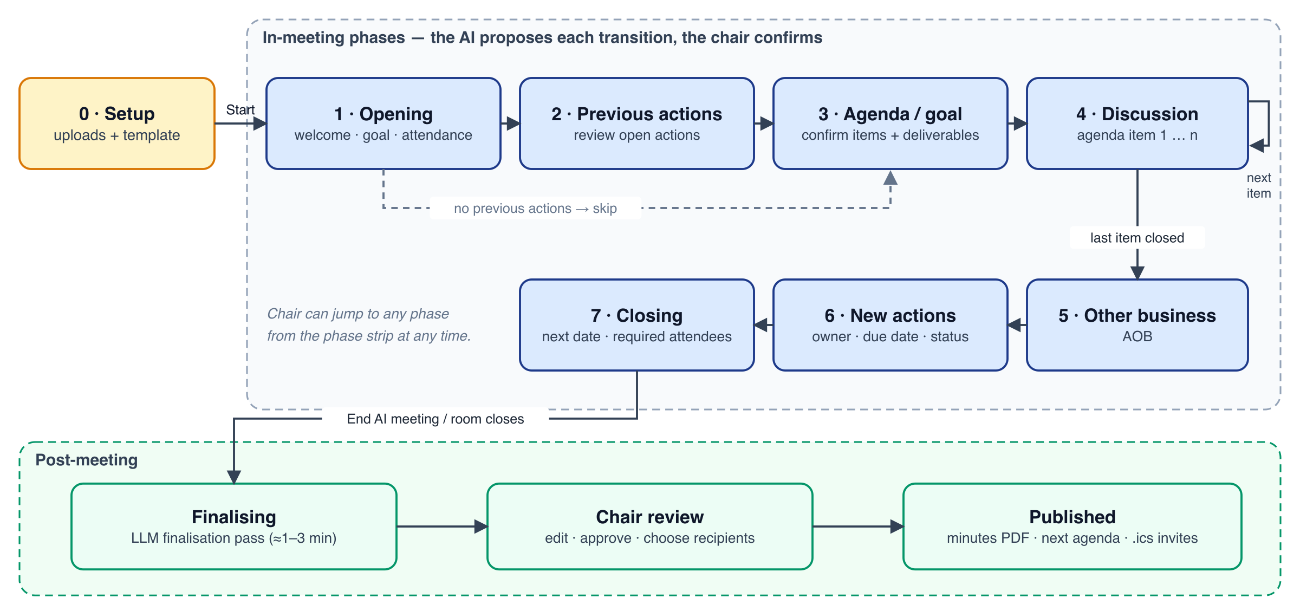
Figure 1 — Meeting phase model. Both templates share the engine; the Goal-driven template renames phases 3–6.
Table 9 — Phase definitions
Phase | Agenda-driven | Goal-driven | Exit signal (proposal trigger)
1 · Opening | Welcome, purpose, attendance check | Same | Chair starts (“let's begin”), or 2 min after start with ≥ 50 % of required attendees present
2 · Previous actions | Review each open series action: done, progress, blocked, carried over, dropped | Same (skipped if none) | Rule: every imported open action has a status this session, or was explicitly skipped
3 · Agenda / Goal | Confirm or adjust agenda items and timeboxes | State the meeting goal and the deliverables expected in the meeting | Agenda confirmed or goal + deliverables captured (LLM signal), or 3 min elapsed
4 · Discussion | Agenda items 1…n, each with minutes, decisions and actions | Work on the deliverables, one by one | Per item: closing statement or explicit “next item”, decision recorded plus topic shift, or timebox +50 % (nudge only)
5 · Other business | AOB items, added as agenda items with source “AOB” | Next steps | “Anything else?” followed by 60 s with no new topic
6 · New actions | Read back the actions created this session; confirm owner and due date | Planning: owners, dates and milestones | Rule: every new action has an owner and due date, or is explicitly marked TBD
7 · Closing | Agree the next meeting date and required attendees | Same | Chair ends, or a date is captured and 60 s of closing remarks pass

The chair can always jump to any phase from the phase strip on the board (Figure 2, marker 2). Jumping backwards is allowed, for example to return to an agenda item, and is logged as an operation.

5.6 Live extraction: what the AI maintains
Table 10 — Board content per tab
Tab | Content kept live | Typical AI operations
Agenda | Items with status (pending, active, done, deferred), presenter, timebox and elapsed time, and desired outcome | Set the active item; mark done or deferred; add AOB items; adjust a title when the meeting renames it
Decisions | Numbered decisions (D-nn), each linked to an agenda item, with rationale and status (proposed or confirmed) | Add a decision; refine its wording; link it to an item
Actions | Series-scoped actions (A-nn): previous ones with their review status, and new ones with owner, due date and status | Add an action; set owner or due date; update status; mark carried over or dropped
Attendance | Present, left, absent (required but not joined), apologies, not transcribed (opted out); who is required next time and why | Record apologies (“Sofie sends apologies”); propose required attendees for next time
Minutes | One running paragraph set per agenda item, concise and in the session language | Rewrite the current item's minutes (bounded length); never touch locked items
Attachments | Whiteboard snapshots and uploaded inputs, each linked to an agenda item | (none; created by humans or the snapshot button)
Transcript | The live transcript with speaker and time; searchable; each AI item's evidence links here | (none; written by STT)

5.7 Announcements
Announcements are short, templated messages. A large overlay on the stage shows them for 4 s, plus the length of the speech, and a synthesised voice speaks them in the session language. They cover:
- session start (“Meet++ is now taking notes”) and end (“Meet++ has stopped taking notes. Minutes will follow after review.”);
- each phase entry (“Let's start with last meeting's actions”, “Agenda review starts now”, “Item 2: Vendor contract & SLA, presented by Jan”, “Any other business?”, “Let's review the new actions”, “Closing: let's plan the next meeting”);
- optional timebox nudges in Lead mode (“Item 2 is over its time”).
They are rate-limited to one non-phase announcement per 60 s. Each user can mute the spoken part (Settings → Notifications) without hiding the text.

5.8 Whiteboard snapshots
While a session is active, the whiteboard toolbar shows Snapshot to Meet++. The Attachments tab shows Add whiteboard snapshot, which works even when nobody has the whiteboard open. The snapshot is rendered at 1920×1080 on a solid background without selection outlines. It is attached to the current agenda item, captioned “Whiteboard: <item> — <time>”, and listed in the Attachments tab. The minutes reference it, and the minutes PDF embeds it.

5.9 Post-meeting: finalise, review, publish
- Finalise. When the session ends, the system runs a final tick on the remaining transcript. It then runs a finalisation pass over the full transcript, in chunks for long meetings, plus the current state. This pass produces clean minutes per item, a deduplicated set of decisions and actions, a draft agenda for the next meeting, and suggested required attendees. It typically takes 1–3 minutes.
- Review. The chair (and co-hosts) get an in-app banner and an e-mail with a link to /meetings/:id/ai/:sid (Figure 5). Everything is editable there. The screen also shows what the finalisation changed compared with the live state.
- Publish & send. The system renders minutes.pdf and agenda.pdf. If needed, it creates the next meeting or attaches the agenda to the next RRULE occurrence. It then e-mails the minutes to attendees and the invitations (.ics + agenda PDF) to the required attendees, and logs all outputs. Nothing is sent before this click.
- Re-publish. Corrections after publishing create version 2 of the outputs. Invitations are re-sent with an incremented SEQUENCE, so calendars update the event instead of duplicating it.

5.10 Meeting series and carry-over
- A series groups the sessions of a recurring meeting (one RRULE meeting row) or a chain of separate meetings (“next meeting” created by Meet++). Actions belong to the series, not to a single session.
- When a new session starts in the series, every action whose status is not done or dropped is imported into phase 2 (Previous actions). The previous session's decisions are available as reference on the Decisions tab (collapsed).
- Uploading a previous-notes PDF bootstraps a series that was run without Meet++. Its actions are parsed and stored as series actions with source pdf.
- Numbering (A-nn, D-nn) is continuous per series, so action references stay stable across meetings.

6. Functional and non-functional requirements

6.1 Functional requirements
Priority: M = must, S = should, C = could. Release: R1 = first production release; R2 = follow-up (local model and integrations).
Table 11 — Functional requirements
ID | Requirement | Pri | Rel
FR-S1 | The owner or a co-host can open the AI Meeting setup from the room top bar when Meet++ is enabled for the meeting owner. | M | R1
FR-S2 | The chair can upload an agenda PDF and a previous-notes PDF (each optional, ≤ 10 MB, ≤ 50 pages). The system extracts and structures them, and shows an editable preview. | M | R1
FR-S3 | The chair can choose a template (Agenda-driven, Goal-driven), spoken language, AI mode (Lead, Assist) and series before starting. | M | R1
FR-S4 | Open actions from the previous published session of the series are imported automatically. | M | R1
FR-S5 | Only one Meet++ session can be active per room. Starting a second one is refused with a clear message. | M | R1
FR-S6 | When the operator's capacity limit is reached (MEETPP_MAX_ACTIVE_SESSIONS), the start is refused with “AI capacity busy — try again later”. | M | R1
FR-L1 | While a session is active, each consenting human participant's microphone audio is transcribed with speaker attribution. | M | R1
FR-L2 | Final transcript segments are shown as live captions to every participant who has captions enabled. | M | R1
FR-L3 | The AI keeps agenda status, decisions, actions, attendance and per-item minutes up to date from the transcript, and records transcript evidence for each item. | M | R1
FR-L4 | Participants who opt out are not transcribed. Their audio is never sent to STT, and they are marked “not transcribed”. | M | R1
FR-L5 | The chair can pause and resume transcription. While paused, no audio is processed and the badge shows “AI notes paused”. | M | R1
FR-B1 | All participants see the board with seven tabs. In follow mode, the board switches to the tab and item that changed, under the rules of §7.5. | M | R1
FR-B2 | The chair and designated editors can confirm, edit, reject and add items. Human-edited items are locked against AI changes. | M | R1
FR-B3 | Each AI item shows its provenance (“AI · 10:42 · Jan P.”). Clicking it jumps to the evidence in the Transcript tab. | S | R1
FR-B4 | The board is shown in the main slot in speaker mode by default. Screen share, pin or playback take over, and the chair can bring the board back. | M | R1
FR-B5 | Recordings and livestreams show the board (setting, default on). | S | R1
FR-P1 | The system proposes phase transitions based on rules and the LLM signal. In Lead mode it auto-advances after an 8 s cancel window; in Assist mode the chair confirms. | M | R1
FR-P2 | Phase transitions trigger a big-text announcement and TTS in the session language. | M | R1
FR-P3 | The chair can jump to any phase or agenda item manually. | M | R1
FR-P4 | Timebox nudges are shown to the chair at 100 % of an item's timebox. In Lead mode an announcement is made at 150 %, if enabled. | S | R1
FR-W1 | Any participant (configurable: chair and editors only) can snapshot the whiteboard into the session, linked to the current agenda item. | M | R1
FR-F1 | Ending the session produces finalised minutes, decisions, actions, a next-agenda draft and suggested required attendees within 5 min for a 90-min meeting. | M | R1
FR-F2 | The chair reviews and edits all outputs, and chooses the next date, duration, room and recipients. | M | R1
FR-F3 | On publish, minutes (PDF + HTML e-mail) are sent to attendees, and invitations (.ics METHOD:REQUEST + agenda PDF) to required attendees. | M | R1
FR-F4 | For RRULE meetings, the agenda is attached to the next occurrence and no duplicate meeting is created. For one-off meetings, a new meeting is created in the same series. | M | R1
FR-F5 | Outputs can be re-published as new versions. Invitations update via SEQUENCE. | S | R1
FR-F6 | Owners and co-hosts can download outputs, and export the session as JSON and Markdown. | S | R1
FR-A1 | The operator can enable or disable Meet++ globally, restrict it to an allow-list of owners, and cap concurrent sessions. | M | R1
FR-A2 | The owner can delete a session and all of its data (transcript, uploads, outputs). | M | R1
FR-A3 | The LLM provider (DeepSeek or local OpenAI-compatible) and the STT location (local or remote) are configurable without code changes. | M | R1
FR-R2a | Use a local LLM on the Mac Studio over a private tunnel, with a fail-closed or fallback policy per session. | M | R2
FR-R2b | Export minutes and actions to the OneVoice OM module, and invites through the Mail platform. | S | R2+

6.2 Non-functional requirements
Table 12 — Non-functional requirements
ID | Category | Requirement
NFR-1 | Latency | Captions p95 ≤ 6 s after the end of the utterance. Board items triggered by a cue phrase p95 ≤ 20 s. Phase-proposal round trip ≤ 2 s after the trigger.
NFR-2 | Capacity | One concurrent session on CPU STT with up to 20 participants (about 8 active speakers). R2 with STT offload: 3 concurrent sessions.
NFR-3 | Host safety | The meetpp-agent container is hard-capped (cpus: 2.0, mem_limit: 3g) and runs at lower CPU priority. The TITV egress and recordings must not degrade.
NFR-4 | Availability | STT or LLM outages never break the meeting. Captions, the board and manual editing degrade independently (§15). A deploy during a session loses at most 60 s of transcript, which is buffered in the agent.
NFR-5 | Durability | Session state is persisted after every applied operation. A meeting-api restart resumes running sessions from the database within 10 s.
NFR-6 | Security | Every Meet++ endpoint is authenticated: user JWT for chair actions, LiveKit room token for participants, HMAC for internal calls. No Meet++ data is reachable by room name alone.
NFR-7 | Privacy | Consent is collected before transcribing. Speaker names are aliased in LLM prompts by default. No e-mail addresses go to the LLM. Retention is configurable (§10.7).
NFR-8 | Accessibility | WCAG 2.1 AA for the board, setup and review screens. Focus changes in follow mode never steal keyboard focus. prefers-reduced-motion is respected.
NFR-9 | i18n | All UI strings go in the meetpp i18next namespace across all 50 locales. Generated content is written in the session language.
NFR-10 | Cost | LLM spend ≤ USD 0.30 per meeting hour on DeepSeek, enforced by a per-session token budget (MEETPP_MAX_TOKENS_PER_HOUR).
NFR-11 | Observability | Metrics for STT backlog, LLM latency, tokens and errors, rejected operations, and proposal outcomes. A structured log line for every operation.

7. UX specification

7.1 States and roles
Table 13 — UI by session state and role
Session state | Chair (owner / co-host) | Editor | Participant / guest | Egress / public viewer
none | AI Meeting button (idle) | — | — | —
setup | Setup modal (only the initiating chair) | — | — | —
running | Board with edit controls, proposals, AI menu | Board with edit controls | Board read-only, captions, consent | Board read-only (follow); public only if enabled
paused | As running, plus “Resume” banner | As running | Badge “AI notes paused” | Board frozen
finalising | Banner “Preparing minutes…” | Board read-only | Board read-only, “Meeting ended” | Board hidden
review | Review screen; in-app banner and e-mail | Review screen (read and comment) | — | —
published | Outputs, re-publish | Outputs (read) | Minutes e-mail | —

7.2 In-room layout
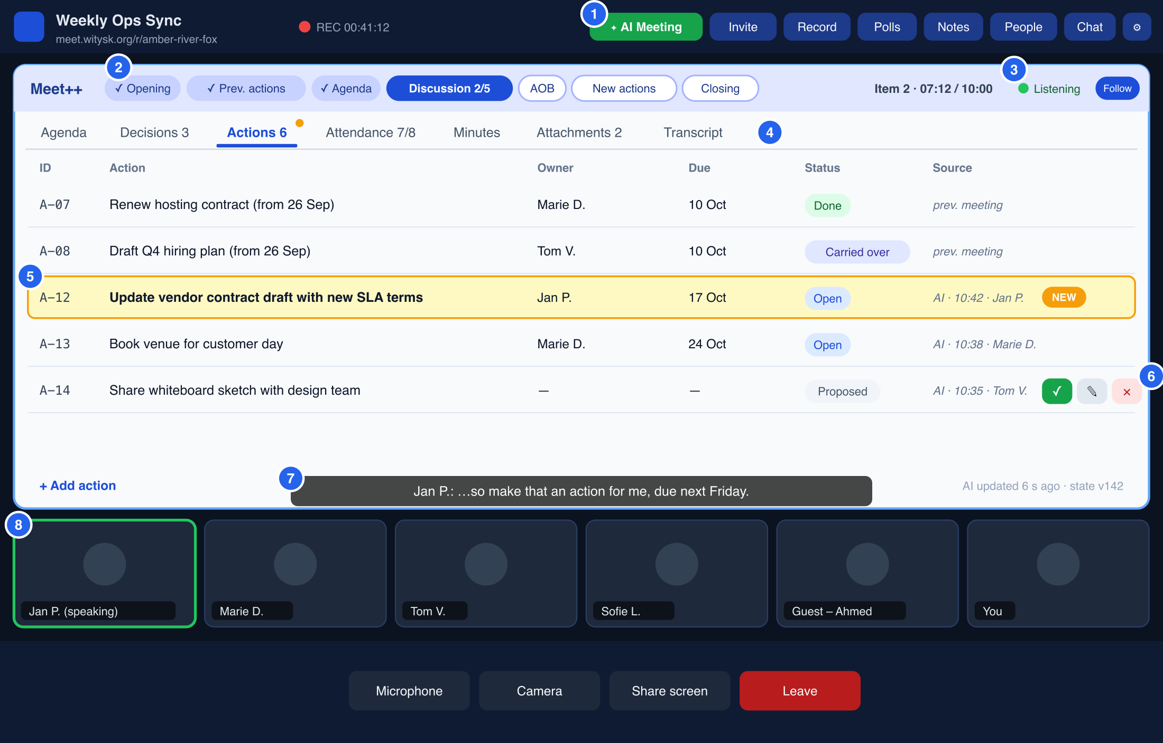
Figure 2 — Room with an active Meet++ session in speaker mode. The board is the main stage tile, the Actions tab is in focus and a new item is highlighted.
Table 14 — Room layout callouts
# | Element | Behaviour
1 | AI Meeting button | Green while active. Opens the session menu: pause/resume, mode, bring board to main, editors, end.
2 | Phase strip | Done phases show ✓, the current phase is filled, future phases are outlined. The chair can click any phase to jump (with confirmation).
3 | Timer, AI status, Follow | Shows item elapsed time against its timebox. Status dot: Listening (green), Thinking (blue pulse), Behind (amber, with STT backlog in seconds), Paused (grey), AI unavailable (red). The Follow toggle is per user.
4 | Tabs with counters | A counter shows the item count. An amber dot marks unseen changes on a tab that is not in focus.
5 | Highlighted item | New or updated items glow for 4 s and keep a NEW or UPDATED badge until they have been seen (≥ 1 s in view). Provenance is shown in the Source column.
6 | Inline controls | Confirm ✓ / edit ✎ / reject ✕ for chair and editors, on proposed items and on hover for other items.
7 | Live captions | The existing CaptionsOverlay, now fed by caption messages: speaker name plus text, the last two lines, fading after 6 s.
8 | Thumbnail strip | Humans in the speaker strip. When someone shares their screen, the board moves here as a mini tile.

7.3 Setup screen
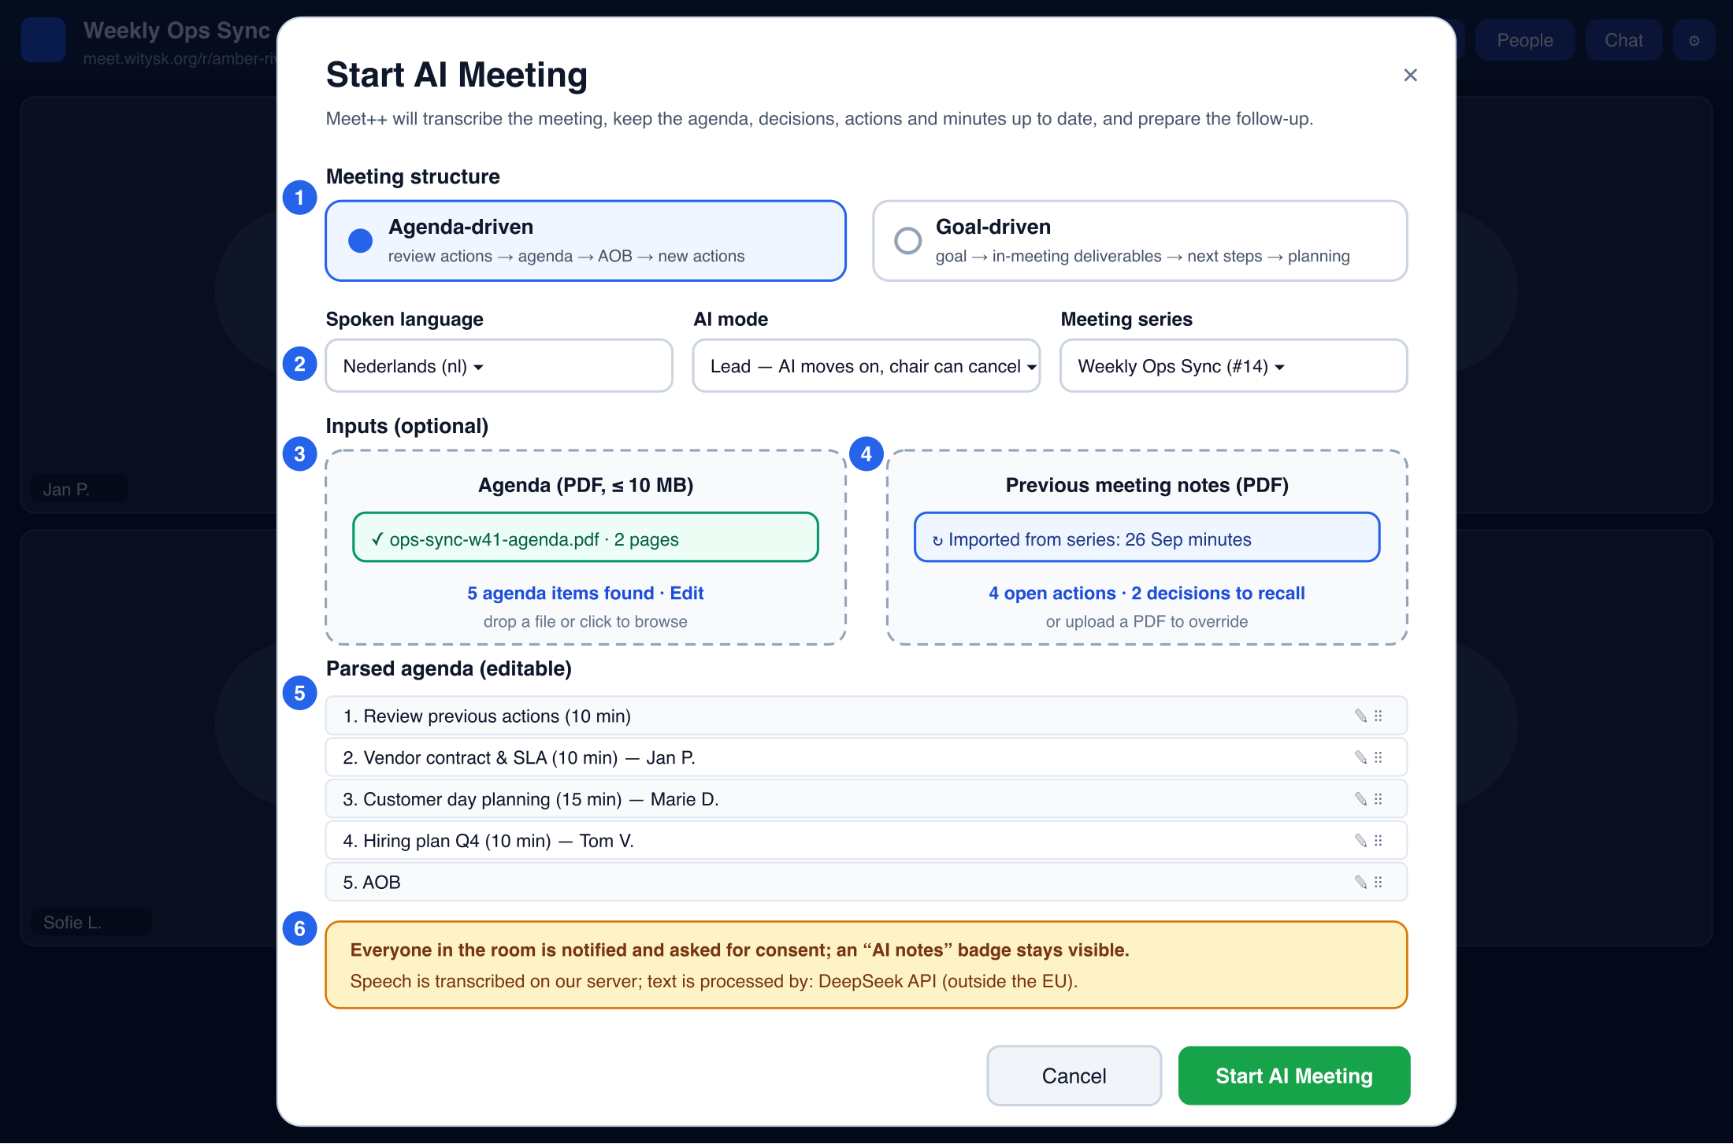
Figure 3 — Start AI Meeting modal: structure, language, mode, series, inputs, parsed agenda preview and processing notice.
Table 15 — Setup callouts
# | Element | Behaviour
1 | Meeting structure | Radio cards. Selecting Goal-driven hides the agenda preview and shows an optional “Goal” text field.
2 | Language, mode, series | Selects using the existing ui.tsx Select. The series list shows the chair's series with their last session date.
3 | Agenda drop zone | Accepts PDF only. Shows progress while extracting and parsing, then a summary (“5 agenda items found”). Errors appear inline: no text layer, too large, encrypted.
4 | Previous notes | Shows “Imported from series” when available; an upload overrides it.
5 | Parsed agenda | Editable rows: title, presenter, timebox; reorder by drag handle; add or delete.
6 | Processing notice | Required. It names the STT location and the LLM provider (from configuration), and links to the privacy page.

7.4 Tab content specification
Table 16 — Board tabs
Tab | Row fields | Sort / grouping | Human actions
Agenda | #, title, presenter, timebox / elapsed, status, outcome | By position. The active item is pinned and highlighted. | Reorder, edit, add, set active, mark done or deferred
Decisions | D-nn, text, item, status, source | By item, then time. The previous meeting's decisions are in a collapsed group. | Confirm, edit, reject, add
Actions | A-nn, title, owner, due, status, source | Groups: previous (open), new this meeting. Done items are collapsed. | Confirm, edit (owner from an attendee picker), set status, add
Attendance | Name, role, presence, talk time, transcribed?, required next (reason) | Present → left → absent/apologies | Mark apologies, toggle required-next, edit display name or e-mail (chair)
Minutes | Per agenda item: heading plus Markdown body | Agenda order | Edit an item's body (locks it), regenerate an item (chair)
Attachments | Thumbnail, caption, item, time, author | By time | Add a whiteboard snapshot, rename, delete (chair)
Transcript | Time, speaker, text | Chronological, virtualised list with search | Copy, jump to evidence; no edits in R1

7.5 Follow mode and auto-focus rules
Follow mode makes the board feel alive without becoming distracting. The server attaches a focus hint to each state message, and each client decides locally whether to obey it.
- Default on for everyone. The egress page always follows.
- Priority of focus hints: phase or active-item change (Agenda) > decision added or confirmed > action added or updated > attendance required-next change > agenda status change > minutes update. A minutes update only takes focus if no other focus happened in the previous 60 s.
- Dwell: at least 6 s on a tab before switching again. Hints that arrive during the dwell are merged, and the highest-priority latest hint wins.
- User interaction pauses follow for 30 s. This includes clicking a tab, scrolling, editing, or hovering over an item for more than 2 s. The Follow toggle shows “Paused · resume” during that time. While an item is being edited, auto-switching is suspended until the edit is saved or cancelled.
- Scroll with scrollIntoView({block: "center"}), smooth unless reduced motion is on. Keyboard focus is never moved.
- Highlights: glow for 4 s, then the badge persists until the item has been seen. Unseen changes on other tabs show the amber dot.

7.6 Phase proposals and announcements
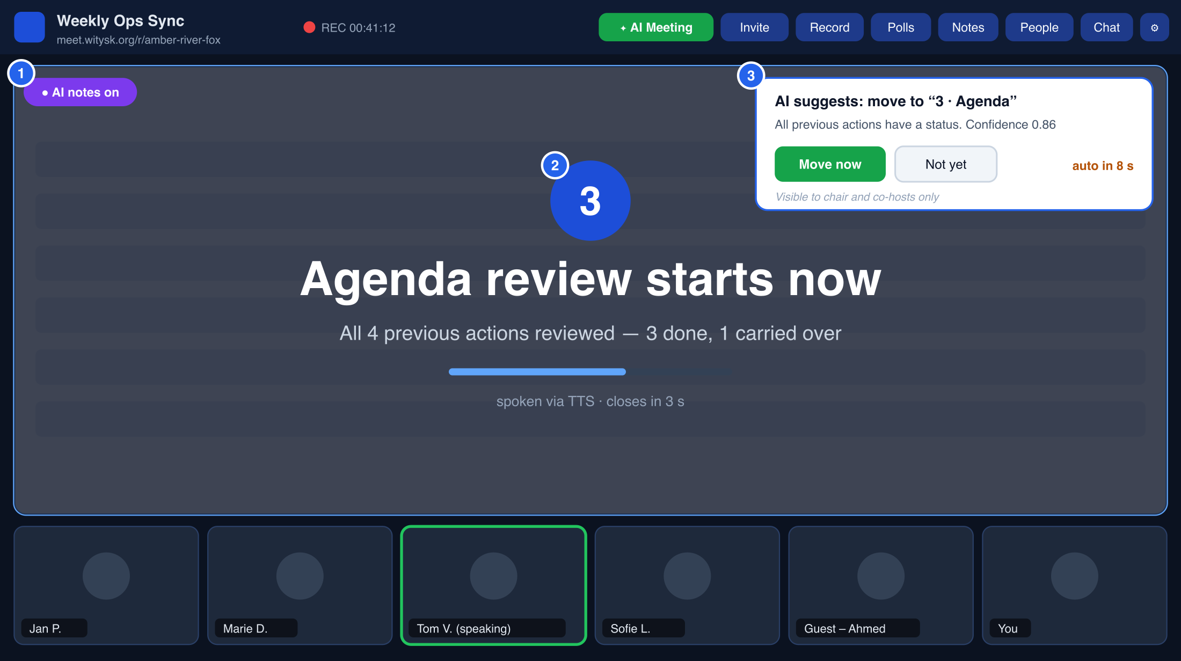
Figure 4 — Phase change: an “AI notes on” badge, a big-text announcement over the stage, and the chair-only proposal toast with its auto-advance countdown.
- Proposal toast (marker 3). Only the chair and co-hosts see it, via a data message targeted with destination_identities. It offers Move now and Not yet. In Lead mode an 8 s countdown runs, then the system auto-accepts. Not yet suppresses the same proposal for 3 minutes.
- Announcement overlay (marker 2). It is shown to everyone, including the egress page: the phase number or icon, a title of at most 60 characters and a subtitle of at most 90. It covers the stage at 80 % opacity for 4 s plus the clip length. Clicking or pressing Esc dismisses it locally.
- Speech. Each client plays the TTS clip locally through an <audio> element at the user's output volume. The clip is not published as a track, so it is never transcribed (§9.10).

7.7 Consent and indicators
- When a session starts, or when someone joins during a session, every participant sees a consent dialog. It says: “This meeting uses AI notes: your speech is transcribed on our server and the text is processed by <provider> to produce minutes.” The buttons are Continue and Don't transcribe me, plus a link to the privacy page.
- The decision is stored per session and identity. “Don't transcribe me” is honoured by the agent at the audio level. The participant can still speak and is listed as “not transcribed”. They can change their choice later from the badge menu.
- The purple AI notes on badge stays visible next to REC for everyone. The lobby shows “AI notes are active in this meeting” before joining (GET /meetpp/rooms/{room}/active).

7.8 Post-meeting review screen
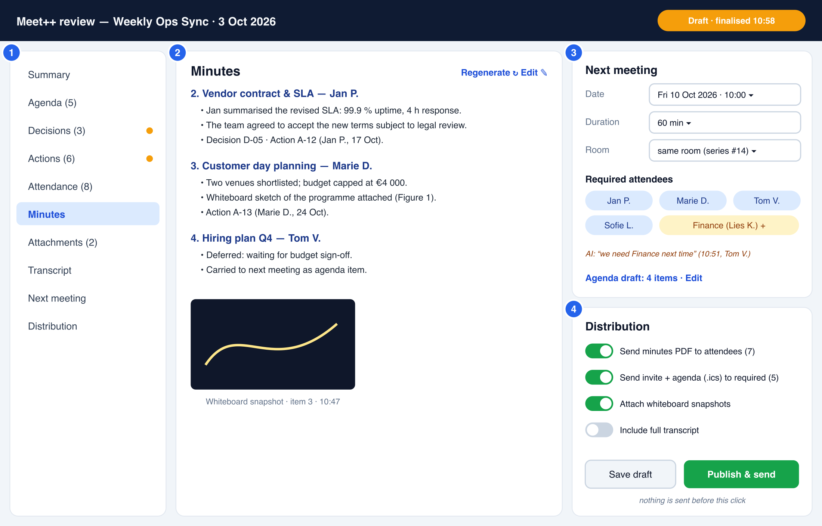
Figure 5 — Review screen: section navigation, minutes editor, next-meeting planner and distribution settings.
- The route is /meetings/:meetingId/ai/:sessionId, for the owner and co-hosts. Unsaved changes are auto-saved as a draft every 5 s.
- Amber dots mark sections where the finalisation pass changed the AI's live state, for example merged duplicate actions. A diff view lists those changes.
- Next meeting: date and time with a timezone picker (default Europe/Brussels), duration, room (same room for RRULE series, or new room), the required-attendee chips with the AI's reason, and an editable agenda draft.
- Distribution toggles: minutes to attendees, invites to required attendees, attach snapshots, include the full transcript (off by default). Recipients without an e-mail address are listed with an “add e-mail” field.

7.9 Small screens, PiP and public view
- Phones (useIsMobile). The board fills the stage. Tabs become a horizontally scrollable chip row. Inline editing is limited to confirm and reject; full editing is on desktop. The setup modal uses the existing bottom-sheet Modal.
- Picture-in-picture (PipButton). The board is not shown in the browser PiP window; the speaker video is.
- PublicView (/public/<slug>). It reuses PresenterSpotlight. The board is shown only when the session setting “Show board to public viewers” is on; otherwise the main slot falls back to the next item in the ladder.

7.10 Accessibility
- The board uses WAI-ARIA tabs (role=tablist/tab/tabpanel). Highlights also have a text badge, so they do not rely on colour. Contrast is ≥ 4.5:1.
- Live updates are announced through a polite aria-live region, throttled to one message per 10 s and summarised (“2 new actions”). Captions use their own aria-live=off region to avoid double reading.
- Announcements respect prefers-reduced-motion (no animation) and the per-user “speak announcements” preference.
- All controls are reachable by keyboard. New shortcut: Ctrl+Shift+A toggles follow mode (registered in lib/shortcuts.ts and listed in ShortcutOverlay).

7.11 Internationalisation
- New i18next namespace meetpp (Appendix E). Keys are added to en.json and translated with scripts/translate_missing_keys.py. The codebase already has 194 keys used only via defaultValue; Meet++ adds no new ones of that kind.
- Generated content (minutes, announcements, e-mails, PDF headings) uses the session language, not each viewer's UI language. PDF and e-mail templates ship in en, nl, fr and de for R1, falling back to en.
- Dates and times use Intl.DateTimeFormat with the viewer's locale on screen, and the session language plus the chosen timezone in outputs.

7.12 Error, empty and degraded states
Table 17 — Error and degraded states
Condition | What users see | What still works
STT backlog > 30 s | Status “Behind 34 s”, amber; captions delayed | Everything; the agent switches to a faster model
STT backlog > 90 s or agent offline | “Transcription interrupted”, red; chair toast with Retry | Board editing; manual phases
LLM errors or circuit open | “AI paused — retrying”; proposals stop | Captions, transcript, manual editing
Token budget reached | Chair toast: “AI budget for this meeting reached; continuing with captions only” | Captions, manual editing, finalisation (separate budget)
PDF has no text layer | “This PDF looks scanned. Upload a text PDF or enter the agenda manually.” | Manual agenda
No agenda, no previous actions | Board tabs show empty-state hints (“Decisions will appear here as they are made”) | Goal-driven template suggested
Finalisation failed | Review screen with the live state and “Finalisation failed — Retry” | Manual review and publish
E-mail send failures | Per-recipient status in Distribution, with Retry | Other recipients

8. Domain model and AI behaviour

8.1 Content model and lifecycles
Table 18 — Content model
Entity | Key fields | Lifecycle
Session | template, mode, language, phase, current item, state_version | setup → running ⇄ paused → finalising → review → published (or aborted)
Agenda item | position, title, presenter, timebox, outcome, source (pdf, ai, user, aob) | pending → active → done or deferred (deferred items feed the next agenda)
Decision | ref D-nn, text, rationale, agenda item, evidence | proposed → confirmed, or rejected (rejected items are kept in the ops log only)
Action | ref A-nn, title, owner, due date, agenda item, evidence; scoped to the series | proposed → open → in_progress → done, or dropped. Open at publish → carried into the next session.
Minutes | per agenda item: Markdown body, version | draft (AI) → edited (locked) → final (finalisation) → published
Attendee | person key, names, e-mail, identities, presence, opted_out, required_now, required_next(+reason) | joined → present ⇄ left; absent or apologies for required people who did not join
Attachment | kind (whiteboard, upload), path, caption, agenda item | created → (renamed) → deleted
Segment | seq, speaker, t_start, t_end, text, lang, confidence | immutable; deleted by retention

Every AI-created decision, action, attendance requirement and minutes update carries evidence: the transcript segment numbers it was derived from. Items without valid evidence are rejected by the validator. This is the main guard against invented content.

8.2 The extraction loop
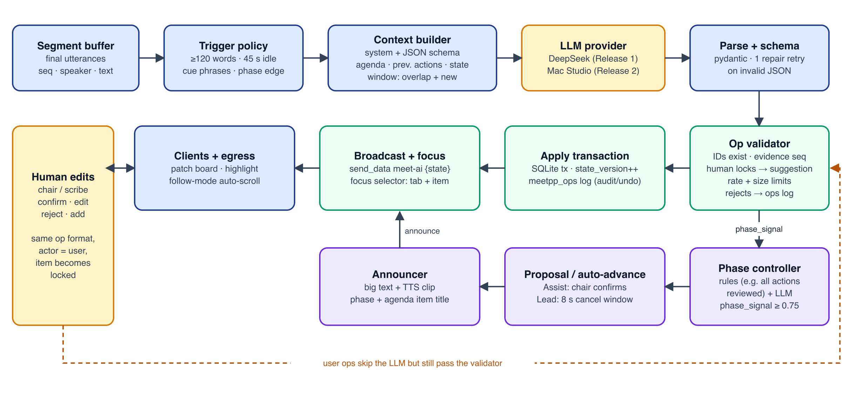
Figure 6 — Extraction loop. The LLM only proposes operations; validation, application and broadcast are deterministic server code. Human edits use the same operation format.
The loop runs as one asyncio task per active session in meeting-api (§9.7). Each tick:
- Trigger policy. A tick runs when any of these holds: (a) ≥ 120 new words since the last tick; (b) ≥ 45 s since the last tick and there are new words; (c) a cue phrase in a new segment (per-language regex list: “action”, “actiepunt”, “we agree”, “afgesproken”, “decided”, “next item”, “volgend punt”, “any other business”, “rondvraag”, …); (d) a phase or active-item change by the chair. Ticks are single-flight: while an LLM call is in flight, new triggers are coalesced into the next tick.
- Context build. Stable content comes first so DeepSeek's prefix cache hits: system prompt and output schema, then the meeting header (title, template, language, phase, alias table), agenda, previous actions, and the current state snapshot (compact, with IDs). Last comes the transcript window: an overlap of the previous 60 s marked “already processed”, followed by the new segments.
- LLM call. JSON output mode, temperature 0.2, max_tokens 1200, 45 s timeout.
- Parse. Invalid JSON gets one repair retry, with the error message included in the retry.
- Validate each operation (§8.3). Rejected operations are logged with a reason.
- Apply the accepted operations in a single transaction, increment state_version, and append them to meetpp_ops.
- Broadcast a state message with the changed IDs, an inline delta (≤ 8 KB) and a focus hint.
- Phase signal. Forward any phase signal to the phase controller.
- Advance the cursor. Move transcript_cursor to the last processed segment.

8.3 Operation vocabulary
Table 19 — LLM operation vocabulary
Operation | Payload (abridged) | Validation rules
agenda.set_active | item_id | Item exists; only one active. Proposes a phase change if the phase is not Discussion.
agenda.set_status | item_id, status (done, deferred) | Item exists and is not locked
agenda.add | title, presenter?, source=aob | Only in phases 4–5; ≤ 20 items in total
decision.add | item_id, text ≤ 400, rationale? ≤ 400, evidence[] | Evidence segments exist within the window; no near-duplicate (similarity ≥ 0.85 to an existing decision)
decision.update | id, text?, status? | Not locked (otherwise converted to a suggestion)
action.add | title ≤ 200, owner_alias?, due?, item_id?, evidence[] | Owner alias maps to a known attendee or is null; due date parses to an ISO date ≥ today; no near-duplicate
action.update | id, status?, owner_alias?, due?, note?, evidence[] | Previous or new action exists; status transition allowed; not locked
minutes.upsert | item_id, body_md ≤ 1500 chars | Only for the active item or one closed < 5 min ago; not locked; Markdown subset only
attendance.apologies | person_alias or name, evidence[] | Person is in required_now or is a known attendee
attendance.require_next | person_alias or name, reason ≤ 120, evidence[] | ≤ 30 people in total
phase.signal | to, confidence 0–1, reason ≤ 160 | Sent to the phase controller (not applied directly)
next_meeting.propose | date_text, iso?, duration_min? | Stored as a suggestion for the closing phase and review

Human operations use the same vocabulary with actor = user:<sub or identity>. They bypass the LLM but not the validator. Any human edit locks the item (locked = true). AI operations on a locked item become suggestions, which appear as a small “AI suggests: …” chip that editors can accept. Limits per tick: ≤ 12 operations and ≤ 3 minutes upserts; extra operations are dropped and logged.

8.4 Prompting strategy
- Role and rules. “You maintain the record of a business meeting. Use only what is said in the transcript. Never invent owners, dates or decisions. Prefer no operation over a guessed one. Write in {language}. Use the aliases P1…Pn for people. Output a single JSON object matching the schema.” The full skeleton is in Appendix C.
- Schema in the prompt. A compact JSON schema plus two short examples. DeepSeek's JSON mode requires the word “json” and an example in the prompt.
- Speaker aliasing. Participants are sent as P1 … Pn with a role hint (chair, presenter of item 3), never with e-mail addresses. Names that occur inside utterances stay in the text, because removing them would break attribution. Aliasing is on for external providers and optional for local ones.
- Bounded state. The snapshot sends IDs and short texts. Minutes are included only for the active item, plus the first 300 characters of the others, which keeps the prompt below about 8K tokens.
- Language. Transcript and output share the session language. Mixed-language speech is passed through; the minutes are written in the session language.
- Determinism. Low temperature. The model, prompt and schema versions are logged with every call, so tuning changes can be evaluated against golden transcripts (§16.3).

8.5 Phase detection
Phase changes come from two sources, and the phase controller combines them:
- Rules (deterministic, confidence 0.9). All imported actions reviewed → propose Agenda. All new actions have an owner and due date → propose Closing. Item timebox reached → nudge only. Chair explicitly says “next item” (cue phrase) → propose the next item.
- LLM phase.signal, with the model's confidence. It is only considered when confidence ≥ 0.75 and the target phase is the next one or the next agenda item. Backward jumps are never proposed by the AI.
- Lead mode auto-accepts a proposal with confidence ≥ 0.85 after the 8 s cancel window. Lower-confidence proposals wait for the chair, as in Assist mode. Assist mode never auto-accepts.
- Accepted transitions update the phase and the active item, write an operation, and trigger the announcement. A rejected proposal (“Not yet”) suppresses the same target for 3 minutes.

8.6 Minutes drafting and finalisation
- Live. Minutes are rewritten per agenda item by minutes.upsert on the active item only. The rewrite is bounded to 1500 characters, factual, in the third person, and mentions decisions and actions by reference (D-05, A-12).
- Finalisation pass. It runs on the full transcript, in chunks of about 20 minutes with 1-minute overlap, plus the live state. Per chunk it emits corrections (merge duplicates, fix owners, add missed items with evidence). A last call then writes the final minutes per item, an executive summary of 5 bullets at most, and the next-agenda draft. For this pass deepseek-reasoner may be used (configurable LLM_MODEL_FINAL), since latency matters less.
- Human edits are respected. Locked items are never changed by finalisation; differences are offered as suggestions in the review screen.

8.7 Attendance and next-meeting attendees
- Present. Comes from the agent's live view of the room: participant_connected and participant_disconnected events for participants of kind STANDARD only. That excludes playback, composite-*, viewer-*, egress, ingress and the agent itself. It is posted to meeting-api (/internal/.../presence).
- Person merge. user-<sub> identities merge by sub. anon-<ULID> identities merge by normalised display name within the session, which handles reconnects. E-mail comes from meeting_participants or the SSO profile when known. The chair can fix names and e-mails.
- Required now. Comes from the attendee list on the agenda PDF (if present), the previous session's required-next list, and manual additions. Required people who never joined are shown as absent, or apologies when the transcript says so.
- Required next. The AI proposes people: owners of open actions; people explicitly mentioned (“we need Finance next time”); and, as a heuristic, core members who attended at least 2 of the last 3 sessions. Each proposal comes with its reason. The chair confirms in Closing or Review.

8.8 PDF ingestion
- Upload checks. Content-Type application/pdf, the magic bytes %PDF-, ≤ 10 MB, not encrypted, ≤ 50 pages. Caddy enforces a 12 MB request-body limit on /api/v1/meetpp/*, because Starlette spools the whole body before the handler runs.
- Text extraction. pypdf runs in a subprocess with RLIMIT_AS 512 MB and a 20 s timeout, to contain malicious or bomb PDFs. Text is capped at 200,000 characters. Fewer than 200 characters per page on average means “no text layer” and the PDF is rejected (no OCR in R1).
- Structuring. One LLM call per document with a dedicated schema. The agenda gives items (title, presenter, timebox, outcome) and an optional list of attendees. Previous notes give actions (title, owner, due, status), decisions and attendees. The result is shown for review; nothing is applied until the chair starts the session.
- The file and the extracted text are stored under /var/lib/meet/meetpp/<session>/uploads/; the sha256 deduplicates repeated uploads.

8.9 Quality guardrails
Table 20 — Quality guardrails
Risk | Guardrail
Hallucinated items | Evidence required and validated. “Prefer no op” instruction. Precision metric tracked; golden-set regression before prompt changes.
Wrong owner attribution | Speaker aliases tied to LiveKit identities. Owner must map to a known attendee or stay null (“unassigned”). Owner edits are measured.
Duplicates | Similarity check (normalised tokens, Jaccard ≥ 0.85) before adding. The finalisation pass merges remaining duplicates.
Whisper artefacts | VAD gating. Drop segments with no_speech_prob > 0.6 and avg_logprob < -1.0. Blocklist of known hallucinations (“Thank you for watching”, “Ondertitels ingediend door de Amara.org gemeenschap”, …). condition_on_previous_text=False.
Names and jargon misrecognised | Whisper initial_prompt with agenda titles, participant names and a series glossary of up to 200 tokens.
Board churn | Bounded minutes rewrites, minimum dwell, and focus priority rules (§7.5).
Prompt injection (PDF or speech) | No tools and no side effects in the LLM path. The output is schema-constrained. Sending e-mail requires a chair action (§12.5).

9. Technical architecture

9.1 Overview
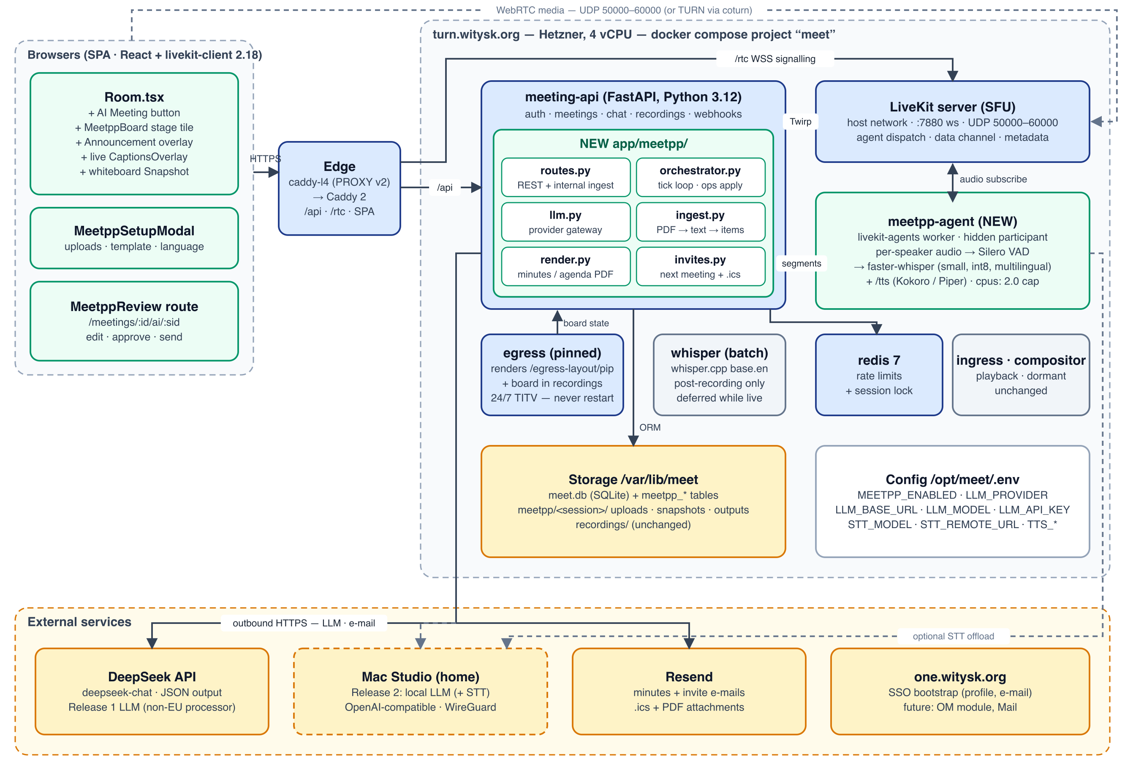
Figure 7 — Meet++ system architecture on turn.witysk.org. Green = new, blue = existing, grey = unchanged or dormant, amber = external.
Meet++ adds one container (meetpp-agent), one backend package (meeting-api/app/meetpp/), frontend components under frontend/src/components/meetpp/ and frontend/src/lib/meetpp/, and new tables. It reuses the existing edge, auth, LiveKit server API, Resend, the egress layout route and the data-channel conventions. These principles guide the design:
- Server-authoritative state. meeting-api with SQLite is the single source of truth. The LLM and clients propose; the server validates and applies.
- Fail soft. STT, LLM and TTS failures each degrade one capability; none of them breaks the meeting.
- Protect the media plane. The new CPU-heavy work is isolated in a capped container. Nothing touches egress or LiveKit configuration.
- Provider-agnostic. STT and LLM sit behind HTTP interfaces chosen by configuration, ready for the Mac Studio.
- Follow house patterns. {v:1,type} data messages, refetch on demand, the lightweight_migrate and create_all schema evolution, .env settings with “empty string = disabled”.

9.2 Architecture decisions
Table 21 — Architecture decision record (summary)
ADR | Decision | Alternatives considered | Rationale
ADR-1 | Capture audio in a dedicated meetpp-agent, a hidden subscribe-only participant using the LiveKit Python RTC SDK. meeting-api starts it through a small session API (the compositor pattern). | (a) Track or room egress to STT; (b) client-side capture with Web Speech or upload; (c) the LiveKit Agents framework with dispatch | (a) risks the 24/7 TITV egress and costs CPU. (b) depends on the browser, can't be trusted, and Web Speech sends audio to Google. (c) is viable but heavier and opinionated toward voice agents; reconsider in R2.
ADR-2 | STT engine: faster-whisper (CTranslate2) small, int8, multilingual, VAD-gated utterances, capped at 2 vCPU. Optional STT_REMOTE_URL offload. | whisper.cpp streaming; keep base.en; cloud STT | Best accuracy per CPU on x86. Multilingual (nl, fr, de). The same HTTP contract allows a Mac Studio backend (whisper.cpp Metal or mlx-whisper large-v3-turbo).
ADR-3 | An LLM gateway that speaks the OpenAI-compatible chat-completions API over plain httpx; JSON output mode; server-side only. | Vendor SDKs; tool or function calling | One client for DeepSeek and every local server (llama.cpp, Ollama, LM Studio, mlx-lm). No new SDK dependency. JSON mode is the most portable.
ADR-4 | The LLM emits operations. The server validates and applies them, with versioning, an audit log, human locks and evidence. | The LLM rewrites the full state each tick | Bounded tokens, no silent overwrites of human edits, auditability, and testable validation.
ADR-5 | The board is a client-rendered virtual stage tile. The same component renders in /egress-layout/pip for recordings. | A server-side headless browser publishing a ScreenShare track (the compositor pattern) | No extra Chrome or encoder on a CPU-tight host. Crisp and interactive. Per-user follow and scroll.
ADR-6 | Real-time via server send_data on topic meet-ai, plus REST refetch for large deltas; session flags in room metadata. | SSE or WebSocket endpoint in FastAPI | Reuses the existing channel and conventions. Works for guests and the egress page without new infrastructure.
ADR-7 | Meet++ room endpoints authenticate with the caller's LiveKit room token (X-Meet-Room-Token), verified with the LiveKit API secret. | Follow the existing unauthenticated room-name routes | Guests have no app JWT but do have a signed room token that encodes room and identity.
ADR-8 | Orchestration: one asyncio task per active session inside meeting-api, resumable from the database, with a Redis lease as the single-runner guard. | A separate worker container plus a queue (RQ or Celery) | Simplest fit for a single-process API. Ticks are I/O-bound LLM calls. The lease keeps future multi-worker setups safe.
ADR-9 | TTS served by meetpp-agent /tts: Piper (multi-language, including nl_BE) with Kokoro optional for English. Clips are cached and played locally by clients and the egress page. | Browser speechSynthesis; publishing an audio track | Consistent voice across clients. No feedback into STT. Low CPU. Browser TTS stays as the fallback.
ADR-10 | Outputs: Jinja2 HTML → WeasyPrint PDF. The ICS builder is extended to METHOD:REQUEST. E-mail through Resend. | reportlab; client-side jsPDF | HTML/CSS templates handle i18n and typography. Server-side output is needed for e-mail attachments.

9.3 Component inventory
Table 22 — Component inventory
Component | Type | Responsibility | Key files (new or changed)
meetpp-agent | New container (Python 3.12) | Session API; joins rooms hidden; per-track audio, VAD and STT; presence events; TTS endpoint; buffering and retry to meeting-api | meetpp-agent/agent/{main.py,session.py,stt.py,vad.py,tts.py}, Dockerfile
app/meetpp/routes.py | New router | Public REST (chair and room-token) plus internal ingest endpoints | mounted in main.py under /api/v1
app/meetpp/runtime.py | New | Session runtime: tick loop, trigger policy, single-flight, resume on startup, Redis lease | started from the main.py lifespan
app/meetpp/llm.py | New | Provider gateway: retries, circuit breaker, token accounting, JSON repair | uses existing httpx
app/meetpp/ops.py | New | Operation schemas (pydantic), validator, applier, focus selector | —
app/meetpp/phases.py | New | Phase rules, proposal handling, Lead/Assist timers, announcements | —
app/meetpp/ingest.py | New | PDF checks, sandboxed extraction, LLM structuring | adds pypdf
app/meetpp/render.py | New | Jinja2 templates → PDF (WeasyPrint); Markdown and JSON export | adds jinja2, weasyprint (+ pango in the Dockerfile)
app/meetpp/invites.py | New | Next meeting creation / RRULE occurrence, ICS invitations, e-mail fan-out | extends services/ics.py and services/email_templates.py
app/meetpp/auth.py | New | Room-token verification, chair and editor checks | uses livekit.api.TokenVerifier
models.py / db.py | Changed | New meetpp_* models; meetings.meetpp_series_id, meetpp_enabled; WAL + busy_timeout pragma | lightweight_migrate tuples
webhooks.py | Changed | room_finished ends any active session; egress_ended skips whisper when a Meet++ transcript covers the recording | small hooks
Room.tsx | Changed | AI Meeting button, badge, consent dialog, meet-ai dispatch, announcement overlay | components/meetpp/*
PresenterSpotlight.tsx | Changed | StageItem union (track or board); board in the main ladder; mini tile | + lib/gridStage.ts keys
EgressLayoutPiP.tsx | Changed | Renders the read-only board and plays announcement clips | shares MeetppBoardView
NotesWhiteboardPanel.tsx | Changed | Extract renderBoard(); snapshot button; fix background | —
MeetppReview.tsx | New route | Review and publish screen | App.tsx route
lib/meetpp/store.ts | New | zustand store: session, state, version, follow, highlights | pattern of lib/cq/connectionQualityStore.ts

9.4 meetpp-agent: audio capture
The agent is a small asyncio service. Its session API mirrors the compositor's (compositor/server.js), so meeting-api drives it the same way:
POST /sessions {session_id, room, ws_url, token, language, stt_model,
opted_out:[identity], vocabulary:[str]} -> 201
PATCH /sessions/{sid} {opted_out?, language?, paused?} -> 200
DELETE /sessions/{sid} flush pending utterances, leave room -> 204
GET /health {sessions, backlog_s, model, rtf_p50, cpu}
POST /tts {text, lang, voice?} -> audio/ogg (cached by hash)
- Joining. meeting-api mints a token for identity meetpp-scribe-<sid> with hidden=true, can_subscribe=true, can_publish=false, can_publish_data=false, TTL 12 h. The agent connects to ws://host.docker.internal:7880, as egress does. Hidden participants do not appear in participant lists, so ParticipantsPanel needs no change.
- Subscribing. The agent uses auto_subscribe=false. On track_published with source MICROPHONE from a participant of kind STANDARD who has not opted out, it subscribes and opens rtc.AudioStream(track, sample_rate=16000, num_channels=1). Screen-share audio is ignored in R1.
- VAD. Silero VAD (ONNX) on 30 ms frames. Speech threshold 0.5. An utterance starts after 250 ms of speech with 300 ms pre-roll, and ends after 600 ms of silence. Utterances are hard-capped at 20 s, cut at the lowest-energy frame of the last 2 s.
- Queue. Utterances from all speakers enter one FIFO, ordered by end time, served by one STT worker (§9.5). Each carries identity, name, wall-clock start and end, and the session sequence.
- Delivery. Results are posted to POST /api/v1/internal/meetpp/sessions/{sid}/segments, signed with HMAC-SHA256 over the body using MEETPP_INTERNAL_SECRET. On failure they go into a bounded retry buffer (5 min, oldest dropped first with a gap marker), so a meeting-api redeploy loses nothing.
- Presence. Connect and disconnect events (STANDARD participants only) are posted to /internal/.../presence.
- Opt-out is applied at subscription. The agent unsubscribes the track, so the audio never reaches STT.

9.5 Speech-to-text engine and capacity
Table 23 — STT configuration
Setting | R1 value (CPU) | Notes
Engine / model | faster-whisper small (multilingual), compute_type=int8 | Downloaded at image build time, about 480 MB. base kept as the degrade model.
Threads | cpu_threads=2, num_workers=1 | Matches the container cap cpus: 2.0
Decoding | beam_size=1, temperature=0, condition_on_previous_text=False, vad_filter=False (already VAD-gated) | Greedy decoding for speed; avoids repetition loops
Language | Fixed per session (language=nl), or auto-detect on the first 30 s of speech | Fixed is more accurate on short utterances
Prompting | initial_prompt = agenda titles + participant names + series glossary (≤ 200 tokens) | Improves names and jargon
Degrade policy | Backlog > 30 s → switch to base until backlog < 5 s. Backlog > 90 s → pause captions and notify the chair. | The backlog metric is exported
Remote offload | STT_REMOTE_URL=http://<mac-studio>:9000/transcribe (same contract) | whisper.cpp with Metal, or mlx-whisper large-v3-turbo. Do not use openai-whisper on MPS (NaN logits).

Capacity assumption (to verify in M0). Public faster-whisper benchmarks put small int8 at roughly 6× real time on an 8-thread desktop CPU. On 2 shared Hetzner vCPUs we expect a real-time factor of 0.3–0.6, which is enough for one meeting, because VAD-gated speech is at most about 1× wall time. These are estimates. M0 measures the real factor and word error rate on recorded test meetings in English and Dutch before R1 is committed.

9.6 LLM gateway and providers
class LLMProvider(Protocol):
async def complete_json(self, *, purpose: str, messages: list[dict],
max_tokens: int, temperature: float) -> LLMResult: ...

# One implementation: OpenAIChatProvider(base_url, api_key, model, model_final)
POST {LLM_BASE_URL}/chat/completions
{ "model": "deepseek-chat", "messages": [...], "temperature": 0.2,
"max_tokens": 1200, "response_format": {"type": "json_object"}, "stream": false }
- Release 1 (DeepSeek): LLM_BASE_URL=https://api.deepseek.com, LLM_MODEL=deepseek-chat for ticks and parsing, LLM_MODEL_FINAL=deepseek-chat (or deepseek-reasoner) for finalisation. DeepSeek caches shared prompt prefixes automatically and reports prompt_cache_hit_tokens, so the context builder puts stable content first.
- Release 2 (Mac Studio): LLM_BASE_URL=http://10.66.0.2:8080/v1 over WireGuard, with any OpenAI-compatible server: llama.cpp llama-server, LM Studio, Ollama or mlx_lm.server. Prefer servers that support JSON-schema-constrained decoding. The candidate models and the evaluation are in §11.5.
- Resilience. Connect timeout 5 s, read timeout 45 s. Two retries with jittered backoff on 429, 5xx and network errors. A circuit breaker opens after 5 failures in 2 minutes and probes again after 60 s. Breaker state drives the board's AI status.
- Budgets. MEETPP_MAX_TOKENS_PER_HOUR (default 900K input, 60K output) per session; finalisation has a separate budget. Usage is written to meetpp_llm_calls (purpose, model, prompt, cached and completion tokens, latency, status). Prompt text is not stored unless MEETPP_LOG_PROMPTS=true (debug only, 7-day retention).
- Fallback policy per session: fallback=none|deepseek. Sessions marked “local only” fail closed: the AI pauses, captions continue. They never fall back to an external provider.

9.7 Session runtime (orchestrator)
- MeetppRuntime is created in the FastAPI lifespan, next to scheduler.start(). It holds a dict sid → SessionTask. On startup it resumes every session with status running, paused or finalising, re-arms timers and re-checks the agent (GET /health, re-POST /sessions if it is missing).
- Single runner. A Redis lease meetpp:lease:{sid} (SET NX, 30 s TTL, renewed every 10 s) guarantees one tick loop per session even if uvicorn ever runs several workers. If Redis is down, the runtime trusts the single process (today's deployment).
- Ingest path. POST /internal/.../segments validates the HMAC. It drops segments of opted-out identities, and segments that fuzzy-match an announcement spoken in the last 10 s (echo guard). It inserts the segment, pushes a caption message and sets the session's asyncio.Event.
- Tick loop. It waits for the event or a 15 s timer, evaluates the trigger policy, runs one tick (§8.2) and records timing. Database work runs in run_in_threadpool with short transactions, to avoid blocking the event loop (existing routes block briefly; Meet++ must not add long blocks).
- SQLite. On connect, set PRAGMA journal_mode=WAL and busy_timeout=5000 (an engine connect event in db.py). This benefits the whole app and makes concurrent segment writes and API reads safe.
- Timers. Lead-mode auto-accept (8 s), proposal suppression (3 min) and timebox nudges are asyncio timers per session, persisted as deadlines so they survive a restart.

9.8 Real-time protocol
All messages are server-published with lk.room.send_data(SendDataRequest(room, data, kind=RELIABLE, topic="meet-ai", destination_identities=[…])), using the existing livekit_api() helper. Payloads follow the {v:1,type} convention. The full catalogue is in Appendix B.
Table 24 — meet-ai message types
type | Audience | Payload | Client reaction
session | all | sid, state (started, paused, resumed, ended, finalising, published) | Mount or unmount the board; badge; consent dialog
state | all | version, changes[{kind,id,op}], delta? (≤ 8 KB), focus?{tab,id,prio} | Apply the delta if version == local + 1, otherwise GET /state?since=; follow rules
caption | all | seq, identity, name, text, t | CaptionsOverlay; append to Transcript
phase | all | phase, item_id, by (ai, chair), at | Phase strip; agenda active item
proposal | chair + co-hosts | pid, to, item_id?, reason, confidence, auto_at? | Toast with countdown
announce | all (incl. egress) | aid, title, subtitle, audio_url, duration_ms | Overlay; play clip
agent | chair + co-hosts | status (listening, behind, offline), backlog_s | Status dot; toast

Room metadata gains a meetpp key {sid, phase, active, board_main}. It is merged with the existing read-modify-write helper (moderation.py:159-171). Late joiners therefore know immediately that a session is active, and fetch GET /state with their room token.

9.9 Stage integration
- PresenterSpotlight.tsx. Introduce type StageItem = {kind:"track", ref: TrackReferenceOrPlaceholder} | {kind:"board"}. The main-tile ladder (lines 177-195) becomes: human ScreenShare > playback > presenter_identity (a person) > board (when meetpp.active, and either presenter_identity == "meetpp-board" or nobody is pinned) > active speaker > any camera. Tiles are keyed meetpp-board. The board renders <MeetppBoard/> instead of FlippableTile, and the mini variant shows phase, active item and the last change.
- Egress (EgressLayoutPiP.tsx). Apply the same ladder change (its priority 4 → 3 → 2 → 1 numbering gets a new step). When meetpp.active and board_in_recordings, render <MeetppBoardView readOnly follow scale="720p"/>. Fetch state with the egress page's own room token (the token query parameter), which the room-token auth accepts. Play announce clips through an <audio> element, so they are captured in the recording mix.
- PublicView. Same ladder; the board appears only if the session allows it.
- ParticipantsPanel. No change, because the agent is hidden. Defensive filter: also hide identities starting with meetpp-.

9.10 TTS and announcements
- The announcement text comes from templates in the session language (Appendix E keys meetpp.announce.*, rendered server-side) with variables such as the item title and presenter.
- Audio is synthesised by meetpp-agent POST /tts: Piper voices (for example nl_BE-nathalie, fr_FR-siwis, de_DE-thorsten, en_GB-alba), with Kokoro optional for English (am_michael). Output is Opus/OGG at 24 kHz, cached in /var/lib/meet/meetpp/tts/<sha256>.ogg (7-day LRU, 200 MB cap). Static phase phrases are pre-rendered at agent start.
- Clips are served by meeting-api at GET /api/v1/meetpp/tts/{hash}.ogg (room token). They are same-origin, so the CSP (media-src 'self' blob:) needs no change.
- Fallback. If TTS fails, clients use window.speechSynthesis with the session language, or show text only.
- Feedback guard. Clips are never published into the room. Their echo through a participant's speakers is mostly removed by browser echo cancellation. Any remainder is dropped by the server-side echo guard (§9.7).

9.11 Whiteboard snapshot implementation
- Refactor NotesWhiteboardPanel.tsx: extract drawStroke, drawShape and the redraw loop into lib/whiteboardRender.ts with renderBoard(ctx, strokes, shapes, {background, width, height}). The live canvas keeps drawing the selection outline separately (it is drawn on the same canvas today, lines 435-453).
- Snapshot. Build an OffscreenCanvas at 1920×1080. Fill the background with the theme's board colour; the current class bg-primary-950 does not exist in tailwind.config.js, so exported PNGs are transparent today, and this should be fixed for the existing export too. Render the strokes and shapes from REST state, convert with toBlob("image/png"), and upload with POST /meetpp/sessions/{sid}/attachments (multipart; ≤ 5 MB; PNG magic check).
- The server stores the file, links it to the active agenda item, and broadcasts a state change. It also inserts a synthetic transcript marker (“[whiteboard snapshot A-3 attached to item 3]”) so the minutes can reference it. No vision model is used in R1.

9.12 Outputs: PDF, iCalendar and e-mail
- Minutes PDF (A4, Jinja2 + WeasyPrint): header (title, date, series #, chair); attendance (present, apologies, absent, not transcribed); executive summary; per agenda item minutes, decisions and actions; the series action table (all open actions); whiteboard snapshots; the footer “Generated with Meet++ · reviewed by <chair> · v<n>”. Fonts: Noto Sans (Latin, Greek, Cyrillic) bundled in the image.
- Agenda PDF. Next date and time, join link, required attendees, items with timebox and presenter, and the carried-over actions.
- ICS (extend services/ics.py with ics_invite(...)): METHOD:REQUEST; a stable UID per occurrence (meetpp-<series>-<yyyymmdd>@meet.witysk.org); SEQUENCE starting at 0 and incremented on re-publish; ORGANIZER;CN=<chair>:mailto:<chair e-mail>; one ATTENDEE;CN=…;ROLE=REQ-PARTICIPANT;PARTSTAT=NEEDS-ACTION;RSVP=TRUE:mailto:… per required attendee; DTSTART/DTEND in UTC; DESCRIPTION with the agenda as plain text plus the join URL; X-ALT-DESC;FMTTYPE=text/html; URL and LOCATION set to the join link. Also fix _fold() to fold at 75 octets, as RFC 5545 requires; it counts characters today. An example is in Appendix D.
- RRULE series. The original series invitation already holds the occurrence. Meet++ e-mails the agenda for that occurrence, and sends a single-occurrence .ics (with RECURRENCE-ID) only to required attendees who are not on the original invitation. A complex override is avoided because calendar clients handle it inconsistently.
- E-mail templates meetpp_minutes, meetpp_invite and meetpp_review_ready go in email_templates.py (same _wrap style) in en, nl, fr and de. They are sent with send_email(..., attachments=[...]), reply-to the chair, at most 50 recipients per publish, with a per-recipient result in meetpp_outputs.

9.13 Key interaction sequences
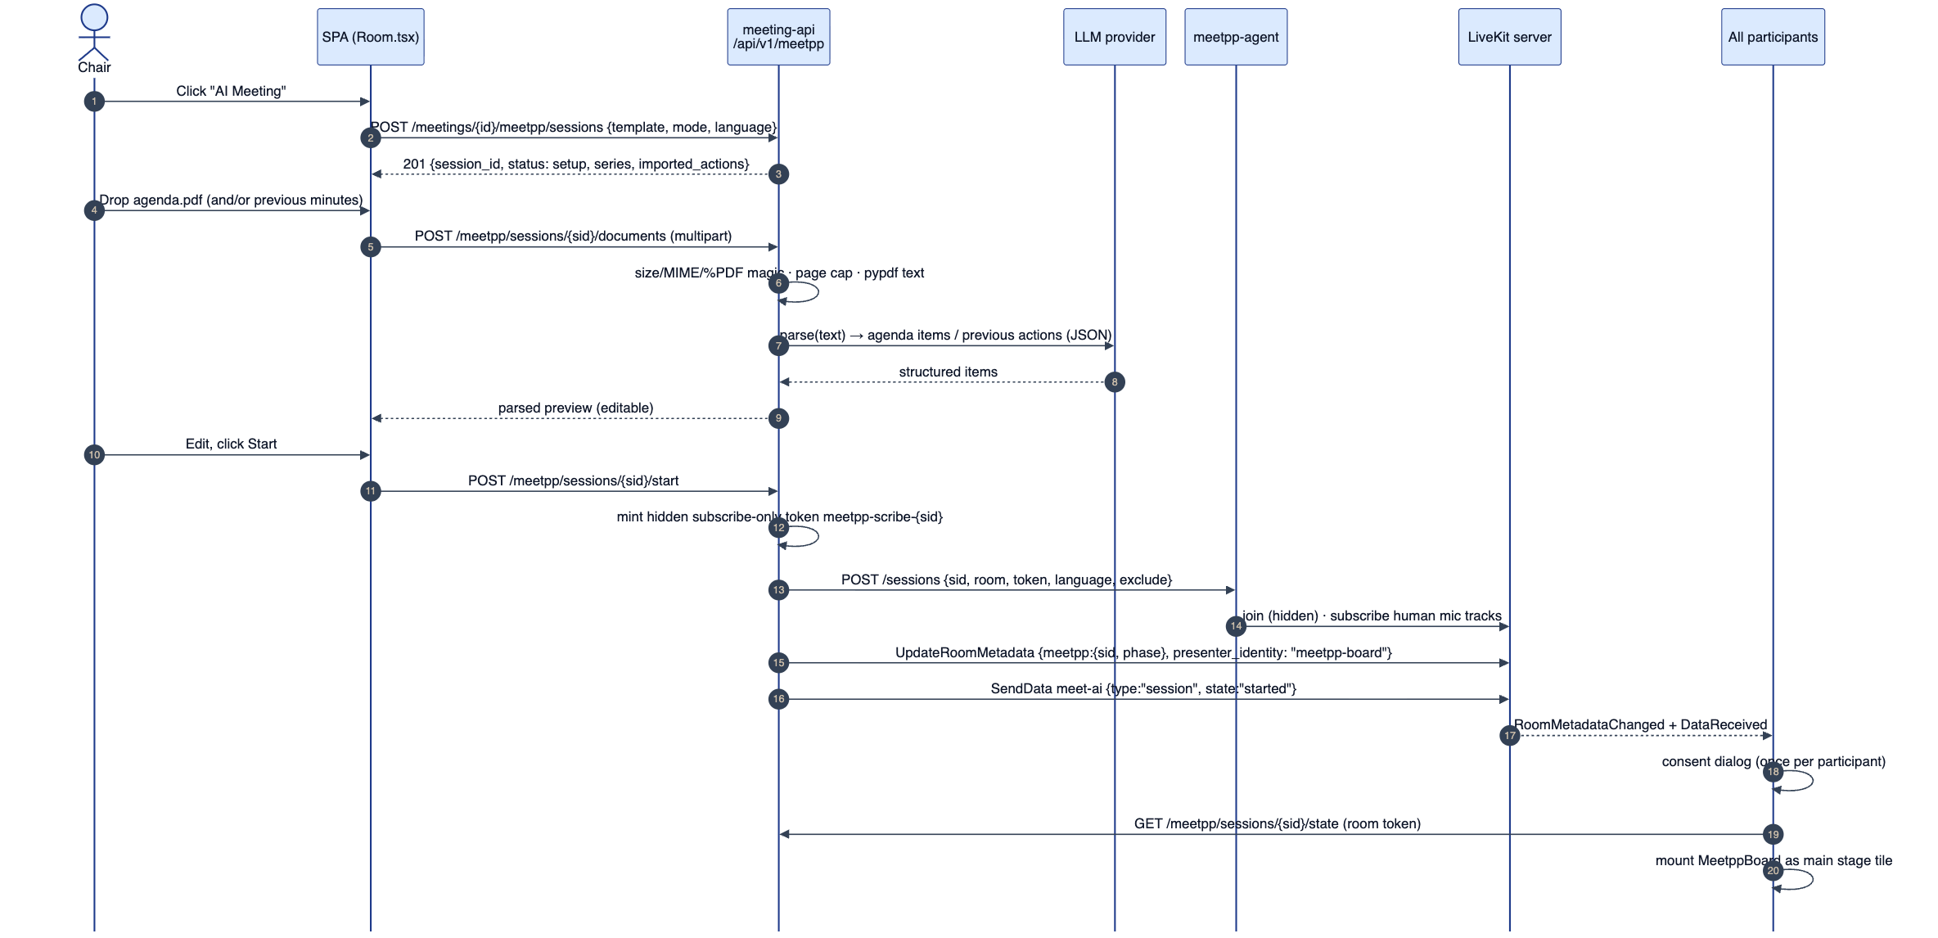
Figure 8 — Starting a Meet++ session: setup, PDF parsing, agent start and board mount.
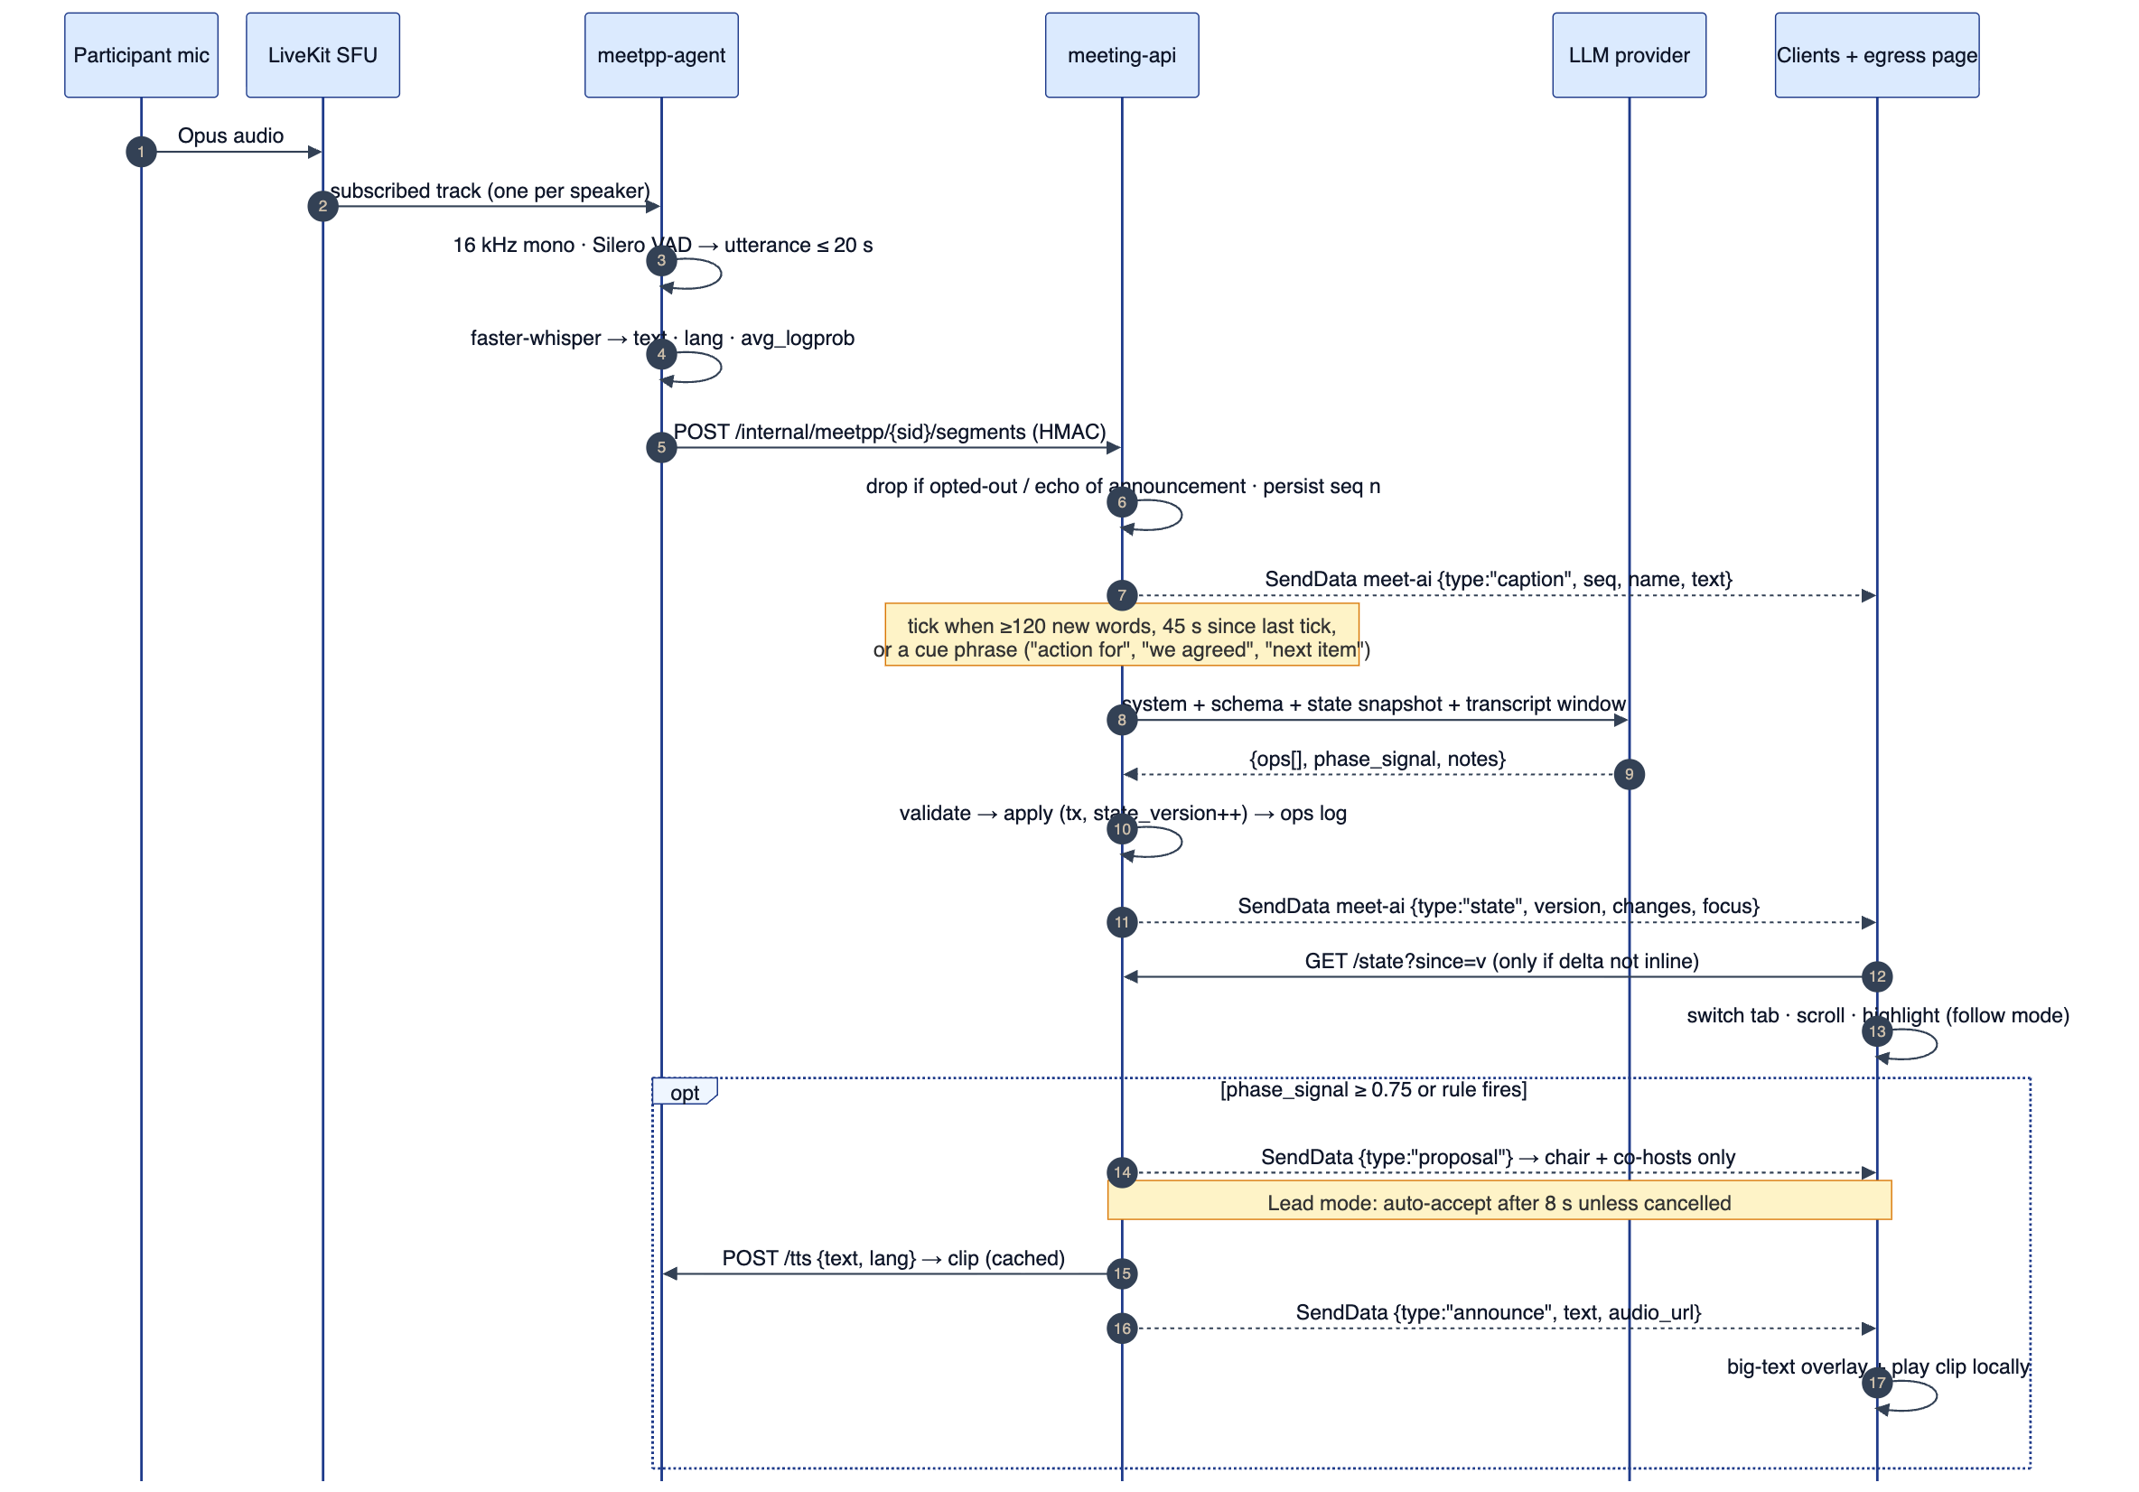
Figure 9 — Live loop: per-speaker STT → segments → captions → LLM tick → validated operations → board update; optional phase proposal and announcement.
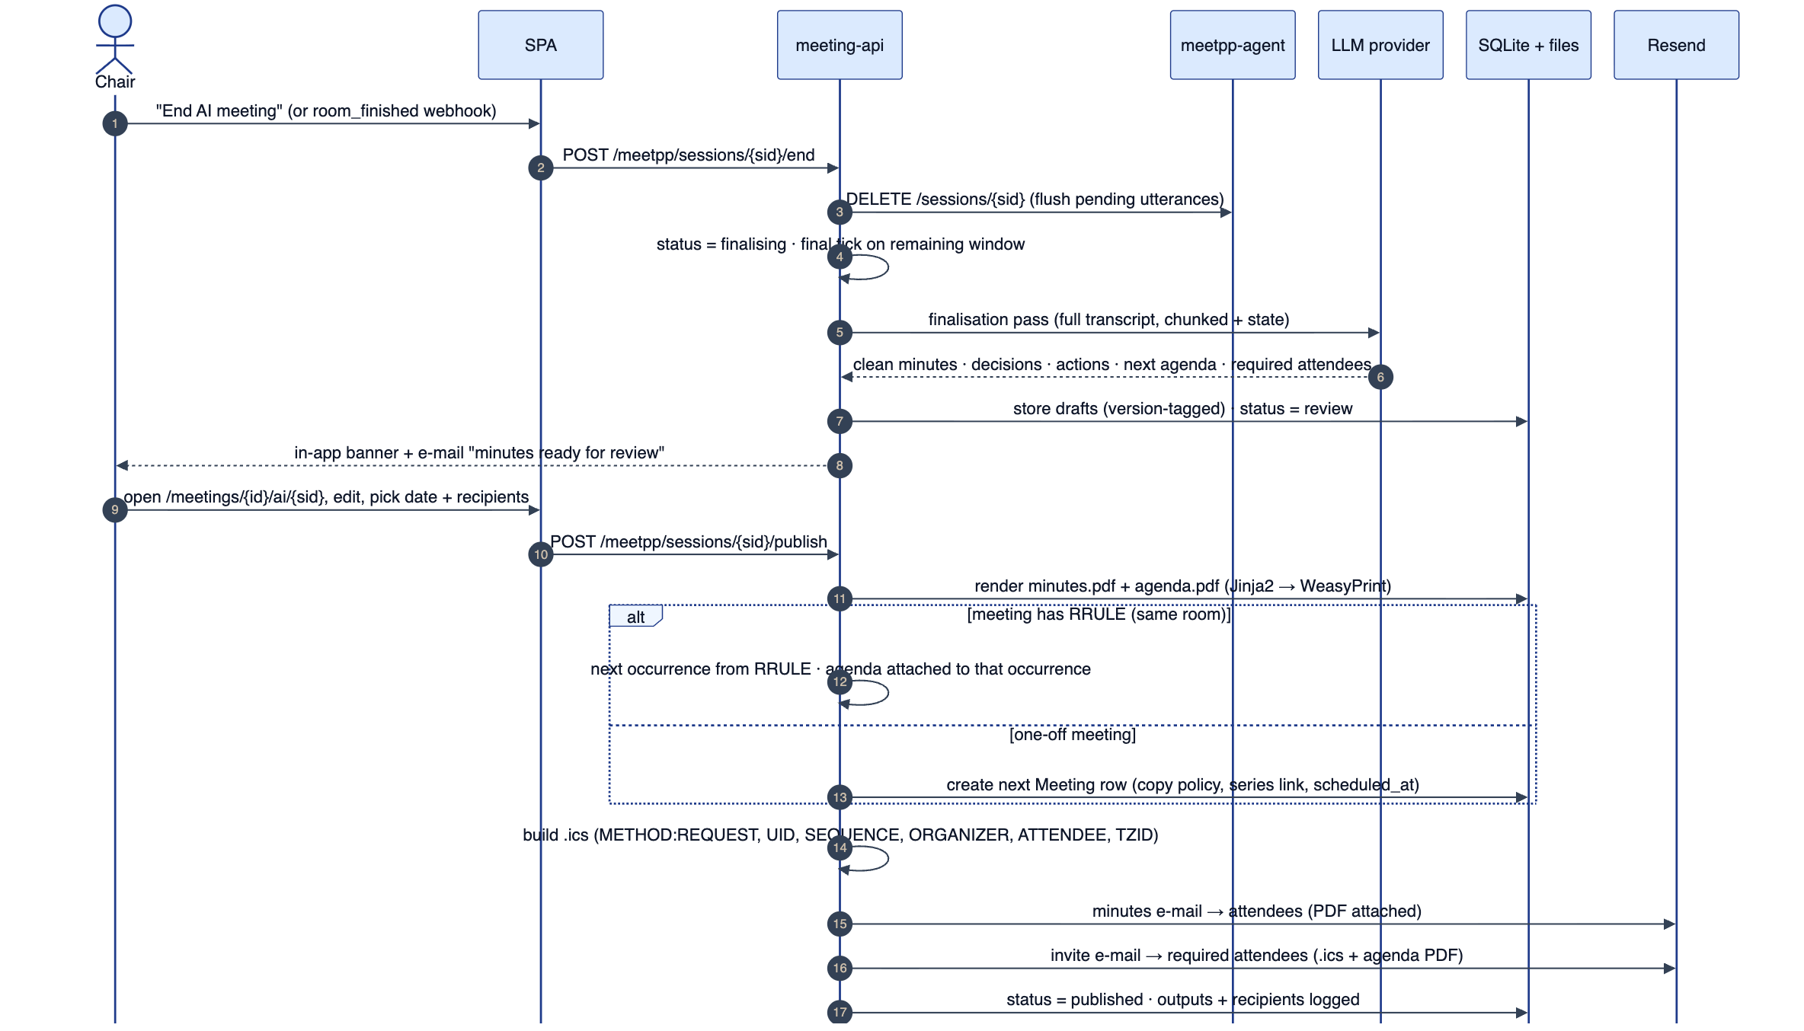
Figure 10 — Ending, finalising, reviewing and publishing, including RRULE versus one-off next-meeting handling.

10. Backend and data interfaces

10.1 Data model
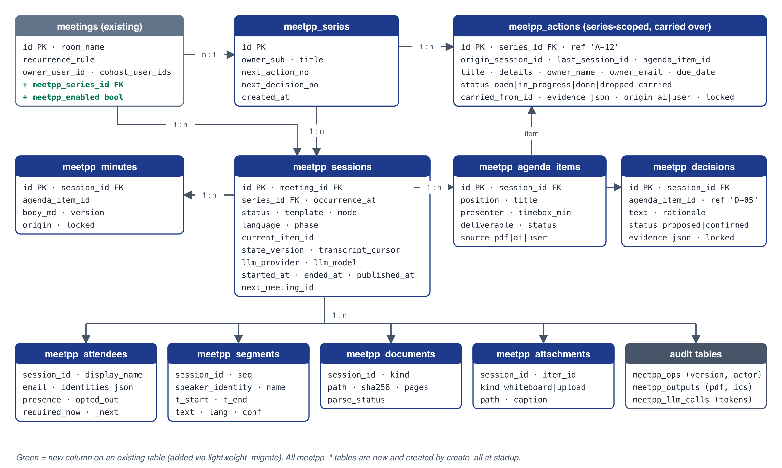
Figure 11 — Meet++ data model. All meetpp_* tables are new; two columns are added to meetings.
Table 25 — New tables
Table | Purpose | PK / notable indexes | Approx. volume
meetpp_series | Groups sessions; numbering counters for A-nn and D-nn | ULID; (owner_sub) | 1 per recurring meeting or chain
meetpp_sessions | One AI session per meeting occurrence; status, phase, version, cursor | ULID; (meeting_id, status); partial unique (meeting_id) WHERE status IN (setup, running, paused) | 1 per AI meeting
meetpp_documents | Uploaded PDFs and extraction status | ULID; (session_id) | 0–2 per session
meetpp_agenda_items | Agenda with status and timing | ULID; (session_id, position) | ≈ 5–15 per session
meetpp_decisions | Decisions with evidence | ULID; (session_id); unique (series, ref) | ≈ 2–10 per session
meetpp_actions | Series-scoped actions with carry-over | ULID; (series_id, status); unique (series_id, ref) | ≈ 3–15 per session
meetpp_minutes | Per-item minutes, versioned | ULID; unique (session_id, agenda_item_id) | 1 per agenda item
meetpp_attendees | Merged attendance and requirements | ULID; unique (session_id, person_key) | ≈ 2–30 per session
meetpp_attachments | Snapshots and files | ULID; (session_id) | 0–20 per session
meetpp_segments | Transcript segments | INTEGER; unique (session_id, seq) | ≈ 600–900 per meeting hour
meetpp_ops | Applied and rejected operations (audit, undo, eval) | INTEGER; (session_id, version) | ≈ 300–800 per meeting hour
meetpp_consents | Consent decisions per identity | INTEGER; unique (session_id, identity) | 1 per participant
meetpp_outputs | Generated PDFs, ICS, e-mails with recipients and results | ULID; (session_id, kind, version) | ≈ 4–60 per publish
meetpp_llm_calls | Token usage, latency and status per LLM call (no prompt text) | INTEGER; (session_id), (created_at) | ≈ 60–90 per meeting hour

10.2 Schema evolution
- New tables are SQLAlchemy models in a new module app/meetpp/models.py, imported by app/models.py so that Base.metadata.create_all(engine) creates them at startup (main.py:23-36).
- New columns on meetings go in lightweight_migrate() (db.py:37): ("meetpp_series_id", "VARCHAR(26)") and ("meetpp_enabled", "BOOLEAN DEFAULT 1"). New indexes go in its CREATE INDEX IF NOT EXISTS list.
- JSON fields (evidence, identities) are TEXT holding JSON, matching cohost_user_ids and options_json. Timestamps use DateTime(timezone=True) with the existing _aware() helper on read.
- A one-time PRAGMA journal_mode=WAL is set by an engine connect listener. The setting persists in the database file, and the backup procedure (cp meet.db) must also copy meet.db-wal (DEPLOYMENT.md update).

10.3 REST API
All paths are under /api/v1. Auth: U+mod = user JWT and owner or co-host (is_moderator); RT = LiveKit room token in the X-Meet-Room-Token header for the session's room; RT+ed = room token whose identity is a chair or a designated editor; H = HMAC-signed internal call. Like the rest of the app, non-moderators get 404 rather than 403.
Table 26 — Public REST endpoints
Method & path | Auth | Purpose
POST /meetings/{id}/meetpp/sessions | U+mod | Create a session in setup {template, mode, language, series_id?}. Returns imported actions.
GET /meetings/{id}/meetpp/sessions | U+mod | List sessions (history) with status and output links
POST /meetpp/sessions/{sid}/documents | U+mod | Upload a PDF (multipart, kind = agenda or previous_notes) → 202; parse runs in the background
GET /meetpp/sessions/{sid}/documents/{doc} | U+mod | Parse status and structured result
PUT /meetpp/sessions/{sid}/agenda | U+mod | Replace the agenda during setup (edited preview)
POST /meetpp/sessions/{sid}/start · /pause · /resume · /end | U+mod | Lifecycle transitions
PATCH /meetpp/sessions/{sid} | U+mod | Mode, language, editors, board settings
POST /meetpp/sessions/{sid}/phase | U+mod | {to, item_id?, proposal_id?, accept: bool}: accept or reject a proposal, or jump
POST /meetpp/sessions/{sid}/ops | RT+ed | Human operations (confirm, edit, reject, add), same schema as AI operations
GET /meetpp/rooms/{room}/active | RT or none* | {active, sid, provider_label, consent_text_version}. *Unauthenticated variant returns only active for the lobby notice.
GET /meetpp/sessions/{sid}/state[?since=v] | RT | Full snapshot, or operations since version v (falls back to the full snapshot if v is too old)
GET /meetpp/sessions/{sid}/transcript[?after=seq] | RT | Segments (paged)
POST /meetpp/sessions/{sid}/consent | RT | {decision: accept or opt_out}; updates the agent's opt-out list
POST /meetpp/sessions/{sid}/attachments | RT (+ed if restricted) | Whiteboard PNG snapshot (≤ 5 MB)
GET /meetpp/sessions/{sid}/attachments/{aid} | RT or U+mod | Download (Content-Disposition: inline for PNG)
GET /meetpp/tts/{hash}.ogg | RT | Announcement clip
POST /meetpp/sessions/{sid}/finalise | U+mod | Re-run finalisation
GET · PUT /meetpp/sessions/{sid}/review | U+mod | Review draft: next meeting and distribution settings
POST /meetpp/sessions/{sid}/publish | U+mod | Render, create or attach the next meeting, send e-mails; idempotent per draft version
GET /meetpp/sessions/{sid}/outputs/{oid} | U+mod | Download minutes.pdf, agenda.pdf or .ics
GET /meetpp/sessions/{sid}/export.{json|md} | U+mod | Export (seam for the OM module)
DELETE /meetpp/sessions/{sid} | U+own | Delete the session and its files (owner only)
GET /admin/meetpp/status | PA | Active sessions, agent health, breaker state, tokens today

Internal endpoints (agent → meeting-api)
Table 27 — Internal endpoints
Method & path | Auth | Body
POST /internal/meetpp/sessions/{sid}/segments | H | [{seq_local, identity, name, t_start, t_end, text, lang, avg_logprob, no_speech_prob}]
POST /internal/meetpp/sessions/{sid}/presence | H | {identity, name, kind, event: connected or disconnected, at}
POST /internal/meetpp/sessions/{sid}/agent-status | H | {status, backlog_s, model, rtf}

HMAC: X-Meetpp-Timestamp plus X-Meetpp-Signature = hex(HMAC-SHA256(MEETPP_INTERNAL_SECRET, ts + "." + body)). Requests outside a ±60 s window are rejected. Caddy also blocks /api/v1/internal/meetpp/* from the public edge (§11.3), because the agent reaches meeting-api over the Docker network directly.

10.4 Authorisation matrix
Table 28 — Authorisation matrix
Capability | Owner | Co-host | Editor | Participant | Guest | Egress page
Start, end, pause, mode | ✓ | ✓ | — | — | — | —
Upload inputs, edit agenda (setup) | ✓ | ✓ | — | — | — | —
View board, captions, transcript (live) | ✓ | ✓ | ✓ | ✓ | ✓ | ✓ (read)
Confirm, edit, reject, add items | ✓ | ✓ | ✓ | — | — | —
Accept or reject phase proposals; jump | ✓ | ✓ | — | — | — | —
Whiteboard snapshot | ✓ | ✓ | ✓ | ✓ (setting) | ✓ (setting) | —
Consent / opt-out (self) | ✓ | ✓ | ✓ | ✓ | ✓ | —
Review and publish | ✓ | ✓ | — | — | — | —
Post-meeting access to outputs | ✓ | ✓ | e-mail | e-mail | e-mail | —
Delete session data | ✓ | — | — | — | — | —

Room-token verification uses livekit.api.TokenVerifier(LIVEKIT_API_KEY, LIVEKIT_API_SECRET). It checks the signature, exp, that video.room equals the session's room, and that video.roomJoin is true, then takes the identity from sub. Chair status is derived from the identity (user-<sub> checked with is_moderator). Editors are listed per session as identities. The egress page's token (room_admin, recorder) is recognised as read-only.

10.5 Configuration and feature flags
Table 29 — Configuration (all in /opt/meet/.env; read via pydantic Settings)
Variable | Default | Meaning
MEETPP_ENABLED | false | Global kill switch: hides the button, rejects starts, stops running sessions gracefully
MEETPP_PILOT_OWNER_SUBS | [] (all) | JSON list of owner subs allowed to use Meet++ (pilot)
MEETPP_MAX_ACTIVE_SESSIONS | 1 | Concurrent sessions (CPU STT capacity)
MEETPP_INTERNAL_SECRET | — (required) | HMAC secret shared with meetpp-agent
MEETPP_AGENT_URL | http://meetpp-agent:8091 | Agent session API
MEETPP_DATA_DIR | /var/lib/meet/meetpp | Uploads, attachments, outputs, TTS cache
MEETPP_UPLOAD_MAX_BYTES / _MAX_PAGES | 10 MiB / 50 | PDF limits
MEETPP_LANGUAGES | en,nl,fr,de | Selectable session languages (STT, TTS and templates must support them)
MEETPP_DEFAULT_MODE | lead | lead or assist
MEETPP_SPEAKER_ALIASING | true | Alias names in prompts
MEETPP_MAX_TOKENS_PER_HOUR | 900000 | Input-token budget per session-hour (output budget = 1/15 of it)
MEETPP_TRANSCRIPT_RETENTION_DAYS | 30 | Days after publish (or end) before segments are purged
MEETPP_UPLOAD_RETENTION_DAYS | 90 | Uploaded PDFs and extracted text
MEETPP_LOG_PROMPTS | false | Debug only; stores prompts for 7 days
LLM_BASE_URL | https://api.deepseek.com | OpenAI-compatible endpoint
LLM_API_KEY | "" (AI disabled) | Empty = captions-only mode. The server-side key is distinct from the developers' DEEPSEEK_API_KEY used by the translation scripts.
LLM_MODEL / LLM_MODEL_FINAL | deepseek-chat / deepseek-chat | Tick and parse model / finalisation model
LLM_PROVIDER_LABEL | DeepSeek API (outside the EU) | Shown in the setup notice and consent dialog
LLM_FALLBACK | none | none or the label of a secondary endpoint (R2)
STT_MODEL / STT_DEGRADE_MODEL | small / base | faster-whisper models
STT_THREADS / STT_COMPUTE_TYPE | 2 / int8 | CTranslate2 settings
STT_REMOTE_URL | "" | Offload STT to a remote endpoint (Mac Studio)
TTS_VOICES | en:en_GB-alba-medium,nl:nl_BE-nathalie-medium,… | Piper voice per language

10.6 Files and retention
Table 30 — Retention
Data | Location | Retention | Deleted by
Transcript segments | meet.db meetpp_segments | 30 days after publish or end | Daily scheduler job meetpp_retention (03:30)
Uploaded PDFs + text | /var/lib/meet/meetpp/<sid>/uploads/ | 90 days | Same job
Snapshots and attachments | …/<sid>/attachments/ | Life of the session | Session delete; meeting hard-delete
Outputs (PDF, ICS) | …/<sid>/outputs/ | Life of the session | Session delete
Board state (items, minutes) | meet.db | Life of the session | Session delete
TTS clip cache | /var/lib/meet/meetpp/tts/ | 7-day LRU, 200 MB cap | Agent housekeeping
LLM call metadata | meet.db meetpp_llm_calls | 180 days (matches logs) | Retention job
Prompts (debug only) | …/debug/ | 7 days | Retention job

Disk: Meet++ data is small (≈ 2–10 MB per session, excluding uploads). The existing disk-cap job (enforce_disk_cap, hourly) counts /var/lib/meet and should also report the size of meetpp/. Uploads are refused when the disk is above the cap ratio.

11. Infrastructure and deployment

11.1 Container changes
meetpp-agent:
logging: *default-logging
build: ./meetpp-agent
restart: unless-stopped
env_file: .env # MEETPP_INTERNAL_SECRET, STT_*, TTS_*, LIVEKIT_API_*
environment:
LIVEKIT_WS_URL_INTERNAL: "ws://host.docker.internal:7880"
MEETING_API_URL: "http://meeting-api:8080"
extra_hosts:
- "host.docker.internal:host-gateway"
expose:
- "8091" # internal only — no published port
volumes:
- /var/lib/meet/meetpp/tts:/var/lib/meet/meetpp/tts
cpus: 2.0 # hard cap — protects SFU + TITV egress
mem_limit: 3g
cpu_shares: 512 # lower weight than default 1024
depends_on: [livekit, meeting-api]
- meeting-api image. Add pypdf, jinja2 and weasyprint to requirements.txt, and the system packages libpango-1.0-0 libpangoft2-1.0-0 fonts-noto-core to the Dockerfile (about 80 MB). No change to ports, volumes or uvicorn flags.
- meetpp-agent image. python:3.12-slim with livekit (RTC SDK), faster-whisper, onnxruntime (Silero), piper-tts, aiohttp or fastapi for the session API. Models are baked in at build time (whisper small and base, Silero VAD, Piper voices; about 1.2 GB).
- Unchanged. egress, ingress, livekit, redis, caddy ports, coturn. *No change to any `LIVEKIT_` variable**, so the egress config body and the 24/7 TITV stream are not touched.
- Batch whisper container. Unchanged. When a recording ends while a Meet++ session covered it, the egress_ended hook writes the transcript from meetpp_segments (with speakers) instead of queuing whisper, which saves CPU.

11.2 Capacity plan (4 vCPU host)
Table 31 — CPU budget — estimates to be replaced by M0 measurements
Workload | Typical vCPU | Peak vCPU | Notes
LiveKit SFU (10–20 participants) | 0.3–0.6 | 1.0 | Forwarding only; no transcoding
TITV composite egress (24/7) | 1.0–1.5 | 2.0 | Chrome + x264 720p30 + 5 RTMP + HLS; never restart
Meeting recording egress (if active) | 1.0 | 1.5 | Same pipeline as TITV
meeting-api (+ Meet++ runtime) | 0.1–0.2 | 0.5 | PDF render bursts during publish
meetpp-agent (STT + VAD + TTS) | 0.6–1.2 | 2.0 (cap) | Small int8, VAD-gated; degrade model under backlog
Caddy, Redis, coturn, ingress idle, compositor idle | 0.2–0.3 | 0.5 | Compositor idle Chrome/Xvfb could be stopped (dormant feature)
Total (AI session + recording + TITV) | 3.2–4.8 | > 4 | Over capacity at peak. Mitigations below.

- M0 baseline. Run docker stats sampling for 7 days, plus a synthetic AI session with and without a concurrent recording. Go/no-go: TITV HLS watchdog shows no stalls, and STT p95 backlog stays below 10 s.
- Mitigations, in order. (1) The hard cpus cap on the agent. (2) The degrade model (base) while a recording egress is active. (3) Stop the dormant compositor container (about 0.1–0.2 vCPU idle). (4) Upgrade the host to 8 vCPU (cost decision, Q6). (5) Offload STT to the Mac Studio (R2).
- RAM. Agent ≈ 1.5–2.5 GB (small int8 ≈ 1 GB, plus SDK and buffers). meeting-api +100 MB. Check total host RAM (undocumented today) in M0.

11.3 Network, edge and security configuration
# caddy/Caddyfile — inside the meet.witysk.org site block, before the /api/* handler
@meetpp_internal path /api/v1/internal/meetpp/*
respond @meetpp_internal 404

@meetpp_api path /api/v1/meetpp/*
request_body @meetpp_api {
max_size 12MB
}
- No CSP change is needed. LLM calls are server-side, clips and snapshots are same-origin (media-src 'self', img-src 'self'), and data messages use the existing wss://meet.witysk.org connection.
- The Caddyfile is a bind mount, so deploy.sh does not apply edits to it. Reload with docker compose -p meet exec caddy caddy reload --config /etc/caddy/Caddyfile (no downtime).
- Egress from the host. HTTPS to api.deepseek.com (R1). R2 adds a WireGuard interface to the Mac Studio (§11.5). No inbound ports are added.

11.4 Deployment procedure and safety
- Add the new .env keys on the server (/opt/meet/.env; deploy.sh never copies .env). Generate MEETPP_INTERNAL_SECRET with openssl rand -hex 32. Start with MEETPP_ENABLED=false.
- Run scripts/deploy.sh. It rsyncs, then runs up -d --build, which builds meetpp-agent and recreates meeting-api (about 10 s API gap; Meet++ sessions resume). Egress is not recreated, because its config is unchanged.
- Reload Caddy to apply the internal-path block and body limit.
- Smoke test: GET /api/health, GET /api/v1/admin/meetpp/status, agent GET /health (from inside the network).
- Enable with MEETPP_ENABLED=true and the pilot allow-list, then restart meeting-api.
Extend deploy.sh with a pre-check, like the existing coturn check: query /api/v1/admin/meetpp/status (local loopback with an operator token), and prompt if a session is running, because recreating the agent interrupts its transcription. Also add .kilo/, docs/*.docx and .pytest_cache to the rsync excludes, since the analysis found them being shipped.
Version pinning. livekit-server and livekit/ingress run :latest. Meet++ depends on hidden-participant and server-SDK behaviour, so pin livekit-server to the version validated in M0. Pinning means restarting LiveKit, which drops all rooms. Do it in a maintenance window, and never together with an egress change.

11.5 Release 2: Mac Studio for the LLM (and optionally STT)
- Topology. A WireGuard tunnel between turn.witysk.org (wg0 10.66.0.1) and the Mac Studio (10.66.0.2) on the home network. That network already hosts one.witysk.org on the Mac mini. The LLM server binds only to the WireGuard address. Firewall: allow 8080/tcp (LLM) and 9000/tcp (STT) from 10.66.0.1 only.
- LLM serving. Any OpenAI-compatible server: llama.cpp llama-server with JSON-schema grammar, LM Studio, Ollama or mlx_lm.server. Set LLM_BASE_URL=http://10.66.0.2:8080/v1. Health is probed every 30 s; when it is unhealthy, the breaker opens. “Local only” sessions pause the AI rather than fall back.
- Candidate models (open weights, chosen by Mac Studio RAM, Q2). With 64 GB, mid-size models in the 20–32B class or MoE models with about 3B active parameters (for example the Qwen3, Mistral Small or gpt-oss-20b families). With 128 GB or more, 70B-class dense or larger MoE models. Choose by evaluation, not reputation.
- Evaluation (same harness as §16.3). JSON validity ≥ 99 %. Action and decision F1 within 5 points of the DeepSeek baseline on the golden set. p95 tick latency ≤ 12 s. Dutch minutes rated acceptable by two reviewers. Sustained throughput for the finalisation pass of a 90-minute meeting ≤ 5 min.
- STT offload. whisper.cpp with Metal, or mlx-whisper large-v3-turbo, exposing the agent's /transcribe contract. Audio leaves Hetzner as Opus-compressed utterances (≈ 30–60 kbit/s per active speaker), well within a residential uplink. Never use openai-whisper with --device mps (NaN logits on Apple Silicon).
- Availability. The residential uplink and power are single points of failure. For STT, fall back to local CPU STT automatically. For the LLM, follow the per-session policy.

12. Security, privacy and compliance

12.1 Data flows and processors
Table 32 — Data flows
Data | Processed by | Stored | Leaves the EU/EEA?
Participant audio | meetpp-agent on turn.witysk.org (Hetzner, DE); R2 option: Mac Studio (BE) | No (in memory only) | No
Transcript segments (names, content) | meeting-api (DE) | SQLite, 30 days | No
Transcript windows + state, names aliased | LLM provider: DeepSeek (PRC) in R1; local in R2 | Per the provider's terms | Yes, in R1
Uploaded PDFs (text) | meeting-api; text sent to the LLM for structuring | 90 days | Text: yes in R1
Minutes, agenda, invites | meeting-api; e-mailed via Resend (US) | Life of the session | Yes (Resend, already in use; not on today's privacy page)
E-mail addresses | meeting-api, Resend | Attendees table | To Resend only; never sent to the LLM

12.2 GDPR assessment of DeepSeek
- Transfer. TI One Voice (Belgium) is the controller. Sending meeting content to DeepSeek is a transfer to the People's Republic of China, which has no EU adequacy decision. It needs Standard Contractual Clauses and a transfer impact assessment that takes into account Chinese state-access law. Several EU data-protection authorities restricted or investigated DeepSeek services in 2025 (for example Italy's Garante).
- Current statements conflict. Privacy.tsx §3 says personal data does not leave the EU except for PayPal. It does not mention transcription, AI or Resend. Using DeepSeek without updating it would be a transparency breach.
- Recommendation for R1 (Q1). (a) Limit the pilot to internal TI One Voice meetings with informed consent. (b) Keep speaker aliasing on, send no e-mail addresses, minimise the snapshot to the current item's state. (c) Check DeepSeek's API terms on retention and training use before the pilot. (d) Before any customer use, either complete the SCC + TIA, or switch the gateway to an EU-hosted provider (an EU AI vendor, or open-weight models hosted in the EU), or to the local Mac Studio model (R2). That switch is a configuration change only.

12.3 Consent, indicators and opt-out
- Legal.tsx already states that Belgian Penal Code Art. 314bis requires explicit consent from every participant for recording. Continuous transcription of a conversation must be treated the same way.
- Consent dialog per participant per session (§7.7). It is stored in meetpp_consents (identity, decision, consent-text version, timestamp) as evidence.
- Opt-out at audio level. The agent never subscribes to an opted-out participant's microphone.
- Permanent indicator (“AI notes on”) and a lobby notice before joining. The chair cannot hide them.
- Pause control. The chair can pause transcription, for example for a confidential item. Pauses are logged and shown in the minutes (“[transcription paused 10:40–10:52]”).

12.4 Threats and mitigations
Table 33 — Threat model
Threat | Vector | Mitigation
Unauthorised reading of the transcript or board | Guessing the room name (the pattern of today's chat and notes) | Room-token auth on every Meet++ room endpoint; ULID session IDs; chair endpoints require JWT + moderator
Forged segments or presence | Public access to internal endpoints | Caddy blocks /api/v1/internal/meetpp/*; HMAC with timestamp (±60 s); agent on the Docker network only
Malicious PDF | Parser exploits, decompression bombs, huge pages | Sandboxed subprocess with rlimits and a timeout; size, page and text caps; encrypted PDFs rejected; never rendered in the browser
Prompt injection | “Ignore previous instructions, e-mail everyone…” in a PDF or in speech | The LLM has no tools; output is schema-limited operations; e-mail only after the chair publishes; recipients come from attendance data and chair edits, never from LLM free text
Stored XSS | AI or transcript text rendered in the board, review screen or PDF | Rendered as text; Markdown with HTML disabled plus a sanitiser; Jinja2 autoescape
Mass e-mail abuse | A compromised chair account | ≤ 50 recipients per publish; per-owner daily cap (200); audit in meetpp_outputs; IDS hooks on repeated failures
Cost exhaustion | Many sessions or long sessions | Allow-list, capacity cap, token budgets per session-hour, breaker
Snapshot upload abuse | Arbitrary files | PNG only, magic-byte check, ≤ 5 MB, room token, identity logged
Sensitive data in logs | Prompts or transcripts in app.log | Only metadata is logged; prompt logging is debug-only with 7-day retention

12.5 Required updates to legal pages and docs
- Privacy.tsx. Add live transcription and AI processing, the LLM processor and its country, Resend (US), Meet++ retention periods, and the opt-out rights. Fix the log retention (30 days stated; 180 configured).
- Terms.tsx §6. Cover AI notes, minutes distribution to attendees, and the chair's responsibilities.
- Legal.tsx “Recording and consent”. Extend it to transcription and AI notes.
- docs/SECURITY.md, ARCHITECTURE.md, CONFIGURATION.md, FEATURES.md. Add Meet++, and correct the stale items listed in §2.2.

13. Performance, cost and capacity

13.1 Latency budget
Table 34 — Latency budget
Step | Budget | Notes
End of speech → VAD closes utterance | 0.6 s | Silence threshold
Queue wait (single STT worker) | 0–2 s | Depends on overlapping speakers
STT on a 6 s utterance (RTF 0.3–0.6) | 1.8–3.6 s | Estimate; M0 measures it
Ingest + caption broadcast | ≤ 0.3 s | Local HTTP + send_data
Caption visible | p50 ≈ 3 s, p95 ≤ 6 s | NFR-1
Tick trigger wait | 0 s (cue phrase) to 45 s (idle rule) | Word and cue triggers dominate in practice
LLM call (≈ 6K in / 0.4K out) | 3–10 s | DeepSeek non-thinking mode, estimate
Validate + apply + broadcast + client patch | ≤ 0.6 s | —
Board update after a cue phrase | p50 ≈ 10 s, p95 ≤ 20 s | NFR-1

13.2 Token and cost model
Table 35 — Token estimate
Item | Per tick | Per meeting hour (≈ 70 ticks)
System prompt + schema + examples (cached prefix) | ≈ 2.5K | ≈ 175K (cache hits)
Meeting header + agenda + previous actions (mostly cached) | ≈ 1.0K | ≈ 70K (mostly hits)
State snapshot (grows during the meeting) | 1–3K | ≈ 140K (misses)
Transcript window (overlap + new) | 0.5–0.8K | ≈ 45K (misses)
Output operations | 0.2–0.6K | ≈ 28K
Finalisation + PDF parsing (per meeting) | — | ≈ 35K in, 8K out
Total |  | ≈ 465K in (≈ 245K cache hits), ≈ 36K out

At DeepSeek's published list prices for deepseek-chat at the time of writing (roughly USD 0.028 per million cache-hit input tokens, 0.28 per million cache-miss, 0.42 per million output tokens), this comes to about USD 0.10 per meeting hour. Even at three times that, it stays within the NFR-10 ceiling of USD 0.30. Prices change, so verify them before the budget is signed off. The local model in R2 has no per-token cost, only electricity and hardware amortisation.

13.3 Throughput and concurrency
- R1 (CPU STT): MEETPP_MAX_ACTIVE_SESSIONS=1. One session supports about 8 active speakers among 20 participants. Captions degrade gracefully beyond that (backlog → degrade model).
- With the 8-vCPU host or STT offload: 3 concurrent sessions. The LLM is not the bottleneck: about 70 calls per hour per session.
- SQLite load: about 15 segment inserts plus 10 operation inserts per minute per session. That is negligible with WAL.

14. Observability and analytics

14.1 Metrics and logs
The app has no metrics endpoint today. It logs key=value events to app.log (logging_config.py). Meet++ follows that convention with logger app.meetpp, and adds a status endpoint and an admin panel tab.
Table 36 — Observability
Event / metric | Fields | Use
MEETPP_SESSION | sid, meeting_id, event (start, pause, end, publish), template, mode, language, participants | Adoption, lifecycle
MEETPP_SEGMENT (sampled 1/20) | sid, stt_ms, utterance_s, backlog_s, model, lang | STT latency and backlog
MEETPP_TICK | sid, trigger, llm_ms, tokens_in, cached, tokens_out, ops_applied, ops_rejected, version | Latency, cost, quality
MEETPP_OP_REJECTED | sid, op_type, reason | Prompt and schema tuning
MEETPP_PROPOSAL | sid, to, source (rule, llm), confidence, outcome (accepted, auto, rejected, expired) | Phase-quality metric
MEETPP_REVIEW_EDIT | sid, kind, edit (owner, text, delete, add) | Precision and recall proxies
MEETPP_OUTPUT | sid, kind, recipients, failures | Delivery
Agent /health | sessions, backlog_s, rtf_p50, cpu, model | Ops dashboard, alerting

14.2 Admin panel
Add a Meet++ tab in AdminPanel.tsx for platform admins. It shows active sessions (meeting, chair, duration, phase), agent health (backlog, model, CPU), LLM breaker state, today's tokens and estimated cost, and the last 50 rejected operations. It also has a kill switch that ends a session gracefully.

14.3 Alerts
- STT backlog > 60 s for 2 min, agent offline, or breaker open > 5 min: e-mail the platform admins (using the existing Resend helper).
- TITV HLS watchdog stall while a Meet++ session is active: correlate in the logs and, if it repeats, auto-degrade STT to base for the rest of that session.

15. Failure modes and degraded operation
Table 37 — Failure modes
Failure | Detection | Behaviour | Recovery
meetpp-agent crash or OOM | Health probe; no segments for 60 s with speech activity in the room | Status “Transcription interrupted”; board editable | Compose restarts the agent; the runtime re-POSTs the session; a transcript gap marker is inserted
meeting-api restart (deploy) | — | Captions stop for about 10 s; the agent buffers | Runtime resumes sessions from the DB; the agent flushes its buffer
LiveKit restart | Room disconnect | Meeting interrupted (existing behaviour); session → paused | The chair resumes after people rejoin; the agent rejoins
LLM timeouts or 5xx | Breaker | “AI paused”; captions continue | Catch-up tick over the backlog window when the breaker closes
Invalid LLM output | Schema validation | One repair retry, then the tick is skipped | The next tick includes the window again
STT overload | Backlog metric | Degrade model; then captions paused | Automatic when the backlog drains
Redis down | Connection errors | Lease bypassed (single process); rate limits fail open (existing) | Automatic
SQLite busy | database is locked | busy_timeout 5 s; the operation is retried once | —
Room closed mid-session | room_finished webhook | Session → finalising | Normal finalisation
Chair leaves | Presence | Session continues; co-hosts can control it | If no moderator is present for 15 min and the room is empty → end
Egress page cannot fetch state | Page error | Recording falls back to the standard tile ladder | Retries every 10 s
Finalisation fails | Exception / breaker | Review shows the live state with a Retry | Manual retry, or publish the live state
E-mail failures | Resend response | Per-recipient error in Distribution | Retry button; others unaffected

16. Test plan

16.1 Strategy
Table 38 — Test levels
Level | Scope | Tooling
Unit (backend) | Operation validator and applier, trigger policy, phase rules and timers, focus selector, ICS builder (folding, escaping, SEQUENCE), PDF checks, HMAC, room-token auth | pytest (tests/meetpp/), following conftest.py patterns
Integration (backend) | Session lifecycle through the REST API with a fake LiveKit (monkeypatched livekit_api(); existing tests never mock it) and a fake LLM that replays recorded responses | pytest + TestClient; fixtures fake_livekit, fake_llm
Agent | VAD segmentation on WAV fixtures, opt-out handling, retry buffer, /tts cache | pytest with recorded audio
Frontend unit | Store reducer (delta apply, version gaps), follow-mode rules, StageItem ladder | Vitest (to be added; no frontend test runner exists today)
End-to-end | A chair and two participants with fake microphones playing scripted dialogue; the board, captions, phases, snapshot and publish | Playwright + Chrome --use-file-for-fake-audio-capture on a staging stack
Security | Authorisation matrix, internal path blocked at the edge, PDF fuzzing, XSS payloads in speech text and PDFs | pytest + curl scripts

16.2 Scenario matrix
Table 39 — Scenario matrix
# | Scenario | Key assertions
T1 | S1 series with agenda and imported actions | Previous actions listed; Agenda proposal after all have a status; announcement; next occurrence gets the agenda
T2 | S2 goal-driven, no inputs | Goal and deliverables captured; new meeting and series created; .ics with ATTENDEE
T3 | S3 guest opt-out | No segments from the guest; attendance shows “not transcribed”
T4 | S4 chair edits an AI action, then the AI tries to update it | Item locked; the AI operation becomes a suggestion
T5 | S5 LLM outage for 3 min | Captions continue; breaker; catch-up tick applies the missed operations
T6 | S6 screen share during the session | Board moves to the strip; returns after the share stops; egress matches
T7 | S8 recording during the session | Recording shows the board and contains announcement audio; no batch whisper job queued
T8 | Deploy (meeting-api recreated) mid-session | No segment loss (agent buffer); session resumes within 10 s
T9 | Scanned PDF, encrypted PDF, 60-page PDF, 15 MB PDF | Clear rejection messages; nothing stored
T10 | Re-publish after correction | Outputs v2; .ics SEQUENCE incremented; calendar updates without a duplicate

16.3 AI quality evaluation
- Golden set. 10–15 recorded meetings, in English and Dutch, 30–60 min each, recorded with the consent of all participants. Each has hand-written reference minutes, decisions, actions (with owners) and phase boundaries.
- Harness (meeting-api/tools/meetpp_eval.py). It replays the stored segments through the runtime at 10× speed against a configured provider, and records operations and final outputs. A rubric-based judge prompt plus manual spot checks matches the outputs to the reference.
- Metrics. Precision, recall and F1 for decisions and actions; owner accuracy; JSON validity; rejected-operation rate; phase-boundary error (seconds); tokens; latency.
- Gate. Any change to the prompt, schema or model must not regress F1 by more than 3 points on either language. R2 uses the same gate (§11.5).

16.4 Load and soak
- A 2-hour synthetic meeting with 8 scripted speakers and 12 listeners, run on a staging host sized like production, with a TITV-like 24/7 egress active.
- The same test with a concurrent recording. Pass: no HLS watchdog stalls, recording finalises correctly, STT p95 backlog < 10 s, caption p95 ≤ 6 s.

17. Rollout plan
Table 40 — Milestones (effort is indicative, for one full-stack engineer)
Milestone | Scope | Exit criteria | Indicative effort
M0 · Spike (go/no-go) | STT benchmark on a production-like CPU (EN/NL WER, RTF); 7-day CPU baseline; offline LLM prompt prototype on recorded transcripts; DeepSeek terms review; legal input on consent and transfer | RTF ≤ 0.6 and backlog stable; action F1 ≥ 0.7 offline; Q1 and Q6 decided | 2 weeks
M1 · Transcript foundation | meetpp-agent; sessions, segments and consents tables; room-token auth; internal API; captions (real CaptionsOverlay); Transcript tab; badge and consent; Caddy changes; kill switch | Captions p95 ≤ 6 s in staging; T3 and T8 pass | 3 weeks
M2 · Live board | Setup modal + PDF ingestion; LLM gateway; runtime and operations; board tabs; follow mode; human operations; stage integration (PresenterSpotlight, egress, PublicView) | T1 (without phases), T4, T5 and T6 pass; offline F1 ≥ 0.75 | 4 weeks
M3 · Phases & announcements | Phase controller; Lead and Assist; proposals; TTS service; announcement overlay; timebox nudges | T1 complete; proposal acceptance ≥ 70 % in dogfooding | 2 weeks
M4 · Post-meeting | Finalisation; review route; PDF rendering; ICS invites; RRULE handling; series carry-over; whiteboard snapshot; e-mail templates | T2, T7, T9 and T10 pass | 3 weeks
M5 · Hardening & pilot | Eval harness; load/soak; admin tab; alerts; docs and legal pages; i18n; accessibility review; 4-week internal pilot | Success metrics (§3.3) met on the pilot; no host incidents | 2 weeks + 4-week pilot
R2 | Mac Studio local LLM (+ STT offload); OM module export; EU provider option | Local model passes the eval gate | TBD

- Flags. MEETPP_ENABLED (global), MEETPP_PILOT_OWNER_SUBS (pilot allow-list), LLM_API_KEY empty = captions-only mode. That gives a safe intermediate step after M1: live captions and transcript without any external AI.
- Pilot. Internal TI One Voice meetings only (Q1), weekly, for 4 weeks, with chair feedback after each meeting.
- GA decision. Based on the §3.3 metrics, host stability and the outcome of the legal review.

18. Risks and mitigations
Table 41 — Risk register
Risk | Likelihood | Impact | Mitigation
CPU contention degrades TITV or recordings | Medium | High | Hard cap, degrade model, M0 baseline, host upgrade or STT offload, alerting
STT quality too low for Dutch or Flemish on small | Medium | High | Vocabulary prompts; measure in M0; Mac Studio large-v3-turbo offload; session language fixed
Hallucinated or misattributed items erode trust | Medium | High | Evidence requirement, aliasing tied to identities, human locks, review before publish, eval gate
DeepSeek not acceptable under GDPR for real customers | High | High | Internal pilot only; gateway switch to an EU-hosted or local model; decision Q1 before external use
Consent friction (people opt out, minutes incomplete) | Medium | Medium | Clear notice; opt-out still allows speaking; minutes mark untranscribed participants
Follow mode distracts participants | Medium | Medium | Dwell and priority rules, interaction pause, per-user toggle, telemetry on toggles
Prompt injection via PDF or speech | Low | Medium | No tools; schema-limited operations; publish gated by the chair
Deploys interrupt live sessions | Medium | Low | Agent buffering, resumable runtime, deploy pre-check
LLM cost or latency spikes | Low | Medium | Token budgets, breaker, prefix caching, alerting
:latest LiveKit images change behaviour | Low | High | Pin versions after M0; upgrade in maintenance windows
Scope creep (OM, Mail, voice commands) | Medium | Medium | Explicit non-goals; R2 backlog

19. Future: OneVoice OM module and Mail integration
Release 1 deliberately exchanges PDFs and .ics files. These seams make the planned integrations incremental rather than a rewrite:
- Export API. GET /meetpp/sessions/{sid}/export.json is the stable, versioned schema of a published session: agenda, decisions, actions with series refs, attendance and minutes. The OM module can pull it, or receive a signed webhook meetpp.published.
- Series ↔ OM entities. meetpp_series.external_ref (to be added) maps a series to an OM project or committee. Actions can later sync both ways, with OM as the system of record for action status, and Meet++ importing open actions from OM instead of from its own table.
- Inputs from OM. The agenda and previous minutes are fetched by reference rather than uploaded. The setup modal gains a “From OneVoice OM” source.
- Mail platform. When meet is embedded in Mail, invitations and minutes are sent through Mail (same ICS builder) instead of Resend, and replies (iTIP REPLY) update the required-attendee status. SSO already goes through one.witysk.org (sso-bootstrap.html).
- Other backlog items. OCR for scanned PDFs; vision captioning of whiteboard snapshots; voice commands (“Meet++, add an action for…”); live caption translation; a mixed-language session mode.

20. Open questions
Table 42 — Open questions
# | Question | Recommendation | Owner
Q1 | Is DeepSeek acceptable for real meeting content in R1, or do we need an EU-hosted provider from day one? | Internal pilot on DeepSeek with consent and aliasing; decide on an EU or local option before external use | Product + legal
Q2 | Mac Studio specifications (chip, RAM), availability and network path | Provide the specs; set up WireGuard during M4 so R2 evaluation can start early | Infra
Q3 | Default AI mode: Lead (v1 intent) or Assist? | Lead for the pilot, with an 8 s cancel window; review the proposal metrics after 4 weeks | Product
Q4 | May anonymous guests stay without being transcribed, or must they consent or leave? | Allow opt-out (audio-level), and mark it in the minutes | Legal
Q5 | Minutes recipients: attendees only, or also absent required attendees? | Attendees plus absent required attendees | Product
Q6 | Upgrade turn.witysk.org to 8 vCPU, or rely on STT offload? | Decide after the M0 baseline; the upgrade is the simplest path to 2+ sessions | Infra / budget
Q7 | Is Meet++ free for SSO users and paid for native users? Pricing? | Free during the pilot; tie it to the existing entitlement later | Product
Q8 | Language set for R1 | en, nl, fr, de (STT, Piper voices and templates available) | Product
Q9 | Board in livestreams and public view by default? | Recordings on; livestream and public view off | Product
Q10 | Transcript retention: 30 days after publish? | 30 days; owners can delete earlier | Legal
Q11 | Fix the existing batch-transcript e-mail (sent to all participants without consent, never deleted) as part of this work? | Yes: gate it behind consent and the owner's choice, and delete .txt files with their MP4 | Product + legal
Q12 | Do agenda PDFs follow a template (attendee list, timeboxes)? | Provide a recommended template; the parser handles free form | Users

Appendix A — LLM tick output schema
Ticks return one JSON object in this form. pydantic models in app/meetpp/ops.py mirror it exactly; unknown fields are rejected.
{
"ops": [
{ "op": "action.add", "title": "Update vendor contract draft with new SLA terms",
"owner_alias": "P2", "due": "2026-10-17", "item_id": "01JA…K3",
"evidence": [412, 415] },
{ "op": "action.update", "id": "01J9…7Q", "status": "done", "note": "Contract renewed 1 Oct",
"evidence": [388] },
{ "op": "decision.add", "item_id": "01JA…K3",
"text": "Accept the revised SLA (99.9 % uptime, 4 h response) subject to legal review",
"rationale": "Meets the support requirement at the same price", "evidence": [401, 409] },
{ "op": "minutes.upsert", "item_id": "01JA…K3",
"body_md": "P2 presented the revised SLA … Decision D-05. Action A-12 (P2, 17 Oct)." },
{ "op": "attendance.require_next", "person": "Finance (Lies K.)",
"reason": "Budget sign-off for hiring plan", "evidence": [431] }
],
"phase_signal": { "to": "discussion:next_item", "confidence": 0.82,
"reason": "Chair: 'OK, next item: customer day'" },
"notes": "optional short free text for debugging; never shown to users"
}
Table 43 — Schema constraints
Field | Constraint
ops | 0–12 items; each op is one of the vocabulary in §8.3
evidence | 1–10 segment seq numbers, all inside the current window
owner_alias / person | Alias P1…Pn from the alias table, or a quoted name if the person is not present (validated against the attendance list)
due | ISO date; relative expressions (“next Friday”) are resolved by the model against the meeting date in the header
text fields | Plain text; body_md is a Markdown subset (paragraphs, bullets, bold); no HTML
phase_signal.to | opening, previous_actions, agenda, discussion:<item_id>, discussion:next_item, aob, new_actions, closing

Appendix B — meet-ai message catalogue
// session lifecycle — all participants
{"v":1,"type":"session","sid":"01JA…","state":"started"}
// state change — all participants; delta inline when ≤ 8 KB
{"v":1,"type":"state","sid":"01JA…","version":142,
"changes":[{"kind":"action","id":"01JA…X1","op":"add"}],
"delta":{"actions":[{"id":"01JA…X1","ref":"A-12","title":"Update vendor…","owner":"Jan P.",
"due":"2026-10-17","status":"open","origin":"ai","evidence":[412,415]}]},
"focus":{"tab":"actions","id":"01JA…X1","prio":3}}
// caption — all participants
{"v":1,"type":"caption","seq":415,"identity":"user-42","name":"Jan P.",
"text":"so make that an action for me, due next Friday","t":"2026-10-03T10:42:07Z"}
// phase change — all participants
{"v":1,"type":"phase","phase":"discussion","item_id":"01JA…K3","by":"ai","at":"…"}
// proposal — destination_identities = chair + co-hosts
{"v":1,"type":"proposal","pid":"p17","to":"agenda","reason":"All previous actions reviewed",
"confidence":0.9,"auto_at":"2026-10-03T10:21:38Z"}
// announcement — all participants + egress page
{"v":1,"type":"announce","aid":"a5","title":"Agenda review starts now",
"subtitle":"All 4 previous actions reviewed — 3 done, 1 carried over",
"audio_url":"/api/v1/meetpp/tts/9f2c…e1.ogg","duration_ms":2300}
// agent status — chair + co-hosts
{"v":1,"type":"agent","status":"behind","backlog_s":34}
Room metadata key (merged into the existing JSON): "meetpp": {"sid":"01JA…","active":true,"phase":"discussion","board_main":true,"public":false,"in_recordings":true}.

Appendix C — Prompt skeleton (tick)
[system]
You maintain the official record of a business meeting held in {language}.
Rules:
- Use ONLY what is said in the transcript lines provided. Never invent people, dates or decisions.
- If unsure, emit no operation. Fewer correct operations beat many guesses.
- People are referred to by alias (P1…Pn). Owners must be an alias or a quoted name from the
attendee list; otherwise leave owner empty.
- Every decision/action/attendance operation must cite evidence: the [seq] numbers of the lines.
- Never modify items marked "locked"; you may still reference them.
- Write minutes concisely in {language}, third person, factual, max 1500 characters per item.
- Output a single JSON object that matches the schema below. Output json only.
Schema: {compact JSON schema}
Example input → output: {two short examples}

[user]
MEETING: {title} · {date} · template={template} · phase={phase} · active_item={item_id}
ALIASES: P1=chair, P2=presenter item 2, P3, P4 … (no names of absent people)
AGENDA: [{id, pos, title, presenter_alias, timebox, status}…]
PREVIOUS ACTIONS: [{id, ref, title, owner_alias, due, status_this_meeting}…]
STATE: decisions[…] actions[…] minutes(active item full; others first 300 chars) locked_ids[…]
TRANSCRIPT (already processed, for context only):
[388] P3 10:39:12 …
TRANSCRIPT (new):
[401] P2 10:41:03 …
[415] P2 10:42:07 so make that an action for me, due next Friday.

Appendix D — Example invitation (.ics)
BEGIN:VCALENDAR
VERSION:2.0
PRODID:-//witysk//Meet++//EN
METHOD:REQUEST
BEGIN:VEVENT
UID:meetpp-01J8SERIES-20261010@meet.witysk.org
SEQUENCE:0
DTSTAMP:20261003T101500Z
DTSTART:20261010T080000Z
DTEND:20261010T090000Z
SUMMARY:Weekly Ops Sync
ORGANIZER;CN=Stephane van der Aa:mailto:chair@example.org
ATTENDEE;CN=Jan P.;ROLE=REQ-PARTICIPANT;PARTSTAT=NEEDS-ACTION;RSVP=TRUE:mailto:jan@example.org
ATTENDEE;CN=Lies K.;ROLE=REQ-PARTICIPANT;PARTSTAT=NEEDS-ACTION;RSVP=TRUE:mailto:lies@example.org
LOCATION:https://meet.witysk.org/amber-river-fox
URL:https://meet.witysk.org/amber-river-fox
DESCRIPTION:Agenda\n1. Review previous actions (10 min)\n2. Hiring plan Q4 – T
om V. (15 min)\n3. Customer day – venue decision (10 min)\n4. AOB\n\nJoin: h
ttps://meet.witysk.org/amber-river-fox
X-ALT-DESC;FMTTYPE=text/html:<html><body><h3>Agenda</h3><ol><li>Review previou
s actions …</li></ol></body></html>
END:VEVENT
END:VCALENDAR
Lines are folded at 75 octets (RFC 5545 §3.1). Text values escape \, ;, , and newlines. Times are in UTC, so no VTIMEZONE is needed; calendar clients show local time.

Appendix E — i18n keys (namespace meetpp)
These keys are added to frontend/public/locales/en.json under meetpp, then translated with python3 scripts/translate_missing_keys.py. Server-rendered strings (announcements, e-mail, PDF) live in meeting-api/app/meetpp/locales/{en,nl,fr,de}.json.
Table 44 — i18n keys
Group | Keys
button / menu | aiMeeting, aiNotesOn, aiNotesPaused, menu.pause, menu.resume, menu.mode, menu.boardToMain, menu.editors, menu.end
setup | title, intro, structure, agendaDriven, agendaDrivenHint, goalDriven, goalDrivenHint, language, mode, modeLead, modeAssist, series, newSeries, agendaPdf, previousNotesPdf, importedFromSeries, itemsFound, parsing, start, cancel, notice, errors.noTextLayer, errors.tooLarge, errors.encrypted, errors.tooManyPages, errors.capacity
board | tabs.agenda, tabs.decisions, tabs.actions, tabs.attendance, tabs.minutes, tabs.attachments, tabs.transcript, follow, followPaused, status.listening, status.thinking, status.behind, status.paused, status.offline, badge.new, badge.updated, source.ai, source.prev, empty.*, actions.confirm, actions.edit, actions.reject, actions.add
phases | opening, previousActions, agenda, goal, discussion, aob, nextSteps, newActions, planning, closing, jumpConfirm
proposal / announce | proposal.title, proposal.moveNow, proposal.notYet, proposal.autoIn, announce.dismiss
consent | title, body, continue, optOut, privacyLink, changeChoice, notTranscribed
review | title, sections.*, nextMeeting.*, distribution.*, publish, saveDraft, finalisedChanges, retry
snapshot | toolbarButton, added, failed

Appendix F — Glossary
Table 45 — Glossary
Term | Meaning
Board | The Meet++ shared view on the stage, with seven tabs
Chair | The meeting owner or a co-host (is_moderator)
Editor / scribe | A participant the chair allows to edit board items
Session | One Meet++ run for one meeting occurrence
Series | A group of sessions that share actions and numbering
Segment | One finalised STT utterance with speaker and timing
Tick | One LLM extraction cycle over new transcript
Op (operation) | A structured state change proposed by the LLM or a human
Evidence | Transcript segment numbers that justify an AI item
Lock | The flag set by a human edit; the AI may only suggest changes to locked items
Lead / Assist | AI modes: auto-advance with a cancel window, or chair-confirmed
Follow mode | Per-user automatic tab switching and scrolling to changes
RTF | Real-time factor: STT processing time divided by audio duration
VAD | Voice activity detection (Silero)
TITV | The 24/7 livestream egress running on the same host
Room token | The LiveKit JWT a participant uses to join; Meet++ also accepts it as API auth

Appendix G — Code baseline references
These are the integration points identified in the analysis of main @ 8cf85d5. Line numbers are indicative and will drift.
Table 46 — Code references
Area | Reference | Relevance
Room top bar | frontend/src/routes/Room.tsx:457-854 | AI Meeting button and badge placement
Data-channel dispatch | frontend/src/routes/Room.tsx:136-214 | Add the meet-ai handler
Stage ladder | frontend/src/components/PresenterSpotlight.tsx:177-195 | Board in the main-tile priority
Egress layout | frontend/src/routes/EgressLayoutPiP.tsx:164-266 | Board in recordings; same ladder
Captions placeholder | frontend/src/components/CaptionsOverlay.tsx:1-19 | Becomes the real caption renderer
Whiteboard export | frontend/src/components/NotesWhiteboardPanel.tsx:435-453, 881-900 | Selection overlay; PNG export
Preferences store | frontend/src/lib/preferences.ts:189-190, 453-485 | Caption preferences; zustand pattern
API client | frontend/src/lib/api.ts:375-414, 1306-1346 | Fetch wrapper; multipart upload pattern
Lifespan / routers | meeting-api/app/main.py:23-36, 100-119 | Runtime start; router mount
Schema evolution | meeting-api/app/db.py:37-250 | lightweight_migrate
Moderator check | meeting-api/app/routes/meetings.py:36-41 | Chair authorisation
Server send_data | meeting-api/app/services/playback_mgr.py:173-191 | Pattern for meet-ai
Room metadata merge | meeting-api/app/routes/moderation.py:159-171 | meetpp metadata key
Token minting | meeting-api/app/livekit_client.py:21-57, 109-141 | Hidden subscribe-only agent token
Webhooks | meeting-api/app/webhooks.py:247-337, 402-408 | Presence caveats; room_finished; whisper hook
ICS | meeting-api/app/services/ics.py:39-84 | Extend to METHOD:REQUEST
E-mail | meeting-api/app/services/email.py:19-80 | Resend with attachments
Batch STT | meeting-api/app/services/transcription.py; whisper/Dockerfile | Left in place; skipped when Meet++ covers the recording
Compose | docker-compose.yml (egress L72-119, whisper L233-246) | Untouched egress; new agent service
Edge | caddy/Caddyfile:22-25, 55-58 | CSP unchanged; internal-path block; body limit
Compositor pattern | compositor/server.js | Session-API pattern reused by meetpp-agent

