Meet++
Feature Design Document & Technical Architecture — v3
Redesign after the Release 1 trial: reliable two-tier transcription, a clear Meet++ screen with a live transcript and timed automatic activation, minutes that are actually written, and a meeting report in the association's format

Document | MeetPlusPlus_FDD_v3
Product | OneVoice Meet: meet.witysk.org (repository onevoice_meet)
Version | 3.0 — draft for approval
Date | 6 October 2026
Author | Stephane van der Aa
Supersedes | Meet++ FDD v2 (3 October 2026) and docs/MeetPlusPlus_FDD_v2_review.md
Code baseline | main @ f1653fd (Release 1, 3 October 2026)
Evidence | Production data and logs of 7 Release 1 sessions; STT benchmarks on turn.witysk.org and an Apple M1; example report meeting_240_2026-10-04.pdf
Status | Draft — approval needed before implementation; open questions in §15
Confidential — internal design document.

Document control
Revision history
Version | Date | Author | Change
1.0 | 2026-10-03 | Stephane van der Aa | Initial brief
2.0 | 2026-10-03 | Stephane van der Aa | Detailed FDD and technical architecture (basis of Release 1)
3.0 | 2026-10-06 | Stephane van der Aa | Review of Release 1; new Meet++ screen and navigation (outline, tabs, live transcript, 5 s / 10 s activation rules, Next/Back); two-tier transcription from measurements; interpretation contract v3; minutes pipeline; OM-style meeting report; aligned data model; acceptance tests and plan

Table of contents
1. Executive summary 5
2. Review of v2 and the Release 1 implementation 7
2.1 What was tested 7
2.2 Transcription: why it stopped and why it was inaccurate 7
2.3 Interpretation and minutes 8
2.4 Navigation and screen 8
2.5 The final document 9
2.6 Where v2 itself was wrong 9
2.7 Your requirements and where v3 addresses them 10
2.8 Disposition of the Release 1 code 10
3. Goals, scope and acceptance 11
3.1 Goals 11
3.2 Scope of Release 1.1 (this FDD) and non-goals 11
3.3 Acceptance criteria 12
4. Feature overview 13
4.1 Lifecycle 13
4.2 The meeting outline 13
5. The Meet++ screen: layout and navigation 14
5.1 Design principles 14
5.2 Layout 14
5.3 Navigation concepts 15
5.4 Meeting outline 15
5.5 Content tabs 16
5.6 Live transcript panel 16
5.7 Automatic activation 17
5.8 Manual navigation and browsing 18
5.9 Announcements and proposals 18
5.10 Roles and where the board appears 18
5.11 Responsive behaviour 19
5.12 Setup screen 19
5.13 Review screen 20
5.14 Accessibility and internationalisation 20
5.15 Error and degraded states 21
6. Functional and non-functional requirements 22
6.1 Functional requirements (Release 1.1) 22
6.2 Non-functional requirements 22
7. Speech-to-text design 24
7.1 What turn.witysk.org can do: measurements 24
7.2 Decision: two tiers 25
7.3 Tier 1 pipeline specification 25
7.4 Tier 2: refinement and final transcript 26
7.5 Reliability: why transcription will not stop 26
7.6 Observability of transcription 27
7.7 Capacity and fallbacks 27
8. Interpretation design 28
8.1 Cadence and window 28
8.2 Output contract v3 28
8.3 Topic, activations and position 28
8.4 Decisions, votes and quorum 29
8.5 Actions: new, previous, carried forward 29
8.6 Attendance and members 29
8.7 Minutes 30
8.8 Robustness, versioning and budget 30
9. The meeting report 31
9.1 Structure 31
9.2 Rendering 32
9.3 Formal and informal meetings 32
10. Technical architecture changes 33
10.1 Architecture decisions 33
10.2 Component changes 34
10.3 Data model changes 35
10.4 Real-time protocol v3 (topic meet-ai) 36
10.5 API changes 36
10.6 Key sequences 37
11. Infrastructure, privacy and operations 38
11.1 turn.witysk.org 38
11.2 Mac Studio tier-2 service 38
11.3 Privacy and consent 38
12. Observability and acceptance tests 39
12.1 Logging and metrics 39
12.2 Acceptance tests 39
13. Implementation plan 40
14. Risks 41
15. Open questions 42
Appendix A — Tick output contract v3 43
Appendix B — Focus queue algorithm 44
Appendix C — Prompt skeletons 45
C.1 Tick (system) 45
C.2 Section composition (system) 45
C.3 Final composition (system) 45
Appendix D — Export shape (OM alignment) 46
Appendix E — Glossary 47
Appendix F — Evidence and method 48

1. Executive summary
Meet++ turns a OneVoice Meet room into an AI-assisted meeting. Speech is transcribed live. An LLM interprets the transcript and keeps the agenda, decisions, actions, attendance and minutes up to date on a shared screen. After the meeting the system produces a formal meeting report and the invitations for the next meeting.
Release 1 was built from FDD v2 and tested in seven short sessions on 3 October 2026. It did not work in practice, for these reasons:
- Transcription appeared to stop after a short while, and when it did run it was not accurate.
- Agenda PDFs never parsed, so there was never an agenda item for anything to attach to.
- Minutes were written into an "unassigned" bucket that the board never displays.
- The navigation mixed four overlapping concepts.
- The final document did not resemble the association's meeting report.
Version 3 is based on the production data from those sessions, measurements on turn.witysk.org itself, a code-level review of the implementation, and your requirements of 6 October. It redesigns the parts that failed and keeps what worked.

What v3 changes
- A Meet++ screen with one clear navigation model. The meeting outline on the left shows where the meeting is, and the chair moves it with Next ▶ / ◀ Back. The tabs in the centre (Agenda, Decisions, Actions, Minutes, Attendance, Papers) mirror the sections of the final report, grouped per agenda point. A live transcript box scrolls on the right. Viewing a section and moving the meeting are separate actions.
- Automatic activation with your timing rules. When the transcript shows that a section is being discussed, or a decision or action is recorded, the board activates that tab and section. It shows each activation for at least 5 seconds and highlights it. After any manual click, automatic switching pauses for 10 seconds, then catches up to the latest activation. Every tab can be clicked at any time.
- Transcription that does not stop. Root causes are fixed. The voice detector was never actually installed (download URL returned 404). Consumers that died were never restarted. Room disconnects were not recovered. Guest consent was lost on reconnect. A caption ticker scrolled new text off-screen. Liveness monitoring and logging are added so that gaps are detected and alerted.
- Two-tier transcription, based on measurements. On turn.witysk.org, faster-whisper small runs at real-time factor 0.21, so it is fine for live use. medium (0.62) and large-v3-turbo (0.73, which also fell into a repetition loop) are not viable live on that host. Tier 1 (live, on turn) therefore keeps small, with corrected segmentation and context. Tier 2 (on the Mac Studio) refines each utterance with large-v3-turbo within seconds and re-transcribes the whole meeting for the final minutes. An M1 Mac already runs large-v3-turbo at real-time factor 0.12.
- Minutes that are actually written. During the meeting, running notes accumulate per section. When a section closes, a narrative is composed for it. At the end a final composition adds the opening, adjournment, record of voting and provenance. Nothing depends on a single 1,500-character rewrite any more.
- A meeting report that matches your example. It follows the structure and look of the OM module's meeting report, generated by a port of the OM ReportLab layout. The data model is aligned with the OM tables so that a direct push to the OM module (R2) is mechanical. Parts:
  - identity block
  - report table and quorum
  - attendance
  - agenda with sub-points
  - decisions with vote tables
  - follow-up actions with carried-forward and "reported at this meeting"
  - papers filed
  - full minutes
Bottom line. Release 1 is not a dead end. The agent container, session runtime, operation validator, room-token auth, data channel and setup flow are kept. The board UI, the interpretation contract, the minutes pipeline, the transcription front end and the report renderer are rebuilt. Tier 1 alone is expected to give live accuracy around 12–13 % word error rate in English. The quality you saw in the 4 October minutes (large-v3-turbo) needs the Mac Studio tier: see Q1.

2. Review of v2 and the Release 1 implementation

2.1 What was tested
Release 1 (commits 657a079 and f1653fd, 3 October 2026) was deployed to turn.witysk.org and exercised in seven sessions. The table summarises the production database (read-only queries on 6 October).
Table 1 — Release 1 sessions in production
Session (UTC, 3 Oct) | Length | Transcript segments | Observation
09:32 · …87Y | aborted | 0 | Started and aborted during setup
09:55 · …BQB | 3 min | 21 (09:55:29 – 09:58:17) | Transcribed throughout; short fragments (“I also want to”, “fine and action.”)
10:17 · …3XQ | 7 min | 21 (10:17:15 – 10:21:06) | No segment in the last 2 min 44 s; names wrong (“Stefan van der Aar”, “Eddie Walley”)
10:36 · …JK1 | 4 min | 1 + 2 snapshot markers | One utterance at 10:36:32, then nothing for 3 min 50 s
10:41 · …0F4 | 48 s | 0 | No transcript at all
11:26 · …PR4 | 3 min | 5 (11:26:05 – 11:27:18) | Nothing in the last 1 min 55 s; first sentence duplicated
11:36 · …8M4 | 85 s | 0 | Agent joined but posted no segment; both agenda PDFs failed to parse

- Across all sessions: 0 agenda items were stored, and all uploaded agenda/notes PDFs failed (AttributeError: module 'app.meetpp.llm' has no attribute 'parse_json_loose').
- Only 3 minutes rows exist, two of them with no agenda item, so the board never shows them. One reads “P1 decided to cancel all Mondays going forward”: the speaker alias leaked into the minutes.
- The LLM itself responded normally: about 1,000 prompt tokens and 1.1 s latency per tick.
- The agent logged 17 lines in three days. Queue drops, filtered utterances, dead consumers and the missing voice-activity model were all invisible in production.

2.2 Transcription: why it stopped and why it was inaccurate
Table 2 — Transcription root causes
# | Root cause | Evidence | v3 fix (§)
T1 | The caption ticker scrolls new captions off-screen after any pause of about 5–10 s, so transcription looks dead | MeetppSubtitles.tsx:76-113: the position is set once and decreases forever | Ticker removed; transcript box (5.6)
T2 | The Silero VAD model was never installed: the download URL returns 404 and curl -f … || true hides it, so a crude energy gate is used | /models in the production container holds only whisper/; meetpp-agent/Dockerfile:27-29 | Model vendored with checksum; build fails without it (7.3)
T3 | A speaker's consumer task dies on any exception and is never restarted; the 20 s watchdog only re-subscribes live subscriptions | session.py:153-166, 209-212 | One supervised consumer per track (7.5)
T4 | A LiveKit room disconnect is only logged; the session still looks healthy to /health and the watchdog | session.py:182-183; runtime.py:170-186 | Reconnect with a fresh token; liveness in health (7.5)
T5 | Guests get a new identity on reconnect; the client restores consent locally without posting it, so the agent never subscribes again (consent is default-deny) | MeetppRoomLayer.tsx:81-89; runtime.py:536-539 | Consent keyed by person and re-posted on every join (7.5)
T6 | The queue silently drops the oldest audio when full; the degrade-to-base valve can never fire (the backlog is never written to the engine) | session.py:226-247; stt.py:38,77 | Backlog wired; drops logged and marked (7.5)
T7 | Fragmentation: 600 ms end-silence, about 30 ms effective pre-roll (not 300), no context between utterances | vad.py:18,63; stt.py:120 | 800 ms end, 300 ms pre-roll, rolling context prompt (7.3)
T8 | Silero framing wrong (480 samples, no 64-sample context) and post-filter stricter than Whisper's own rule (OR instead of AND) | vad.py:15,50-52; stt.py:133-136 | 512 + 64 framing; Whisper's AND rule (7.3)

2.3 Interpretation and minutes
Table 3 — Interpretation root causes
# | Defect | Effect | v3 fix (§)
I1 | PDF structuring calls a function that does not exist (ingest.py:133), and setup has no other way to enter an agenda | No agenda, so no active item, in any session | Fixed call + agenda editor in setup (5.12)
I2 | Minutes without a valid item are stored under item_id = NULL; the Minutes tab renders only minutes attached to agenda items | “Minutes don't work at all” | Minutes per outline section; there is always a live section (8.7)
I3 | minutes.upsert replaces the whole text, is capped at 1,500 characters (hard reject), and the prompt never says it replaces | Minutes are erased, or stop updating once long | Append-only notes + composition per section (8.7)
I4 | Evidence must lie inside a one- or two-line window while ticks run per utterance; strict schema (extra=forbid) rejects ops that add evidence | Most decisions and actions are rejected | Context window 90 s; lenient schema (8.1, 8.8)
I5 | The AI's top-level phase_signal is never read; discussion:<id> is disallowed; there is no rule inside the discussion phase | The meeting never advances by itself | topic + advance contract with hysteresis (8.3)
I6 | Invalid JSON or truncated output stalls the tick (cursor not advanced) and re-bills tokens; finalisation can stay stuck in finalising | Silent stalls; no outputs | Repair once, then skip with a gap note; job-based finalisation (8.8)
I7 | state_version is incremented on a stale object after the LLM await; clients discard the delta as older | Updates vanish until a refetch | Atomic increment (8.8)
I8 | Speaker aliases (P1…Pn) are sent while transcript lines still contain real names, and the aliases are not mapped back | “P1 decided …” in minutes | Display names used; no aliasing (8.1)

2.4 Navigation and screen
v2 itself made the navigation confusing, and the implementation followed it. Four concepts overlapped:
- a phase strip with 7 pills;
- an active agenda item shown in a different place;
- tabs organised by entity type, with no link to agenda points;
- a hidden follow state.
Clicking a phase pill moved the whole meeting rather than just the view. The chair worked in a second, editable board in a side drawer that covered the stage, while everyone else watched a read-only copy without navigation. Follow mode paused itself for 30 s after every automatic scroll. The transcript appeared in four places, none of them a usable scrolling list.
Table 4 — Navigation: v2 versus v3
v2 concept | Problem | v3 replacement
Phase strip (7 pills) + active agenda item | Two position indicators that drift apart; clicking moves the meeting | One meeting outline (sections incl. agenda points) with a single LIVE marker
Tabs per entity type | No way to see the decisions or actions of the point being discussed | Tabs that mirror the report, grouped per section, scrolled to the active section
Follow toggle (owner drawer only) | Invisible on the stage; 30 s pause; self-pausing on programmatic scroll | Follow chip in every header; 5 s minimum display; 10 s pause after a click; catch-up
Owner side drawer | Two boards, covering the stage | One board for everyone; inline edit for chair and editors
Ticker + footer bubble + captions overlay + tab | Transcript scattered, ticker breaks | One live transcript box on the right
Full-screen announcement (6.5 s) | Blocks the board | Large banner inside the board header

2.5 The final document
The R1 minutes template (WeasyPrint) lacked most of the report's content: votes, quorum, carried-forward and reported actions, papers filed, and narrative minutes with RESOLVED blocks, adjournment and provenance. Your example (meeting 240, 4 October 2026) is generated by the OM module's build_meeting_pdf() (onevoice/react/backend/app/services/org_pdf_service.py:1583, ReportLab). v3 adopts that report as the target (§9).
One improvement over the example is deliberate: its minutes are printed as raw Markdown in a monospace font, and its “Record of voting” table renders empty. Meet++ renders both properly.

2.6 Where v2 itself was wrong
- It assumed one transcription tier. The measurements (§7.1) show the turn server can do good live captions but not final-minutes quality, so v3 splits the work.
- It conflated phases with agenda points, and treated the AI's phase signal as the way to move between agenda points.
- It used a single rewrite-in-place minutes operation with a hard cap, instead of notes plus composition.
- It demanded strict evidence inside a tiny window, which was correct in spirit but unworkable with per-utterance ticks.
- It used speaker aliasing, which gave neither privacy (names occur in speech) nor clean output.
- It put the editable board in an owner-only panel and specified a 30 s interaction pause and a full-screen announcement.
- It chose Piper for TTS, which has no Python 3.12 wheel. v3 uses browser speech in R1.1 and optional Mac-hosted TTS later.

2.7 Your requirements and where v3 addresses them
Table 5 — Requirements traceability
Requirement (6 Oct) | v3 design | § | Acceptance
Scrolling box on the right with the live transcriptions coming in | Live transcript panel, auto-scroll with “Jump to live”, speaker and time, evidence links | 5.6 | AT-1
Live transcription stops after a while and is not accurate | Root causes T1–T8 fixed; liveness alarms; Silero; context prompting | 7.3–7.6 | AT-1, AT-2
Determine what the turn server can do; otherwise use the Mac Studio | Measured on turn: small live OK (RTF 0.21); turbo not viable live (0.73) → tier 2 on the Mac Studio | 7.1–7.2 | AT-2
Interpret transcriptions; activate decisions, actions and agenda tabs at the right section; add new decisions and actions | Topic detection per tick, activations per section, operations grouped by section | 5.7, 8.3 | AT-3
Each activation shown ≥ 5 s and highlighted | Focus queue with a 5 s minimum display, highlight and progress bar | 5.7 | AT-3
Manually move to the next agenda point or section | Next ▶ / ◀ Back and “Move meeting here” for the chair | 5.8 | AT-5
Always able to click any tab; no automatic switch for ≥ 10 s after a click | All tabs clickable for everyone; 10 s pause with countdown and catch-up | 5.7–5.8 | AT-4
Writing of the meeting minutes doesn't work | Running notes → section composition → final composition | 8.7 | AT-6
Final document like the meeting-240 report | OM-style report (ReportLab port) with all eight parts | 9 | AT-7
Navigation in the FDD doesn't make sense | Single outline + tabs + transcript; viewing ≠ moving | 5.1–5.3 | AT-3–AT-5

2.8 Disposition of the Release 1 code
Table 6 — Code disposition
Component | Decision | Notes
meetpp-agent: session API, hidden participant, delivery | Keep, rework | Supervision, reconnect, consent by person, async poster, logging
meetpp-agent: VAD + STT | Rewrite | Silero v5 vendored; new segmentation; context prompt; tier-2 client
meeting-api: runtime (lease, resume, ticks) | Keep, rework | Tick cadence, topic/position, atomic versioning, error policy
meeting-api: prompts + operation contract | Rewrite | Contract v3 (Appendix A)
meeting-api: ops validator / applier framework | Keep, extend | Lenient schema, section scoping, votes, reports
meeting-api: minutes / finalisation | Rewrite | Notes, section and final composition jobs
meeting-api: render.py + minutes.html.j2 (WeasyPrint) | Replace | ReportLab port of the OM meeting report; removes the pydyf pin
meeting-api: auth (room token, HMAC), ICS, invites, retention, admin | Keep | Small changes
Frontend: MeetppBoard, MeetppRoomLayer, follow.ts, MeetppSubtitles | Rewrite / remove | New three-pane screen; focus queue; ticker and owner drawer removed
Frontend: store, useMeetppSession, api, setup modal, review route | Keep, rework | Delta handling, transcript paging, agenda editor, report preview

3. Goals, scope and acceptance

3.1 Goals
Table 7 — Goals
ID | Goal
G1 | A continuous, readable live transcript for the whole meeting, visible on the Meet++ screen
G2 | The board shows, without anyone taking notes, which section is being discussed and what has been decided and agreed, in the right section
G3 | The chair stays in control of the meeting's progress; everyone can browse freely without losing the live context
G4 | Every meeting ends with complete minutes and a formal meeting report in the association's format
G5 | Actions and decisions carry across a meeting series and are reported on at the next meeting
G6 | No impact on the 24/7 TITV stream, recordings or call quality

3.2 Scope of Release 1.1 (this FDD) and non-goals
- In scope:
  - the Meet++ screen redesign
  - transcription fixes (tier 1)
  - tier-2 transcription on the Mac Studio
  - interpretation contract v3
  - the minutes pipeline
  - the meeting report and its data model (members, votes, quorum, action reports)
  - setup and review screens
- Unchanged from v2 (still valid; not repeated in full):
  - series and invitations (.ics)
  - consent principles
  - authorisation matrix
  - infrastructure and edge configuration
  - the security threat model
  - retention defaults (except audio, §11.3)
- Not in scope (R2):
  - pushing the meeting record into the OM module
  - a local LLM on the Mac Studio
  - OCR of scanned PDFs
  - live translation
  - voice commands
  - vision on whiteboard snapshots

3.3 Acceptance criteria
Release 1.1 is accepted when every test in §12.2 passes. These are the headline targets:
Table 8 — Headline acceptance targets
Area | Target
Transcript continuity | No speaker who is speaking goes more than 30 s without a segment during a 90-minute soak test with leave/rejoin, mute/unmute and a network drop
Transcript latency | Tier-1 line visible ≤ 4 s p95 after the end of an utterance; tier-2 refinement ≤ 8 s p95
Accuracy (English golden set) | Tier 1 WER ≤ 13 %; tier 2 / final transcript WER ≤ 8 %; glossary names correct ≥ 90 %
Activation | Correct section for ≥ 85 % of topic changes; every activation visible ≥ 5.0 s and highlighted; no automatic switch within 10 s of a click
Minutes | Each closed section has composed minutes ≤ 60 s after closing; the final report has minutes for every section
Report | All eight parts of §9.1 present in the example's order; Markdown rendered; English and Dutch
Robustness | No interpretation stall > 30 s after an LLM error; finalisation always ends in review or a retryable error

4. Feature overview

4.1 Lifecycle
Table 9 — Lifecycle
Stage | What happens
Setup | The chair opens Meet++ and chooses the template, spoken language, AI mode and meeting type. For formal meetings the chair confirms the members and quorum. The chair then drops the agenda PDF or types the agenda in the editor, reviews the imported open actions, and starts.
Live | Speech is transcribed per speaker and appears in the transcript box within seconds; tier-2 refinement replaces each line shortly after. Every 12 s, or immediately on a cue phrase, the AI reports which section is being discussed. It records decisions (with votes), actions, attendance and running notes, and the board activates the matching tab and section. The chair advances the meeting with Next, or in Lead mode the AI advances on a sustained topic shift. Each closed section gets composed minutes.
End | The system re-transcribes the whole meeting on the Mac Studio, composes the remaining sections plus the opening, adjournment, record of voting and provenance, and prepares the report, next-meeting agenda and invitations.
Review | The chair checks the report preview, votes, quorum and attendance, edits anything, then clicks Publish & send. Nothing is sent before that click.

4.2 The meeting outline
The outline is a single ordered list of sections: the template's fixed sections plus the agenda points (with optional sub-points). It replaces v2's separate phase strip and agenda list. Exactly one section is live at any time. The live position is the official “where are we” and is shown to everyone.
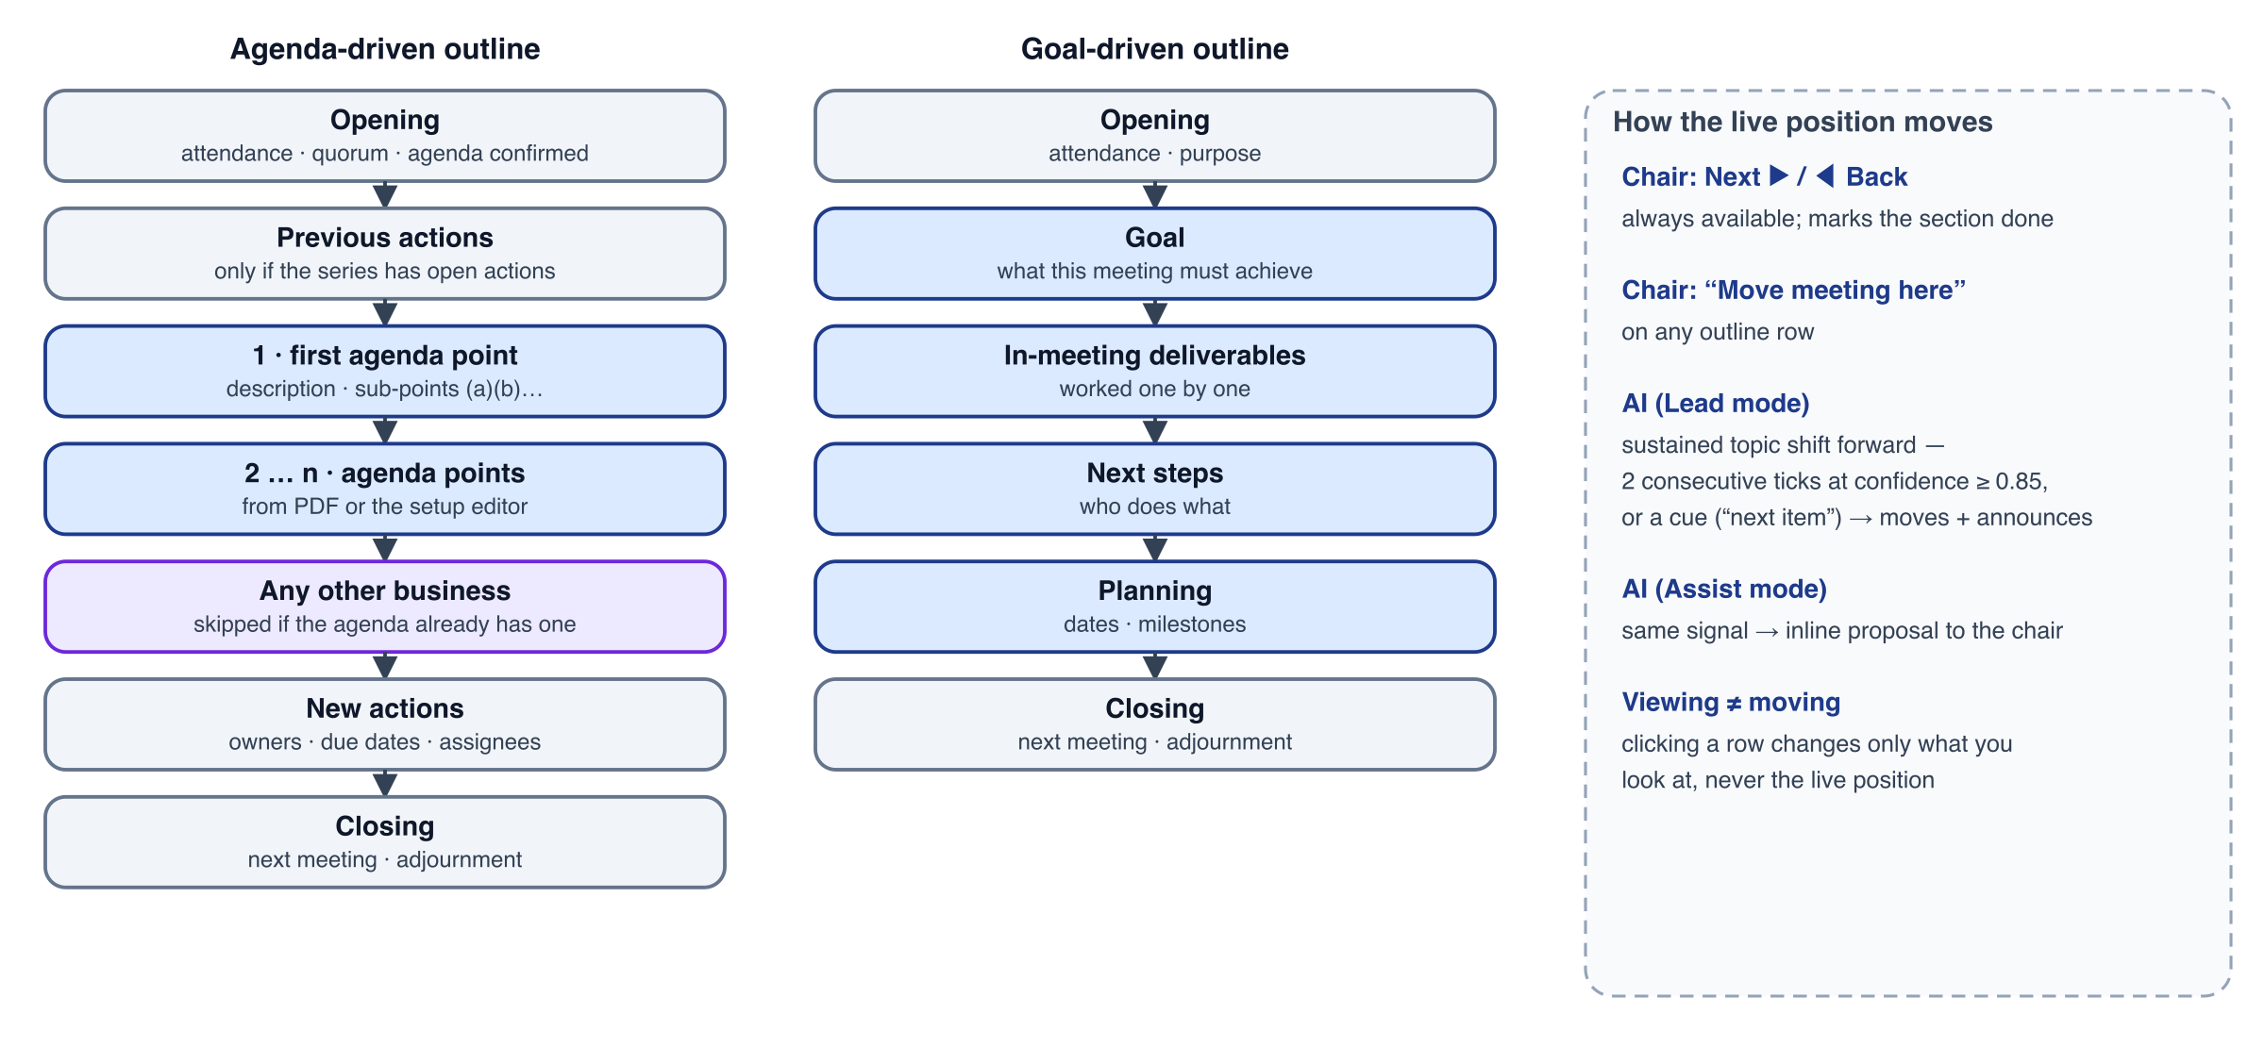
Figure 1 — Meeting outline for both templates, and the ways the live position moves.
- Agenda points come from the PDF (structured by the LLM) or from the setup editor, so an agenda is never missing because a PDF failed. Each point has a title, an optional description, sub-points (a)(b)(c), a presenter and a timebox.
- Fixed sections are skipped when they don't apply. Previous actions is skipped when the series has no open actions. AOB is skipped when the agenda already ends with an “any other business” point; a matcher recognises common wordings in en, nl, fr and de.
- Sub-points can be navigated in the outline. They structure the minutes (3.1, 3.2 …). The live position stays at point level unless the chair moves it to a sub-point.

5. The Meet++ screen: layout and navigation

5.1 Design principles
- One position. The meeting is at exactly one section, shown by a single LIVE marker. Nothing else claims to be “current”.
- Viewing is not moving. Clicking anything only changes what you see. Only the chair's explicit Next ▶ / ◀ Back / Move meeting here, or the AI in Lead mode, move the meeting.
- The tabs mirror the report. Agenda, Decisions, Actions, Minutes, Attendance and Papers are the sections of the final document, so the board is a live preview of it. Content inside each tab is grouped per section of the outline.
- The transcript is always visible, in its own column, because it is the ground truth everything else is derived from.
- Automation yields to people. Automatic activation is predictable: minimum 5 s per activation, always highlighted. It steps aside for 10 s after any manual interaction, and it never moves keyboard focus.

5.2 Layout
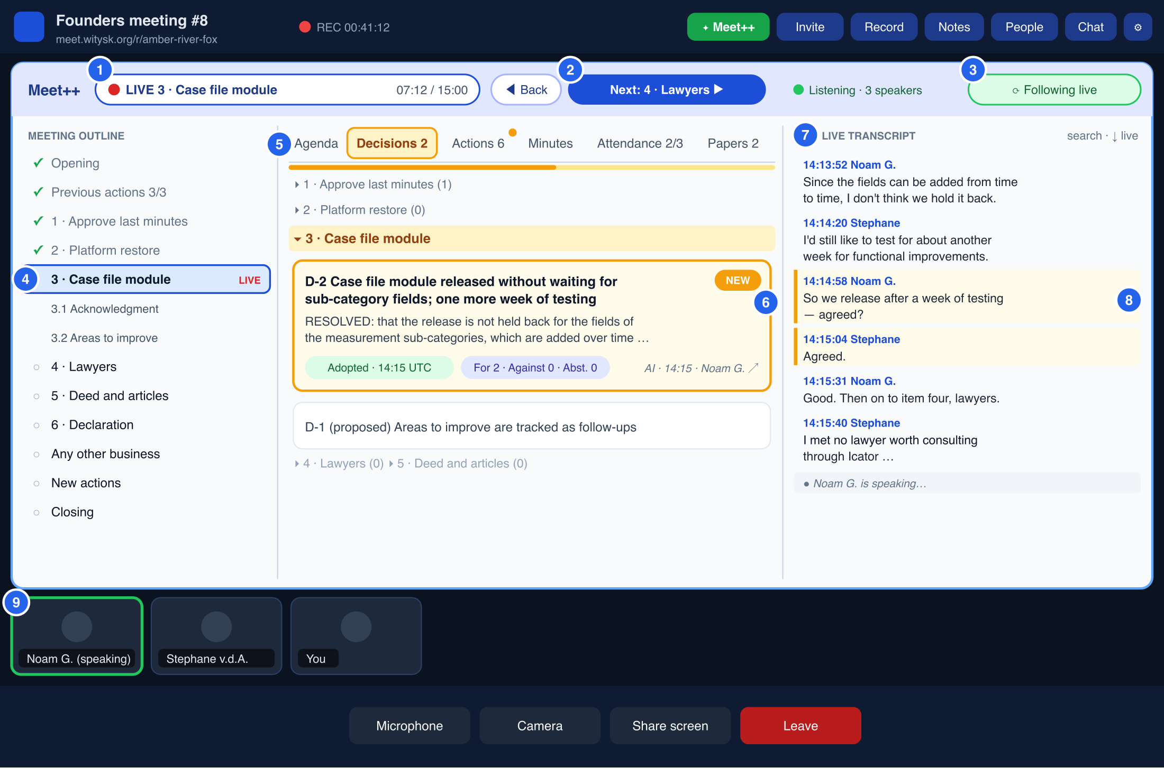
Figure 2 — The Meet++ screen while following live: header, meeting outline, content tabs and live transcript. A new decision is being activated (amber highlight, 5 s progress bar).
Table 10 — Screen callouts
# | Element | Behaviour
1 | Live position chip | Red dot, section number and title, plus elapsed time and timebox. Clicking it brings your view back to the live section (same as “Back to live”).
2 | Back / Next (chair and co-hosts) | Next ▶ closes the live section and moves to the next one; its label names the target. ◀ Back reopens the previous one. Participants don't see these buttons.
3 | Follow chip | “Following live” (green), “Auto-follow in 7 s” (amber, with Resume now) or “Follow off” (grey, toggled by the user). Visible to everyone.
4 | Meeting outline | Sections with status icons (✓ done, ● live, ○ upcoming), sub-points indented. The LIVE row is outlined red; the row you are viewing is filled blue. Click a row to view it; chair menu: Move meeting here · Mark done · Add sub-point.
5 | Content tabs | Agenda · Decisions · Actions · Minutes · Attendance · Papers, with counters and an amber dot for unseen changes. The activated tab is highlighted for its display time. All tabs are always clickable.
6 | Section groups and items | Each tab lists its content under section headers (collapsed when empty). Activation expands and scrolls to the section, highlights the item (amber, NEW or UPDATED badge) and shows the 5 s progress bar.
7 | Live transcript | Newest at the bottom; auto-scrolls while you are at the bottom; “↓ live” appears when you scroll up. Search filters lines. Speaker and time per line; refined lines replace provisional ones in place.
8 | Evidence link | Selecting an item highlights the transcript lines it was derived from (amber bar), and the ↗ on an item scrolls the transcript there.
9 | Camera strip | Speaker thumbnails below the board. A screen share takes over the main area (§5.10).

5.3 Navigation concepts
v3 uses exactly four concepts, each with a single owner:
Table 11 — Navigation concepts
Concept | Owner | Shown by | Changed by
Live position: the section the meeting is at | Server (session) | LIVE chip; red outline in the outline | Chair (Next, Back, Move here); AI in Lead mode (§8.3)
Topic: the section being talked about right now | Server (each tick) | Activations only (not a separate indicator) | AI interpretation (§8.3)
Viewed section and tab: what this user looks at | Each client | Blue outline row; selected tab | Automatic activation, or the user's clicks
Follow state | Each client | Follow chip | Clicks (pause 10 s), Resume now, Follow off/on toggle

The topic usually equals the live position. When people briefly return to an earlier point, or start talking about the next one before the chair moves, the topic differs. The board then activates the topic section so everyone sees the relevant decisions, but the live position stays where the chair put it (or, in Lead mode, moves once the shift is sustained).

5.4 Meeting outline
- Rows: status icon, number, title, and the decision/action count shown as small grey digits. Sub-points are indented and collapsible.
- Live section: red outline, LIVE badge, and elapsed time / timebox. When the timebox is exceeded the time turns amber; at 150 % the chair gets a nudge.
- Clicking a row sets your viewed section. The current tab scrolls to that section's group, or the Agenda tab opens if the current tab has nothing for it. This counts as a manual interaction (§5.7).
- Chair context menu (⋯ on hover, or right-click): Move meeting here · Mark done · Defer to next meeting · Rename · Add sub-point · Delete (only if empty).
- Narrow screens: the outline collapses to a numbered rail (§5.11).

5.5 Content tabs
Table 12 — Content tabs
Tab | Content per section | Item fields | Editing
Agenda | Description and sub-points (a)(b)(c), presenter, timebox, status, running notes count | As in the agenda document | Chair / editors: edit text, add sub-point
Decisions | Decisions taken in that section | D-n, title, resolution text, status (proposed, adopted, rejected, withdrawn), decided at, vote summary (for/against/abstain, method), provenance | Confirm / edit / reject; edit the vote record
Actions | New actions of that section; the Previous actions section lists the series' open actions with this meeting's report | A-n, title, description, assignees, due, status, “reported at this meeting”, from decision, provenance | Confirm / edit / reject; status; assignees picker
Minutes | Running notes for the live section; composed narrative for closed sections (with RESOLVED blocks) | Markdown rendered; version and composed-at time | Edit (locks the section); Regenerate (chair)
Attendance | Members and guests (not grouped by section) | Name, username, status (present, represented, absent, excused, not registered), represented by, mandate, transcribed?, required next | Chair: set status, proxy, required next
Papers | Uploaded documents and whiteboard snapshots with their agenda point | Paper, file, agenda point, time | Add snapshot (anyone, setting), rename and delete (chair)

Groups follow the outline order. Empty groups are collapsed to a single grey line. The live section's group is expanded by default, and the viewed section's group is expanded and scrolled into view.

5.6 Live transcript panel
- Position and size: a fixed column on the right, 300–360 px wide, the full height of the board. It replaces the v2 ticker, the footer bubble and the Transcript tab. The accessibility captions overlay is shown only when the board is not on screen (for example during a screen share).
- Lines: time (hh:mm:ss), speaker name in blue, then text. A tier-1 line shows in dark grey; when its tier-2 refinement arrives it is replaced in place (dark text) without moving the scroll position. Consecutive lines from the same speaker within 4 s are merged visually.
- Live indicator: a grey “● Name is speaking…” row at the bottom, driven by LiveKit's active-speaker events, so people can see that speech is being picked up before the text arrives.
- Scrolling: while the panel is scrolled to the bottom it sticks to the newest line. Scrolling up stops auto-scroll and shows a ↓ live (n new) pill. Scrolling in the transcript is not a board interaction, so it does not pause tab activation.
- Search filters lines (case-insensitive, accent-insensitive) and highlights matches; clearing it returns to live.
- Evidence: lines cited by the selected item get an amber left bar, and clicking a line shows which items cite it.
- Capacity: the list is virtualised. The client keeps the whole session (paged from GET /transcript?after=, no 400-line cap) and reloads incrementally after a reconnect.
- Gap markers: “— transcription interrupted 14:22:10–14:22:40 (agent reconnecting) —” lines make outages visible instead of silent.

5.7 Automatic activation
An activation is a request from the server to show a specific tab, section and (optionally) item, produced when the interpretation finds something worth showing (§8.3). The client processes activations through a small queue with the rules below. The pseudocode is in Appendix C.
Table 13 — Activation rules
Rule | Specification
Sources and priority | Topic change → Agenda tab at that section (priority 3). Decision added or adopted → Decisions (5). Action added or status changed → Actions (4). Attendance change → Attendance (2). Minutes notes and composition never activate; they only mark the Minutes tab unseen.
Minimum display | Each activation stays on screen for at least 5.0 s before the next one is applied, even if newer activations are waiting.
Highlight | During its display time the tab button and the section header are amber, the target item has an amber outline with a NEW or UPDATED badge, and a 5 s progress bar runs under the tabs. The badge stays until the item has been seen for ≥ 1 s.
Merging | Activations for the same tab and section that arrive while one is waiting are merged into one (all items highlighted). A newer topic change replaces an older waiting one.
Queue | FIFO, at most 4 waiting activations. On overflow the lowest-priority, oldest one is dropped; its items keep their badges and the tab shows the unseen dot.
Manual pause | Any click or keyboard selection on a tab, outline row or item, any scroll-wheel action in the content pane, and any edit pause automatic activation for 10 s after the last such interaction. The Follow chip counts down; Resume now ends the pause.
Catch-up | When the pause ends, only the newest waiting activation is shown (5 s, highlighted). All items that arrived during the pause keep their NEW badges.
Programmatic actions | Scrolls and tab changes made by the activation logic itself never count as interactions (fixes the v2 self-pause).
Follow off | A user can switch Follow off. Activations then only update counters and unseen dots, until Follow is switched on again.
Recording / egress | Always follows, never pauses, same 5 s rule.

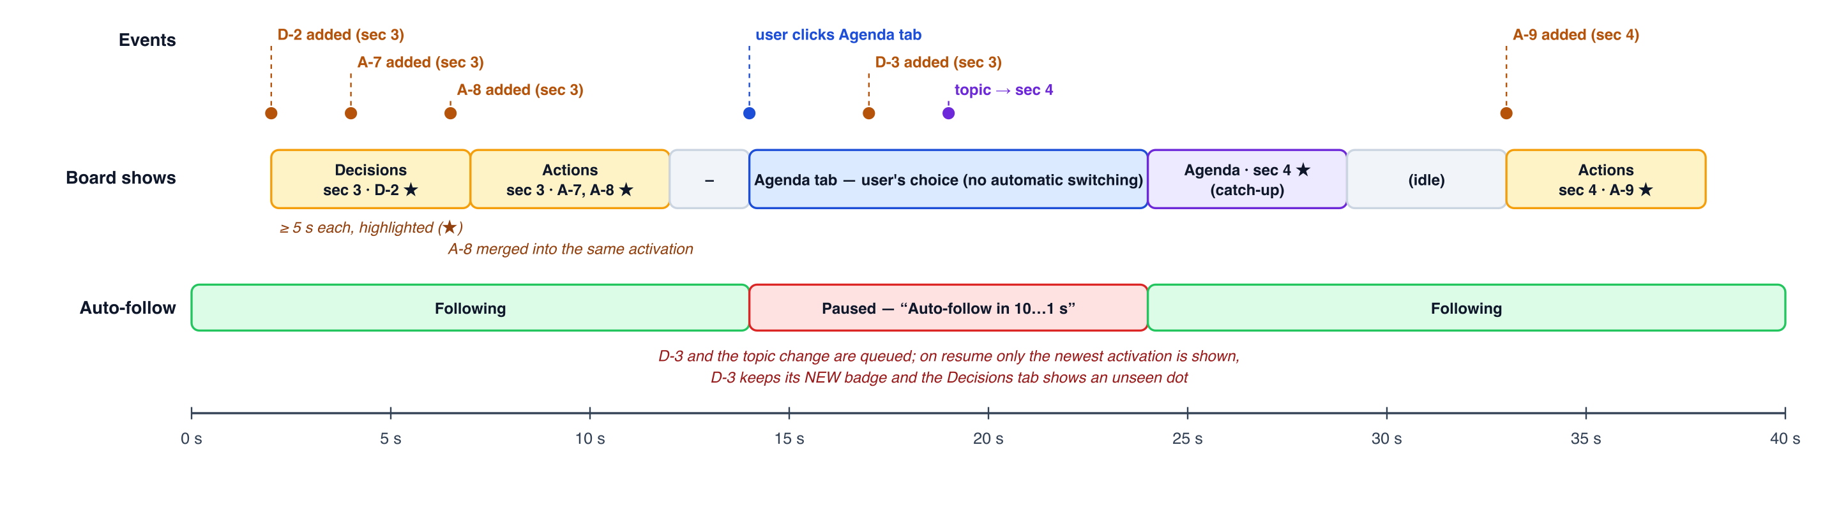
Figure 3 — Example timeline: activations shown for at least 5 s and merged; a click pauses automatic switching for 10 s; on resume the newest activation is shown (catch-up).

5.8 Manual navigation and browsing
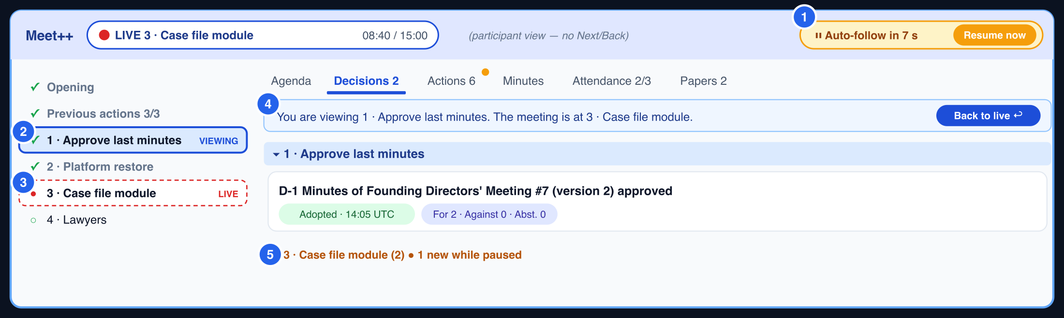
Figure 4 — Participant browsing: viewing point 1 while the meeting is at point 3. Follow is paused with a countdown; the live section remains marked; “Back to live” returns immediately.
Table 14 — Navigation controls
Action | Who | Effect
Click a tab | Everyone | Shows that tab; keeps the viewed section; pauses activation for 10 s
Click an outline row | Everyone | Views that section in the current tab (or Agenda if empty); pauses for 10 s; shows the “You are viewing …” bar when it is not the live section
Back to live / click the LIVE chip | Everyone | Views the live section; ends the pause immediately
Next ▶ | Chair, co-hosts | Marks the live section done (status ✓), moves live to the next section, announces it, and starts composing minutes for the closed section
◀ Back | Chair, co-hosts | Moves live to the previous section (reopens it; its composed minutes become a draft again)
Move meeting here (row menu) | Chair, co-hosts | Moves live to any section; skipped sections stay “upcoming”
Undo (10 s toast) | Chair, co-hosts | Reverts an AI-initiated move in Lead mode
Keyboard | Everyone / chair | Alt+1…6 tabs; Alt+↑/↓ outline; Esc back to live; chair Ctrl+Shift+→ / ← Next / Back. Listed in the shortcut overlay

5.9 Announcements and proposals
- Announcements (section change, session start and end, timebox overrun) appear as a large banner over the board header and outline for 4 s. Text is 28 px with the section number and title, and the transcript stays visible. Each client speaks it with the browser's speech synthesis in the session language (respecting the user's mute preference). The egress page plays it too, so recordings include it. Full-screen overlays are removed.
- Proposals appear in Assist mode, and in Lead mode when confidence is below the auto threshold. They show as an inline bar under the header for the chair and co-hosts only: “AI suggests moving to 4 · Lawyers — Move / Not now”. “Not now” suppresses the same target for 3 minutes; the next proposal is not blocked.
- AI moves in Lead mode show the same bar after the fact: “Moved to 4 · Lawyers by AI — Undo (10 s)”.

5.10 Roles and where the board appears
- One board. The same board component runs for everyone. Chair, co-hosts and designated editors see inline edit controls; participants and guests see the same board read-only but can navigate freely.
- Stage: while a session runs, the board occupies the main area in speaker mode and the camera strip sits below. A human screen share or playback takes the main area; the board then shows as a mini tile (live section + latest change), and clicking it opens the board in a right-side drawer for that user. The chair can Bring board back.
- Recording and livestream (/egress-layout/pip): the read-only board at 720p scale with the transcript column narrowed to 260 px; it follows live without pausing. Public view: only if the session allows it.

5.11 Responsive behaviour
Table 15 — Responsive layouts
Board width | Layout
≥ 1,200 px | Three panes: outline 220 px · tabs (flexible, ≥ 480 px) · transcript 340 px
900 – 1,199 px | Outline becomes a 48 px numbered rail (tooltips on hover; click to expand as an overlay); transcript 300 px
640 – 899 px | Transcript becomes a drawer toggled from the header (badge with new lines); outline as a dropdown in the header
< 640 px (phones) | Single column: segmented control [Outline · Tabs · Transcript]; header shows only the live chip and Follow; Next/Back in a bottom bar for the chair

5.12 Setup screen
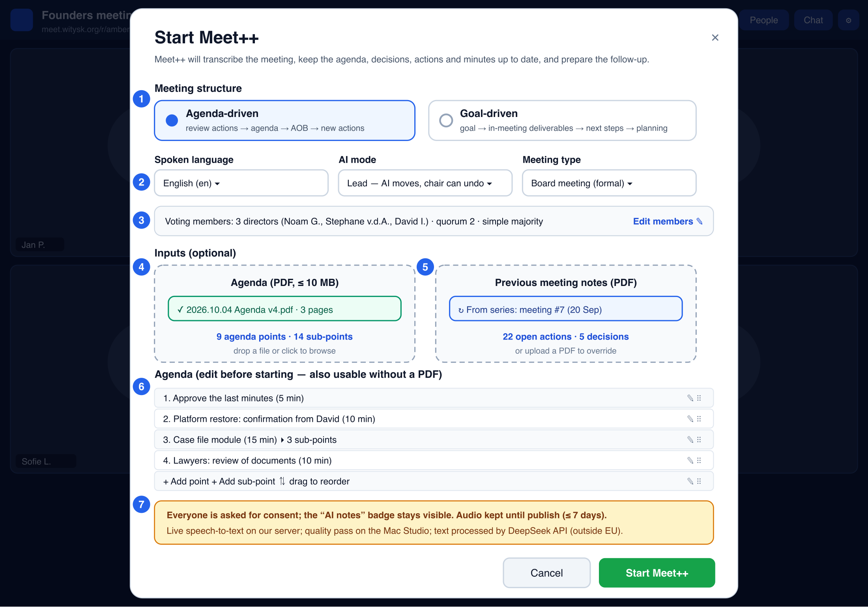
Figure 5 — Start Meet++: structure, language, AI mode, meeting type, voting members and quorum, inputs, and the agenda editor (usable with or without a PDF).
- Meeting type has three values. The two formal types show the voting members row (members, entitled to vote, quorum, majority rule) taken from the series, which the chair can edit; the first time it is pre-filled from the previous report PDF if one was uploaded.
  - Informal: no votes or quorum in the report
  - Board meeting
  - General assembly
- The agenda editor is always present. A PDF fills it, and so does the series' next-agenda draft; it can also be typed directly. Sub-points, descriptions, presenters and timeboxes are editable, and items can be reordered by drag.
- Start is disabled only in one case: a formal meeting type with no members defined. A guided “Add members” button appears instead.

5.13 Review screen
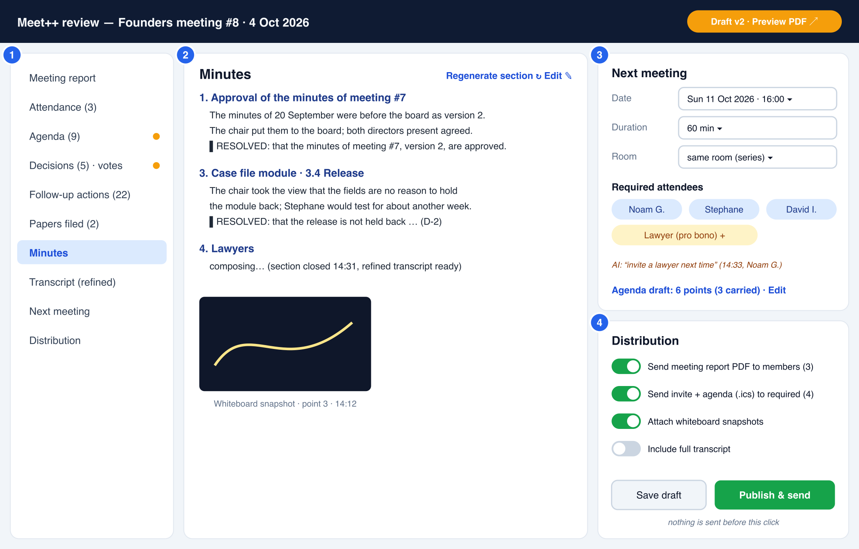
Figure 6 — Review: navigation follows the report sections; minutes per section with RESOLVED blocks and composition status; next meeting and distribution.
- Navigation follows the report. The left navigation lists the report's sections. Preview PDF renders the actual report (§9) in a new tab at any time.
- Decisions get a vote editor per decision: method; for, against and abstain; per-member ballots for formal meetings; and quorum, computed from attendance and shown for confirmation.
- Minutes sections show their composition status and source tier (“refined transcript” or “live transcript”), with Regenerate section and Edit.

5.14 Accessibility and internationalisation
- Tabs use the WAI-ARIA tab pattern and the outline is a tree. Activations change the visible tab without moving keyboard focus. A polite live region announces “New decision in 3 · Case file module” at most every 10 s.
- Highlights combine colour with a badge and outline, and contrast is at least 4.5:1. prefers-reduced-motion disables the smooth scroll and pulse.
- All labels use the meetpp i18n namespace; v2's hard-coded tab labels are fixed. Generated content, announcements and the report use the session language (en, nl, fr, de in R1.1).

5.15 Error and degraded states
Table 16 — Degraded states
Condition | Board shows | Still works
A speaker's audio is being received but no text for 20 s | Amber dot on that speaker in the header (“Stephane: no transcript — restarting”), gap marker in the transcript | Everything else; the agent restarts that consumer
Agent disconnected from the room | Red status “Transcription reconnecting”, gap marker | Board, manual editing
Tier 2 unavailable | Small grey note “live-quality transcript” in the transcript header | Everything (tier-1 text used)
LLM unavailable or circuit open | Status “AI paused — retrying”; no activations | Transcript, manual navigation and editing
Section composition failed | Minutes group shows “Composition failed — Retry” | Running notes remain
No agenda | Outline shows the fixed sections plus “Add agenda point” (chair) | Goal-driven template suggested at setup

6. Functional and non-functional requirements

6.1 Functional requirements (Release 1.1)
Table 17 — Functional requirements
ID | Requirement | Pri
FR-1 | The Meet++ screen shows the header (live position, Next/Back for the chair, AI status, Follow chip), the meeting outline, content tabs and the live transcript panel, for every participant. | M
FR-2 | Every tab and outline row is clickable by every participant at all times. | M
FR-3 | The live transcript panel shows each final segment with speaker and time, auto-scrolls while at the bottom, offers “↓ live” when scrolled up, supports search, and shows refined text in place. | M
FR-4 | The system detects the section being discussed and emits activations for topic changes, new or adopted decisions, new or updated actions and attendance changes. | M
FR-5 | Each activation is displayed for at least 5 s with highlight (tab, section header, item, progress bar); same-target activations are merged; the queue holds at most 4. | M
FR-6 | After a manual interaction, no automatic activation is applied for 10 s after the last interaction; then the newest waiting activation is shown. | M
FR-7 | The chair and co-hosts can move the meeting to the next or previous section, or to any section; all clients update within 1 s and an announcement is made. | M
FR-8 | New decisions and actions are added under the section they belong to, with evidence links to the transcript. | M
FR-9 | Running notes are kept per section; composed minutes are produced for each section when it closes, and final minutes at the end. | M
FR-10 | The setup screen offers an agenda editor (with or without a PDF), meeting type, and series members with voting rules. | M
FR-11 | Decisions carry a resolution text, status, decided-at time, and a vote record (method, tallies, ballots for formal meetings); quorum is computed from attendance. | M
FR-12 | Previous open actions of the series are reported on during “Previous actions” and carried forward if still open. | M
FR-13 | The meeting report PDF contains the eight parts of §9.1 in that order and look; Markdown minutes are rendered. | M
FR-14 | Transcription continues across reconnects, mute/unmute, leave/rejoin and agent restarts; interruptions are marked in the transcript and alerted. | M
FR-15 | Tier-2 refinement (Mac Studio) replaces live text when available; the final transcript for minutes uses tier 2 when available and records which tier was used. | M
FR-16 | AI moves in Lead mode can be undone within 10 s; Assist mode only proposes. | S
FR-17 | Everything specified in v2 for consent, series, invitations, review and publishing remains, except where this document changes it. | M

6.2 Non-functional requirements
Table 18 — Non-functional requirements
ID | Requirement
NFR-1 | Tier-1 line visible ≤ 4 s p95 after the end of an utterance; tier-2 refinement ≤ 8 s p95; activation ≤ 15 s p95 after the triggering utterance
NFR-2 | meetpp-agent stays within 2 vCPU / 3 GB; TITV HLS shows no stalls during a session with a concurrent recording
NFR-3 | No silent data loss: every dropped utterance, filtered segment, rejected operation and failed job is logged with a reason and counted in the agent and admin health
NFR-4 | A meeting-api or agent restart loses no transcript (buffers) and resumes the session within 15 s
NFR-5 | The board stays responsive with a 3-hour transcript (virtualised list, ≥ 50 fps scrolling on a 2020 laptop)
NFR-6 | Accessibility WCAG 2.1 AA; all strings localised
NFR-7 | LLM spend ≤ USD 0.40 per meeting hour (§8.8)

7. Speech-to-text design

7.1 What turn.witysk.org can do: measurements
All tests used the same 120-second excerpt of a real meeting recording (4 October 2026, English, several speakers). They ran on 6 October inside the production meetpp-agent container at the lowest CPU priority (nice 19), with the 24/7 TITV egress running throughout. The TITV HLS stream kept producing segments and its watchdog logged nothing, and the temporary model files were removed afterwards.
Table 19 — Test set-up on turn.witysk.org
Item | Value
Host | AMD EPYC (Genoa) · 4 vCPU · AVX-512 incl. VNNI/BF16 · 7.6 GiB RAM, no swap · root disk 38 GB, 87 % used
Baseline load | Load average about 2.5 before testing: TITV egress ≈ 1.2 vCPU, ingress ≈ 0.3 vCPU
Engine | faster-whisper 1.0.3 / CTranslate2 4.8.2, int8, cpu_threads=2 (the container cap is 2 vCPU), greedy decoding

Table 20 — Speed by model
Model (int8, 2 threads) | Time for 120 s | Real-time factor | Live use on turn? | Notes
small (deployed) | 24.7 s | 0.21 | Yes: about 5× headroom | Close to the reference on continuous audio
medium | 74.6 s | 0.62 | No: too little headroom | No better than turbo on names
large-v3-turbo | 87.3 s | 0.73 | No: falls behind with a recording running | Ended in a repetition loop (“I'm going to say” × 40)
large-v3-turbo, MLX on an Apple M1 Mac mini | 14.1 s incl. model load | ≤ 0.12 | n/a (reference) | A Mac Studio is several times faster

A second experiment measured how much segmentation matters for the same small model. Word error rate (WER) is computed against the large-v3-turbo transcript of the same audio; that reference is itself machine output, so the numbers are relative.
Table 21 — Effect of segmentation and context
Strategy (small, int8) | WER vs reference
Whole excerpt, VAD + previous-text conditioning (best case) | 8.1 %
Live-like: short VAD utterances (avg 3.8 s), no context (Release 1 behaviour) | 14.7 %
Longer utterances (≈ 12 s) + rolling context + vocabulary prompt (v3 tier 1) | 12.7 %
Fixed 3 s chunks, no context (worst case) | 19.7 %

Conclusion. The turn server can run good-enough live transcription with small, provided segmentation and context are fixed. It cannot run large-v3-turbo live without hurting the media services, and medium is not a worthwhile middle ground. Final-minutes quality equal to your 4 October minutes therefore needs a second tier on the Mac Studio. In production, Release 1 also lost accuracy to the missing Silero model (energy gate) and to clipped starts (≈ 30 ms pre-roll), which this experiment does not include.

7.2 Decision: two tiers
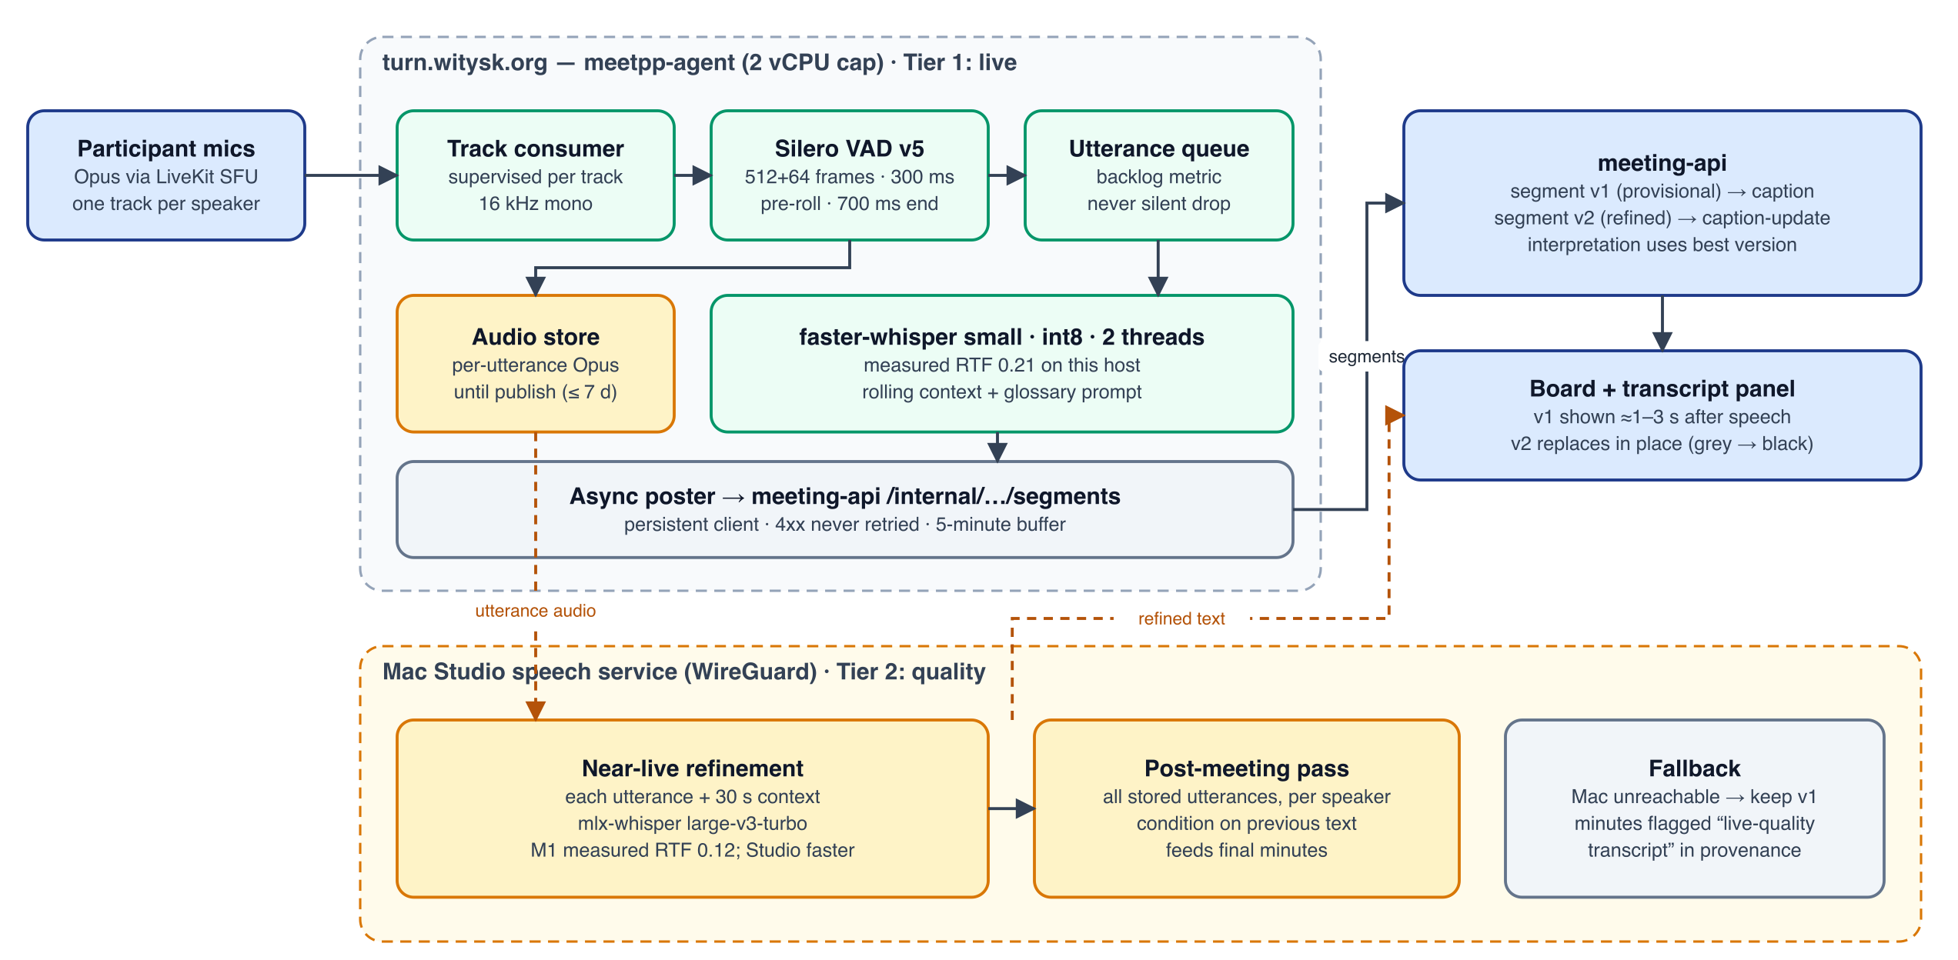
Figure 7 — Two-tier transcription. Tier 1 runs live on turn.witysk.org; tier 2 refines on the Mac Studio near-live and re-transcribes everything for the final minutes. Without the Mac Studio, the system degrades to tier 1.
Table 22 — Tier responsibilities
 | Tier 1: live (turn.witysk.org) | Tier 2: quality (Mac Studio)
Purpose | Transcript box within seconds; input for live interpretation | Replace each line with a better version within seconds; final transcript for minutes
Model | faster-whisper small, int8, 2 threads | large-v3-turbo via mlx-whisper (or whisper.cpp Metal)
Input | Per-speaker audio from LiveKit | Per-utterance Opus audio from the agent's audio store, plus 30 s of previous text as prompt
Latency target | ≤ 4 s p95 after end of utterance | ≤ 8 s p95 (near-live); whole meeting ≤ 5 min after end
Availability | Always (part of the stack) | Best effort; health-checked every 30 s; automatic fallback to tier 1
Expected quality (English) | ≈ 12–13 % WER | ≈ reference quality (about 5–8 %)

7.3 Tier 1 pipeline specification
Table 23 — Tier-1 parameters
Stage | Release 1 | v3
VAD model | Silero download 404 → energy gate (RMS > 0.01) | Silero VAD v5 ONNX vendored in the repo with SHA-256 check; the build fails if it is missing; the active VAD is logged at start
Framing | 480 samples, no context | 512 samples + 64-sample context carry-over (as Silero v5 expects); state reset per stream
Thresholds | start 250 ms, end 600 ms | speech prob ≥ 0.5 to start (250 ms), < 0.35 to end, 800 ms end silence; min utterance 400 ms
Pre-/post-roll | ≈ 30 ms effective | 300 ms pre-roll, 150 ms post-roll
Max utterance | 20 s hard cut (mid-word) | 15 s; cut at the lowest-energy 30 ms frame in the last 3 s
Prompt | comma list of titles + names, frozen at start | Prose glossary (“Meeting of <org>. Participants: … Topics: …”, refreshed on every outline or attendance change) + the last 200 characters of transcript
Decoding | beam 1, temperature 0, no fallback | beam 1; temperature fallback 0.0 → 0.2 → 0.4 on compression ratio > 2.4 or avg log-prob < −1.0
Language | Forced; default en | Session language; “auto” detects on the first 30 s of speech and then fixes it
Filters | Drop if no-speech > 0.6 or log-prob < −1.0 (silent) | Whisper's rule (and); hallucination blocklist per language (≥ 30 phrases); every drop logged with its reason
Queue | 128, drop oldest silently; degrade never fires | Measured backlog; > 20 s → base; > 60 s → drop with a gap marker (“audio skipped”) and an alert

7.4 Tier 2: refinement and final transcript
- Service: a small HTTP service on the Mac Studio, POST /transcribe (Opus or WAV body, language, prompt) → {text, words?, avg_logprob}. It is reachable only over WireGuard from turn.witysk.org and authenticated with a shared HMAC key. A health endpoint reports model, load and real-time factor.
- Near-live refinement: after tier 1 posts segment v1, the agent sends the same utterance audio with the previous 30 s of refined text as prompt. When the answer arrives (budget 8 s), the agent posts segment v2. meeting-api stores both versions (text_live, text_refined) and broadcasts a caption-update. Interpretation uses v2 when it is available at tick time.
- Audio store: utterances are kept as Opus (24 kbit/s, ≈ 11 MB per hour of speech) under /var/lib/meet/meetpp/<sid>/audio/ until the report is published, and at most 7 days. This needs disk space first: the root disk is 87 % full (Q6).
- Final pass: at session end the agent submits all stored utterances per speaker in order, with conditioning on previous text (this is where the 8 % → reference gain comes from). The finalisation waits up to 5 minutes. If the Mac is unreachable, finalisation uses v2 where present and v1 otherwise, and the report's provenance says so.
- Repetition guard: turbo repetition loops (observed on turn) are detected by n-gram repetition and compression ratio; the affected text is replaced by the tier-1 text for that utterance.

7.5 Reliability: why transcription will not stop
Table 24 — Reliability mechanisms
Failure | v3 mechanism
Consumer task crashes | One supervised consumer per track SID, restarted with backoff (1, 2, 5, 10 s); track_unpublished / unsubscribed stop it, track_subscribed starts it; never two consumers per track
Room disconnect | On disconnected the agent asks meeting-api for a fresh token (POST /internal/meetpp/sessions/{sid}/agent-token) and reconnects with backoff; /health reports connected=false meanwhile and a gap marker is posted
Speaker silent in transcript while speaking | Liveness check: LiveKit active-speaker events vs. VAD activity. If someone is marked speaking for 10 s within a 20 s window with no utterance, the consumer is restarted, logged and alerted
Guest reconnects with a new identity | Consent is stored per person: SSO sub, or a guest key kept in sessionStorage and sent as a participant attribute. The client re-posts consent on every join; the server pushes the accepted list to the agent on change and every 20 s
Lost pause/resume or consent PATCH | The watchdog reconciles paused and the consent list every 20 s
meeting-api restart or 5xx | Async poster with a persistent client; 5-minute ordered retry buffer; 4xx never retried (logged)
Agent container restart | Runtime detects a missing session in /health and re-starts it within 15 s; a gap marker covers the outage
UI shows nothing although segments arrive | Ticker removed; transcript panel renders every segment; captions never time out silently

7.6 Observability of transcription
- Per-session summary at INFO every 60 s:
MEETPP_STT sid=… speakers=3 consumers_alive=3 utterances=41 decoded=40 dropped=1(no_speech) backlog_s=0.8 rtf_p50=0.19 rtf_p95=0.31 tier2_ok=38 tier2_fail=0 last_segment_age_s=4
- Events at WARNING: consumer restart (with exception), reconnect, liveness restart, queue drop, tier-2 unreachable, VAD fallback (which should never happen).
- Board: the header status shows Listening / Behind (backlog) / Reconnecting / Paused, plus per-speaker amber markers on liveness failures.
- Admin panel Meet++ tab: per-session consumers, backlog, real-time factor, tier-2 health and the last 20 warnings. Alerts are e-mailed to platform admins when the backlog stays above 60 s or a liveness failure repeats 3 times in 5 minutes.

7.7 Capacity and fallbacks
Table 25 — Capacity and fallbacks
Situation | Behaviour
One session, ≤ 8 active speakers, recording running | Tier 1 within budget (RTF 0.21 → ≈ 1 vCPU at continuous speech); tier 2 on the Mac
Backlog > 20 s | Switch to base until the backlog is < 5 s; tier 2 still refines, so final quality is unaffected
Mac Studio offline | Tier-1 text only; board note; provenance says “live-quality transcript”
Second concurrent session | Refused while MEETPP_MAX_ACTIVE_SESSIONS=1 (unchanged); can rise to 2 once M1 measurements on the new pipeline confirm headroom

8. Interpretation design

8.1 Cadence and window
- Tick cadence: every 12 s when there is at least one new final segment. A cue phrase (per-language list: “next item/point”, “volgend punt”, “agreed”, “akkoord”, “all in favour”, “action for”, “we decided”, …) triggers a tick at once, and so does a chair move. Ticks are single-flight; triggers that arrive during a call are merged into the next tick.
- Window: new segments since the last tick (at most 2 minutes; a longer backlog is processed in consecutive ticks) plus 90 s of preceding context, marked as such. Tier-2 text is used when available.
- Context sent: the outline (short ids S1…Sn, titles, sub-points, status, live position); decisions and actions of the live and topic sections in full, others as one line each; the open previous actions; members and attendance; running notes of the live section.
- Names: v2's P1…Pn aliasing is dropped (§2.6). Display names are sent as spoken in the meeting; e-mail addresses and usernames are never sent. The privacy implication is recorded in §11.3.

8.2 Output contract v3
Each tick returns one JSON object with four parts (full schema in Appendix A):
- topic: the section being discussed (and optionally the sub-point), with confidence;
- advance: an optional request to move the live position, with confidence and reason;
- ops: structured changes to decisions, actions, attendance and outline;
- notes: short factual bullet points for the minutes of a section, each with evidence.
Server validation is lenient on shape and strict on meaning:
- unknown fields are ignored;
- over-long text is truncated;
- unknown section ids fall back to the topic section;
- evidence must reference segments in the window or context, with at least one new;
- duplicates are checked within the session (and against previous actions by reference);
- every rejected operation is stored with its raw payload and reason.

8.3 Topic, activations and position
Table 26 — Topic and position rules
Signal | Rule
Topic change → activation | Emit a topic activation when topic.section differs from the last topic and confidence ≥ 0.6. When confidence is < 0.8, require the same topic in 2 consecutive ticks (hysteresis against flicker).
Item activations | Every applied decision, action or attendance operation produces an activation {tab, section, item} with the priorities of §5.7; at most 3 per tick (highest priority first).
Position (Lead mode) | Move the live position forward when (a) advance names the next section with confidence ≥ 0.85, or (b) the topic has been a later section for 2 consecutive ticks with confidence ≥ 0.85, or (c) a cue phrase such as “next item” is followed by talk about that item. Show “Moved … — Undo (10 s)”. Never move backwards.
Position (Assist mode) | Same conditions produce a proposal to the chair instead.
Chair overrides | A chair move suppresses AI moves for 60 s and resets the hysteresis.
Closing a section | When the position leaves a section, its status becomes done (or deferred when chosen), its timer stops and section composition starts (§8.7).

8.4 Decisions, votes and quorum
- decision.add carries:
  - a short title (as in the report heading);
  - the resolution (written in the “that …” form for adopted motions);
  - how it was taken (“Put by the chair as a voice vote; both directors present answered in favour.”);
  - the status (proposed, adopted, rejected, withdrawn);
  - the decided-at segment (giving the time);
  - an optional vote: method (voice, show of hands, consensus/assent, roll call), tallies and, when names are audible, ballots.
- For formal meetings, Meet++ computes quorum and entitled to vote from members and attendance (present + represented). It applies the series' majority rule (ordinary, unanimous, two thirds, four fifths, matching the OM vote model) to derive the result. AI-derived votes are marked “to confirm” until the chair confirms them in review.
- Assent without explicit voting (“Taken with the assent of both directors present.”) is recorded as method assent, with ballots “for” for the present voting members who agreed and “not recorded” for the rest.

8.5 Actions: new, previous, carried forward
- New actions: title, description, assignees (one or more members or guests), due date, from-decision link, section.
- Previous actions (open series actions) are listed in the Previous actions section. During that section, and whenever they are mentioned later, action.update records a report for this meeting (“reported at this meeting”), status changes (done → completed at, with completion note) and progress notes.
- At publish, actions still open are marked carried forward. The next meeting's report lists them with “— carried forward” and “Also on: <meetings>”, as in the example.

8.6 Attendance and members
- Series members (name, username, e-mail, role, entitled to vote) are maintained in setup, imported from a previous report, or (in R2) synced from the OM module.
- Live presence comes from the agent (STANDARD participants only) and is matched to members by SSO identity, then by name (the chair can correct it). Unmatched people are guests.
- Status per member: present, represented (with represented-by and written mandate, entered by the chair), absent, excused (set by the AI when apologies are mentioned; chair confirms), or not registered.

8.7 Minutes
Table 27 — Minutes pipeline
Stage | When | What | Output
Running notes | Every tick | notes[]: short factual bullets per section with evidence; deduplicated; never rewritten by the AI | Minutes tab, live section (“Running notes”)
Section composition | When a section closes, or on the chair's “Compose now” | One LLM call per section with: the section's transcript (best tier), notes, decisions, actions and agenda text | Narrative Markdown in the style of the example: third person, past tense, sub-sections per sub-point (### 3.1 …), a > **RESOLVED:** that … block per adopted decision, “No resolution was put.” when none
Final composition | At session end, after the tier-2 final pass | (1) Re-compose sections whose source text improved (unless edited). (2) Opening paragraph: present, absent, quorum, start time. (3) Adjournment. (4) Record of voting (table). (5) Provenance: models, tier, attribution method, list of figures and names to verify | Complete minutes document, version n
Edits | Any time | A human edit locks that section's narrative; Regenerate (chair) replaces it with a new version | Version history kept

Composition prompts are in Appendix D. Each composition is validated: non-empty, every RESOLVED block refers to an adopted decision, and length within 50–1,500 words per section. On failure it is retried once, after which the section is marked “Composition failed — Retry” and the running notes remain.

8.8 Robustness, versioning and budget
- Invalid JSON or truncated output: one repair re-prompt (with the parse error); if it still fails, the window is skipped, the cursor advances, and an “interpretation gap” marker is stored and shown in the admin log. The loop never stalls.
- LLM unavailable: the breaker opens per purpose (ticks and compositions separately). Ticks resume with a catch-up window of at most 3 minutes; older segments are covered by the section composition.
- Versioning: state_version is incremented atomically in SQL (UPDATE … SET state_version = state_version + 1 RETURNING). The session row is refreshed after every await. Clients apply deltas only for version = local + 1, otherwise they refetch.
- Finalisation as jobs: tier-2 pass, section compositions, final composition, render. Each has a status and can be retried individually; the session moves to review when all are done or have failed retryably. It is never stuck in finalising.
- Budget: about 300 ticks per hour × ≈ 4.5K prompt tokens (mostly cache hits) plus about 15 compositions. That is ≈ 1.5M input and 0.15M output tokens per meeting hour, ≈ USD 0.15–0.30 per hour at the late-2025 list prices (verify). The default budget is 3M input tokens per session-hour; when exceeded, ticks slow to one per 30 s instead of stopping.

9. The meeting report
The final document follows the OM module's meeting report: the one you supplied as meeting_240_2026-10-04.pdf, generated by build_meeting_pdf() in onevoice/react/backend/app/services/org_pdf_service.py. Meet++ produces the same document, from its own data, for every meeting.
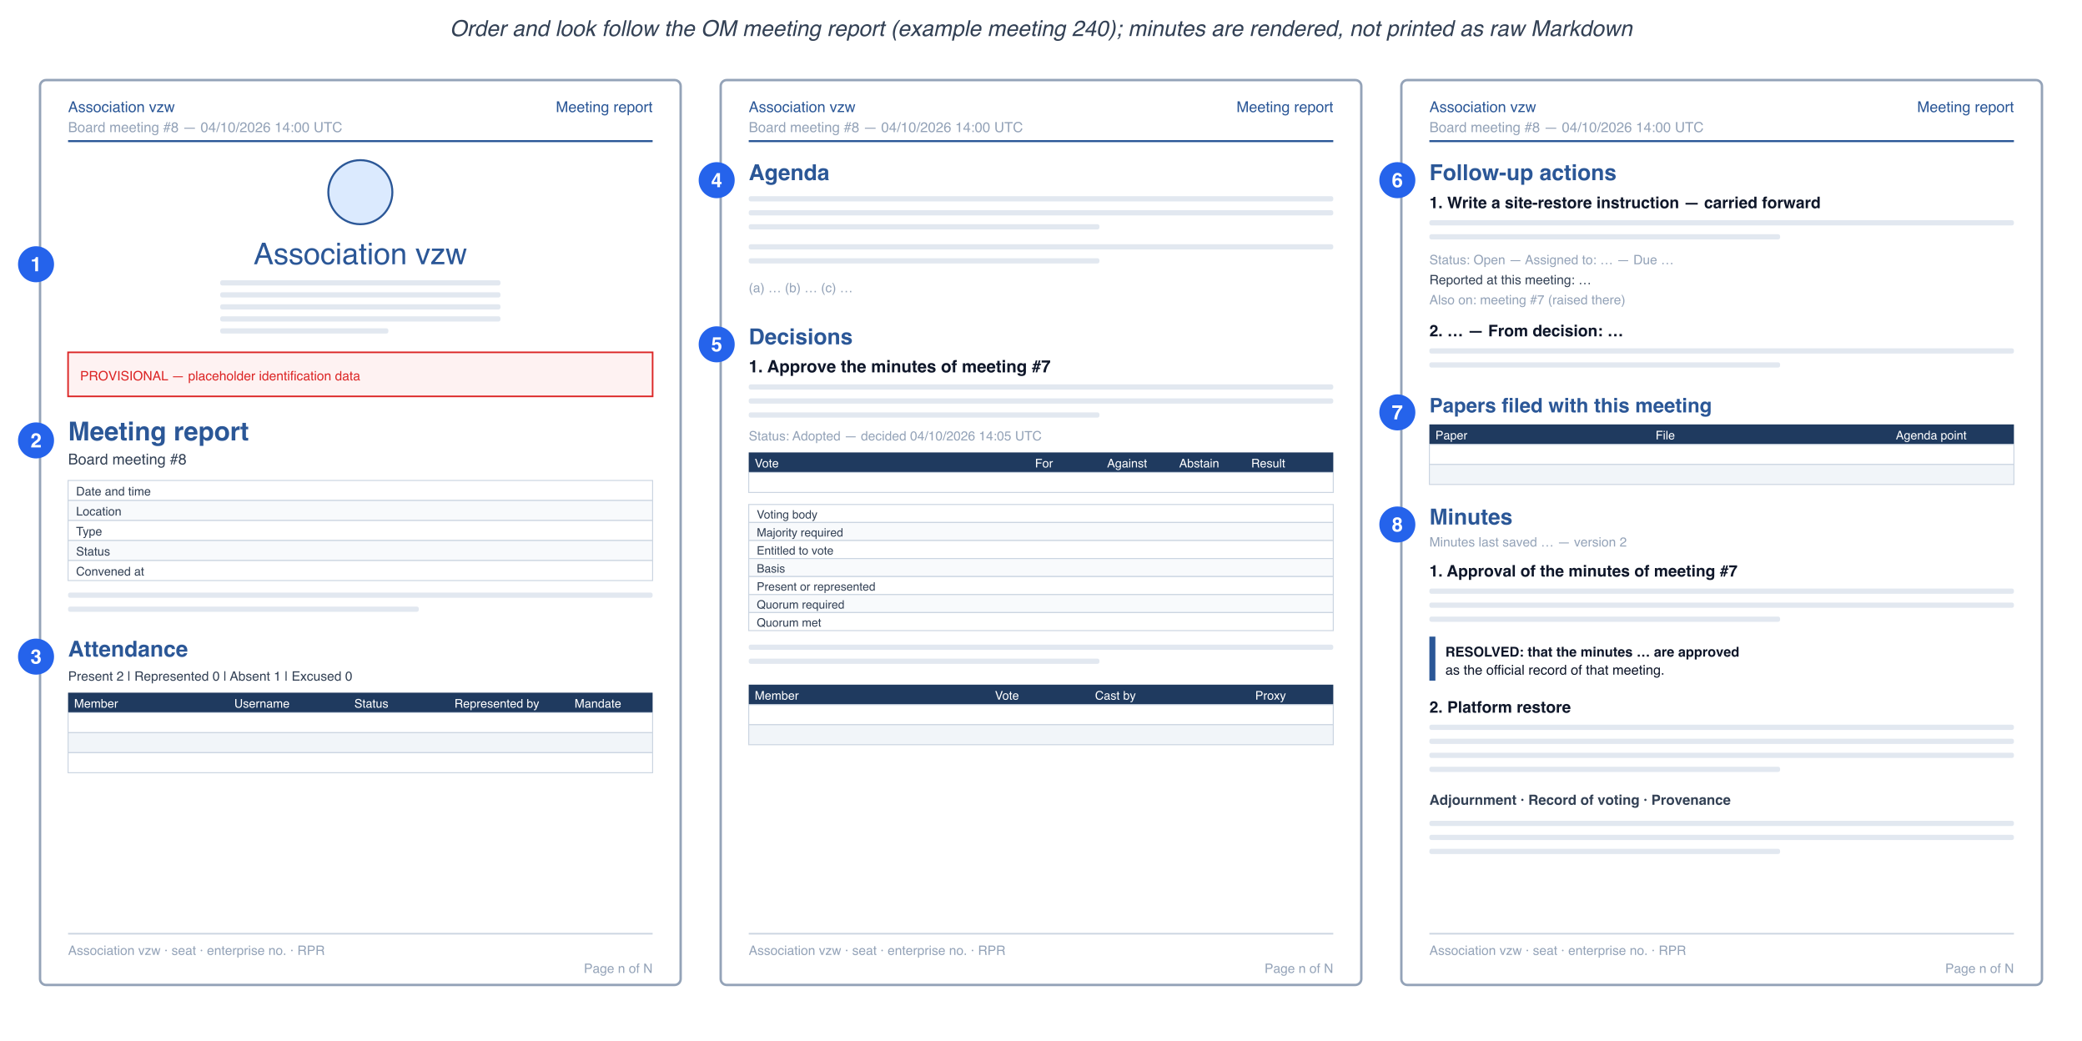
Figure 8 — Report anatomy (schematic, placeholder content): the eight parts in the order of the example.

9.1 Structure
Table 28 — Report structure
# | Part | Content (as in the example) | Meet++ source
0 | Running header and footer | Org name · “Meeting report”; meeting title — date/time UTC. Footer: org address · enterprise no. · RPR; e-mail · website; “Generated <timestamp>”; “Page n of N” | MEETPP_ORG_* settings; session
1 | Identity block | Logo, org name, legal form, registered seat, enterprise number, RPR court, e-mail and website, IBAN. Red PROVISIONAL — NOT FOR FILING banner while placeholder values are present | MEETPP_ORG_*; placeholder detection as in OM
2 | Meeting report | Title + meeting name; table: Date and time · Location (meeting link) · Type · Status (Held) · Convened at (actual start). Quorum statement with business-taken-from and adjourned times | Session, meeting type, live-position timestamps, quorum computation
3 | Attendance | Summary “Present n | Represented n | Absent n | Excused n | Not registered n”; table Member · Username · Status · Represented by · Written mandate | Members + attendance
4 | Agenda | Numbered points with title, description and sub-points (a)(b)(c)… | Outline (agenda sections)
5 | Decisions | Per decision: number and title; resolution text; how taken; “Status: Adopted — decided dd/mm/yyyy hh:mm UTC”; vote table (Vote · For · Against · Abstain · Result); voting-body table (Voting body · Majority required · Entitled to vote · Basis · Present or represented · Quorum required · Quorum met); outcome sentence; ballots table (Member · Vote · Cast by · Proxy). Informal meetings: only title, text, status and time | Decisions + votes + ballots
6 | Follow-up actions | Numbered; title with “— carried forward” when from an earlier meeting; description; “Status: Open — Assigned to: … — Due … — Completed …”; “Reported at this meeting:”; “Progress notes”; “Completion note”; “Also on: <meeting> (raised there) — date”; “From decision: …” | Series actions + action reports
7 | Papers filed with this meeting | Table Paper · File · Agenda point | Documents + snapshots
8 | Minutes | “Minutes last saved <time> — version n”, then the narrative: title, org and date line, Present/Absent/Quorum, Opening, one section per agenda point (with sub-sections), RESOLVED blocks, Adjournment, Record of voting, Provenance | Composed minutes (§8.7), rendered (headings, emphasis, lists, block quotes, tables)

9.2 Rendering
- Port, don't imitate. app/meetpp/report/ is a port of the OM meeting-report code path. It keeps fonts, colours, table styles and page furniture identical, and uses ReportLab (pure Python, no system libraries), which replaces the WeasyPrint template and its pydyf pin. It ports:
  - build_meeting_pdf() and its helpers _paged_canvas, _cover, _placeholder_banner, _table, _keep_with_table and _rich_text;
  - the strings in org_pdf_i18n.py (en, nl, fr, de).
- Markdown rendering: the minutes are converted (markdown-it-py → ReportLab flowables) instead of being printed verbatim in monospace. Block quotes become a left-ruled paragraph, and tables render as real tables. This fixes the empty “Record of voting” table seen in the example.
- Next-meeting agenda PDF: the same renderer, “Agenda” variant (identity block, meeting table, agenda, carried-forward actions).
- Exports: the PDF; Markdown of the minutes; and a JSON export whose shape matches the OM tables (Appendix E), to be pushed to the OM module in R2.

9.3 Formal and informal meetings
Table 29 — Formal versus informal
Part | Informal | Board meeting / general assembly
Identity block, provisional banner | Shown (banner only if placeholders) | Shown
Quorum statement | Omitted | Computed from members and attendance; shown
Attendance | Present / absent / guests | Full table incl. represented by and written mandate
Decision vote and voting-body tables | Omitted (status “Agreed — decided …”) | Shown; ballots when recorded
Record of voting in the minutes | Omitted | Shown

10. Technical architecture changes
The v2 architecture remains: meeting-api owns state, meetpp-agent captures audio, the board is client-rendered, and the data channel is meet-ai. This chapter lists what changes. v2 chapters 9–12 remain valid where not contradicted here.
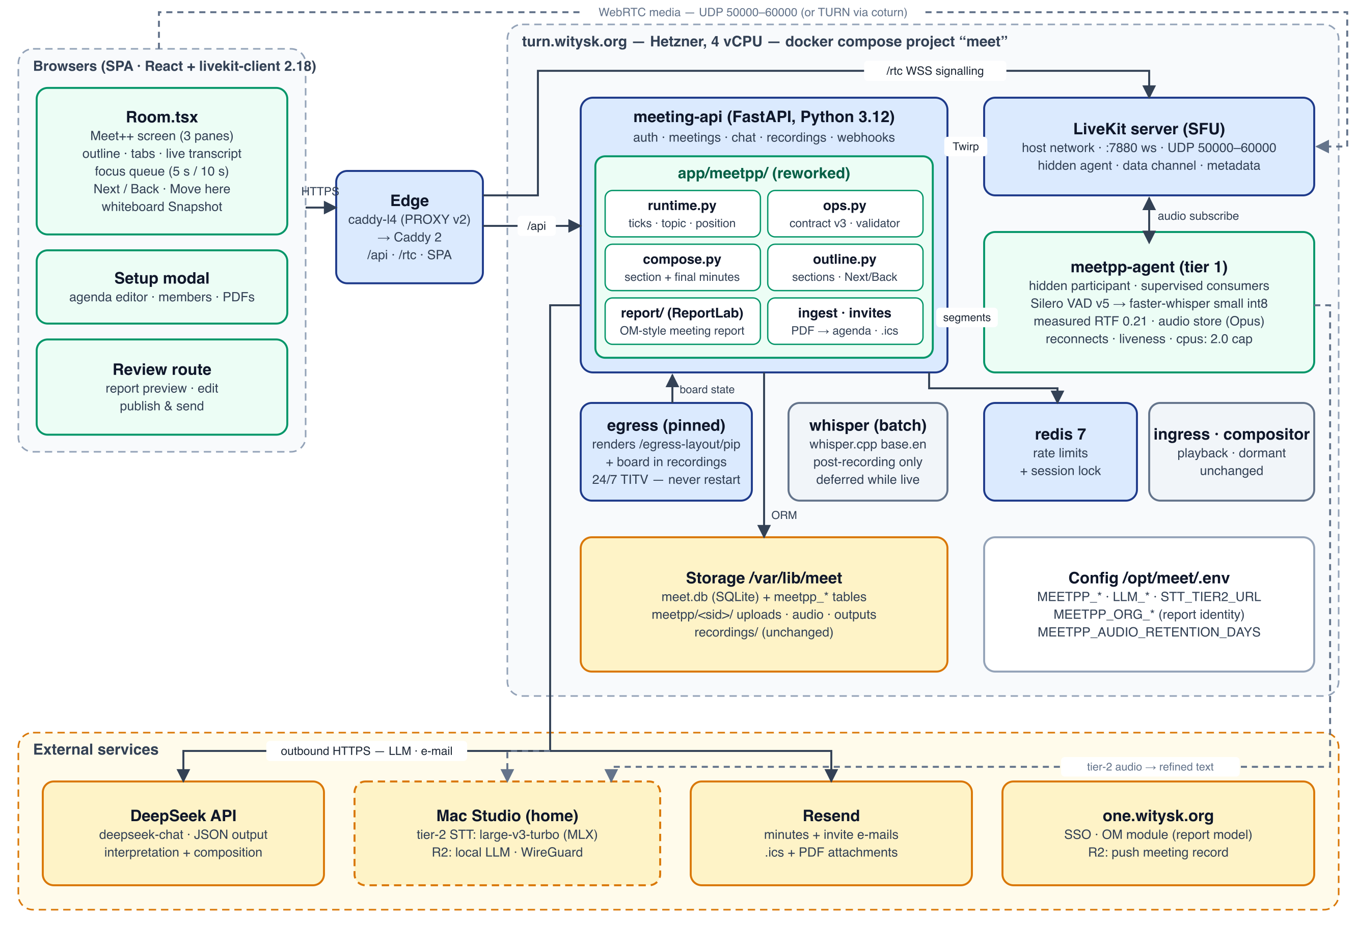
Figure 9 — Architecture v3. Main changes: tier-1 agent rework, tier-2 service on the Mac Studio, reworked runtime/ops/compose/outline modules, and the ReportLab report.

10.1 Architecture decisions
Table 30 — Decisions changed in v3
ADR | v2 | v3 | Reason
ADR-2 STT | One tier: small on turn | Two tiers: small live on turn + large-v3-turbo on the Mac Studio | Measured capacity and quality (§7.1)
ADR-4 Ops | LLM proposes ops; strict schema; aliases | Contract v3 with topic, advance, ops, notes; lenient schema; names | Release 1 rejected most ops; aliases leaked (§2.3)
ADR-5 Board | Stage tile + owner drawer; phase pills | One three-pane board for all; outline + tabs + transcript | Navigation review (§2.4)
ADR-9 TTS | Piper in the agent | Browser speech synthesis (R1.1); optional Mac-hosted TTS later | Piper not installable on Python 3.12
ADR-10 Outputs | Jinja2 + WeasyPrint | ReportLab port of the OM meeting report | Identical look; no pydyf pin
ADR-11 (new) Minutes | Rewrite-in-place upsert | Notes + section composition + final composition | Reliability and quality (§8.7)
ADR-12 (new) Data model | Meet++-specific | Aligned with the OM model (members, votes, ballots, action reports) | Report fidelity; R2 push

10.2 Component changes
Table 31 — Component changes
Component | Change
meetpp-agent/agent/vad.py | Silero v5 with 512 + 64 framing, hysteresis, 300 ms pre-roll; model vendored at meetpp-agent/models/silero_vad.onnx + SHA-256
meetpp-agent/agent/session.py | Per-track supervision, reconnect with token refresh, liveness check, consent by person, async poster, per-minute summary log
meetpp-agent/agent/stt.py | Context prompt, temperature fallback, AND filter, backlog/degrade wiring; tier-2 client and repetition guard
meetpp-agent/agent/audio_store.py (new) | Per-utterance Opus files; final-pass submission; deletion on publish or after 7 days
Mac Studio: meetpp-speech (new) | Small FastAPI service around mlx-whisper large-v3-turbo; /transcribe, /health; launchd service; WireGuard-only
meeting-api/app/meetpp/outline.py (new) | Sections, live position, Next/Back/Move, close → compose trigger; replaces phase logic
meeting-api/app/meetpp/runtime.py | 12 s cadence + cues; 90 s context; topic/advance handling; atomic versioning; job-based finalisation
meeting-api/app/meetpp/ops.py + prompts.py | Contract v3 (Appendix A); lenient validation; section scoping; votes, reports, members
meeting-api/app/meetpp/compose.py (new) | Section and final composition with validation and versions
meeting-api/app/meetpp/report/ (new) | ReportLab port of the OM meeting report + agenda variant + JSON export
meeting-api/app/meetpp/ingest.py | Fix parse_json_loose; agenda body and sub-points; members from a previous report
frontend/src/components/meetpp/board/ (new) | MeetppScreen, Outline, TabsPane, TranscriptPanel (virtualised), FocusQueue, FollowChip, NavControls, AnnouncementBanner
frontend: removed | MeetppSubtitles (ticker), owner side drawer in MeetppRoomLayer, phase pills, footer caption bubble
frontend/src/routes/MeetppReview.tsx | Report-section navigation, vote editor, composition status, PDF preview

10.3 Data model changes
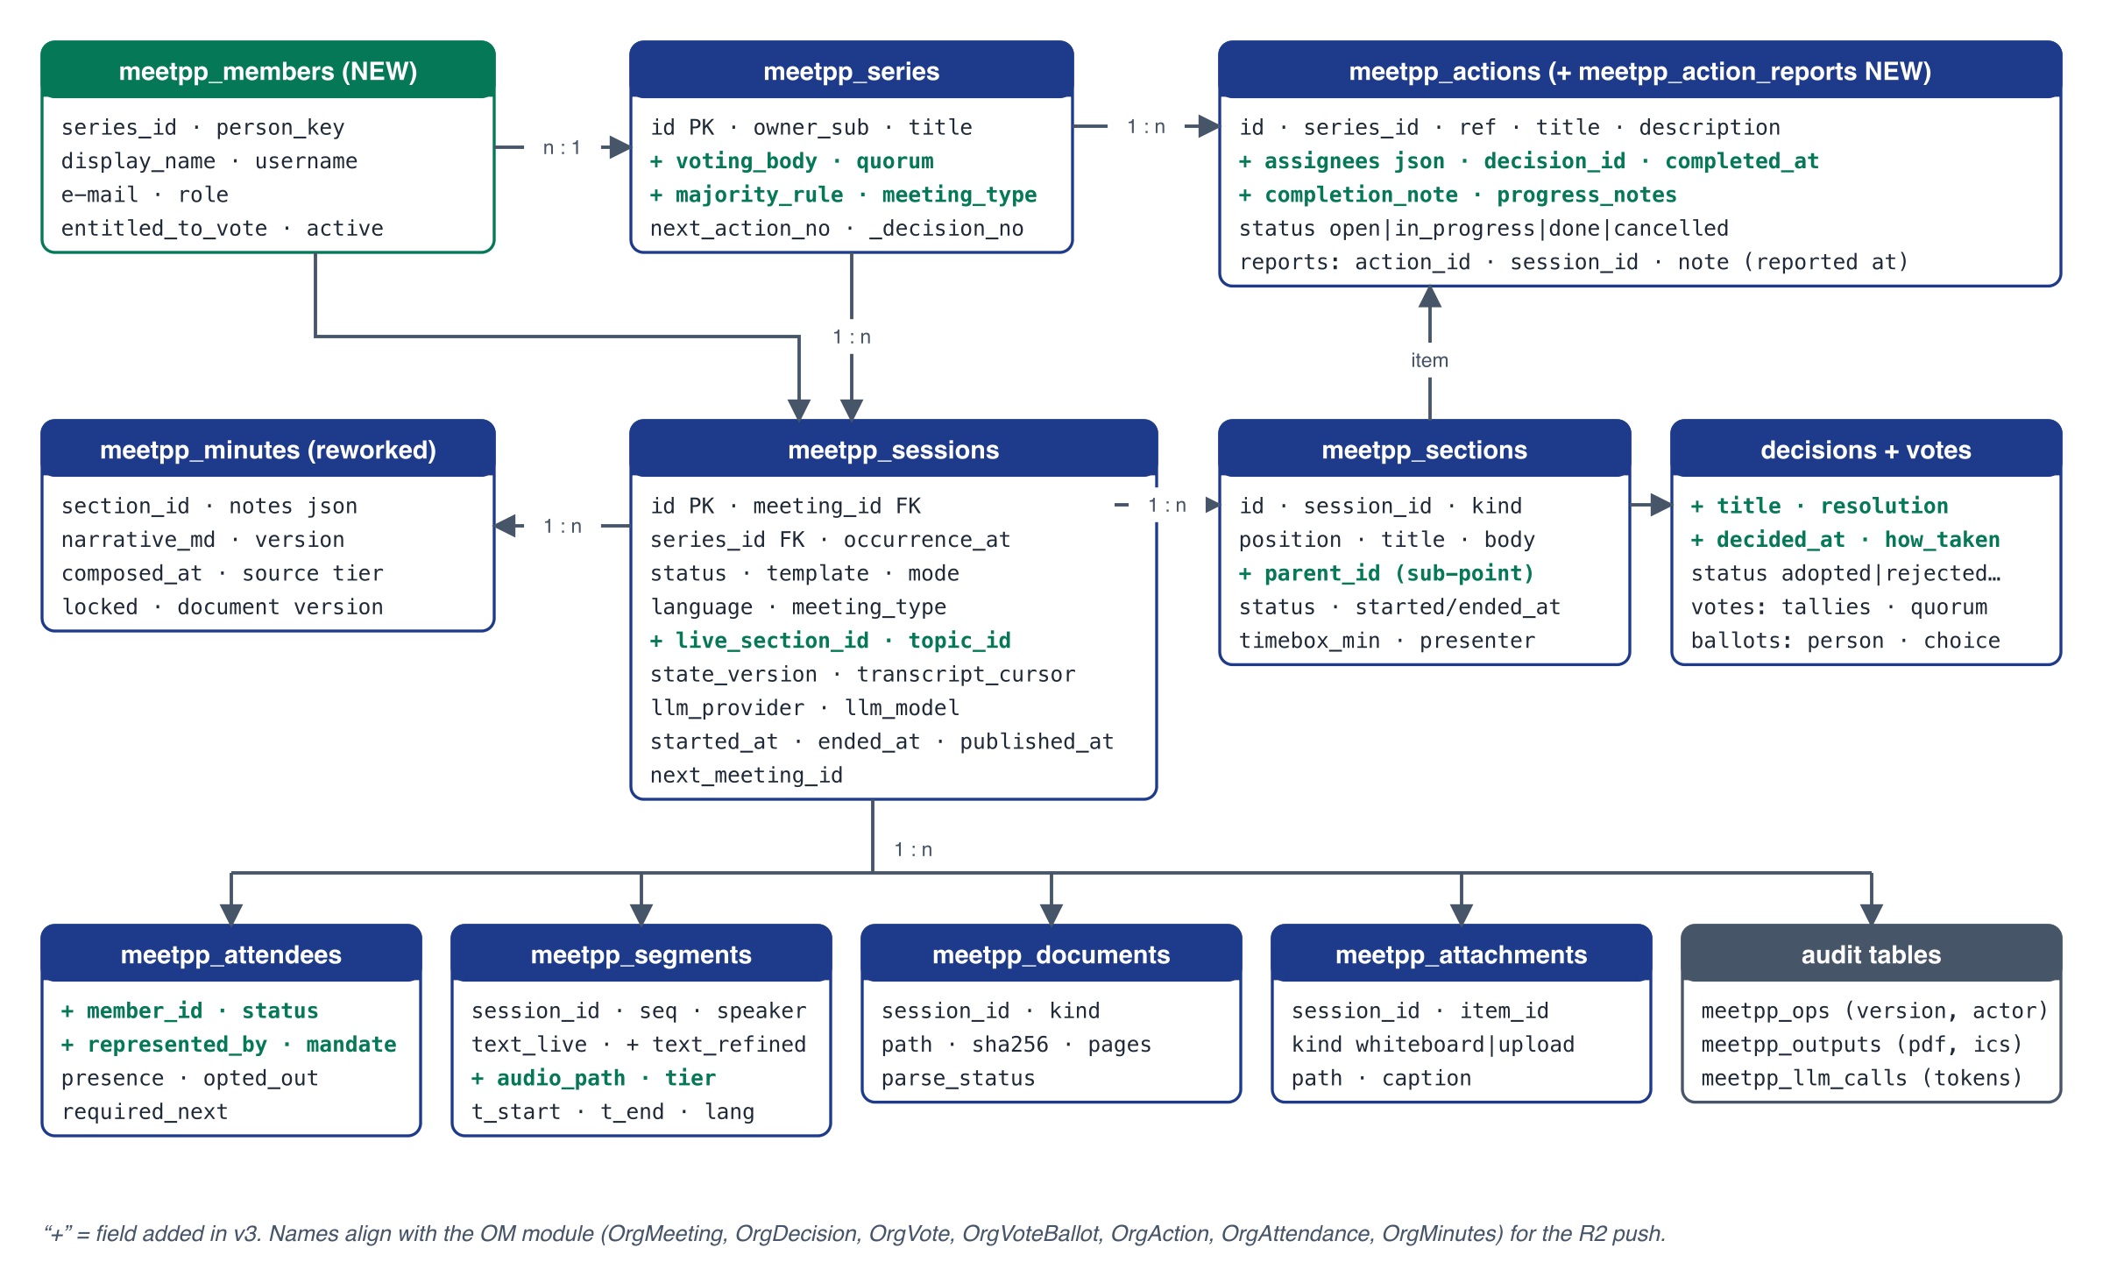
Figure 10 — Data model v3: new and changed tables; names aligned with the OM module.
Table 32 — Data model changes
Table | Change | OM equivalent
meetpp_members (new) | series_id, person_key, display_name, username, e-mail, role, entitled_to_vote, active | users + membership
meetpp_series | + meeting_type, voting_body, majority_rule, quorum_rule | OrgMeetingSeries / org settings
meetpp_sections (replaces agenda_items) | + kind (opening, previous_actions, agenda, aob, new_actions, closing, goal…), parent_id, body, started_at, ended_at, status | OrgAgendaItem (agenda kind)
meetpp_decisions | + title, resolution, how_taken, decided_at, voting_body, majority_rule; status adopted/rejected/withdrawn/proposed | OrgDecision
meetpp_votes, meetpp_ballots (new) | method, tallies, eligible/present counts, quorum required/met, result; ballots: member, choice, cast_by, proxy | OrgVote, OrgVoteBallot
meetpp_actions | + description, assignees, decision_id, completed_at, completion_note, progress_notes; status open/in_progress/done/cancelled | OrgAction, OrgActionAssignee
meetpp_action_reports (new) | action_id, session_id, note (“reported at this meeting”) | OrgActionMeeting
meetpp_attendees | + member_id, status (present/represented/absent/excused/not_registered), represented_by, mandate_ref | OrgAttendance
meetpp_minutes | Per section: notes (JSON), narrative_md, version, composed_at, source_tier, locked; document version table | OrgMinutes, OrgMinutesVersion
meetpp_segments | + text_refined, tier, audio_path | —

Migration: Release 1 test data (7 sessions) is discarded. The new tables are created by create_all, and dropped columns are left unused (SQLite).

10.4 Real-time protocol v3 (topic meet-ai)
Table 33 — meet-ai messages
type | Payload | Client
caption | seq, identity, name, t_start, text, tier=1 | Append to the transcript panel
caption-update | seq, text, tier=2 | Replace the line in place
gap | from, to, reason | Gap marker line
state | version, delta, activations[{tab, section, item?, prio, kind}] | Apply delta; enqueue activations
position | live_section, prev_section, by (chair, ai), undo_until? | Outline, header, announcement banner
proposal | pid, to, reason, confidence (chair only) | Inline proposal bar
agent | status, backlog_s, speakers[{name, ok}] | Header status; per-speaker markers
session | state | Mount/unmount; consent

10.5 API changes
Table 34 — API changes
Endpoint | Purpose
POST /meetpp/sessions/{sid}/position | {action: next, back or move, section_id?} (chair) → position message
POST /meetpp/sessions/{sid}/position/undo | Undo an AI move within 10 s
GET · PUT /meetpp/series/{id}/members | Members and voting rules
PUT /meetpp/sessions/{sid}/outline | Agenda editor (setup and live: add sub-point, rename, reorder)
POST /meetpp/sessions/{sid}/sections/{id}/compose | Compose or regenerate minutes for a section
PUT /meetpp/decisions/{id}/vote | Edit or confirm a vote record
GET /meetpp/sessions/{sid}/transcript?after=&limit= | Paged without the 400-line cap; includes refined text
GET /meetpp/sessions/{sid}/report.pdf · /export.json | Meeting report and OM-shaped export
POST /internal/meetpp/sessions/{sid}/agent-token | Fresh hidden token for agent reconnects (HMAC)
POST /internal/meetpp/sessions/{sid}/segments | Now accepts tier and replaces_seq

10.6 Key sequences
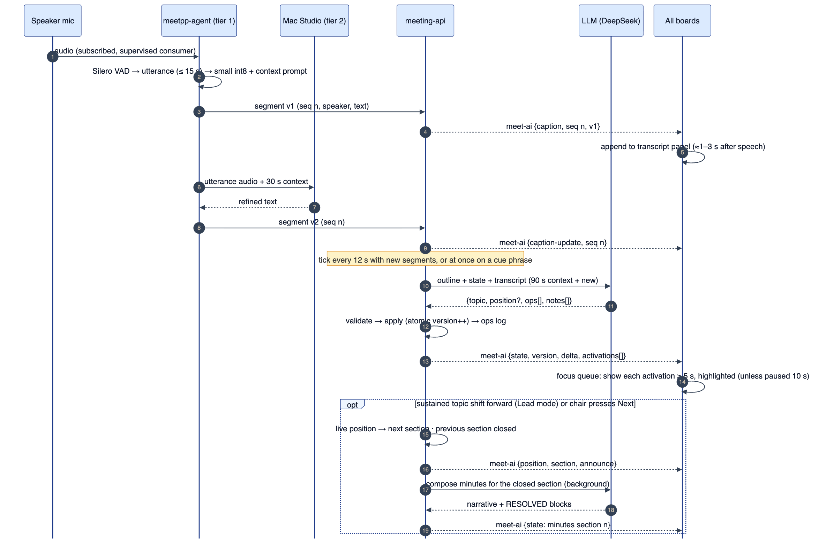
Figure 11 — Live loop v3: tier-1 caption, tier-2 refinement, tick with topic and activations, position move and section composition.
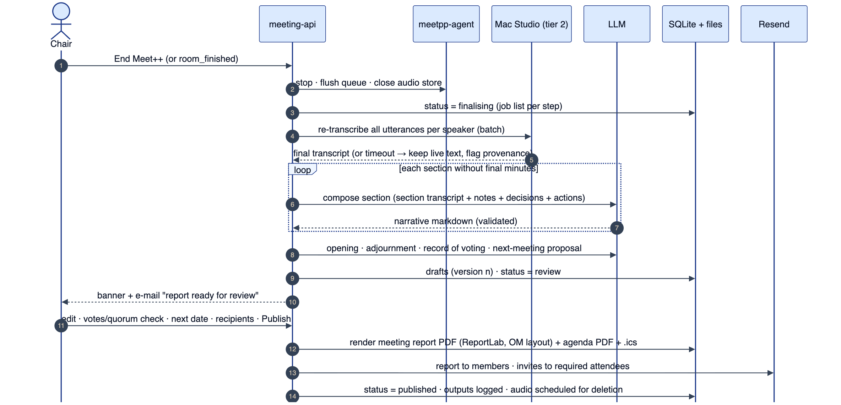
Figure 12 — End of meeting: tier-2 final pass, section and final composition, review, OM-style report, distribution.

11. Infrastructure, privacy and operations

11.1 turn.witysk.org
- Disk first. The root disk is at 87 % (4.7 GB free), and one 90-minute recording is about 1.1 GB. Before enabling the audio store, the 30-day recording clean-up must be verified, and old recordings and orphaned files removed, or the volume extended (Q6). The audio store refuses to write when free space is below 3 GB and marks tier 2 unavailable.
- meetpp-agent keeps cpus: 2.0, mem_limit: 3g and cpu_shares: 512. The model image adds the vendored Silero model (2 MB); the tier-1 models are unchanged.
- Deploys keep the v2 pre-check: prompt if a session is running. Agent restarts are now survivable (buffer + gap marker), but are still avoided during meetings.
- The dormant compositor container can be stopped to free idle CPU (≈ 0.1 vCPU). Optional.

11.2 Mac Studio tier-2 service
- Network: WireGuard between turn.witysk.org (10.66.0.1) and the Mac Studio (10.66.0.2). The service binds to the WireGuard address only, and requests are HMAC-signed.
- Service: a launchd job running meetpp-speech (FastAPI + mlx-whisper large-v3-turbo). The model stays resident (≈ 1.6 GB unified memory). Concurrency is 2 requests and the queue holds 30 s of audio. Never use openai-whisper with --device mps (NaN logits).
- Health: GET /health every 30 s from meeting-api. Three failures in a row mark tier 2 down (board note); recovery is automatic.
- Later (R2): the same machine can host the local LLM (OpenAI-compatible endpoint) and neural TTS.

11.3 Privacy and consent
- Audio retention is new. Per-utterance audio is kept until publish (at most 7 days, MEETPP_AUDIO_RETENTION_DAYS), then deleted. The consent text and the privacy page must say so.
- Tier-2 processing happens on infrastructure controlled by the association, in Belgium (the Mac Studio); no new third party is involved.
- Names instead of aliases: display names now appear in LLM prompts. This does not materially change the exposure, because names were already in the transcript text sent to DeepSeek. The GDPR question about DeepSeek (v2 Q1) remains open (Q7).
- Consent per person: the default-deny rule stays, but it no longer breaks on reconnects (§7.5).

12. Observability and acceptance tests

12.1 Logging and metrics
- Agent: the MEETPP_STT summary (§7.6) plus warnings. meeting-api: MEETPP_TICK (with topic, activations, rejected operations and reasons), MEETPP_POSITION, MEETPP_COMPOSE, MEETPP_FINALISE (per-job status), and MEETPP_REPORT.
- Admin panel: per-session health (consumers, backlog, tier 2, LLM breaker, tick latency, rejected operations), plus the last composition errors.

12.2 Acceptance tests
Table 35 — Acceptance tests
ID | Test | Pass criteria
AT-1 | 90-minute soak, 3 speakers (SSO + guest), with mute/unmute, leave/rejoin, a 20 s network drop for one participant, and one agent restart | Transcript panel shows lines throughout; no speaker without a segment for > 30 s while speaking; gaps marked; tier-1 p95 ≤ 4 s
AT-2 | Golden meetings (EN, and NL if Q9), compared with human references | Tier 1 WER ≤ 13 % (EN); final WER ≤ 8 %; glossary names ≥ 90 % correct
AT-3 | Scripted meeting: 6 agenda points, 5 decisions, 8 actions, 2 returns to an earlier point | Correct section on ≥ 85 % of topic changes; every decision and action appears in the right section; each activation visible ≥ 5.0 s with highlight
AT-4 | Manual interaction during activations (tab click, outline click, scroll in the content pane) | No automatic switch within 10 s of the last interaction (±0.3 s); newest activation shown on resume; transcript scrolling never pauses
AT-5 | Chair Next / Back / Move here; AI move in Lead mode with Undo | All clients update ≤ 1 s; banner shown; closed section composed ≤ 60 s; Undo restores the position
AT-6 | End of AT-3 meeting | Minutes for every section, opening, adjournment, record of voting and provenance; RESOLVED blocks for all adopted decisions
AT-7 | Report for the AT-3 meeting, formal type, 3 members | All parts of §9.1 present in order; quorum and votes correct; Markdown rendered; en and nl renders checked side by side with the example
AT-8 | Fault injection: LLM down 3 min; invalid JSON ×3; Mac Studio offline; meeting-api restart mid-meeting | No stall > 30 s; gap markers; finalisation completes or offers Retry; no transcript loss
AT-9 | Host safety: 60-minute session plus a recording on production-like load | No TITV HLS watchdog events; agent CPU ≤ 2 vCPU

13. Implementation plan
After approval, the work is done in this order. Each milestone ends with its acceptance tests on the staging stack, then production.
Table 36 — Milestones
Milestone | Scope | Exit | Size
M1 · Transcription reliability | Agent rework (VAD, supervision, reconnect, consent by person, liveness, poster, logging); transcript panel; removal of the ticker; disk clean-up | AT-1 (tier 1), AT-8 partial | M
M2 · Interpretation and outline | Contract v3, runtime cadence, topic/advance, outline and position API, notes, section composition, atomic versioning, job-based finalisation | AT-5, AT-6 (without the final pass) | L
M3 · Meet++ screen | Three-pane board, focus queue (5 s / 10 s), navigation controls, announcement banner, responsive layouts, editors inline, egress view | AT-3, AT-4 | L
M4 · Meeting report | Members, votes, quorum, action reports; ReportLab port; review screen; setup agenda editor and members | AT-7 | M
M5 · Tier 2 | Mac Studio service, WireGuard, refinement, final pass, fallbacks | AT-2 | M (needs Q1)
M6 · Acceptance run | Golden meetings, full soak, host safety, docs | AT-1 … AT-9 | S

14. Risks
Table 37 — Risks
Risk | Mitigation
Mac Studio not available or not reachable 24/7 | Tier 1 remains fully functional; final minutes use tier-1/2 mix; provenance flags it; consider a small cloud GPU as a backup tier 2
Topic detection flickers or is wrong on short exchanges | Hysteresis, minimum display time, chair override suppresses AI for 60 s; measured in AT-3
Vote and quorum extraction from speech is unreliable | AI votes marked “to confirm”; review screen vote editor; formal decisions never auto-published
Disk pressure on turn.witysk.org from the audio store | 3 GB free-space guard; deletion on publish; disk clean-up in M1
LLM cost grows with 12 s ticks | Prefix caching; budget throttling to 30 s; measured per session
Port of the OM renderer drifts from OM over time | Shared i18n keys and a visual regression check against an OM-generated PDF of the same data

15. Open questions
Table 38 — Open questions
# | Question | Recommendation
Q1 | Which Mac Studio (chip, RAM), is it always on, and can WireGuard reach it from turn.witysk.org? | Needed for tier 2 (M5). Without it, final quality stays at tier 1 (≈ 12–13 % WER).
Q2 | Where do series members and voting rules come from? | Enter them in Meet++ now, or import from the last report; sync from the OM module in R2.
Q3 | Should Meet++ push the final record into the OM module, so that OM produces the official report? | R2. R1.1 produces the same report itself with an OM-shaped export.
Q4 | Lead mode: may the AI move the live position (with Undo), or only propose? | Lead with Undo as default; Assist available per session.
Q5 | Is keeping per-utterance audio until publish (≤ 7 days) acceptable? | Yes. It is required for the tier-2 final pass; stated in consent and privacy.
Q6 | Clean up or extend the turn.witysk.org root disk (87 % used)? | Required before M1 ends.
Q7 | DeepSeek for meeting content (GDPR, carried over from v2 Q1) | Unchanged: internal use only until an EU-hosted or local LLM (R2).
Q8 | Real identity values for the report header (enterprise number, IBAN, e-mail)? | Until provided, reports carry the PROVISIONAL banner, as in the example.
Q9 | Which spoken languages must R1.1 support at acceptance (en only, or en + nl)? | en + nl; nl depends on tier 2 for acceptable quality.

Appendix A — Tick output contract v3
{
"topic": { "section": "S5", "sub": "b", "confidence": 0.86 },
"advance": { "to": "S6", "confidence": 0.9, "reason": "Chair: 'then on to item four, lawyers'" },
"ops": [
{ "op": "decision.add", "section": "S5",
"title": "Case file module released without waiting for sub-category fields",
"resolution": "that the release of the case file module is not held back for the fields of the measurement sub-categories …",
"how_taken": "Taken with the assent of both directors present.",
"status": "adopted", "decided_at_seq": 233,
"vote": { "method": "assent", "for": 2, "against": 0, "abstain": 0,
"ballots": [ { "person": "Noam Grunes", "choice": "for" },
{ "person": "Stephane van der Aa", "choice": "for" } ] },
"evidence": [229, 231, 233] },
{ "op": "action.add", "section": "S5", "title": "Clear the test user's documents from the library",
"description": "The library refuses a file another user already uploaded.",
"assignees": ["Stephane van der Aa"], "due": null, "from_decision": null, "evidence": [214] },
{ "op": "action.update", "ref": "A-13", "report_note": "Now on Case File v1.6/1.6.1; test plan circulated.",
"status": "open", "evidence": [205] },
{ "op": "attendance.set", "person": "David Iorlano", "status": "absent", "evidence": [3] },
{ "op": "section.add", "kind": "subpoint", "parent": "S5", "title": "Release" }
],
"notes": [
{ "section": "S5", "text": "Stephane will test for about another week before release is discussed.", "evidence": [231] }
]
}
Table 39 — Contract rules
Field / op | Rules
topic.section | An outline id S1…Sn from the prompt; sub optional (a, b, …); confidence 0–1
advance | Optional; only to a later section; ignored in Assist mode except as a proposal
decision.add / .update | status ∈ proposed, adopted, rejected, withdrawn; resolution ≤ 1,200 chars (truncated beyond); vote.method ∈ voice, show_of_hands, assent, consensus, roll_call; ballots only with audible names
action.add / .update | assignees: names of members or guests (fuzzy-matched; unknown names become guests); due ISO date or null; ref A-n for existing actions; report_note, progress_note, completion_note ≤ 600 chars
attendance.set | status ∈ present, represented, absent, excused; represented_by optional
section.add | kind ∈ subpoint, aob; parent required for a sub-point
notes | ≤ 6 per tick; each ≤ 300 chars; must cite evidence
evidence | 1–10 segment numbers within window ∪ context, at least one new
Unknown fields | Ignored (logged at DEBUG)

Appendix B — Focus queue algorithm
const MIN_DISPLAY_MS = 5000, PAUSE_MS = 10000, MAX_QUEUE = 4;
state: current = null; shownAt = 0; queue = []; pausedUntil = 0; follow = true;

onActivation(a): // from a 'state' message
markUnseen(a); setBadge(a.item)
if (!follow) return
const same = queue.find(q => q.tab === a.tab && q.section === a.section)
if (same) { same.items.push(a.item); same.prio = max(same.prio, a.prio); return }
if (a.kind === "topic") queue = queue.filter(q => q.kind !== "topic")
queue.push(a); if (queue.length > MAX_QUEUE) dropLowestOldest(queue)
pump()

onUserInteraction(): // click/keyboard on tab, outline, item; wheel in content; edit
pausedUntil = now() + PAUSE_MS; showChip("Auto-follow in", PAUSE_MS)

pump(): // also runs on a 250 ms timer
if (now() < pausedUntil) return
if (current && now() - shownAt < MIN_DISPLAY_MS) return
if (!queue.length) { current = null; return }
const next = wasPausedSinceLastShow() ? queue.pop() : queue.shift() // catch-up = newest
if (wasPausedSinceLastShow()) queue = []
show(next) // programmatic: setTab, expand+scroll section, highlight items,
current = next; shownAt = now() // run 5 s progress bar; never moves keyboard focus

Appendix C — Prompt skeletons

C.1 Tick (system)
You keep the live record of a {meeting_type} of {org}, held in {language}.
You receive the meeting outline (sections S1…Sn), the current record and new transcript lines.
Return json only, matching the schema. Rules:
- topic: the outline section the NEW lines are about (use sub-points when clear).
- advance: only when the meeting clearly moves on to a later section.
- Record decisions when something is agreed, resolved, approved or rejected; write the
resolution in the form "that …". Record how it was taken and any vote you can hear.
- Record actions when someone undertakes or is asked to do something; list assignees by name.
- For previous actions (A-n) record what was reported about them at this meeting.
- notes: short factual points for the minutes of that section; no speculation.
- Cite evidence as transcript line numbers. Lines marked CONTEXT may be cited; at least one
cited line must be NEW. If nothing applies, return empty lists.

C.2 Section composition (system)
Write the minutes for one agenda section of a {meeting_type} of {org} in {language}.
Style: formal minutes; third person; past tense; names as given; concise but complete;
use "### n.m Title" sub-headings for sub-points that were discussed; for every ADOPTED decision
add a block quote "> **RESOLVED:** that …" using its resolution text; if no decision was taken
end with "No resolution was put."; do not invent figures; list any figure, amount or name you are
unsure about in "verify". Return json {"markdown": "...", "verify": ["..."]}.

C.3 Final composition (system)
Assemble the opening (present, absent, quorum, start time, agenda version), the adjournment
(time), the record of voting (one table row per decision: #, resolution, rule, result) and a
provenance paragraph (transcription tiers and models, speaker attribution by per-participant
audio, items to verify). Do not rewrite section minutes. Return json with these four parts.

Appendix D — Export shape (OM alignment)
Table 40 — Export mapping
Meet++ export key | OM table / field | Notes
meeting {title, date, location, type, status, convened_at, quorum_note} | OrgMeeting (meeting_date, meeting_url, is_general_assembly, status, convened_at, quorum_note) | type → is_general_assembly
agenda[] {title, body, sort_order, subpoints[]} | OrgAgendaItem (title, body, sort_order) | Sub-points rendered into the body as (a)(b)…
decisions[] {title, body, status, decided_at, voting_body, majority_rule} | OrgDecision | body = resolution + how taken
decisions[].vote {tallies, eligible_count, present_count, quorum_required, quorum_met, result, ballots[]} | OrgVote, OrgVoteBallot | ballots need member → user mapping
attendance[] {member, status, represented_by, mandate_ref} | OrgAttendance | —
actions[] {title, description, due, status, assignees[], decision_ref, completed_at, completion_note, progress_notes} | OrgAction, OrgActionAssignee | —
action_reports[] {action_ref, note} | OrgActionMeeting (note) | “Reported at this meeting”
minutes {content_md, version, source: 'meetpp'} | OrgMinutes, OrgMinutesVersion | source distinguishes Meet++ minutes
papers[] {title, file, agenda_ref} | OrgMeetingAttachment | —

Appendix E — Glossary
Table 41 — Glossary
Term | Meaning
Outline | The ordered list of sections of a meeting: fixed sections plus agenda points and sub-points
Live position | The one section the meeting is at; moved by the chair (or the AI in Lead mode)
Topic | The section the latest speech is about, detected per tick
Activation | A request to show a tab, section and item on the board for ≥ 5 s with highlight
Follow / pause | Per-user automatic activation; paused for 10 s after a manual interaction
Tier 1 / tier 2 | Live transcription on turn.witysk.org / quality transcription on the Mac Studio
RTF | Real-time factor: processing time divided by audio duration (lower is faster)
WER | Word error rate against a reference transcript
Running notes | Factual bullets per section collected live
Composition | LLM-written narrative minutes for a section, or for the whole meeting

Appendix F — Evidence and method
- Production data: read-only SQLite queries on /var/lib/meet/meet.db (meetpp_sessions, meetpp_segments, meetpp_ops, meetpp_minutes, meetpp_consents, meetpp_llm_calls) and the meeting-api and agent logs, 6 October 2026.
- Code review: Release 1 at commit f1653fd (agent, meeting-api app/meetpp/, frontend components/meetpp/ and lib/meetpp/) and docs/MeetPlusPlus_FDD_v2_review.md.
- Benchmarks: a 120 s excerpt (16 kHz mono) of the 4 October 2026 meeting recording.
  - On turn.witysk.org: faster-whisper int8, 2 threads, nice 19, inside the capped agent container, TITV running; temporary models removed afterwards.
  - On an Apple M1 Mac mini: mlx-whisper large-v3-turbo, whose output served as the WER reference.
  - Segmentation experiment: faster-whisper small int8 on the same excerpt, with Silero-based chunking (get_speech_timestamps) at different settings.
- Report target: meeting_240_2026-10-04.pdf (24 pages), generated by the OM module (org_pdf_service.build_meeting_pdf).

