Azure Automation: Weekly Resource Cleanup

Summary
This document outlines the setup and use of Azure Automation runbooks used to purge all resources in specific course subscriptions managed under CIAT. The runbooks are scheduled to run every Sunday at 12:01 AM.

Details
• Runbooks are split by course subscription to avoid hitting the 3-hour execution limit for Azure Automation jobs.
• Each runbook deletes all resources in its associated subscription and attempts to move undeletable resources to a trash bin resource group (`trashbin-rg`).
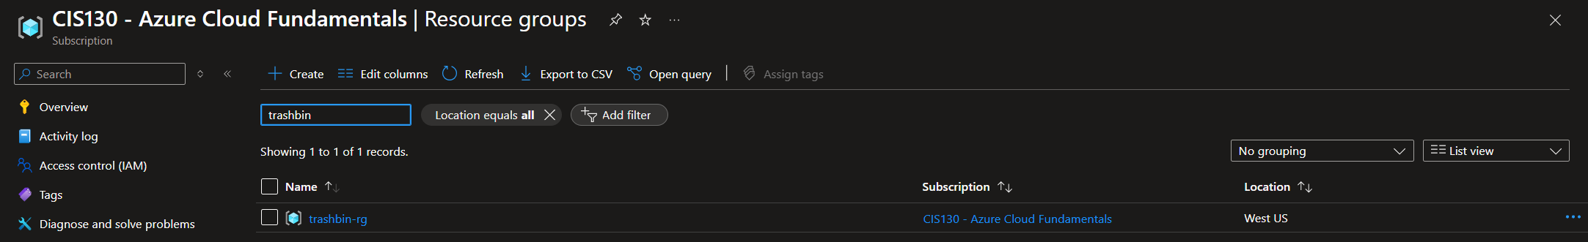
• Logs can be reviewed by navigating to the Automation Account (CIS130 Subscription) → Runbooks → [RunbookName] → Jobs → Select Job → View Logs.

Known Behaviors
• Some resources, such as Recovery Services Vaults, cannot be deleted through automation and will be moved to `trashbin-rg`.

Manual Cleanup of Remaining Resources
• Navigate to the Azure portal.
• Select the relevant subscription.
• Go to 'Resources' under 'Settings'.
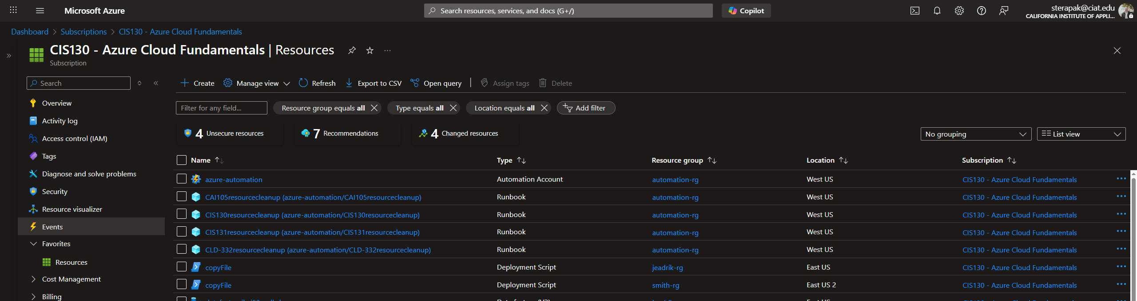
• Select all listed resources and click the 'Delete' button.
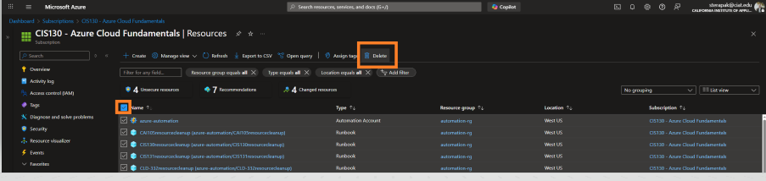

How to Add a New Course
• Steps to create a cleanup runbook for a new course:
1. Copy an existing runbook (e.g., 'CIS130resourcecleanup').
2. Update the script to include only the new course's subscription.
3. Save and publish the new runbook but use the naming convention of [course]resourcecleanup.
4. Ensure the azure-automation identity has Contributor access to the subscription.
5. Create a new schedule to run the script weekly on Sunday at 12:01 AM.
6. Link the schedule to the runbook from within the Automation Account interface.

Additional Manual Cleanup – Resource Group Deletion
In addition to the scheduled resourcecleanup runbooks, a second set of runbooks labeled [course]rgcleanup have been created for each course. These runbooks are designed to delete the resource groups themselves after the course term has ended.
Naming Convention:
These runbooks follow the pattern:
- CAI105rgcleanup
- CIS130rgcleanup
- CIS131rgcleanup
- CLD332rgcleanup
...and so on, corresponding to each course.
Manual Execution Required:
These rgcleanup runbooks must be triggered manually, as the exact date for deletion depends on the end of the term and confirmation that no student data is needed. The recommended time to run them is the Thursday after the term ends, but this may vary.
To run manually:
1. Navigate to the Azure Automation Account.
2. Select the relevant [course]rgcleanup runbook.
3. Click Start to execute the runbook.
Important: These runbooks permanently remove resource groups. Ensure all necessary grading and backup tasks are complete before triggering.

