使用物件導向，操作管理系統

利用MVC架構分別管理系統(M: Model 控制學生模型)(V: Veiw 控制介面邏輯)(C: Controller 控制程式處理邏輯)

以下是我的介面，可以輸入需要添加的科目，一開始科目的人數都為 0，需要自行添加，但也可以直接添加預設學生(5人)

執行結果:

先選擇要進去的科目

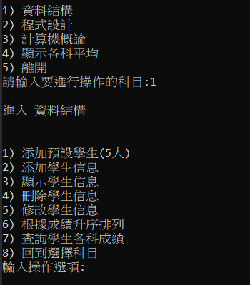

可以添加預設學生(5位)

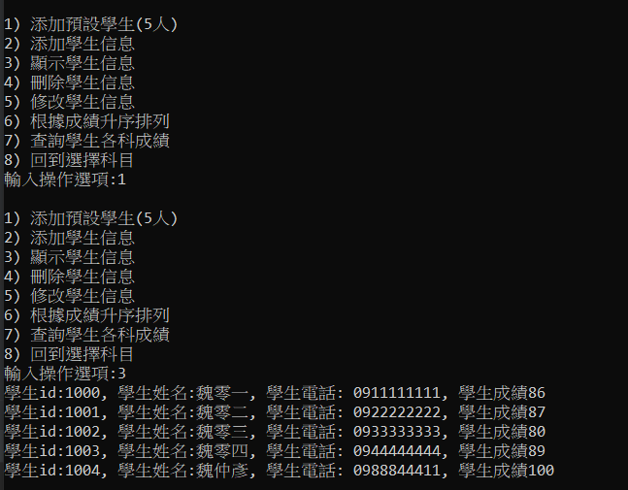

也可以自行增加學生和修改刪除學生資料

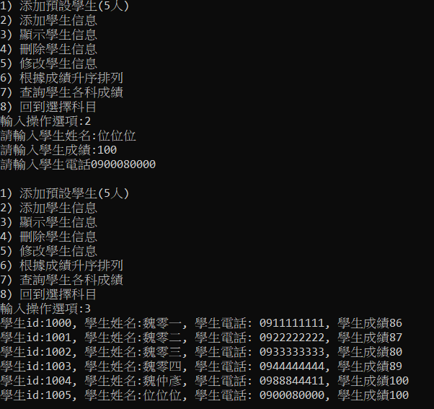

當然，換一個科目顯示資料就不會顯示前一個科目的了!!

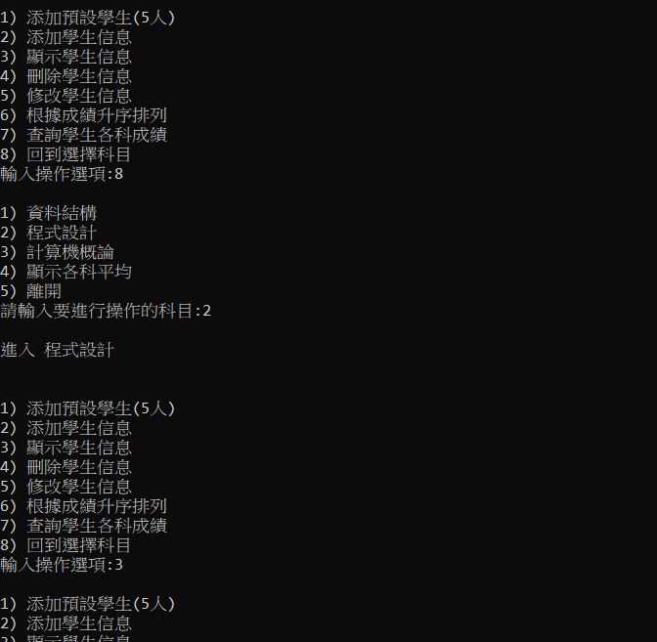

修改則是要用ID去做設定，如果沒有此ID則修改失敗

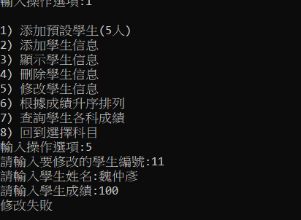

以下是修改成功的結果

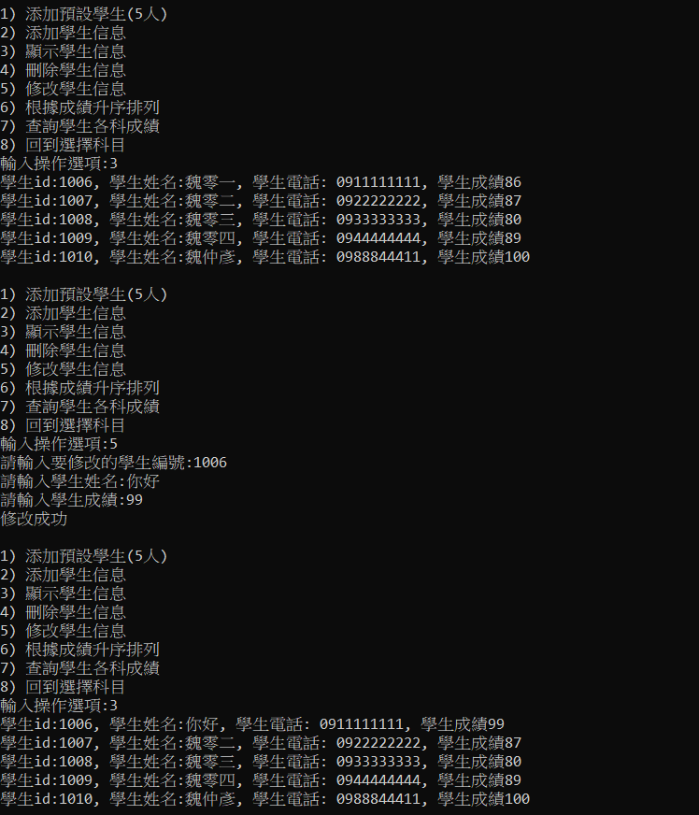

刪除也是一樣，根據編號進行資料的刪除

以下是實作圖片

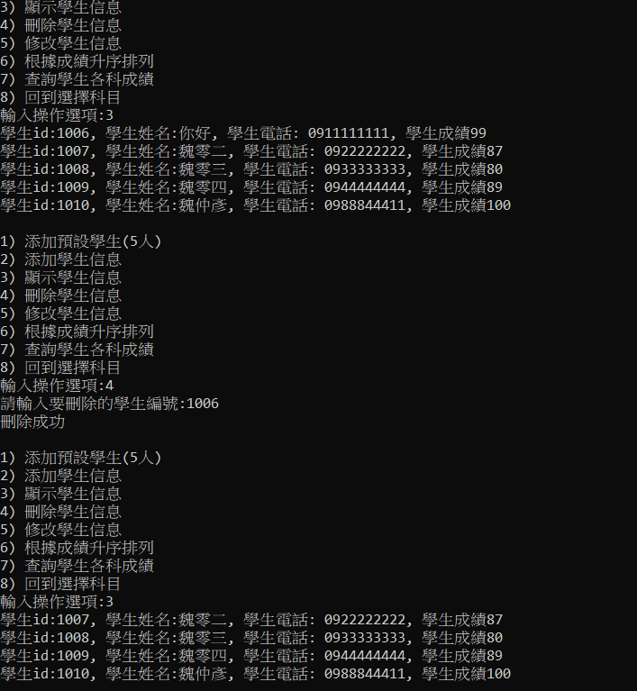

以下是我的程式碼: # 裡面有詳細解說細部程式碼 :

class StudentManagerController:  
 *"""  
 學生管理控制器:住要負責業務邏輯處理  
 """* init_id = 1000  
  
 @classmethod  
 def __generate_id(cls, stu):  
 stu.id = cls.init_id  
 cls.init_id += 1 # 讓id自增長  
  
 def __init__(self):  
 self.__stu_list = []  
 self.__class = SubjectManager()  
  
 @property  
 def stu_list(self):  
 return self.__stu_list  
  
 @property  
 def sub_data(self):  
 return self.__class  
  
 def add_student(self, stu, sub):  
 *"""  
 添加學生訊息  
 :param stu: 需要添加的學生對象  
 :param sub: 需要添加的科目  
 """* StudentManagerController.__generate_id(stu) # 加入學生id  
 self.__class.add_subject_list(sub, stu) # 加入學生到dict裡面  
  
 def add_base_stu(self, sub):  
 *"""  
 添加基本學生訊息  
 :param sub: 需要添加的科目  
 """* std_name = ["魏零一", "魏零二", "魏零三", "魏零四",  
 "魏仲彥"]  
 std_score = [86, 87, 80, 89, 100]  
 std_phone = ["0911111111", "0922222222", "0933333333", "0944444444", "0988844411"]  
  
 for stu in self.__class.subject_dict[sub]:  
 for s in std_name:  
 if stu.name == s:  
 return True  
  
 for i in range(len(std_name)):  
 self.add_student(StudentModel(std_name[i], std_phone[i], std_score[i]), sub)  
  
 def remove_student(self, stu_id, sub):  
 *"""  
 移除學生信息  
 :param stu_id: 需要移除的學生編號  
 :param sub: 需要添加的科目  
 :return: 移除是否成功  
 """* for item in self.__class.subject_dict[sub]:  
 if item.id == stu_id:  
 self.__class.subject_dict[sub].remove(item)  
 return True  
 return False # 告知使用者沒有刪到任何人  
  
 def update_student(self, new_stu, sub):  
 *"""  
 修改學生信息(需要id)  
 :param new_stu: 需要修改的學生  
 :param sub: 需要添加的科目  
 :return: 是否修改成功  
 """* for item in self.__class.subject_dict[sub]:  
 if item.id == new_stu.id:  
 item.name = new_stu.name  
 item.score = new_stu.score  
 return True  
 return False  
  
 def order_by_score(self, sub):  
 *"""  
 根據成績升序排列  
 :param sub: 需要添加的科目  
 """* for i in range(len(self.__class.subject_dict[sub]) - 1):  
 for y in range(i + 1, len(self.__class.subject_dict[sub])):  
 if self.__class.subject_dict[sub][i].score > self.__class.subject_dict[sub][y].score:  
 self.__class.subject_dict[sub][i], self.__class.subject_dict[sub][y] = \  
 self.__class.subject_dict[sub][y], self.__class.subject_dict[sub][i]  
  
 def order_by_id(self, sub):  
 *"""  
 根據序號升序排列  
 :param sub: 需要添加的科目  
 """* for i in range(len(self.__class.subject_dict[sub]) - 1):  
 for y in range(i + 1, len(self.__class.subject_dict[sub])):  
 if self.__class.subject_dict[sub][i].id > self.__class.subject_dict[sub][y].id:  
 self.__class.subject_dict[sub][i], self.__class.subject_dict[sub][y] = \  
 self.__class.subject_dict[sub][y], self.__class.subject_dict[sub][i]  
  
 def clear_stu_data(self):  
 self.__stu_list = []  
  
 def query_score(self, std_nam):  
 *"""  
 用名字查詢科目成績  
 :return: 字典，{科目:分數}  
 """* flag = False  
 q_dict = {}  
 for k, v in self.__class.subject_dict.items():  
 for s in v:  
 if std_nam == s.name:  
 q_dict[k] = s.score  
 flag = True  
 if flag:  
 return q_dict  
 else:  
 return False # 查無此人  
  
  
class StudentManageView:  
 *"""  
 學生管理視圖:住要負責介面邏輯處理  
 """* def __init__(self):  
 self.__controller = StudentManagerController()  
  
 def __diplay_menu(self):  
 print()  
 print("1) 添加預設學生(5人)")  
 print("2) 添加學生信息")  
 print("3) 顯示學生信息")  
 print("4) 刪除學生信息")  
 print("5) 修改學生信息")  
 print("6) 根據成績升序排列")  
 print("7) 查詢學生各科成績")  
 print("8) 回到選擇科目")  
  
 def __select_menu(self, sub):  
 item = input("輸入操作選項:")  
 if item == "1":  
 if (self.__controller.add_base_stu(sub)):  
 print("以添加過預設學生")  
 return False  
 if item == "2":  
 self.__input_student(sub)  
 return False  
 elif item == "3":  
 self.__output_student(sub)  
 return False  
 elif item == "4":  
 self.__delete_student(sub)  
 return False  
 elif item == "5":  
 self.__modify_student(sub)  
 return False  
 elif item == "6":  
 self.__output_student_order_by_score(sub)  
 return False  
 elif item == "7":  
 self.query_stu_score()  
 return False  
 elif item == "8":  
 self.__controller.clear_stu_data()  
 return True  
 else:  
 print("輸入錯誤")  
 return False  
  
 def main(self):  
 while True:  
 self.__diplay_subject()  
 sub_name = self.__select_subject()  
 if sub_name: # True --> != 0 False == 0  
 print("\n進入 " + sub_name + "\n")  
 while True:  
 self.__diplay_menu()  
 if self.__select_menu(sub_name):  
 break  
  
 def __input_student(self, sub):  
 name = input("請輸入學生姓名:")  
 score = int(input("請輸入學生成績:"))  
 phone = input("請輸入學生電話")  
 stu = StudentModel(name, phone, score)  
 self.__controller.add_student(stu, sub)  
  
 def __output_student(self, sub):  
 sdu_dict = self.__controller.sub_data.subject_dict  
 for item in sdu_dict[sub]:  
 print("學生id:%d, 學生姓名:%s, 學生電話: %s, 學生成績%d" %  
 (item.id, item.name, item.phone, item.score))  
  
 def __delete_student(self, sub):  
 stu_id = int(input("請輸入要刪除的學生編號:"))  
 if self.__controller.remove_student(stu_id, sub):  
 print("刪除成功")  
 else:  
 print("刪除失敗")  
  
 def __modify_student(self, sub):  
 stu = StudentModel()  
 stu.id = int(input("請輸入要修改的學生編號:"))  
 stu.name = input("請輸入學生姓名:")  
 stu.score = int(input("請輸入學生成績:"))  
  
 if self.__controller.update_student(stu, sub):  
 print("修改成功")  
 else:  
 print("修改失敗")  
  
 def __output_student_order_by_score(self, sub):  
 self.__controller.order_by_score(sub)  
 self.__output_student(sub)  
 self.__controller.order_by_id(sub)  
  
 def query_stu_score(self):  
 name = input("輸入要查詢對象的姓名: ")  
 query_dict = self.__controller.query_score(name)  
 sum = 0  
 if not query_dict:  
 print("查無此人")  
 return 0  
 for k, v in query_dict.items():  
 sum += v  
 print("科目: '" + str(k) + "' 的分數是: " + str(v))  
 print("個人總分: " + str(sum))  
 print("平均分數: " + str(sum / len(query_dict)))  
  
 # 下面是選擇科目  
 def __diplay_subject(self):  
 print()  
 print("1) 資料結構")  
 print("2) 程式設計")  
 print("3) 計算機概論")  
 print("4) 顯示各科平均")  
 print("5) 離開")  
  
 def __select_subject(self):  
 item = input("請輸入要進行操作的科目:")  
 if item == "1":  
 return "資料結構"  
 elif item == "2":  
 return "程式設計"  
 elif item == "3":  
 return "計算機概論"  
 elif item == "4":  
 self.show_all_class_score()  
 elif item == "5":  
 sys.exit(0)  
 else:  
 print("輸入錯誤")  
 return False  
  
 def show_all_class_score(self):  
 average = self.__controller.sub_data.show_all_average()  
 print()  
 for k, v in average.items():  
 print(str(k) + " 平均分數是: " + str(v))  
 print()  
  
  
class SubjectManager:  
 def __init__(self):  
 self.__subject_dict = {  
 "資料結構": [],  
 "程式設計": [],  
 "計算機概論": [],  
 }  
  
 @property  
 def subject_dict(self):  
 return self.__subject_dict  
  
 def add_subject_list(self, sub_nam, stu):  
 self.__subject_dict[sub_nam].append(stu)  
  
 def show_all_average(self):  
 query_dict = {}  
 sum_num = 0  
 for k, v in self.__subject_dict.items():  
 for s in v:  
 sum_num += s.score  
 query_dict[k] = sum_num / (len(self.__subject_dict[k]) + 1)  
 sum_num = 0  
 return query_dict  
  
  
view = StudentManageView()  
view.main()