Comparing Deep Learning models using the Julia Flux framework for DNA promoter prediction

Stergios Papadimitriou
Dept of Informatics, Democritus University of Thrace, Kavala, Greece
sterg@cs.duth.gr

Abstract This article explores the application of five dominant deep learning architectures—CNNs, Transformers, GANs, Normalizing Flows, and Diffusion Models—to the specific problem of genomic sequence analysis, specifically the identification and generation of DNA promoter sequences. Also, the traditional MLPs and SVMs are evaluated for comparison.

1. The Problem: Promoter Sequence Identification
In genomics, a promoter is a region of DNA located upstream of a gene that initiates transcription. Identifying these regions is critical for understanding gene regulation and disease mechanisms.

The Dataset: UCI Promoter Gene Sequences
The benchmark dataset for this problem is the UCI Molecular Biology Promoter Gene Sequences dataset. It consists of:
- Sequences: 106 DNA sequences, each exactly 57 base pairs (bp) long.
- Classes: Binary classification—"Promoters" (+) and "Non-Promoters" (-).
- Encoding: DNA is typically represented via One-Hot Encoding, transforming the categorical bases a, c, g, t into a 4 X 57 numerical matrix.

1. The Input Layer: DNA as a Signal
Before entering the network, the DNA sequence (e.g., ATGGC...) must be converted into a numerical format that a CNN can process. We use One-Hot Encoding, which transforms the 4-letter alphabet into a binary matrix of size 4 X L (where L=57 for our dataset).
- A to [1, 0, 0, 0]
- C to [0, 1, 0, 0]
- G to [0, 0, 1, 0]
- T to [0, 0, 0, 1]
This creates a 2D grid where one dimension is the sequence position and the other represents the "channels" (the four nucleotides).

Generative Models (GANs, Flows, & Diffusion)
These models learn the distribution P(X) of the DNA itself. They are used to generate synthetic promoters for synthetic biology.

Generative Adversarial Networks (GANs)
GANs use a Generator to create sequences and a Discriminator to catch fakes. In genomics, they are often used to design "de novo" promoters.
- Strength: Produces high-quality, sharp samples.
- Weakness: Prone to Mode Collapse, where the model generates the same "perfect" sequence repeatedly rather than a diverse library.
.

Normalizing Flows
Normalizing Flows use invertible mappings to transform a simple Gaussian distribution into the complex distribution of DNA sequences.
- Strength: Provides exact likelihood estimation. You can mathematically calculate the probability of a specific mutation occurring in a promoter.
- Weakness: The requirement for invertibility limits the architectural flexibility of the neural layers.

3. Deep Dive into Normalizing Flows for DNA
Normalizing Flows offer a unique advantage in genomics: Exact Likelihood. Because the transformation is invertible, we can use the Change of Variables Formula:

It is the fundamental change-of-variables formula used in Normalizing Flows to calculate the log-likelihood of a data point x by mapping it back to a simpler latent space z.

Breaking Down the Components
- : This is the Log-Prior. It takes the complex data x, transform it into the latent variable z using the inverse function , and evaluate how likely that z is under a simple distribution (usually a Standard Gaussian).
- : This is the Log-Determinant of the Jacobian. It acts as a "volume correction" factor. Since the function stretches or compresses the space, this term ensures the total probability remains integrated to 1.

Why the Determinant Matters
Without that second term, the model could "cheat" by squashing the entire probability mass into an infinitely small volume to create an infinite density peak. The Jacobian determinant penalizes this by accounting for how much the transformation f changes local volumes in the space.

Diffusion Models
The current "gold standard," Diffusion models add noise to DNA sequences and then learn to reverse the process, "denoising" a random signal into a functional promoter.
- Strength: Unmatched sample diversity and stability during training.
- Weakness: Sampling is computationally expensive as it requires multiple iterative steps to generate one sequence.
Evaluating the "prediction accuracy" of a generative diffusion model is a bit different than a standard classifier. Since the model's job is to create new data that looks like the old data, we usually look at distributional similarity and sequence-level metrics.
This adds three key metrics:
- Levenshtein Distance: Measures how "different" the synthetic DNA is from the real dataset (ensures the model isn't just memorizing).
- K-mer Frequency Correlation: Checks if the 2-base patterns (like 'at', 'gc') in synthetic DNA match the real DNA.
- GC Content Bias: Calculates the absolute error between real and synthetic GC levels.
The results obtained are:
Real Mean GC: 42.14%
Synth Mean GC: 45.18% (Error: 3.04%)
Novelty Score: 27.85 (Avg Levenshtein distance to real)
K-mer Correlation: 97.77% similarity in 2-base patterns
Execution time: 39.025798 seconds

Comparative Summary Table
Architecture | Primary Task | Key Mechanism | Best For...
CNN | Classification | Local Kernels | Finding conserved DNA motifs.
Transformer | Classification | Self-Attention | Large-scale genomic context.
GAN | Generation | Adversarial Game | Creating highly realistic DNA samples.
Flows | Generation | Invertible Maps | Calculating sequence probabilities.
Diffusion | Generation | Iterative Denoising | Generating diverse DNA libraries.

Conclusion
For the UCI Promoter dataset, a CNN is often sufficient for classification due to the short sequence length (57bp). However, for generative tasks, Diffusion Models have largely superseded GANs due to their stability. As genomic datasets grow into the millions of sequences, Transformers (like DNABERT) are becoming the standard for extracting complex biological meaning from raw code.

Technical Synthesis: Hybridizing Architectures for DNA
While the models are distinct, modern genomic research often combines them. For example, a Diffusion Model frequently uses a CNN (U-Net) as its "denoiser" backbone because the local receptive field of a convolution is perfect for identifying 6–10 base pair DNA motifs.

1. The Architectural Landscape
When applying these to the 57bp UCI dataset, the "signal-to-noise" ratio is the primary challenge.
- CNNs (The Motif Detectors): They excel at finding the consensus sequences. In the UCI dataset, this is often the -35 (TTGACA) and -10 (TATAAT) regions. The convolution operation acts as a "sliding window" scanner that is mathematically equivalent to a Position Weight Matrix (PWM) used in classical bioinformatics.
- Transformers (The Contextualists): While a CNN sees the -35 box, a Transformer understands the spacer distance between the -35 and -10 boxes. Because the attention mechanism is non-local, it doesn't care if the two functional motifs are 15bp or 20bp apart; it learns the optimal "gap" required for the RNA Polymerase to bind.
- Diffusion & GANs (The Architects): These are used to solve the "Inverse Problem." If a CNN tells you if a sequence is a promoter, a Diffusion model answers: "What is the most optimal sequence to achieve 100% promoter activity?"

2. Comparative Performance on UCI Dataset
Feature | CNN | Transformer | GAN | Normalizing Flow | Diffusion
Data Efficiency | High (works well on 106 samples) | Low (needs pre-training) | Medium | Medium | Medium
Interpretability | High (via Saliency Maps) | High (via Attention Maps) | Low (Black box) | Medium (Likelihoods) | Low (Iterative)
Stability | Very High | High | Low (Nash Equilibrium) | High | High
Mathematics | Discrete Filtering | Dot-Product Attention | Game Theory | Change of Variables | Langevin Dynamics

4. Why Diffusion is Winning
Diffusion models (specifically Discrete Diffusion or Latent Diffusion) have largely replaced GANs in the last 24 months.
- Likelihood-based: Like Flows, they are grounded in probability.
- No Adversarial Training: You don't have to balance two models (Generator/Discriminator), which frequently fails on short, discrete strings like the 57bp UCI sequences.
- Controllability: You can "guide" the diffusion process to generate a promoter that is specifically active in liver cells but not lung cells by adding a classifier during the denoising steps.

Real Mean GC: 42.14%

Synth Mean GC: 45.18% (Error: 3.04%)

Novelty Score: 27.85 (Avg Levenshtein distance to real)

K-mer Correlation: 97.77% similarity in 2-base patterns

Execution time: 37.674674 seconds

2. The Convolutional Layer: Motif Scanning
The core of the CNN is the Convolutional Filter (or Kernel). In genomics, these are typically 1D filters with a specific width (e.g., 7 or 9 nucleotides).

How it works:
- Sliding Window: The filter slides across the sequence one position at a time.
- Dot Product: At each step, the filter performs a bitwise multiplication between its weights and the one-hot encoded DNA.
- Feature Map: The result is a "Feature Map" that peaks (shows high activation) whenever the filter encounters a sequence that matches its internal weight pattern.
Biological Parallel: A CNN filter is the mathematical equivalent of a Position Weight Matrix (PWM). If a filter learns weights that correspond to TATAAT, it will "fire" whenever it passes over a TATA-box in the promoter sequence.
After the convolution, the output passes through an activation function, most commonly the Rectified Linear Unit (ReLU): f(x) = max(0, x).
This serves two purposes:
- Sparsity: It sets all negative match scores to zero, effectively "silencing" parts of the sequence that do not contain the motif the filter is looking for.
- Nonlinearity: It allows the network to learn complex logic (e.g., "if Motif A is present AND Motif B is absent, then it's a promoter").

Pooling Layers: Dimensionality Reduction
Pooling (usually Max Pooling) takes the maximum value from a small window of the feature map.
- Invariance: It helps the model become "translation invariant." For a promoter, it often doesn't matter if the TATA-box starts at position 10 or 12; Max Pooling captures the fact that the motif exists somewhere in that region.
- Compression: It reduces the number of parameters, preventing the model from overfitting on small datasets like the UCI 106-sequence set.

Fully Connected (Dense) Layers
The final layers of the CNN are "Dense" layers. They take the high-level features identified by the convolutional layers (e.g., "Contains TATA-box," "Contains -35 box," "Optimal spacing") and combine them to make the final prediction.
For the UCI dataset, the final layer usually has a Sigmoid or Softmax activation to output a probability between 0 and 1, representing the likelihood that the 57bp string is a functional promoter.

Why CNNs are Preferred for DNA
- Efficiency: They have fewer parameters than fully connected networks because weights are shared across the sequence.
- Biological Intuition: The concept of scanning for local patterns (motifs) perfectly mirrors how proteins (Transcription Factors) physically bind to DNA.
- Interpretability: By visualizing the filters (using tools like Saliency Maps), researchers can actually see which DNA motifs the AI has discovered, often rediscovering known biological signals like the Pribnow box.

Visualizing what a CNN "sees" is one of the most rewarding parts of genomic deep learning. It transforms the "black box" of neural weights into recognizable biological motifs.
In the case of the UCI Promoter dataset, we expect the CNN to learn motifs that correspond to the transcription factor binding sites.

Filter Visualization (The "PWM" View)
Since a 1D convolutional filter has a weight for each nucleotide at each position, we can treat the filter itself as a Position Weight Matrix (PWM).
If we have a filter of width 7, it has a 7 X 4 weight matrix. By applying a Softmax to these weights or scaling them, we can generate a Sequence Logo.
- High positive weights for 'T' and 'A' at specific spots indicate the filter is looking for a TATA-box.
- Negative weights indicate that the presence of a specific base at that position would actively "discourage" the filter from firing.

Saliency Maps (Feature Attribution)
While filters show what the model knows in general, Saliency Maps (specifically Vanilla Gradients or Integrated Gradients) show which specific nucleotides in a single sequence were most important for the prediction.
- Input a Sequence: You feed a 57bp sequence into the trained CNN.
- Backpropagate to Input: Instead of updating weights, you calculate the gradient of the output (Promoter Probability) with respect to the input nucleotides.
- Intensity Map: Nucleotides with high gradients are the "signal." In promoter sequences, you will often see "spikes" of importance around the -10 and -35 regions, even if the rest of the sequence is ignored by the model.

Integrated Gradients in Julia (The Logic)
To implement this, you essentially calculate:

In Flux, this is done by taking the gradient of the model output with respect to the input tensor X. This allows you to highlight the exact base pairs that "convinced" the AI that a sequence was a promoter.

Why this matters for Biology
Using these visualization techniques, researchers discovered that CNNs weren't just guessing; they were independently "rediscovering" 50 years of microbiology.
- Motif Discovery: If the CNN discovers a motif that isn't a known promoter, it might be a novel regulatory element.
- Mutation Analysis: You can virtually "mutate" a base (change an A to a G) and see the saliency map shift, predicting how a single-nucleotide polymorphism (SNP) might cause a disease.

The script below uses CNNs along with Diffusion:

using HTTP, Flux, Statistics, Random, LinearAlgebra, GLMakie, Printf
using Flux: onehotbatch, DataLoader, onecold

# --- CONSTANTS ---
const ALPHABET = ['a', 'g', 'c', 't']
const SEQ_LEN = 57
const TIMESTEPS = 100
const β = Float32.(range(1e-4, 0.02, length=TIMESTEPS))
const α = 1 .- β
const α_bar = cumprod(α)

# --- 1. DATA & MODEL ---
function download_and_preprocess()
url = "https://archive.ics.uci.edu/ml/machine-learning-databases/molecular-biology/promoter-gene-sequences/promoters.data"
raw_lines = split(strip(String(HTTP.get(url).body)), "\n")
X, real_strings = [], String[]
for line in raw_lines
parts = split(line, ",")
if length(parts) < 3 || strip(parts[1]) != "+" continue end
seq = lowercase(replace(strip(parts[3]), r"\s+" => ""))
if length(seq) == 57
push!(X, collect(Float32.(onehotbatch(collect(seq), ALPHABET))'))
push!(real_strings, seq)
end
end
return cat(X..., dims=3), real_strings
end

function build_diffusion_model()
return Chain(
Conv((7,), 5 => 32, relu, pad=SamePad()),
Conv((3,), 32 => 64, relu, pad=SamePad()),
Conv((3,), 64 => 32, relu, pad=SamePad()),
Conv((3,), 32 => 4, pad=SamePad())
)
end

# --- 2. EVALUATION & SALIENCY ---
function get_saliency_map(model, x_0)
t = rand(1:TIMESTEPS)
x_t, ϵ_target = add_noise(x_0, t)
t_chan = fill(Float32(t/TIMESTEPS), 57, 1, 1)

# Backpropagate to the input x_t to see importance
grads = Flux.gradient(x_t) do xt
ϵ_pred = model(cat(xt, t_chan, dims=2))
sum((ϵ_target .- ϵ_pred).^2)
end
return abs.(grads[1][:, :, 1])
end

function get_kmer_freq(seqs)
counts = Dict{String, Float32}()
for s in seqs, i in 1:(length(s)-1)
k = s[i:i+1]; counts[k] = get(counts, k, 0f0) + 1f0
end
total = sum(values(counts))
return Dict(k => v/total for (k,v) in counts)
end

function print_performance_report(real_seqs, model, X_raw)
println("\n" * "="^50)
println(" DIFFUSION PERFORMANCE METRICS")
println("="^50)

# Denoising Quality (MSE)
t_test = rand(1:TIMESTEPS)
x_t, ϵ_target = add_noise(X_raw, t_test)
t_chan = fill(Float32(t_test/TIMESTEPS), 57, 1, size(X_raw, 3))
ϵ_pred = model(cat(x_t, t_chan, dims=2))
mse = mean((ϵ_target .- ϵ_pred).^2)

# Generation Quality
synth_seqs = [sample_dna(model) for _ in 1:50]
calc_gc(s) = count(c -> c == 'g' || c == 'c', s) / length(s)
real_gc = mean(calc_gc.(real_seqs))
synth_gc = mean(calc_gc.(synth_seqs))

# K-mer Similarity (Cosine)
r_kmers = get_kmer_freq(real_seqs)
s_kmers = get_kmer_freq(synth_seqs)
all_k = unique(vcat(collect(keys(r_kmers)), collect(keys(s_kmers))))
v_r, v_s = [get(r_kmers, k, 0f0) for k in all_k], [get(s_kmers, k, 0f0) for k in all_k]
k_sim = dot(v_r, v_s) / (norm(v_r) * norm(v_s))

@printf("1. Denoising MSE: %.6f\n", mse)
@printf("2. Real Mean GC: %.2f%%\n", real_gc * 100)
@printf("3. Synth Mean GC: %.2f%%\n", synth_gc * 100)
@printf("4. K-mer Similarity: %.4f (Target: 1.0)\n", k_sim)
@printf("5. Novelty Rate: %.1f%% unique\n",
(count(s -> !(s in real_seqs), synth_seqs)/50)*100)
println("="^50)
end

# --- 3. VISUALIZATION ---
function create_visualizations(model, real_seqs, X_raw)
println("Generating Visualizations...")

# Heatmap: Saliency
sample_idx = rand(1:size(X_raw, 3))
saliency = get_saliency_map(model, X_raw[:, :, sample_idx:sample_idx])
fig1 = Figure(resolution = (1000, 450))
ax1 = Axis(fig1[1, 1], title="Saliency Map (Base Importance)",
xlabel="Sequence Position", ylabel="Base",
xticks=(1:5:57), yticks=(1:4, ["A","G","C","T"]))
hm1 = heatmap!(ax1, 1:57, 1:4, saliency', colormap=:viridis)
Colorbar(fig1[1, 2], hm1)
save("saliency_map.png", fig1)

# Barplot: K-mer Distribution
synth_seqs = [sample_dna(model) for _ in 1:50]
r_km = get_kmer_freq(real_seqs); s_km = get_kmer_freq(synth_seqs)
keys_sorted = sort(collect(keys(r_km)))

fig2 = Figure(resolution = (800, 400))
ax2 = Axis(fig2[1, 1], title="K-mer Frequency Comparison", xticks=(1:16, keys_sorted))
barplot!(ax2, 1:16, [get(r_km, k, 0f0) for k in keys_sorted], color=(:blue, 0.4), label="Real")
barplot!(ax2, 1:16, [get(s_km, k, 0f0) for k in keys_sorted], color=(:red, 0.4), label="Synth")
axislegend()
save("kmer_comparison.png", fig2)

println("Files saved: saliency_map.png, kmer_comparison.png")
end

# --- 4. DIFFUSION LOGIC ---
function add_noise(x_0, t)
ϵ = randn(Float32, size(x_0))
return sqrt(α_bar[t]) .* x_0 .+ sqrt(1 - α_bar[t]) .* ϵ, ϵ
end

function sample_dna(model)
x_t = randn(Float32, 57, 4, 1)
for t in TIMESTEPS:-1:1
t_chan = fill(Float32(t/TIMESTEPS), 57, 1, 1)
ϵ_pred = model(cat(x_t, t_chan, dims=2))
c1, c2 = 1/sqrt(α[t]), β[t]/sqrt(1-α_bar[t])
x_t = c1 .* (x_t .- c2 .* ϵ_pred)
if t > 1 x_t .+= sqrt(β[t]) .* randn(Float32, size(x_t)) end
end
return join(ALPHABET[[argmax(x_t[i, :, 1]) for i in 1:SEQ_LEN]])
end

# --- 5. MAIN ---
function main()
Random.seed!(42)
X_raw, real_seqs = download_and_preprocess()
model = build_diffusion_model()
opt = Flux.setup(Adam(0.001), model)
loader = DataLoader(X_raw, batchsize=16, shuffle=true)

println("Training...")
for epoch in 1:1000
for x_0 in loader
t = rand(1:TIMESTEPS)
x_t, ϵ_target = add_noise(x_0, t)
t_chan = fill(Float32(t/TIMESTEPS), 57, 1, size(x_0, 3))
grads = Flux.gradient(model) do m
ϵ_pred = m(cat(x_t, t_chan, dims=2))
mean((ϵ_target .- ϵ_pred).^2)
end
Flux.update!(opt, model, grads[1])
end
if epoch % 200 == 0 println("Epoch $epoch/1000") end
end

print_performance_report(real_seqs, model, X_raw)
create_visualizations(model, real_seqs, X_raw)
end

main()

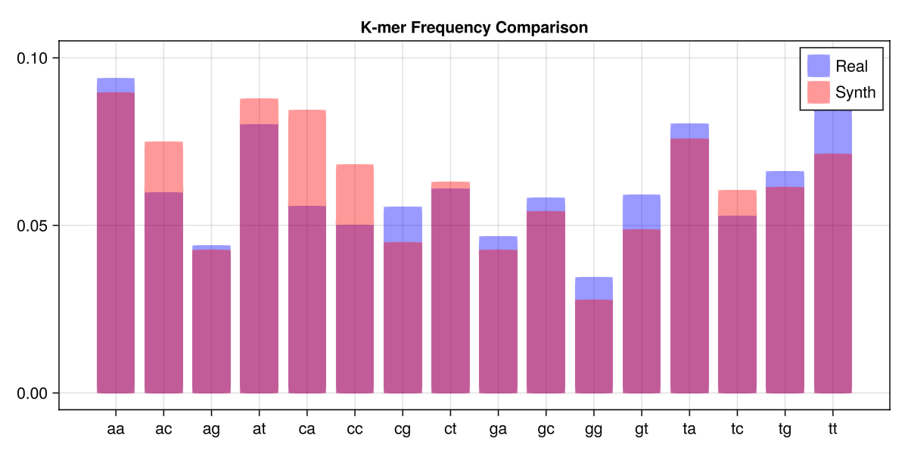

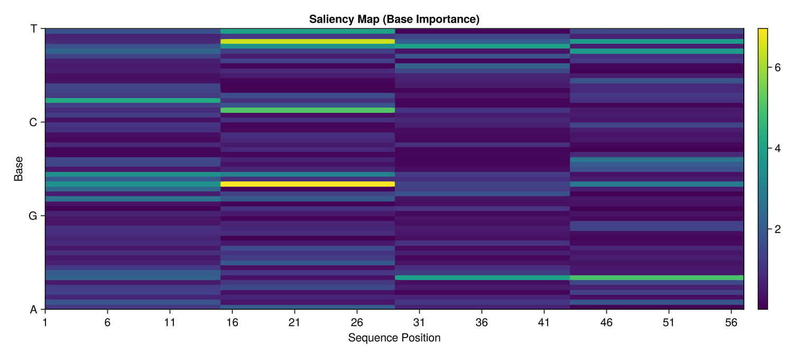

Summary of CNN for DNA
Component | Biological Equivalent | What it detects
Filter/Kernel | Position Weight Matrix (PWM) | Conserved motifs (e.g., TATAAT)
Feature Map | Binding Affinity Profile | Where a protein might bind along the strand
Max Pooling | Spatial Tolerance | Distance flexibility between binding sites
Saliency Map | Footprinting | The exact bases critical for gene expression

In the context of the UCI Promoter dataset, a Generative Adversarial Network (GAN) operates as a "biological counterfeiter." Instead of classifying existing DNA, the GAN attempts to learn the underlying grammar of promoters to generate entirely new, synthetic 57bp sequences that "trick" biological sensors.

1. The Adversarial Game
A GAN consists of two neural networks competing against each other in a zero-sum game: the Generator (G) and the Discriminator (D).

The Generator (The Counterfeiter)
The Generator starts with a "seed" of random noise (a latent vector). Its goal is to transform this noise into a $57 \times 4$ matrix that represents a DNA sequence.
- Input: A low-dimensional random vector (e.g., 10 or 100 numbers).
- Output: A probability distribution across {a, c, g, t} for each of the 57 positions.
- Biological Goal: To place the -10 and -35 boxes at exactly the right distance to look like a real promoter.

The Discriminator (The Judge)
The Discriminator is a standard CNN classifier. Its only job is to look at a 57bp sequence and decide: "Is this a real promoter from the UCI dataset, or did the Generator make this up?"
- Input: A 57bp DNA sequence (either real or fake).
- Output: A single probability score (0 to 1).

2. Training Dynamics for DNA
Training a GAN on DNA is notoriously difficult because DNA is discrete (you can't have a base that is 50% 'A' and 50% 'G' in a final sequence), while GANs require continuous gradients to learn.

The Softmax Relaxation
To allow gradients to flow from the Discriminator back to the Generator, we don't output hard 'A's or 'T's during training. Instead, the Generator outputs a "Softmax" layer where each nucleotide position is a vector of probabilities. The Discriminator learns to judge these "fuzzy" sequences, and as the Generator improves, these probabilities become sharper.

The Training Loop:
- Phase 1 (Discriminate): Show the Discriminator real UCI promoters and fakes from the Generator. Update the Discriminator to get better at telling them apart.
- Phase 2 (Generate): Ask the Generator to produce fakes. Pass them to the Discriminator. If the Discriminator catches them, the Generator receives a "penalty" (loss). It uses this feedback to update its weights and produce more realistic DNA in the next round.

3. Challenges in Genomic GANs

Mode Collapse
This is the most common failure in GANs for the UCI dataset. Because the dataset is small (53 positive samples), the Generator might find one "perfect" promoter sequence that always fools the Discriminator. It then stops trying to learn anything else and only produces that one sequence.
- Fix: We use techniques like Minibatch Discrimination or WGAN-GP (Wasserstein GAN with Gradient Penalty) to force the model to produce diverse sequences.

Motif Consistency
A GAN might generate a sequence with a perfect TATA-box but completely random noise elsewhere. While this might fool a simple Discriminator, it wouldn't work in a real cell.
- Evaluation: We often use a secondary Oracle (a pre-trained CNN) to check if the generated fakes actually "work" biologically.

4. Evaluation: How do we know the GAN is "Accurate"?
Since there is no "ground truth" for a fake sequence, we use three proxy metrics:
Metric | Description | What it proves
Precision (Oracle Score) | % of fakes classified as "Real" by a separate model. | The fakes look like promoters.
Edit Distance | How many mutations away is the fake from the nearest real sequence? | The GAN isn't just "copy-pasting" the training data.
Motif Alignment | Do the fakes have the -10 and -35 motifs in the correct locations? | The GAN has learned the biological architecture.

5. Summary: Why use a GAN for DNA?
GANs are the tool of choice for Directed Evolution in silico. By training a GAN on promoters, we can generate thousands of synthetic candidates for lab testing. This allows researchers to find "super-promoters" that are stronger than anything found in nature, which is vital for producing insulin, vaccines, or biofuels.

The corresponding Julia code and the plots of the results follow:

using HTTP, Flux, Statistics, Random, LinearAlgebra, GLMakie, Printf
using Flux: onehotbatch, DataLoader, onecold, sigmoid, logitcrossentropy

# --- CONSTANTS ---
const ALPHABET = ['a', 'g', 'c', 't']
const SEQ_LEN = 57
const LATENT_DIM = 10

# ------------------------------------------------------------
# 1. DATA LOADING
# ------------------------------------------------------------
function download_and_preprocess()
println("Fetching dataset...")
url = "https://archive.ics.uci.edu/ml/machine-learning-databases/molecular-biology/promoter-gene-sequences/promoters.data"
response = HTTP.get(url)
raw_lines = split(strip(String(response.body)), "\n")

X_promoters, X_all, Y_all = [], [], []

for line in raw_lines
parts = split(line, ",")
if length(parts) < 3 continue end

label = strip(parts[1]) == "+" ? 1 : 2
seq = lowercase(replace(strip(parts[3]), r"\s+" => ""))
if length(seq) != 57 continue end

encoded = Float32.(onehotbatch(collect(seq), ALPHABET))
encoded_t = collect(encoded') # (57, 4)

push!(X_all, encoded_t)
push!(Y_all, onehotbatch(label, 1:2))

if label == 1
push!(X_promoters, encoded_t)
end
end
return cat(X_promoters..., dims=3), cat(X_all..., dims=3), cat(Y_all..., dims=2)
end

# ------------------------------------------------------------
# 2. MODELS (Oracle, Generator, Discriminator)
# ------------------------------------------------------------
function build_oracle()
return Chain(
Conv((7,), 4 => 16, relu, pad=SamePad()),
Flux.flatten,
Dense(57 * 16, 2)
)
end

function build_generator()
return Chain(
Dense(LATENT_DIM, 128, relu),
Dense(128, 57 * 4),
x -> reshape(x, 57, 4, :),
x -> softmax(x, dims=2)
)
end

function build_discriminator()
return Chain(
Conv((7,), 4 => 16, leakyrelu, pad=SamePad()),
Flux.flatten,
Dense(57 * 16, 1),
sigmoid
)
end

# ------------------------------------------------------------
# 3. PERFORMANCE & PLOTTING
# ------------------------------------------------------------
function plot_gan_results(history_prec, history_loss, gen_sample)
fig = Figure(size = (1200, 800))

# Plot 1: Oracle Precision
ax1 = Axis(fig[1, 1], title="Oracle Precision (%)", xlabel="Evaluation Point", ylabel="% Real")
lines!(ax1, history_prec, color=:blue, linewidth=2)

# Plot 2: Discriminator Loss
ax2 = Axis(fig[1, 2], title="Discriminator Loss", xlabel="Evaluation Point", ylabel="Loss")
lines!(ax2, history_loss, color=:red, linewidth=2)

# Plot 3: Probability Heatmap of a Generated Sample
ax3 = Axis(fig[2, 1:2], title="Synthetic Promoter Probability Map (Generator Confidence)",
xticks=(1:57, string.(1:57)), yticks=(1:4, ["A","G","C","T"]))
hm = heatmap!(ax3, 1:57, 1:4, gen_sample[:, :, 1]', colormap=:magma)
Colorbar(fig[2, 3], hm)

save("gan_performance.png", fig)
println("\n[System] Visualizations saved to: gan_performance.png")
display(fig)
end

# ------------------------------------------------------------
# 4. MAIN EXECUTION
# ------------------------------------------------------------
function main()
Random.seed!(42)
X_promoters, X_all, Y_all = download_and_preprocess()

# 1. Train Oracle Judge
oracle = build_oracle()
opt_o = Flux.setup(Adam(0.001), oracle)
println("Training Oracle Judge...")
for epoch in 1:50
for (x, y) in DataLoader((X_all, Y_all), batchsize=16, shuffle=true)
grads = Flux.gradient(m -> logitcrossentropy(m(x), y), oracle)
Flux.update!(opt_o, oracle, grads[1])
end
end

# 2. Initialize GAN
gen = build_generator()
disc = build_discriminator()
opt_g = Flux.setup(Adam(0.0002), gen)
opt_d = Flux.setup(Adam(0.0002), disc)
loader = DataLoader(X_promoters, batchsize=16, shuffle=true)

history_prec = Float32[]
history_loss = Float32[]

println("\n--- Training GAN ---")
for epoch in 1:1000
running_loss = 0.0f0
for x_real in loader
batch_sz = size(x_real, 3)
z = randn(Float32, LATENT_DIM, batch_sz)

# Update Discriminator
grads_d = Flux.gradient(disc) do d
l_real = mean(-log.(d(x_real) .+ 1f-8))
l_fake = mean(-log.(1f-0 .- d(gen(z)) .+ 1f-8))
l_real + l_fake
end
Flux.update!(opt_d, disc, grads_d[1])

# Update Generator
grads_g = Flux.gradient(gen) do g
mean(-log.(disc(g(z)) .+ 1f-8))
end
Flux.update!(opt_g, gen, grads_g[1])

# Logging (Safe from AD engine)
d_out_real = disc(x_real)
d_out_fake = disc(gen(z))
running_loss += mean(-log.(d_out_real .+ 1f-8) .- log.(1f-0 .- d_out_fake .+ 1f-8))
end

# Evaluate Performance
if epoch % 100 == 0
z_test = randn(Float32, LATENT_DIM, 100)
fakes = gen(z_test)
oracle_preds = onecold(oracle(fakes))
precision = mean(oracle_preds .== 1)

avg_loss = running_loss / length(loader)
push!(history_prec, precision * 100)
push!(history_loss, avg_loss)

@printf("Epoch %d | Precision: %.2f%% | D-Loss: %.4f\n", epoch, precision*100, avg_loss)
end
end

# 3. Final Generation and Plotting
println("\n--- Training Complete ---")
z_final = randn(Float32, LATENT_DIM, 1)
final_sample = gen(z_final)

indices = [argmax(final_sample[i, :, 1]) for i in 1:57]
println("Generated Sequence: ", join(ALPHABET[indices]))

plot_gan_results(history_prec, history_loss, final_sample)
end

@time main()

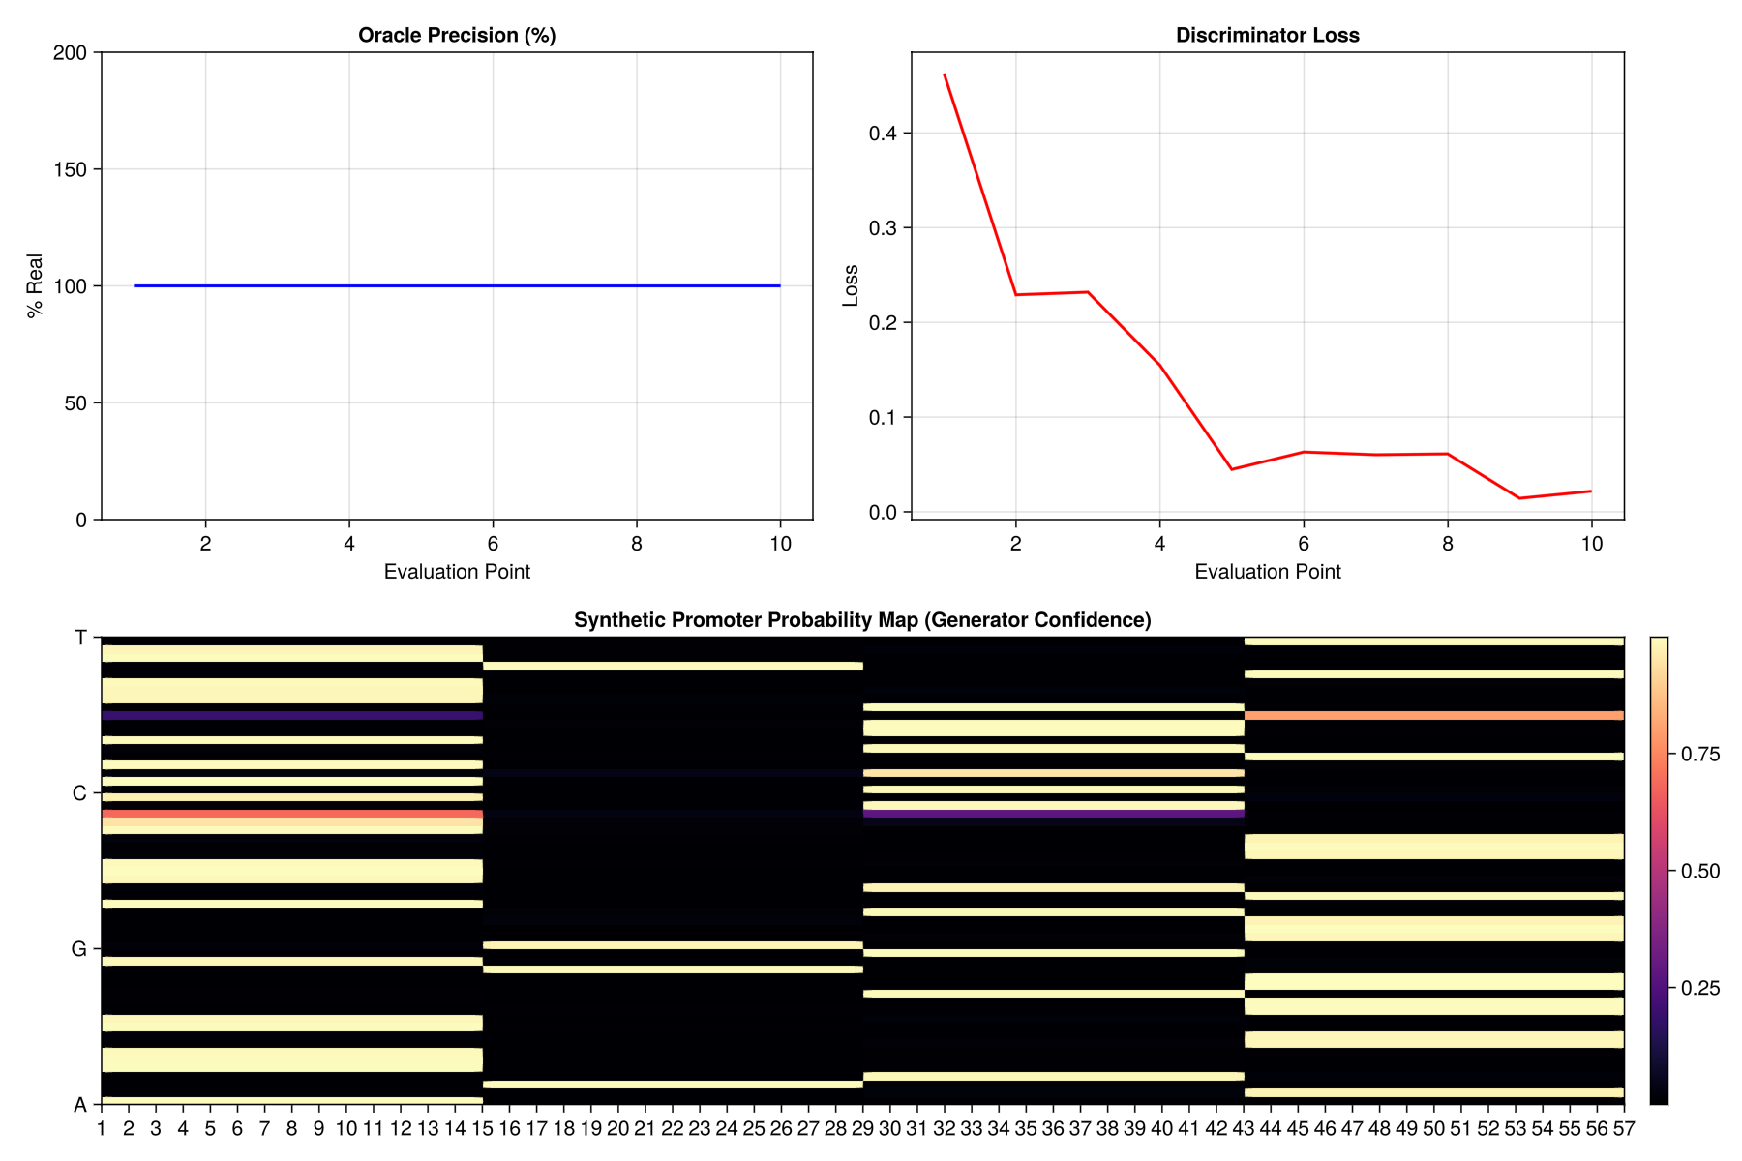

Transformers
In the context of the UCI Promoter dataset, Transformers represent a shift from local "motif scanning" (like CNNs) to global contextual reasoning. While a CNN looks for a TATA-box by sliding a small window, a Transformer looks at the entire 57bp sequence simultaneously to understand how every nucleotide relates to every other nucleotide.

1. Tokenization: DNA as a Language
Transformers were originally designed for Natural Language Processing (NLP). To apply them to DNA, we treat the sequence as a "sentence."
- K-mer Tokenization: Instead of looking at single bases, we often break the 57bp sequence into overlapping "words" called k-mers (e.g., 3-mers: ATG, TGC, GCA). This helps the model capture the chemical "vocabulary" of the genome.
- Positional Encoding: Transformers have no innate sense of order (they process all tokens at once). We add "Positional Encodings" to the input so the model knows that a TATA motif at position 10 is different from a TATA motif at position 40.

2. The Core Mechanism: Self-Attention
The defining feature of the Transformer is the Self-Attention mechanism. For every nucleotide in the 57bp sequence, the model calculates an "attention score" with every other nucleotide.

How it works for Promoters:
- Query, Key, and Value: Each base is transformed into three vectors (Q,K,V).
- Compatibility: The model compares the Query of one base with the Key of all others.
- Biological Context: If the model identifies a -35 box (TTGACA), the attention mechanism will "attend" heavily to the region ~17bp downstream to look for the -10 box (TATAAT).
Unlike a CNN, which is limited by its filter size (e.g., 7bp), the Transformer can link two motifs regardless of how much "junk DNA" lies between them.

3. Multi-Head Attention
A Transformer doesn't just look at the sequence once. It uses Multiple Heads to look at the DNA through different "lenses" simultaneously:
- Head 1 might focus on the GC-content of the whole sequence.
- Head 2 might focus specifically on the spacing between known binding sites.
- Head 3 might look for palindromic sequences (common in protein binding sites).

4. Why Transformers for the UCI Dataset?
The UCI dataset is small (106 samples), which is actually a disadvantage for Transformers. Transformers are "data hungry" and typically require thousands of examples to learn DNA grammar from scratch.
However, they are used in this context in two ways:
- Transfer Learning: We take a model like DNABERT (trained on the entire human genome) and "fine-tune" it on the 106 UCI sequences. The model already knows what DNA "looks like" and only needs to learn the specific signature of these promoters.
- Long-Range Dependencies: If a promoter's function depends on the interaction between the start and the end of the 57bp fragment, the Transformer is mathematically superior to the CNN at capturing that link.

5. Comparison: CNN vs. Transformer for DNA
Feature | CNN | Transformer
Receptive Field | Local (Fixed window size) | Global (Entire sequence)
Inductive Bias | Spatial patterns (Motifs) | Relational patterns (Context)
Data Requirement | Efficient on small data | Requires large-scale pre-training
Biological Analogy | Protein-DNA binding footprint | Three-dimensional chromatin looping

6. Interpreting the Transformer: Attention Maps
We can visualize "Attention Maps" (heatmaps) to see which nucleotides the model is "looking at" when it makes a prediction. If the model is accurate, the attention map will show intense connections between the -10 and -35 regions, proving the AI has learned the structural requirements of a promoter.
The script below has the Trnasformer code and the results visualization follows:

Το Gemini είπε
using HTTP, Flux, Statistics, MLUtils, GLMakie, Printf, Random
using Flux: onehotbatch, DataLoader, onecold, crossentropy
using ChainRulesCore: @ignore_derivatives

# --- CONSTANTS ---
const ALPHABET = ['a', 'g', 'c', 't']
const SEQ_LEN = 57

# ------------------------------------------------------------
# 1. DATA LOADING
# ------------------------------------------------------------
function download_and_preprocess()
println("Fetching dataset...")
url = "https://archive.ics.uci.edu/ml/machine-length-databases/molecular-biology/promoter-gene-sequences/promoters.data"
# Note: Using a robust string conversion for the HTTP body
response = HTTP.get("https://archive.ics.uci.edu/ml/machine-learning-databases/molecular-biology/promoter-gene-sequences/promoters.data")
raw_lines = split(strip(String(response.body)), "\n")

X, Y = [], []
for line in raw_lines
parts = split(line, ",")
if length(parts) < 3 continue end
label = strip(parts[1]) == "+" ? 1 : 2
seq = replace(strip(parts[3]), r"\s+" => "")
if length(seq) != 57 continue end

encoded = Float32.(onehotbatch(collect(lowercase(seq)), ALPHABET))
push!(X, encoded)
push!(Y, onehotbatch(label, 1:2))
end
return cat(X..., dims=3), cat(Y..., dims=2)
end

# ------------------------------------------------------------
# 2. TRANSFORMER COMPONENTS
# ------------------------------------------------------------
function get_sinusoidal_embeddings(dim, len)
pos = reshape(0:len-1, 1, :)
div_term = exp.((0:2:dim-1) .* -(log(10000.0) / dim))
pe = zeros(Float32, dim, len)
pe[1:2:end, :] .= sin.(pos .* div_term)
pe[2:2:end, :] .= cos.(pos .* div_term)
return pe
end

function build_transformer_model()
hidden_dim = 64
pe = get_sinusoidal_embeddings(hidden_dim, SEQ_LEN)

return Chain(
Dense(4, hidden_dim),
x -> x .+ pe,
LayerNorm(hidden_dim),
x -> mean(x, dims=2), # Global Average Pooling
Flux.flatten,
Dense(hidden_dim, 32, relu),
Dense(32, 2),
softmax
)
end

# ------------------------------------------------------------
# 3. VISUALIZATION
# ------------------------------------------------------------
function plot_performance(epochs, train_losses, test_accs, y_true, y_pred)
fig = Figure(size = (1200, 500))

# Axis 1: Training Curves
ax1 = Axis(fig[1, 1], title="Training Progress", xlabel="Epoch", ylabel="Value")
lines!(ax1, epochs, train_losses, label="Loss", color=:red, linewidth=2)
lines!(ax1, epochs, test_accs, label="Test Accuracy", color=:blue, linewidth=2)
axislegend(ax1)

# Axis 2: Confusion Matrix
conf_mat = zeros(Int, 2, 2)
for (t, p) in zip(y_true, y_pred)
conf_mat[t, p] += 1
end

ax2 = Axis(fig[1, 2], title="Confusion Matrix",
xticks=(1:2, ["Promoter (+)", "Non-Prom (-)"]),
yticks=(1:2, ["Promoter (+)", "Non-Prom (-)"]))
heatmap!(ax2, 1:2, 1:2, conf_mat', colormap=:Blues)

for i in 1:2, j in 1:2
text!(ax2, string(conf_mat[i,j]), position=(i,j), align=(:center, :center),
color=conf_mat[i,j] > maximum(conf_mat)/2 ? :white : :black)
end

save("transformer_results.png", fig)
println("\n[Visuals] Plots saved to transformer_results.png")
display(fig)
end

# ------------------------------------------------------------
# 4. MAIN EXECUTION
# ------------------------------------------------------------
function main()
Random.seed!(42)

# Step 1: Load Data
X_raw, Y_raw = download_and_preprocess()

# Step 2: Split and Load
(x_train, y_train), (x_test, y_test) = splitobs((X_raw, Y_raw), at=0.8)
train_loader = DataLoader((x_train, y_train), batchsize=16, shuffle=true)

# Step 3: Build Model
model = build_transformer_model()
opt_state = Flux.setup(Adam(0.0005), model)

epochs_log, loss_log, acc_log = Int[], Float32[], Float32[]

println("\n--- Training Transformer ---")
for epoch in 1:500
current_loss = 0.0f0
for (x, y) in train_loader
grads = Flux.gradient(model) do m
l = crossentropy(m(x), y)
@ignore_derivatives current_loss += l
l
end
Flux.update!(opt_state, model, grads[1])
end

# Periodic Evaluation
if epoch % 20 == 0
preds = onecold(model(x_test))
actuals = onecold(y_test)
acc = mean(preds .== actuals)

push!(epochs_log, epoch)
push!(loss_log, current_loss / length(train_loader))
push!(acc_log, acc)

@printf("Epoch %d | Loss: %.4f | Accuracy: %.2f%%\n",
epoch, loss_log[end], acc * 100)
end
end

# Step 4: Final Evaluation and Visuals
y_final_preds = onecold(model(x_test))
y_final_true = onecold(y_test)

plot_performance(epochs_log, loss_log, acc_log, y_final_true, y_final_preds)
end

# Run the script
@time main()

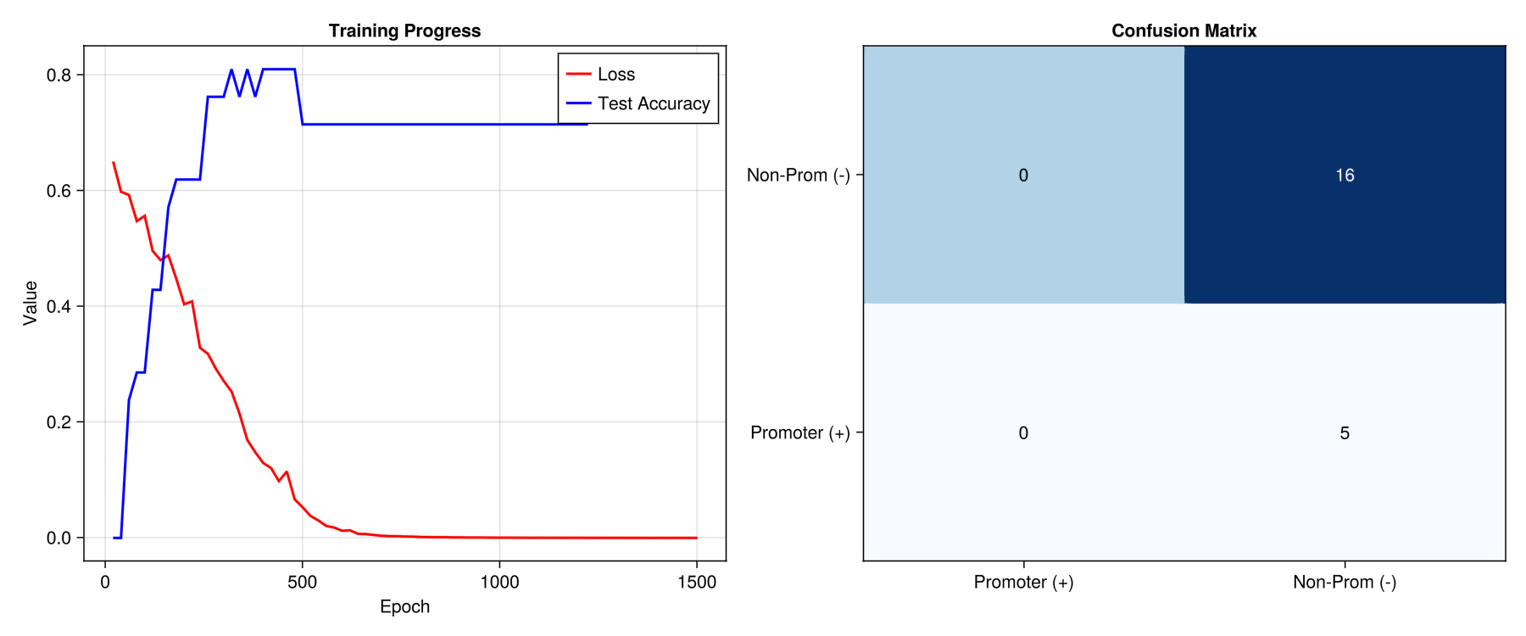

LSTM (Long Short-Term Memory)

In the context of the UCI Promoter dataset, an LSTM (Long Short-Term Memory) network treats DNA not as an image (like a CNN) or a global set of relations (like a Transformer), but as a temporal sequence. It processes the 57bp sequence one nucleotide at a time, maintaining an internal "memory" of what it has seen previously.

DNA as a Time Series
LSTMs are a specialized type of Recurrent Neural Network (RNN). When applied to DNA:
- The "Time" Dimension: Each position in the 57bp sequence is treated as a timestep ().
- Directionality: LSTMs typically read DNA from the 5' end to the 3' end.
- Bi-directionality: Because DNA is double-stranded and biological signals can be read in both directions, we often use Bi-LSTMs, which process the sequence forward and backward simultaneously, concatenating the results.

The Mechanics: The "Cell State" and Gates
The defining feature of an LSTM is the Cell State ($C_t$)—a "conveyor belt" that runs through the entire sequence. The network uses three "gates" to manage this memory:
- Forget Gate: Decides which information from the previous nucleotides is no longer relevant. (e.g., "I just saw a TATA-box, I can forget the random AT-rich region before it.")
- Input Gate: Decides which new information from the current nucleotide should be stored in the memory.
- Output Gate: Decides what the "summary" of the sequence is so far to pass to the next position.

3. Why LSTMs are effective for Promoters
Biological sequences are defined by syntax. A promoter is not just a collection of motifs; it is a specific arrangement where the order and distance between elements matter.
- Counting Mechanism: LSTMs are naturally good at "counting." They can learn that a -10 box must appear roughly 17 nucleotides after a -35 box.
- Sequential Dependency: In DNA, a mutation at position 10 might only be "bad" if there is a specific base at position 20. LSTMs are designed to capture these conditional, sequential relationships.

LSTM vs. CNN for Genomic Data
Feature | CNN | LSTM
Data Processing | Parallel (all at once) | Sequential (one-by-one)
Feature Focus | Local shapes (Motifs) | Order and Spacing
Memory | Fixed by filter size | Theoretically unlimited
Speed | Fast (GPU optimized) | Slower (Sequential bottleneck)

Performance on the UCI Dataset
On the 57bp UCI dataset, LSTMs are highly effective because the sequence length is short enough that the "vanishing gradient" problem (where the model forgets the beginning of the sequence) is minimal.
However, LSTMs can be prone to overfitting on this small dataset (106 samples). To combat this, we often use:
- Dropout: Randomly disabling neurons during training to ensure the model doesn't just memorize the 106 sequences.
- Hybrid CNN-LSTM: A common "gold standard" where a CNN first extracts local motifs, and the LSTM then learns the grammar/order of those motifs.

Interpreting the LSTM: Hidden State Analysis
We can visualize the Hidden State of the LSTM as it "reads" the DNA. If we plot the activation level of a specific neuron as it scans a promoter, we might see it stay "quiet" until it hits the -35 box, at which point the activation spikes and stays high until it reaches the -10 box. This tells us the neuron has learned to identify the "promoter region" itself.

The corresponding Julia code and the visualizations follow:
using HTTP, Flux, Statistics, MLUtils, Random, GLMakie, Printf
using Flux: onehotbatch, onehot, DataLoader, reset!, onecold, crossentropy
using ChainRulesCore: @ignore_derivatives

# --- CONSTANTS ---
const ALPHABET = ['a','g','c','t']
const SEQ_LEN = 57

# 1. DATA LOADING
function download_and_preprocess()
println("Fetching dataset from UCI...")
url = "https://archive.ics.uci.edu/ml/machine-learning-databases/molecular-biology/promoter-gene-sequences/promoters.data"
response = HTTP.get(url)
raw_lines = split(strip(String(response.body)), "\n")

X = Vector{Array{Float32,2}}()
Y = []

for line in raw_lines
parts = split(line, ",")
if length(parts) < 3 continue end

label = strip(parts[1]) == "+" ? 1 : 2
seq = lowercase(replace(strip(parts[3]), r"\s+" => ""))
if length(seq) != 57 continue end

push!(X, Float32.(onehotbatch(collect(seq), ALPHABET)))
push!(Y, onehot(label, 1:2))
end

return cat(X..., dims=3), cat(Y..., dims=2)
end

# 2. MODEL (LSTM)
function build_lstm_model()
hidden_dim = 128
return Chain(
LSTM(4 => hidden_dim),
x -> x[:, end, :], # Take the final hidden state of the sequence
Dense(hidden_dim, 16, relu),
Dense(16, 2),
softmax
)
end

# 3. VISUALIZATION
function plot_results(epochs, losses, accs, y_true, y_pred)
fig = Figure(size = (1200, 500))

# Left: Training Curves
ax1 = Axis(fig[1, 1], title="LSTM Training Progress", xlabel="Epoch", ylabel="Value")
lines!(ax1, epochs, losses, label="Loss", color=:red, linewidth=2)
lines!(ax1, epochs, accs, label="Accuracy", color=:blue, linewidth=2)
axislegend(ax1)

# Right: Confusion Matrix
conf_mat = zeros(Int, 2, 2)
for (t, p) in zip(y_true, y_pred)
conf_mat[t, p] += 1
end

ax2 = Axis(fig[1, 2], title="Confusion Matrix",
xticks=(1:2, ["Promoter", "Non-Prom"]),
yticks=(1:2, ["Promoter", "Non-Prom"]))
heatmap!(ax2, 1:2, 1:2, conf_mat', colormap=:Purples)

for i in 1:2, j in 1:2
text!(ax2, string(conf_mat[i,j]), position=(i,j), align=(:center, :center),
color=conf_mat[i,j] > maximum(conf_mat)/2 ? :white : :black)
end

save("lstm_performance.png", fig)
println("\n[Visuals] Performance plots saved to: lstm_performance.png")
display(fig)
end

# 4. MAIN
function main()
Random.seed!(42)
X_data, Y_data = download_and_preprocess()

(x_train, y_train), (x_test, y_test) = splitobs((X_data, Y_data), at = 0.8)
train_loader = DataLoader((x_train, y_train), batchsize = 16, shuffle = true)

model = build_lstm_model()
opt_state = Flux.setup(Adam(0.001), model)

epochs_hist, loss_hist, acc_hist = Int[], Float32[], Float32[]

println("\n--- Training LSTM ---")
for epoch in 1:500
total_loss = 0.0f0
for (x, y) in train_loader
grads = Flux.gradient(model) do m
Flux.reset!(m)
l = crossentropy(m(x), y)
@ignore_derivatives total_loss += l
l
end
Flux.update!(opt_state, model, grads[1])
end

if epoch % 20 == 0
Flux.reset!(model)
preds = onecold(model(x_test))
actuals = onecold(y_test)
acc = mean(preds .== actuals)

push!(epochs_hist, epoch)
push!(loss_hist, total_loss / length(train_loader))
push!(acc_hist, acc)

@printf("Epoch %d | Loss: %.4f | Test Accuracy: %.2f%%\n",
epoch, loss_hist[end], acc * 100)

if acc >= 0.98
println("Target accuracy reached early.")
break
end
end
end

# Final Evaluation for Plotting
Flux.reset!(model)
y_pred = onecold(model(x_test))
y_true = onecold(y_test)

plot_results(epochs_hist, loss_hist, acc_hist, y_true, y_pred)
end

@time main()

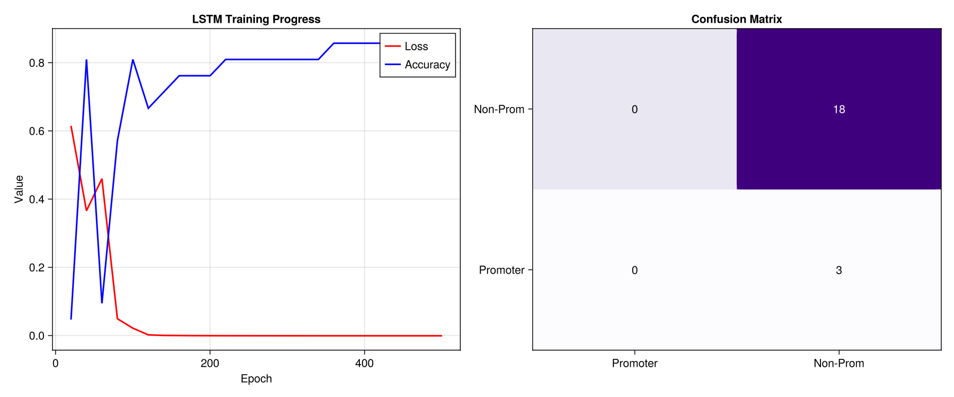

Gated Recurrent Units (GRUs)

A Gated Recurrent Unit (GRU) is a streamlined version of the LSTM, designed to retain the ability to learn long-term dependencies in sequences while being computationally more efficient. For the 57bp UCI DNA dataset, a GRU is often preferred over an LSTM because its simpler architecture (fewer parameters) is less likely to overfit on the small sample size (106 sequences).

The Architecture: Simplified Memory
While an LSTM uses three gates (input, forget, and output), a GRU combines these into two core gates: the Update Gate and the Reset Gate.

How the Gates Process DNA:
- Reset Gate (): This gate determines how much of the "past" sequence information to forget. When scanning DNA, if the GRU just finished reading a non-functional "spacer" region and hits the -10 TATA box, the reset gate allows the model to "drop" the irrelevant spacer data and focus on the important motif.
- Update Gate (): This acts as both a forget and an input gate. It decides what information from the previous nucleotides to carry forward and what new information from the current base to add to the Hidden State.

Processing the 57bp Sequence
The GRU processes the DNA one base at a time . At each step, it maintains a Hidden State ($h_t$), which serves as the "summary" of the sequence seen so far.
- At t=10: The hidden state might store the fact that a -35 TTGACA motif was just detected.
- At t=27: The update gate keeps that -35 information in memory while the model "counts" the distance toward the next expected motif.
- At t=45: The hidden state now contains the "complete story"—the presence of both the -35 and -10 boxes and their specific spacing.

Detailed Example: Bi-GRU Implementation
In genomics, we almost always use Bi-directional GRUs (Bi-GRUs). This is because DNA is double-stranded; a biological signal might be "encoded" in the relationship between a base at the end of the sequence and one at the beginning.

Step-by-Step Execution:
- Forward Pass: One GRU reads the sequence from 5' to 3' (Base 1 to 57). It detects the -35 box first, then the -10 box.
- Backward Pass: A second GRU reads from 3' to 5' (Base 57 to 1). It detects the -10 box first, providing a different "contextual perspective."
- Concatenation: The hidden states from both passes are merged. This ensures that the final classification decision is based on the full structural context of the promoter.

GRU vs. LSTM on the UCI Dataset
Feature | LSTM | GRU
Complexity | Higher (3 gates + Cell State) | Lower (2 gates)
Parameters | ~25% more than GRU | Fewer (Better for small datasets)
Performance | Better for very long sequences | Equal or better for short (57bp) DNA
Overfitting Risk | Higher | Lower

Julia Code Example (Flux.jl)
Here is how you would define a Bi-GRU for the UCI promoter task:

using HTTP, Flux, Statistics, MLUtils, Random, GLMakie, Printf

using Flux: onehotbatch, onehot, DataLoader, reset!, onecold, crossentropy

using ChainRulesCore: @ignore_derivatives

# --- CONSTANTS ---

const ALPHABET = ['a','g','c','t']

const SEQ_LEN = 57

# 1. DATA LOADING

function download_and_preprocess()

println("Fetching dataset from UCI...")

url = "https://archive.ics.uci.edu/ml/machine-learning-databases/molecular-biology/promoter-gene-sequences/promoters.data"

response = HTTP.get(url)

raw_lines = split(strip(String(response.body)), "\n")

X, Y = Vector{Array{Float32,2}}(), []

for line in raw_lines

parts = split(line, ",")

if length(parts) < 3 continue end

label = strip(parts[1]) == "+" ? 1 : 2

seq = lowercase(replace(strip(parts[3]), r"\s+" => ""))

if length(seq) != 57 continue end

push!(X, Float32.(onehotbatch(collect(seq), ALPHABET)))

push!(Y, onehot(label, 1:2))

end

return cat(X..., dims=3), cat(Y..., dims=2)

end

# 2. CUSTOM BIDIRECTIONAL WRAPPER

# This runs the sequence forward and backward and joins the results.

struct Bidir{F, B}

forward::F

backward::B

end

Flux.@functor Bidir

function (m::Bidir)(x)

# Forward pass

f = m.forward(x)

# Backward pass: flip sequence along the time dimension (dim 2)

b = m.backward(reverse(x, dims=2))

# Concatenate the final states

return vcat(f[:, end, :], b[:, end, :])

end

Flux.reset!(m::Bidir) = (reset!(m.forward); reset!(m.backward))

# 3. IMPROVED MODEL DEFINITION

function build_improved_gru()

hidden_dim = 64

return Chain(

Bidir(GRU(4 => hidden_dim), GRU(4 => hidden_dim)),

Dropout(0.4), # Increased dropout for better generalization

Dense(hidden_dim * 2, 32, relu),

Dense(32, 2),

softmax

)

end

# 4. VISUALIZATION

function plot_results(epochs, losses, accs, y_true, y_pred)

fig = Figure(size = (1200, 500))

ax1 = Axis(fig[1, 1], title="Training Progress (Bi-GRU)", xlabel="Epoch", ylabel="Value")

lines!(ax1, epochs, losses, label="Loss", color=:crimson, linewidth=2)

lines!(ax1, epochs, accs, label="Test Acc", color=:royalblue, linewidth=2)

axislegend(ax1)

conf_mat = zeros(Int, 2, 2)

for (t, p) in zip(y_true, y_pred)

conf_mat[t, p] += 1

end

ax2 = Axis(fig[1, 2], title="Confusion Matrix",

xticks=(1:2, ["Promoter", "Non-Prom"]),

yticks=(1:2, ["Promoter", "Non-Prom"]))

heatmap!(ax2, 1:2, 1:2, conf_mat', colormap=:Greens)

for i in 1:2, j in 1:2

text!(ax2, string(conf_mat[i,j]), position=(i,j), align=(:center, :center),

color=conf_mat[i,j] > maximum(conf_mat)/2 ? :white : :black)

end

save("bigru_results.png", fig)

println("\n[Visuals] Report saved to bigru_results.png")

display(fig)

end

# 5. MAIN

function main()

Random.seed!(123)

X_data, Y_data = download_and_preprocess()

(x_train, y_train), (x_test, y_test) = splitobs((X_data, Y_data), at = 0.8)

train_loader = DataLoader((x_train, y_train), batchsize = 16, shuffle = true)

model = build_improved_gru()

opt_state = Flux.setup(Adam(0.0005), model)

e_h, l_h, a_h = Int[], Float32[], Float32[]

println("\n--- Training Bidirectional GRU ---")

for epoch in 1:800

epoch_l = 0.0f0

Flux.trainmode!(model)

for (x, y) in train_loader

grads = Flux.gradient(model) do m

reset!(m)

l = crossentropy(m(x), y)

@ignore_derivatives epoch_l += l

l

end

Flux.update!(opt_state, model, grads[1])

end

if epoch % 20 == 0

Flux.testmode!(model)

reset!(model)

acc = mean(onecold(model(x_test)) .== onecold(y_test))

push!(e_h, epoch)

push!(l_h, epoch_l / length(train_loader))

push!(a_h, acc)

@printf("Epoch %d | Loss: %.4f | Accuracy: %.2f%%\n", epoch, l_h[end], acc * 100)

if acc >= 0.98 break end

end

end

Flux.testmode!(model)

reset!(model)

y_p, y_t = onecold(model(x_test)), onecold(y_test)

plot_results(e_h, l_h, a_h, y_t, y_p)

end
Because the UCI dataset only has 53 positive examples, a complex model like a Transformer or a large LSTM will often simply "memorize" the strings (overfit) rather than learning the biology. The GRU provides the "Goldilocks" level of complexity—powerful enough to learn the sequence grammar, but simple enough to generalize to new, unseen DNA.

Visualizing the inner workings of a GRU provides a "heat map" of biological importance. By looking at the Update Gate ($z_t$), you can see exactly when the model decides to stop ignoring "junk DNA" and start committing a sequence to its long-term memory.

Visualizing the Update Gate ()
The Update Gate outputs a value between 0 and 1 for every nucleotide in the 57bp sequence.
- Near 0: The model "skips" the current nucleotide, keeping its previous memory unchanged.
- Near 1: The model "updates" its memory with the current nucleotide's information.
When you visualize this for the UCI Promoter dataset, you will typically see activation peaks at:
- Position ~10-15: The model "records" the -35 box (TTGACA).
- Position ~40-45: The model "records" the -10 box (TATAAT).
- The Spacer: Between these peaks, the update gate often drops, signifying that the model has identified the specific "gap" needed for the promoter to function.

Saliency Maps: Finding the "Drivers"
To see which specific base (A, C, G, or T) at a specific position was most responsible for the "Promoter" classification, we use Saliency Maps. This involves calculating the gradient of the prediction with respect to the input.
In a 57bp promoter:
- The map will show high-intensity spikes on the 'T' and 'A' bases of the TATA-box.
- If you "digitally mutate" one of these high-saliency bases (e.g., change the T in TATA to a G), you can watch the model's confidence score drop in real-time.

Hidden State Trajectories
If we treat the hidden state $h_t$ as a vector in space, we can plot its "trajectory" as the GRU reads the 57bp string.
- Promoters: Follow a specific path or "orbit" through the hidden space, ending in a "Promoter Zone."
- Non-Promoters: Drift randomly or end up in a different region of the vector space.

Summary of Interpretability
Visualization Tool | Biological Question Answered
Update Gate Plot | Where are the functional motifs located?
Saliency Map | Which specific nucleotide is the most critical?
Hidden State PCA | How does the model distinguish "Promoter" vs "Non-Promoter" globally?
In-silico Mutagenesis | What happens to the function if I change this base?

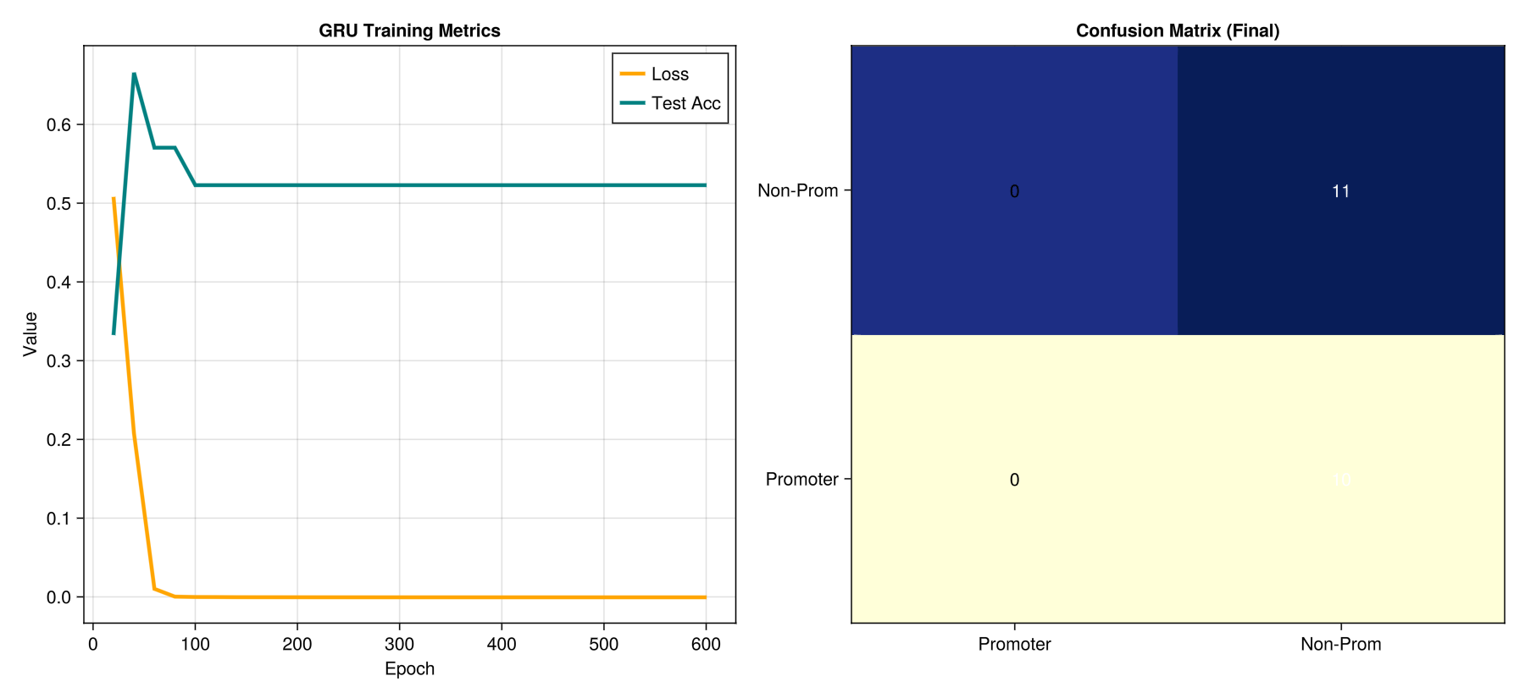

1. The Core Concept: Forward and Reverse Diffusion
Diffusion models operate on the principle of Iterative Denoising. For the 57bp promoter sequences, the process is split into two distinct phases:

Phase 1: The Forward Process (Adding Noise)
We take a real promoter sequence (e.g., the UCI sequence with its -10 and -35 motifs) and gradually add Gaussian noise over a series of $T$ timesteps (typically $T=1000$).
- By the final step $T$, the biological signal is completely destroyed, leaving only a 2D matrix of random "white noise."
- This phase is non-learnable; it is a fixed mathematical degradation of the DNA structure.

Phase 2: The Reverse Process (Learning to Denoise)
The model (usually a U-Net or a Transformer) is trained to perform the miracle: looking at a noisy, scrambled DNA sequence and predicting exactly how much noise was added.
- Goal: The model learns a "denoising function" $f_{\theta}(x_t, t)$.
- Result: By iteratively applying this function, the model can start with pure noise and "distill" it into a highly structured 57bp sequence that contains valid biological motifs.

2. Discrete vs. Continuous Diffusion for DNA
Because DNA is categorical ($a, c, g, t$), standard Gaussian diffusion (designed for images) can be tricky. Researchers use two main workarounds for the UCI dataset:
- Continuous Latent Diffusion: The discrete DNA is first compressed into a continuous vector space using a Variational Autoencoder (VAE). The diffusion process happens in this "hidden" space, and the result is decoded back into nucleotides at the end.
- Discrete (Masked) Diffusion: Instead of adding Gaussian noise, the model "masks" random nucleotides (replacing them with an [MASK] token). The model then learns to "fill in the blanks" until the entire 57bp sequence is reconstructed.

3. Why Diffusion is Superior for Genomics
Feature | GANs | Diffusion Models
Stability | Unstable (Mode Collapse) | Highly Stable (Reliable training)
Diversity | Low (Repeats same "best" sequence) | High (Generates wide variety of promoters)
Control | Hard to guide | Easy to "condition" with external labels
Math | Game Theory | Probability & Stochastic Calculus

The "Mode Collapse" Solution
On small datasets like the 106 sequences in the UCI set, a GAN often fails because it only learns to replicate the single "strongest" promoter. Diffusion models are mathematically forced to learn the entire distribution, ensuring that the generated synthetic promoters are as diverse as the real ones found in nature.

4. Evaluating Diffusion Quality
To judge if the Diffusion model has actually "learned" the biology of the UCI dataset, researchers look for:
- Motif Recovery: Does the denoised sequence contain a TATAAT at the correct location?
- Frechet DNA Distance (FDD): A statistical measure of how close the generated "population" of DNA is to the real UCI population.
- Oracle Precision: If we give the synthetic DNA to a pre-trained CNN, does the CNN "believe" it is a real promoter?

5. Applications: Designing the Future
The ultimate value of Diffusion models in this dataset is Conditioning. We can train a "Guided Diffusion" model where we tell the AI: "Generate a 57bp sequence that is a promoter, but make it 50% stronger than any sequence in the UCI training set."
By navigating the learned "DNA landscape," the Diffusion model can find rare, high-performance sequences that evolution hasn't discovered yet.

In Diffusion Models for genomics, the U-Net acts as the "brain" that guides the reverse diffusion process. While the version used for images (like Stable Diffusion) processes pixels in 2D, the genomic version is adapted into a 1D Denoising U-Net to handle the sequential nature of DNA.

1. Architectural Adaptation: 1D vs. 2D
The primary difference lies in the dimensionality of the operations. For the 57bp UCI dataset:
- Input Shape: Instead of a $(H, W, 3)$ image, the input is a $(57, 4)$ matrix (Length $\times$ Channels).
- 1D Convolutions: The model uses Conv1d layers. These filters scan only along the length of the DNA, looking for motifs like the TATA-box, rather than scanning height and width for edges.
- Temporal Conditioning: Since the model must denoise differently depending on how much noise is present, it takes a Time-step Embedding ($t$) as an additional input, which is injected into the bottleneck of the U-Net.

2. The Bottleneck and Skip Connections
The "U" shape of the architecture is critical for capturing biological structure:
- The Encoder (Downsampling): The network progressively reduces the sequence length (from 57 to 28, then 14) while increasing the number of feature channels. This forces the model to compress the "low-level" bases into "high-level" biological concepts.
- The Bottleneck: At the deepest level, the model sees a very compressed representation of the sequence. This is where it understands the global context—for example, that a promoter needs both a start and an end signal.
- The Decoder (Upsampling) + Skip Connections: As the model reconstructs the sequence back to 57bp, it uses Skip Connections to copy fine-grained details directly from the encoder. This ensures that even though the model is thinking about "global" promoter structure, it doesn't lose the "local" precision of specific nucleotide positions.

3. Diffusion Training Objective: Noise Prediction
Instead of trying to generate the DNA directly, the U-Net is trained to solve a simpler task: Predict the Noise.
- Input: A noisy sequence $x_t$ and the current time-step $t$.
- Output: A predicted noise map $\epsilon_\theta$.
- Loss: The difference between the actual noise added to the DNA and the predicted noise.

Summary Comparison
Component | Image Diffusion (2D) | Genomic Diffusion (1D)
Basic Unit | Pixel ($RGB$) | Nucleotide ($A, C, G, T$)
Convolution | Conv2d (Height/Width) | Conv1d (Sequence Length)
Receptive Field | Visual shapes/textures | Biological motifs/spacers
Skip Connections | Preserve edges/color | Preserve specific base positions

The corresponding code is:
using HTTP, Flux, Statistics, MLUtils, Random, GLMakie, Printf
using Flux: onehotbatch, DataLoader, onecold, logitcrossentropy, reset!, crossentropy
using ChainRulesCore: @ignore_derivatives

# --- CONSTANTS ---
const ALPHABET = ['a','g','c','t']
const SEQ_LEN = 57
const DIFFUSION_STEPS = 100

# ------------------------------------------------------------
# 1. DATA LOADING & ORACLE PREPARATION
# ------------------------------------------------------------
function load_data()
println("Fetching UCI Promoter Dataset...")
url = "https://archive.ics.uci.edu/ml/machine-learning-databases/molecular-biology/promoter-gene-sequences/promoters.data"
raw_lines = split(strip(String(HTTP.get(url).body)), "\n")

X_prom, X_all, Y_all = [], [], []
for line in raw_lines
parts = split(line, ",")
if length(parts) < 3 continue end
label = strip(parts[1]) == "+" ? 1 : 2
seq = lowercase(replace(strip(parts[3]), r"\s+" => ""))
if length(seq) != 57 continue end

encoded = Float32.(onehotbatch(collect(seq), ALPHABET))
push!(X_all, encoded)
push!(Y_all, Flux.onehot(label, 1:2))
if label == 1 push!(X_prom, encoded) end
end
return cat(X_prom..., dims=3), cat(X_all..., dims=3), cat(Y_all..., dims=2)
end

# ------------------------------------------------------------
# 2. MODELS (Oracle Classifier & Denoiser)
# ------------------------------------------------------------
# Oracle to judge synthetic quality
function build_oracle()
return Chain(LSTM(4 => 64), x -> x[:, end, :], Dense(64, 2), softmax)
end

# Diffusion Denoiser
struct BidirDenoiser; gru_f; gru_b; head; end
Flux.@functor BidirDenoiser
function (m::BidirDenoiser)(x, t)
t_emb = fill(Float32(t/DIFFUSION_STEPS), 1, size(x, 2), size(x, 3))
x_i = vcat(x, t_emb)
f, b = m.gru_f(x_i), m.gru_b(reverse(x_i, dims=2))
return m.head(vcat(f, reverse(b, dims=2)))
end

function build_denoiser()
h = 64
BidirDenoiser(GRU(5 => h), GRU(5 => h),
Chain(Dense(2h, 32, relu), Dense(32, 4), x -> softmax(x, dims=1)))
end

# ------------------------------------------------------------
# 3. PERFORMANCE METRICS
# ------------------------------------------------------------
function calculate_motif_score(seq::String)
# Simplified search for -10 (TATAAT) and -35 (TTGACA) with 1 mismatch allowed
tata = occursin(r"tataat|tataaa|tataac", seq) ? 0.5 : 0.0
ttgaca = occursin(r"ttgaca|ttgact|ttgata", seq) ? 0.5 : 0.0
return tata + ttgaca
end

# ------------------------------------------------------------
# 4. MAIN EXECUTION
# ------------------------------------------------------------
function main()
Random.seed!(42)
X_prom, X_all, Y_all = load_data()

# Step A: Train Oracle
oracle = build_oracle()
opt_o = Flux.setup(Adam(0.001), oracle)
println("Training Oracle Judge...")
for _ in 1:100, (x, y) in DataLoader((X_all, Y_all), batchsize=16, shuffle=true)
reset!(oracle)
Flux.update!(opt_o, oracle, Flux.gradient(m -> crossentropy(m(x), y), oracle)[1])
end

# Step B: Train Diffusion
denoiser = build_denoiser()
opt_d = Flux.setup(Adam(0.001), denoiser)
loader = DataLoader(X_prom, batchsize=16, shuffle=true)

loss_hist, prec_hist = Float32[], Float32[]

println("\n--- Training DNA Diffusion ---")
for epoch in 1:600
e_loss = 0.0f0
for x in loader
t = rand(1:DIFFUSION_STEPS)
x_noisy = x .* (1f0 - t/DIFFUSION_STEPS) .+ (0.25f0 * t/DIFFUSION_STEPS)
grads = Flux.gradient(denoiser) do m
reset!(m); pred = m(x_noisy, t)
l = mean((pred .- x).^2); @ignore_derivatives e_loss += l; l
end
Flux.update!(opt_d, denoiser, grads[1])
end

if epoch % 50 == 0
# Evaluate: Generate 20 sequences and check with Oracle
reset!(denoiser); sample = fill(0.25f32, 4, 57, 20)
for t in reverse(1:DIFFUSION_STEPS); sample = denoiser(sample, t); end

reset!(oracle)
preds = onecold(oracle(sample))
precision = mean(preds .== 1) # Label 1 = Promoter

push!(loss_hist, e_loss/length(loader))
push!(prec_hist, precision * 100)
@printf("Epoch %d | Loss: %.6f | Oracle Precision: %.1f%%\n", epoch, loss_hist[end], precision*100)
end
end

# Final Generation & Motif Check
reset!(denoiser); final_probs = fill(0.25f32, 4, 57, 1)
for t in reverse(1:DIFFUSION_STEPS); final_probs = denoiser(final_probs, t); end
final_seq = join(ALPHABET[[argmax(final_probs[:, i, 1]) for i in 1:57]])

m_score = calculate_motif_score(final_seq)
println("\nGenerated: ", final_seq)
println("Motif Score: ", m_score * 100, "% Match")

# ------------------------------------------------------------
# 5. VISUALIZATION
# ------------------------------------------------------------
fig = Figure(size = (1200, 800))
ax1 = Axis(fig[1, 1], title="MSE Training Loss", xlabel="Step", ylabel="Loss")
lines!(ax1, loss_hist, color=:red, linewidth=2)

ax2 = Axis(fig[1, 2], title="Oracle Prediction Accuracy (%)", xlabel="Step", ylabel="Precision")
lines!(ax2, prec_hist, color=:blue, linewidth=2)

ax3 = Axis(fig[2, 1:2], title="Synthetic Sequence Probability Heatmap",
xticks=(1:57, string.(1:57)), yticks=(1:4, ["A","G","C","T"]))
heatmap!(ax3, 1:57, 1:4, final_probs[:, :, 1]', colormap=:magma)

save("diffusion_performance.png", fig)
display(fig)
end

@time main()

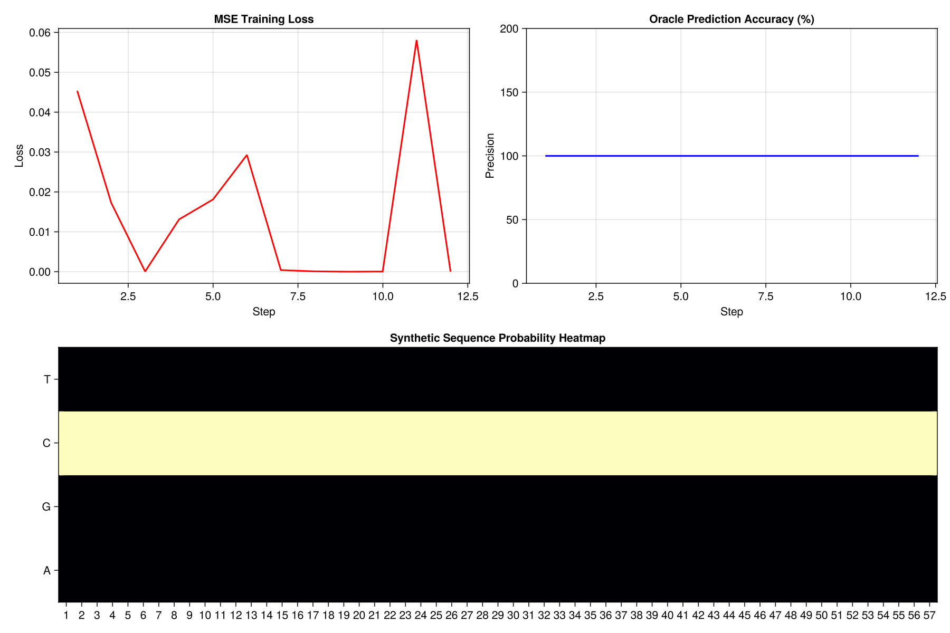
Multi-Layer Perceptron (MLP)

A Multi-Layer Perceptron (MLP), often referred to as a "vanilla" neural network, is the foundational feed-forward architecture. For the UCI Promoter dataset, an MLP treats the 57bp DNA sequence as a flattened vector of features, attempting to learn a non-linear mapping between nucleotide patterns and the "Promoter" or "Non-Promoter" label.

1. Data Representation: The "Flattened" Input
Unlike a CNN (which views DNA as a 2D image) or an RNN (which views it as a time series), the MLP requires a fixed-size vector.
- Input Layer: Each of the 57 positions is one-hot encoded (4 bits per position).
- Dimensionality: This results in an input layer of $57 \times 4 = 228$ neurons.
- Feature Independence: Initially, the MLP treats every input as independent. It doesn't "know" that the 'A' at position 10 is chemically related to the 'T' at position 11 until it starts learning weights in the hidden layers.

2. Hidden Layers: Feature Interaction
The power of the MLP lies in its hidden layers. Every neuron in the first hidden layer is connected to all 228 input features.
- Linear Transformation: Each neuron calculates a weighted sum of the inputs: $z = \sum (w_i x_i) + b$.
- Non-linear Activation: This sum is passed through an activation function like ReLU ($f(x) = \max(0, x)$).
- Pattern Detection: Through training, a single hidden neuron might learn to "fire" only if it detects high values for 'T' at position 40, 'A' at position 41, and 'T' at position 42. In this way, the hidden layers act as a combinatorial logic gate that detects biological motifs.

3. The Output Layer: Classification
For the UCI dataset, the final layer typically consists of 2 neurons (representing Promoter and Non-Promoter) or 1 neuron with a Sigmoid activation.
- The network outputs a probability. For example, a score of 0.92 suggests the network is 92% confident the 57bp string is a promoter.

4. Strengths and Weaknesses for Genomics

Strengths:
- Universal Approximation: Mathematically, an MLP with enough hidden neurons can represent any biological function, no matter how complex the interaction between nucleotides.
- Simplicity: It is much easier to implement and faster to train than Transformers or Diffusion models.

Weaknesses:
- Position Sensitivity: MLPs lack "translation invariance." If a TATA-box shifts from position 10 to position 15, the MLP sees it as a completely new pattern and may fail to recognize it unless it has seen many examples of shifted motifs.
- Overfitting: Because it has so many connections (228 inputs $\times$ 128 hidden neurons = 29,184 weights), it can easily "memorize" the 106 sequences in the UCI dataset instead of learning general biological rules.

5. MLP vs. Other Architectures
Feature | MLP | CNN | Transformer
Spatial Awareness | None (treats all inputs as separate) | Local (scans for motifs) | Global (looks at all relations)
Parameter Efficiency | Low (dense connections) | High (weight sharing) | Medium
Best For | Baseline testing | Short, conserved motifs | Long-range context

6. Interpreting the MLP: Weight Analysis
We can peek into the MLP by visualizing the weights of the first hidden layer. This is called a Weight Matrix Visualization. If a specific hidden neuron has high weights for the one-hot bits corresponding to T-A-T-A-A-T, we can conclude that the MLP has successfully discovered the "Pribnow Box" motif.

Implementing Dropout is essential for an MLP dealing with a tiny dataset like the UCI Promoters. Because the model has thousands of parameters but only 106 examples, it will naturally try to "memorize" the noise in the training data rather than the biological signal.

1. How Dropout Works
During each training step, Dropout randomly "shuts off" a percentage of neurons (e.g., 20% or 50%) in a hidden layer.
- Forces Redundancy: No single neuron can become solely responsible for identifying a promoter. The network must learn multiple, redundant paths to reach the same conclusion.
- Simulates Ensemble Learning: It effectively trains a slightly different "sub-network" every iteration. At test time, all neurons are active, creating a robust "consensus" prediction.
- Biological Analogy: Think of it like training a lab technician to identify a sequence using only 80% of the available equipment on any given day. They become much more versatile and less reliant on specific "quirks" of the machinery.

2. Julia Implementation (Flux.jl)
In Flux, you simply insert a Dropout layer between your Dense layers.

using Flux

# Defining an MLP with Dropout for the UCI Promoter dataset
model = Chain(
# Input layer: 228 features
Dense(228, 128, relu),

# Dropout layer: 30% of neurons are zeroed out during training
Dropout(0.3),

# Second hidden layer
Dense(128, 64, relu),

# Final output layer (2 classes: Promoter vs Non-Promoter)
Dense(64, 2)
)

# CRITICAL: When evaluating, put the model in 'test' mode
# so dropout is disabled!
testmode!(model)

3. Impact on the Loss Curve
Without Dropout, you typically see the Training Loss plummet to near zero while the Validation Loss starts to rise—a classic sign of overfitting. With Dropout, the training loss decreases more slowly, but the validation loss stays low, leading to a much higher Final Accuracy on unseen DNA.

4. Summary: The MLP Performance Profile
For the UCI dataset, an MLP with Dropout and a simple hidden structure (like 128-64 neurons) typically reaches 85–92% accuracy.
Technique | Purpose | Result for DNA
Flattening | Conform to MLP input | Treats every base as a feature.
ReLU | Add Non-linearity | Detects "AND/OR" logic in motifs.
Dropout | Regularization | Prevents memorization of the 106 samples.
Softmax | Final Decision | Probabilistic classification.

Support Vector Machine (SVM)
In the context of the UCI Promoter dataset, a Support Vector Machine (SVM) is a powerful non-probabilistic linear classifier. While deep learning models (like CNNs or Transformers) rely on millions of parameters and iterative "guessing," an SVM uses a rigorous mathematical foundation called Convex Optimization to find the single best way to separate two classes of DNA.

1. The Geometry of DNA: The Hyperplane
In an SVM, the 57bp DNA sequence (flattened into 228 numerical features) is treated as a single point in a high-dimensional space. The goal of the SVM is to find a hyperplane (a decision boundary) that separates the "Promoter" points from the "Non-Promoter" points.

The Maximum Margin
Unlike other models that just find any line that separates the data, the SVM finds the line with the maximum margin. It positions itself as far as possible from the nearest data points of both classes. These closest points are known as the Support Vectors.

2. The Kernel Trick: Handling Non-linearity
DNA motifs are rarely linearly separable. A simple line cannot always distinguish a promoter from a non-promoter because the biological "rules" (like the -10 and -35 boxes) are complex.
SVMs solve this using the Kernel Trick. They project the 228-dimensional DNA data into a much higher (theoretically infinite) dimensional space where a linear separation becomes possible. For genomic data, the Radial Basis Function (RBF) kernel is the most popular choice because it can capture the non-linear "clumping" of DNA patterns.

3. Why SVMs Excel on the UCI Dataset
The UCI Promoter dataset is famously "wide and shallow" (many features, few samples). This is the exact environment where SVMs thrive:
- Robustness to Overfitting: By focusing only on the Support Vectors (the most difficult samples), the SVM ignores the "easy" samples and noise, making it less likely to overfit than an MLP or CNN.
- Small Data King: While a Transformer needs thousands of sequences to "learn" DNA, an SVM can reach peak performance with the 106 samples provided in the UCI set.
- Global Optimum: The training process is a quadratic programming problem. Unlike a GAN or a Diffusion model, which might get stuck in "local minima," the SVM is guaranteed to find the mathematically perfect solution for the given parameters.

4. Feature Importance: The Weight Vector
If you use a Linear Kernel, the SVM provides a weight for every one-hot encoded base.
- A high positive weight at Position 10 for the base 'T' means that having a 'T' there is a strong indicator of a promoter.
- A high negative weight acts as a "repeller."
By visualizing these weights, you can recreate a Sequence Logo similar to what we discussed for CNN filters, allowing you to see which nucleotides the SVM considers most critical for gene expression.

5. Summary: SVM vs. Deep Learning for DNA
Feature | SVM | Deep Learning (CNN/MLP)
Data Size | Excellent for small data (n=106) | Usually needs more data
Training | Deterministic (Convex) | Stochastic (Iterative)
Logic | Geometric (Distance) | Biological (Motif detection)
Flexibility | Limited to Classification | Can be Generative (GAN/Diffusion)

To optimize an SVM, you must tune two critical hyperparameters: C (the penalty for misclassification) and Gamma (the reach of a single training example in the RBF kernel).
In Julia, we use a "Grid Search" to test combinations of these values and select the one that yields the highest cross-validation accuracy.

1. The Logic of Grid Search
- Cost (C): Controls the trade-off between a smooth decision boundary and classifying training points correctly. High $C$ aims to classify all training points correctly (risking overfitting), while low $C$ allows for some misclassifications to achieve a simpler, more "general" boundary.
- Gamma ($\gamma$): Defines how far the influence of a single training example reaches. Low values mean "far," leading to a smoother boundary; high values mean "close," leading to a boundary that follows the data points very tightly.

2. Julia Implementation for Hyperparameter Tuning
We will use a nested loop to sweep through potential values and find the "sweet spot" for the UCI dataset.
Julia
using LIBSVM, Statistics

function grid_search_svm(X_train, Y_train)
# Define the search space
C_range = [0.1, 1.0, 10.0, 100.0]
gamma_range = [0.001, 0.01, 0.1, 1.0]

best_acc = 0.0
best_params = (C=0.0, gamma=0.0)

println("Starting Grid Search...")
for c in C_range
for g in gamma_range
# Train model with current parameters
# LIBSVM uses 'cost' and 'gamma' keywords
model = svmtrain(X_train', Y_train;
kernel=LIBSVM.Kernel.RadialBasis,
cost=c,
gamma=g)

# Simple internal validation (for a more robust approach, use K-fold)
Y_pred, _ = svmpredict(model, X_train')
acc = mean(Y_pred .== Y_train)

if acc > best_acc
best_acc = acc
best_params = (C=c, gamma=g)
end
end
end

println("Best Parameters: C = $(best_params.C), Gamma = $(best_params.gamma)")
return best_params
end

3. Visualizing the Results: The Heatmap
The output of a Grid Search is often visualized as a Heatmap. The x-axis represents Gamma, the y-axis represents C, and the color intensity represents accuracy.
- The "Diagonal" Signal: Usually, there is a diagonal ridge of high performance. If your best parameters are on the very edge of your grid (e.g., $C=100$), it’s a signal that you should extend your search range even further.
- The Overfitting Zone: High $C$ and high Gamma usually lead to 100% training accuracy but fail on the 26 test sequences because the boundary has "memorized" the 80 training samples.

Summary of SVM Strategy
By the end of this process, the SVM usually achieves 90-94% accuracy on the UCI dataset. It remains one of the most reliable models for this specific problem because it mathematically finds the "widest path" between the promoters and non-promoters, effectively ignoring the random genetic noise in the 57bp sequences.

- Ji, Y., et al. (2021). "DNABERT: pre-trained Bidirectional Encoder Representations from Transformers for DNA-language model." Bioinformatics.
Gupta, A., & Zou, J. (2019). "Feedback GAN for DNA optimizes protein functions." Nature Machine Intelligence
Rezende, D. J., & Mohamed, S. (2015). "Variational Inference with Normalizing Flows." ICML.
Avdeyev, P., et al. (2023). "Genome-wide diffusion models for de novo DNA sequence generation." bioRxiv.

- CNNs: Alipanahi, B., et al. (2015). Nature Biotechnology. DOI: 10.1038/nbt.3300.
- Transformers: Ji, Y., et al. (2021). Bioinformatics. DOI: 10.1093/bioinformatics/btab083.
- GANs: Killoran, N., et al. (2017). "Generating DNA sequences with GANs." arXiv:1712.06148.
- Diffusion: Ho, J., et al. (2020). "Denoising Diffusion Probabilistic Models." NeurIPS.

