Deep Learning of Sequential Data with Transformers and Comparison with Recurrent Neural Networks
Stergios Papadimitriou (sterg@cs.duth.gr)
MLV Research Group, Department of Informatics, Democritus University of Thrace, 65404 Kavala, Greece

Abstract. Transformers were introduced mainly to solve the shortcomings of Recurrent Neural Networks (RNNs), namely their inability to handle long-range dependencies. Transformers overcome the drawbacks of RNN-based techniques through the use of self-attention mechanisms, positional encoding, and multi-head attention. This work aims to highlight the role of Transformers and compare it with RNNs for temporal processing, presenting the basic attributes of Transformers, such as their structure and functioning, followed by detailed procedures concerning their applications, developing two efficient implementations of Transformers, one for protein prediction with the Julia Flux framework and one for the classification of breast cancer ultrasound images with the Python PyTorch framework using two different datasets, the Breast Ultrasound Images Dataset (BUSI) and the BUS-UCLM-Breast Ultrasound Le-sion Segmentation Dataset (BUS-UCLM). Results indicate that Transformer succeeds in modeling the statistical properties of the aminoacid composition of proteins, while for the breast cancer classification problem accuracies of up to 99.62% and 100% are reported, for BUSI and BUS-UCLM datasets, respectively, not only demonstrating the versatility of Transformers across domains but also highlight their potential as a unifying framework for complex biological and medical tasks, underscoring the broader relevance of Transformer architectures in advancing both computational biology and medical imaging.
Keywords: Recurrent Neural Networks, Long Short-Term Memory, Gated Recurrent Units, Transformers, Positional Encoding, Multi-Head Attention, Sequence Modeling.
- Introduction
Transformers have advanced deep learning by overcoming the drawbacks of conventional sequence-based models such as Recurrent Neural Networks (RNNs), especially in natural language processing and speech recognition, due to the use of the self-attention mechanism [1]. This mechanism enables them to process complete sequences in parallel, in contrast to RNNs, which process data sequentially and report problems with vanishing gradients and long-range dependency [2–4]. As a result, training efficiency is greatly increased, and models are better equipped to capture intricate relationships. The primary novelty of the Transformers is their capacity to give distinct segments of an input sequence differing degrees of significance, allowing for more contextually aware predictions. Their capacity to simulate sequential data without depending on recurrence is further improved by elements like feedforward layers, positional encoding, and multi-head attention. Transformers form the foundation of cutting-edge speech and language systems since Vaswani introduced them with the Transformer architecture in 2017, opening the door for more effective technologies [1].
To this end, this work aims to unravel the role of Transformers and to compare it with RNNs for temporal processing. The basic attributes of Transformers, such as their structure and functioning, are highlighted, followed by detailed procedures concerning their applications. This work elaborates on various architectures of these networks in terms of training and evaluation methodologies, including case studies. It further includes a list of problems and limitations that remain with the current developed models and ends up with possible research directions and emerging tendencies.
The paper proceeds as follows. Section 2 describes key components of the Transformer architecture and compares them with RNNs. Section 3 presents two implementations of Transformers and the corresponding results, respectively. Finally, conclusions are presented along with directions for future work.
- Transformer Architecture
Unlike RNNs, which capture temporal dependencies through intermediate features passed from previous states, the self-attention mechanism can access information from any position in the sequence with a constant computational cost.
Transformers, instead of using sequence aligning as RNNs, or convolution operators, rely exclusively on the powerful self-attention mechanism. A Transformer for text translation for example builds relationships between words after processing them with self-attention and outputs their translation into another language.
Moreover, Transformers have encoder-decoder components. The layers of the encoder and decoder are stack of layers at the original Transformer model; the encoder receives the input and outputs a matrix representation of it, while the decoder is fed with the encoder outputs and generates an output.
Token processing starts with the input embedding layers. The input tokens are converted into vectors using embedding. Although the original coordinate space ignores semantic context, the embedding spaces construct precious semantic structure. Following the input embedding layer, the positional encoding layer injects position dependence, permitting token ordering and the residual connections preserve the position information across layers.
The original encoder Transformer model has N=6 layers. These layers have the same layer structure. Additionally, they contain two main sublayers: the first is the multi-head attention layer and the second is the fully connected feedforward layer.
This clever mechanism of the Transformer model keeps the positional information as it passes from layer to layer. Sublayer(x) denotes this positional information. Positional learning can either be trained or learned. Therefore, the normalized output of each layer is:
y=LayerNorm (𝑥 + Sublayer(𝑥)) (1)
where x is the input to the current layer (either the initial embedding of the tokens in the first layer or the output from the previous layer), Sublayer(x) denotes the transformation applied within the layer (such as multi-head self-attention or a feed-forward network), and y is the final normalized output after applying the residual connection and layer normalization. Each of the six layers, although they are identical in structure, they own different weight vectors. For example, the embedding sublayer is at the bottom of the stack only. The top five layers lack an embedding layer, therefore the encoded input is stable as it flows through the layers.
The multi-head attention machinery accomplishes the same functions through all the layers. The tasks however that they perform are different. They associate the tokens in the sequence in disperse manners. Thus each layer learns from the previous layers and exploits additional associations of the tokens.
RNNs construct a hidden state that captures an overall representation of the input. A drawback is that some part of the processed input may not be relevant to the current task at hand. Transformers do not suffer from this problem, since the attention mechanism filters the proper context sensitive information from the input.
One subtlety remains: information from future tokens can leak. To avoid the leakage we apply causal masking that uses a mask that hides the future tokens. A single component of the architecture is the transform block. This block applies some skip connections, feed forward dense layers, and normalization around the multi-head attention layer. A skip connection passes around the multi-head attention layer and is added to the output. The skip connection alleviates the gradient vanishing problem by providing a gradient free highway that allows to transfer information forward uninterrupted. Additionally, layer normalization is used to provide stability.
A clever design choice is the constant dimension for the output of each sublayer. At the original transformer this dimension is dmodel=512. The constant dimension implies that all key operations consist of dot products that produce results of the same dimensionality. This reduces the number of operations and makes it easier to trace the information as it passes through the layers. In the original Transformer model, the input embedding sublayer transforms the input tokens to vectors of dimension dmodel=512 exploiting learned embeddings.
The multi-head attention sublayer consists of eight heads and is followed by post-layer normalization that adds residual connections to the output of the sublayer and normalizes it. The input to the multi-head attention of the first layer of the encoder stack is a vector that contains the embedding and the positional encoding of each word. Each head of the attention mechanism computes three representations:
- A query matrix (𝑄) with dimension 𝑑_{𝑞} = 64. This seeks all the key-value pairs of the other matrices.
- A key matrix (𝐾) with dimension 𝑑_{𝑘} = 64.
- A value matrix (V) with dimension 𝑑_{𝑣} = 64.
Attention is defined as scaled dot-product attention, which is represented in by the equation (2):
$Attention(Q,K,V)=softmax(\frac{QK^{T}}{\sqrt{d_{k}}})$ (2)
These matrices have the same dimension, therefore it is relatively simple to use scaled dot product to compute the attention values for each head and then concatenate the output of the 8 heads. The derivation of Q, K, and V is done with training the model with their respective weight matrices Q_{w}, K_{w}, and V_{w}, that have d_{k}=64 columns and dmodel=512 rows. The architecture of the Transformer is illustrated in Fig. 1.
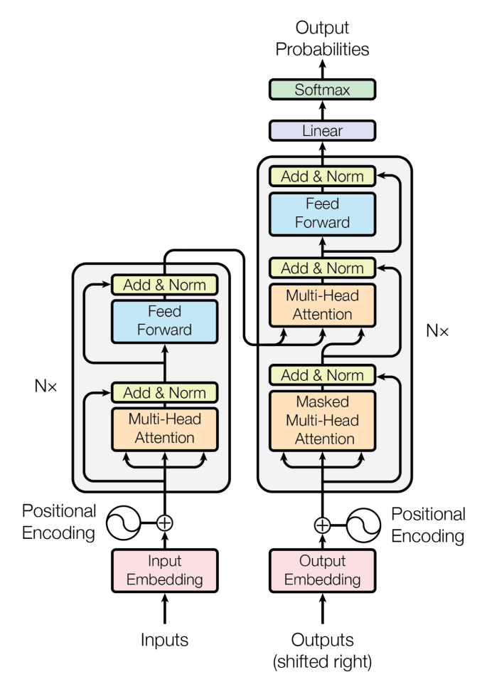
Fig. 1. The Transformer architecture [1].
- Implementations
In what follows, we present two Transformer architectures, one implemented in Julia with the Flux deep learning library and one in Python with the PyTorch library.
  - Protein Prediction with the Julia Flux Framework
The problem considered is protein prediction, i.e. given a known part of the sequence of amino acids to predict the next one. Given the ambiguity of the genetic code and the complex processes of DNA transcription and translation, the next amino acid is determined probabilistically and it is rather difficult to predict it. Transformers, as they are ample to consider interactions between distant amino acids and thus distant nucleotides at the DNA level, are an excellent vehicle for this application. We used protein sequences obtained from the UniProt database (https://www.uniprot.org/).
The application starts by importing important libraries such as the Flux deep learning package, the NNLib (Neural Network Library), the Zygote ChainRules automatic differentiation framework, the CUDA package for accelerating on NVIDIA GPU devices, and some other important libraries as the Functors, Distributions, StatsBase, Random and the ProgressMeter useful utility. Subsequently, some important Julia packages of the local application are imported and global functionality is exported.
Next, the application defines some general constants, such as the batch size, the maximum iterations, the learning rate and also some constants for the architecture of the Transformer as the embedding dimensionality, the number of heads, the number of layers, the dropout parameter, the vocabulary size. Also, a causal mask is created. In our case, the batch size was set to 64, the learning rate to 0.03, the embedded dimension to 384, the number of heads to 8, the number of layers to 6 and the dropout probability to 0.2.
It should be noted the essential structure of TransformerBlock. It consists of a MultiheadAttention block, a LayerNormalization, followed by two Dense layers, another LayerNormalization layer, and finally a Dropout layer for regularization. A scaled dot attention is implemented according to Equation 1. Next, a GPTLanguage model is defined as a structure that includes as fields the token embedding table, the position embedding table, the blocks of the Transformer, and subsequently the Normalization layer and the Dense output layer. The operation of the Transformer is coded elegantly with a Julia anonymous function (i.e. lambda expression). This function applies initially the embedding layer to the input. Next, it position encodes the input. Subsequently, a series of multi-head attention blocks are applied to capture the dependencies between tokens, i.e., aminoacids in the particular application. One-hot encoding is used for output aminoacid. Also, the logit cross entropy is used as a loss function.
Next, we read the protein training file which consists of sequences with total length 99.345 aminoacids, not a very large file but capable of illustrating Transformer learning, requiring about 30-50 minutes of training on a machine with an NVIDIA RTX3070 card and Intel Ultra Core i9 285K CPU. The newline character signifies the ending of a protein molecule and the beginning of the next. Clearly, the vocabulary size is 21, the 20 aminoacids plus the protein termination newline marker. Dictionaries are created for efficiently taking the index of a symbol and from each symbol its own index. Results, indicate that the Transformer succeeds in modeling the statistical properties of the aminoacid composition of proteins. Specifically, we obtained an accuracy of about 63.5% at the prediction of the next aminoacid.

3.2 Classification of breast cancer ultrasound images with the Python PyTorch framework

In the following, the application of Transformers for classifying images obtained with ultrasound for the detection of breast cancer is presented. In these implementations, two datasets are used.

Data Sets. Two datasets are employed, the Breast Ultrasound Images Dataset (Dataset BUSI) [5] on Kaggle, and the BUS-UCLM-Breast Ultrasound Lesion Segmentation Dataset, published by Vallez et al. [6].

Dataset BUSI. The model was trained on ultrasound images retrieved from the Breast Ultrasound Images Dataset (Dataset BUSI) [5] on Kaggle. These images show ultrasound scans of breast tissue, captured using medical imaging technology from the Medical Center and Hospital “Baheya” in Cairo in Egypt, with the aim of early-stage detection and treatment of breast cancer. The dataset consists of 830 ultrasound (US) images, which were captured from 600 female patients, between the ages of 25 and 75 years old. The images are categorized into three classes: normal, benign and malignant. In the dataset 133 images of normal tissues, 487 images of benign tumors and 210 images of malignant tumors are included.

Dataset BUS-UCLM. The BUS-UCLM-Breast Ultrasound Lesion Segmentation Dataset-, published by Vallez et al. [6], comprises of breast ultrasound images from 38 patients, collected between the year 2022 and 2023, using the Siemens ACUSON S2000TM Ultrasound System. The dataset consists of 683 images, distributed as 419 normal, 174 benign and 90 malignant images.

We begin by tokenizing the dataset, meaning the input images are broken up into a bunch of little pieces called tokens or patches. Each one of these tokens is then associated with a vector, which could be illustrated as a list of numbers, in order to encode the semantic meaning of that patch. Each patch is then flattened and projected into a higher-dimensional embedding space. We then split the image into non-overlapping patches and project each patch to a 128-dimensional vector, using the “Conv2d” and the “projection” function. Meanwhile in the forward method, the image turns into a sequence of embedded patches with the “Conv2d” and “projection” function. The output is then reshaped and flattened. Finally, the positional embeddings are added to all elements in the sequence so we will know where each patch is located. We return the sequence as tensor as the final result.
The newly formed sequence of vectors are then passed through an operation that’s known as a multi-head self-attention block. This operation allows the vectors to “talk” to each other and pass information back and forth to update their values. It helps us distinguish the similarities of the patches of the image as well as learn the relationship between them. Similar contextual patches tend to land on vectors that are close to each other in the multidimensional space.
The encoding in the transformer model has two layers. First, it has a self-attention layer meaning a layer that takes list of vectors as input and calculate the self-attention score of each vector in that list. As aforementioned, self-attention allows the vectors to “understand” their own semantic meaning by taking clues from other nearby vectors. Second, the outputs of the self-attention layer are fed to a feed-forward neural network, which is independently applied to each vector.
In the constructor, we initialize the number of attention heads of each sequence of patches, which work in parallel to each other (in our case we use 4 heads), in order to capture the different relationships between the patches. Each head will provide us with a different interpretation of the relationships between the patches.
Firstly, we apply a layer normalization before the attention block and then apply multi-head self-attention, where each head “focuses” on a different part of the relationships between the patches, for example one “focuses” contrasts between patches, while another on repeating patterns within them.
For the self-attention layer, the Q (Query), K (Key), V (Value) vectors are calculated. The Q, K, V are weight matrices that are used to calculate the score of each patch in order to determine its position in the multidimensional space. It takes as parameters, in the addition to the size of each patch’s vector, the number of parallel attention heads, the dropout probability on attention weights and the size of the hidden layer inside the model for self-attention.
After the self-attention, the feed-forward layer follows where each vector is fed into the feed-forward neural network. We use this layer in order to filter out noise, created by the sharing of information between the patches in the previous layer, as well as to highlight only the important information that patch needs.
In the feed-forward layer, we apply first a normalization layer into each input vector, then implement two affine linear transformations. As a result, the model returns a 128- dimensional vector (x). Finally the images are classified into the three categories.

In the “train” function we initialize our custom dataset class and we create two data loaders, one for training and one for evaluating the results of the training. Subsequently we randomize the data of the training data loader with the parameter shuffle and we set the byte size of the data loader, because Pytorch processes the images in batches or groups, for optimization reasons of the images. In the training we iterate through the number of generations or epochs. For each generation we take a batch of data and their labels. We pass the data forward through the model, taking back the resulting labels and we evaluate the outputting labels using the function “CrossEntropyLoss”. With this criterion the cross entropy loss, between the input logits and target is calculated and as a result the losses of the training are given. Then we go through the process of the back propagation, using as optimizer the Stochastic Gradient Descent (SDG) method. Finally we save the weights of the model.

In this following, the quantitative evaluation of the proposed model’s performance is described. The evaluation criteria were computed using the aforementioned datasets BUSI and BUS-UCLM.
The performance of the model was assessed using standard criterion, for instance the model’s diagnostic accuracy, which provides insights into its ability to correctly identify and distinguish between normal, benign and malignant breast ultrasound images. Additionally, the receiver operating characteristic (ROC) curve and the area under the curve (AUC), were utilized to evaluate the model’s discrimination capability across different thresholds. The results which are presented in this section provide an analysis of the model’s strengths and limitations and offer insights related into potentials for its clinical application in breast cancer detection.
Fig. 2 illustrates the results of the transformer-based model’s training while using the BUSI dataset. The model starts with a percentage of accuracy 55.77% to 58.85% from the initial 10 to 100 epochs. In 200 epochs it shows a significant increase in the percentage of accuracy to 88.85%. From the threshold of 400 (88.85%) to 1000 (99.62%) epochs the model shows stability with an average accuracy percentage of 99.49%.

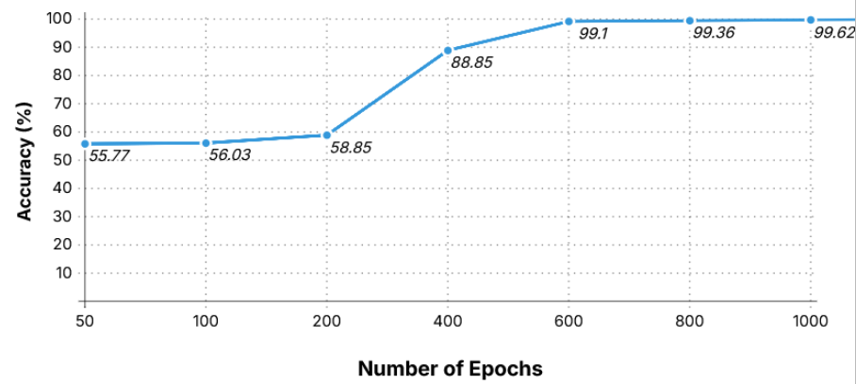
Fig. 2. The performance accuracy of the Transformer model with the BUSI dataset during different epochs.
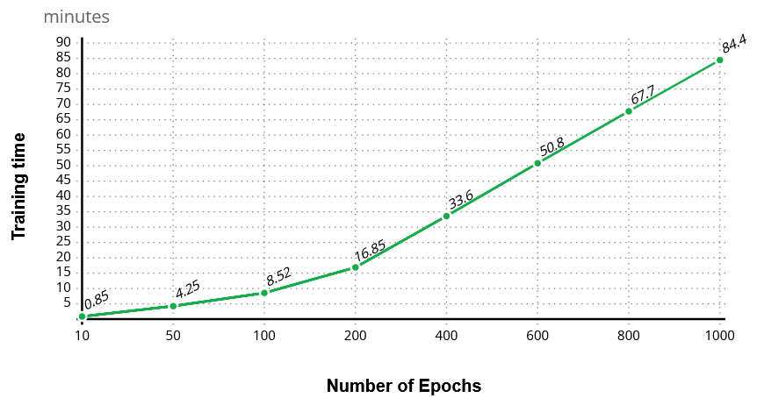
Regarding the training time, results indicate that it increases linearly with the number of epochs, as seen in Fig. 3. The training time grows gradually in every tier of
Fig. 3 The training time of the Transformer model with the BUS-UCLM dataset during different epochs.

epochs of the training until the threshold of 400 epochs, but is quadrupled between 50 and 100 epochs. From the threshold of 400 epochs until 1000 epochs, the training time continues to rise, yet the percentage of its rise tends to decline gradually. Indicatively, it should be mentioned that the training time from 400 epochs to 600 epochs has increased by 42.2%, from 600 epochs to 800 epochs it has risen by 32.8%, and from 800 to 1000 epochs the training time has increased by 25.3%.
When using the BUS-UCLM dataset, the model begins the initial training with an accuracy of 61.20% at 10 epochs, which gradually increases to 76.57% by 100 epochs. At the threshold of 200 epochs, the model achieves a notable increase in accuracy of 95.75%. From 400 to 800 epochs, the model maintains a high performance in the percentage of accuracy with its values ranging between 97.71% and 99.85%, until the threshold of 1000 epochs where it achieves perfect accuracy (100.00%). The training time increases linearly with the number of epochs (Fig. 4).
As it can be seen in Fig. 4, the training time grows gradually in every tier of epochs of the training until the threshold of 400 epochs, but it is nearly doubled between each step (e.g., from 9.09 minutes at 50 epochs to 18.03 at 100, and 36.32 at 200). From the threshold of 400 epochs until 800 epochs, the training time continues to rise, yet the percentage of its increase tends to decline gradually. More precisely, the training time from 400 epochs to 600 epochs increased by 49.7%, and from 600 epochs to 800 epochs, it rose by 31.5%.

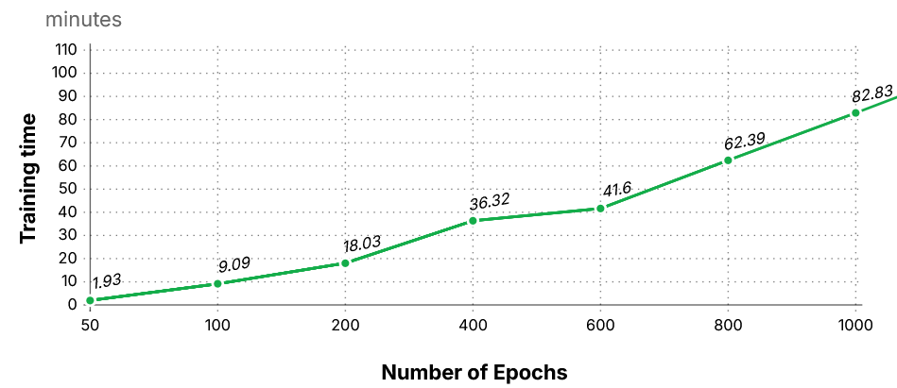
Fig. 4 The training time of the Transformer model with the BUS-UCLM dataset during different epochs.
- Conclusions
The indisputable influence of Transformers on contemporary sequential data processing applications is among the main conclusions drawn from this study. We scrutinized with RNNs’ drawbacks, such as their inability to handle long-range dependencies and disappearing gradients. Transformers have successfully addressed these problems through parallel processing and self-attention techniques. Τwo efficient implementations of Transformers were presented, for protein prediction and for the classification of breast cancer ultrasound images with two different datasets. Results indicated the efficiency of Transformer in modeling the statistical properties of the aminoacid composition of proteins, while for the breast cancer classification problem accuracies of up to 100% were reported.
Numerous unanswered questions and potential study topics have surfaced during our effort. A crucial concern is striking a balance between model efficiency and complexity, with transformers and other deep learning models having shown impressive gains in voice recognition performance, having a price, though, as huge models demand a significant amount of memory, processing power, and energy. Smaller businesses, mobile devices, or real-time embedded system applications may find it prohibitively expensive to train and implement such models. Therefore, one of the important research questions is how to create Transformer-based models that are lighter, more accurate, and use less computing power, requiring however additional research to improve them and make them more feasible for widespread use, although methods like quantization, knowledge distillation, and model pruning have shown promise.

Acknowledgments
This work was supported by the MPhil program “Advanced Technologies in Informatics and Computers”, which was hosted by the Department of Informatics, Democritus University of Thrace, Kavala, Greece.

References

1. Vaswani, A., Shazeer, N., Parmar, N., Uszkoreit, J., Jones, L., Gomez, A.N., Kaiser, L., Polosukhin, I.: Attention Is All You Need. arXiv. arXiv:1706, (2017).
2. Aggarwal, C.C.: Neural Networks and Deep Learning. Springer International Publishing, Cham (2023). https://doi.org/10.1007/978-3-031-29642-0.
3. Bishop, C.M., Bishop, H.: Deep Learning. Springer International Publishing, Cham (2024). https://doi.org/10.1007/978-3-031-45468-4.
4. Theodoridis, S.: Machine Learning from the Classics to Deep Networks, Transformers and Diffusion models, Academic Press (2025)
5. Al-Dhabyani, W., Gomaa, M., Khaled, H., Fahmy, A.: Dataset of breast ultrasound images. Data Br. 28, 104863 (2020). https://doi.org/10.1016/j.dib.2019.104863.
6. Vallez, N., Bueno, G., Deniz, O., Rienda, M. A., Pastor, C.: BUS-UCLM: Breast ultrasound lesion segmentation dataset. Scientific Data. 12, 242 (2025)

