Required Capstone Checkpoint 5.1: Designing and Evaluating an Agent-Based RAG System

Directions
Download this worksheet and save a copy to your device before you begin working. Use this worksheet to plan, organize, and complete your submission for Required Capstone Checkpoint 5.1. Type your responses directly into the document, save your completed work, and upload the finished file when you are ready to submit.

Completion Checklist
☐ Description of the agent-based system and task
☐ Explanation of how the system coordinates retrieval, reasoning, and multistep execution
☐ Evaluation results from 2-3 representative multistep test cases
☐ Description of refinements made to the system
☐ Analysis of the impact of those refinements
☐ Reflection on system strengths, limitations, and future improvements

Step 1. System Design
Describe the task that your agent-based system is designed to complete.
Examples may include generating reports, answering complex questions, synthesizing information across multiple documents, or completing another multistep task relevant to your capstone scenario.
Task description
My agent-based system answers questions that require connecting information across multiple saved Wikipedia articles. For example, “What spot did Jeremiyah Love get drafted, and how does that compare to Arizona’s picks in the same round from five earlier drafts?” To answer that, the system needs to find Love’s draft position and round, then find Arizona’s selections from five previous drafts and put the results together into a comparison. The goal is to support the answer with article citations and clearly explain when the collection doesn’t have enough information.

Agent workflow: Describe how your system works
My system starts with a hybrid search, combining keyword matching and semantic search to find relevant articles. The LLM then reviews the results and decides what to do next. It can run another search, follow links to related articles in the saved collection, ask for clarification, or move on to answering.
For the draft question, the idea is to first establish Love’s draft details, then use that information to search for Arizona’s earlier picks. The planner keeps track of previous searches and retrieved articles so it can focus on what’s still missing.
When the planner chooses to answer, it has to provide article IDs and supporting quotes for each part of the question. My code checks that the articles were retrieved and that the quotes actually appear in the text. If something is missing or invalid, the code changes the action to replan.
That replan step sends the missing-information feedback back to the LLM and asks it to choose a new search, follow links, or request clarification. Answering is excluded from the allowed choices for that retry. This gives the planner a chance to write a more useful query based on what it has already learned.
Separate prompts guide planning and final answering. They tell the system to avoid repeating searches, use retrieved evidence, cite its sources, and acknowledge gaps instead of guessing. I also limit the workflow to three action rounds and six collected articles. If it reaches those limits, it answers using what it found and is instructed to explain what remains unanswered.

Step 2. Initial Evaluation
Develop and evaluate your system using 2-3 representative test cases for your capstone scenario. Each test case should require more than one retrieval step or action.
For each test case, compare the agent-based system with your fixed retrieval pipeline from Checkpoint 2.1 or 3.1. Record relevant differences in answer quality, completeness, retrieval behavior, model calls, latency, or cost.
Evaluation results
I compared my agent-based system with the fixed retrieval pipeline using two questions that needed information from multiple articles. Automated judging was turned off for this run, so I reviewed the responses and logs myself.
During development, I noticed the agent was answering too soon. It would find part of the answer, but wasn’t consistently using that information to dig deeper and finish the question. I added the replan phase so that when the evidence check finds missing information, the planner gets that feedback and must choose another search, follow links, or ask for clarification.

Test case 1:
What spot did Jeremiyah Love get drafted, and how does it compare with Arizona’s picks in the same round from five older drafts?
Fixed pipeline 1:
Found Love’s draft position but didn’t complete the five-year comparison. 1 search, 1 model call, 3.33 seconds.
Agent-based system 1:
Used replan to identify missing years and search again. The comparison was longer, but still incomplete and included unsupported claims and a comparison error. 5 searches, 5 model calls, 11.92 seconds.

Test case 2:
What is the capital of the state that the actor who played Cooter Davenport represented in Congress?
Fixed pipeline 2:
Answered Atlanta while acknowledging that the retrieved documents didn’t explicitly support the capital. 1 search, 1 model call, 4.27 seconds.
Agent-based system 2:
Identified the actor and state, then used replan to search for the missing capital. The final answer cited both the actor’s article and the Georgia article. 3 searches, 3 model calls, 5.62 seconds.

The capital question showed the clearest improvement. The agent used what it learned to find the next piece of information. The draft question showed that more searching doesn’t necessarily produce a complete or reliable answer.

Strengths observed
Adding replan helped the agent move past its tendency to answer with whatever it found first. It could identify missing information and use the retrieved articles to create more specific follow-up searches. For the capital question, it connected Cooter Davenport to the actor, the actor to Georgia, and then searched for Georgia’s capital.
The logs also made the workflow easier to understand. I could see what the agent searched for, why it continued, and whether the additional work improved the answer. This helped me spot the early-answering problem and evaluate the change.

Weaknesses or challenges identified
The biggest challenge was getting the agent to recognize that finding a relevant article wasn’t the same as answering the whole question. Even after adding replan, the draft comparison still had missing information and unsupported claims.
My evidence check confirms that a quote exists in a retrieved article, but it doesn’t confirm that the quote supports the claim. In the draft test, the planner reused a quote about the 2026 draft as evidence for earlier years. That exposed a gap in the validation.
The extra planning and searches also increased latency and model calls. The draft question took about 3.6 times as long as the baseline. I didn’t measure dollar costs, but the additional calls increased usage.
Finally, the three-round and six-article limits can stop the agent before it finishes a complex question. Replan improved how it continued searching, but it didn’t guarantee that the final answer would be complete or correct.

Step 3. System Refinement
Based on your evaluation results, make one or more improvements to your system. Examples may include:
- Improving system prompts
- Adjusting workflow structure
- Modifying retrieval behavior
- Improving how the agent uses retrieved information
Changes implemented
The main improvement I made was adding the replan phase. The agent was answering too soon, before it had enough information to cover the whole question. It wasn’t consistently using what it found to dig deeper.
Previously, when the evidence check found missing information, the code automatically turned those missing items into search queries. If a query had already been tried, it added “supporting evidence” to the search text.
I changed that so the missing-information feedback goes back to the LLM, along with the retrieved articles and search history. The planner then chooses a more focused search, follows article links, or asks for clarification. Answering is excluded from the allowed actions during that retry.
I also updated the planning prompt to tell the agent to carry names, subjects, and other details learned from retrieved articles into follow-up searches, and to target the specific parts of the question that remain unanswered.

Justification
I made these changes because identifying a gap wasn’t enough—the system needed to use what it had learned to decide how to fill it. Simply repeating a missing subquestion, or adding “supporting evidence,” didn’t necessarily create a useful search.
The capital question showed why this matters. Once the agent identified Georgia as the state, it could search specifically for Georgia’s capital instead of repeating the original question about Cooter Davenport.
The draft comparison also showed more focused follow-up searches for missing years, although the final answer still had problems. The changes improved how the agent searched, but the results showed that checking whether evidence actually supports each claim is still an area I need to improve.

Step 4. Impact of Refinement
Evaluate the updated system. Describe any changes in task completion, accuracy, relevance, or overall system behavior. Compare the refined agent-based system with both its initial version and the fixed baseline. Explain whether the refinement improved performance and identify any trade-offs.

Impact on system performance
Adding replan improved how the agent used information it had already found. Instead of answering too soon or automatically retrying the missing question as a search, it could use the evidence-check feedback to decide what to look for next.
The clearest improvement was the Cooter Davenport capital question. The initial agent answered Atlanta but labeled that fact as missing from the provided documents. The refined agent used Georgia as the subject of its next search and retrieved an article supporting the capital. This made the final answer better supported.
The draft comparison had mixed results. The refined agent searched for specific missing draft years, which was better behavior, but its answer still contained unsupported claims and a comparison error. It looked more complete without being reliably more accurate. Both versions failed to finish the full five-year comparison.

Comparison of initial and refined systems
I compared the earlier run before replan with the updated run and the fixed baseline:
Test case 1: Draft comparison
Fixed baseline:
1 search, 1 model call, 3.33 seconds. Incomplete comparison.
Initial agent:
3 searches, 3 model calls, 8.78 seconds. Still incomplete.
Refined agent:
5 searches, 5 model calls, 11.92 seconds. More focused searches, but incomplete and partly unsupported.
Test case 2: Actor → state → capital
Fixed baseline:
1 search, 1 model call, 4.27 seconds. Gave the capital without direct supporting evidence.
Initial agent:
2 searches, 3 model calls, 6.93 seconds. Still lacked evidence for the capital.
Refined agent:
3 searches, 3 model calls, 5.62 seconds. Retrieved and cited supporting evidence for the capital.
The refinement improved follow-up searching and helped complete the evidence chain for the capital question. It didn’t establish an overall accuracy improvement across both tests.
The main trade-off was additional work. For the draft question, the refined agent used more searches and model calls and took longer than either previous approach. The capital test happened to run faster than the initial agent, but these are individual runs, so I wouldn’t treat that as a consistent speed improvement. I also didn’t measure dollar costs. The results showed that better planning helps, but stronger evidence validation is still needed.

Step 5. Reflection
Reflect on your experience designing and evaluating an agent-based RAG system.
What contributed most to successful task completion?
The biggest help was making the retrieval process visible through the logs. Looking at the final answer alone didn’t tell me whether the agent had found supporting evidence or just produced something that sounded right. The logs showed what it searched for, what it retrieved, and why it stopped.
That helped me identify the early-answering problem and add replan. Giving the planner feedback about missing information, along with what it had already found, made its follow-up searches more useful. The capital question was a good example: once it identified Georgia, it could search for the capital and support the answer with another article.
Comparing the agent against the fixed baseline was also useful. It showed me that the extra steps sometimes improved the evidence, but didn’t automatically improve the answer.

What limitations remain?
My evidence check verifies that a quote appears in a retrieved article, but not whether it actually supports the claim. The draft comparison exposed that problem when the planner reused information from one draft year as evidence for other years.
The system is also limited by what’s in the saved collection and by the three-round and six-article limits. It can reach those limits with parts of the question still unanswered. Additional planning increases model usage and often latency, without guaranteeing better accuracy.
The evaluation is still small, and automated judging was turned off for these runs. I can identify specific improvements, but I don’t yet have enough testing to say the agent consistently outperforms the baseline.

What improvements would you prioritize next?
First, I would improve evidence validation so it checks whether a passage supports the specific claim, including the correct person, year, and context. I would also check the final answer for unsupported claims and comparison mistakes.
Next, I would keep a clearer checklist of the requested information and which parts have verified support. For the draft question, each year would remain unfinished until the system found evidence for that year—or explicitly reported that it couldn’t.
Finally, I would expand the test set and repeat the comparisons using complete grading criteria. I’d want to measure whether these changes improve accuracy and completeness enough to justify the extra calls and time before simply increasing the retrieval limits.

Supporting Materials
Use this section to list, describe, or link to any supporting materials included with your submission.
Supporting material | Location, link, or note
System prompts: | These excerpts show how I guide the planner to use retrieved information and respond to missing evidence:  "Use retrieved articles to resolve vague names and references, and carry the "  "identified subject, domain, and entities into follow-up queries. Target specific "  "missing facts or comparison items, rather than repeating the original request. "  "If an evidence check rejects an answer, use its feedback and the retrieved "  "articles to choose a focused search, link expansion, or clarification. "  The answering prompt tells the model to support its response and acknowledge gaps:  "Answer the question using ONLY the provided documents, "  "quoting where you can. Cite supporting articles using their exact [article_id] "  "labels next to factual claims. If the documents do not answer part of the question, "  "say which information is missing rather than guessing."
Evaluation results: | The recorded results show the differences between the fixed baseline and refined agent:  Test case 1:  Draft comparison  Baseline 1:  1 search, 1 model call, 3.33 seconds  Refined agent 1:  5 searches, 5 model calls, 11.92 seconds  Test case 2:  Actor → state → capital  Baseline 2:  1 search, 1 model call, 4.27 seconds  Refined agent 2:  3 searches, 3 model calls, 5.62 seconds  The agent improved source support for the capital question, but the draft comparison remained incomplete and included unsupported claims. I reviewed these results manually; automated judging was disabled: RUN_JUDGE = False
Screenshots or diagrams: | 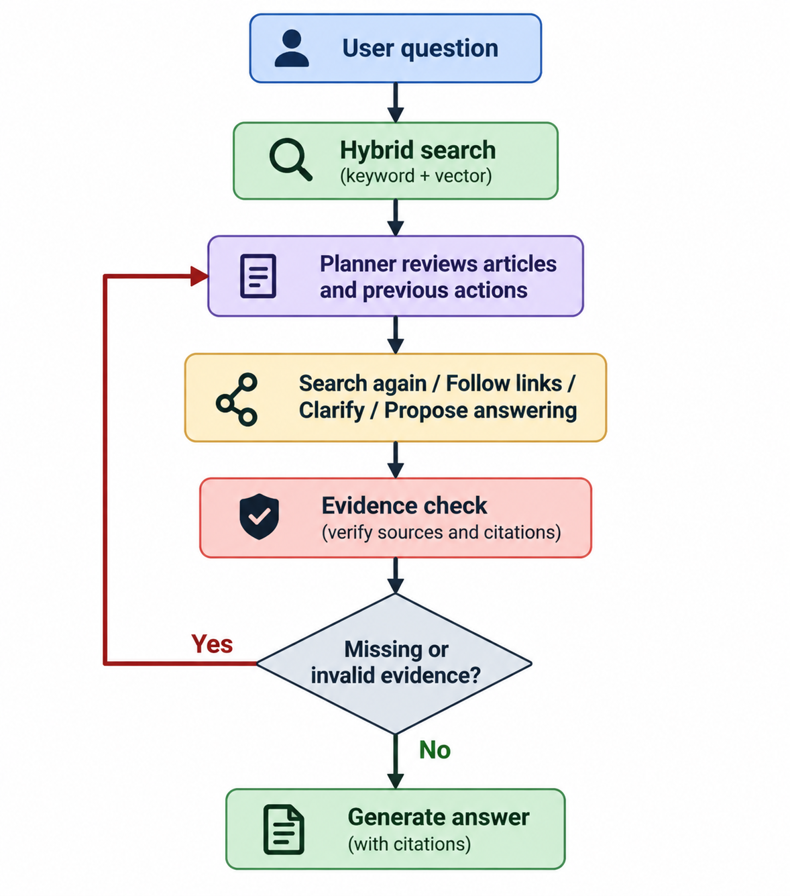  The workflow also stops at its configured limits and generates an answer from the evidence collected so far:  TOP_K = 3  MAX_STEPS = 3  MAX_CONTEXT_DOCS = 6
Code, notebook, or repository link: | This is the code that checks the planner’s proposed evidence and triggers replan:  if action == "answer":  result["requirements"] = decision.get("requirements", [])  missing = missing_evidence(result["requirements"], collected, question)  result["missing_information"] = missing  if missing:  result["action"] = "replan"  result["reasoning"] = "Missing or invalid evidence for: " + "; ".join(missing)  return result  The agent loop then sends the feedback back to the planner. Answering is excluded from the allowed actions for this retry:  if decision["action"] == "replan":  feedback = decision["missing_information"]  result["planner_calls"] += 1  revised = decide(  llm,  question,  {doc_id: hit[1] for doc_id, hit in collected.items()},  executed,  available_actions=("search", "follow_links", "clarify"),  action_history=action_history,  clarification_history=clarification_history,  expanded_articles=expanded_articles,  evidence_feedback=feedback,  )  revised["evidence_check"] = decision  decision = revised
Other supporting evidence: | This excerpt from the capital-question log shows the agent using what it learned to choose its next search:  {  "step": 2,  "action": "search",  "reasoning": "We have identified the actor as Ben Jones, who represented Georgia in Congress. The missing fact is Georgia’s capital, so a focused search on Georgia’s state capital should provide direct evidence.",  "queries": [  "Georgia capital state capital Atlanta",  "Georgia state capital Atlanta"  ]  }  This helped demonstrate that the updated agent was using the first retrieval to dig deeper into the missing part of the question.

End of Required Capstone Checkpoint 5.1
Return to the assignment page in the learning platform to upload and submit your completed capstone checkpoint worksheet and complete any remaining items in this module.

