**Chico Youth Court Adult Volunteer Form**

Date: __________________

Name: _______________________________________________

Address: _____________________________________________

Phone Number: Home ________________________ Cell _____________________________

Employer _________________________________________ Email ________________________

How did you hear about us?

What qualities do you have that would make you a good youth court volunteer?

What are you hoping to get out of this experience?

Would you like to volunteer for Advocate Mentor, Court Attendant, Case Manager or Spanish-English Translator?

Have you completed your background check?

**Code of Ethics**

* I will not discriminate against or refuse services to anyone on the basis of race, color, creed, age, sex, sexual orientation, religion, disability or nationality.
* I will evidence a genuine interest in all persons served, and do hereby dedicate myself to their best interests and helping them help themselves.
* I will respect the rights, views and confidences of my colleagues, and treat them with fairness, courtesy and good faith.
* If I know that a colleague has violated ethical standards, I will bring this to my colleague’s attention. If this fails, I will report the activity to my supervisor.
* I will act in accordance with standards of professional integrity.
* I will seek assistance for any problem that impairs my performance.

**Conflict of Interest**

I will avoid a conflict of interest or the appearance of a conflict of interest during and after any volunteer services are provided the Youth Court. A conflict of interest can arise from involvement by me that reasonably raises a question of my impartiality.

If a conflict of interest might reasonably be viewed as undermining the integrity of my work, I will withdraw from or decline to proceed regardless of the expressed desire or agreement of the parties to the contrary.

**Confidentiality**

I will respect the privacy concerns of the people the Youth Court serves. I will hold in confidence all information obtained in the course of my volunteer service, whether that information is obtained through written records or personal interaction with any person

1. as mandated by law;
2. to prevent a clear and immediate danger to a person or persons;
3. where I am compelled to do so by a court or pursuant to the rules of a court.

I will store or dispose of professional records in ways that maintain confidentiality.

I understand that violation of this Confidentiality Statement may be grounds for immediate release.

Further, I, upon leaving, will maintain client and co-worker confidentiality and I will hold confidential any information about sensitive situations within the Youth Court.

**Policy Regarding Violations of Law Committed by Volunteers**

Duty of Disclosure:

It is the duty of each and every volunteer to promptly notify the Program Coordinator or other Youth Court staff member of the fact the (s)he has been charged with or convicted of any violation of the law.

1. “charged with” includes arrest, citation or detention for any violation of the law
2. “conviction” includes conviction or adjudication by a court after trial, hearing, plea or admission of guilt made to a probation officer, responsible school official or member of the Youth Court.

Infractions, Misdemeanors, Felonies Violations:

* Upon being charged with an infraction, misdemeanor or felony violation, the volunteer will be suspended from the volunteer team until any and all legal actions are completed.
* Upon the second or subsequent conviction of any misdemeanors, felonies or tobacco and truancy violations, the volunteer will be removed from the volunteer team.

Application of this Policy:

* This policy shall be effective for all violations occurring after November 1, 2015.
* This policy shall be applicable to adult and youth volunteer team members.

Signed this __________day of _____________________________, ___________________

Signature of applicant: _______________________________________________________

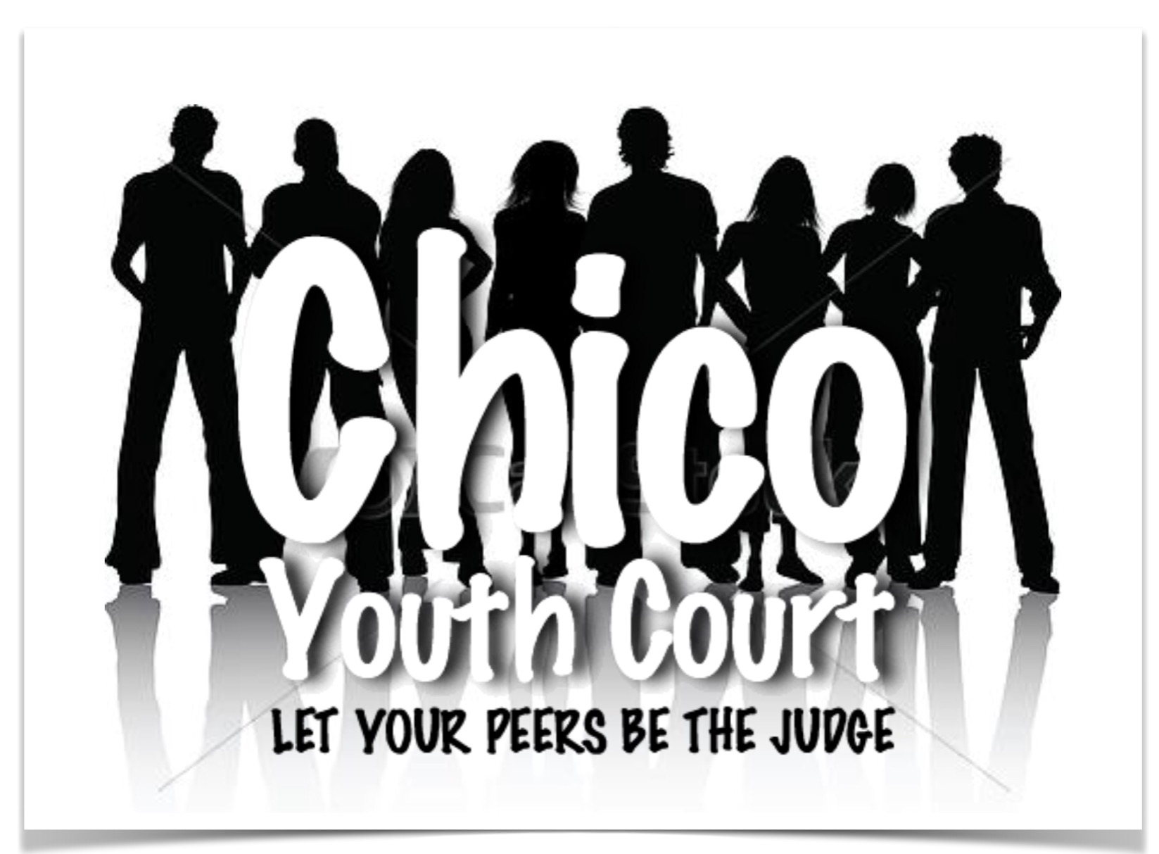

Please return volunteer form to: Chico Youth Court

336 Broadway St. Ste. 11

Chico, CA 95928