Lab 2
HTTP Reverse Proxy Load Balancing

- For lab 2, the objective was to load balance 4 server VM’s as to relieve stress off of a single server that was getting bogged down from too much traffic. After completing this lab, traffic from clients is evenly distributed among the different servers.

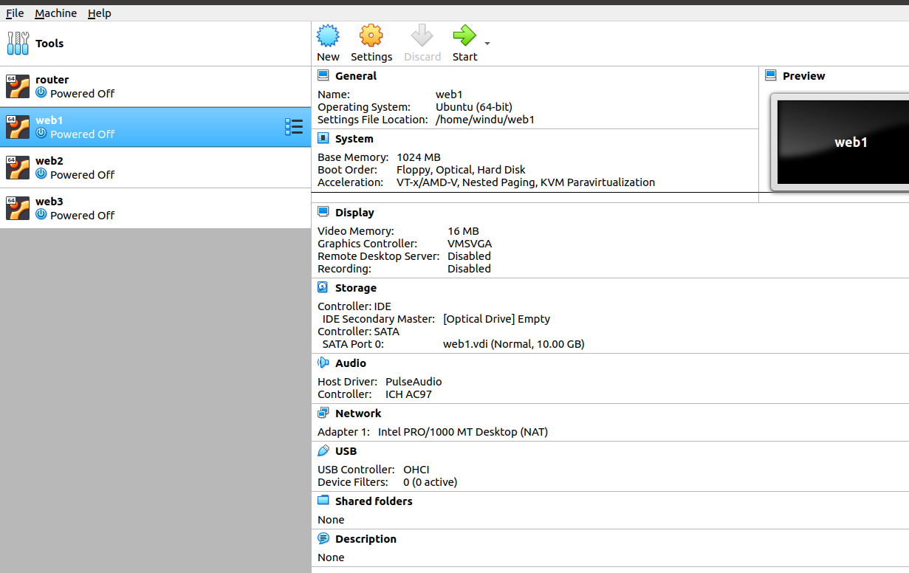
1. The first step was to install 4 server VM’s named: router, web1, web2, and web3.

The key here was to make sure that they all were type NAT network.
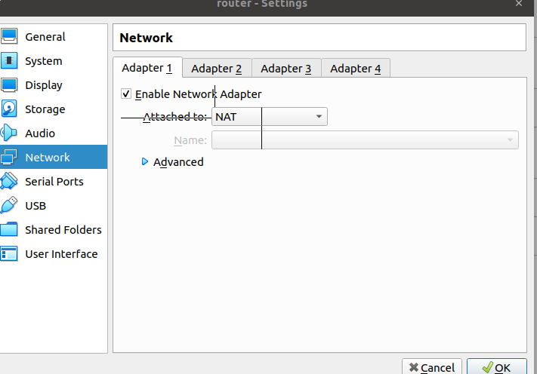

2. The second step was to install openssh-server on the 4 VM’s and openssh-client on the client VM

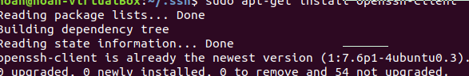

3. Then you need to copy your public key to the authorized_key file on each server. The first thing is to remote connect via ssh into our servers.

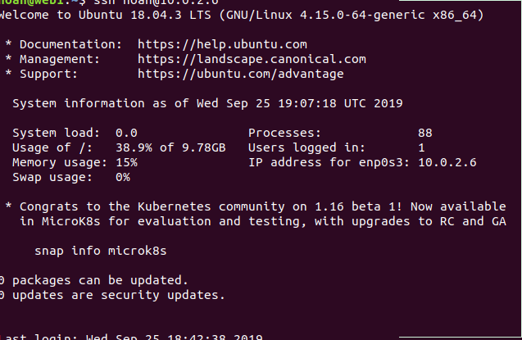
Then we need to copy our public key to every server.
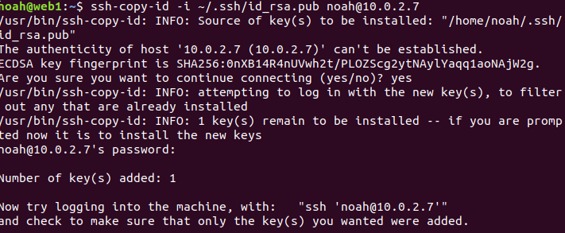

4. Then we need to install nginx web server on the server VM’s

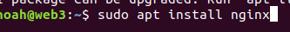

5. Now we need to modify the nginx defauilt page to include the server name. Then check to see if you can access it using the client vm.

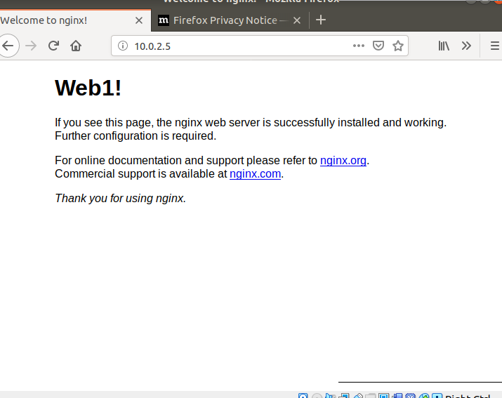
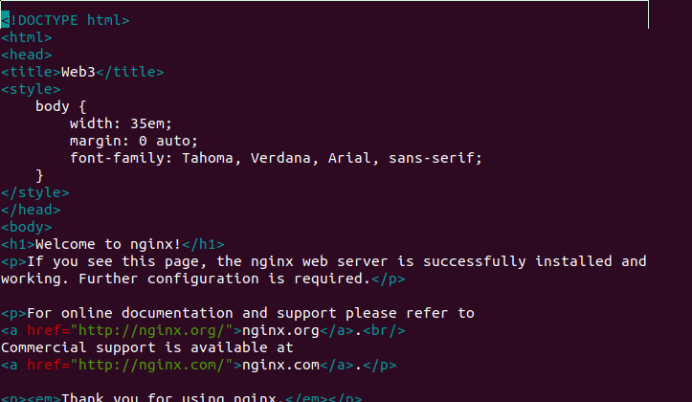

6. The final step is to configure nginx to do a round robin reverse proxy.

