Parkinson's Disease
Parkinson's disease is a progressive neurological disorder that affects movement control. It is one of the most common neurodegenerative diseases worldwide, primarily affecting the elderly population. Early diagnosis and treatment are critical for managing the symptoms and slowing down disease progression.
This Parkinson’s dataset, available on Kaggle, provides a rich collection of clinical and acoustic voice measurements to help develop AI models for early detection, progression monitoring, and treatment optimization.
This dataset is an essential resource for researchers and healthcare professionals focusing on neurological disorders. It includes detailed voice recordings and acoustic features that have been linked to Parkinson's disease symptoms.
The dataset provides valuable insights for developing machine learning models aimed at early diagnosis, monitoring disease progression, and predicting treatment outcomes.

  - Patient Information
Name (Patient ID): Unique identifier for each patient.
Status: Indicates whether the individual is diagnosed with Parkinson’s disease (1 for positive, 0 for negative).

  - Acoustic Features
MDVP (Hz): Average vocal fundamental frequency.
MDVP (Hz): Maximum vocal fundamental frequency.
MDVP (Hz): Minimum vocal fundamental frequency.
MDVP (%), MDVP (Abs), MDVP, MDVP, Jitter:DDP: Various measures of variations in frequency (jitter).
MDVP, MDVP(dB), Shimmer, Shimmer, Shimmer:DDA: Various measures of amplitude variation (shimmer).
NHR (Noise-to-Harmonics Ratio): Measures the proportion of noise to tonal components in the voice.
HNR (Harmonics-to-Noise Ratio): Quantifies the ratio of harmonic sound to noise in the voice.

  - Additional Clinical Features
RPDE (Recurrence Period Density Entropy): A nonlinear dynamical analysis of voice.
DFA (Detrended Fluctuation Analysis): Measures the long-term signal correlation in the voice.
Spread1, Spread2: Measures of variation in voice frequency.
D2: Another nonlinear dynamical measure.
PPE (Pitch Period Entropy): Measures the regularity of the pitch period.

  - Data Preprocessing
Data Cleaning: Ensure that no missing or inconsistent values exist in the dataset. Handle outliers in voice measurements, ensuring clean and accurate data for model input.
Normalization: Normalize features such as frequency and jitter measures to ensure consistency across samples before feeding them into machine learning models. Standardization can be applied to continuous variables like Fo, Fhi, and Flo.

  - Model Training
Frameworks: Leverage popular machine learning frameworks such as TensorFlow, PyTorch, or scikit-learn to train models on this dataset.
Model Selection: Algorithms like Support Vector Machines (SVM), Decision Trees, Random Forests, or Deep Neural Networks can be explored to classify patients as having Parkinson’s disease or not, based on their voice metrics.
Evaluation: Evaluate model performance using metrics like accuracy, precision, recall, and F1-score to ensure the effectiveness of models in classifying Parkinson's disease.

  - Deployment
Clinical Decision Support: Integrate the trained model into clinical tools to assist healthcare providers in diagnosing Parkinson’s disease early based on voice recordings.
Testing and Feedback: Continuously test the tool in clinical settings to ensure its reliability. Incorporate feedback from healthcare professionals to improve the model’s accuracy and usability.

  - Potential Applications
Machine Learning Models: Develop algorithms for early diagnosis and monitoring of Parkinson’s disease progression, as well as predicting patient outcomes based on vocal patterns.
Healthcare Insights: Provide clinicians with valuable insights for better understanding the vocal characteristics associated with Parkinson’s disease.
Academic Research: Facilitate research into vocal biomarkers for Parkinson’s disease, the development of non-invasive diagnostic tools, and personalized treatment plans.

  - Conclusion
The Parkinson’s Disease dataset offers an invaluable resource for the medical and research community. With its rich collection of acoustic measurements, it provides a robust foundation for the development of AI-based solutions to improve Parkinson’s disease diagnosis and treatment.
  - What to do with it…

firstly
differences between healthy vs Parkinson
we should watch when jitter ↑, shimmer ↑, noise ↑, entropy ↑
relationships between variables jitter vs shimmer and noise vs jitter
voice stability: How stable is the voice?

Very basic analysis
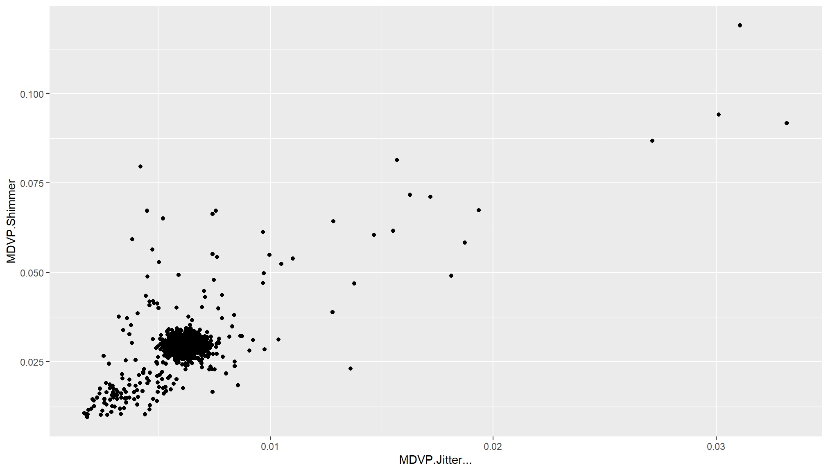
ggplot(parkins, aes(x = MDVP.Jitter..., y = MDVP.Shimmer)) +
geom_point()
The scatter plot reveals a positive relationship between jitter and shimmer, indicating that increased frequency instability is associated with increased amplitude variability in vocal signals.

> summary(parkins$`MDVP.Jitter...`)
Min. 1st Qu. Median Mean 3rd Qu. Max.
0.001680 0.005769 0.006188 0.006221 0.006557 0.033160
> summary(parkins$`MDVP.Shimmer`)
Min. 1st Qu. Median Mean 3rd Qu. Max.
0.00954 0.02799 0.02958 0.02967 0.03101 0.11908

Which was odd because status should be just 0 or 1
But from 195 row it was sort of random floating point so now working with 0-195 rows

table(parkins_clean$status)
48 Healthy
147 Parkinson
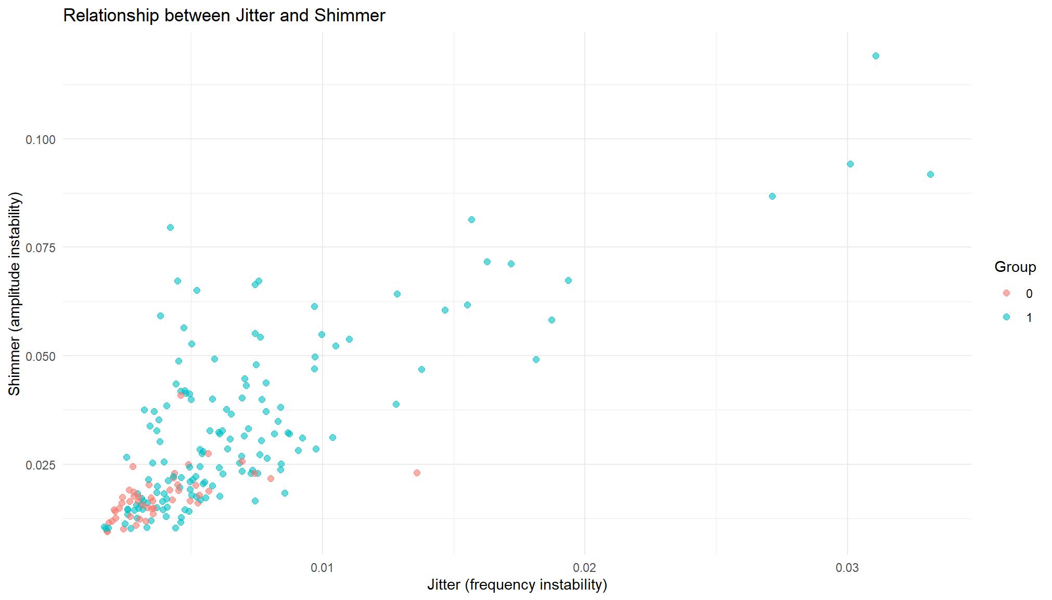

Healthy individuals show more consistent vocal characteristics, while Parkinson patients demonstrate increased dispersion and extreme values.

Basic question
How do acoustic voice features differ between healthy individuals and Parkinson’s patients?

Main question of the project
Can we combine acoustic features into a single measure of vocal instability that distinguishes Parkinson’s disease?

Added value
Can vocal instability be modeled as a multidimensional phenomenon, and does this structure reveal patterns specific to Parkinson’s disease?
What chat suggested - hard level
To what extent can combined acoustic features serve as a reliable biomarker for neurological impairment, and what is their explanatory power compared to individual features?
Made by: Shreya Dutta; Student, JIS College of Engineering

Temporal Coverage Start Date
10/15/2024

Temporal Coverage End Date
12/31/2024

@misc{shreya_dutta_2024,
title={Parkinson's Disease},
url={https://www.kaggle.com/dsv/9759604},
DOI={10.34740/KAGGLE/DSV/9759604},
publisher={Kaggle},
author={Shreya Dutta},
year={2024}
}

