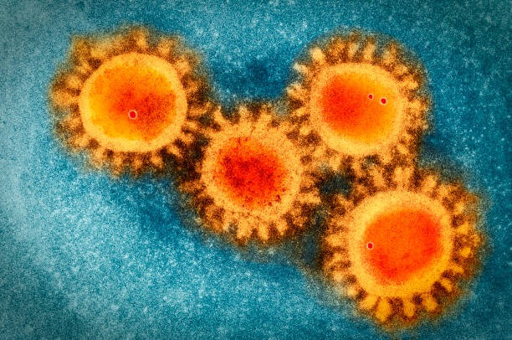
How do vaccination trends differ across countries, and what do they reveal about global health inequality?
Eva Štětinová
Ayushman Mandhotra
Reporting period: January – September 2021
Key highlights
- Only 61 of 216 countries (28.2%) reached 50% full vaccination coverage by September 2021. The remaining 155 countries — 71.8% of the world — remained below this threshold throughout the entire study period.

- The gap between income groups widened continuously throughout 2021. High-income countries reached approximately 50 fully vaccinated per 100 inhabitants by September 2021, while low-income countries remained near zero — a difference that accelerated from April 2021 onwards.

- The difference between the highest and lowest observed vaccination coverage exceeded a factor of 11,000. Gibraltar reported 116.4 fully vaccinated per 100 inhabitants; the Democratic Republic of Congo reported 0.01.

- Among the 61 countries that reached 50% coverage, the median rollout time was 160 days. The fastest countries achieved this in under 30 days; the slowest required 235 days. Speed, not just coverage, was unequally distributed.

- Missing data is not random. Countries with near-complete missingness (≥95%) are overwhelmingly lower-income and lower-capacity nations. Tokelau — with 100% missing records — nonetheless achieved 96% vaccination coverage, demonstrating that absence of data does not mean absence of a campaign.

- PCA and k-means clustering confirm that country vaccination profiles fall into three structurally distinct groups, not a continuous spectrum. Global health inequality in vaccination was categorical, not gradual.

- ARIMA forecasting reveals a further dimension of inequality: Germany's 30-day forecast carries narrow confidence intervals, while Bangladesh's forecast is highly uncertain. Unreliable data makes evidence-based planning harder precisely where it is needed most.

Overview
This report examines global COVID-19 vaccination trends during the period January to September 2021, with a focus on identifying patterns of health inequality across countries and income groups. Using data from Our World in Data (Mathieu et al., 2021), the analysis applies descriptive statistics, data visualisation, principal component analysis (PCA), k-means clustering, and ARIMA time series forecasting to characterise differences in vaccination rollout speed, coverage, and data availability.
The findings demonstrate substantial disparities in vaccination outcomes. High-income countries reached the 50% full vaccination threshold significantly faster and with greater consistency than lower-income countries. Only 28.2% of countries reached this threshold during the study period. Forecasting models further reveal that uncertainty in future vaccination progress is systematically higher in lower-income countries, reflecting both slower rollout and weaker data infrastructure.

Keywords: COVID-19, vaccination, global health inequality, ARIMA, PCA, k-means clustering, Our World in Data

Table of Contents

1. Introduction 5
2. Problem Definition 6
2.1 State of the Art 6
2.2 Problem Statement 6
3. Objectives 7
4. Methods 8
4.1 Dataset 8
4.2 Data Cleaning 8
4.3 Descriptive Statistics and Visualisation 8
4.4 Rollout Speed Analysis 8
4.5 Principal Component Analysis (PCA) 8
4.6 K-means Clustering 9
4.7 ARIMA Time Series Forecasting 9
5. Results 10
5.1 Descriptive Overview 10
5.2 Rollout Speed 11
5.3 Income Group and Continental Inequality 12
5.4 Missing Data as a Proxy for Inequality 13
5.5 Correlation Analysis 14
5.6 PCA and K-means Clustering 14
5.7 ARIMA Forecasting 15
6. Discussion 19
6.1 Strengths 19
6.2 Limitations 19
6.3 Implications 19
7. Conclusions 20
Literature 21
Appendix 22

1. Introduction
The COVID-19 pandemic presented an unprecedented challenge to global public health systems. The rapid development and subsequent global deployment of COVID-19 vaccines in 2020 and 2021 represented a landmark achievement in medical science. However, the distribution and administration of these vaccines across countries was deeply uneven, raising fundamental questions about global health equity.
This report presents a data-driven analysis of COVID-19 vaccination trends across 216 countries and territories during the first nine months of global vaccine deployment. The analysis is framed around a central research question: How do vaccination trends differ across countries, and what do they reveal about global health inequality?
The study is structured as follows. Section 2 provides a problem definition and state-of-the-art review. Section 3 defines the analytical objectives. Section 4 describes the dataset and methods applied. Section 5 presents and interprets the results. Section 6 discusses the findings critically. Section 7 concludes with a summary and outlook.

2. Problem Definition

2.1 State of the Art
Vaccine inequity during the COVID-19 pandemic has been documented extensively in the scientific literature. Wouters et al. (2021) identified multiple barriers to equitable vaccine access, including financial constraints, supply chain limitations, and geopolitical factors. The COVAX initiative, established to ensure equitable global vaccine distribution, faced significant challenges in reaching low-income countries during 2021 (Eccleston-Turner & Upton, 2021).
The relationship between national income and vaccination coverage has been highlighted in multiple studies. Acharya and Porwal (2020) identified structural healthcare inequalities as key determinants of differential health outcomes during the pandemic. Duke Global Health Innovation Center analyses consistently documented that high-income countries administered the vast majority of global vaccine doses in the first half of 2021.
Data availability itself represents a dimension of health inequality. Countries with stronger health information systems were able to report vaccination data continuously, while lower-income countries often reported sporadically or not at all (Mboussou et al., 2019). This pattern has direct implications for monitoring vaccination campaigns and allocating resources.

2.2 Problem Statement
Despite extensive documentation of vaccine inequity at the macro level, granular data-driven analyses comparing vaccination trajectories across countries using publicly available datasets remain limited. Specifically, the following gaps are addressed in this report:
- How large is the quantitative gap in vaccination coverage between high-income and low-income countries?
- Do differences manifest only in final coverage, or also in the speed of rollout?
- Does data missingness correlate with income level, and what does this imply for monitoring?
- Can forecasting models reliably project vaccination progress, and does forecast reliability differ by country income group?

3. Objectives
The primary objective of this study is to characterise global COVID-19 vaccination inequality through a rigorous quantitative analysis of publicly available vaccination data. The specific analytical objectives are:
- To describe the distribution of vaccination coverage across countries using descriptive statistics and visualisation.
- To compare vaccination rollout speed by measuring the time required for countries to reach 50% full vaccination coverage.
- To analyse income group and continental differences in vaccination trajectories.
- To apply unsupervised learning methods (PCA and k-means clustering) to identify country groupings by vaccination profile.
- To evaluate the predictive capacity of ARIMA time series models for vaccination forecasting across countries at different income levels.

4. Methods

4.1 Dataset
The analysis uses the Our World in Data COVID-19 vaccination dataset (Mathieu et al., 2021), covering 217 countries and territories with daily observations from January 2021 to September 2021. The dataset provides 14 variables per observation, including total vaccinations, people vaccinated, people fully vaccinated, and booster doses, all available both as absolute counts and as rates per 100 inhabitants.

Note. Source: Mathieu et al. (2021). Our World in Data COVID-19 vaccination dataset.
The dataset was loaded in R using a semicolon delimiter, as the raw file uses this non-standard separator. Several numeric columns contained corrupted values resulting from OCR-like encoding errors, where Roman numerals replaced Arabic digits (e.g., 'IV.7' instead of '14.7'). A custom cleaning function was written to detect and correct these patterns systematically before analysis.

4.2 Data Cleaning
The following R code illustrates the custom cleaning function applied to all percentage-type columns:
…
Regional aggregate rows (World, Europe, High income, etc.) were retained for income group analysis but excluded from country-level analyses to avoid double-counting. The final country-level dataset comprised 216 individual countries and territories.

4.3 Descriptive Statistics and Visualisation
Descriptive statistics were computed for the primary outcome variable, people fully vaccinated per 100 inhabitants, including the mean, median, standard deviation, minimum, and maximum. A cross-sectional snapshot was constructed by retaining each country's latest available observation. All visualisations were produced using ggplot2 (Wickham, 2016) with a consistent colour palette to facilitate comparison across figures.

4.4 Rollout Speed Analysis
To quantify differences in vaccination speed, each country was classified according to whether it reached the 50% full vaccination threshold during the observation period. For countries that did reach this milestone, the number of days elapsed between the first recorded vaccination and the date of reaching 50% coverage was calculated as a proxy for rollout speed.

4.5 Principal Component Analysis (PCA)
Principal Component Analysis was applied to four vaccination indicators — total vaccinations per hundred, people vaccinated per hundred, people fully vaccinated per hundred, and daily vaccinations per million — after standardisation (mean = 0, SD = 1). PCA reduces the dimensionality of correlated variables into orthogonal components, each capturing a proportion of total variance. The first two components were retained for visualisation.

4.6 K-means Clustering
K-means clustering was applied to the standardised PCA input variables to identify distinct country groupings by vaccination profile. Three clusters were specified based on the expected segmentation into high, moderate, and low vaccination coverage groups. To ensure reproducibility of results, a fixed random seed was set prior to model fitting (set.seed(42)), in accordance with the minimum standard of reproducibility described by Peng (2011), which requires that data and code produce identical results when re-executed.

4.7 ARIMA Time Series Forecasting
Autoregressive Integrated Moving Average (ARIMA) models were fitted to the vaccination time series of selected countries using the auto.arima() function from the forecast package (Hyndman & Athanasopoulos, 2021). ARIMA models capture temporal autocorrelation and seasonality in time series data. A frequency of 7 was specified to account for the weekly reporting cycle in the data. Maximum differencing parameters were constrained to d = 1 and D = 1 to avoid over-differencing. Forecast uncertainty was quantified via 80% and 95% prediction intervals.
For the multi-country inequality comparison, models were fitted to daily changes in vaccination coverage rather than cumulative levels, as cumulative vaccination series are monotonically increasing and therefore not stationary — a requirement for valid ARIMA inference. Model fit was assessed using residual diagnostics including the Ljung-Box test and ACF analysis.

5. Results

5.1 Descriptive Overview
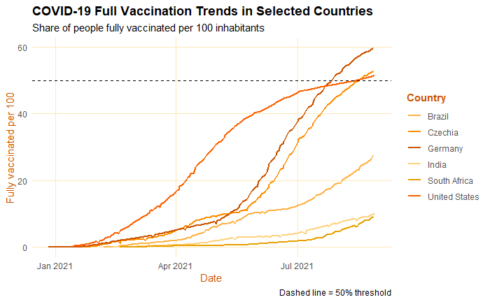
The dataset covers 216 countries and territories over the period January 2021 to September 2021. Substantial variation in vaccination coverage was observed across countries. The median full vaccination coverage at the latest available observation was approximately 17 fully vaccinated individuals per 100 inhabitants, with a mean considerably higher due to right-skew driven by high-income countries. Several countries reported coverage below 1%, while Gibraltar exceeded 100% due to cross-border vaccination of non-residents.

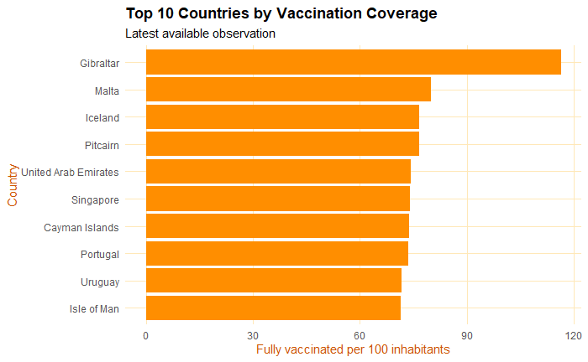
Figure 1. COVID-19 full vaccination trends in six selected countries (Germany, Czechia, India, Brazil, South Africa, and the United States), January–September 2021. The dashed line indicates the 50% full vaccination threshold.
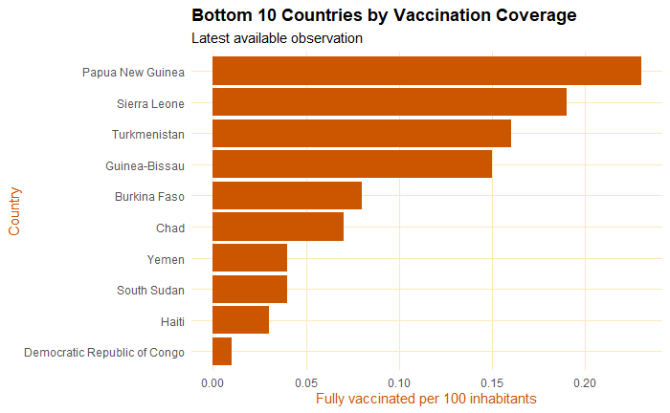

Figure 2. Top 10 countries by full vaccination coverage, based on the latest available observation per country, August 2021. Gibraltar exceeded 100 fully vaccinated per 100 inhabitants due to the vaccination of non-resident individuals.
Figure 3. Bottom 10 countries by full vaccination coverage, based on the latest available observation per country, August 2021. All listed countries reported fewer than 0.25 fully vaccinated individuals per 100 inhabitants.

Figures 2 and 3 illustrate the extreme range of vaccination outcomes. The highest-coverage countries were predominantly small island territories and high-income European states, with coverage exceeding 70 fully vaccinated per 100 inhabitants. The lowest-coverage countries were predominantly Sub-Saharan African nations, with coverage below 1 per 100 inhabitants.

5.2 Rollout Speed
Of 216 countries, only 61 (28.2%) reached the 50% full vaccination threshold by September 2021. Among the 155 countries that did not reach this threshold, many had not yet started meaningful vaccination campaigns. Among the 61 countries that did achieve 50% coverage, the median time to reach this milestone was 160 days from the first recorded vaccination, with a mean of 139 days, indicating that a small number of countries achieved exceptionally rapid rollout.
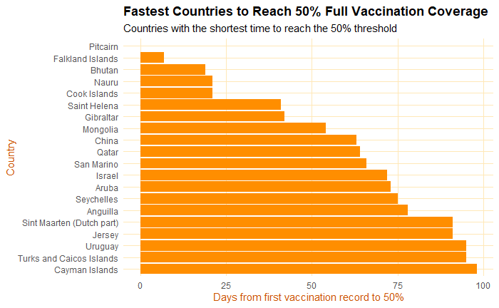
Figure 4. Fastest 20 countries to reach 50% full vaccination coverage, measured in days elapsed between the first recorded vaccination and the date of reaching the threshold. Only 61 of 216 countries reached this milestone during the study period.
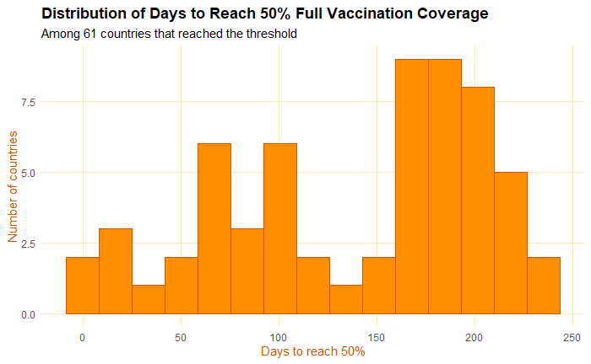
Figure 5. Distribution of days required to reach 50% full vaccination coverage among the 61 countries that achieved this threshold. The median was 160 days and the mean was 139 days, indicating a right-skewed distribution driven by a small number of exceptionally rapid campaigns.

5.3 Income Group and Continental Inequality
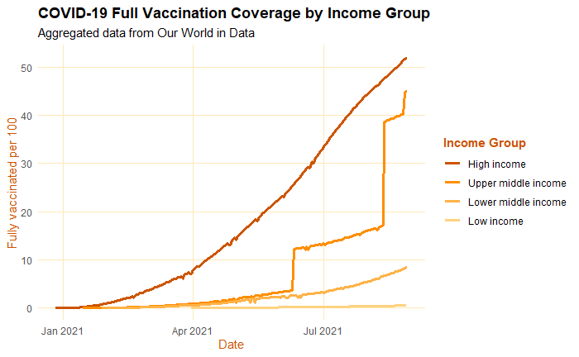
The income group time series (Figure 6) reveals a widening gap in vaccination coverage throughout 2021. High-income countries reached approximately 50 fully vaccinated per 100 inhabitants by September 2021, while low-income countries remained near zero. The divergence accelerated from April 2021 onwards, coinciding with large-scale vaccine rollout programmes in Europe and North America.
The continent-level boxplot (Figure 7) confirms this pattern geographically. Africa's median vaccination coverage was near zero, while Europe's median exceeded 50 per 100. The wide interquartile ranges within continents, particularly in Asia and the Americas, indicate considerable within-continent heterogeneity.

Figure 6. COVID-19 full vaccination coverage by World Bank income group, January–September 2021. Aggregated data from Our World in Data. The widening gap between high-income and low-income countries is clearly visible from April 2021 onwards.
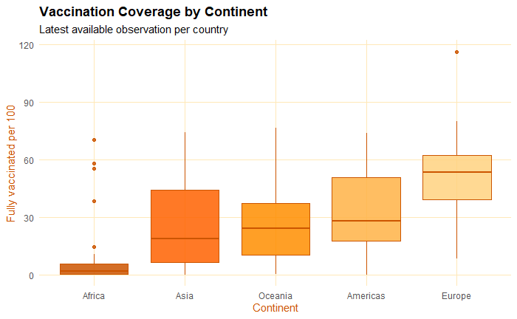
Figure 7. Distribution of full vaccination coverage by continent, based on the latest available observation per country. Boxes represent the interquartile range; whiskers extend to 1.5× IQR. Africa shows the lowest median coverage; Europe the highest.

5.4 Missing Data as a Proxy for Inequality
Near-complete missingness (≥95% of records missing) was observed in 20 countries. Notably, several of these countries — including Tokelau — had nonetheless conducted vaccination campaigns. Tokelau achieved over 96% vaccination coverage of its eligible population (ReliefWeb, 2021) yet reported no data to the Our World in Data database. This discrepancy illustrates a critical limitation: the dataset captures reporting capacity rather than vaccination activity, and missing data is itself a signal of structural disadvantage.
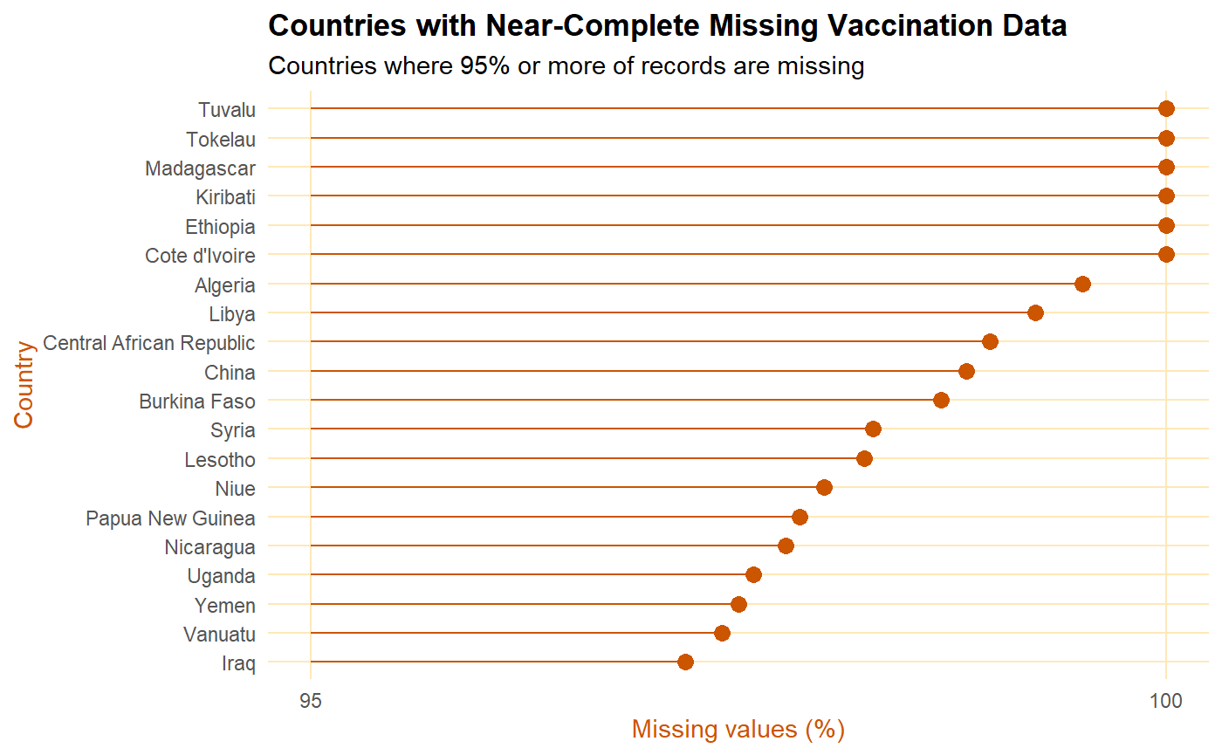
Figure 8. Countries where 95% or more of vaccination records are missing from the dataset. The x-axis is restricted to the 95–100% range to show within-group variation. High missingness does not necessarily indicate the absence of a vaccination campaign.

5.5 Correlation Analysis
Strong positive correlations (r = 0.94–0.98) were observed between cumulative vaccination indicators. Daily vaccinations per million showed only weak to moderate correlation with cumulative measures (r = 0.16–0.40), indicating that current vaccination intensity did not reliably reflect overall campaign success. This suggests that global inequality in outcomes was primarily a function of accumulated rollout capacity over time rather than day-to-day vaccination effort.

5.6 PCA and K-means Clustering
PCA identified two dominant components explaining 94.3% of total variance in vaccination indicators (PC1: 80.3%, PC2: 14.0%). The dominant first component represents a general axis of overall vaccination success, separating highly vaccinated from minimally vaccinated countries. K-means clustering with k = 3 produced three well-separated clusters corresponding to countries with high, moderate, and minimal vaccination coverage.

Figure 9. Pearson correlation matrix for the four main vaccination indicators. Strong positive correlations (r = 0.94–0.98) are observed between cumulative coverage metrics. Daily vaccinations per million shows only weak to moderate correlation with cumulative indicators (r = 0.16–0.40).

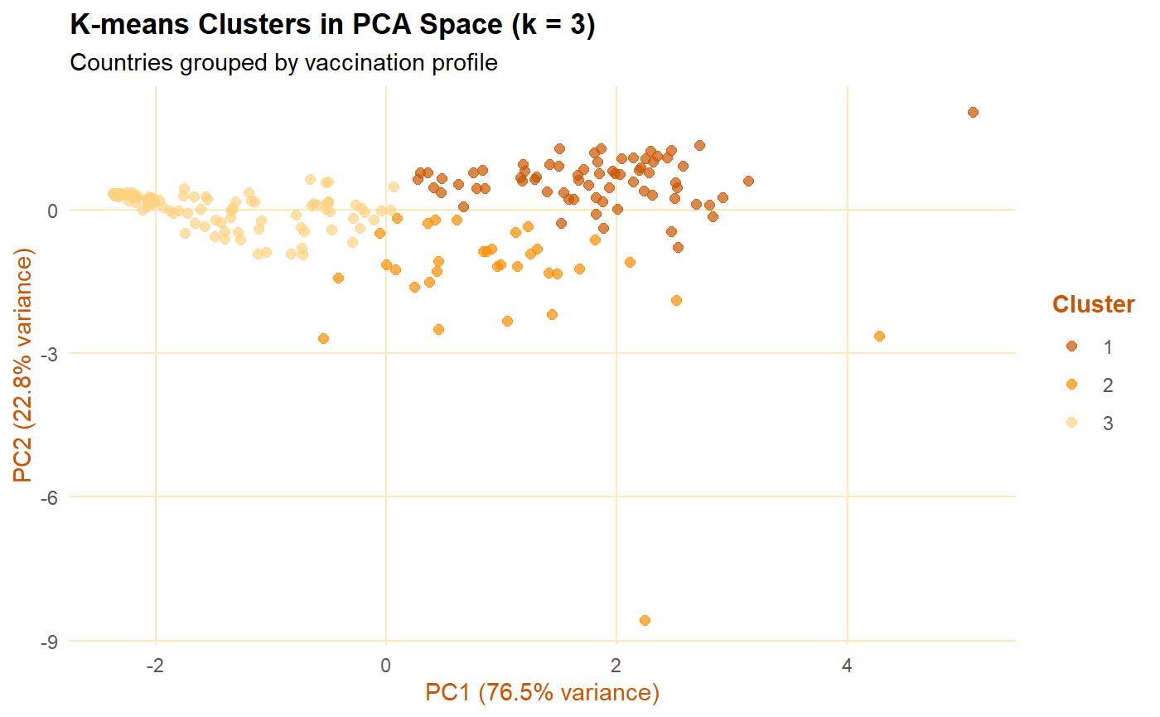
5.7 ARIMA Forecasting
An ARIMA(2,1,2)(0,1,1)[7] model was fitted to Germany's cumulative vaccination series. Residual diagnostics confirmed adequate model fit: residuals were approximately normally distributed and showed no significant autocorrelation. The 30-day forecast projected continued but decelerating vaccination progress, with narrow confidence intervals reflecting Germany's data consistency.
Multi-country forecasts of daily vaccination changes (Figure 14) revealed a clear gradient in forecast reliability. Germany's forecast showed narrow confidence intervals and a smooth mean forecast. India's forecast showed wider intervals and irregular historical patterns. Bangladesh exhibited the widest confidence intervals of the three, reflecting only 93 observations and highly irregular reporting patterns.
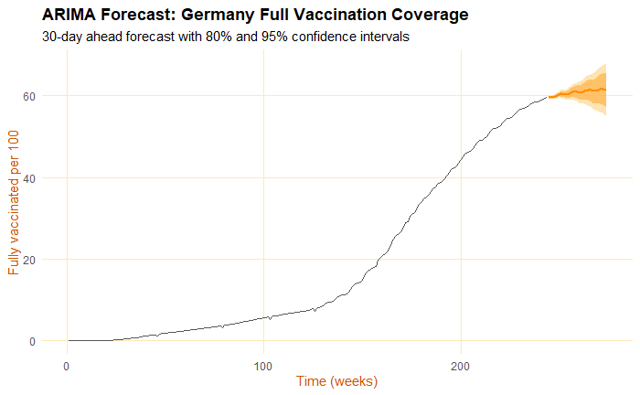
Figure 10. PCA variable contribution plot for the four vaccination indicators. Arrow length and colour indicate the contribution of each variable to the first two principal components, which together explain 94.3% of total variance.
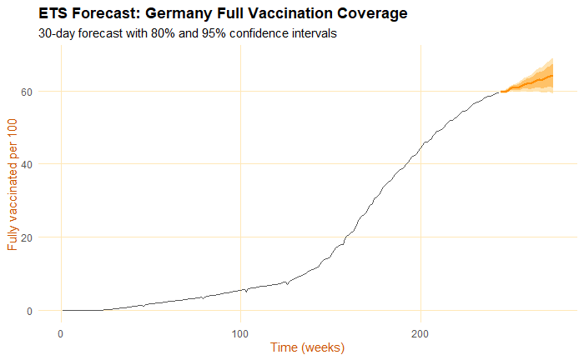
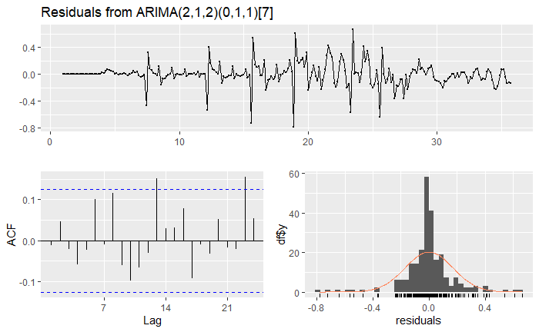
Figure 11. K-means cluster assignments (k = 3) visualised in PCA space. Each point represents one country. PC1 (76.5% variance) separates countries primarily by overall vaccination success. Cluster separation is clear, indicating structural rather than gradual differences between country groups.

Figure 12. ARIMA(2,1,2)(0,1,1)[7] 30-day forecast for Germany's cumulative full vaccination coverage. Shaded bands represent 80% and 95% prediction intervals. The narrow intervals reflect Germany's consistent and well-reported vaccination data.
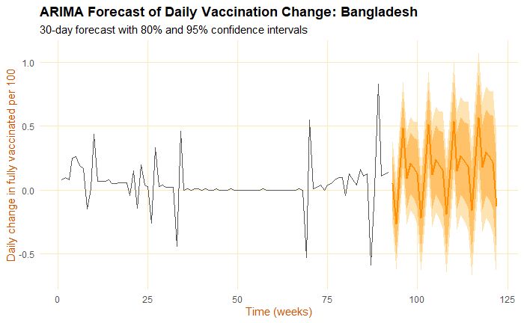

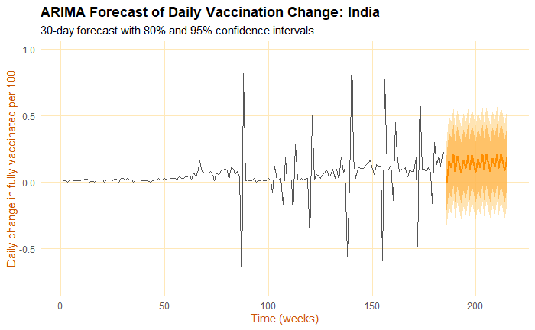
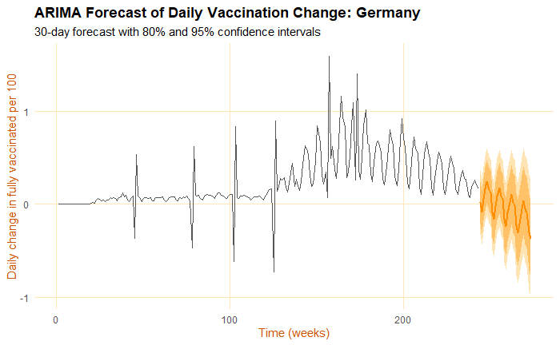
Figure 14. ARIMA 30-day forecasts of daily vaccination changes for Germany (top), India (middle), and Bangladesh (bottom). The width of confidence intervals increases from Germany to Bangladesh, reflecting decreasing data reliability and consistency across income groups.

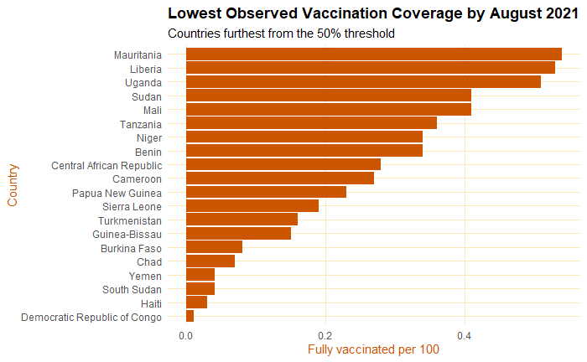
Figure 15. Lowest observed full vaccination coverage by August 2021, showing the 20 countries furthest from the 50% threshold. All listed countries reported fewer than 0.5 fully vaccinated individuals per 100 inhabitants. The Democratic Republic of Congo recorded the lowest coverage in the entire dataset at 0.01 per 100 inhabitants — a difference of more than 11,000-fold compared to the highest-coverage country, Gibraltar (116.4 per 100 inhabitants).

6. Discussion

6.1 Strengths
This analysis provides a comprehensive, multi-method characterisation of COVID-19 vaccination inequality using a publicly available, regularly updated dataset. The combination of descriptive statistics, unsupervised learning, and time series forecasting enables both cross-sectional and longitudinal perspectives on inequality. The use of income group aggregates already embedded in the dataset avoids the need for external data merging and ensures consistency with widely used international classifications.
The ARIMA forecasting component adds a forward-looking dimension that goes beyond descriptive observation. By demonstrating that forecast uncertainty is itself distributed unequally across income groups, the analysis shows that inequality is not only a historical pattern but a structural feature with implications for future monitoring.

6.2 Limitations
Several limitations must be acknowledged. First, the dataset reflects reported data only, which is subject to substantial reporting gaps, particularly in lower-income countries. As demonstrated in Section 5.4, near-complete missingness does not necessarily mean the absence of vaccination activity, which means the analysis may systematically underestimate vaccination progress in lower-income countries.
Second, the observation period ends in September 2021, capturing only the first phase of the global vaccination campaign. Subsequent rollout — including the substantial expansion of vaccination programmes in lower-income countries during 2022 and 2023 — is not captured in this analysis.
Third, k-means clustering is sensitive to the chosen number of clusters. While k = 3 was selected based on theoretical expectations, a formal elbow method or silhouette analysis would provide a more objective justification.

6.3 Implications
The findings have direct implications for public health policy and global health governance. The concentration of early vaccine access in high-income countries, combined with the systematic under-reporting from lower-income countries, underscores the need for strengthened international data sharing mechanisms and more equitable vaccine distribution frameworks.

7. Conclusions
This report demonstrates that COVID-19 vaccination trends during January to September 2021 were profoundly unequal across countries. The key findings are as follows:
- Only 28.2% of countries reached 50% full vaccination coverage during the study period.
- The gap between high-income and low-income countries widened continuously throughout 2021.
- PCA and k-means clustering confirm that country vaccination profiles cluster into three well-separated groups, suggesting that inequality was not gradual but structural.
- ARIMA forecasting reveals that forecast uncertainty is itself distributed unequally, with lower-income countries exhibiting wider prediction intervals.
- Missing data is not random — it is concentrated in lower-income countries and is itself a dimension of health inequality.

Future work could extend this analysis to the full 2021–2023 period to capture the later phases of global vaccine rollout. Integration of additional covariates — including GDP per capita, healthcare expenditure, and COVAX participation — would enable a more granular analysis of the determinants of vaccine access. A formal spatial analysis using choropleth maps could further illustrate the geographic concentration of vaccination inequality.

Literature
Acharya, A., & Porwal, A. (2020). A vulnerability index for the management of and response to the COVID-19 epidemic in India: An ecological study. The Lancet Global Health, 8(9), e1142–e1151. https://doi.org/10.1016/S2214-109X(20)30300-4
Eccleston-Turner, M., & Upton, H. (2021). International collaboration to ensure equitable access to vaccines for COVID-19: The ACT-Accelerator and the COVAX Facility. The Milbank Quarterly, 99(2), 426–449. https://doi.org/10.1111/1468-0009.12503
Hyndman, R. J., & Athanasopoulos, G. (2021). Forecasting: Principles and practice (3rd ed.). OTexts. https://otexts.com/fpp3
Mathieu, E., Ritchie, H., Ortiz-Ospina, E., Roser, M., Hasell, J., Appel, C., Giattino, C., & Rodés-Guirao, L. (2021). A global database of COVID-19 vaccinations. Nature Human Behaviour, 5, 947–953. https://doi.org/10.1038/s41562-021-01122-8
Mboussou, F., Ndumbi, P., Ngom, R., Hamblion, E., Butt, W., Maruta, A., Ismail, A., Williams, G., & Impouma, B. (2019). Infectious disease outbreaks in the African region: Overview of events reported to the World Health Organization in 2018. Epidemiology & Infection, 147, e299. https://doi.org/10.1017/S0950268819001912
Peng, R. D. (2011). Reproducible research in computational science. Science, 334(6060), 1226–1227. https://doi.org/10.1126/science.1213847
ReliefWeb. (2021). COVID-19 vaccination in Tokelau. United Nations Office for the Coordination of Humanitarian Affairs. https://reliefweb.int
Wickham, H. (2016). ggplot2: Elegant graphics for data analysis. Springer. https://doi.org/10.1007/978-3-319-24277-4
Wouters, O. J., Shadlen, K. C., Salcher-Konrad, M., Pollard, A. J., Larson, H. J., Teerawattananon, Y., & Jit, M. (2021). Challenges in ensuring global access to COVID-19 vaccines: Production, affordability, allocation, and deployment. The Lancet, 397(10278), 1023–1034. https://doi.org/10.1016/S0140-6736(21)00306-8

Appendix

Appendix A: Dataset Variable Descriptions
The following variables from the Our World in Data COVID-19 vaccination dataset were used in this analysis:
- people_fully_vaccinated_per_hundred: Share of the population that received all doses prescribed by the vaccination protocol.
- total_vaccinations_per_hundred: Total number of doses administered per 100 people.
- daily_vaccinations_per_million: Daily doses administered per million population (7-day rolling average).

Appendix B: R Session Information

Appendix C: Full R Notebook
The complete R Markdown notebook (final.Rmd) and ARIMA analysis (arima.Rmd) are submitted as separate files alongside this report.

