Architetture dei Sistemi di Elaborazione  02GOLOV | Computer Architectures  02LSEYG
Laboratory  0x04 | Expected delivery of lab_04.zip must include:  - program_1.s, program_1_a.s, and program_1_b.s  - This file, filled with information and possibly compiled in a PDF format.
Delivery date:
November 7th 2025

This lab will explore some of the concepts seen during the lessons, such as hazards, rescheduling, and loop unrolling. The first thing to do is to configure the GEM5 simulator with the Initial Configuration provided below:
INTEGER_ALU_LATENCY = 1
INTEGER_MUL_LATENCY = 1
INTEGER_DIV_LATENCY = 1
FLOAT_ALU_LATENCY = 4
FLOAT_MUL_LATENCY = 8
FLOAT_DIV_LATENCY = 20

- Write an assembly program (program_1.s) for the RISCV architecture able to compute the output (y) of a neural computation (see the Fig. below):

x = $\sum_{j=0}^{K-1}{i_{j}*w_{j}+b}$
y = f(x)

where, to prevent the propagation of NaN (Not a Number), the activation function f is defined as:

$$f\left(x\right)=\left\{\begin{aligned}0, &if the exponent part of x is equal to 0x7FF \\ x, &otherwise\end{aligned}\right.$$

Assume the vectors i and w respectively store the inputs entering the neuron and the weights of the connections. They contain K=16 single precision floating point elements. Assume that b is a single precision floating point constant and is equal to 0xab, and y is a single precision floating point value stored in memory.
Compute y.


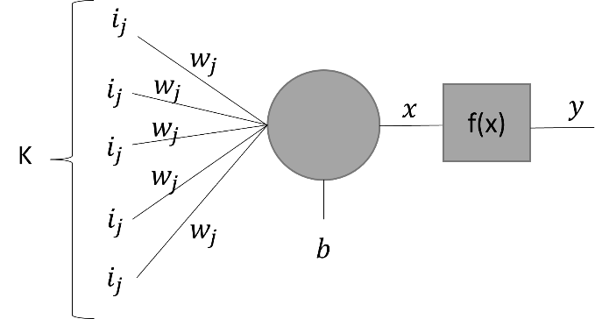

Given the Base Configuration, run your program and extract the following information.

 | Number of clock cycles | Total Instructions | CPI (Clock per Instructions)
program_1.s | 330 | 151 | 2.18543

    - Optimize the program by re-scheduling instructions to eliminate as many hazards as possible. Manually calculate the number of clock cycles for the new program (program_1_a.s) to execute and compare the results with those obtained by the simulator.

    - Unroll the program (program_1_a.s) two times; If necessary, re-schedule instructions and increase the number of registers used. Manually calculate the number of clock cycles to execute the new program (program_1_b.s) and compare the results obtained with those obtained by the simulator.

Complete the following table with the obtained results:

Program | program_1.s | program_1_a.s | program_1_b.s
Clock cycles by hand | 310 | 246 | 180
Clock cycles by simulation | 330 | 281 | 182

Collect the Cycles Per Instruction (CPI) from the simulator for different programs

 | program_1.s | program_1_a.s | program_1_b.s
CPI | 2.18543 | 1.86093 | 1.4918

Compare the results obtained in 1) and provide some explanation if the results are different.

Eventual explanation:
Hand calculations assumed ideal conditions. The simulator accounts for real hardware constraints: structural hazards, memory conflicts, and variable latencies.
program_1_b.s is most accurate because fewer iterations reduce cumulative error and behavior is more predictable.
CPI improve from 2.18 to 1.49: loop unrolling reduces stalls by 32% through fewer branches and independent accumulators.

    - Try different unrolls for the program (program_1_a.s); If necessary, re-schedule instructions and increase the number of registers used. Manually calculate the number of clock cycles to execute the new program (program_1_b.s) and compare the results obtained with those obtained by the simulator.

Complete the following table with the obtained results:

Program | Number of Loop Unrolling | Code size [bytes] | Clock Cycles  [CC]
program_1_a.s |  | 140 | 281
program_1_a.s | 2 | 168 | 182
program_1_a.s | 4 | 200 | 146
program_1_a.s | 8 | 284 | 148
program_1_a.s | 16 | 388 | 134

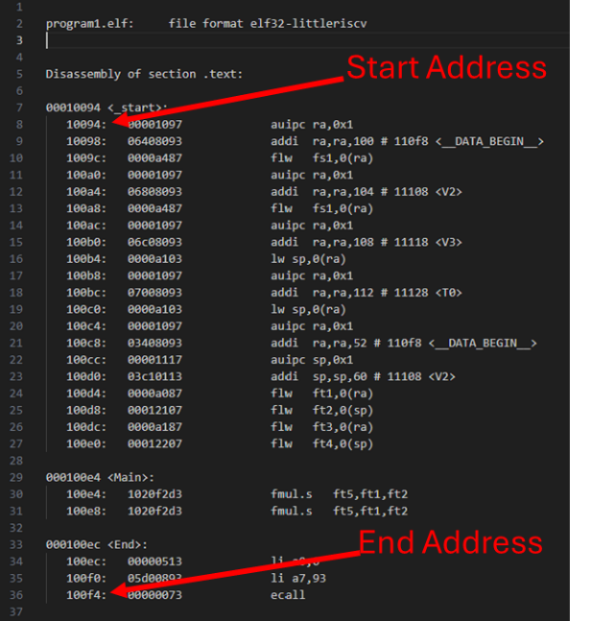
In order to calculate the code size of your program you can open in ./programs/you_program/your_program.dump file to retrieve the compiled disassembled code of your executable in which you have the effective addresses from which the code will be executed.

For example (on the right), for your_program you have your disassembled file on 32 bit addresses.

