Architetture dei Sistemi di Elaborazione  02GOLOV | Computer Architectures  02LSEYG
Laboratory  0x05 | Expected delivery of lab_5.zip must include:  - each configuration of the custom architecture (riscv_o3_custom.py and create_predictor.py) that you modify.  - This document with all the field compiled and in PDF form.
Delivery date:
November 13th 2025

Introduction and Background

Simulating an Out-of-Order (OoO) CPU (O3CPU)
Dispatch/Issue
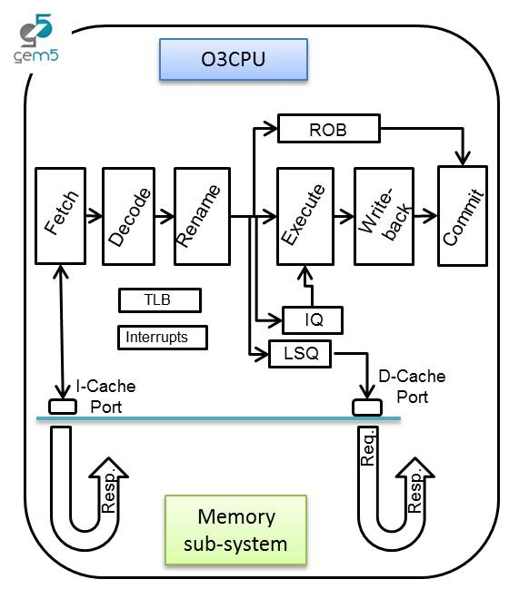

In this laboratory, you will be able to configure an OoO CPU by using a script called riscv_o3_custom.py (in the gem5 folder). In a few words, the script configures an Out-of-Order (O3) processor based on the DerivO3CPU, a superscalar processor with a reduced number of features.

Pipeline

The processor pipeline stages can be summarized as:

- Fetch stage: instructions are fetched from the instruction cache. The fetchWidth parameter sets the number of fetched instructions. This stage does branch prediction and branch target prediction.
- Decode stage: This stage decodes instructions and handles the execution of unconditional branches. The decodeWidth parameter sets the maximum number of instructions processed per clock cycle.
- Rename stage: As suggested by the name, registers are renamed, and the instruction is pushed to the IEW (Issue/Execute/Write Back) stage. It checks that the Instruction Queue (IQ)/Load and Store Queue (LSQ) can hold the new instruction. The maximum number of instructions processed per clock cycle is set by the renameWidth parameter.

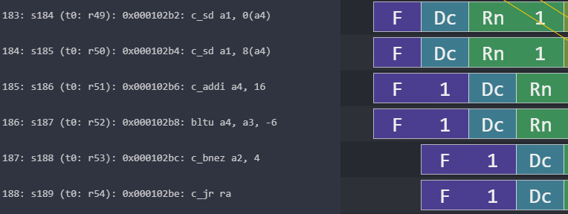
Stalls: the pipeline can’t move on
decodeWidth=2
renameWidth=2
fetchWidth=4
Figure 1: Understanding configurable OoO CPU parameters.

- Dispatch stage: instructions whose renamed operands are available are dispatched to functional units (FU). For loads and stores, they are dispatched to the Load/Store Queue (LSQ). The maximum number of instructions processed per clock cycle is set by the dispatchWidth parameter.
- Issue stage: The simulated processor has a single instruction queue from which all instructions are issued. Ordinarily, instructions are taken in-order from this queue. An instruction is issued if it does not have any dependency.
- Execute stage: the functional unit (FU) processes their instruction. Each functional unit can be configured with a different latency. Conditional branch mispredictions are identified here. The maximum number of instructions processed per clock cycle depends on the different functional units configured and their latencies.
- Writeback stage: it sends the result of the instruction to the reorder buffer (ROB). The maximum number of instructions processed per clock cycle is set by the wbWidth parameter.
- Commit stage: it processes the reorder buffer, freeing up reorder buffer entries. The maximum number of instructions processed per clock cycle is set by the commitWidth parameter. Commit is done in order.

In the event of a branch misprediction, trap, or other speculative execution event, "squashing" can occur at all stages of this pipeline. When a pending instruction is squashed, it is removed from the instruction queues, reorder buffers, requests to the instruction cache, etc.

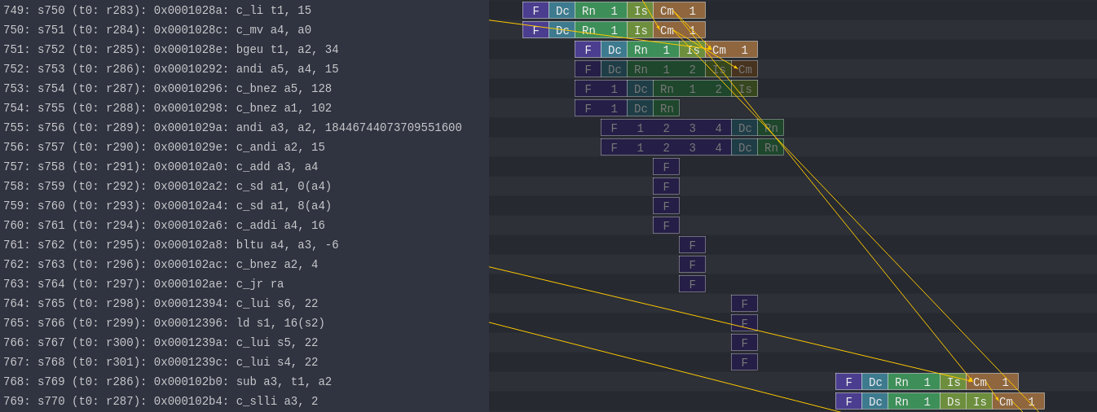
Mispredicted branch
Flushed Instructions
Figure 2: Example of a branch misprediction (transparent rows)

Pipeline Resources
Additionally, it has the following structures:
- Branch predictor (BP)
  - Allows for selection between several branch predictors, including a local predictor, a global predictor, and a tournament predictor. Also has a branch target buffer (BTB) and a return address stack (RAS).
- Reorder buffer (ROB)
  - Holds instructions that have reached the back end. Handles squashing instructions and keep instructions in program order.
- Instruction queue (IQ)
  - Handles dependencies between instructions and scheduling ready instructions. Uses the memory dependence predictor to tell when memory operations are ready.
- Load-store queue (LSQ)
  - Holds loads and stores that have reached the back end. It hooks up to the d-cache and initiates accesses to the memory system once memory operations have been issued and executed. Also handles forwarding from stores to loads, replaying memory operations if the memory system is blocked, and detecting memory ordering violations.
- Functional units (FU)
  - Provides timing for instruction execution. Used to determine the latency of an instruction executing, as well as what instructions can issue each cycle.
  - Floating point units, floating point registers, and respective instructions are supported.
Figure 3: Pipeline example of FP instructions and FP registers

All the needed resources are at a GitHub repository:
https://github.com/cad-polito-it/ase_riscv_gem5_sim

To update your simulation environment:

~/ase_riscv_gem5_sim$ git pull

ATTENTION: You may have modified files that would prevent you to directly pull the workspace. Please save them and then pull the repository.

In order to simulate an OoO CPU you MUST set the following variables in your setup_default file:

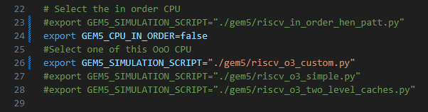

This sets the python scripts modelling the OoO CPU (line 23-24 and 25).

Moreover, you must install an additional pipeline visualizer called Konata

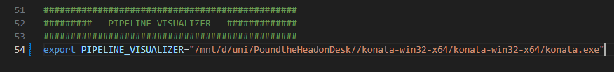

And change the path accordingly in your setup_default file (line 54).

In the repository’s README there are the instructions for installing konata (it is necessary to download a precompiled binary for your system).

Exercise 1:

Simulate the programs written in the previous lab with the OoO CPU based on the CPU architecture described in riscv_o3_custom.py ,
You can visualize the pipeline (i.e., load the trace.out file on Konata).

Collects statistics about the execution of your programs in the following table:

Laboratory | Program | Clock Per Instructions
Laboratory | Program | In Order CPU | OoO CPU
0x01 | program3.s | 1.35 | 1.84
0x02 | program1.s | 5.97 | 1.30
0x03 | program1.s | 2.36 | 0.93
0x03 | program1_a.s | 1.98 | 0.92
0x03 | program1_b.s | 1.95 | 1.80
0x04 | program1.s | 2.19 | 1.30
0x04 | program1_a.s | 1.86 | 1.25
0x04 | program1_b.s | 1.59 | 1.62

Can you identify situations (at least three) in which the OoO architecture perform better/worse than the In order architecture and viceversa?

Situation 1: OoO performs better than In Order (Lab 0x02, program1.s)
Explanation: This program includes a slow division operation. The In-Order CPU must wait for this division to complete before continuing with dependent instructions, causing the pipeline to stall frequently. The OoO CPU solves this problem by executing independent instructions while waiting for the division, such as address calculations and memory loads from the next loop iteration. Register renaming allows multiple iterations to execute simultaneously. This keeps the pipeline busy instead of stalled.
In order CPU screenshot:
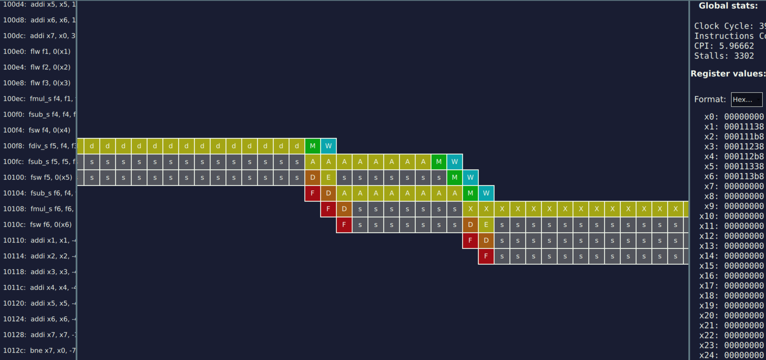
OoO CPU screenshot:
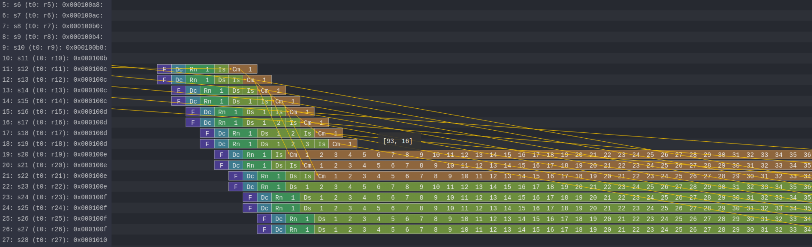

Situation 2: OoO performs better than In Order (Lab 0x03, program1.s)
Explanation: The OoO CPU achieves exceptional CPI because it can execute instructions from multiple loop iterations simultaneously. While the In-Order CPU must wait through long-latency floating-point divisions before proceeding, the OoO CPU uses this time to execute loads, address calculations, and computations from subsequent iterations. The three independent loads at each loop start can be issued simultaneously through the Load-Store Queue rather than sequentially. Additionally, register renaming eliminates false dependencies from register reuse (f4, f5, f6), allowing parallel execution of multiple functional units. This high instruction-level parallelism combined with predictable branches enables the OoO CPU to execute more than one instruction per cycle on average, while the In-Order CPU frequently stalls waiting for dependencies to resolve.
In order CPU screenshot:
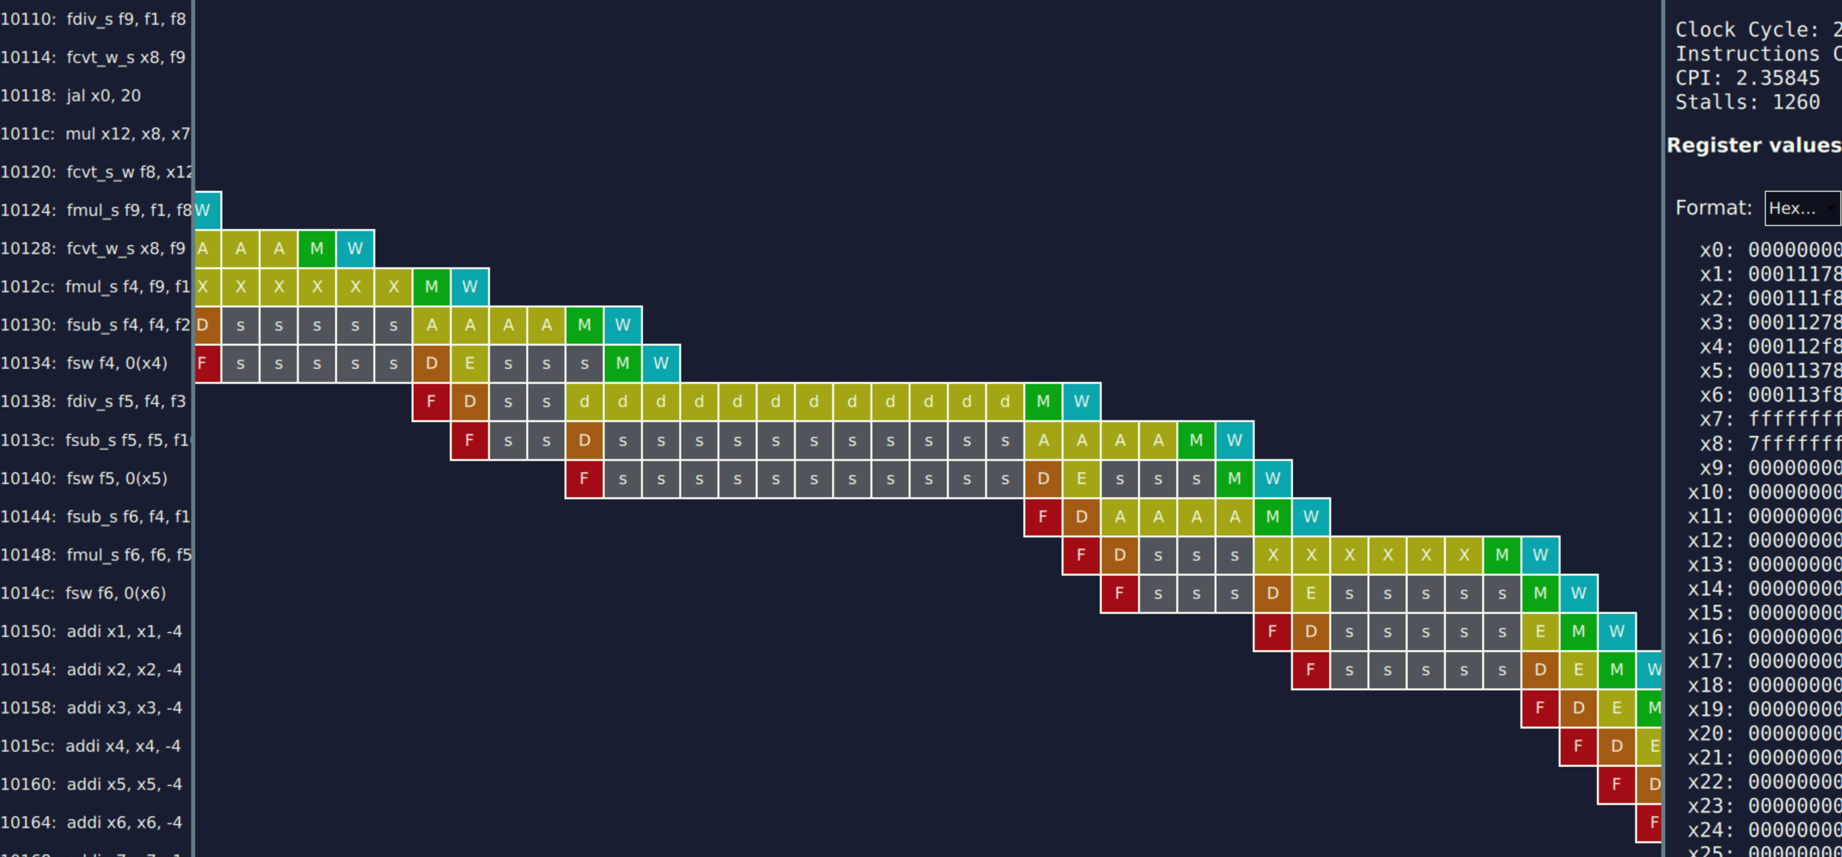
OoO CPU screenshot:
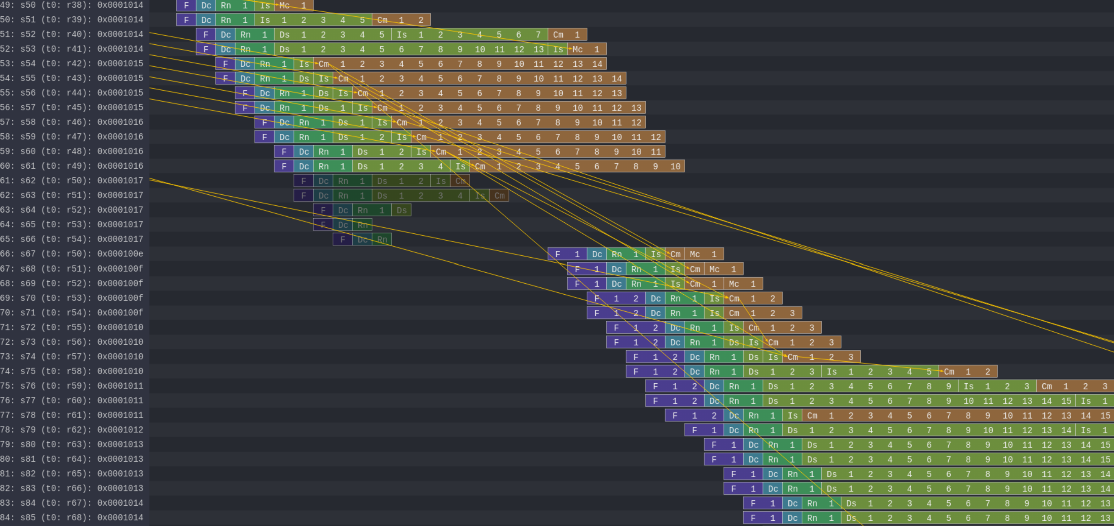

Situation 3: In Order performs better than OoO (Lab 0x01, program3.s)
Explanation: The OoO CPU performs worse due to frequent branch mispredictions that are more costly. The code has tight dependencies between loads and branches (lb immediately followed by beq), providing no independent instructions for the OoO to reorder. With no instruction-level parallelism to exploit and frequent control-flow disruptions, the OoO’s complexity becomes pure overhead while the In-Order CPU’s simpler pipeline recovers from mispredictions faster.
In order CPU screenshot:
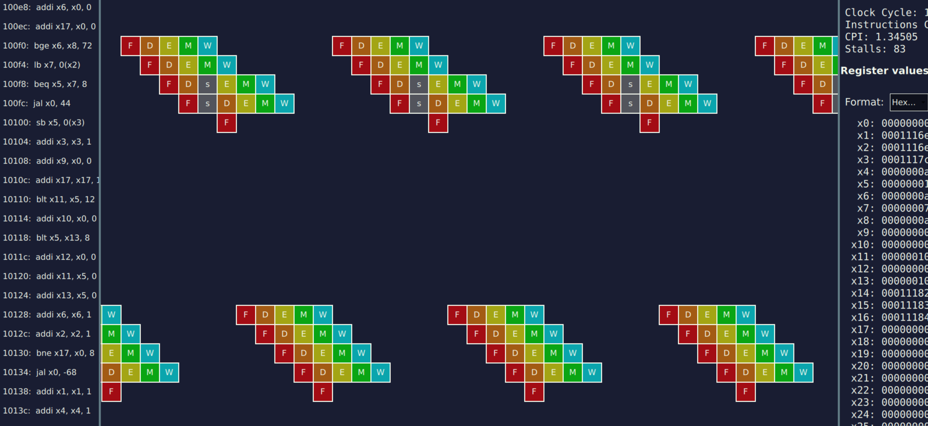
OoO CPU screenshot:
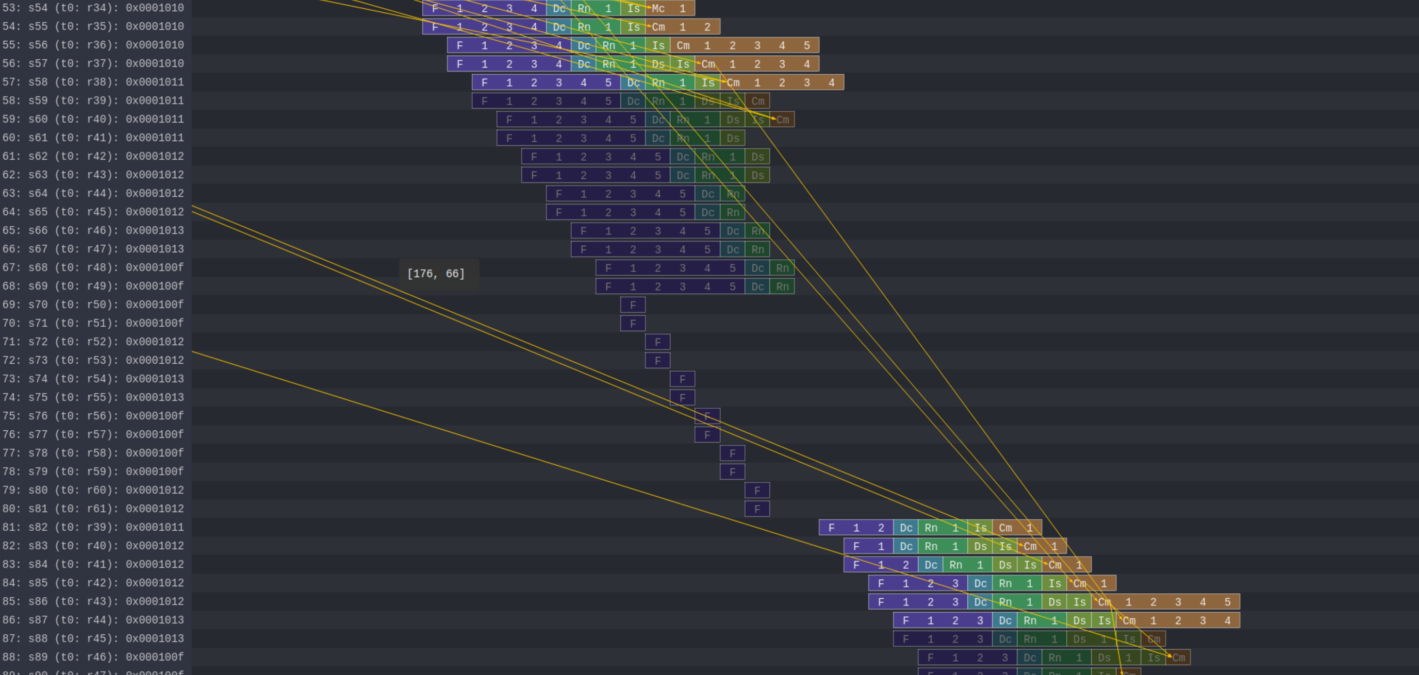

Exercise 2:

In this exercise you will experiment the usage of different Branch Prediction Unit (BPU).

You are asked to avoid as much as possible mis-predicted branches by resorting to different BPUs. Use as benchmarks the two programs developed in lab 0x03 and 0x04 (program1.s).

To modify the CPU BPU, open the configuration file of the CPU (i.e., the riscv_o3_custom.py):

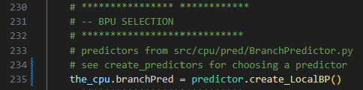

You can create/use a different branch predictors. They are defined in create_predictor.py
You are encouraged to change their internal values.

Collects statistics about the execution of your programs in the following table:

Laboratory | Program | Clock Per Instructions
Laboratory | Program | In Order CPU | OoO CPU  BPU = Tournament improved | OoO CPU  BPU = TAGE | OoO CPU  BPU = BiMode improved
0x03 | program1.s | 2.36 | 0.90 | 1.14 | 0.99
0x04 | program1.s | 2.19 | 0.97 | 1.29 | 1.00

