Computer Architectures  02LSEOV | Delivery date:  November 22th 2025, 11.59 PM
Laboratory  6 | Expected delivery of lab_06.zip must include:  - Solutions of exercises 1, 3, and 4.  - This file, filled with information and possibly compiled in a pdf format.

This lab will continue to delve into ARM programming.
- Write a program using the ARM assembly that performs the following operations:
  - Initialize registers R3, R4, and R5 with arbitrary (chosen by you) signed values.
  - Subtract R3 to R4 (R4 – R3) and store the result in R6.
  - Sum R4 to R5 (R4 + R5) and store the result in R7.
- Using the debug log window, change the values ​​of the written program in order to set the following flags to 1, one at a time and when possible:
    - carry
    - overflow
    - negative
    - zero
Report the selected values in the table below:
 | Hexadecimal representation of the obtained values
Updated flag | R4 – R3 |  | R4 + R5
Updated flag | R4 | R3 | R4 | R5
Carry = 1 | 0x0000002A | 0x0000000F | 0x0000002A | 0xFFFFFFFF
Carry = 0 | 0x0000000A | 0x0000000F | 0x00000001 | 0xFFFFFFF0
Overflow | 0x7FFFFFFF | 0x80000001 | 0x7FFFFFFF | 0x00000001
Negative | 0x0000000A | 0x00000064 | 0x0000000A | 0xFFFFFF9C
Zero | 0x000001F4 | 0x000001F4 | 0x0000007B | 0xFFFFFF85
Please explain the cases where it is not possible to force a single FLAG condition:

In the case of the Zero flag (Z=1) isolation using subtraction (R4 - R3), the attempt fails because Z=1 requires the result to be zero, meaning R4 must equal R3 (as shown by 0x000001F4 - 0x000001F4). Since R4 is greater than or equal to R3, the subtraction requires no borrow. In ARM arithmetic, this condition simultaneously sets the Carry flag (C) to 1. Therefore, the operation designed to set Z=1 inherently results in Z=1 and C=1, making isolation impossible for this specific instruction type.

The isolation of the Overflow flag (V=1) is unsuccessful because the operation that creates overflow determines the sign of the result. For instance, the values provided for addition (0x7FFFFFFF + 0x00000001) cause the result to overflow the positive limit and wrap around to the minimum negative value (0x80000000). This immediately sets the Negative flag (N) to 1 because the most significant bit is now set. The result is V=1 and N=1, preventing the isolation of V. (While the table shows the R4-R3 values leading to overflow, these also set N=1 for the same reason: 0x7FFFFFFF - 0x80000001 results in 0xFFFFFFFF, which is negative).

The key failures arise when one arithmetic condition is mathematically forced to trigger another, as seen with the Z and C flags in subtraction.

- Write two versions of a program that performs the following operations:
  - Initialize registers R1 and R2 with arbitrary (chosen by you) signed values.
  - Compare the two registers:
    - If they differ, store in register R8 the maximum among R1 and R2.
    - Otherwise, perform a logical right shift of 1 on R1 (is it equivalent to what?), then subtract this value from R2 and store the result in R9 (i.e., R4 = R2 – (R1 >> 1)).

The first version should be based on a traditional assembly programming approach using conditional branches, while the second version should be based on a conditional statement execution approach.
Considering a CPU clock frequency (clk) of 16 MHz, report the number of clock cycles (cc) and the simulation time in milliseconds (ms) in the following table:
 | R2 == R3 [cc] | R2 == R3 [ms] | R2 != R3 [cc] | R2 != R3 [ms]
1) Traditional | 10 | 0.00063 | 12 | 0.00075
2) Conditional Execution | 10 | 0.00063 | 10 | 0.00063
Note: you can change the CPU clock frequency by following the brief guide at the end of the document.

- Write a program that calculates the parity bit of a variable. The parity bit is used for error detection and indicates whether the number of 1s in the binary data is odd (parity = 1) or even (parity = 0), calculated by performing an XOR operation on all bits of the variable: for example, the parity of 0b00000101 is 0 (even parity) because it has two 1s. The variable to be checked is in R10 that you have to initialize to 0b00110101. After calculating the parity, store the result (0 or 1) in R13.

To recap, implement ASM code that does the following:
- Calculate the parity bit of R10 by XORing all its bits together.
- Store the parity bit result in R13 (0 for even parity, 1 for odd parity).

- Assuming a 15 MHz clk, report the code size and execution time in the following table:
Code size [Bytes] | Execution time
36 | 0.004 ms
- Add some comments regarding the solution you wrote:
The implemented solution correctly calculates the parity bit by iterating through all 32 bits of register R10, using a straightforward approach with XOR operations. The algorithm uses general-purpose registers (<R10) to avoid conflicts with reserved registers. A notable concern is the manipulation of R13, which serves as the Stack Pointer in ARM Cortex-M3 architecture. While the original SP value is saved in R1 before modification, it is never restored, leaving the stack in a corrupted state that would prevent any subsequent function calls or interrupt handling. For a production environment, the stack pointer should be immediately restored after debugging, or the result should be stored in a different register.

How to set the CPU clock frequency in Keil

- Launch the debug mode and activate the command console.
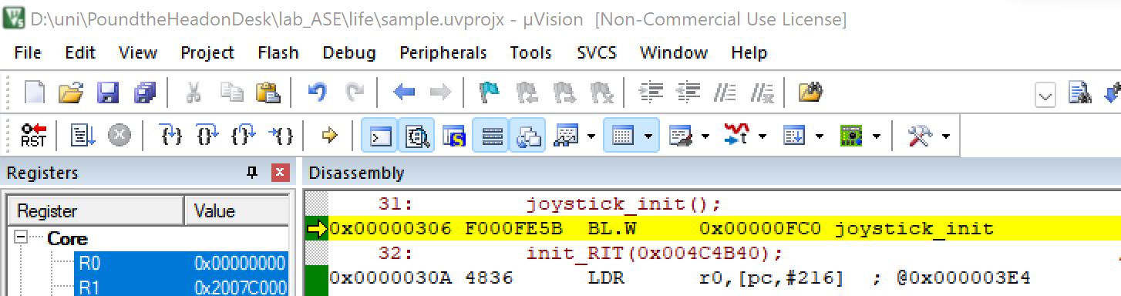
- A window will appear:
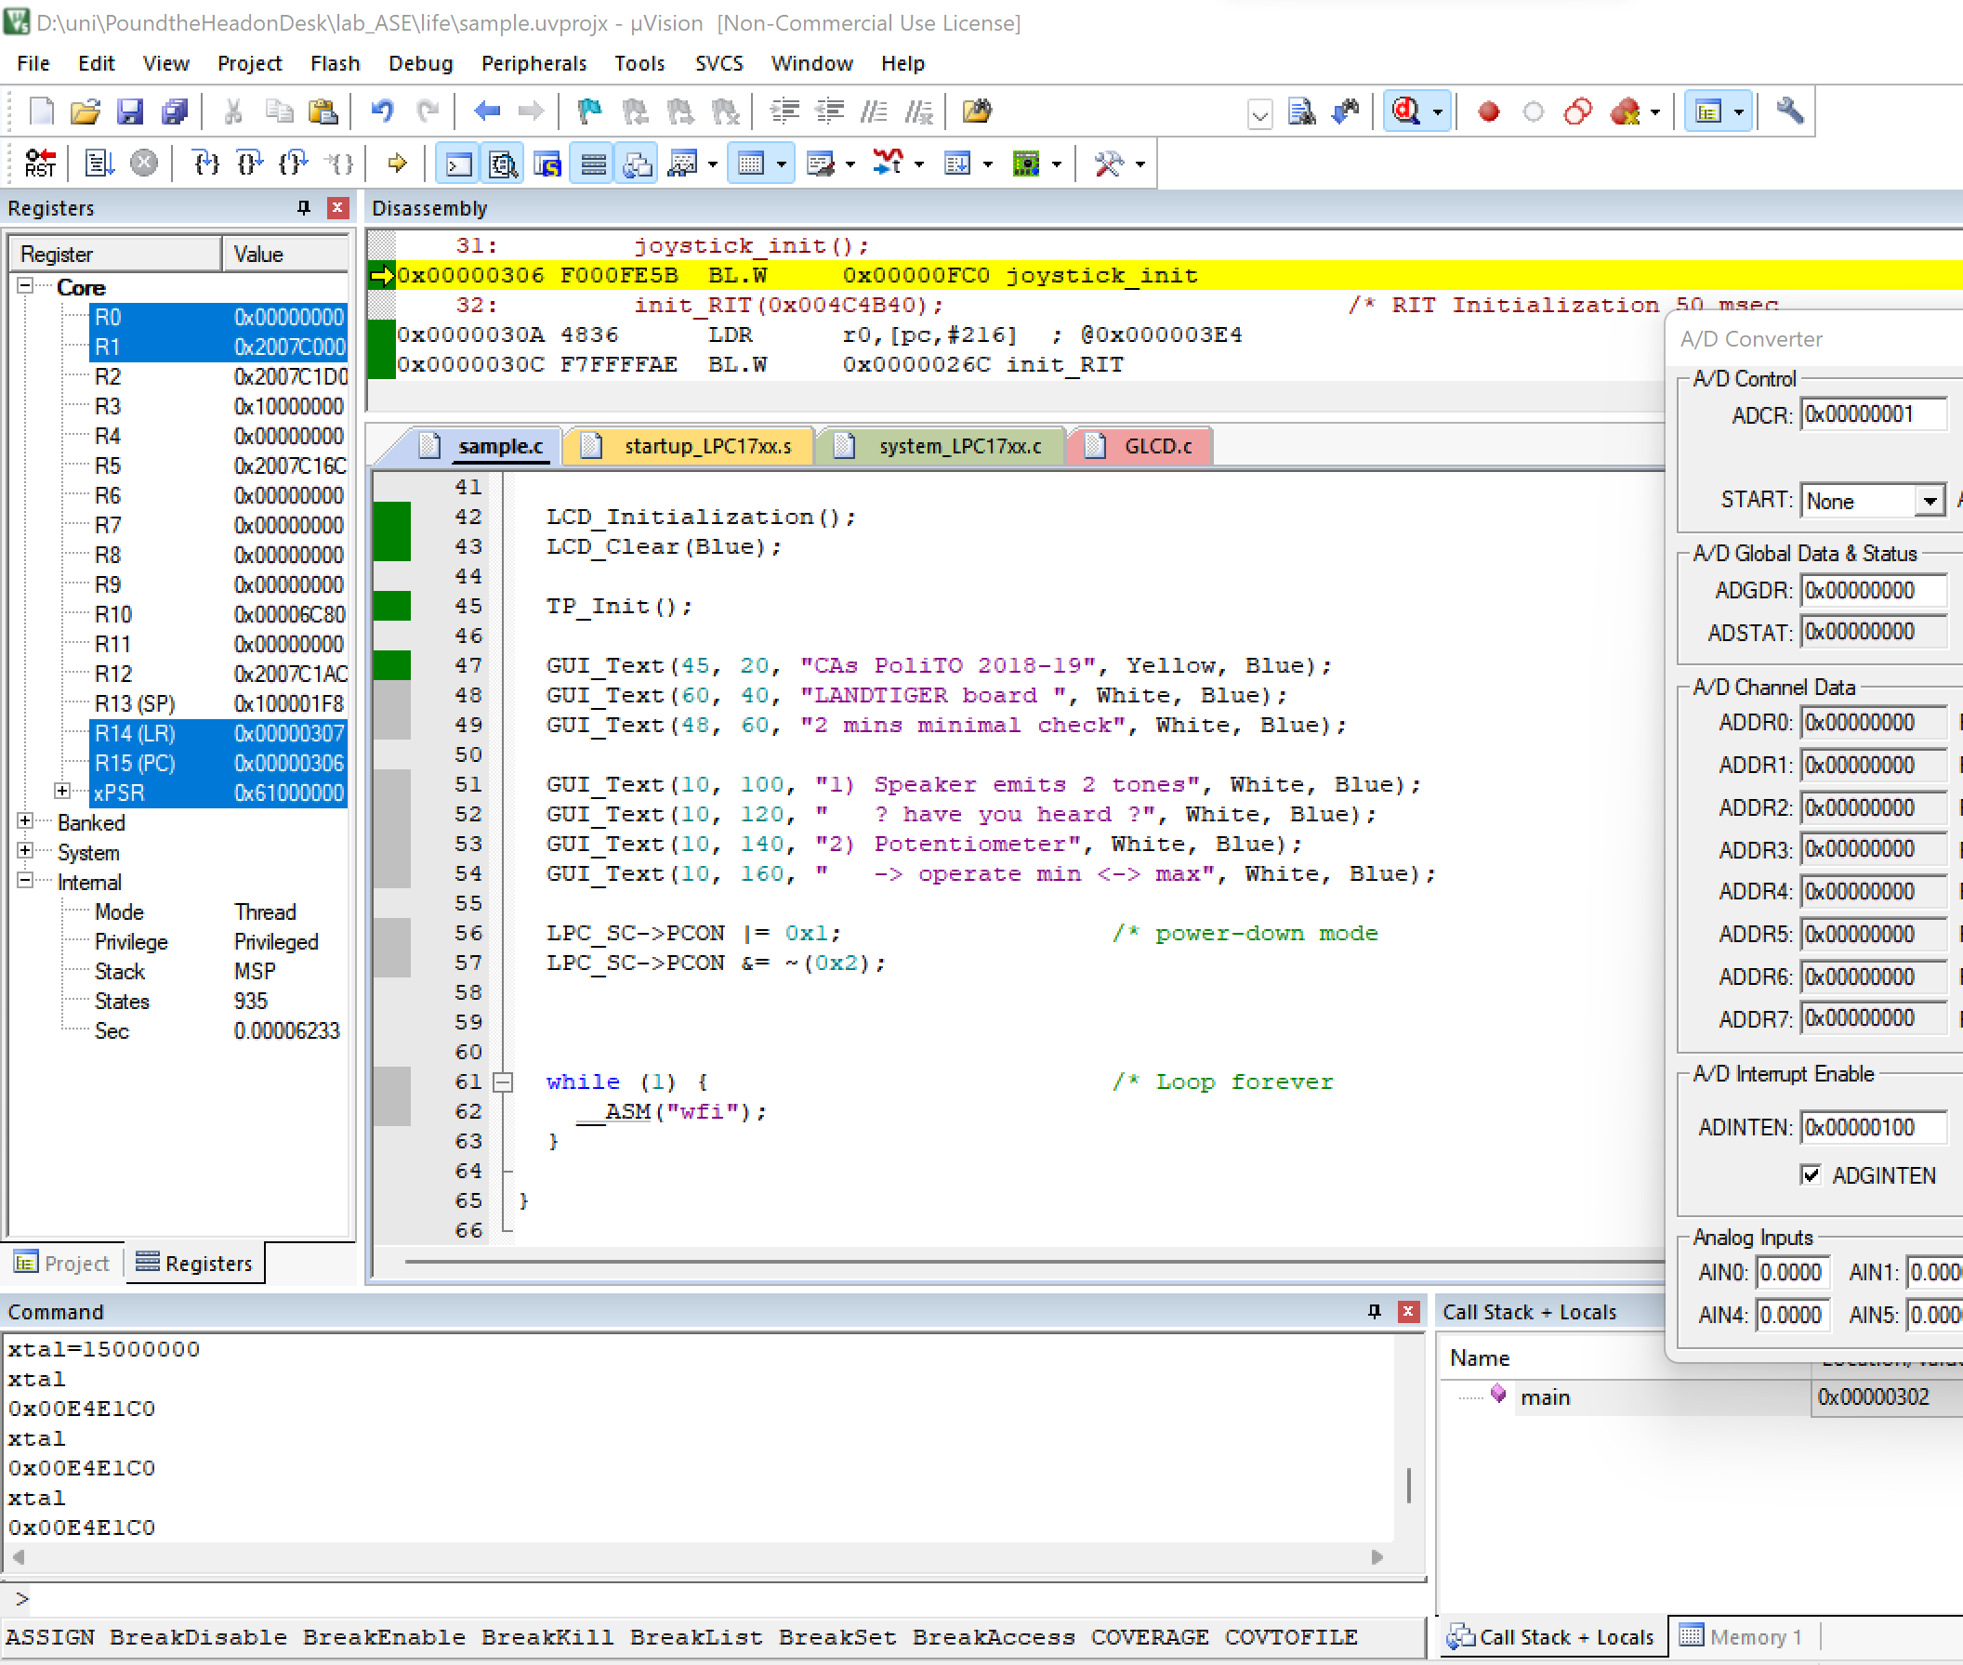
You can type xtal to check its value. To change its value, make a routine assignment, i.e., xtal=frequency, keeping in mind that frequency is in Hz must be entered. To set a frequency of 15 MHz, you must write as follows: xtal=15000000.

