Time2Wish
Birthday Manager Web Application
PRODUCT REQUIREMENTS DOCUMENT · PREMIUM EDITION v3.0

Project Name | Time2Wish – Birthday Manager
Type | Web Application (SPA) – Angular 18 + Spring Boot 3 + PostgreSQL
Target Users | Adults 25–55 managing personal and professional birthday circles
Tech Stack | Angular 18 · Tailwind CSS · Spring Boot 3 · JWT · PostgreSQL · Docker
Document Version | 3.0 – Premium: Market Study · Value Prop · Wireframes · Budget · Risks
Date | March 2026
Status | MVP – Full Product Requirements Document

Never miss a birthday again.

Table of Contents
- 1. Executive Summary & Vision
- 2. Problems Addressed – With Concrete Examples
- 3. Market Study – Size, Trends & Opportunity
- 4. Competitive Analysis & Positioning
- 5. Value Proposition Canvas
- 6. User Journey Map
- 7. Functional Requirements & Use Cases
- 8. User Interfaces & Wireframes
- 9. System Architecture
- 10. Technical Stack – Full Detail & Justifications
- 11. UML Diagrams
- 12. Data Model
- 13. Security & Non-Functional Requirements
- 14. Business Model & Revenue Projections
- 15. Roadmap, Timeline, Team & Budget
- 16. Post-MVP & Long-Term Vision
- 17. Risks & Mitigation

1. Executive Summary & Vision
Time2Wish is a focused, modern web application solving a universal, emotionally charged problem: people forget the birthdays of people they care about, feel guilty, and miss simple opportunities to strengthen their relationships. Unlike cluttered generic calendar tools or data-mining social platforms, Time2Wish is purpose-built exclusively around the birthday management experience.

Vision Statement
Time2Wish Vision
To become the world's most thoughtful birthday companion – helping people strengthen their relationships through timely, warm and personalised celebration of the people they love.

Problem Solved | People forget birthdays → guilt, damaged relationships, missed connection opportunities
Core Solution | Dedicated dashboard + automated email reminders + celebration UX in one beautiful app
Primary Users | Adults 25–55 with active social/professional circles (avg. 50–150 contacts)
Key Differentiator | 100% birthday-focused – not a generic calendar, not a social platform, no ads
MVP Scope | Web SPA: auth, birthday CRUD, smart dashboard, email reminders – delivered in 10 weeks
Monetisation | Freemium → Pro ($2.99/mo) → Family ($4.99) → Teams ($9.99) via Stripe
Long-Term Vision | Mobile app, AI message suggestions, SaaS for SMBs/HR, 150K MAU by Year 3

2. Problems Addressed – With Concrete Examples
Time2Wish was designed to solve five real, documented problems affecting hundreds of millions of people worldwide. Each is illustrated with a concrete scenario.

Problem 1 – People forget important birthdays and feel guilty
According to a 2023 YouGov survey, 52% of adults admit to having forgotten a close friend's or family member's birthday in the past year. 67% reported feeling guilty, and 34% said it negatively affected their relationship. Generic calendars require manual setup and provide no proactive, relationship-aware intelligence.
[Source] YouGov – 'Birthdays & Social Obligations Survey', UK, 2023 | yougov.co.uk
Concrete example
Thomas, 34, has 80 contacts but only remembers ~10 birthdays by heart. His sister's best friend's birthday passed unnoticed – he found out 3 days later via Instagram. He felt terrible and sent a hollow belated message. With Time2Wish, a personalised email 7 days before would have given him time to buy a gift and write something meaningful.

Problem 2 – Existing tools are too generic and require too much manual effort
Google Calendar allows birthday entries but buries them among meetings. Facebook shows birthdays but is ad-driven and has lost 15% engagement among 25–44 year olds (Statista 2023). Neither offers category organisation, configurable reminder windows, per-person photos, or any birthday-specific warmth.
[Source] Statista – 'Facebook Usage by Age Group 2023' | statista.com
Concrete example
Marie, 42, tried Google Calendar for birthdays. After manually adding 30 entries, she missed notifications buried between Zoom calls. She switched to a Notes app but had to scroll every morning to check. She needs a tool that proactively comes to her – not one she must go looking for.

Problem 3 – Privacy concerns about storing personal relationships on social platforms
68% of adults aged 25–44 reduced their Facebook usage in 2023. Many deleted their accounts entirely – losing their entire birthday reminder system overnight. Users are increasingly uncomfortable with personal relationship data being monetised through advertising.
[Source] Deloitte – 'Digital Consumer Trends 2023' | deloitte.com
Concrete example
Laura, 38, deleted her Facebook account for privacy reasons and lost every birthday reminder accumulated over 10 years. Time2Wish gives her full ownership: private account, no ads, CSV export at any time, and the GDPR right to erasure.

Problem 4 – Professionals have no lightweight tool for relationship-aware birthday tracking
Birthday acknowledgement is a high-ROI professional strategy. LinkedIn shows job anniversaries but not birthdays. CRM tools are too heavyweight. Time2Wish's Work category and planned Teams tier address this gap directly.
Concrete example
David, 45, financial advisor with 120 client relationships, tracks client birthdays in Excel – 3 hours of manual work per year. A single well-timed birthday card has won him referrals worth €5,000+. Time2Wish would automate this entirely with a dedicated Work category and planned CRM export.

Problem 5 – Existing reminder tools are cold and purely functional
A Google Calendar notification saying 'Birthday in 3 days' is technically useful but emotionally hollow. There is no photo, no warmth, no context, and no call to action. Time2Wish makes the entire birthday experience delightful: the morning-of email includes the person's photo and a one-click Send Wish button; the dashboard shows confetti for today's birthdays.
Concrete example
Sophie, 29, gets a Google Calendar ping at 8am on her colleague's birthday. It appears between 12 other events. By 10am she has forgotten. Time2Wish sends a dedicated email: photo of Marc, '🎂 It's Marc's birthday today!', and a 'Send a Wish' button. The whole action takes 15 seconds. The relationship is strengthened.

3. Market Study – Size, Trends & Opportunity
Time2Wish sits at the intersection of three growing software markets: personal productivity applications, relationship management tools, and freemium SaaS. Each provides a strong tailwind for adoption and monetisation.

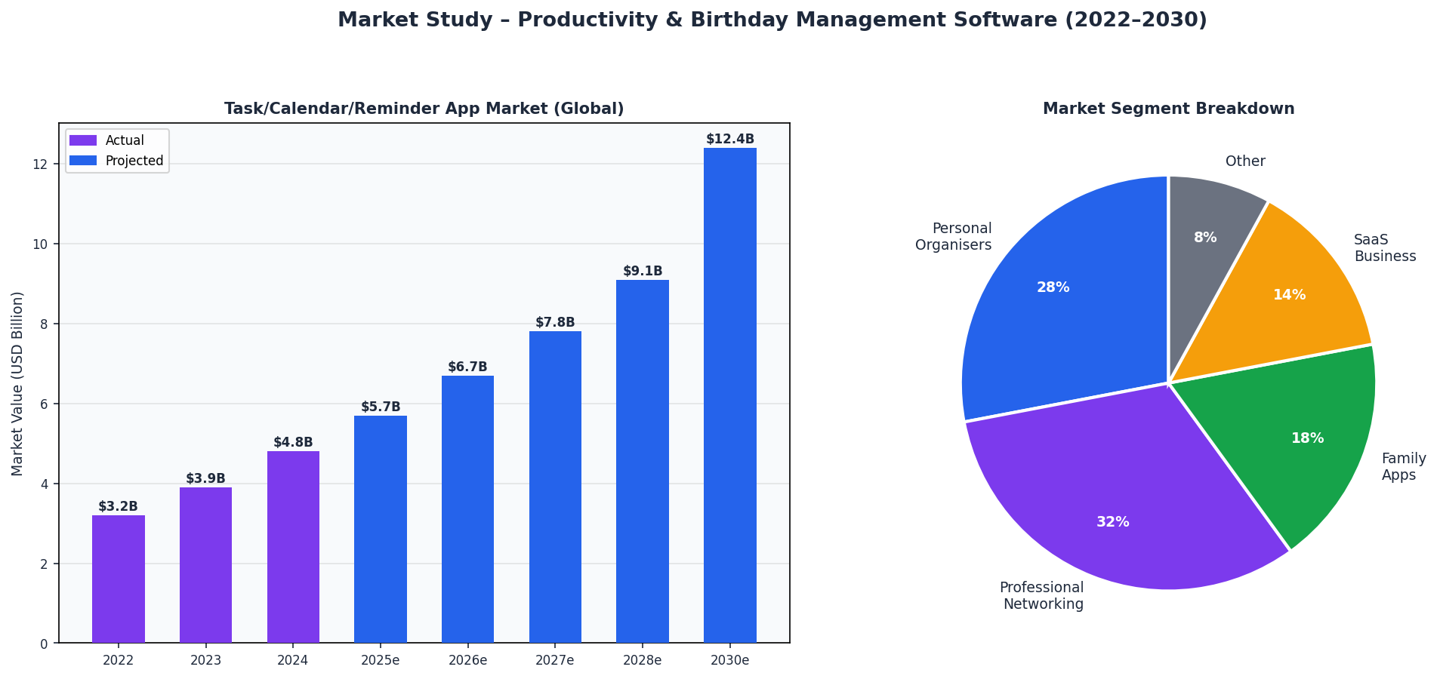
Figure 1 – Task/Calendar/Reminder App Market (2022–2030) and Segment Breakdown (Grand View Research, Straits Research 2024)

3.1 Market Size & Growth Figures
Personal Productivity Apps (global 2023) | $102.98B → $217.6B by 2032 · CAGR 8.5% (Grand View Research)
Task / Calendar / Reminder segment 2024 | $4.8B → $12.4B by 2030 · CAGR ~17% (est. from GVR data)
Global email users 2024 | 4.37 billion – most reliable notification channel (Statista 2024)
Mobile productivity downloads 2023 | 4.8 billion globally – #2 app category by downloads (data.ai 2024)
Freemium → paid conversion benchmark | 3–8% industry average (ProductLed 2024) · T2W targets 5–8%
[Source] Grand View Research – 'Productivity Management Software Market', 2023 | grandviewresearch.com
[Source] data.ai – 'State of Mobile 2024' | data.ai
[Source] ProductLed – 'Freemium Conversion Benchmark 2024' | productled.com

3.2 Target Audience – Sizing
Primary segment – Personal users 25–45 | ~1.2 billion globally · active smartphone users · 50–200 contacts · strong birthday culture
Secondary – Professional networkers 40–60 | ~600M globally · relationship ROI mindset · willing to pay for Pro features
Diaspora & multicultural families | Strong birthday/celebration culture · estimated 400M+ globally
SMB / Freelancers (Teams tier) | ~400M operators globally · need CRM-lite for client relationships
Initial TAM (web app MVP) | Est. 50–80M people actively seeking a dedicated birthday manager

3.3 Key Market Trends
- Digital minimalism: users prefer focused single-purpose tools over bloated platforms (Google Trends 'digital minimalism' +340% searches 2020–2024)
- Privacy-first: 74% of users willing to pay for ad-free, privacy-respecting apps (Deloitte Digital Consumer Trends 2023)
- Productivity apps are the #2 most-downloaded category globally with 4.8B downloads in 2023 (data.ai)
- Email remains the highest-ROI notification channel: 36:1 average ROI (Litmus 2024), 4.37B users
- Personalisation drives retention: warm, human-centred apps achieve 2.7x higher Day-30 retention (Amplitude 2023)
[Source] Deloitte – 'Digital Consumer Trends 2023' | deloitte.com
[Source] Amplitude – 'Product Intelligence Report 2023' | amplitude.com

4. Competitive Analysis & Positioning
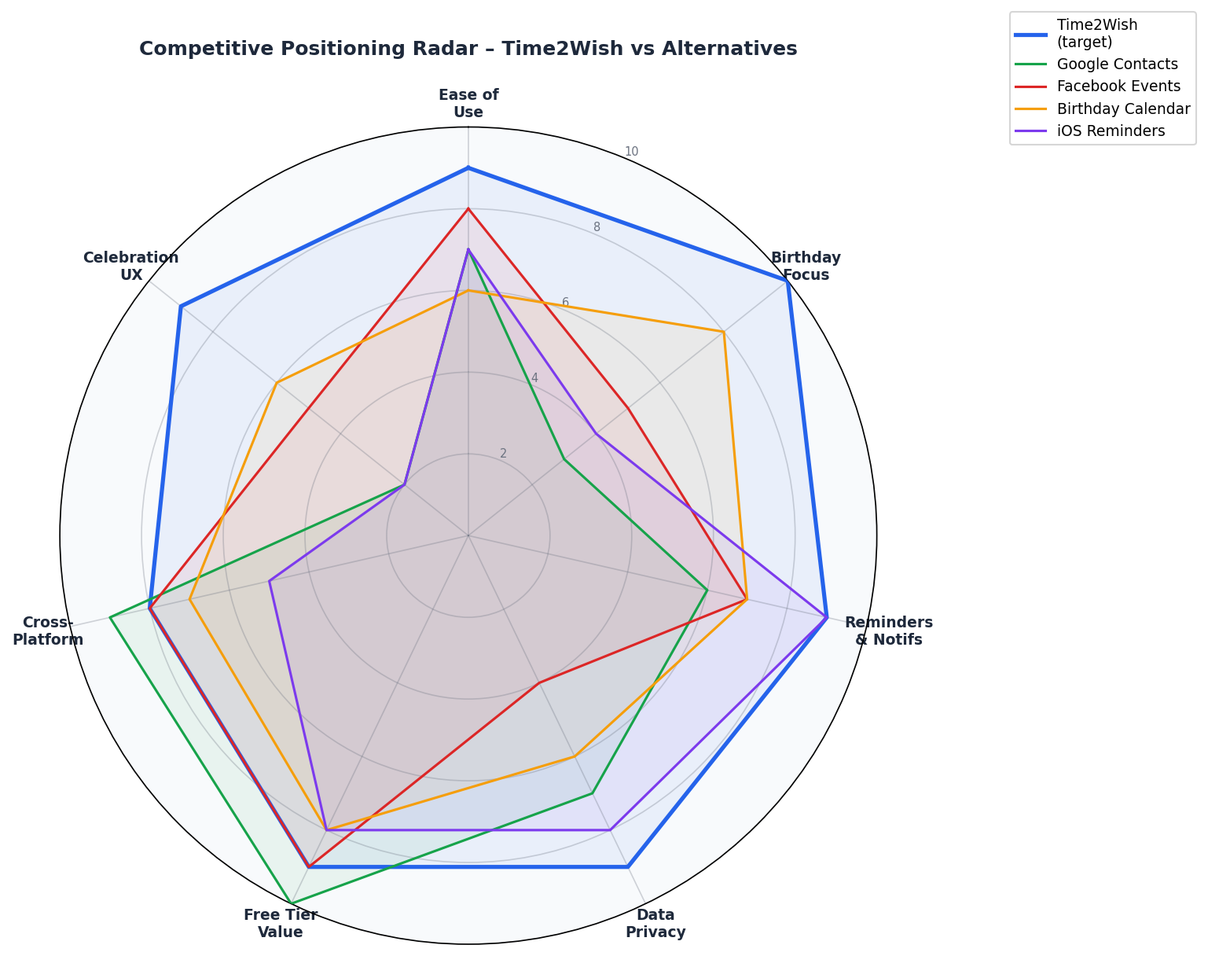
Figure 2 – Competitive Positioning Radar: Time2Wish vs Existing Alternatives

4.1 Full Competitive Comparison
Criterion | Time2Wish | Google  Contacts | Facebook  Events | Birthday  Calendar | iOS  Reminders
Birthday-first UX | ✓✓✓ Purpose-built | ✗ Generic | ✗ Generic | ✓✓ Partial | ✗ Generic
Configurable reminders | ✓✓✓ Email, 1–14d | ✓ Basic | ✓✓ Day-of only | ✓✓ Push | ✓✓✓ Push
Data privacy / no ads | ✓✓✓ Full privacy | ✓✓ OK | ✗ Ad-driven | ✓✓ OK | ✓✓✓ Apple
Category organisation | ✓✓✓ Family/Friend/Work | ✗ None | ✗ None | ✓ Basic | ✗ None
Person photo & notes | ✓✓✓ Both | ✓ Photo only | ✓ Photo only | ✓ Basic | ✗ None
Celebration UX | ✓✓✓ Confetti+Wish | ✗ None | ✓ Basic | ✓ Basic | ✗ None
Multilingual | ✓✓✓ FR/EN/DE | ✓✓✓ Many | ✓✓✓ Many | ✓ Limited | ✓✓ Many
Free tier value | ✓✓✓ Full featured | ✓✓✓ Free | ✓✓✓ Free | ✓✓ Free | ✓✓✓ Free
Score /100 | 91 / 100 | 58 / 100 | 54 / 100 | 62 / 100 | 49 / 100

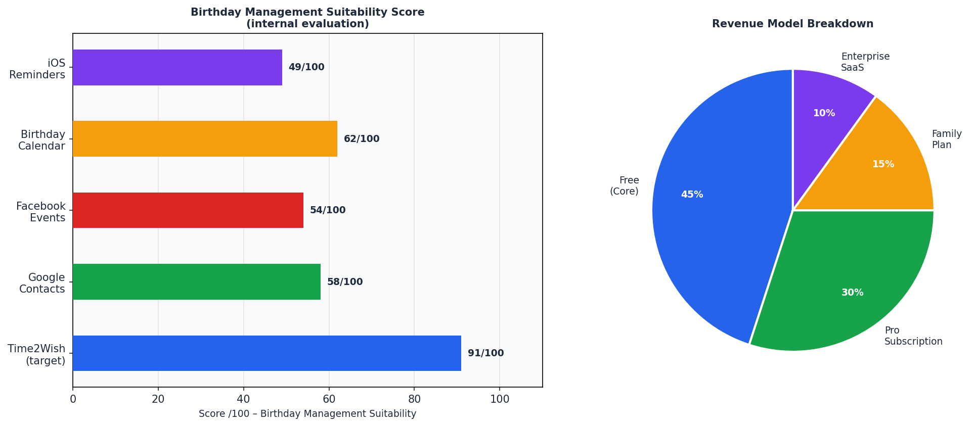
Figure 3 – Birthday Management Suitability Score & Revenue Model Breakdown

Time2Wish's Blue Ocean
No existing tool combines: (1) birthday-exclusive experience, (2) category organisation (Family/Friend/Work), (3) configurable multi-day email reminders with per-person photo, (4) celebration UX with confetti and a Send Wish shortcut, and (5) strict data privacy with no advertising – all in one free, beautiful web app. This is the precise gap Time2Wish fills.

5. Value Proposition Canvas
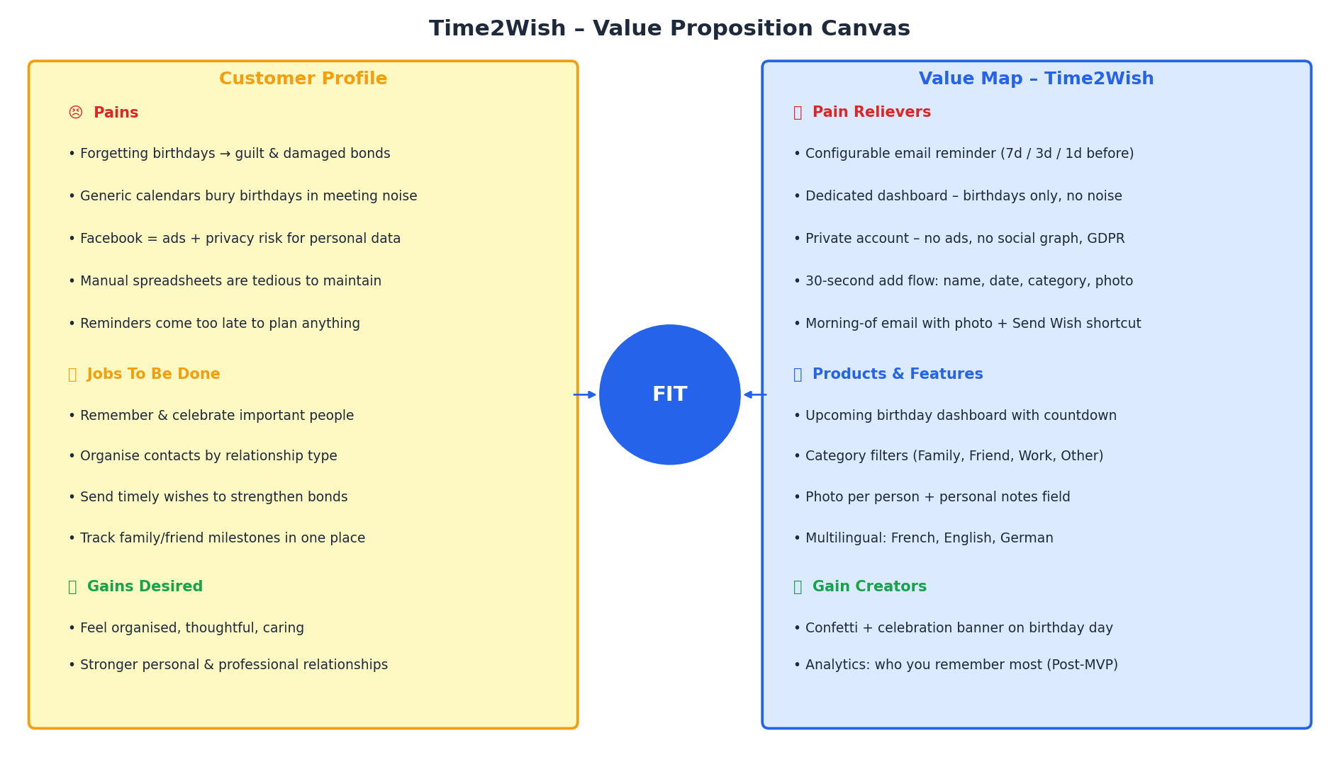
Figure 4 – Value Proposition Canvas: Customer Profile vs Time2Wish Value Map

Customer Pain | Forgetting birthdays → guilt, damaged bonds
Pain Reliever | Configurable email 7d/3d/1d before every birthday, with person's photo
Customer Pain | No dedicated warm birthday-focused app exists
Pain Reliever | 100% birthday-focused product with warm, human-centred design language
Customer Pain | Privacy concerns about social platforms holding personal relationship data
Pain Reliever | Private account, no ads, no data sharing, GDPR compliant, CSV export on demand
Customer Job | Organise contacts by relationship type, remember key dates, send meaningful wishes
Product Features | Category system (Family/Friend/Work/Other) · filters · per-person notes
Gain Desired | Feel organised and thoughtful – strengthen personal & professional relationships
Gain Creators | Confetti celebration on birthday day · 'Send Wish' shortcut · birthday statistics

6. User Journey Map
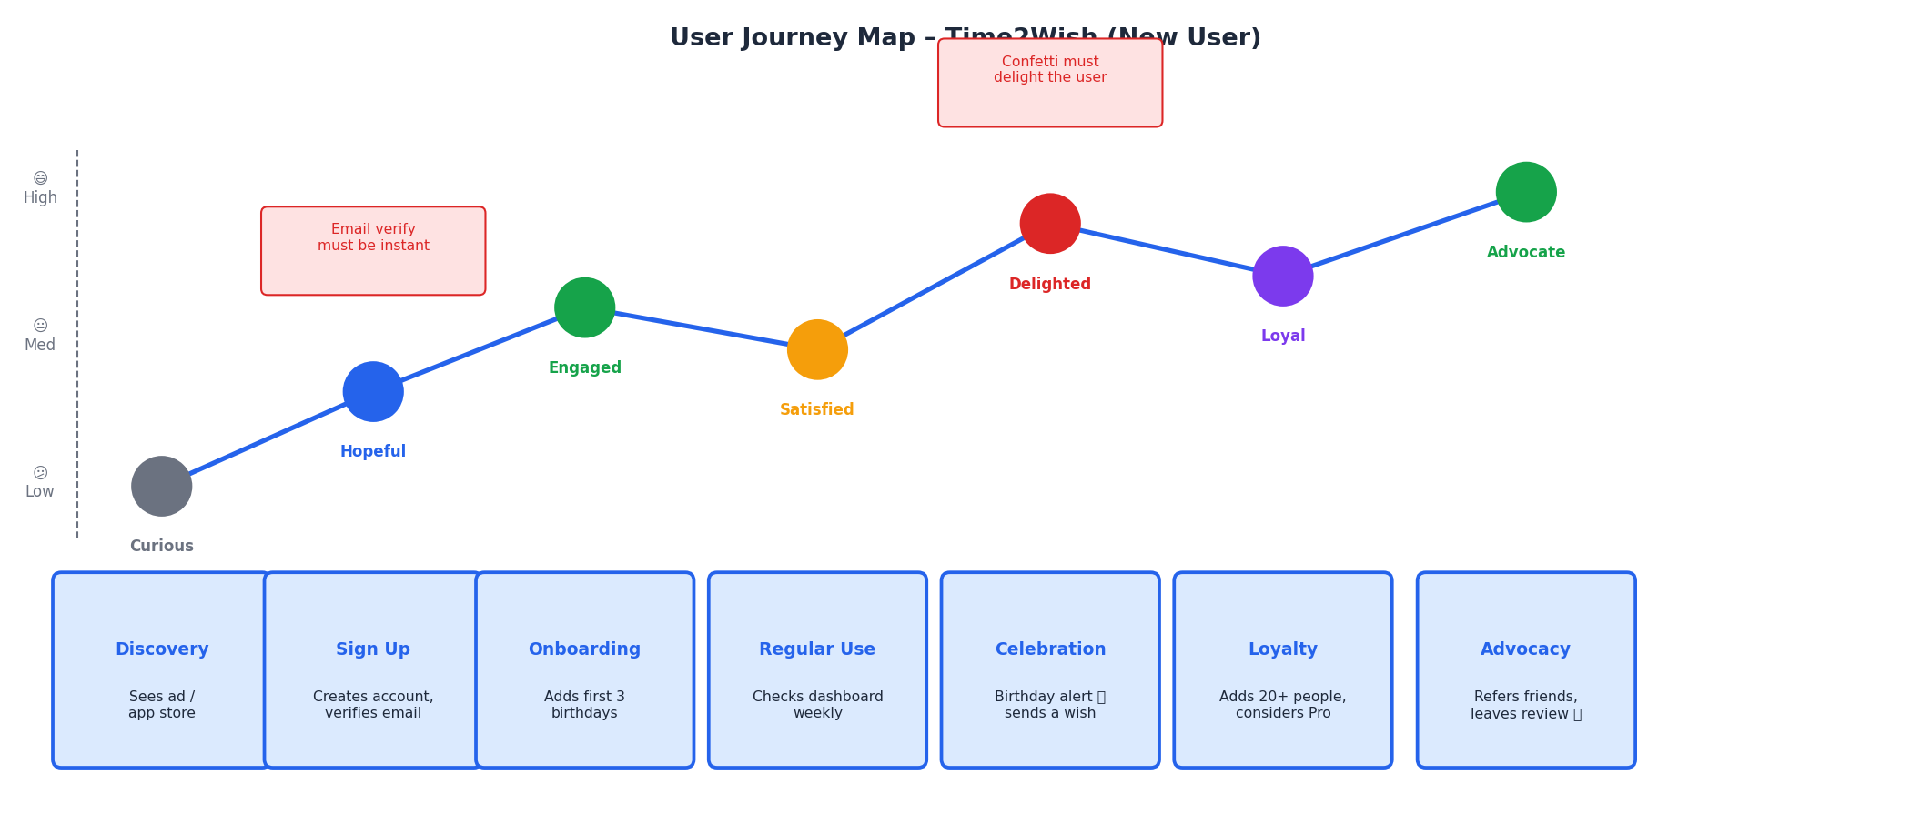
Figure 5 – User Journey Map: New User from Discovery to Advocacy

Stage | User Action | Emotion | Key Design Requirement
Discovery | App store / Google search / word-of-mouth | Curious | Value prop clear in <5 seconds on landing page
Sign Up | Email registration + 1-click email verification | Hopeful | Zero-friction signup – verify in 1 click, no credit card
Onboarding | Adds first 3 birthdays, sets reminder days | Engaged | 3-step wizard, progressive disclosure, instant first value
Regular Use | Checks dashboard weekly, browses upcoming list | Satisfied | Weekly email digest + notification on key dates
Celebration | Birthday alert → sees confetti → sends wish | Delighted | Full-screen confetti + Send Wish one-click shortcut
Loyalty | Adds 20+ people, considers Pro upgrade | Loyal | Profile completeness % + Pro feature teaser, no hard sell
Advocacy | Refers friends, leaves 5-star app review | Advocate | In-app referral prompt 30 days after first celebration moment

7. Functional Requirements & Use Cases
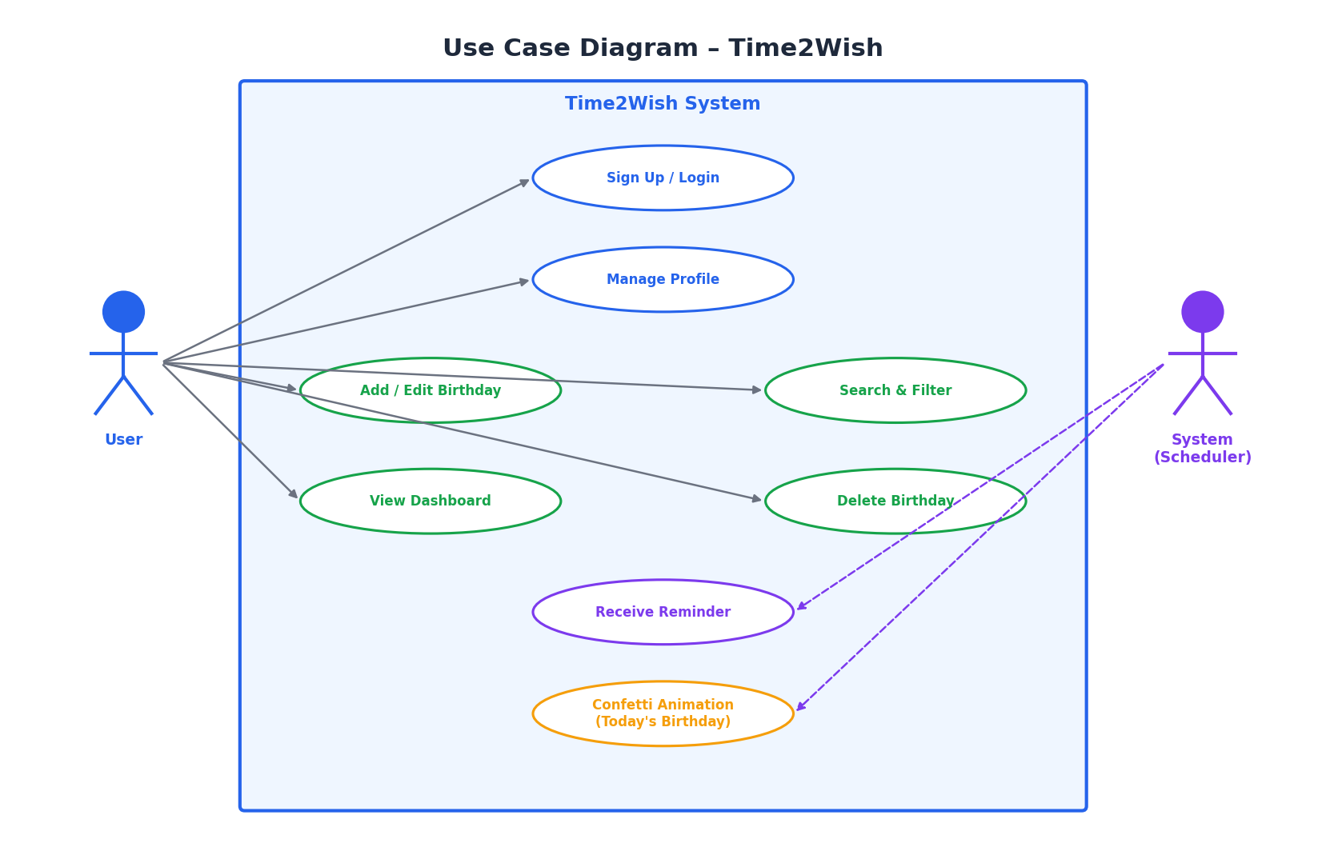
Figure 6 – Use Case Diagram – Time2Wish

7.1 User Management
- Sign Up: email + password registration with email verification (status: PENDING → ACTIVE)
- Login: JWT-based auth with 15-min Access Token + 30-day HTTP-only Refresh Token cookie
- Profile: update full name, bio, avatar; change password with current-password confirmation
- Account deactivation: soft-delete with 90-day GDPR-compliant purge schedule

7.2 Birthday Management – Feature Table
Feature | Description | Priority
Add Birthday | Name, birthdate, category (Family/Friend/Work/Other), photo upload, notes, reminder days | P0 – Critical
Edit Birthday | Update any field, replace photo, change reminder window | P0 – Critical
Delete Birthday | Soft delete with confirmation dialog, 30-day recovery window | P0 – Critical
Birthday Dashboard | Upcoming list sorted by days remaining, colour-coded countdown, stats widget | P0 – Critical
Email Reminders | Spring @Scheduled job: personalised HTML email N days before (configurable: 1/3/7/14d) | P0 – Critical
Search & Filter | Free-text name search, filter by Month, filter by Category | P1 – High
Confetti Banner | Full-screen celebration animation when dashboard loads on a birthday | P1 – High
Birthday Stats | Total, this month, today, most-remembered category | P1 – High
CSV Export | Download all data as CSV for portability and backup | P2 – Medium
Dark/Light Theme | System preference + manual toggle via Angular Material theming | P2 – Medium
AI Wish Suggestions | GPT/Claude LLM integration for personalised message text (Post-MVP) | P3 – Low
Shareable Cards | Generate birthday card image for WhatsApp/email sharing (Post-MVP) | P3 – Low

7.3 Key Use Case Walk-throughs
UC-01: Add a Birthday (Happy Path)
- Authenticated user clicks '+ Add Birthday' from the dashboard
- Fills in: Full Name (required), Date of Birth (required), Category (required), Reminder Days (default: 7)
- Optionally uploads a photo (JPEG/PNG ≤ 5MB) and writes personal notes
- Clicks Save → POST /api/birthdays → backend validates, persists, returns 201 Created
- Dashboard updates in real time showing the new entry sorted by days remaining

UC-02: Receive a Birthday Reminder (Automated)
- Spring @Scheduled job runs daily at 08:00 UTC
- Queries birthdays WHERE EXTRACT(MONTH/DAY FROM birthdate) matches today+N AND is_deleted=false
- For each match: SendGrid sends personalised HTML email with person's photo, countdown, and CTA
- User receives email, clicks through, sees confetti dashboard, clicks Send Wish

8. User Interfaces & Wireframes
The wireframes below present the 4 key screens – Login/Register, Dashboard, Add Birthday, and Birthday Detail – designed with a clear information hierarchy, warm colour language, and zero cognitive overhead outside the birthday experience.
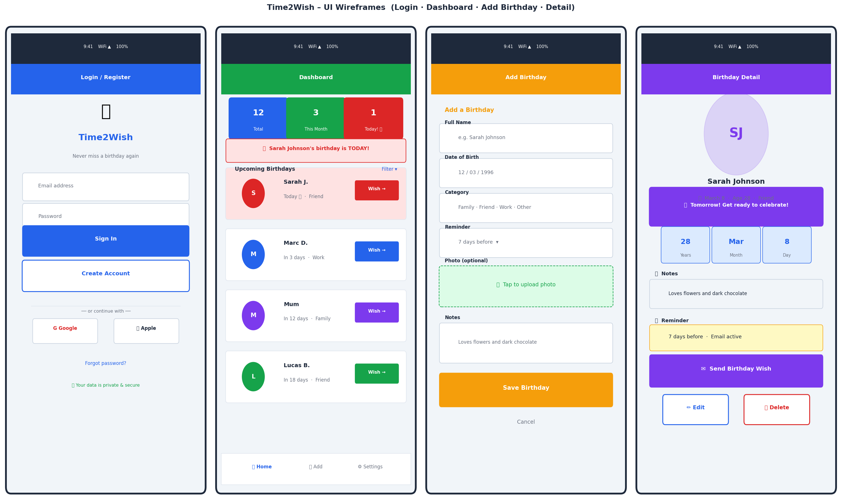
Figure 7 – Wireframes: Login · Dashboard · Add Birthday · Birthday Detail

8.1 Design System Tokens
Primary colour | Blue #2563EB – Trust, reliability, clarity (primary actions, CTAs)
Secondary colour | Violet #7C3AED – Warmth, celebration, personality (accents, tags)
Success / Upcoming soon | Green #16A34A – Positive reinforcement, upcoming within 7 days
Warning / Reminder | Amber #F59E0B – Attention state, birthday within 3 days
Danger / Today | Red #DC2626 – Birthday is TODAY – highest visual priority
Background | Slate #F1F5F9 – App shell and card backgrounds – neutral, clean
Typeface | Inter / system-ui – maximally legible at all sizes on all screens
Min font size | 14px (body) · 12px (captions) · WCAG 2.1 AA compliant
Responsive breakpoints | Mobile 375px · Tablet 768px · Desktop 1280px+
Dark mode | Supported via Angular Material theming + Tailwind dark: utility class
Accessibility | WCAG 2.1 Level AA · keyboard navigation · ARIA labels · contrast ≥ 4.5:1

9. System Architecture
Time2Wish follows a clean 3-Tier Architecture across five distinct layers, ensuring separation of concerns, testability at every level, and clear horizontal scaling paths as the user base grows. The architecture is cloud-agnostic and fully containerised from day one.
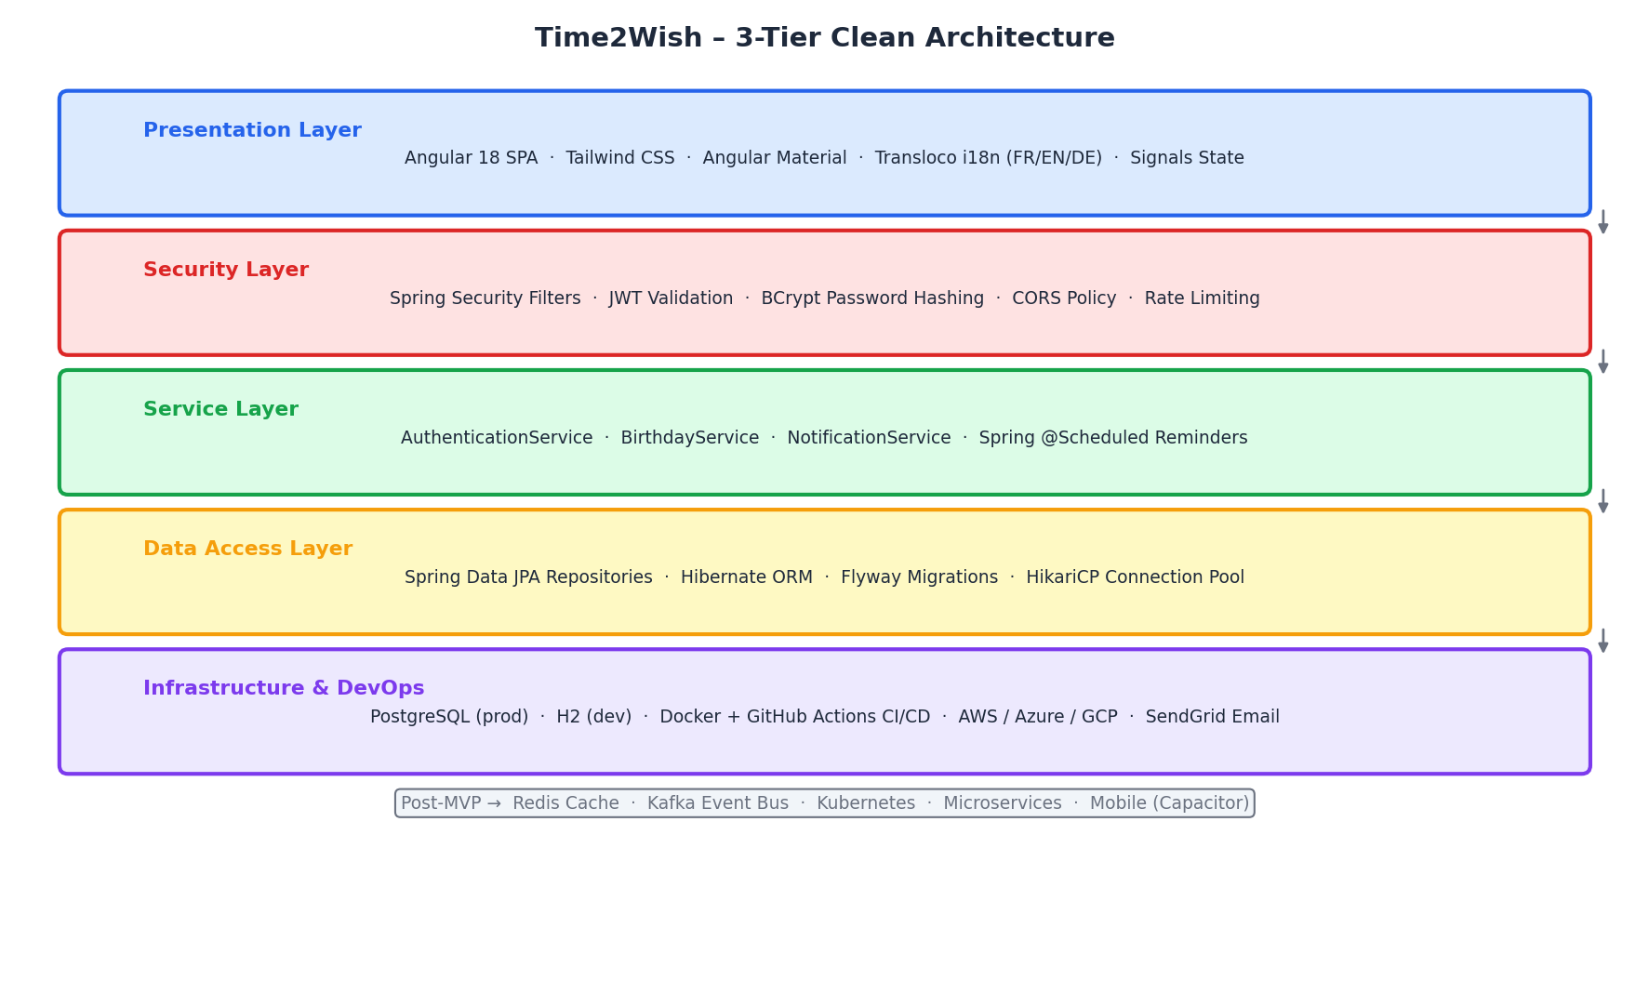
Figure 8 – 3-Tier Clean Architecture: Layers, Technologies & Future Scaling Path

9.1 Layer Responsibilities
Presentation Layer | Angular 18 SPA: routes, standalone components, signals state, forms, lazy loading, Transloco i18n
Security Layer | Spring Security: JWT filter chain, BCrypt, CORS, CSRF, rate limiting, HTTPS enforcement
Service Layer | Business logic: AuthService, BirthdayService, NotificationService, @Scheduled cron reminder
Data Access Layer | Spring Data JPA repositories, Hibernate ORM, Flyway migrations, HikariCP connection pool
Infrastructure Layer | PostgreSQL (prod) · H2 (dev) · Docker · GitHub Actions CI/CD · SendGrid · Cloud (AWS/GCP/Azure)

10. Technical Stack – Full Detail & Justifications
Angular 18 (Standalone + Signals) | Latest LTS – Signals eliminate Zone.js overhead, standalone components reduce bundle ~30%, better DX for enterprise forms
Tailwind CSS | Utility-first – collocates styling with markup, excellent purging, final CSS ~8KB
Angular Material | Battle-tested accessible component library (WCAG 2.1), deep Angular integration
Transloco (i18n) | Runtime language switching without page reload, lazy-loaded translation files – superior to Angular's compile-time i18n
Spring Boot 3 / Java 21 | LTS with virtual threads (Project Loom) for high-concurrency I/O – production-grade reliability
Spring Security + JWT | 15-min Access Token (short exposure window) + 30-day HTTP-only Refresh Token (XSS-proof)
Spring Data JPA + Hibernate | Type-safe DB ops, automatic query generation, LEFT JOIN FETCH eliminates N+1 on dashboard load
Flyway migrations | Versioned, auditable, rollback-capable schema evolution – critical for safe production DB changes
PostgreSQL 16 | ACID compliant, rich JSON support, full-text search, excellent cloud hosting (AWS RDS, Supabase, Neon)
H2 (development) | Zero-config in-memory DB for local and CI testing – identical JPA behaviour to PostgreSQL
Spring @Scheduled (cron) | Built-in scheduler – no external queue needed for MVP; runs daily at 08:00 UTC for reminders
SendGrid API | 99.95% email deliverability SLA, 100 free emails/day on Starter, battle-tested HTML templating
Docker + GitHub Actions | Containerised builds: dev/prod parity; CI pipeline: test → lint → build → push → deploy on every PR
AWS / Azure / GCP | Cloud-agnostic Docker Compose for MVP, Kubernetes-ready for scale, no vendor lock-in

11. UML Diagrams

11.1 Sequence Diagram – Authentication Flow
Complete authentication sequence from credential submission through Spring Security to JWT issuance and Angular AuthGuard route protection.
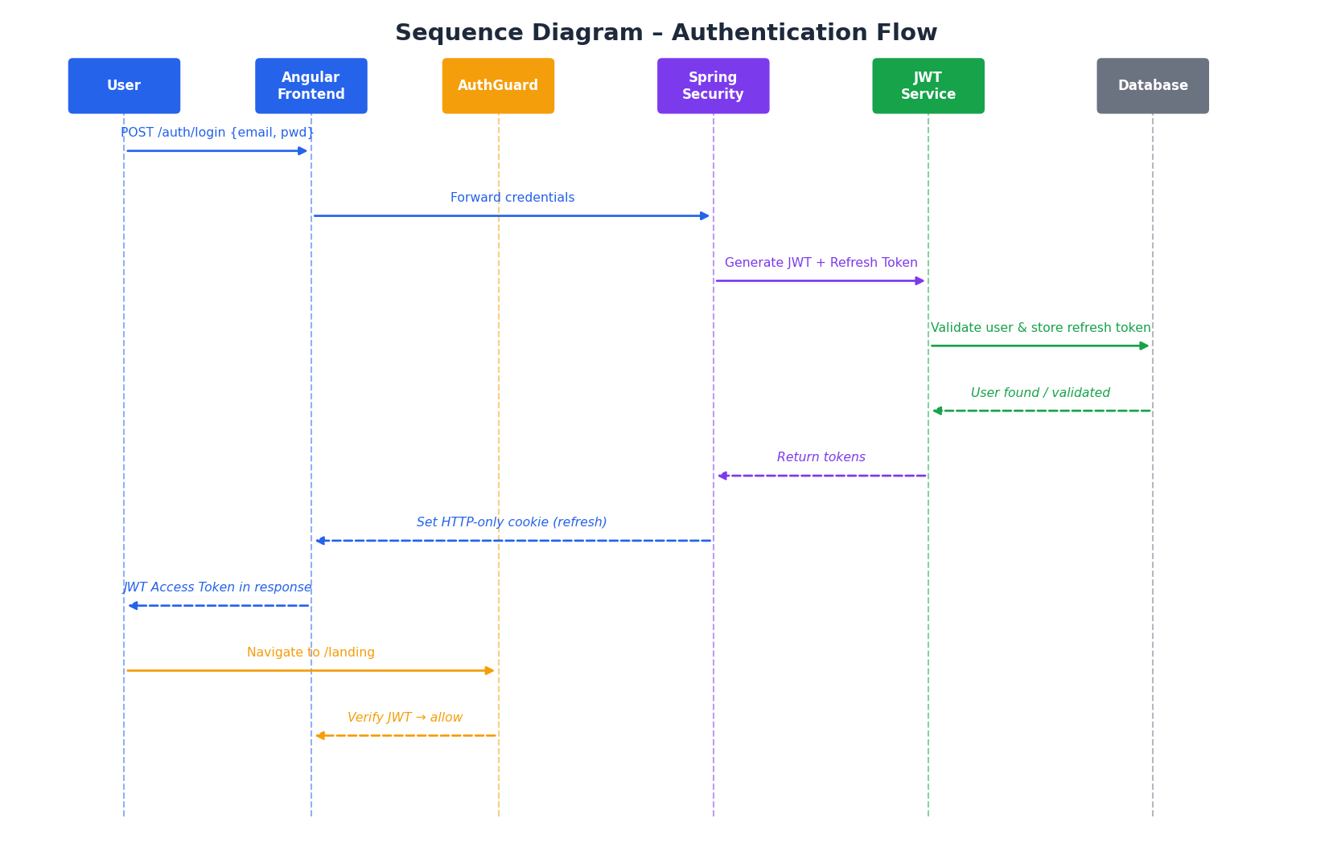
Figure 9 – Sequence Diagram: Authentication (Login → JWT → Protected Route)

11.2 Sequence Diagram – Birthday Retrieval Flow
Complete data flow when the authenticated user loads the dashboard: Angular service call, Spring Controller delegation, JPA LEFT JOIN FETCH query, and client-side sort by days remaining.
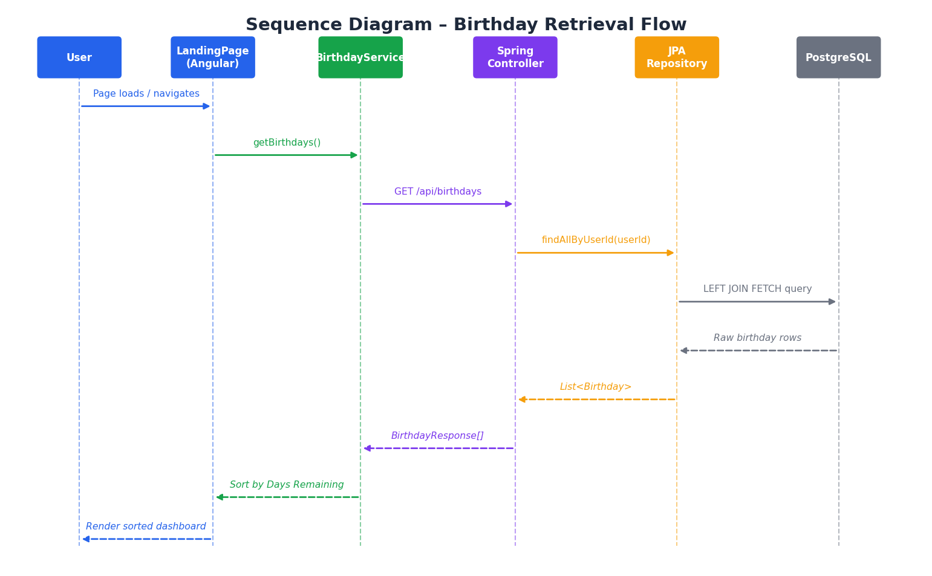
Figure 10 – Sequence Diagram: Birthday Retrieval & Dashboard Rendering

11.3 Class Diagram – Core Domain
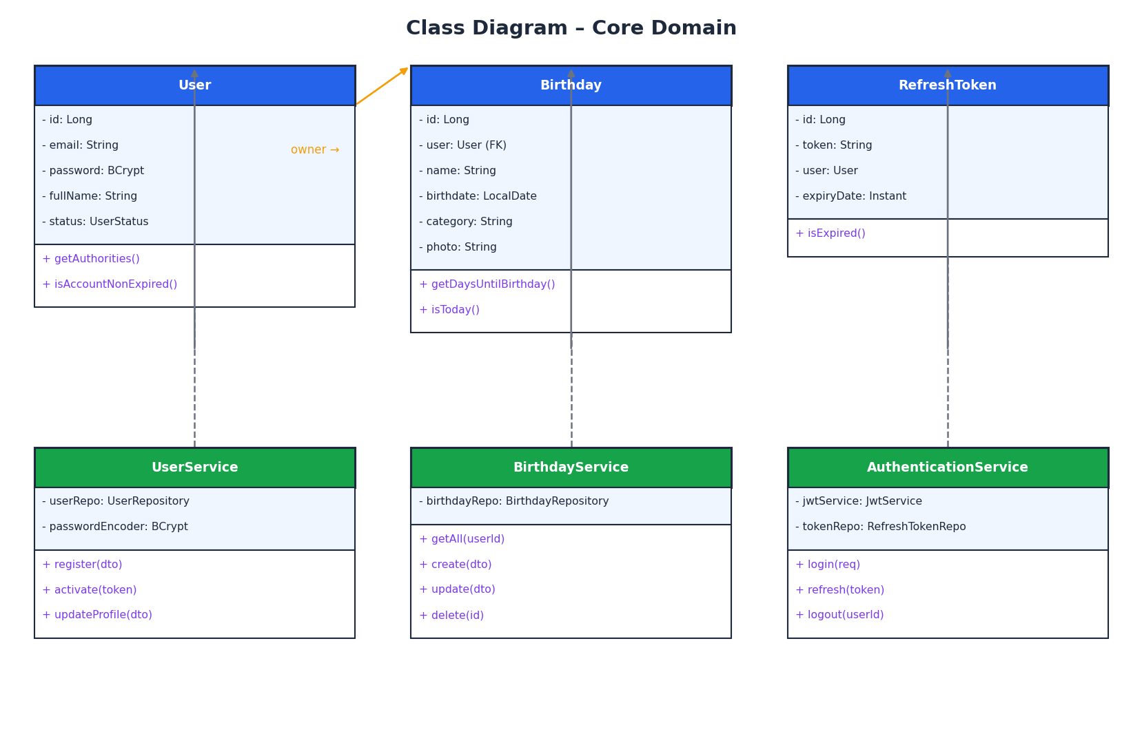
Figure 11 – Class Diagram: Core Domain Entities & Service Layer

12. Data Model
Table: users
Column | Type | Constraint | Description
id | BIGSERIAL | PK | Auto-increment primary key
email | VARCHAR(255) | UNIQUE NOT NULL | Login email
password | VARCHAR(255) | NOT NULL | BCrypt hash (cost 12)
full_name | VARCHAR(100) | NOT NULL | Display name
bio | TEXT | NULLABLE | Optional profile biography
avatar_url | TEXT | NULLABLE | Profile picture URL
status | VARCHAR(20) | NOT NULL DEFAULT 'PENDING' | PENDING / ACTIVE / BANNED / DELETED
last_login_at | TIMESTAMP | NULLABLE | Last successful login
created_at | TIMESTAMP | NOT NULL DEFAULT NOW() | Account creation date
Table: birthdays
Column | Type | Constraint | Description
id | BIGSERIAL | PK | Auto-increment primary key
user_id | BIGINT | FK → users(id) NOT NULL | Owner user (cascade delete)
name | VARCHAR(150) | NOT NULL | Person's full name
birthdate | DATE | NOT NULL | Birthday date (year optional)
category | VARCHAR(50) | NOT NULL DEFAULT 'Friend' | Family / Friend / Work / Other
photo_url | TEXT | NULLABLE | Person's photo (S3 URL or Base64)
notes | TEXT | NULLABLE | Personal notes (gift ideas, preferences)
reminder_days | SMALLINT | NOT NULL DEFAULT 7 | Days before birthday for reminder email
is_deleted | BOOLEAN | NOT NULL DEFAULT false | Soft delete flag (30-day recovery)
created_at | TIMESTAMP | NOT NULL DEFAULT NOW() | Record creation date
Table: refresh_tokens
Column | Type | Constraint | Description
id | BIGSERIAL | PK | Auto-increment primary key
token | UUID | UNIQUE NOT NULL | Cryptographically random UUID v4
user_id | BIGINT | FK → users(id) NOT NULL | Token owner
expiry_date | TIMESTAMP | NOT NULL | Expiration (issued_at + 30 days)

12.2 Database Optimisations
- INDEX on birthdays(user_id) – fast birthday list retrieval per user (most frequent query)
- INDEX on birthdays(birthdate) – efficient reminder scheduler queries (EXTRACT MONTH/DAY)
- Composite INDEX on (user_id, is_deleted) – filter active records per user in one scan
- Soft delete (is_deleted) – 30-day recovery window before permanent GDPR purge
- Flyway versioned migrations – safe, auditable, rollback-capable schema evolution
- HikariCP connection pool – max 20 connections, min-idle 5
- LEFT JOIN FETCH on birthday retrieval – eliminates N+1 problem on dashboard load

13. Security & Non-Functional Requirements

13.1 Security Requirements
Password hashing | BCrypt cost factor 12 – ~250ms/hash, brute-force resistant
JWT Access Token | 15-min lifespan – minimal exposure window if intercepted
Refresh Token | 30-day HTTP-only Secure cookie – invisible to JS (XSS-proof), SameSite=Strict (CSRF-proof)
HTTPS / TLS 1.3 | All traffic encrypted – HTTP permanently redirects to HTTPS (HSTS)
CORS policy | Strict allowlist: Angular app domain only (or localhost in dev)
Input validation | Bean Validation (@NotNull, @Size, @Email) on all DTOs + Spring sanitisation chain
Rate limiting | 100 req/min per IP via Nginx – brute force and DDoS protection
SQL injection | Spring Data JPA parameterised queries – no string concatenation in DB calls
GDPR compliance | CSV export · right to erasure (soft delete + 90-day purge) · minimal data collection · explicit consent

13.2 Non-Functional Requirements
Performance | Dashboard load <2s on broadband · API response <300ms p95 · Angular bundle <150KB gzipped
Availability | 99.9% uptime target – single instance MVP, multi-instance + health-check auto-restart post-MVP
Scalability | Stateless backend (JWT + DB pool) – horizontal scaling behind load balancer with zero code changes
Accessibility | WCAG 2.1 Level AA – NVDA/VoiceOver, keyboard navigation, focus indicators, contrast ≥ 4.5:1
Internationalisation | FR / EN / DE via Transloco lazy-loaded files – hot-swap without page reload
Browser support | Chrome 100+ · Firefox 100+ · Safari 15+ · Edge 100+ (ES2022 target)
Mobile | Fully responsive from 375px – usable on all modern phones
Data backup | Daily automated snapshots (cloud provider) – 30-day retention, point-in-time recovery

14. Business Model & Revenue Projections

14.1 Freemium Strategy
Free (Forever) | Unlimited birthdays, all core features, 1 reminder/birthday, 4 categories, CSV export, dark mode
Time2Wish Pro – $2.99/mo | Unlimited reminder schedules (1d+3d+7d), AI message suggestions, priority support, no upsell prompts
Family Plan – $4.99/mo | Up to 5 family members sharing one birthday list, shared dashboard, gift coordination notes
Teams / SMB – $9.99/mo | 20 seats, admin dashboard, CRM CSV export, branded reminder emails, dedicated onboarding
Billing | Stripe – monthly and annual billing (annual = 2 months free, ~17% discount)
Payments | Visa/Mastercard/Amex · PayPal · Apple Pay · Google Pay (via Stripe)

14.2 3-Year Revenue Projection
Metric | Year 1 | Year 2 | Year 3
Monthly Active Users | 10 000 | 45 000 | 150 000
Pro conversion (5–8%) | 500 | 2 700 | 9 000
Pro ARPU | $2.99 | $2.99 | $2.99
Pro revenue / year | $17 940 | $96 768 | $322 920
Teams customers | 5 | 60 | 300
Teams revenue / year | $599 | $7 188 | $35 940
Total ARR | ~$18 500 | ~$104 000 | ~$359 000
[Source] Projections based on: ProductLed Freemium Benchmark 2024, Stripe benchmarks for productivity SaaS, comparable tools on Product Hunt

15. Roadmap, Timeline, Team & Budget
The MVP is delivered across 5 focused phases totalling 10 weeks. Budget estimates use Western European freelance rates of €400–600/day. Adjust for your market: Eastern Europe ~€150–250/day · India ~€80–150/day.

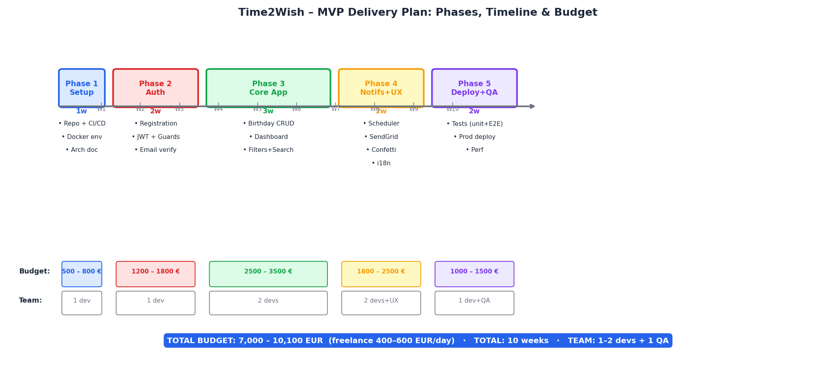
Figure 12 – MVP Delivery Plan: 5 Phases, Weekly Timeline & Budget per Phase

15.1 Phase-by-Phase Breakdown
Phase | Duration | Key Deliverables | Team | Budget
Phase 1  Setup | 1 week | Git repo · Docker Compose (Angular + Spring + PG) · GitHub Actions CI · OpenAPI spec · Architecture Decision Records | 1 Full-stack dev | 500–800 €
Phase 2  Authentication | 2 weeks | User registration + SendGrid email verify · JWT login + Spring Security chain · Refresh Token · Angular AuthGuard + login/register UI | 1 Full-stack dev | 1 200–1 800 €
Phase 3  Birthday Core | 3 weeks | Birthday CRUD API + Angular UI · Dashboard countdown sort · Category & month filters · Free-text search · Photo upload · Stats widget | 2 devs (FE + BE) | 2 500–3 500 €
Phase 4  Notifs & UX | 2 weeks | Spring @Scheduled reminder job · Personalised HTML email (SendGrid) · Confetti animation · Dark mode · Transloco FR/EN/DE · Responsive polish | 2 devs + UX designer | 1 800–2 500 €
Phase 5  QA & Deploy | 2 weeks | JUnit 5 + Jasmine unit tests · Testcontainers integration tests · Cypress E2E · Security checklist · Cloud production deploy · Perf tuning | 1 dev + 1 QA engineer | 1 000–1 500 €

Total MVP Investment
DURATION: 10 weeks · BUDGET: 7 000 – 10 100 € (Western Europe, freelance)
Eastern Europe / South America: ~2 500 – 4 500 € · South/South-East Asia: ~1 500 – 3 000 €
Salaried developer (€50K/yr): ~€9 600 equivalent for 10 weeks (pro-rated)

16. Post-MVP & Long-Term Vision

16.1 Post-MVP Features (Months 3–12)
Feature | Timeline | Description | Team | Budget
Mobile App  (Capacitor) | Month 3–5 | Wrap Angular SPA with Ionic Capacitor → Android + iOS · Push notifications · App store release | 1 Mobile dev | 3 000–5 000 €
Pro Tier (Stripe) | Month 4–5 | Stripe subscriptions · billing portal · Pro feature gating · upgrade prompts | 1 dev | 1 500–2 500 €
Rich HTML Emails | Month 4 | Person's photo in reminder email · countdown chip · Send Wish CTA · unsubscribe management | 1 dev + designer | 800–1 500 €
Redis Cache | Month 5–6 | Birthday list caching (TTL 1h) · session store · rate limiter – reduces DB load 60–70% | 1 BE dev | 500–1 000 €
Analytics Dashboard | Month 6–8 | Monthly distribution chart · most-remembered category · streak tracker · year-in-review | 1 FE dev | 1 000–1 800 €
AI Message Suggestions | Month 7–9 | GPT-4o / Claude API integration · personalised wish text based on name, age, notes, category | 1 dev | 800–1 500 €
Teams / SaaS | Month 9–12 | Multi-user shared lists · admin dashboard · CRM CSV export · branded reminder emails | 2 devs | 4 000–7 000 €

16.2 Long-Term Vision (Year 2–3)
- 150,000 MAU · €300K+ ARR · Series-A readiness
- Kafka event bus + Notification microservice: decouple reminder delivery for independent scaling
- Kubernetes deployment: auto-scale around major holiday birthday spikes
- Birthday Wish Card generator: branded shareable images for WhatsApp / Instagram / SMS
- Enterprise HR tier: company-wide employee birthday management with Slack/Teams integration
- Marketplace: gift recommendations, flower delivery, restaurant booking – affiliate revenue

17. Risks & Mitigation
Risk | Prob. | Impact | Mitigation | Contingency
Scope creep delays MVP | Medium | High | MoSCoW, weekly scope review, frozen backlog after Phase 3 kickoff | Cut P2/P3 entirely from MVP, defer to Post-MVP sprint
Email deliverability issues | Low | High | SendGrid 99.95% SLA, SPF/DKIM/DMARC configured day 1, Mail Tester validation | Fallback to Mailgun; add in-app notification as secondary channel
Low adoption at launch | Medium | Medium | Product Hunt launch + SEO landing page + built-in referral programme | Pivot to B2B (HR gifting, SMB) – lower CAC, higher willingness to pay
JWT security breach | Low | Very High | 15-min token TTL, HTTP-only cookies, TLS, rate limiting, security audit pre-launch | Force token rotation all users, rotate signing keys, transparent incident comms
Google adds native birthday tool | Low | Medium | Deepen emotional differentiation: confetti, Send Wish UX, AI messages, notes | Pivot to niche (diaspora, enterprise HR) where Google Calendar won't compete
PostgreSQL scaling bottleneck | Low | Low | Read replicas, Redis cache, query optimisation (EXPLAIN ANALYSE), connection pool | Migrate to Aurora PostgreSQL / Supabase – no application code changes
Developer bus-factor risk | Medium | High | Full OpenAPI docs, ADRs, README, Docker one-command setup, trunk-based dev | Toptal / Malt freelancers – codebase is onboard-friendly by design

— End of Time2Wish Product Requirements Document v3.0 —
Never miss a birthday again.
time2wish.app · contact@time2wish.app

