How to Run The Script “Login_SSH_and_Run_Command”

Edit the IP credential for the target ssh hosts : the sequence of parameters must follow the format :IP+Username+Passwd
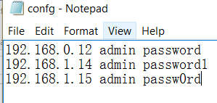
Run the script with parameters:

It supposed to work like this: python+script_name+configure.txt+"command"

stevek@stevek-VirtualBox:/mnt$ python Login_SSH_and_Run_Command_0.8.py config.txt "switchshow | grep E-Port">devices.txt

Theoretically, we can utilize this script to login any target host which utilize SSH include: Linux/switch/windows power shell and etc.

And we can run this on windows/Linux/OSX as long as python2.7 and paramiko module are properly installed.
The command line is slightly different in windows powershell:

Paramiko installation:
http://www.paramiko.org/installing.html
Python 2.7 install:
https://www.python.org/download/releases/2.7/

