SPRINT 2 FEEDBACK · CAPSTONE

Smart CCTV Analytics Platform
Steve Prathik Fernandes · Status as of 29 October 2026

Summary
Sprint 2 made every event watchable and gave admins the screens to run the system. 8 of 12 backlog items are done; the 4 that carry over depend on the AWS account or on Docker.
Item | Detail
Sprint period | Weeks 4 to 6, 19 October to 8 November 2026
Sprint goal | Clips and thumbnails for every event, admin screens for users, cameras, zones, rules and the audit log, and a measure of tracking quality
Team | Solo project
Tools | Trello (sprint tracking), GitHub (code and history), GitHub Actions (CI)

Sprint structure
The sprint is tracked on Trello with To Do, Doing and Done lists, one card per backlog item.
trello.com/b/Lt2EjwUr/cctv-analytics-platform
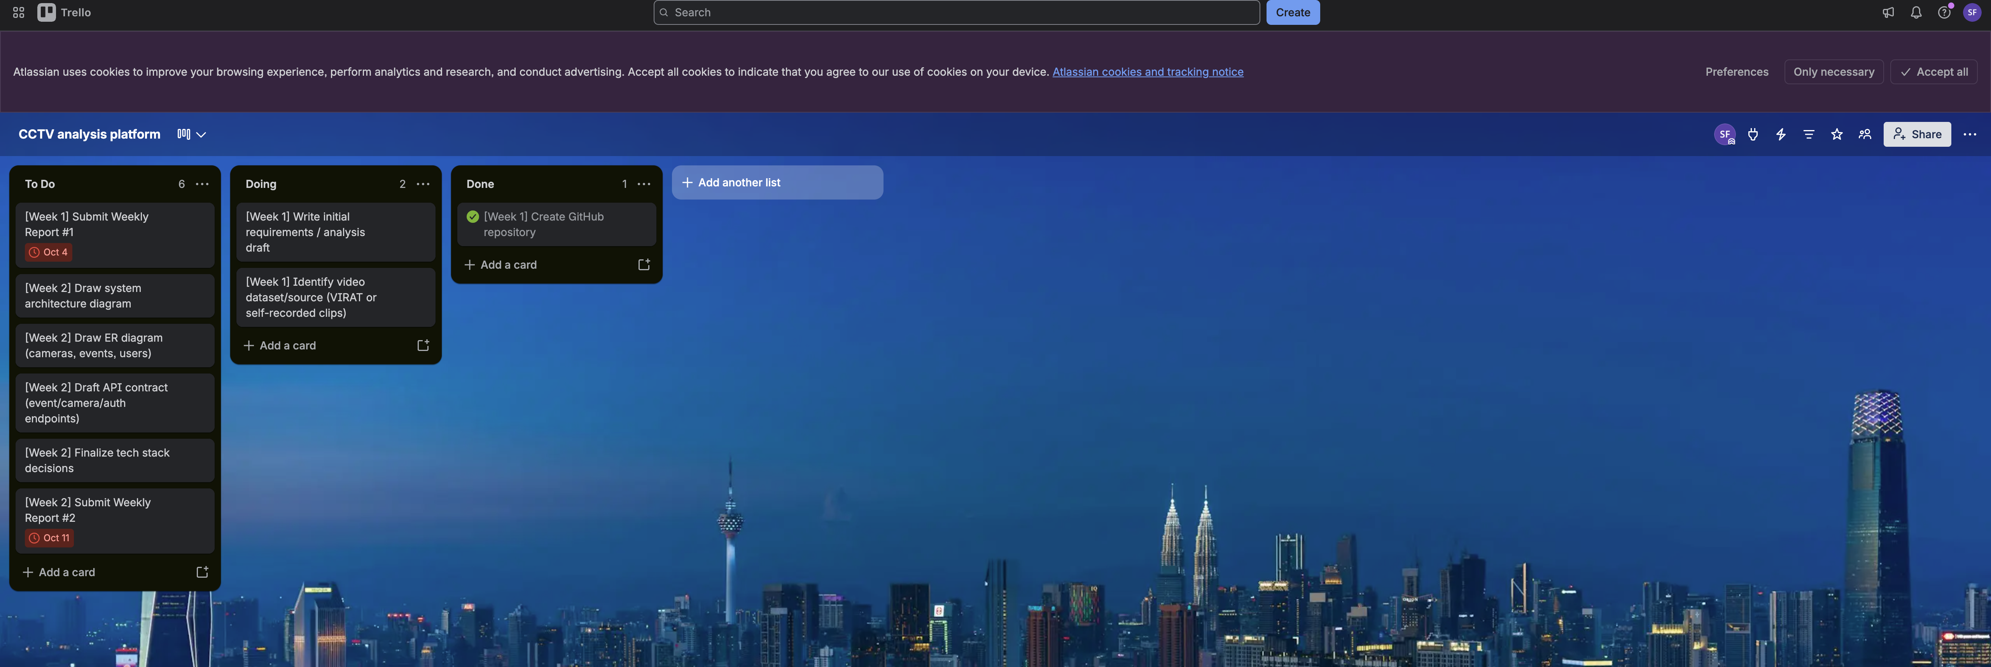
Backlog item | Status | Evidence
Thumbnail and short clip for every event | Done | ml-service/app/media.py, 5 tests
Short-lived signed links for clips and thumbnails | Done | LinkSigner.java, MediaController.java
Clip playback in the dashboard | Done | frontend/src/EventPanel.tsx
User management and camera access screen | Done | frontend/src/UsersPage.tsx
Audit log screen | Done | frontend/src/AuditPage.tsx
Edit and delete cameras | Done | PUT and DELETE /api/cameras/{id}, 3 tests
Zone drawing and rules screens | Done | frontend/src/CameraAdmin.tsx
Tracking quality on MOT17 | Done | ml-service/app/track_eval.py; results in docs/06-detection-baseline.md
Cloud deployment (from Sprint 1) | Carried over | AWS account not set up yet
Encrypted S3 storage | Carried over | Needs the AWS account; the storage interface is ready for it
Run the whole system with Docker Compose | Carried over | Docker was not available on the development machine
Demo clips and vehicle evaluation set | Carried over | Needs recording with consenting people

What has been completed

Detection service
- A thumbnail of each event’s clearest frame, with the tracked person or vehicle boxed.
- A short clip per event, from 2 seconds before to 2 seconds after, at most 30 seconds.
- Clips saved as H.264 MP4, or WebM where H.264 is unavailable; both play in browsers.
- If clip creation fails, the events are still saved, so detection results are never lost.
- Tracking quality measured on MOT17 with the standard motmetrics library.

Backend
- Clip and thumbnail endpoints that check camera access, then redirect to a signed link.
- Signed links that expire after 5 minutes; forged or expired links are refused.
- Video seeking supported through partial (range) requests.
- Every clip view written to the audit log.
- Camera editing, and camera deletion that requires confirmation when footage exists.
- Read access to which cameras an operator can see, for the users screen.

Dashboard
- Play button on each event, opening its clip and details.
- Users screen: add users, change roles, enable or disable, assign cameras.
- Audit log screen with a filter by action.
- Camera settings: rename, delete, draw zones by clicking on a real frame, add and switch off rules.
- Navigation between Cameras, Users and Audit log for admins.

Quality
- 104 automated tests: 59 backend, 45 detection service, all passing.
- Full flow checked end to end: upload, detection, clips, signed links and playback.
- API contract, architecture and test documents updated to match the code.

Frontend progress
Each event now opens to its clip, and admins manage the system without using the API directly.
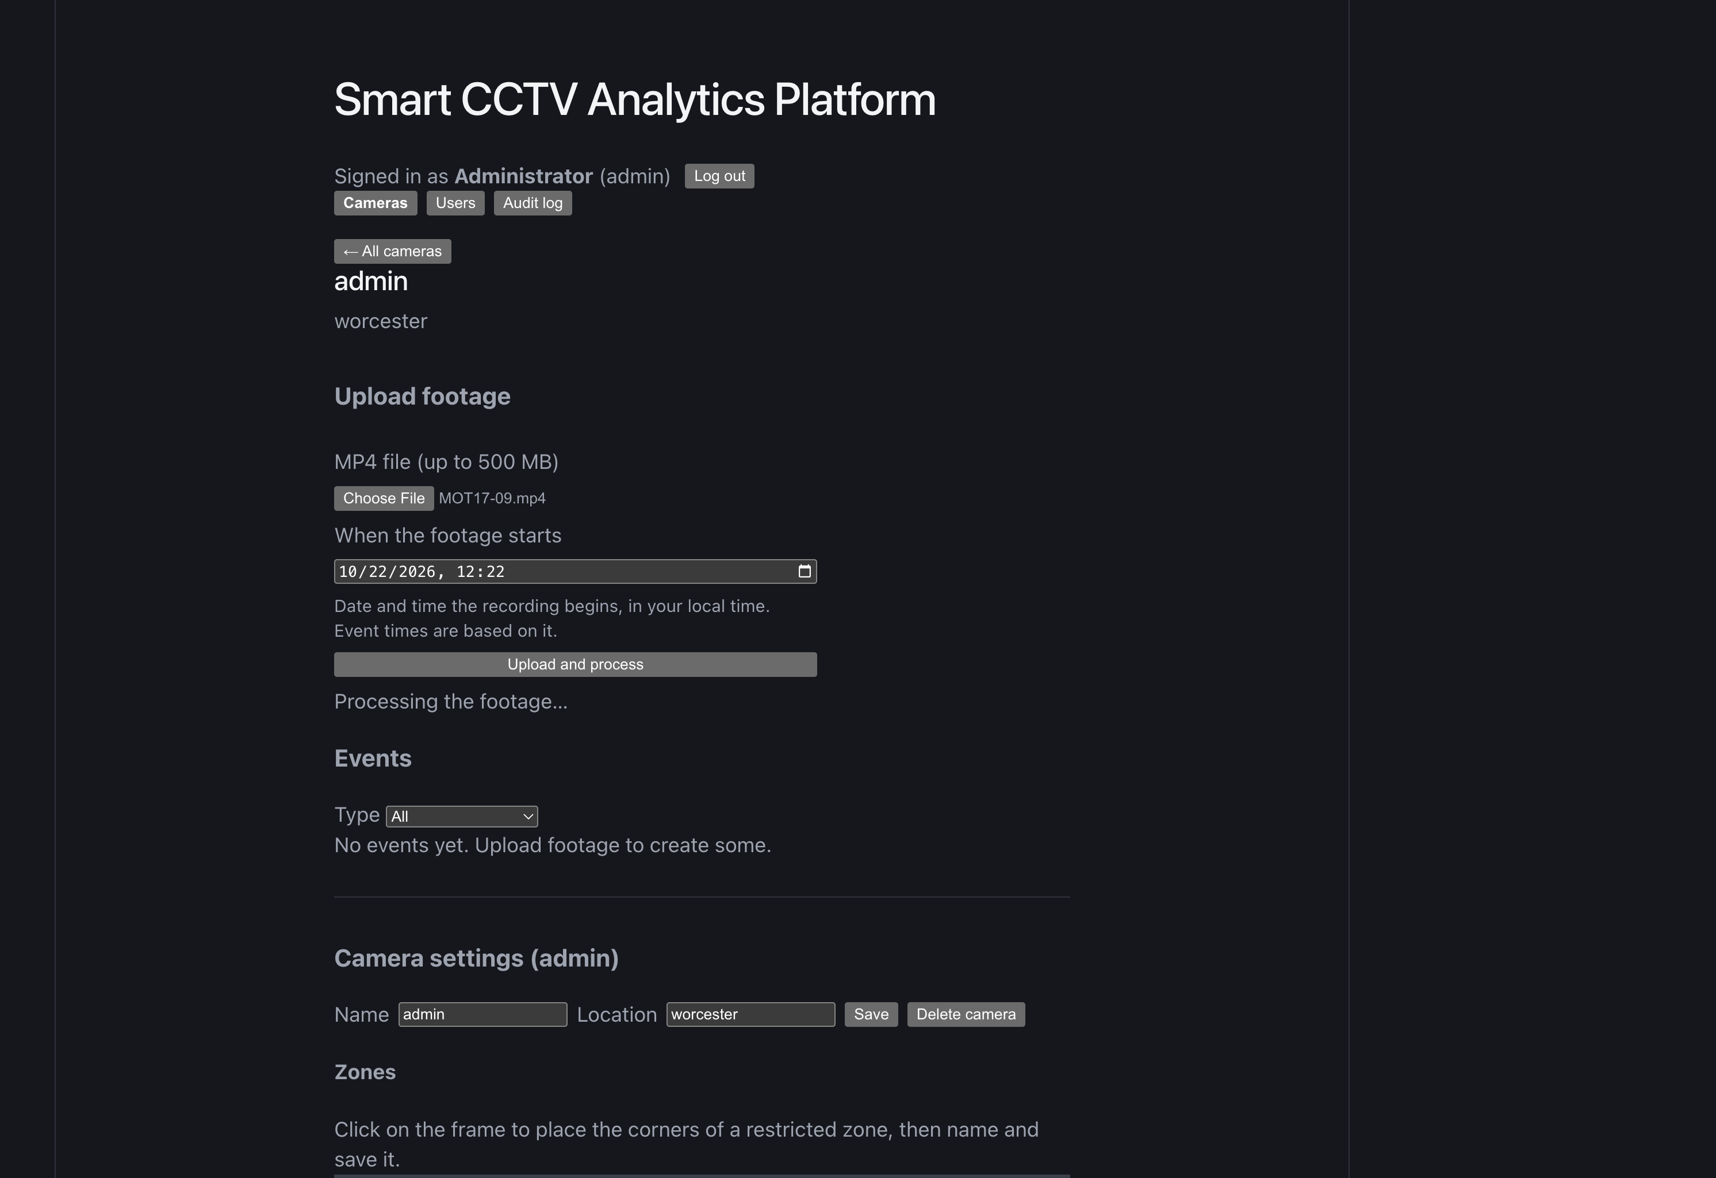
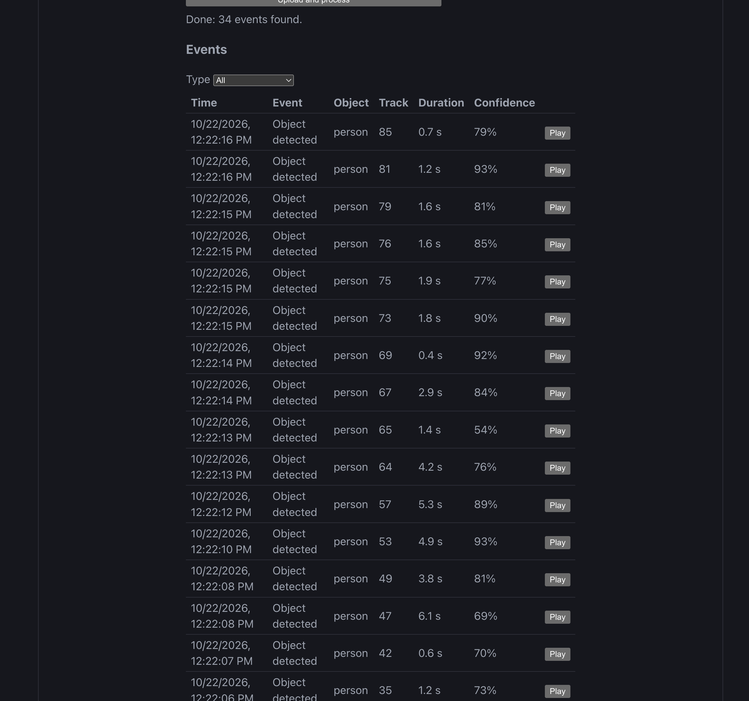

Backend progress
A 17.5-second test clip went from upload to 38 events in 12.5 seconds, each event with its own clip and thumbnail.
New endpoint | Purpose | Who may call
GET /api/events/{id}/clip | Redirect to the event’s clip; audited | Operator (own cameras), admin
GET /api/events/{id}/thumbnail | Redirect to the event’s thumbnail | Operator (own cameras), admin
GET /api/media | Serve a file through a signed, expiring link | Anyone holding a valid link
PUT /api/cameras/{id} | Rename or relocate a camera | Admin
DELETE /api/cameras/{id} | Delete a camera; footage only with confirmation | Admin
GET /api/users/{id}/cameras | Cameras an operator can see | Admin

Tracking quality on MOT17
Sequence | People | MOTA | IDF1 | ID switches
MOT17-02 | 52 | 32.9% | 43.7% | 23
MOT17-04 | 79 | 35.0% | 49.5% | 30
MOT17-09 | 26 | 73.8% | 67.2% | 52
All | 157 | 37.4% | 50.1% | 105
Every 3rd frame, as the service runs. IDF1 is how long each person keeps one track ID. Scores are limited by missed small, distant people (recall 41%); precision stays at 93%. Sampling every 3rd frame scores no worse than every frame.

GitHub repository
github.com/steve-prathik-fernandes/cctv-analytics-platform
Date | Commit
29 Oct 2026 | Sprint 2: event clips, signed media links, admin screens, tracking evaluation
15 Oct 2026 | Week 3 work: detection pipeline, event rules, upload-to-event flow
15 Oct 2026 | Database migrations, login and roles, user management, audit log
6 Oct 2026 | Requirements, architecture, database design, API contract
6 Oct 2026 | Initial project scaffold

Supporting material
Document | What changed this sprint
docs/06-detection-baseline.md | New section on tracking quality
docs/03-architecture.md | How clips and thumbnails are made; signed links; storage cost
docs/api/openapi.yaml | New endpoints and audit actions
docs/weekly-reports/week-05.md | Weekly report for 26 October to 1 November

Carry-over and Sprint 3 plan
The main risk is the cloud deployment, now carried over twice; setting up the AWS account comes first in Sprint 3.
- Set up the AWS account and deploy the API, dashboard and detection service.
- Encrypted S3 storage with presigned links, replacing the local folder.
- Run the whole system with Docker Compose.
- Record demo clips with consenting people and label a small vehicle test set.

