Predicting Fentanyl Overdose Deaths
A County Level Early Warning System
Stephen Riesenberg
Data Science, CUNY Graduate Center, New York City, New York, US, steve.riesenberg@gmail.com

ABSTRACT
I train a model to predict the county wide risk of fentanyl overdose deaths. As input, the model uses a county’s number of fentanyl overdose deaths, a county’s percent of renter’s in distress, and a county’s rate of opioid prescription. The model is able to predict with 80% accuracy which counties with no previous fentanyl overdose deaths will experience an increase in deaths in the next year.
Fentanyl, Drug Epidemiology, Classification, Boosted Decision Trees
- Introduction
In 2017, over 20,000 Americans died from drug overdoses involving fentanyl. Fentanyl is a synthetic opioid drug. Because it is many times stronger than heroin, the difference between a lethal and non-lethal dose of fentanyl is very small. Combined with the fact that many users do not know that their drugs contain fentanyl, overdoses have become a health crisis for many US counties¹.
Counties can take action to reduce the overdose risk of their residents, for example by purchasing naloxone and training paramedics and other personnel in its use. By predicting a county’s risk level for fentanyl overdose deaths, we can focus these interventions on communities most in need, before a large number of deaths occur.
- Related Work
The opioid epidemic as a whole as received a lot of attention both from journalists and from researchers. While most of this work involves the demography or geography of opioid dependence and overdose, some researchers have used machine learning to predict overdose risk, including a paper by Lo-Ciganic, Huang, and Zhang predicting individual overdose risk. The work most similar to the aim of this paper has been done by Daniel Neill, who used machine learning techniques to enable early detection of clusters of overdose deaths by county in New York State. This paper represents the first attempt known to me to predict fentanyl specific overdose risk by county nationally.

- Your method/approach
I formulate the problem of assigning a fentanyl overdose risk level to a county as a binary classification problem. The two possible labels are high risk and low risk. Any county that had any fentanyl related overdose deaths in the previous year is automatically classified as high risk. I therefore restrict my attention to counties that have not had any previous deaths, and I am interested in identifying the counties that are likely to have their first deaths in the following year. A low risk county is a county that has no previous deaths and no deaths in the following year. A high risk county is either a county with previous deaths, or a county with no previous deaths that has deaths in the following year. By formulating the problem this way, I can build an early alert system that can help identify an emerging problem before it becomes a crisis.

- Your Dataset
Data on fentanyl related overdose deaths from 2013-2017 was collected from the CDC WONDER Multiple Cause of Death Database. For the ‘underlying cause of death’ field, I selected X40-44 (drug poisonings overdose unintentional), X60-64 (drug poisonings overdose suicide), X85 (drug poisonings overdose homicide), and Y10-Y14 (drug poisonings overdose undetermined). This is consistent with the approach commonly adopted in drug overdose epidemiology, such as [4] and [5].
To get fentanyl specific overdose deaths, I specified category T40.4 (other synthetic narcotics) under the multiple cause of death option. It is worth noting that this is a grouped category and is not fentanyl specific. However, the other main synthetic narcotic is methadone, which has its own category T40.3. While there could be other synthetic narcotics, such as tramadol, in this category, they are uncommon enough that we can assume the vast majority of deaths in this category involve fentanyl.
The result is a dataset with an instance for each county in the United States and a column for deaths, population, and death rate per 100,000 (calculated as deaths divided by population times 100,000). I then calculated the ‘spatial lag’ death rate for each county, which is simply the average of the death rate in the neighboring counties.
Another concern with this data is that medical examiners may have different practices in different counties, especially in different states. For instance, some medical examiners may not test for fentanyl in the toxicology report. As another example, different medical examiners may have different criteria for assigning the underlying cause of death. The overall effect of these differences will be to under report the total number of fentanyl deaths. While some work has been done to identify the states with the most consistent death certificates, incorporating this research with the current aim will be left to future work.
The biggest concern with this data is that the CDC suppresses values below 10 for privacy concerns. This means that 2633 of the 3110 counties in the US have suppressed data. This is of particularly concern because the suppressed data is not evenly distributed across the data. A county with a low population is less likely to have 10 or more deaths, meaning that the model will struggle to accurately assess the risk of low population counties.
For now, I set any suppressed value to 0. This means that our binary labels are assigning a high risk to counties with deaths greater than 10 and a low risk to counties with deaths less than 10, which will still work. However, resolving these data suppression issues will be the next task in extending this work.
As additional inputs to the model, I use the percent of renters paying more than 50% of their monthly income as rent, intended as a measure of economic distress. This data was collected from the American Community Survey. I also use the rate of opioid prescriptions per 100 people. This data was copied from the following CDC website: https://www.cdc.gov/drugoverdose/maps/rxcounty2017.html

The resulting map of death overdose rates in 2017:
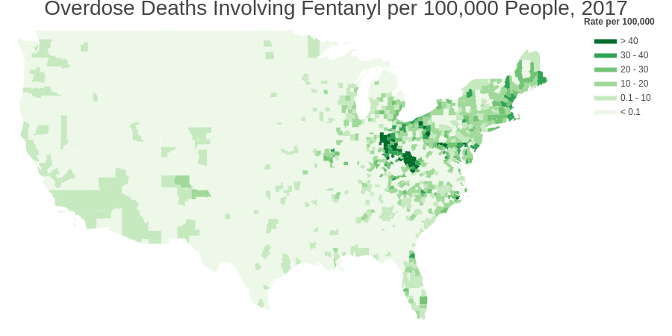

- Your experiment
As mentioned in the methodology section, experiments are only run on the subset of the data that had less than 10 deaths before 2017. Any county with more than 10 deaths in one year before 2017 is automatically classified as high risk. This results in a very imbalanced data set, with only 5% of instances in the positive class. Thus, the baseline accuracy for these experiments is about 94%. Experiments were done using 2016 data and predicting 2017 labels because 2017 is the most recent available data.
As a first experiment, I tried both an SVM classifier and a boosted decision tree classifier (XGBoost). The SVM classifier had a recall of 0, it predicted all instances as belonging to the negative class. The XGBoost classifier had a modest improvement over the baseline, but was only able to successfully identify about 25% of the positive instances. I decided to use the XGBoost classifier for following experiments.
I then modified the XGBoost classifier to account for the imbalance in the data set by setting the ‘scale_pos_weight’ parameter equal to the number of negative instances divided by the number of positive instances. This model was able to achieve a much higher recall with only a small sacrifice in accuracy. I therefore adopted this change for future models.
Because the goal was to create a web application, I wanted to experiment with fewer features. With only four features (population, percent in distress, opioid prescription rate, and spatial lag death rate) the model was able to almost match the performance of the model with all features.
Finally, because the most recent data is from 2017, I wanted to make sure that the model would be able to predict two years in advance. I trained the model on 2015 data instead of 2016, and was still able to predict 2017 labels.
The previous discussion is summarized in the following table, all numbers were averaged over 10 runs:

Model | Notes | Variables | Accuracy | Recall
SVM | First Attempt | All | 0.94 | 0
XGBoost | First Attempt | All | 0.95 | 0.27
XGBoost | Test of less variables | Smaller 6 | 0.95 | 0.24
XGBoost | Adjust for imbalance | All | 0.89 | 0.77
XGBoost | Adjust for imbalance | Smaller 6 | 0.89 | 0.81
XGBoost | Test for 2 years in advance | Smaller 6 | 0.88 | 0.71

Add confusion matrix
- Application System
The model with the best recall (XGBoost with adjusted scale_pos_weight and only six variables) was retrained on 2017 data. The model then predicted the counties at risk for seeing an increase in deaths in 2018 and 2019. The model identified 500 counties at risk for seeing an increase in deaths. The model was saved to a pickle and built into a web app where users can either enter data for a county or just search directly by a county name to see the risk of fentanyl overdose rates in that county. This app could help medical professionals and law enforcement better prepare for the possibility of fentanyl coming to their county.

- Conclusions and Future Work
I was able to build a model that successfully identified counties at risk of seeing fentanyl overdose deaths for the first time. The model has many shortcomings that could be addressed in future work. First, the model was built on data that had a lot of missing values that were very crudely imputed. Because the missing values were concentrated in low population counties, the model is likely underestimating the risk for these low population counties. Finding a better method for imputing this data would be the first step to improving the model.

REFERENCES
[1] Seth P, Scholl L, Rudd RA, Bacon S. Overdose Deaths Involving Opioids, Cocaine, and Psychostimulants — United States, 2015–2016. MMWR Morb Mortal Wkly Rep 2018;67:349–358. DOI: http://dx.doi.org/10.15585/mmwr.mm6712a1External.
[2] Lo-Ciganic W, Huang JL, Zhang HH, et al. Evaluation of Machine-Learning Algorithms for Predicting Opioid Overdose Risk Among Medicare Beneficiaries With Opioid Prescriptions. JAMA Netw Open. 2019;2(3):e190968. doi:10.1001/jamanetworkopen.2019.0968
[3] Daniel B. Neill & William Herlands (2018) Machine Learning for Drug Overdose Surveillance, Journal of Technology in Human Services, 36:1, 8-14, DOI: 10.1080/15228835.2017.1416511
[4] Stewart, K., Cao, Y., Hsu, M.H. et al. J Urban Health (2017) 94: 572. https://doi.org/10.1007/s11524-017-0177-7
[5] Wilt GE, Lewis BE, Adams EE. A Spatial Exploration of Changes in Drug Overdose Mortality in the United States, 2000–2016. Prev Chronic Dis 2019;16:180405. DOI: http://dx.doi.org/10.5888/pcd16.180405

