CS 510: Foundations of Operating Systems  
Fall 2017, Dr. Jonathan Walpole

Stephen Braich  
sbraich@pdx.edu  
PSU ID: 953378420

**Programming Project 1:**  
Introduction to the Blitz Tools  
October 2nd, 2017

Machine generated alternative text:
steve@ubuntu141arge: — 
sbratch@ada:—/cs5100s/p1S asm Hello. s 
sbratch@ada:—/cs5100s/p1S Iddd Hello .0 -o Hello 
sbratch@ada:—/cs5100s/p1S blitz -g Hello 
Beginning execution... 
Hello, world! 
**** A 'debug' instruction was encountered ***** 
Done! The next instruction to execute will be: 
000080: AIFFFFB8 
jmp 
OXFFFFB8 
! targetAddr 
Entering machine-level debugger... 
The BLITZ Machine Emulator 
copyright 2001-2007, Harry H. porter 111 
Enter a command at the prompt. 
Type 
'quit' 
to exit or 
info about commands. 
Number of Disk Reads 
Number of Disk Writes 
Instructions Executed 
= 1705 
Time Spent Sleeping 
Total Elapsed Time 
= 1705 
sbratch@ada:—/cs5100s/p1S 
asm Echo. s 
sbratch@ada:—/cs5100s/p1S 
Iddd Echo .0 
sbratch@ada:—/cs51eos/p1S 
blitz Echo 
-o Echo 
The BLITZ Machine Emulator 
Copyright 2001-2007, Harry H. Porter Ill 
Enter a command at the prompt. 
Type 
'quit' 
' help' 
' help' 
info about commands. 
Beginning execution... 
abcd 
abcd 
this is a test 
this ts a test 
q 
q 
A 'debug' instruction 
was encountered 
to execute will 
OXFFFFAC 
to exit or 
be: 
Done ! 
eeeeA4: 
The next instruction 
AIFFFFAC 
cont: 
jmp 
! targetAddr 
= main 
for 
for 
= loop 

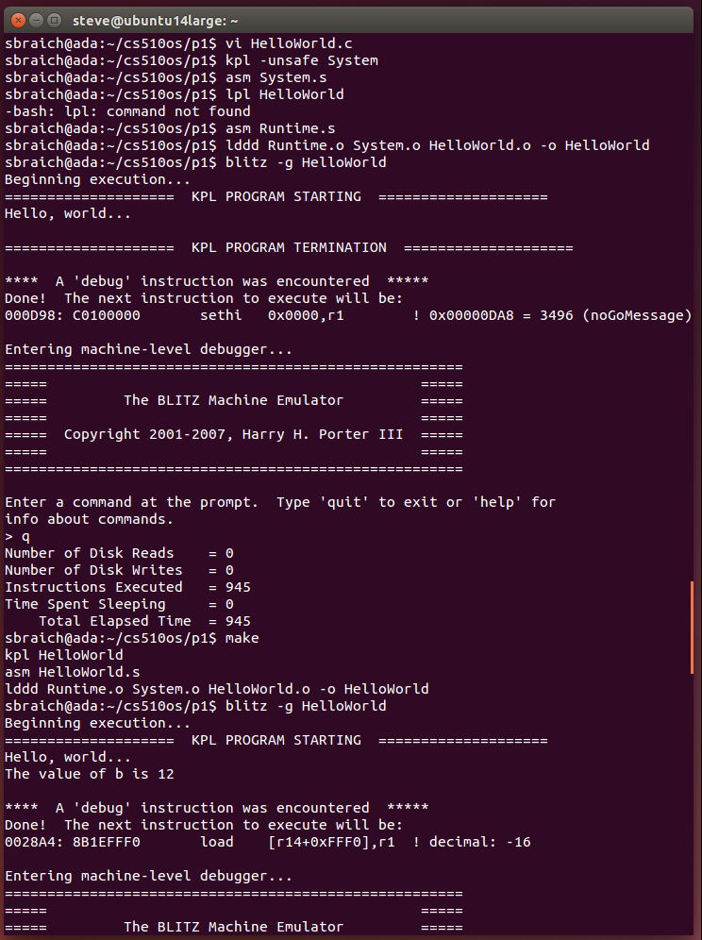

Enter Ln. 
8LIrz 
Harry H. 
Enter a at 
me to 
8BIEFFfe 
or Otsk 
or Olsk 
blitz 
Hello, 
or b 12 
me to 
8BIEFFfe 
Type 
•quit' 
Enter Ln. 
8LIrz 
Harry H. Ill 
Enter a at 
or Otsk 
or Otsk 
•quit' 
= seg 
= seg 

ΙΙΙ -Η 
• ο-ιΙΉ 

issi 
2 

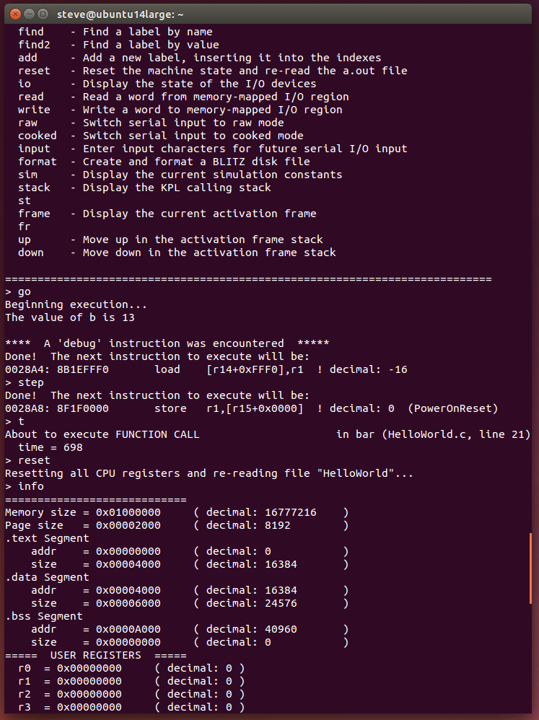

「11 
「12 
「13 
「14 
「15 
「11 
「12 
「13 
「14 
「15 
『12 
『13 
『14 
『15 

r 15 
Interrupts 
System 
Not Negative 
Inter roots 
rlhER_INrERRwr 
Trap 
Address 
or disk 
serial In 
serial 
or Disk Reds 
or "rites 
= 2147483647 
= 2147483647 
me to 
a«ute 
to 
taroetAddr = 
•"INVLRLIO HIGH-LEVEL STATEBENr REGISTER 
Addr 
to 
at or st«k' 
to 
_ Staarop = 
stack' 
to or st«k' 
stack' 
r stackrop e) 
stack' 
or st«k' 
stackrop = e) 
stack' 
or st«k' 